SOFTWARE TESTING REPORT
SauceDemo E-commerce Web Application
Functional Testing • Black-Box Testing • Screenshot Evidence

Student Name | MS. HARSHITA MALVIYA
Student ID | 2504030100426
Application Under Test | SauceDemo (Swag Labs) — https://www.saucedemo.com/
Evidence Reviewed | Six screenshots supplied by the student

1. Introduction
This report documents functional testing of SauceDemo, a demo e-commerce website. The supplied browser screenshots are used as evidence for the login, product inventory, shopping cart, checkout-information, and order-completion stages.

2. Aim and Objectives
- To verify that the demo login flow reaches the product inventory page.
- To inspect the product listing and shopping cart display.
- To review the visible checkout-information form and order-completion result.
- To record expected and observed results with evidence-based Pass/Fail status.

3. Scope and Test Approach
Scope: login page display, successful demo login, product inventory display, lower inventory, shopping cart contents, checkout-information screen, and order confirmation screen.
Approach: manual functional testing using the screenshots supplied by the student. This report does not claim that unshown negative tests, sorting, removal, or checkout validation were executed.

4. Test Environment
Website | https://www.saucedemo.com/
Application type | Browser-based demo shopping application
Testing method | Manual functional / black-box testing
Evidence | Six screenshots captured on 10 October 2026

5. Test Execution Summary
Section | Testing Step | Expected Result | Actual Result | Status
Login | Open SauceDemo login page | Login page appears with username and password fields, Login button, and demo credential guidance. | Login page is visible. The page lists accepted usernames and the shared password. | Pass
Authentication | Log in with a standard demo user | Valid credentials are accepted and the user is redirected to the product inventory page. | The product inventory page is displayed after login. | Pass
Product Inventory | Review product cards and shopping controls | Products, descriptions, prices, and Add to cart/Remove controls are displayed. | Product cards and prices are visible; some page content is obscured by the browser password prompt in the supplied capture. | Pass
Product Inventory | Scroll to lower inventory items | Remaining product cards and page footer are displayed. | Lower product cards and footer are visible. | Pass
Shopping Cart | Open and inspect the cart | Cart lists selected products, quantities, prices, and Remove controls. | Four products are listed, each with quantity 1, a price, and a Remove button. | Pass
Checkout | Review checkout information form | Required information can be entered and Continue moves to order overview. | The checkout information form is displayed with fields filled and Continue visible; the screenshot does not prove that Continue was clicked. | Not Verified
Order Completion | Verify order confirmation page | Order completion page displays a confirmation message. | The page shows “Thank you for your order!” and a completion check icon. | Pass
Status note: “Pass” is used only where the supplied screenshot visibly supports the expected result. The checkout-information submission is marked “Not Verified” because the screenshot shows the form but not the result after pressing Continue.

6. Screenshot Evidence and Explanation

Screenshot 1 — Login Page
The login page is open. The username and password inputs and Login button are visible, along with the demo credentials list. This establishes the starting point for login testing.
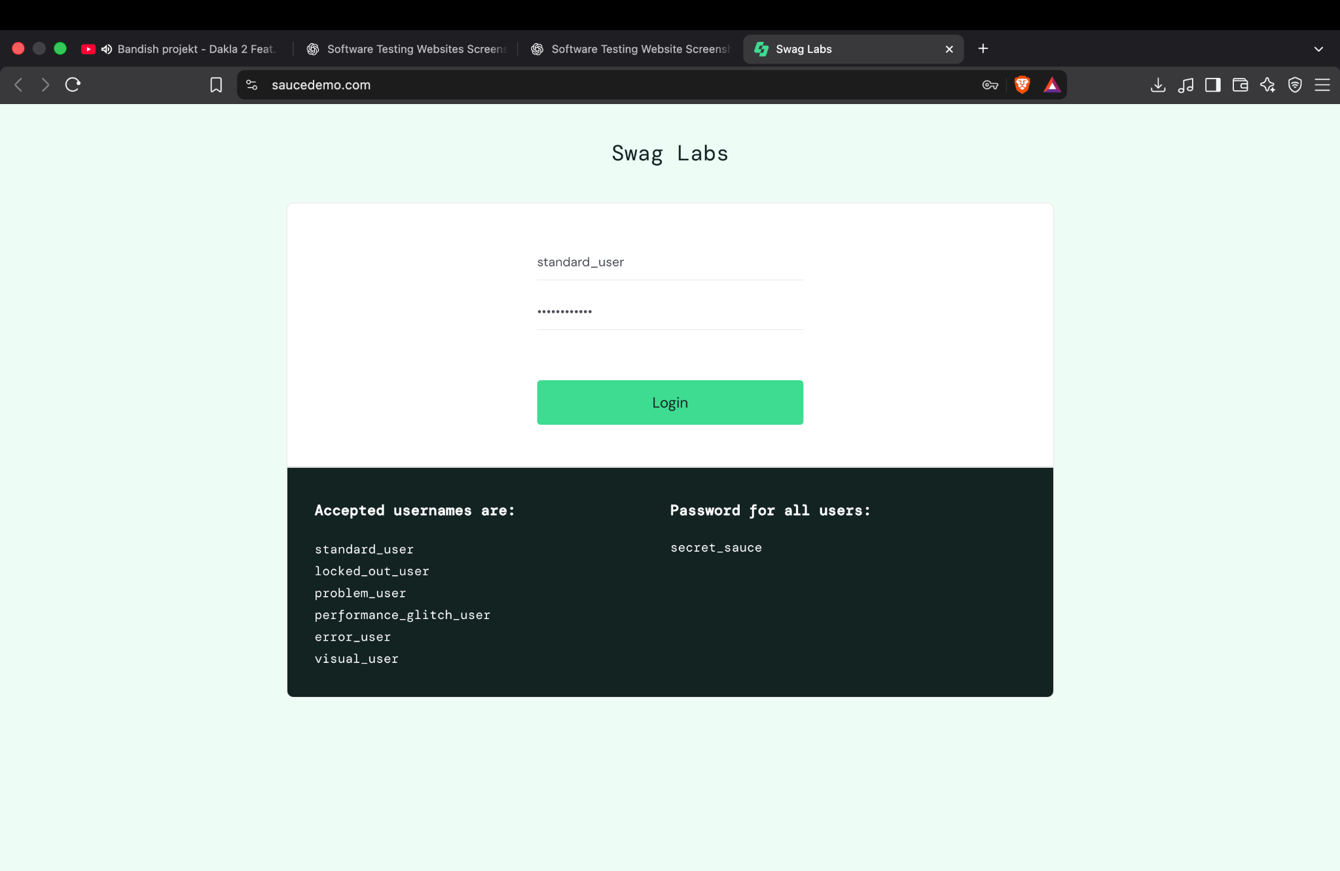

Screenshot 2 — Product Inventory After Login
The inventory page is visible and the cart badge shows two items in this capture. A browser password-save dialog overlays part of the page. The screenshot supports that login reached the inventory page, but the popup reduces visibility.
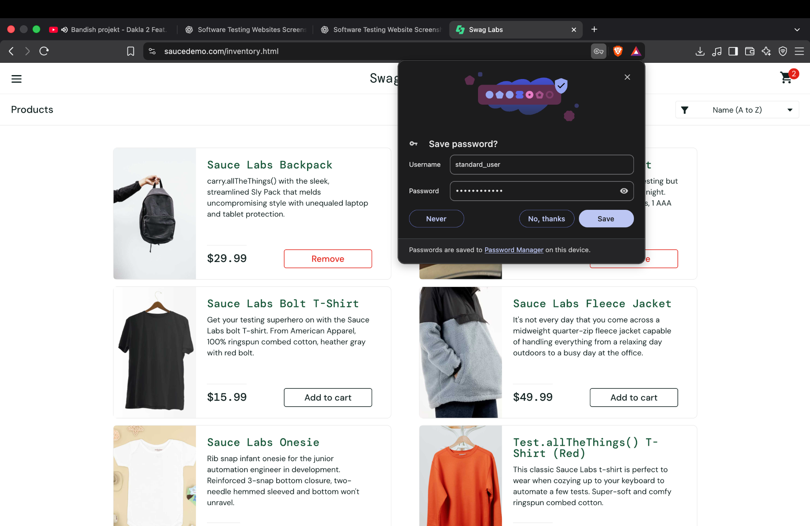

Screenshot 3 — Lower Product Inventory
The lower product cards and page footer are visible. Several products show prices and Add to cart controls, supporting the inventory display check.
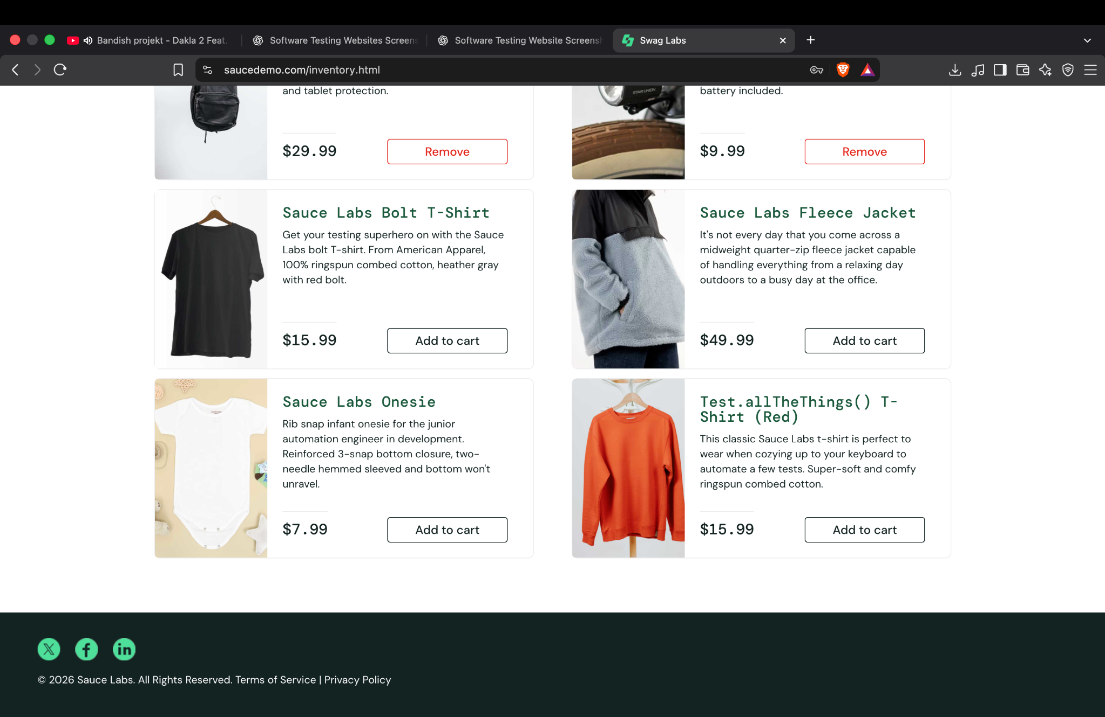

Screenshot 4 — Shopping Cart
The cart page lists four selected items with quantity, description, price, and Remove controls. This supports the cart contents display test; it does not by itself verify removal behavior.
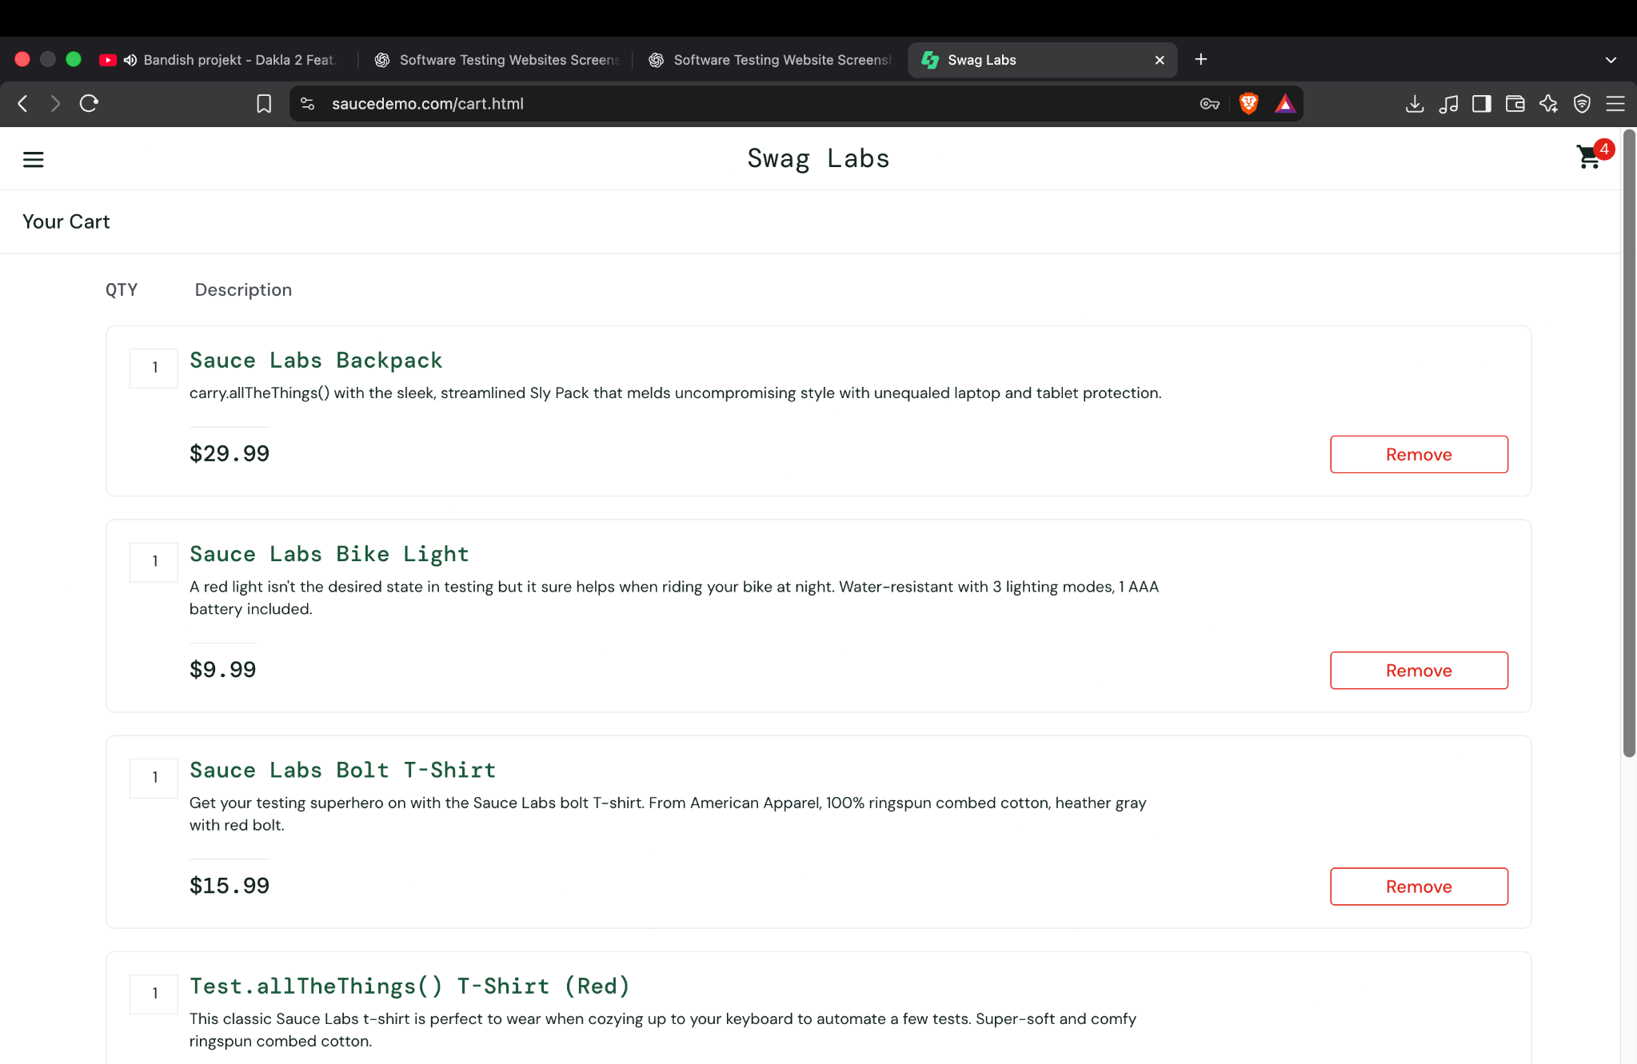

Screenshot 5 — Checkout Information
The checkout form displays first name, last name, and postal code fields with values entered. The Continue button is visible. This image does not prove the form was submitted or that the order overview loaded.
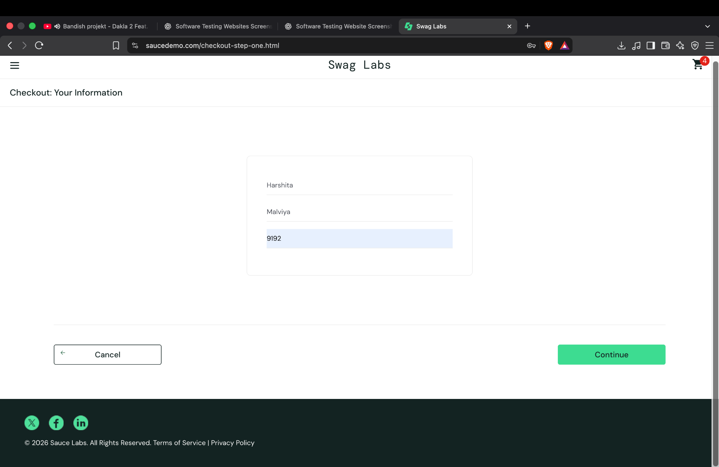

Screenshot 6 — Order Completion
The completion page displays a check icon and the message “Thank you for your order!” This supports that the demo flow reached the order-completion page. The intermediate overview screen was not included in the evidence.
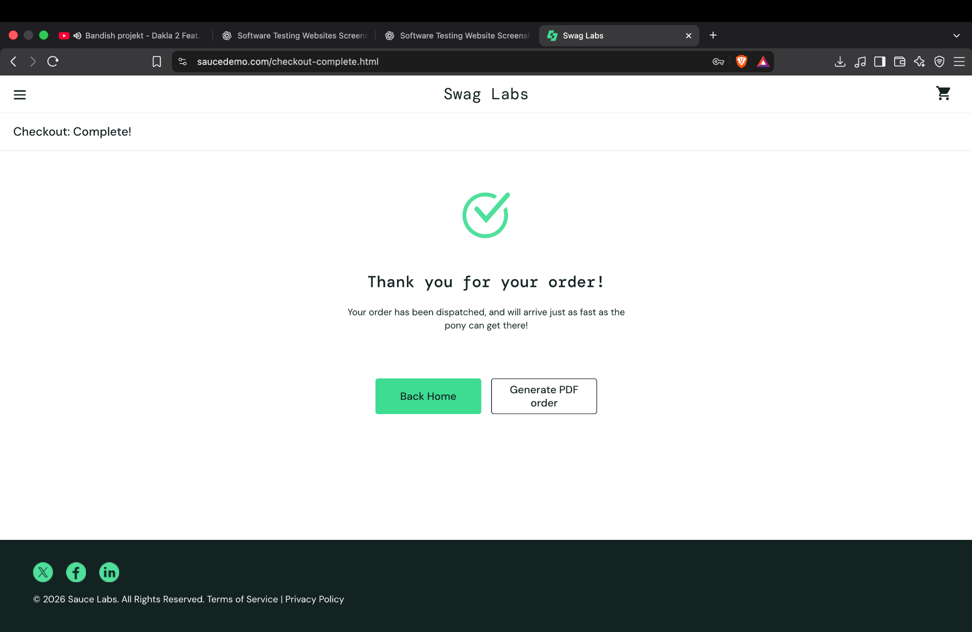

7. Observations, Limitations, and Recommendations
- The screenshots show a successful happy-path flow from login to the order-completion page.
- The browser password-manager dialog partly obscures the product inventory screenshot; dismiss popups before taking evidence screenshots.
- The checkout-information screenshot does not show the result after Continue. Capture the order overview to verify this step.
- Add separate tests for invalid login, empty checkout fields, product sorting, adding/removing products, and canceling checkout if required by the instructor.
- The report records the supplied screenshots as evidence; it does not claim that unshown interactions were independently retested.

8. Conclusion
Based on the six supplied screenshots, the login page, inventory display, cart display, and final order-confirmation page are evidenced. The checkout-information form is visible, but its submission is not independently verified by the supplied image. Additional screenshots and test executions are recommended before declaring the entire workflow fully verified.

