SOFTWARE TESTING REPORT
Real-World Website Testing: Flipkart
Practical evidence report based on screenshots supplied by the student

Student ID | 2504030100426
Student Name | Ms. Harshita Malviya
Website Under Test | Flipkart — https://www.flipkart.com/
Evidence Reviewed | 5 screenshots supplied by the student

1. Objective
To review selected visible features of the real-world Flipkart shopping website and document observations using screenshot evidence. The review covers the homepage, login modal, product details, shopping cart and promotional product sections.

2. Scope and test approach
This is a black-box, UI-focused review based on the five screenshots provided. It records only what is visible in the supplied evidence. It does not claim that every workflow was independently re-executed, and it does not assess Flipkart's internal source code, backend, security controls or requirements specification.

3. Test environment
Website | Flipkart (flipkart.com)
Browser shown | Brave browser (based on visible browser UI)
Device context | Desktop browser screenshot
Test method | Visual inspection / black-box observation
Evidence date | 10 October 2026 (as indicated by screenshot filenames)

4. Test summary
Five screenshots were supplied. They provide evidence of the homepage, login prompt, product detail page, cart page and promotional deals area. The screenshots show these pages rendered, but they do not independently prove that all controls or workflows function correctly. Therefore, the report uses 'Observed' for screenshot-backed observations and 'Not Tested' where the available evidence does not demonstrate an interaction.

5. Detailed test observations

TC-01 — Homepage display
Test input / action: Open flipkart.com
Expected result: Homepage, search field, categories and promotions are visible
Actual result based on evidence: Homepage and category/promotion areas are visible in supplied screenshots
Status: Observed
Personal comments & suggestions: Main navigation and product promotion panels are visible. Check layout at different screen sizes in a separate test.

TC-02 — Login modal display
Test input / action: Select Login
Expected result: Login dialog and phone-number field are displayed
Actual result based on evidence: Login dialog is visible, with phone number field, email option and Continue button
Status: Observed
Personal comments & suggestions: The Continue button appears disabled while the phone number field is empty. Do not enter a personal phone number for this practical.

TC-03 — Product detail display
Test input / action: Open a product listing
Expected result: Product title, images, rating and price are displayed
Actual result based on evidence: Product detail screenshot shows product images, title, rating and price
Status: Observed
Personal comments & suggestions: The product page is displayed. Price and availability can vary; record the values visible at the time of testing.

TC-04 — Cart display
Test input / action: Open Cart
Expected result: Cart items and price details are displayed when items are present
Actual result based on evidence: Cart screenshot shows two items, item prices and price details
Status: Observed
Personal comments & suggestions: The screenshot shows cart contents and a Place order button. No order was placed.

TC-05 — Promotional deals area
Test input / action: Scroll homepage to deals
Expected result: Promotional product cards and prices are displayed
Actual result based on evidence: Deals sections and multiple product cards are visible
Status: Observed
Personal comments & suggestions: Promotional cards are visible. Verify each product link separately if required by the instructor.

TC-06 — Search results
Test input / action: Search for headphones
Expected result: Relevant product results appear for the search term
Actual result based on evidence: No search-results screenshot supplied
Status: Not Tested
Personal comments & suggestions: Capture a separate search-results screenshot and record the actual result before assigning Pass or Fail.

TC-07 — Filter/sort interaction
Test input / action: Apply a product filter or sort
Expected result: Results update according to selected filter/sort
Actual result based on evidence: No filter/sort interaction screenshot supplied
Status: Not Tested
Personal comments & suggestions: Capture before/after results and verify that the selected filter or sorting order is applied.

6. Screenshot evidence
The following evidence images were supplied for this report. Captions describe visible content, not unverified behaviour.

Screenshot 1 — Login modal
A login dialog overlays the homepage. The phone-number field, email sign-in option and Continue button are visible.
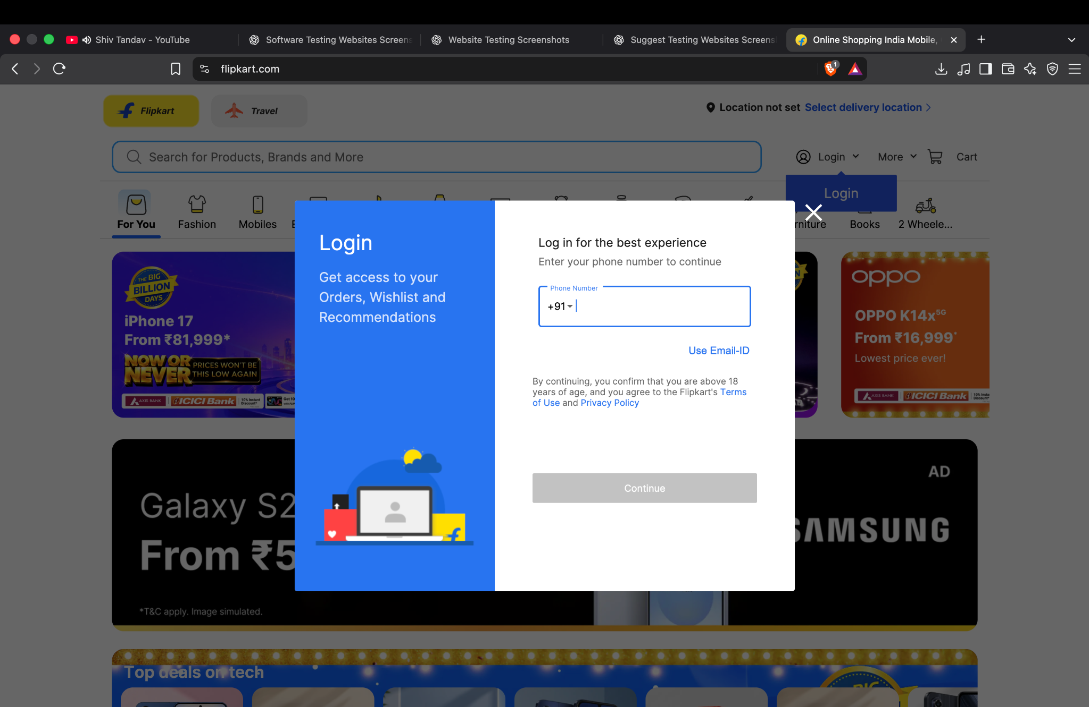

Screenshot 2 — Homepage
The homepage shows search, category navigation, promotional banners and product cards.
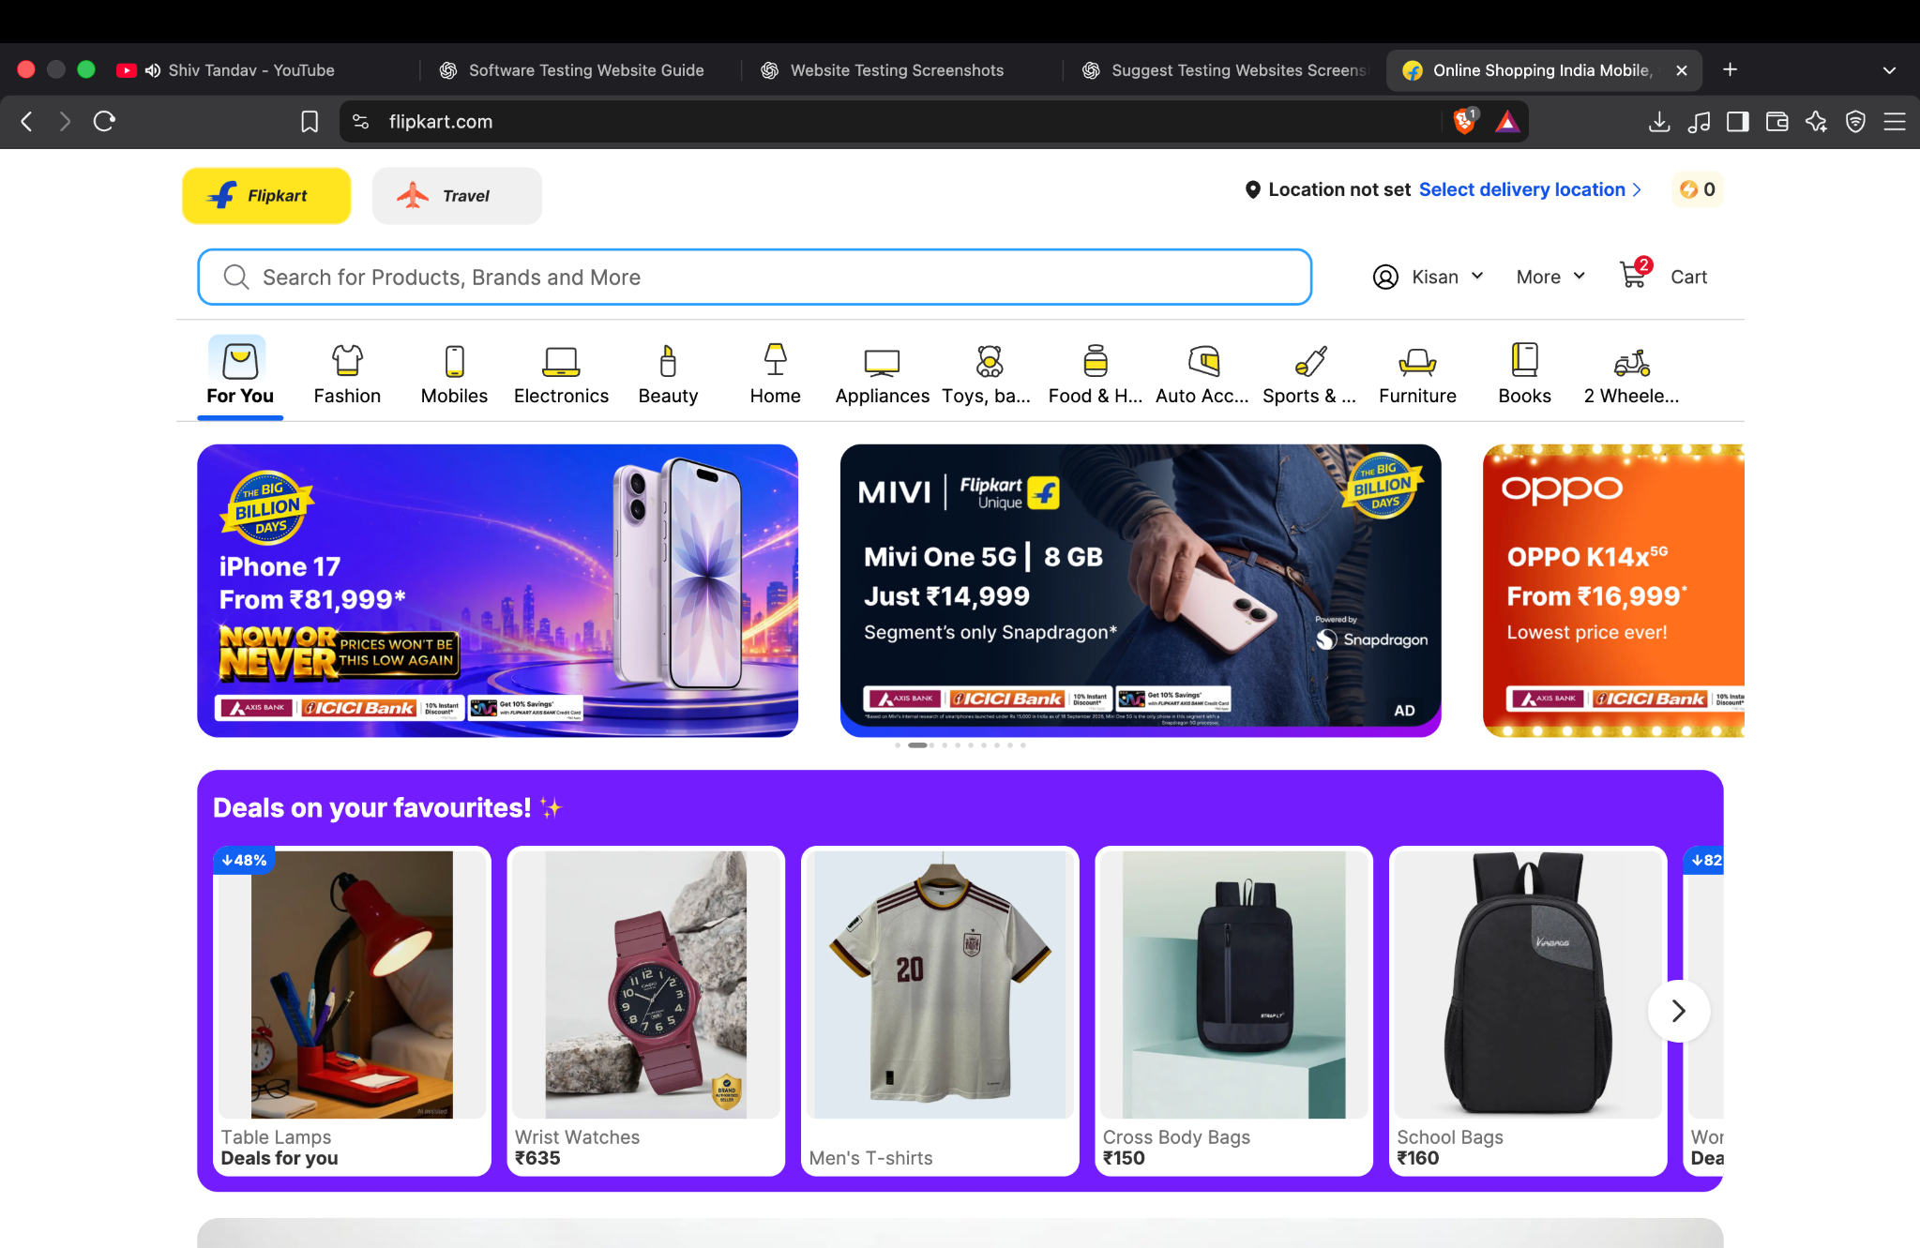

Screenshot 3 — Product details
The product page shows product imagery, title, rating, price and purchase controls.
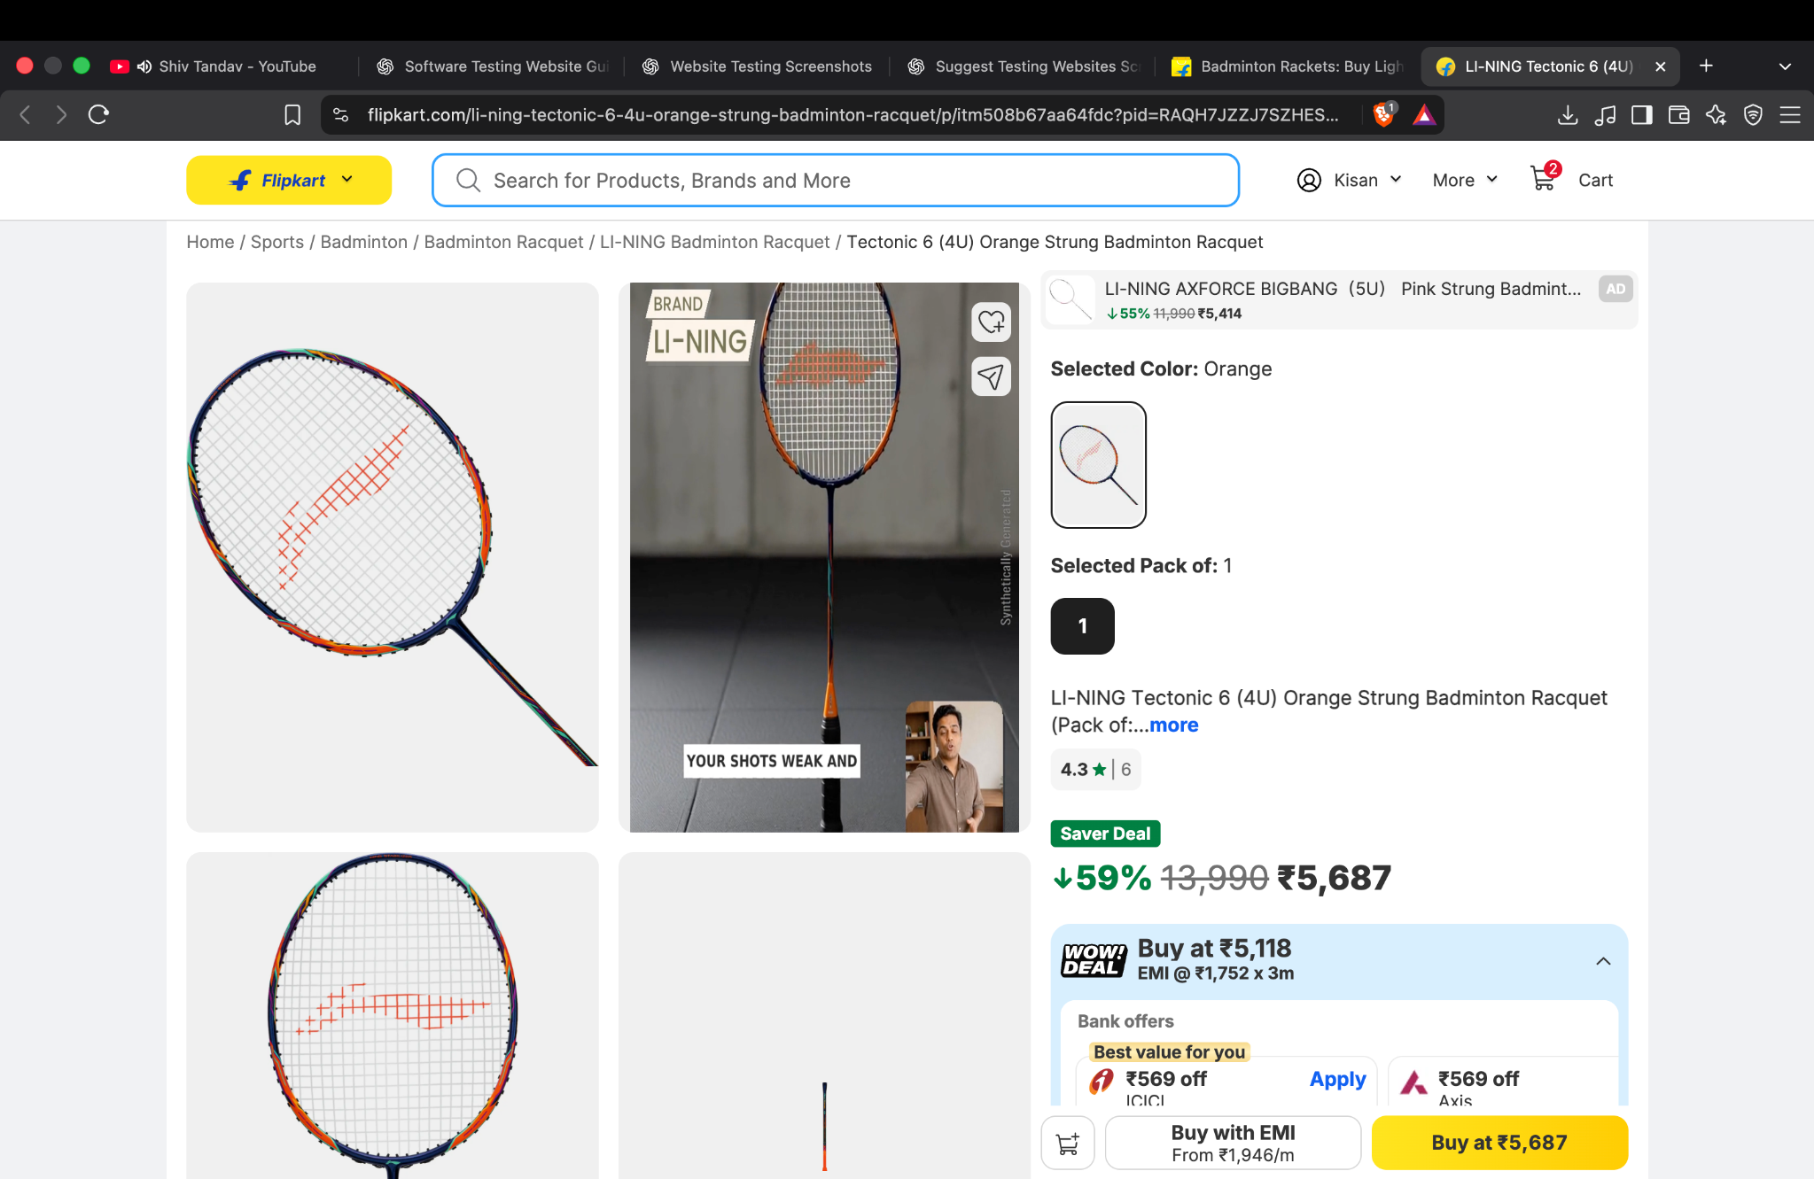

Screenshot 4 — Shopping cart
The cart page shows listed items, quantities/prices, price details and a Place order control.
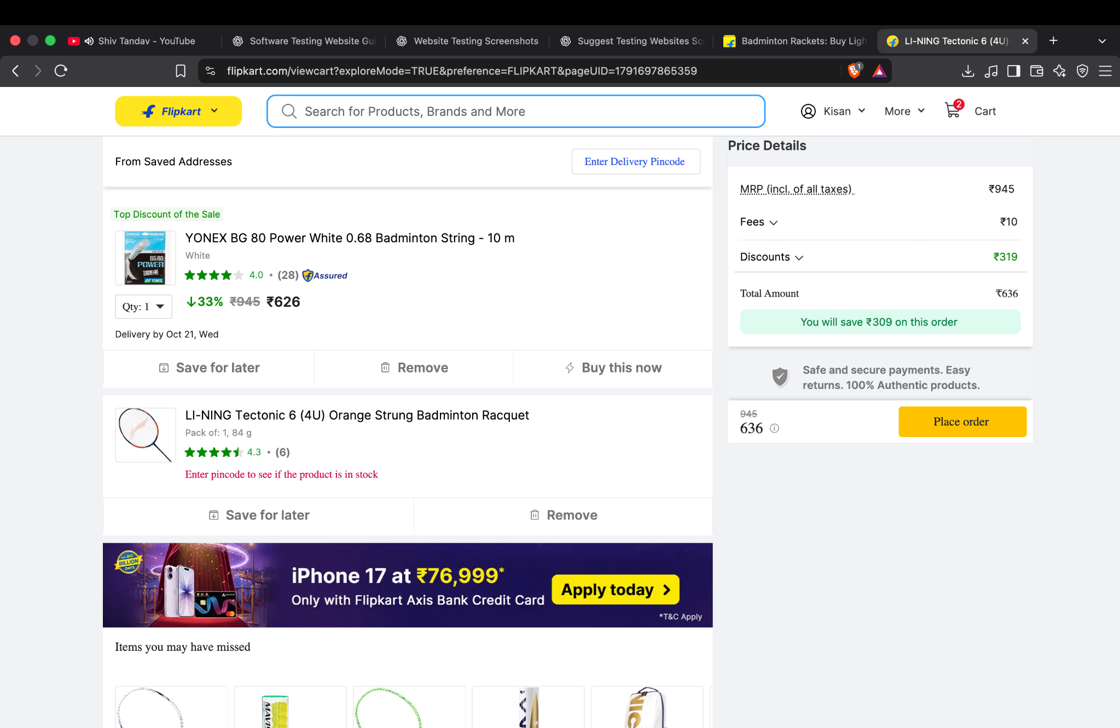

Screenshot 5 — Promotional deals
The homepage promotional section shows product cards, images and advertised prices.
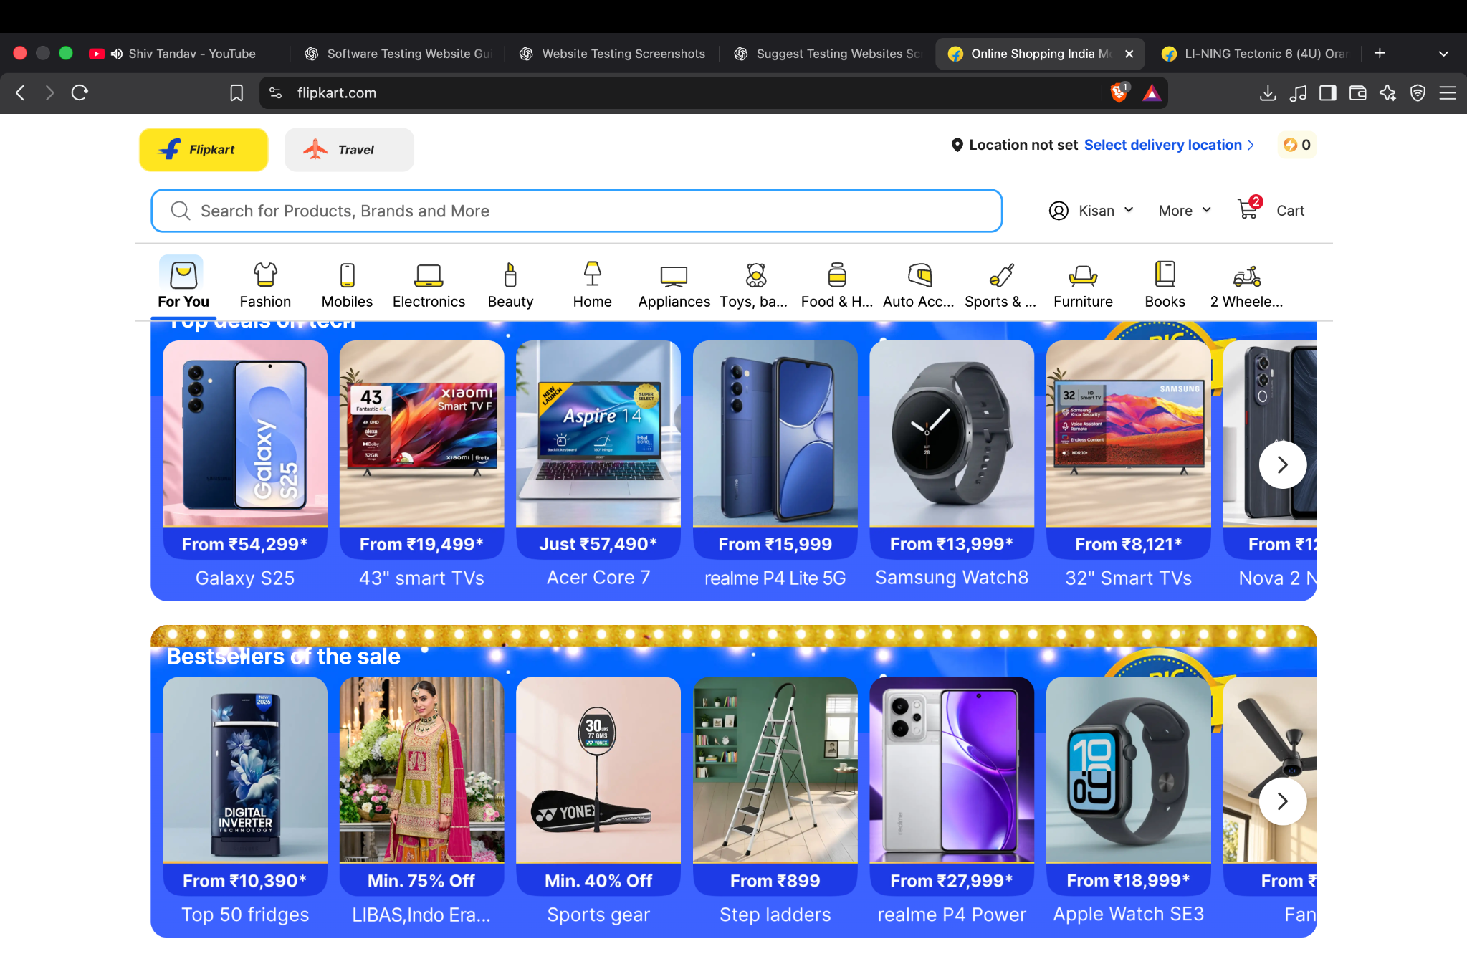

7. Defects, risks and recommendations
- No confirmed functional defect can be concluded from these screenshots alone; they primarily show page states.
- Add a search-results screenshot and filter/sort before-and-after evidence to complete the planned coverage.
- For login testing, use only approved test data and avoid recording real phone numbers, passwords, OTPs or personal account details.
- Check keyboard navigation, visible focus, field labels, responsive layout and error-message clarity as separate usability/accessibility tests.
- Do not click Place order or complete a payment as part of this practical.

8. Conclusion
The supplied screenshots provide useful visual evidence for a basic black-box review of Flipkart's homepage, login prompt, product page, cart and promotional area. Three additional interaction checks (search, filter and sort) should be executed and documented if required. Statuses in this report reflect the available screenshot evidence and should be updated only after the student performs and observes each test.

Prepared for academic practical submission

