SOFTWARE TESTING REPORT
Functional, Positive, Negative and Non-Functional Testing
Website Under Test: Zomato
Student Name | MS. HARSHITA MALVIYA
Student ID / Enrollment No. | 2504030100426
Evidence | Six screenshots supplied by the student

1. Aim
To examine selected visible functions of the Zomato website and document functional, positive, negative and non-functional testing observations using screenshot evidence.

2. Website and Scope
Website: https://www.zomato.com/. The supplied screenshots show the landing page, login dialog, OTP verification interface, restaurant collections, filtered restaurant results and checkout/payment methods. The scope is limited to these visible states; no backend logs, automation results, successful payment receipt or performance timings were supplied.

3. Testing Types
- Functional testing: Checks visible features and screens such as login UI, restaurant discovery and checkout.
- Positive testing: Checks a valid user path. Successful login is not evidenced and is marked Blocked.
- Negative testing: Checks missing or invalid input. These cases are proposed, not claimed as executed.
- Non-functional testing: Observes rendering and readability. No measured performance timing is claimed.

4. Test Environment and Method
Evidence shows Zomato opened in a desktop web browser on macOS. The screenshots were reviewed manually and each visible state mapped to a test objective. Pass applies only to the limited visible-interface objective. Blocked and Not Tested indicate that the provided evidence does not establish the result.

5. Execution Summary
Status | Count
Pass | 9
Blocked | 1
Not Tested | 3
This is an evidence-based practical report, not a certification of Zomato backend behavior, account authentication, payment processing, security controls or production performance.

6. Detailed Test Cases and Results

TC-01: Verify landing page loads
Section | Functional Testing
Testing Step | Verify landing page loads
Test Input | Open https://www.zomato.com/
Expected Result | Landing page and branding render
Actual Result | Zomato branding, headline and app-store links visible in screenshot 01
Status (Pass/Fail) | Pass
Personal Comments & Suggestions | Confirms visible rendering only; links were not individually tested.

TC-02: Open login dialog
Section | Functional Testing
Testing Step | Open login dialog
Test Input | Select Log in / login entry point
Expected Result | Login dialog shows available sign-in options
Actual Result | Phone field, OTP button, email and Google options visible in screenshot 02
Status (Pass/Fail) | Pass
Personal Comments & Suggestions | Authentication itself is not confirmed.

TC-03: Display OTP verification screen
Section | Functional Testing
Testing Step | Display OTP verification screen
Test Input | Request OTP using an account/number you control
Expected Result | OTP screen displays input boxes and timer
Actual Result | Six OTP boxes, countdown and resend text visible in screenshot 03
Status (Pass/Fail) | Pass
Personal Comments & Suggestions | Screen appeared; successful OTP validation is not shown.

TC-04: Display dining-out collections
Section | Functional Testing
Testing Step | Display dining-out collections
Test Input | Open restaurant discovery page
Expected Result | Collections and restaurant cards appear
Actual Result | Collections heading and collection cards visible in screenshot 04
Status (Pass/Fail) | Pass
Personal Comments & Suggestions | Visual rendering only.

TC-05: Display filtered restaurant results
Section | Functional Testing
Testing Step | Display filtered restaurant results
Test Input | Open restaurant listing with Thali filter applied
Expected Result | Results show restaurant names and useful details
Actual Result | Restaurant cards, ratings, offer labels, prices and delivery estimates visible in screenshot 05
Status (Pass/Fail) | Pass
Personal Comments & Suggestions | Filter correctness was not compared against a formal requirement.

TC-06: Open checkout and payment methods
Section | Functional Testing
Testing Step | Open checkout and payment methods
Test Input | Select an item and proceed to checkout
Expected Result | Checkout shows order summary, total and payment options
Actual Result | Checkout summary, grand total and payment categories visible; Place order appears disabled in screenshot 06
Status (Pass/Fail) | Pass
Personal Comments & Suggestions | Checkout rendered; order placement/payment completion not tested.

TC-07: Complete valid sign-in
Section | Positive Testing
Testing Step | Complete valid sign-in
Test Input | Use own authorized phone/email/Google account
Expected Result | Successful login reaches authenticated state
Actual Result | No successful-login confirmation in supplied evidence
Status (Pass/Fail) | Blocked
Personal Comments & Suggestions | Capture a success state before marking Pass.

TC-08: Submit blank login input
Section | Negative Testing
Testing Step | Submit blank login input
Test Input | Leave phone field blank and attempt to continue
Expected Result | Validation message appears or action is prevented
Actual Result | Not shown in supplied screenshots
Status (Pass/Fail) | Not Tested
Personal Comments & Suggestions | Execute and record the actual message before assigning Pass/Fail.

TC-09: Submit invalid phone input
Section | Negative Testing
Testing Step | Submit invalid phone input
Test Input | Use a clearly invalid test value, not another person’s number
Expected Result | Invalid input is rejected or validation feedback appears
Actual Result | Not shown in supplied screenshots
Status (Pass/Fail) | Not Tested
Personal Comments & Suggestions | Avoid repeated OTP requests and do not use numbers you do not control.

TC-10: Observe landing page rendering
Section | Non-Functional Testing
Testing Step | Observe landing page rendering
Test Input | Load the landing page in browser
Expected Result | Key content renders without obvious layout breakage
Actual Result | Landing-page content visible in screenshot 01
Status (Pass/Fail) | Pass
Personal Comments & Suggestions | No load-time measurement supplied.

TC-11: Check restaurant-card readability
Section | Non-Functional Testing
Testing Step | Check restaurant-card readability
Test Input | Inspect names, ratings, prices and delivery estimates
Expected Result | Important restaurant information is readable
Actual Result | These details are visible on screenshot 05
Status (Pass/Fail) | Pass
Personal Comments & Suggestions | Usability observation limited to captured viewport.

TC-12: Measure page load time
Section | Non-Functional Testing
Testing Step | Measure page load time
Test Input | Use browser DevTools Network/Performance and record a metric
Expected Result | Measured timing meets a defined target
Actual Result | No timing measurement supplied
Status (Pass/Fail) | Not Tested
Personal Comments & Suggestions | Record metric, browser, URL and network conditions.

TC-13: Sanitize evidence before submission
Section | Privacy/Security Observation
Testing Step | Sanitize evidence before submission
Test Input | Review checkout screenshot for contact/address details
Expected Result | Report avoids unnecessary personal-data exposure
Actual Result | Contact/address areas redacted in report copies and collage
Status (Pass/Fail) | Pass
Personal Comments & Suggestions | Do not include OTPs, payment credentials or full personal details.

7. Screenshot Evidence
Screenshots are included below. The checkout screenshot copy has contact/address regions redacted for privacy.

01 — Zomato landing page
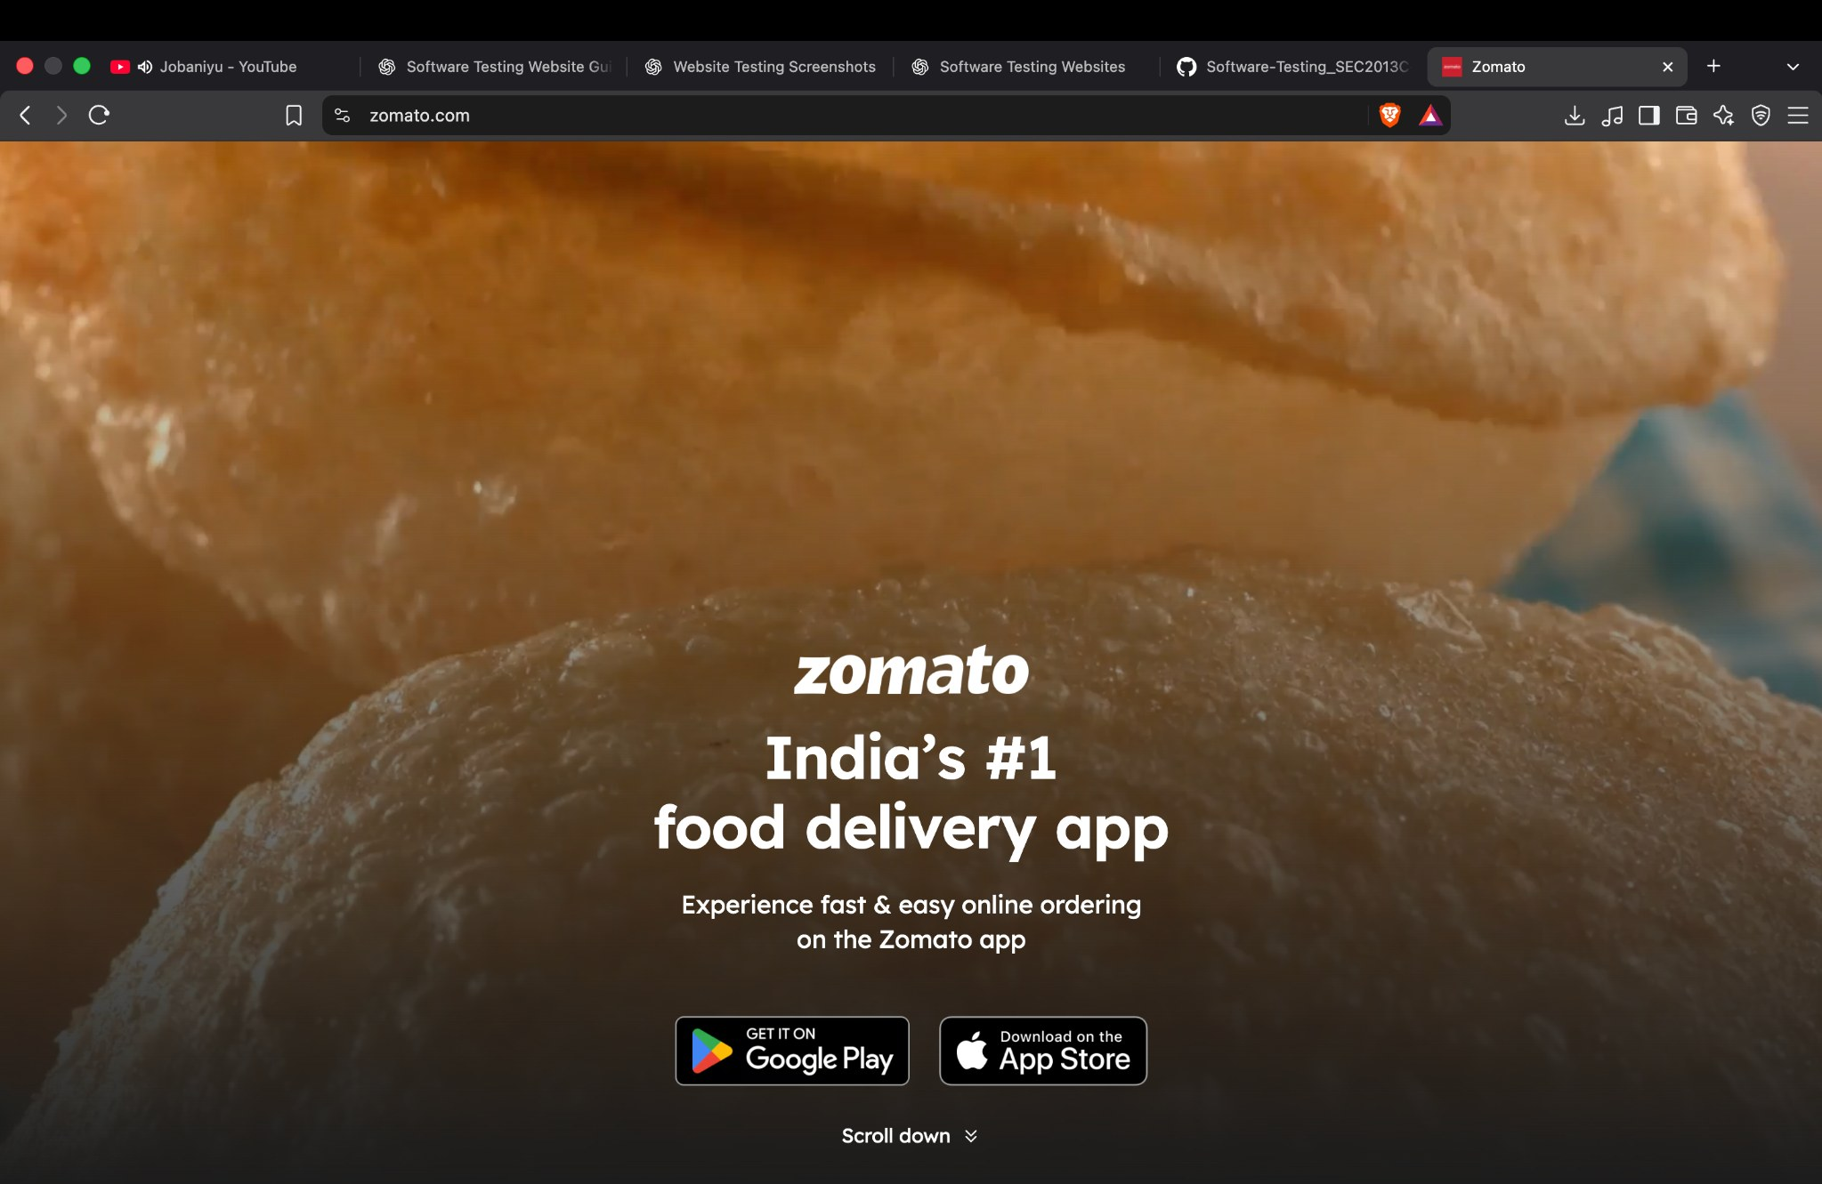
Public landing page and branding.

02 — Login dialog
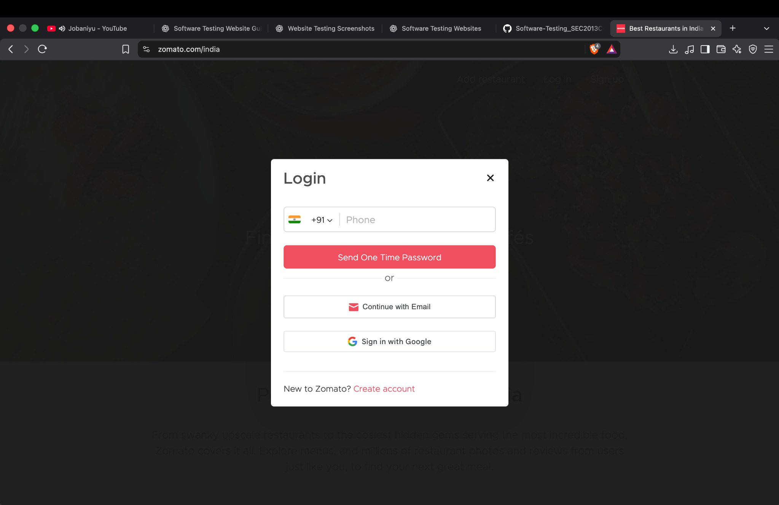
Login dialog and available authentication methods.

03 — OTP verification interface
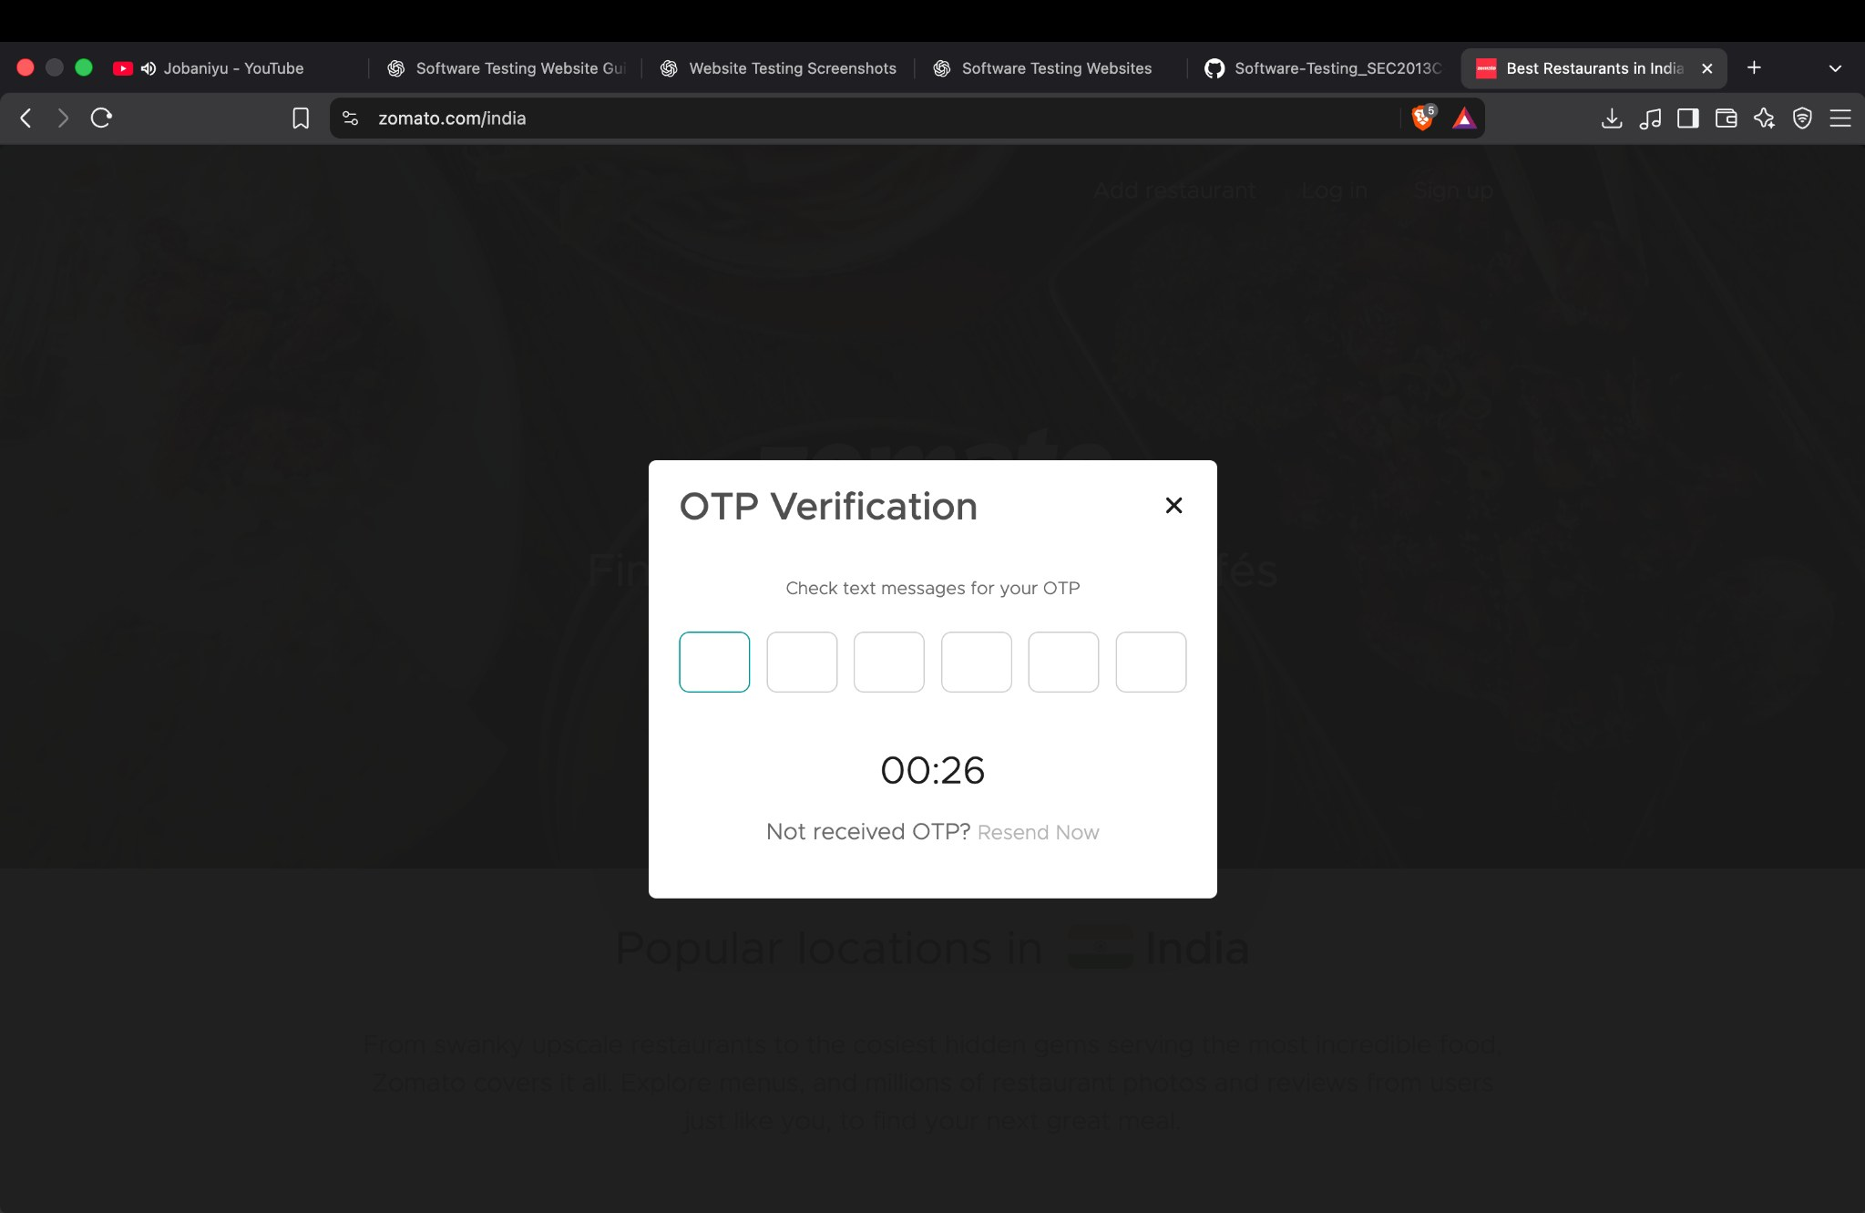
OTP verification interface is visible; successful verification is not shown.

04 — Dining-out collections
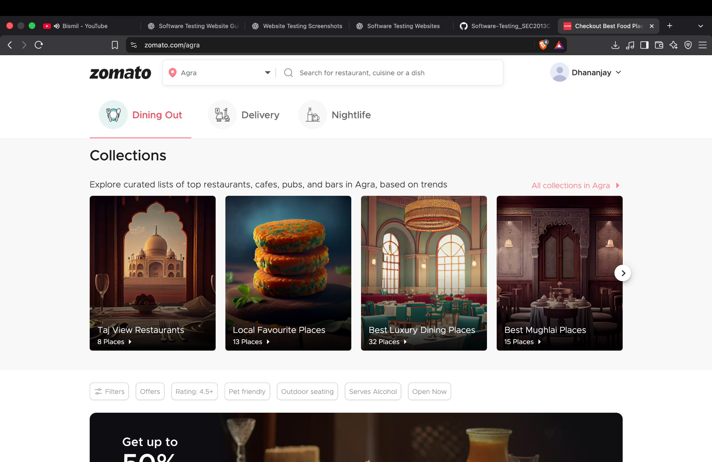
Restaurant discovery collections page.

05 — Restaurant results and filter
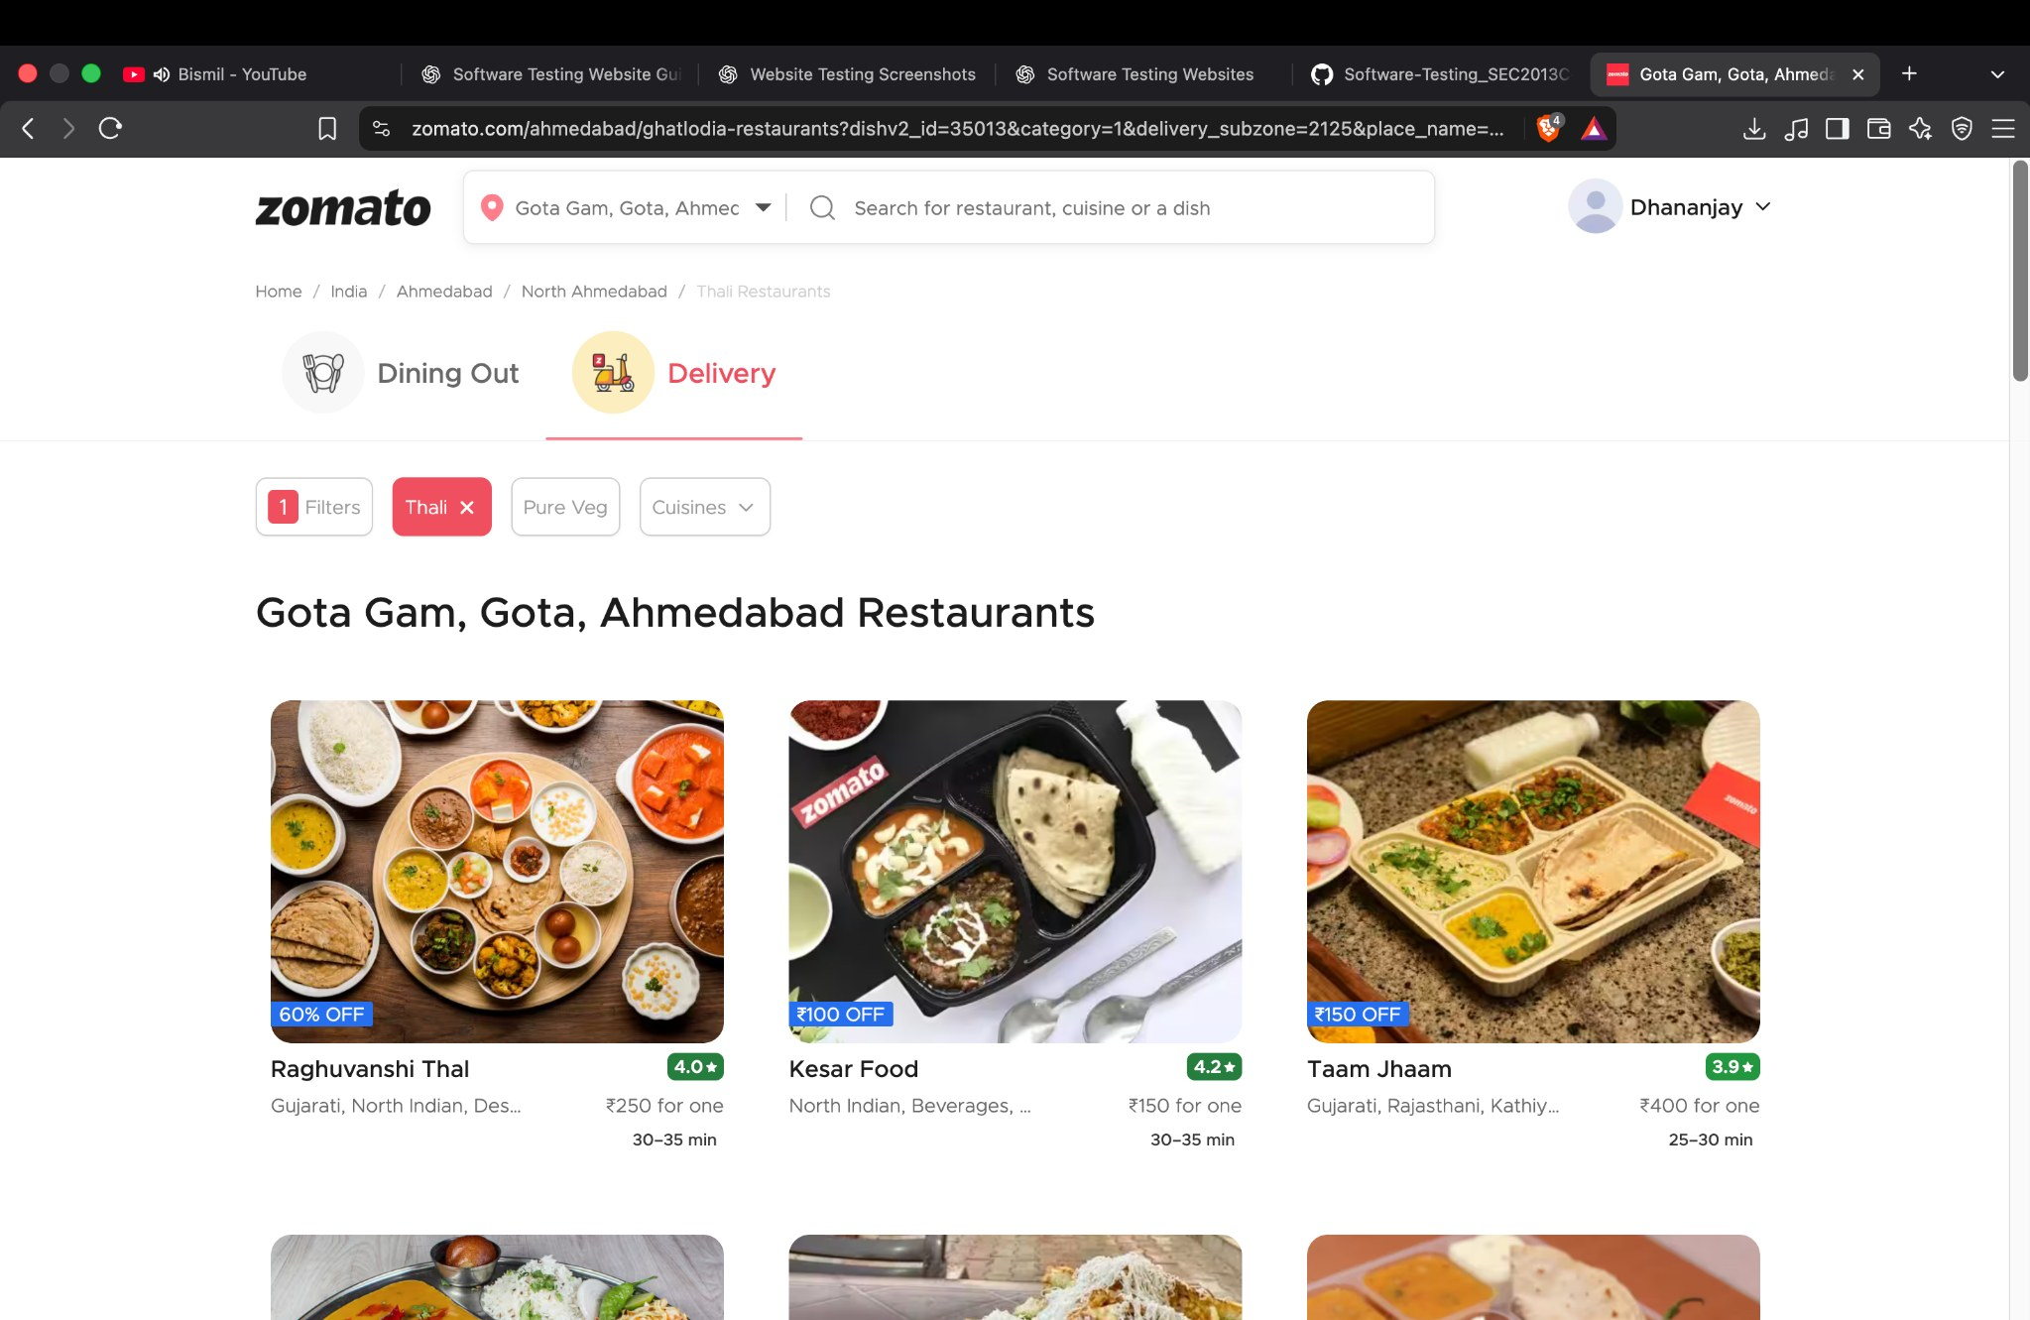
Restaurant cards, ratings, offers/prices and delivery estimates.

06 — Checkout and payment methods
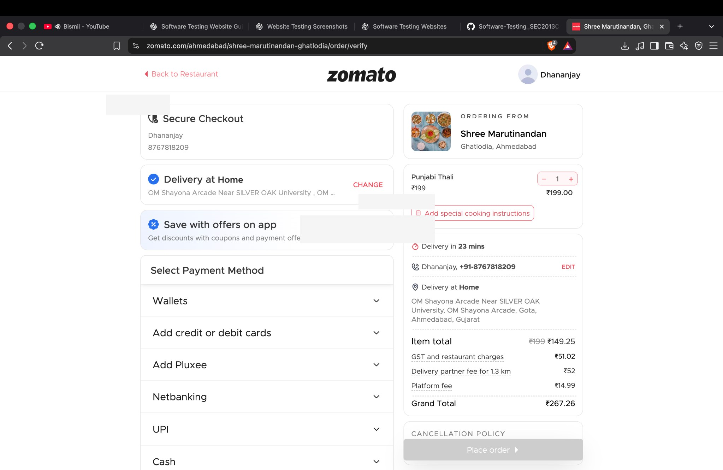
Checkout summary and payment methods. Personal contact/address areas have been redacted; the Place order button appears disabled.

8. Limitations and Recommendations
- The screenshots do not establish a confirmed functional defect; they mainly demonstrate rendered screens.
- Execute blank and invalid sign-in tests and record the actual validation feedback before assigning a result.
- Do not claim OTP success, login success, order placement or payment completion without a confirmation state or receipt.
- Measure load timing with browser DevTools and record the metric, browser, URL and network conditions.
- If required by the assignment, repeat key flows at another viewport/browser.
- Keep phone numbers, full addresses, OTPs and payment information out of submitted evidence.

9. Conclusion
The screenshots provide evidence that Zomato’s landing page, login/OTP interfaces, restaurant discovery/results and checkout/payment-method interface rendered during the captured browser session. These visible-screen checks are marked Pass only for their limited objectives. Successful authentication, invalid-input handling, measured performance and payment completion remain unverified and are marked Blocked or Not Tested.
Prepared for academic practical submission. Screenshot dates: 10 October 2026.

