SOFTWARE TESTING REPORT
Manual Testing & Defect Reporting — Swag Labs (SauceDemo)

Student ID | 2504030100426
Student Name | MS. HARSHITA MALVIYA
Website Under Test | https://www.saucedemo.com/
Testing Type | Manual Functional Testing / Negative Testing
Evidence Submitted | 6 screenshots and screenshot collage

Prepared for academic practical submission

1. Objective
To perform manual functional testing on the Swag Labs demo shopping website, verify login and checkout behavior, capture execution evidence, and document observed results in a structured report.

2. Scope of Testing
- Login screen and invalid-credential handling.
- Access to the product inventory after authentication.
- Shopping cart display and checkout navigation.
- Checkout form validation when required information is missing.
- Checkout overview and displayed price total.

3. Test Environment
Application | Swag Labs / SauceDemo demo website
URL | https://www.saucedemo.com/
Testing method | Manual, black-box functional testing
Browser | Browser shown in the submitted screenshots
Operating system | Not independently verified from the screenshots
Execution date | 10 October 2026 (based on screenshot timestamps)

4. Test Execution Summary
The submitted evidence shows an invalid login attempt, access to the product inventory, a populated cart, a checkout form validation message, and the checkout overview. The screenshots support these observations; they do not show the final order confirmation page.
Test area | Observed outcome | Assessment
Invalid login | Mismatch error message is displayed | Pass — expected negative-login behavior
Inventory | Products and add-to-cart controls are visible | Observed; no dedicated interaction proof in this image
Cart | Cart entries and Checkout control are visible | Observed
Required-field validation | Error states first name is required | Pass — validation is shown
Checkout overview | Payment, shipping, tax, and total are displayed | Observed; total shown as $79.89

5. Screenshot Evidence and Explanation
The collage below provides a quick overview. Individual screenshots and their explanations follow.
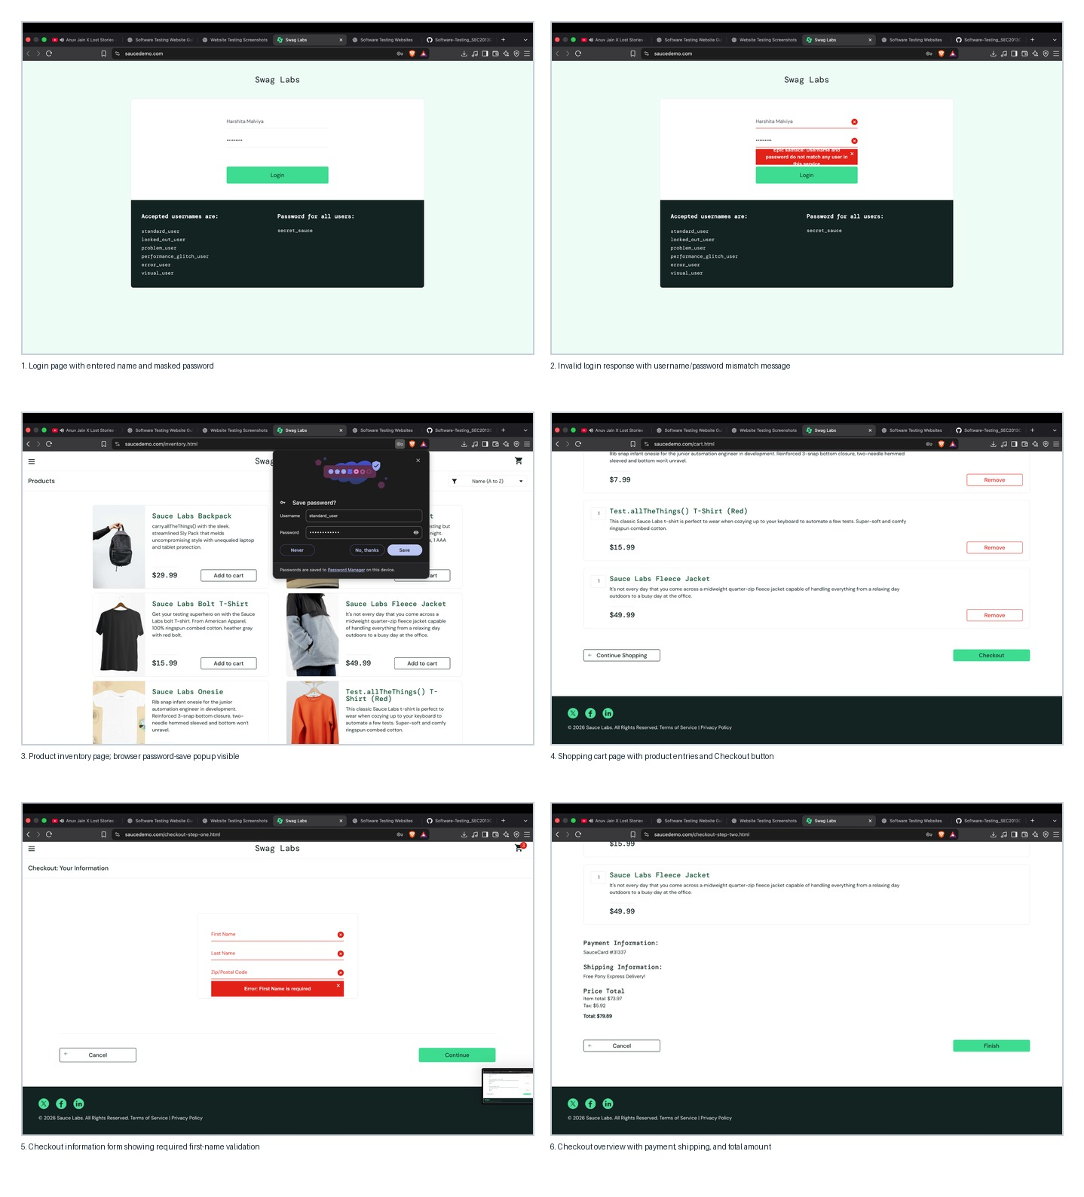

Screenshot 1 — Login page
The login screen contains a username field, a masked password field, and a Login button. The submitted username text is “Harshita Malviya”; this is not one of the documented demo usernames displayed on the page. This supports the negative-login test setup.
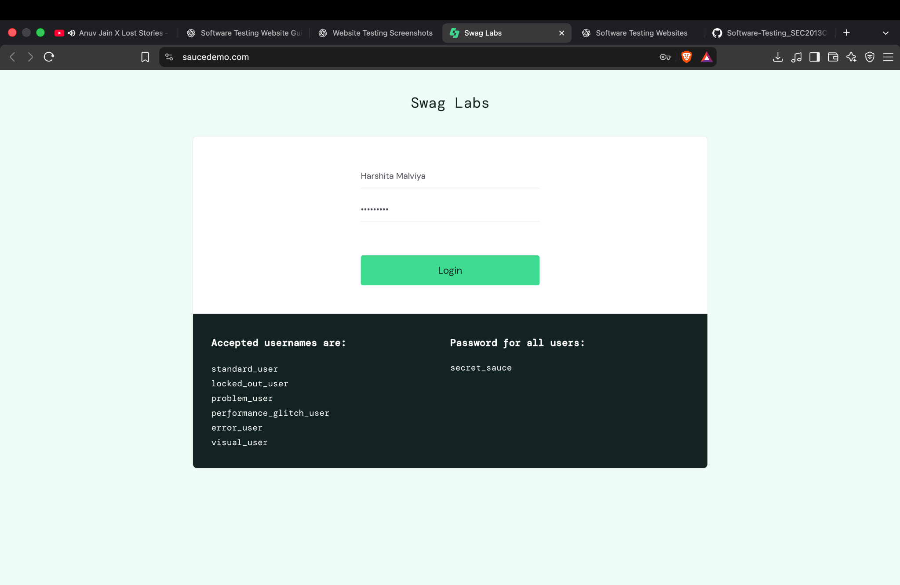

Screenshot 2 — Invalid login response
The page displays an error stating that the username and password do not match any user in the service. This is expected behavior for invalid credentials, so it is recorded as a pass for negative-login handling rather than a defect.
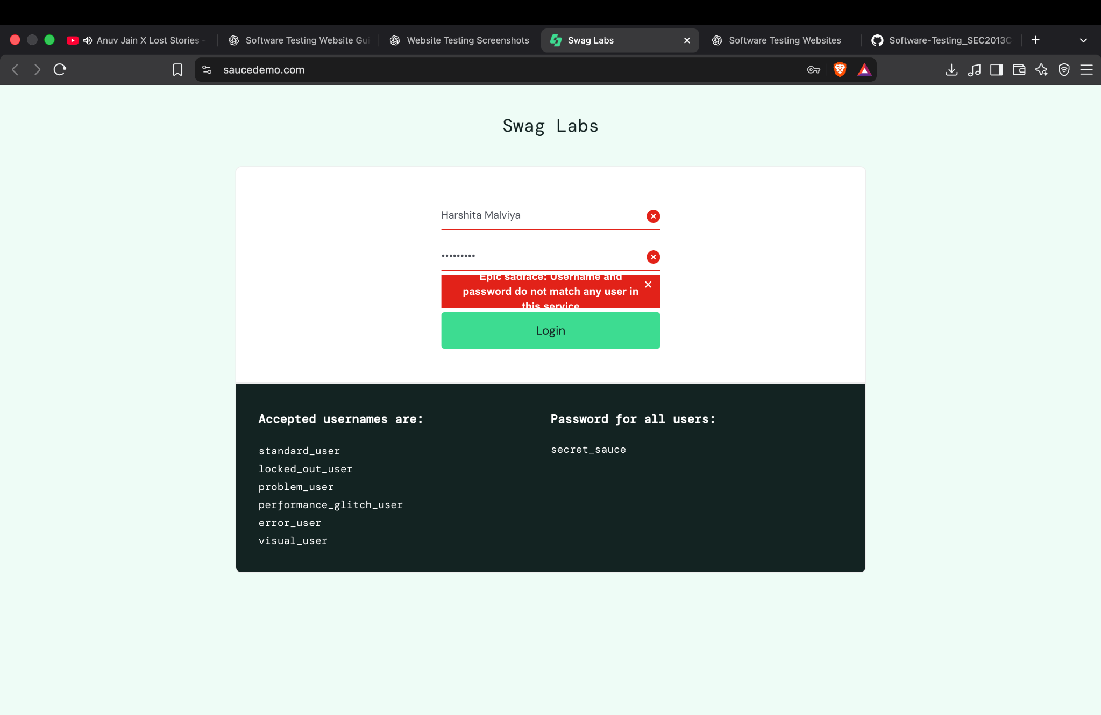

Screenshot 3 — Product inventory
The inventory page displays product cards and Add to cart buttons. A browser password-save popup overlays part of the page; it appears to be browser UI, not a confirmed defect in the website.
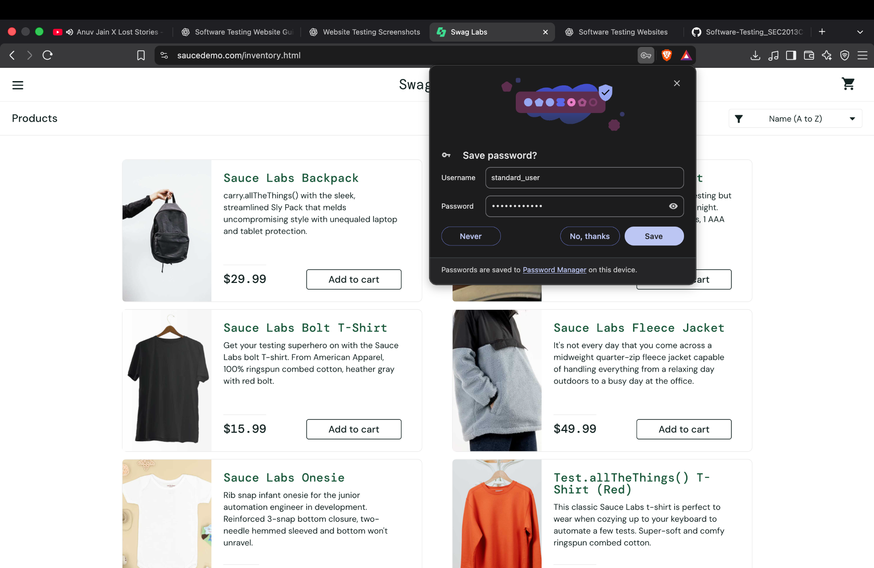

Screenshot 4 — Shopping cart
The cart shows product rows, quantities, prices, Remove controls, Continue Shopping, and Checkout. This screenshot confirms that the cart page is accessible and populated.
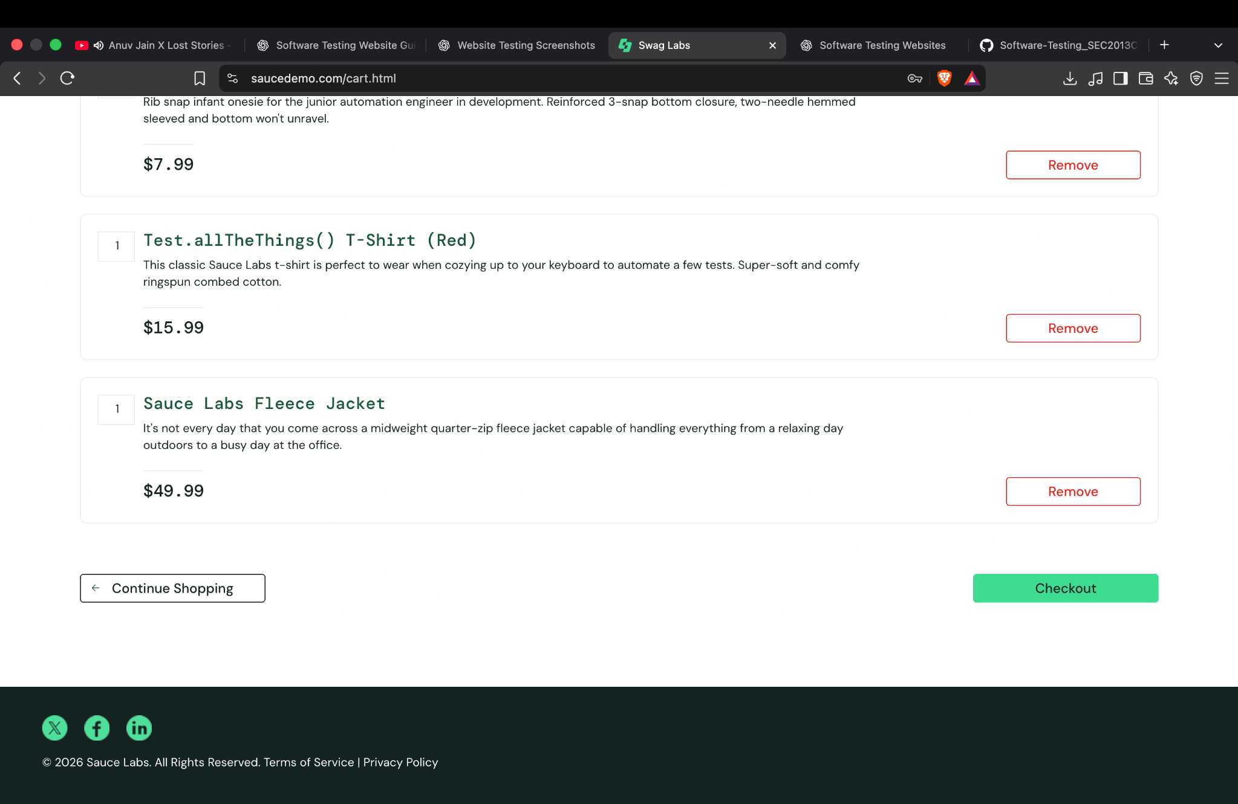

Screenshot 5 — Checkout validation
The checkout information form displays red validation indicators and the message “Error: First Name is required” while the fields are empty. This is expected required-field validation. Further separate tests would be needed for last name and postal code.
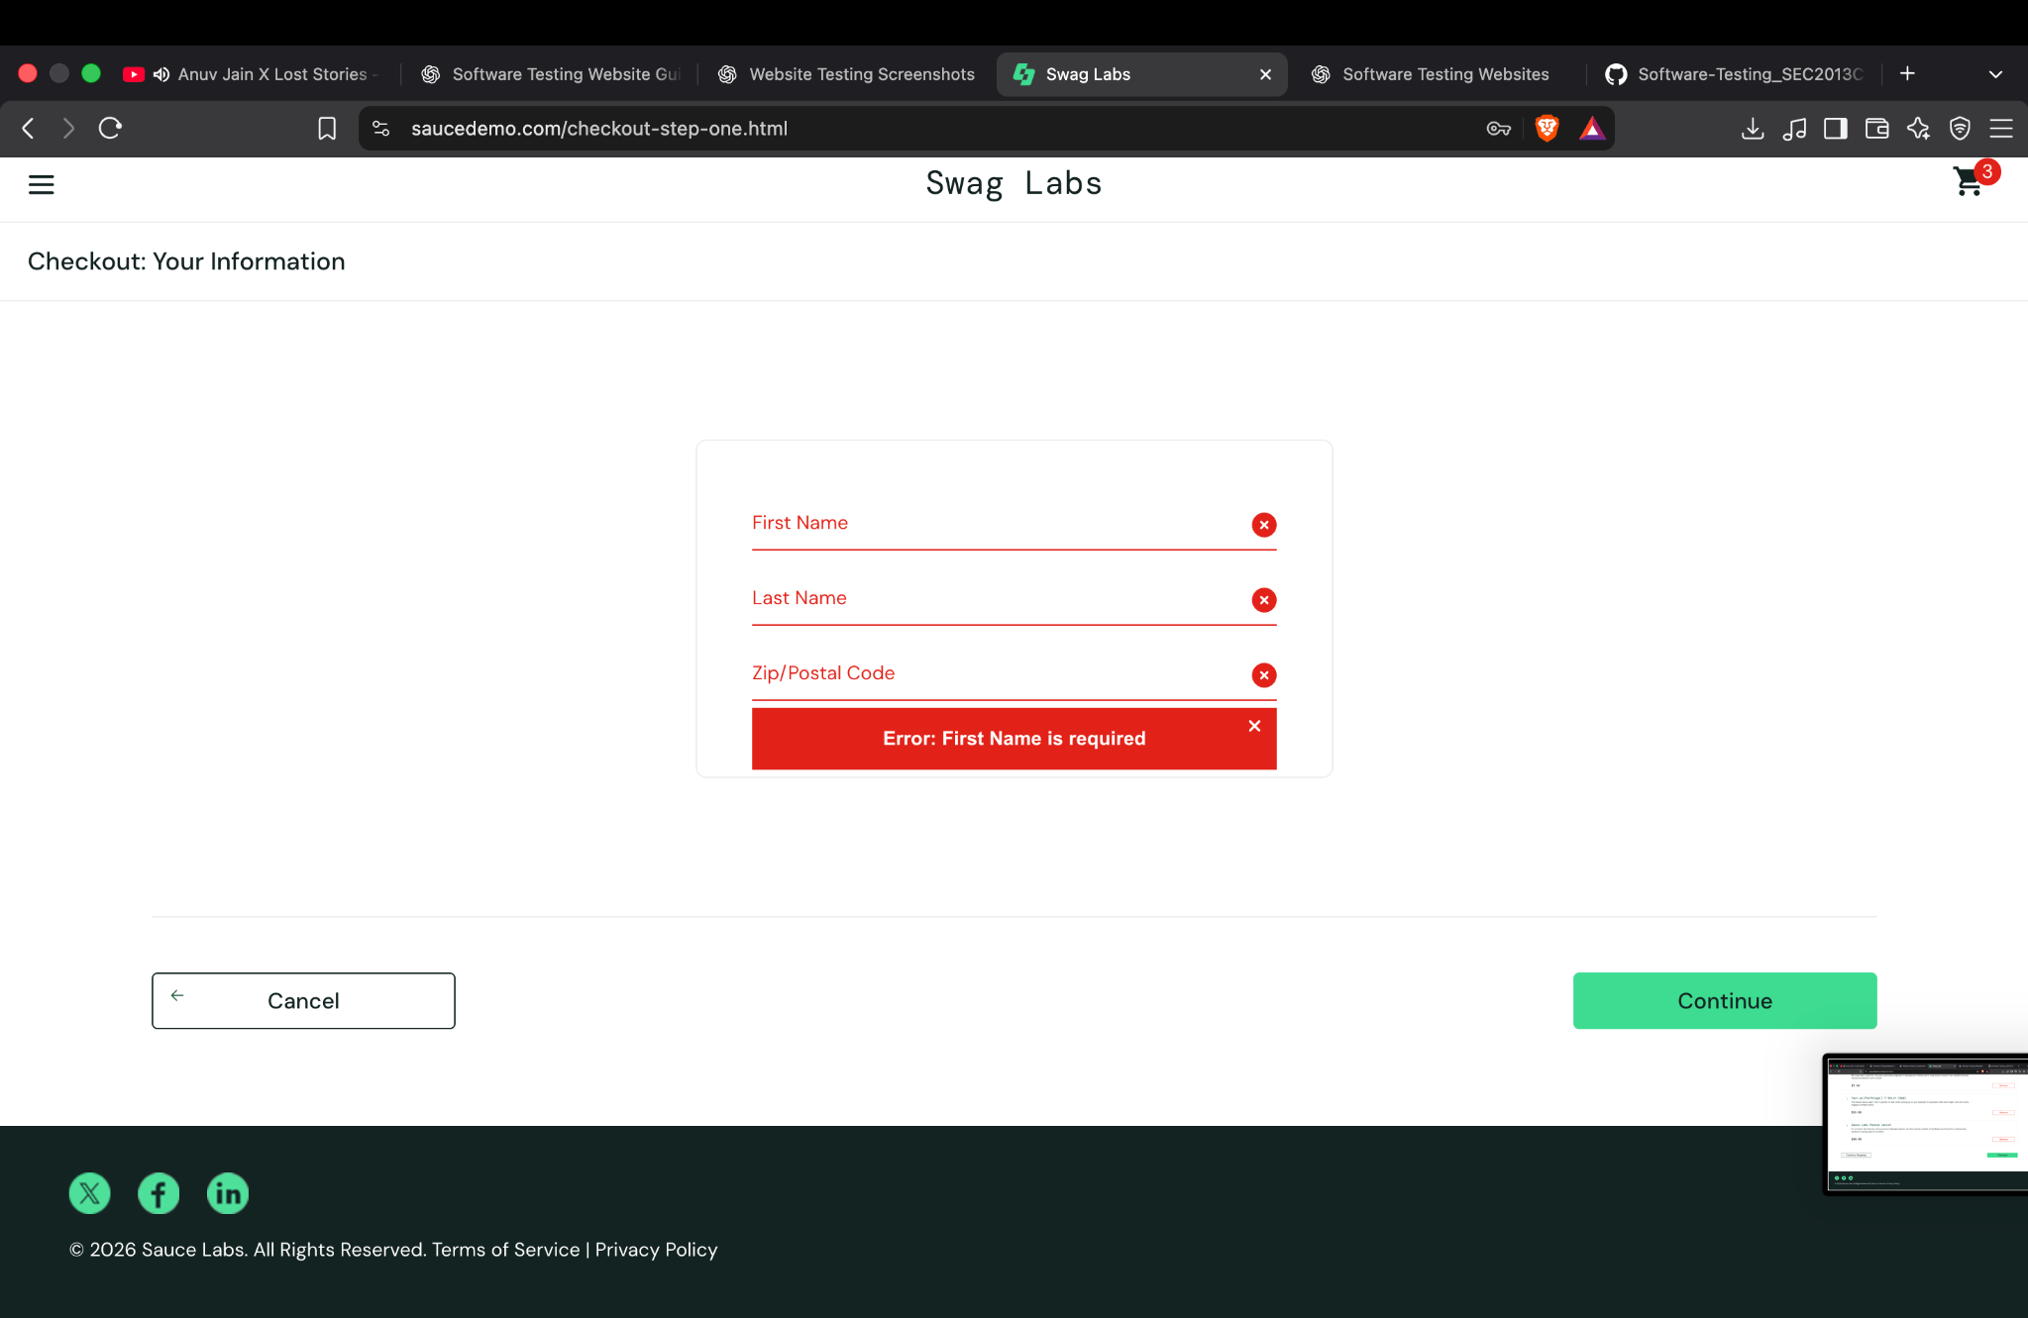

Screenshot 6 — Checkout overview
The checkout overview displays payment information, shipping information, item total $73.97, tax $5.92, and total $79.89. The Finish control is visible. The screenshot does not demonstrate that Finish was clicked or that an order was completed.
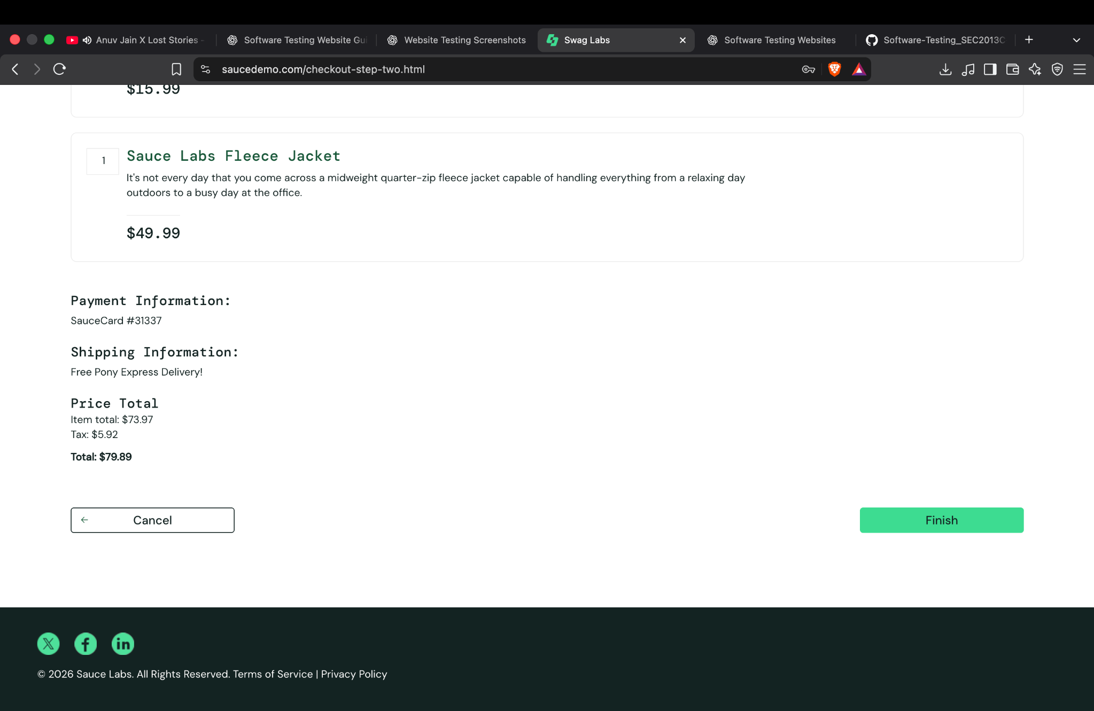

6. Defect Reporting
No confirmed application defect is established by the supplied screenshots alone. The invalid-login message and missing-first-name validation appear to be expected behavior. The browser password-save popup is browser-generated and should not be logged as a website defect without additional evidence. If further testing reveals unexpected behavior, record a separate bug with reproducible steps, expected result, actual result, severity, priority, environment, and evidence.
Bug ID | No confirmed defect assigned from current evidence
Severity / Priority | Not applicable until a reproducible defect is confirmed
Status | Not raised — more evidence required for a defect

7. Conclusion
The screenshots document several important user flows on Swag Labs: invalid login handling, product inventory, cart review, checkout form validation, and checkout overview. The observed validation messages are consistent with the expected behavior of a demo shopping application. The test execution spreadsheet provides the detailed step-by-step record. Additional tests should be performed for blank login fields, locked-out-user behavior, cart removal, and successful order completion before drawing broader conclusions.
End of report.

