SOFTWARE TESTING REPORT
Manual Test Execution — GitHub Login and Account Pages
Prepared from screenshots supplied by the student
Student ID | 2504030100426
Student Name | Ms. Harshita Malviya
Website Under Test | GitHub — https://github.com/
Evidence | 5 screenshots supplied, dated 10 October 2026 (filename timestamps)

1. Objective
To document manual, black-box observations of GitHub's sign-in page and selected signed-in account pages, compare available evidence with expected outcomes, and prepare a test execution record.

2. Scope and limitations
This report is based only on the five screenshots supplied. One screenshot shows an authentication message stating that the account does not support password sign-in. Other screenshots show a signed-in dashboard, profile page and issues page. The screenshots do not show a verified wrong-password test, blank-field submission result, or a complete test execution for every scenario. Statuses are therefore marked as Observed or Not Tested rather than inventing Pass/Fail results.

3. Test environment
Application | GitHub website
Browser context | Brave browser, based on visible browser chrome
Platform context | Desktop browser
Technique | Manual black-box / UI observation
Evidence date | 10 October 2026, based on screenshot filenames

4. Test execution summary
Five screenshots were reviewed. The login page and account pages are visible. The authentication error is directly evidenced; the dashboard, profile and issues pages indicate an authenticated session. No claims are made about underlying system correctness beyond the visible screenshot contents.

5. Detailed test cases

TC001 — Login page display
Testing step / input: Open https://github.com/login
Expected result: Sign-in form and available authentication options are displayed
Actual result: Username/email, password, Sign in, Google/Apple options, account creation and passkey link are visible
Status: Observed
Personal comments & suggestions: Screenshot 1 supports page-display observation; this does not prove all buttons work.

TC002 — Authentication message
Testing step / input: Use the sign-in flow that produced the captured error
Expected result: A clear message explains why sign-in cannot proceed
Actual result: Message says the account does not support password sign-in and suggests another method or account recovery
Status: Observed
Personal comments & suggestions: This is an account-specific message; do not label it a website defect without further evidence.

TC003 — Successful authenticated session
Testing step / input: Access the account dashboard
Expected result: Authenticated dashboard is displayed after successful authentication
Actual result: GitHub dashboard welcomes the account and displays signed-in navigation
Status: Observed
Personal comments & suggestions: Screenshot shows an authenticated session, but does not document the exact credentials or steps used.

TC004 — Profile page display
Testing step / input: Open the account profile
Expected result: Profile and repository/contribution sections are displayed
Actual result: Profile page shows account name, overview, repositories and contribution area
Status: Observed
Personal comments & suggestions: Screenshot shows no public repositories at the time captured; this is not necessarily a defect.

TC005 — Issues page display
Testing step / input: Open Issues / Assigned to me
Expected result: Issues page and result state are displayed
Actual result: Page shows Assigned to me and 'No results matched your search'
Status: Observed
Personal comments & suggestions: No assigned issues are shown. This may be normal for a new or inactive account.

TC006 — Blank username/password
Testing step / input: Submit the sign-in form with fields blank
Expected result: Required-field validation or a defined sign-in response is shown
Actual result: No blank-field submission screenshot supplied
Status: Not Tested
Personal comments & suggestions: Run only as a controlled test; capture the actual result before deciding Pass/Fail.

TC007 — Incorrect password
Testing step / input: Use an authorized test account and incorrect password
Expected result: Authentication is rejected with an appropriate message
Actual result: No incorrect-password result is evidenced; screenshot 2 is a different account-method message
Status: Not Tested
Personal comments & suggestions: Do not repeatedly attempt login. Use only your own account and record the exact response.

6. Screenshot evidence and explanation

Screenshot 1 — GitHub login page
Shows username/email and password fields, Sign in button, alternate sign-in options and account creation link.
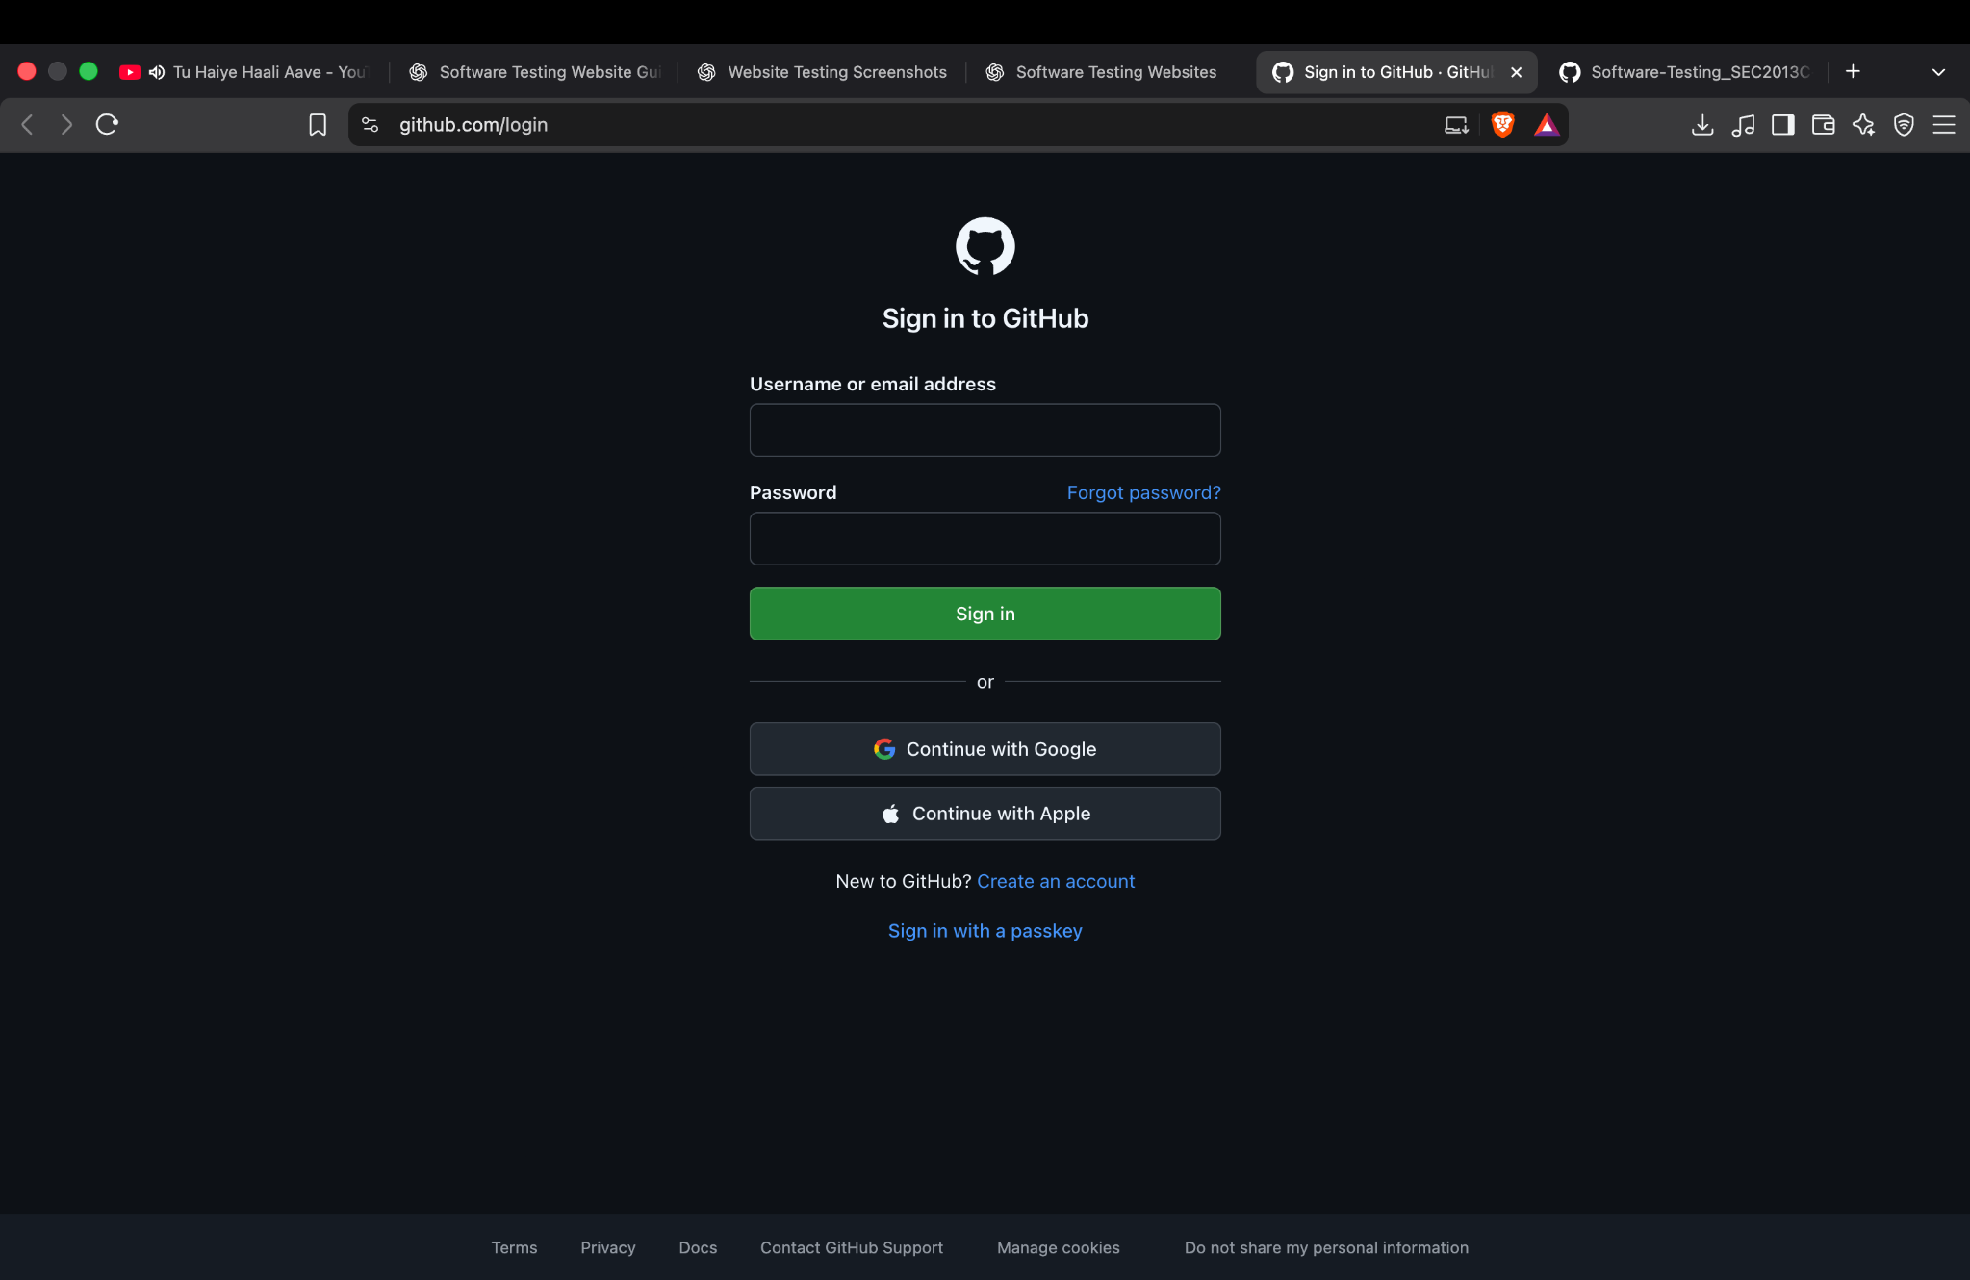

Screenshot 2 — Authentication message
Shows the message that this account does not support password sign-in, with advice to try another sign-in method or account recovery.
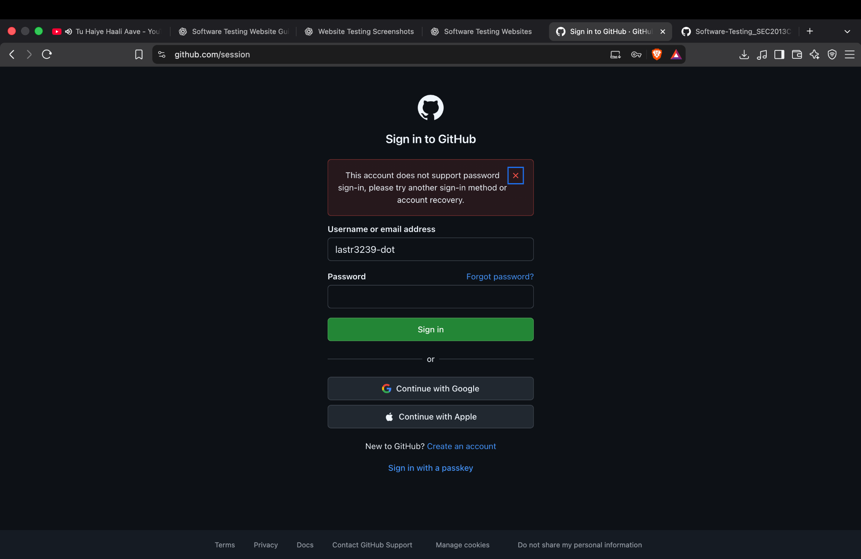

Screenshot 3 — GitHub dashboard
Shows the signed-in dashboard, account welcome message, navigation, and getting-started content.
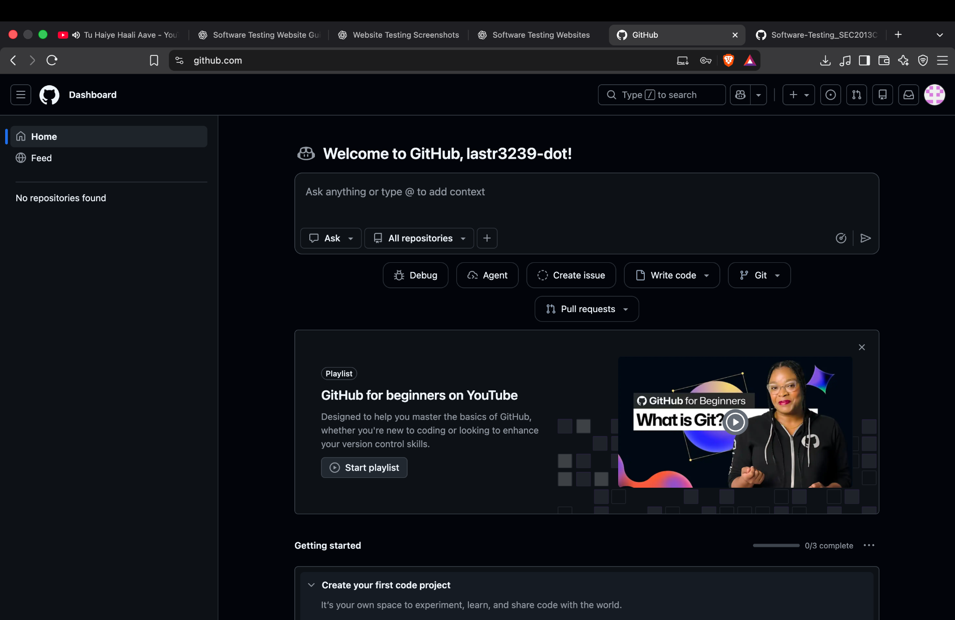

Screenshot 4 — Account profile
Shows the profile overview, repositories area, contribution graph and account activity.
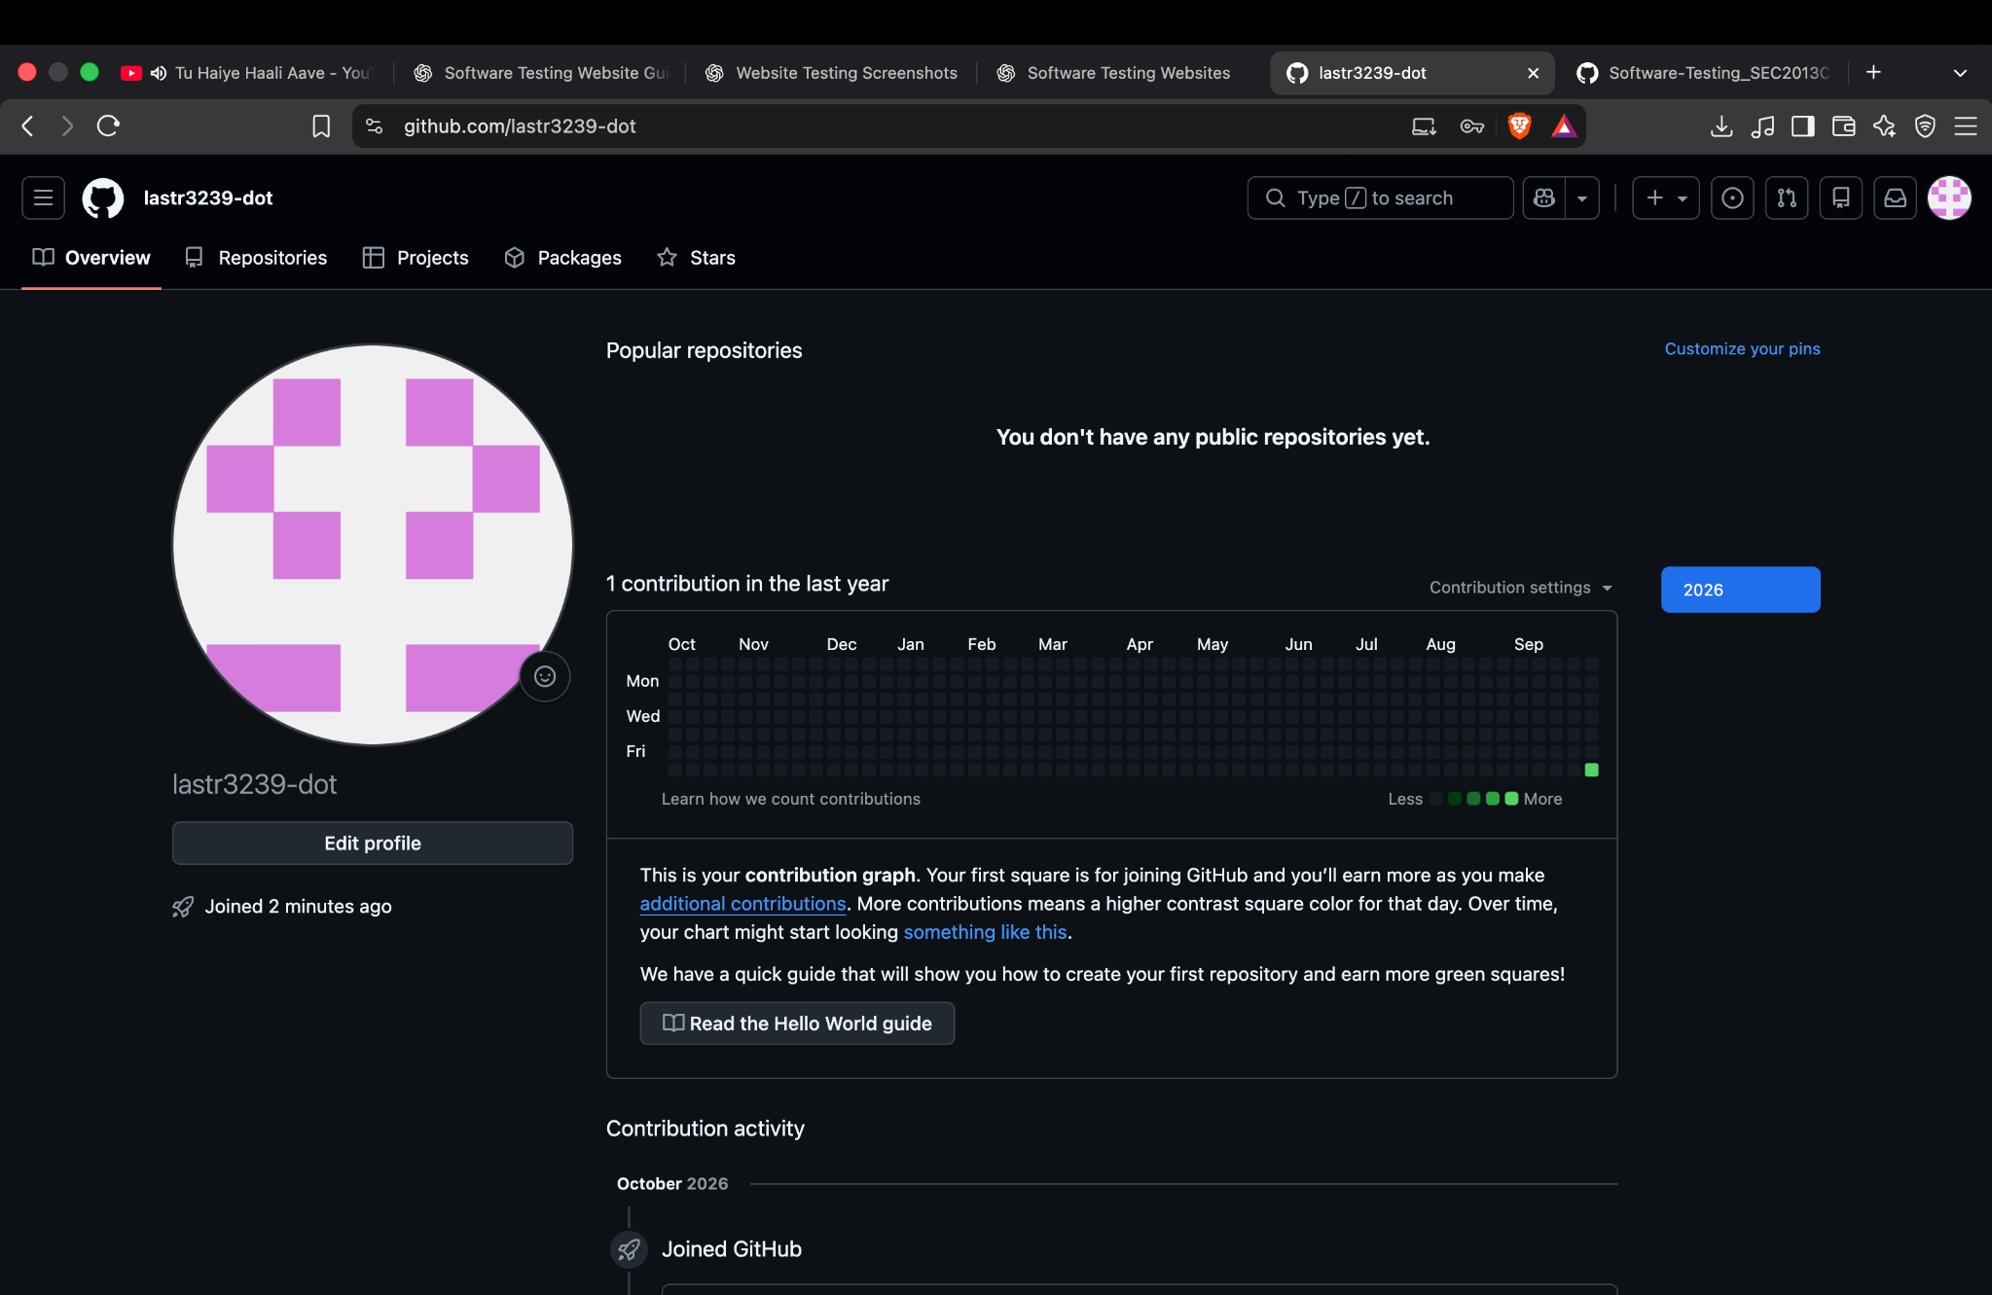

Screenshot 5 — Issues page
Shows the Assigned to me issues view with no matching results.
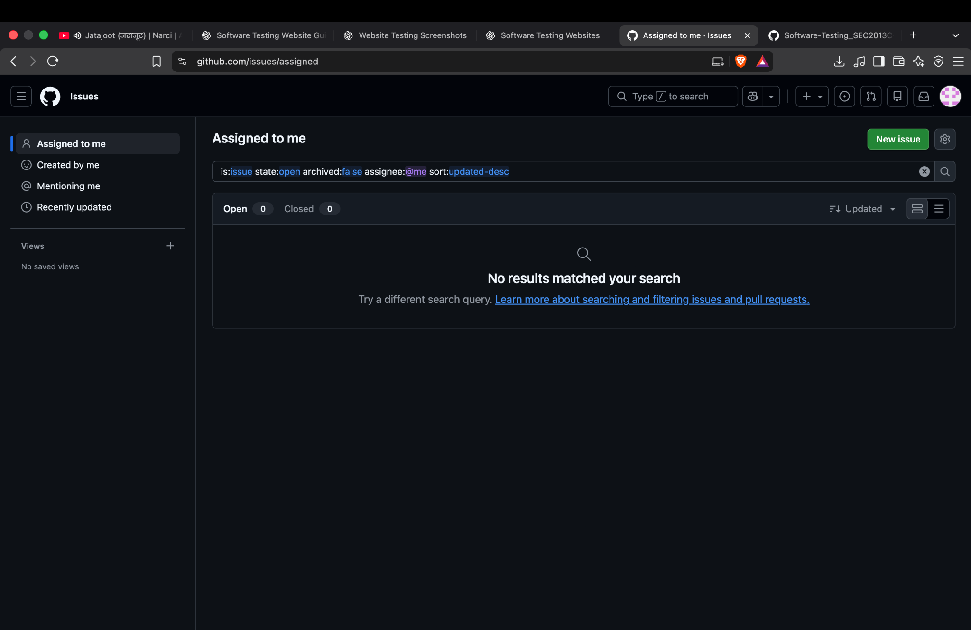

7. Defect and risk observations
- One screenshot shows an account-specific password sign-in restriction. It should be treated as an authentication outcome, not automatically as a defect.
- The Issues page reports no matching issues. This may be an expected empty state, not a defect.
- No evidence was supplied for blank-field validation or an incorrect-password response; those scenarios remain Not Tested.
- Do not include real passwords, recovery codes, OTPs or sensitive account details in the report.
- Use only an account you own or are authorized to test. Avoid repeated attempts that could trigger account protection.

8. Test summary
Total evidence-based checks: 7. Observed: 5. Not Tested: 2. Confirmed defects: 0 from the supplied screenshots. This is not a pass percentage because the evidence does not establish pass/fail outcomes for every test.

9. Conclusion
The screenshots document the GitHub login interface, an account-specific authentication message, and three authenticated account pages. They provide a useful basis for a manual test execution report. To complete the practical, execute the blank-input and incorrect-password scenarios safely, capture their actual outcomes, and update the Excel statuses accordingly.
Prepared for academic practical submission

