SOFTWARE TESTING REPORT
Pinterest Website — Functional, Negative, EP & BVA Review
Academic Practical Report
Student Name | MS. HARSHITA MALVIYA
Student ID / Enrollment No. | 2504030100426
Website Under Test | https://in.pinterest.com/

1. Aim
To manually review selected Pinterest website screens and document functional and negative testing observations, with Equivalence Partitioning (EP) and Boundary Value Analysis (BVA) considered where the website provides testable input rules.

2. Scope and Limitation
This report is based on nine screenshots supplied by the student. The evidence covers the public homepage, login dialog, an invalid-email message, a subsequent feed view, the Ideas page and Settings & Support menu. Pinterest is a real production website, but it does not necessarily implement the tutorial's example rule that usernames must be 5–15 characters. That exact BVA rule cannot be claimed as tested from these screenshots.

3. Testing Concepts
- Functional testing: Checks whether visible features and screens appear and respond as expected.
- Negative testing: Checks invalid or missing inputs and whether useful validation feedback is shown.
- Equivalence Partitioning (EP): Groups inputs into classes expected to behave similarly, such as registered, unregistered and malformed email addresses.
- Boundary Value Analysis (BVA): Tests values around a documented minimum/maximum. A length rule must be known before valid boundary values can be asserted.
- Non-functional observation: Reviews readability and visual rendering. Performance requires measured timing and is not inferred from screenshots.

4. Test Environment and Method
Evidence shows Pinterest opened in a desktop browser on macOS. The screenshots were reviewed manually and mapped to test objectives. Actual results are limited to visible evidence. Credential values have been redacted in report copies; the original uploads are unchanged.

5. Summary of Results
Status | Count
Pass | 10
Partial | 1
Not Tested | 3
The statuses reflect the screenshot evidence and do not constitute a complete audit of Pinterest or its backend. EP coverage is partial, and BVA for a 5–15-character username range is not demonstrated.

6. Test Cases and Results

TC-01: Verify Pinterest public homepage loads
Section | Functional Testing
Testing Step | Verify Pinterest public homepage loads
Test Input | Open https://in.pinterest.com/
Expected Result | Homepage loads and displays navigation, search, and sign-in options
Actual Result | Homepage displayed Pinterest branding, search field, Explore, Log in, Sign up and visual content
Status (Pass/Fail) | Pass
Personal Comments & Suggestions | Pass applies to visible page rendering only.

TC-02: Open the login dialog
Section | Functional Testing
Testing Step | Open the login dialog
Test Input | Click Log in
Expected Result | Login dialog displays email and password fields plus alternative sign-in options
Actual Result | Login dialog showed email, password, Log in, Google sign-in and forgotten-password options
Status (Pass/Fail) | Pass
Personal Comments & Suggestions | Credentials have been redacted in report evidence for privacy.

TC-03: Submit an email not associated with an account
Section | Negative Testing
Testing Step | Submit an email not associated with an account
Test Input | Use a test account/email you control; do not reuse a real password in the report
Expected Result | System displays a clear validation/error message and does not authenticate the account
Actual Result | Screenshot showed the message: email entered is not associated with an account
Status (Pass/Fail) | Pass
Personal Comments & Suggestions | This confirms an error message was displayed for the captured attempt, not every invalid-input case.

TC-04: Retry login with credentials
Section | Functional Testing
Testing Step | Retry login with credentials
Test Input | Enter authorized account credentials
Expected Result | If credentials are valid, user reaches an authenticated Pinterest feed; otherwise a clear error appears
Actual Result | A later screenshot shows the Pinterest feed with account navigation, consistent with a signed-in state
Status (Pass/Fail) | Pass
Personal Comments & Suggestions | Do not include actual credentials in the report. The screenshot sequence suggests sign-in succeeded.

TC-05: Check browser password-save prompt after sign-in
Section | Security/Privacy Observation
Testing Step | Check browser password-save prompt after sign-in
Test Input | Observe browser prompt after sign-in; do not save credentials in report
Expected Result | Credential values are not exposed in submitted evidence
Actual Result | Browser displayed a Save password prompt; credential values are redacted in report copies
Status (Pass/Fail) | Pass
Personal Comments & Suggestions | The browser prompt is not a Pinterest feature. Avoid saving credentials on shared devices.

TC-06: Verify authenticated feed renders
Section | Functional Testing
Testing Step | Verify authenticated feed renders
Test Input | Open the Pinterest home/feed after sign-in
Expected Result | Feed displays navigation, search and visual pins
Actual Result | Pinterest feed with search bar, navigation icons and pin cards was visible
Status (Pass/Fail) | Pass
Personal Comments & Suggestions | Only the displayed feed is verified; deeper pin interactions were not tested.

TC-07: Open Explore / Ideas page
Section | Functional Testing
Testing Step | Open Explore / Ideas page
Test Input | Navigate to in.pinterest.com/ideas or Explore
Expected Result | Ideas page shows topic categories and discovery content
Actual Result | Ideas page showed topic tiles and a 'What's new on Pinterest' section
Status (Pass/Fail) | Pass
Personal Comments & Suggestions | Page content was visible in the captured browser session.

TC-08: Open Settings & Support menu
Section | Functional Testing
Testing Step | Open Settings & Support menu
Test Input | Click settings/profile menu
Expected Result | Settings/support menu opens and lists available options
Actual Result | Menu displayed Settings, Help Centre, Privacy Policy, Terms of Service and related options
Status (Pass/Fail) | Pass
Personal Comments & Suggestions | Menu rendering is verified; each menu link was not opened individually.

TC-09: Recheck Settings & Support menu
Section | Functional Testing
Testing Step | Recheck Settings & Support menu
Test Input | Open the same menu again
Expected Result | Menu opens consistently without visible layout errors
Actual Result | A second screenshot showed the same menu and page content
Status (Pass/Fail) | Pass
Personal Comments & Suggestions | This is a repeat visual check, not a full regression test.

TC-10: Test empty login fields
Section | Negative Testing
Testing Step | Test empty login fields
Test Input | Leave email and password blank and attempt login
Expected Result | Submission is prevented or clear required-field validation appears
Actual Result | Not shown in the supplied screenshots
Status (Pass/Fail) | Not Tested
Personal Comments & Suggestions | Capture the actual response before marking Pass or Fail.

TC-11: Test valid and invalid email classes
Section | Equivalence Partitioning (EP)
Testing Step | Test valid and invalid email classes
Test Input | Use controlled test values: valid-format registered email, malformed email, unregistered email
Expected Result | Registered valid account proceeds; malformed/unregistered values are rejected with suitable feedback
Actual Result | Unregistered-email feedback is evidenced; malformed email and registered-account partitions are not separately documented
Status (Pass/Fail) | Partial
Personal Comments & Suggestions | The screenshots support one invalid partition only. Test the other classes separately.

TC-12: Test email/username length boundaries
Section | Boundary Value Analysis (BVA)
Testing Step | Test email/username length boundaries
Test Input | Test min−1, min, min+1, max−1, max, max+1 only if a documented length limit exists
Expected Result | Inputs outside the documented range are rejected and boundary-valid inputs are accepted
Actual Result | No specific Pinterest username length requirement or boundary test result is evidenced
Status (Pass/Fail) | Not Tested
Personal Comments & Suggestions | Pinterest may not enforce the 5–15-character rule from your Tutorial 7. Do not claim those boundary tests passed.

TC-13: Observe page readability and layout
Section | Non-Functional Testing
Testing Step | Observe page readability and layout
Test Input | View homepage, feed and Ideas page at the captured desktop viewport
Expected Result | Main controls and content are readable with no obvious rendering breakage
Actual Result | Screenshots show readable navigation, search and content cards
Status (Pass/Fail) | Pass
Personal Comments & Suggestions | Visual observation only; responsiveness and accessibility were not formally measured.

TC-14: Measure page load performance
Section | Non-Functional Testing
Testing Step | Measure page load performance
Test Input | Use browser DevTools Network/Performance and record timings
Expected Result | Measured performance meets a stated requirement
Actual Result | No load-time measurement was supplied
Status (Pass/Fail) | Not Tested
Personal Comments & Suggestions | Record actual timing and test environment before reaching a performance conclusion.

7. Screenshot Evidence
Nine screenshot captures are included below. Email/password values and the browser password-manager credential area have been redacted in the evidence copies for privacy.

01 — Pinterest public homepage
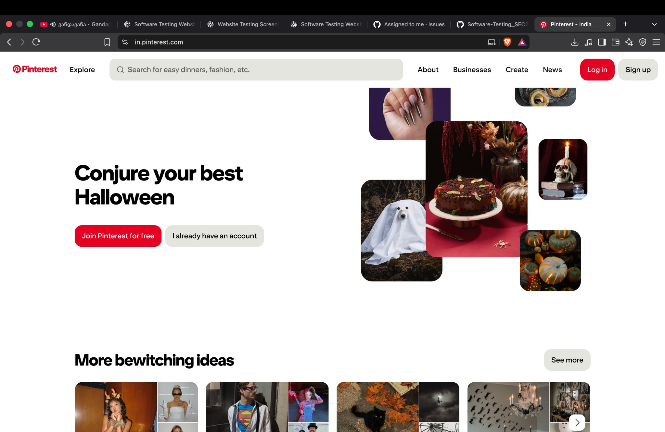
Public landing page with navigation, search and sign-in entry points.

02 — Login form (credentials redacted)
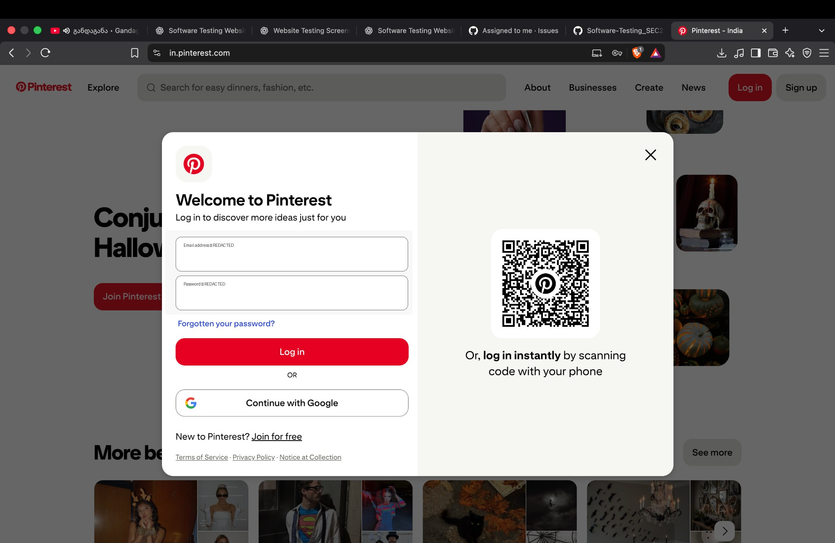
Login dialog and available sign-in options; entered credentials redacted.

03 — Invalid email validation message
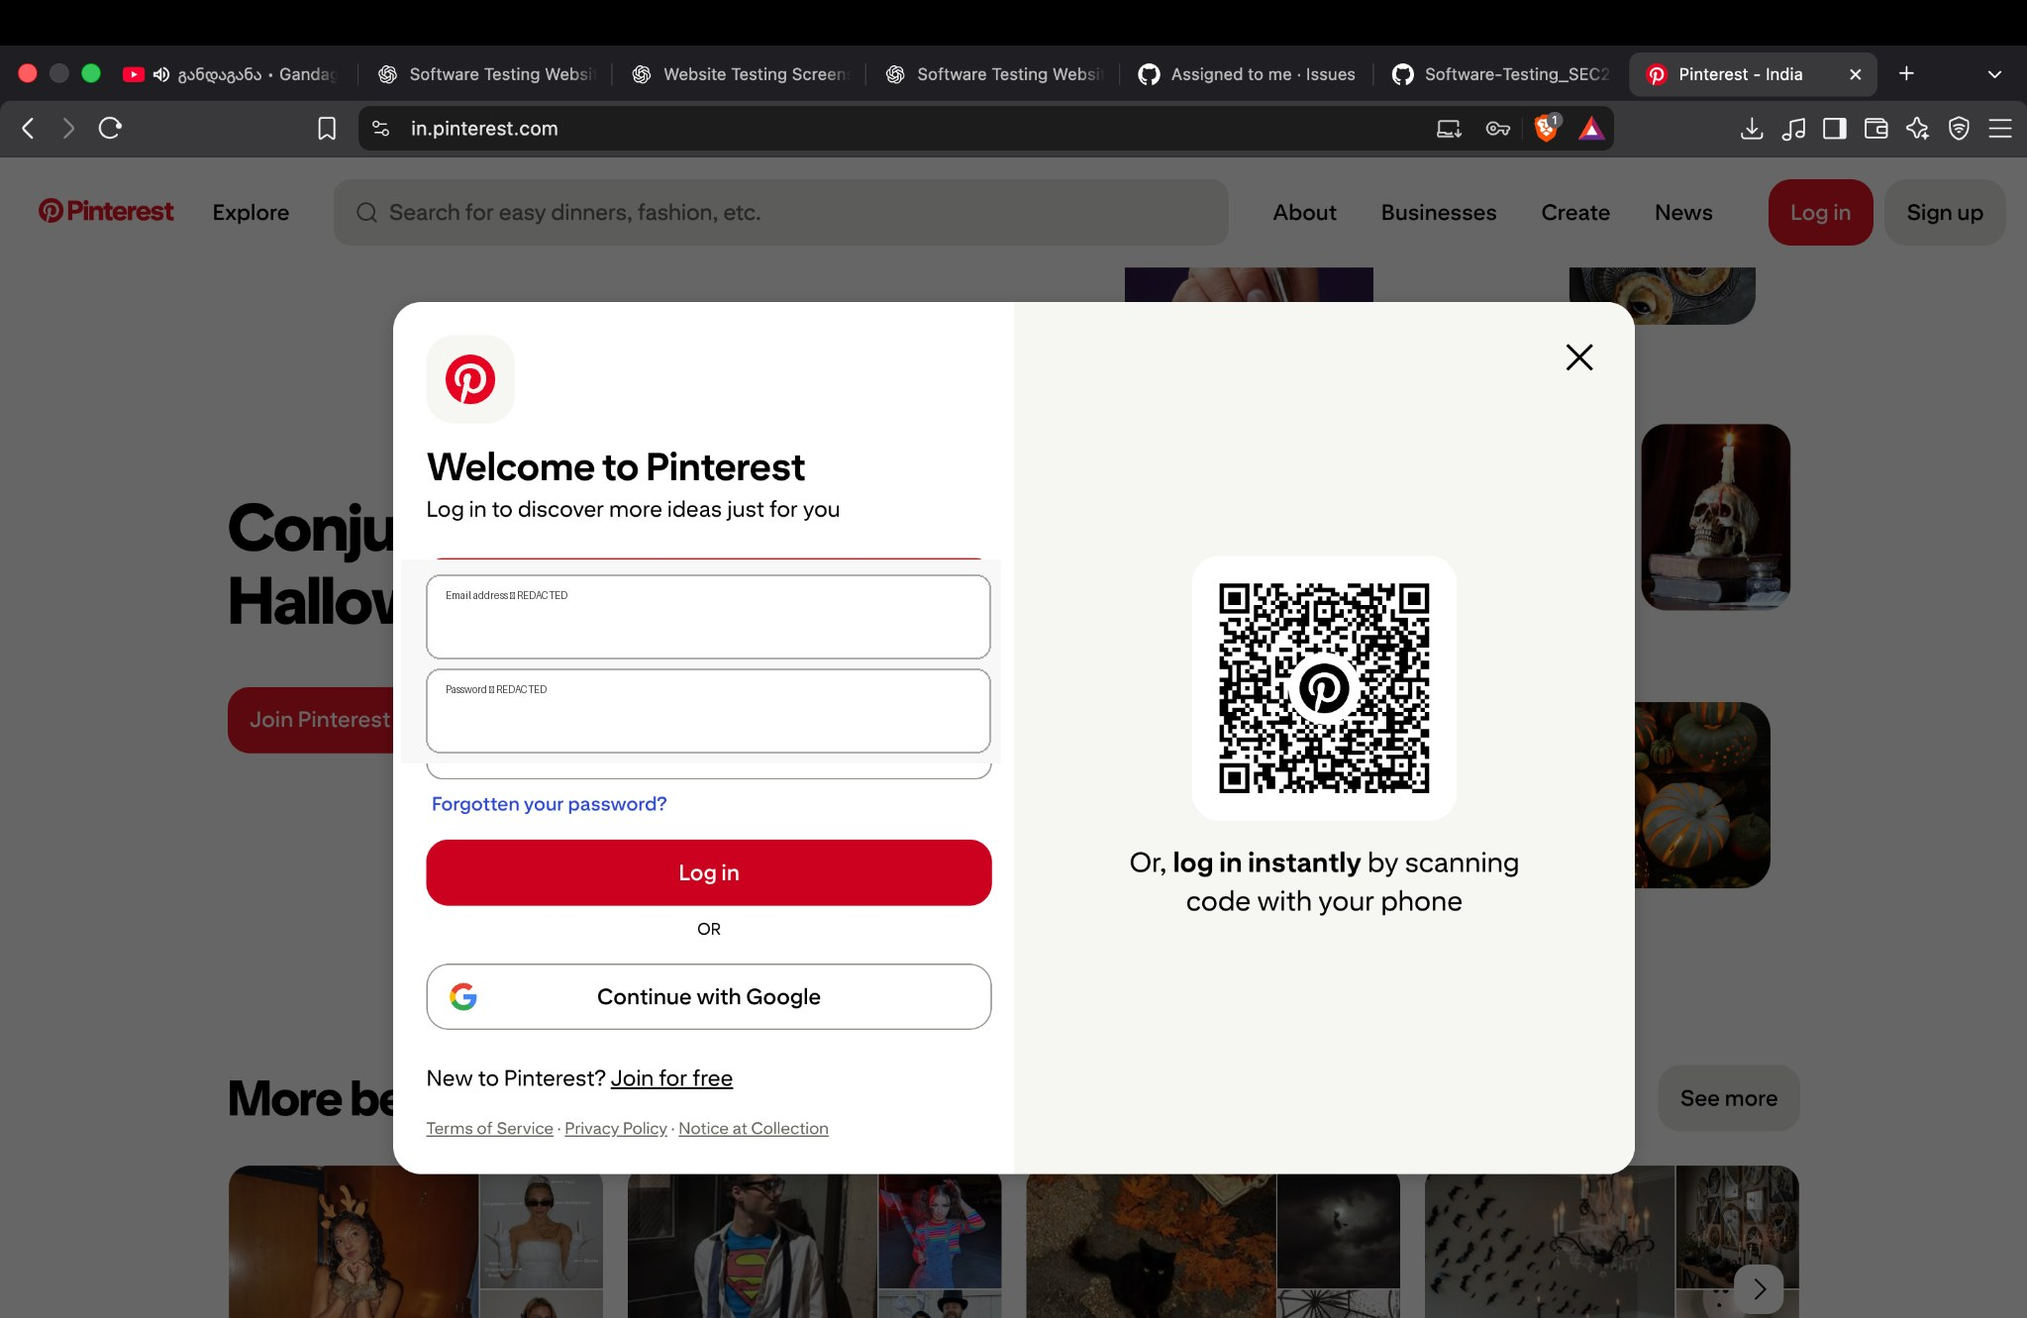
Visible error message indicates the entered email is not associated with an account.

04 — Login form retry (credentials redacted)
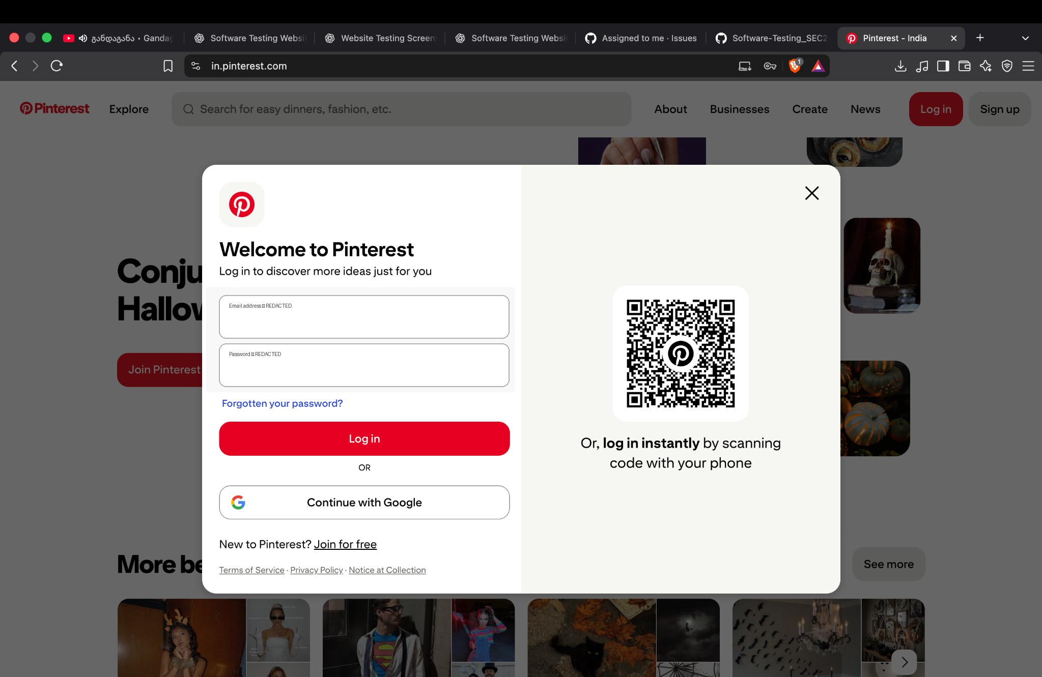
Login form retry state; credentials redacted.

05 — Pinterest feed / browser password prompt (credentials redacted)
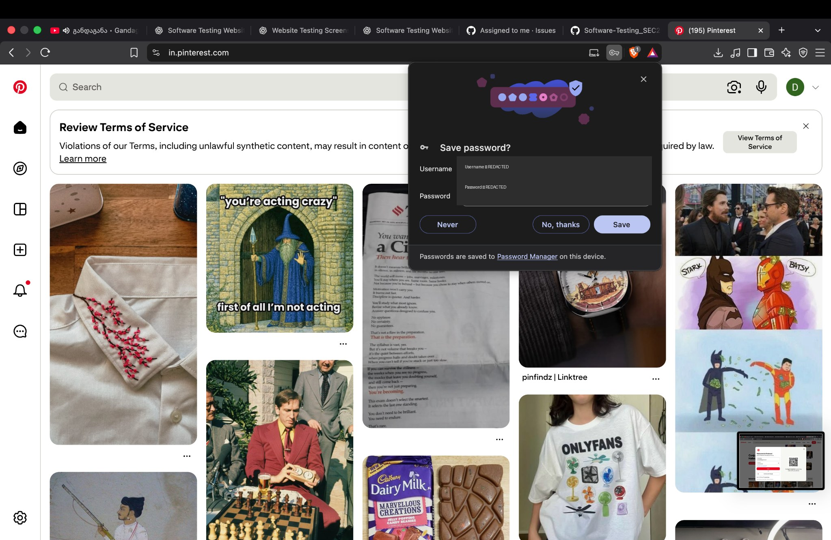
Pinterest feed is visible behind a browser password-save prompt; credential values redacted.

06 — Pinterest feed after sign-in
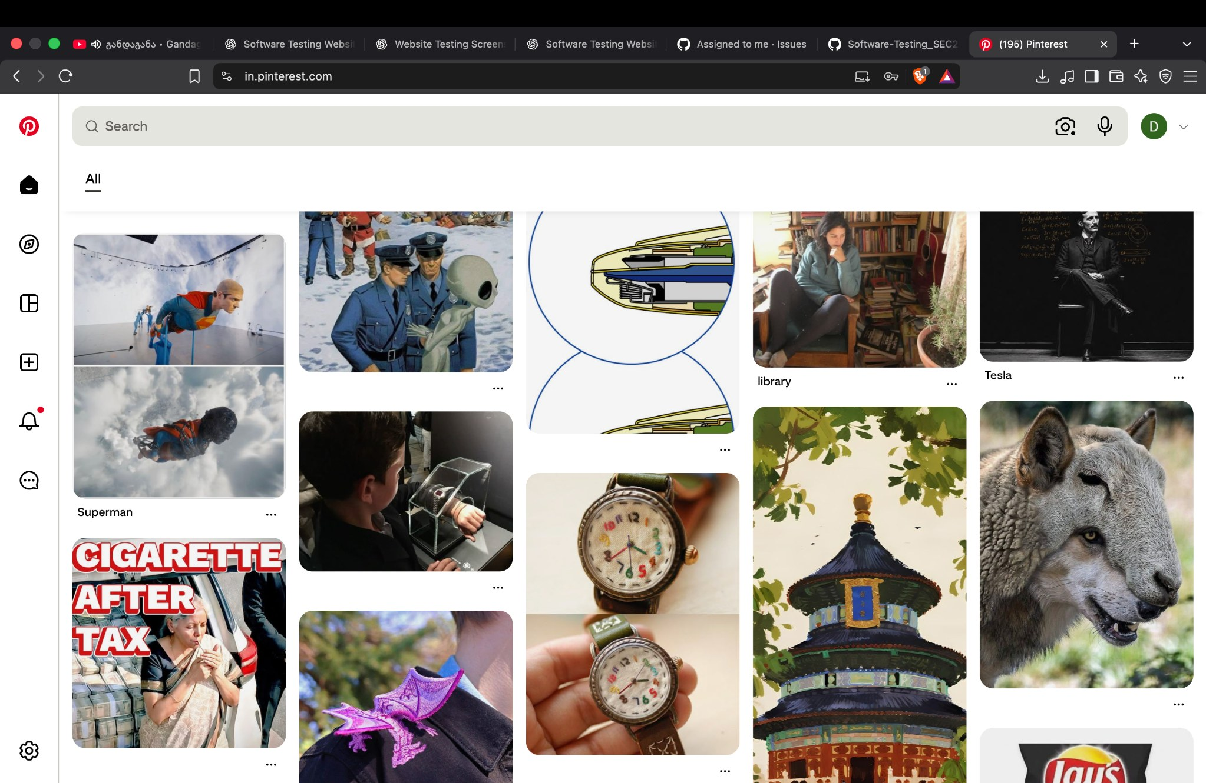
Feed content and navigation visible after the login sequence.

07 — Explore / ideas page
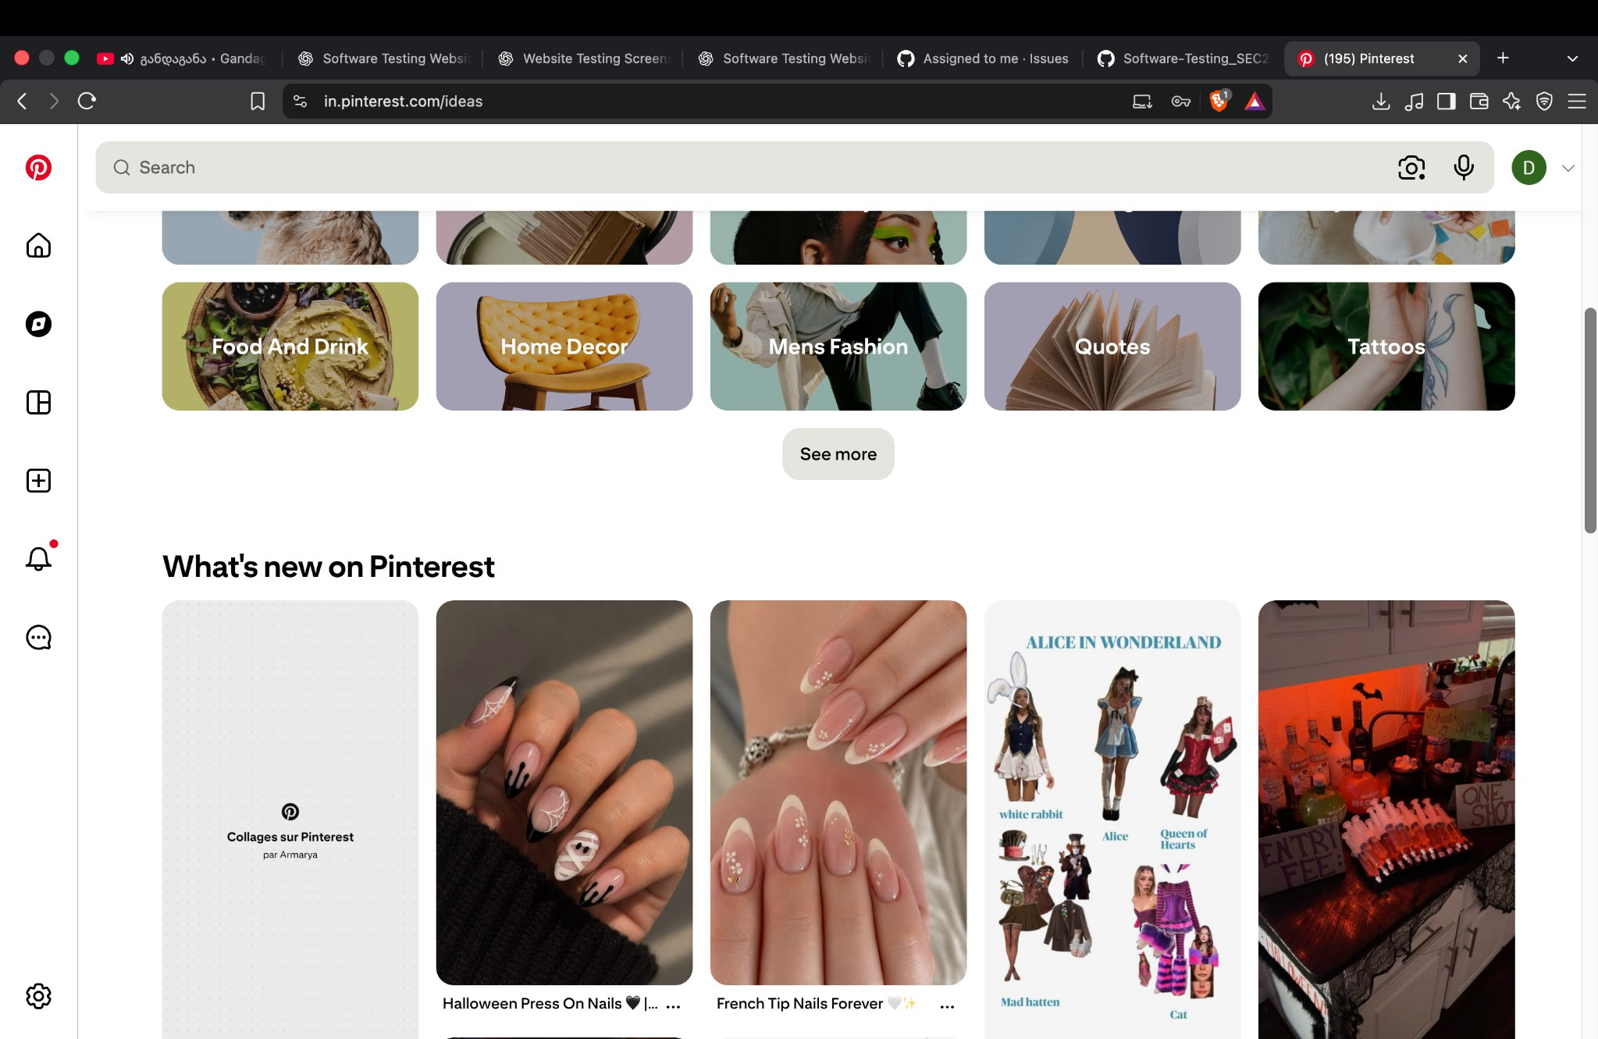
Ideas/discovery page with topic tiles and new content.

08 — Settings & Support menu
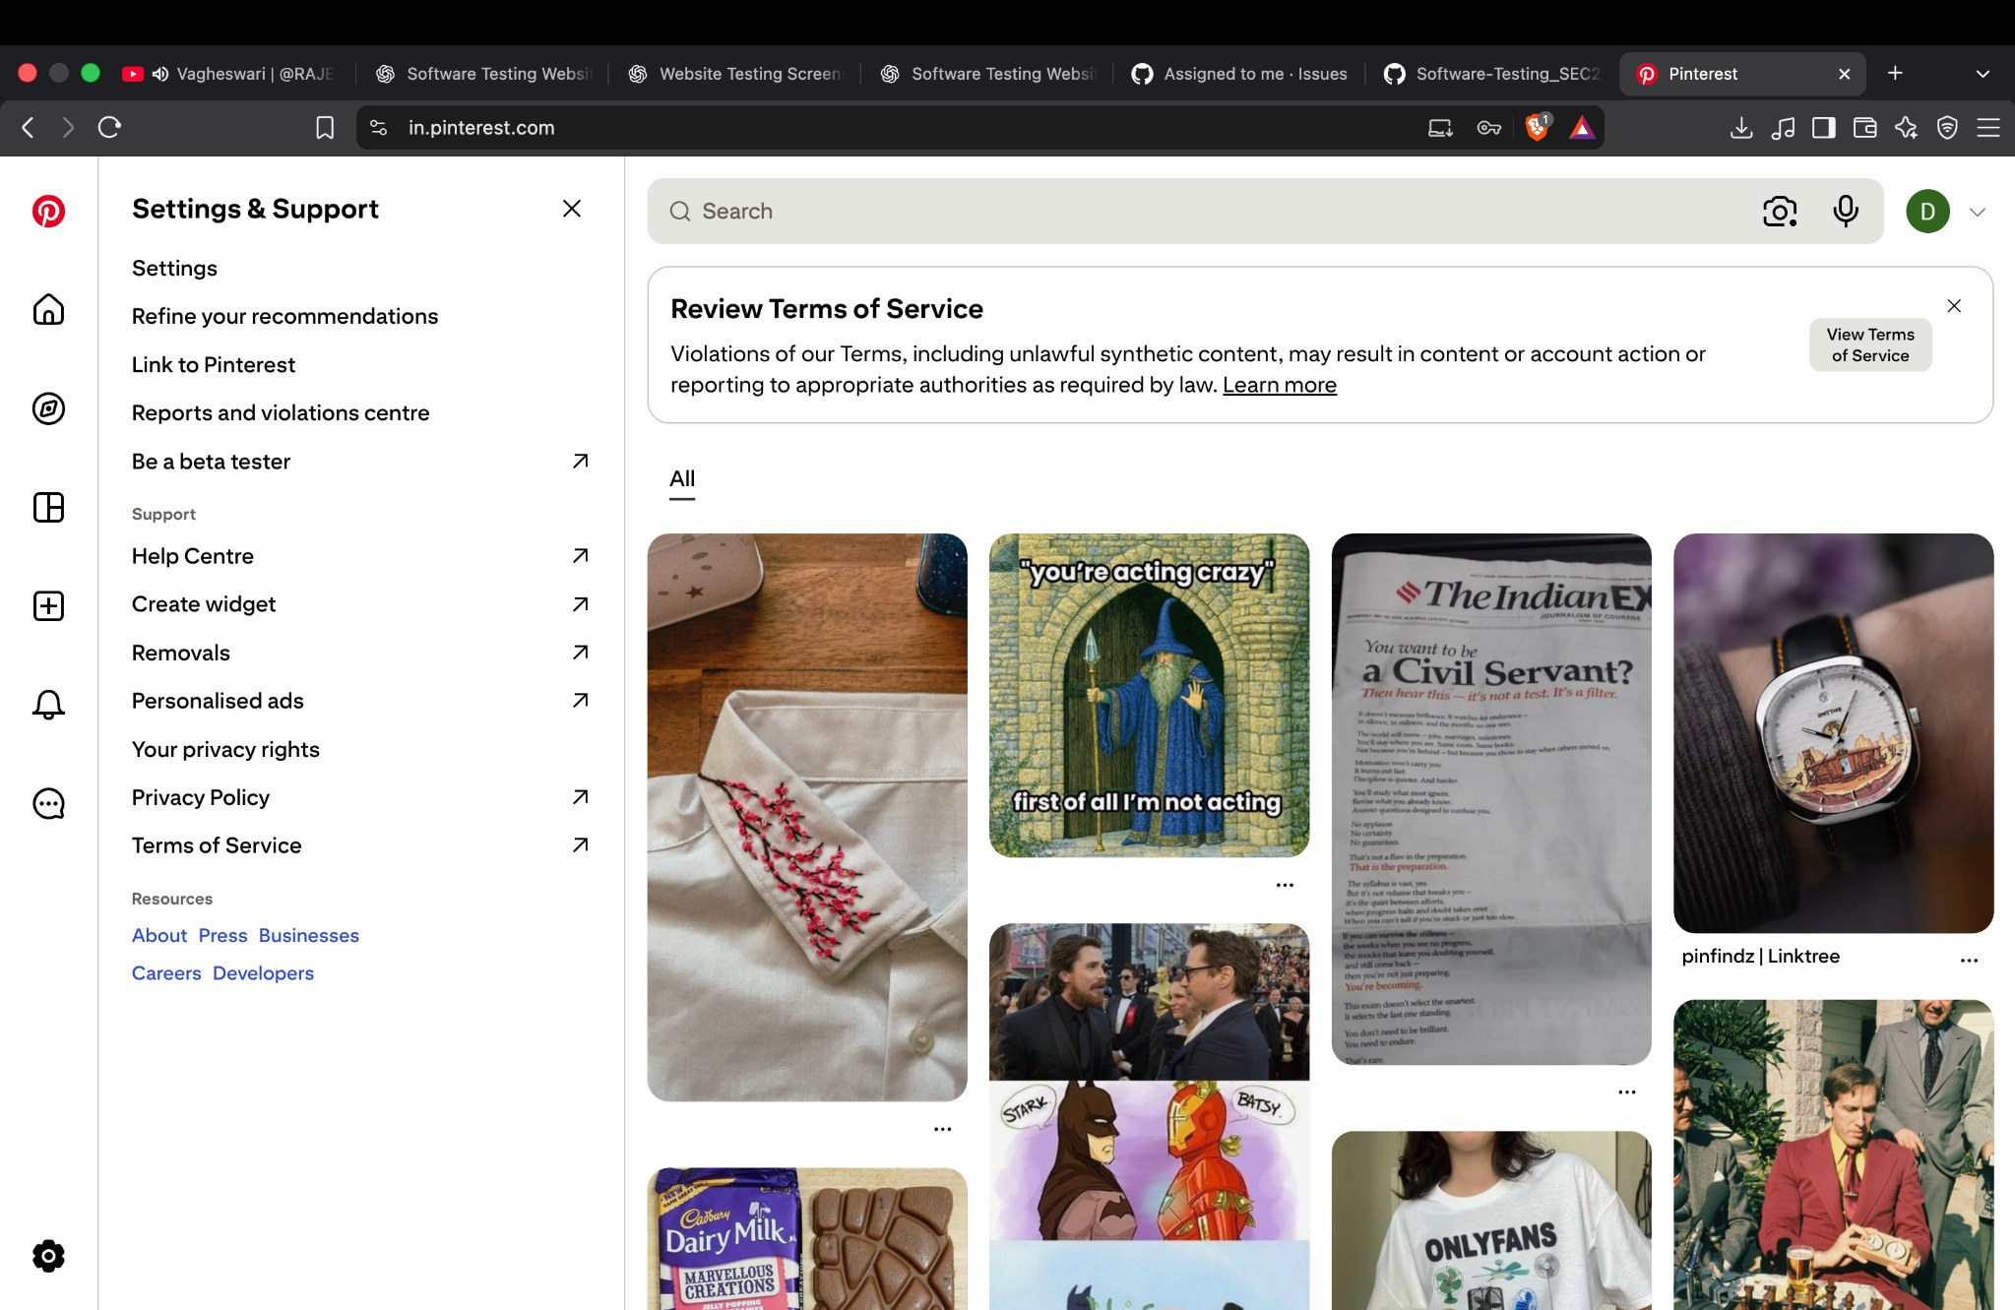
Settings & Support menu with help, privacy and terms options.

09 — Settings & Support menu (repeat capture)
Repeat capture of the same Settings & Support menu.

8. Recommendations
- Use a test account or test data that you control; never include passwords or authentication codes in a practical report.
- Capture a blank-field login attempt and record the actual validation response.
- Test registered, unregistered and malformed email partitions separately, using safe test inputs.
- Only perform BVA when the application has a documented minimum/maximum input constraint. Pinterest's 5–15-character username rule is not established by this evidence.
- Use browser DevTools to measure page performance if required by the assignment.
- For a practical requiring the exact 5–15-character username rule, test the Student Management System program specified in the tutorial or a dedicated form that implements that rule.

9. Conclusion
The supplied screenshots demonstrate Pinterest's homepage, login dialog, invalid-email feedback, feed, Ideas page and Settings & Support menu. These visible interface checks are recorded as Pass for their limited objectives. Blank-field validation, full EP coverage, exact username-length BVA and measured performance remain unverified. No defect is asserted without evidence.
Student: MS. HARSHITA MALVIYA | ID: 2504030100426 | Evidence date: 10 October 2026.

