SOFTWARE TESTING REPORT
Manual Functional Testing — Spotify Web Player
Student ID | 2504030100426
Student Name | MS. HARSHITA MALVIYA
Application Under Test | Spotify Web Player
Website URL | https://open.spotify.com/
Testing Type | Manual UI and navigation testing
Prepared for academic practical submission

1. Objective
To inspect the Spotify Web Player through manual testing, review key user interface screens, verify that the captured pages load and display expected interface elements, and document evidence in a structured test report.

2. Scope of Testing
- Homepage preview and browser media-permission prompt.
- Sign-in page and visible authentication options.
- Home page after sign-in and recommendation areas.
- Artist profile page and visible track list.
- Playlist page and playlist management controls.
- Track details page, playback controls, and lyrics area.
- Related artists and track-list section.

3. Test Environment
Application | Spotify Web Player
URL | https://open.spotify.com/
Test approach | Manual, black-box UI/navigation checks
Browser | Brave browser (as visible in screenshots)
Operating system | Not independently verified
Evidence date | 10 October 2026 (from screenshot timestamps)

4. Summary of Evidence
Seven screenshots were provided. They show the public homepage, sign-in page, a home page in a signed-in session, an artist page, a playlist page, a track details page, and the lower track page with related content. The screenshots demonstrate that these views were rendered. They do not, by themselves, prove every control works or that audio playback was successful.
Area | Evidence observed | Assessment
Homepage | Homepage content is visible; browser asks for Widevine permission | Page rendered; permission prompt is not a confirmed Spotify defect
Sign-in | Email and alternate sign-in choices visible | Sign-in page rendered
Home | Navigation, library, recommendations, player controls visible | Page rendered
Artist | Artist heading, verification badge, tracks visible | Page rendered
Playlist | Playlist heading and Add / Name and details controls visible | Page rendered
Track | Track metadata, Play and save controls, lyrics area visible | Page rendered; playback not proven by screenshot
Related content | Related artists and track listing visible | Page rendered

5. Screenshot Collage
The collage provides a labeled overview of all seven supplied screenshots.
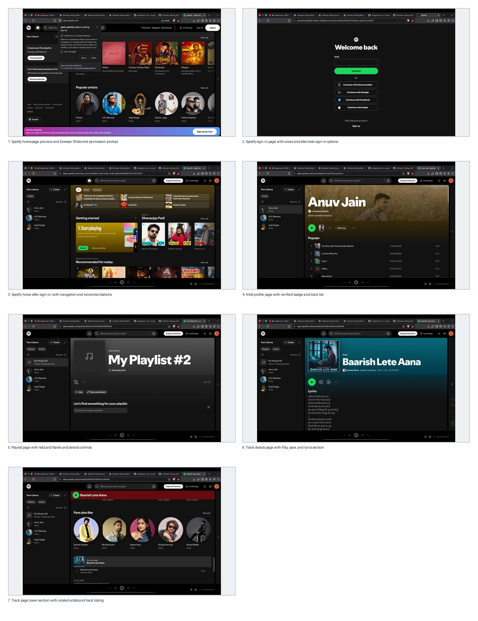

Screenshot 1 — Homepage preview
The public Spotify homepage and music recommendations are visible. A browser-generated Widevine permission prompt overlays part of the screen. This is a browser/media component permission request, not enough evidence to classify a Spotify application defect.
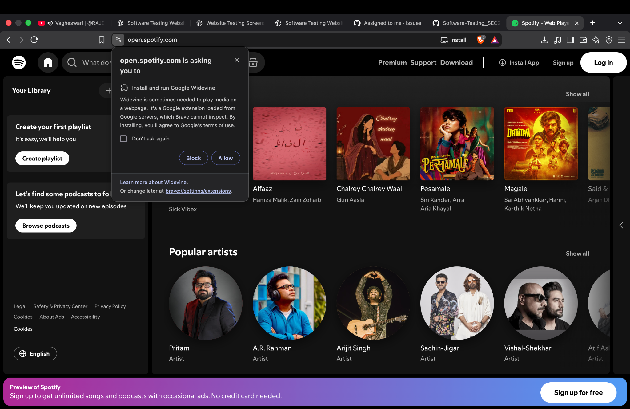

Screenshot 2 — Sign-in page
The sign-in page displays an email field, Continue button, phone-number option, and third-party sign-in options. The screenshot confirms that the authentication interface loaded; it does not test a successful or failed login.
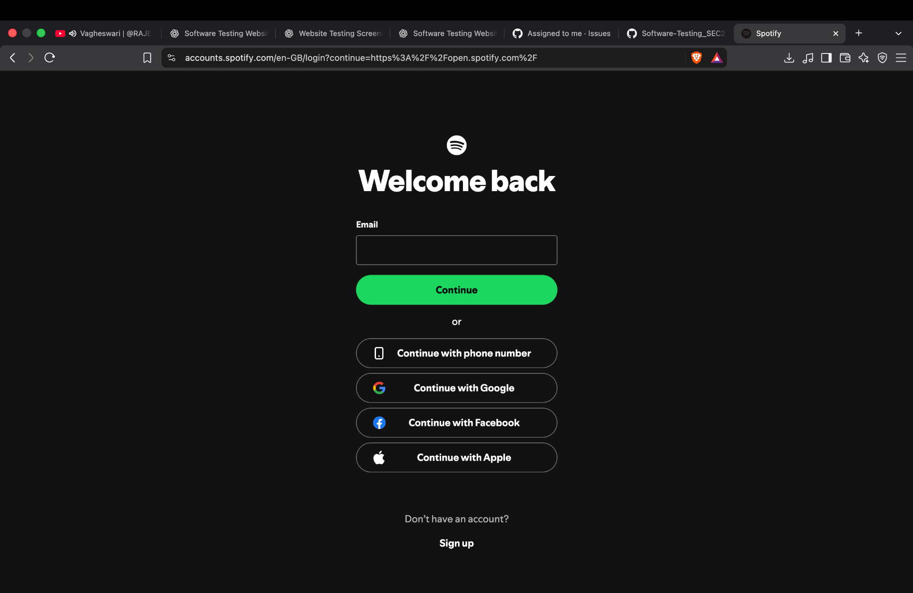

Screenshot 3 — Signed-in home page
The home screen shows navigation, Your Library, recommendations, and the bottom playback bar. This supports a UI rendering/navigation observation, but does not independently verify each control.
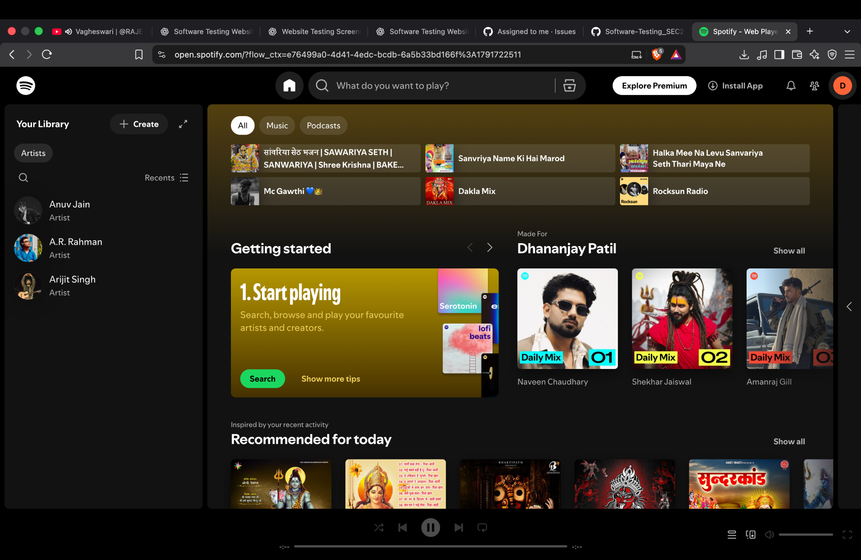

Screenshot 4 — Artist profile
An artist page displays the profile header, verified badge, monthly-listener count, Play control, and a list of popular tracks. This is evidence that the artist page rendered.
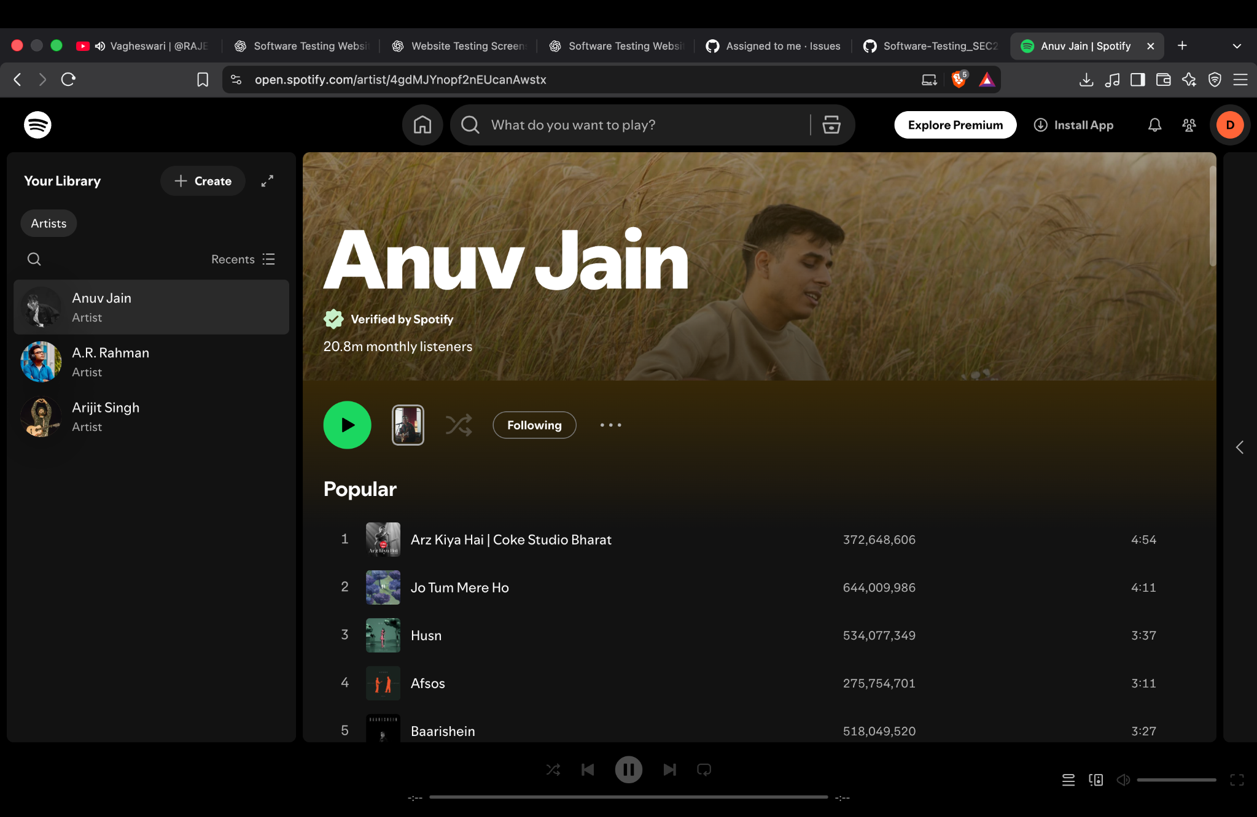

Screenshot 5 — Playlist page
A playlist page displays the playlist title and owner area, plus Add and Name and details controls. The screenshot shows the playlist interface; it does not prove adding or editing a playlist succeeds.
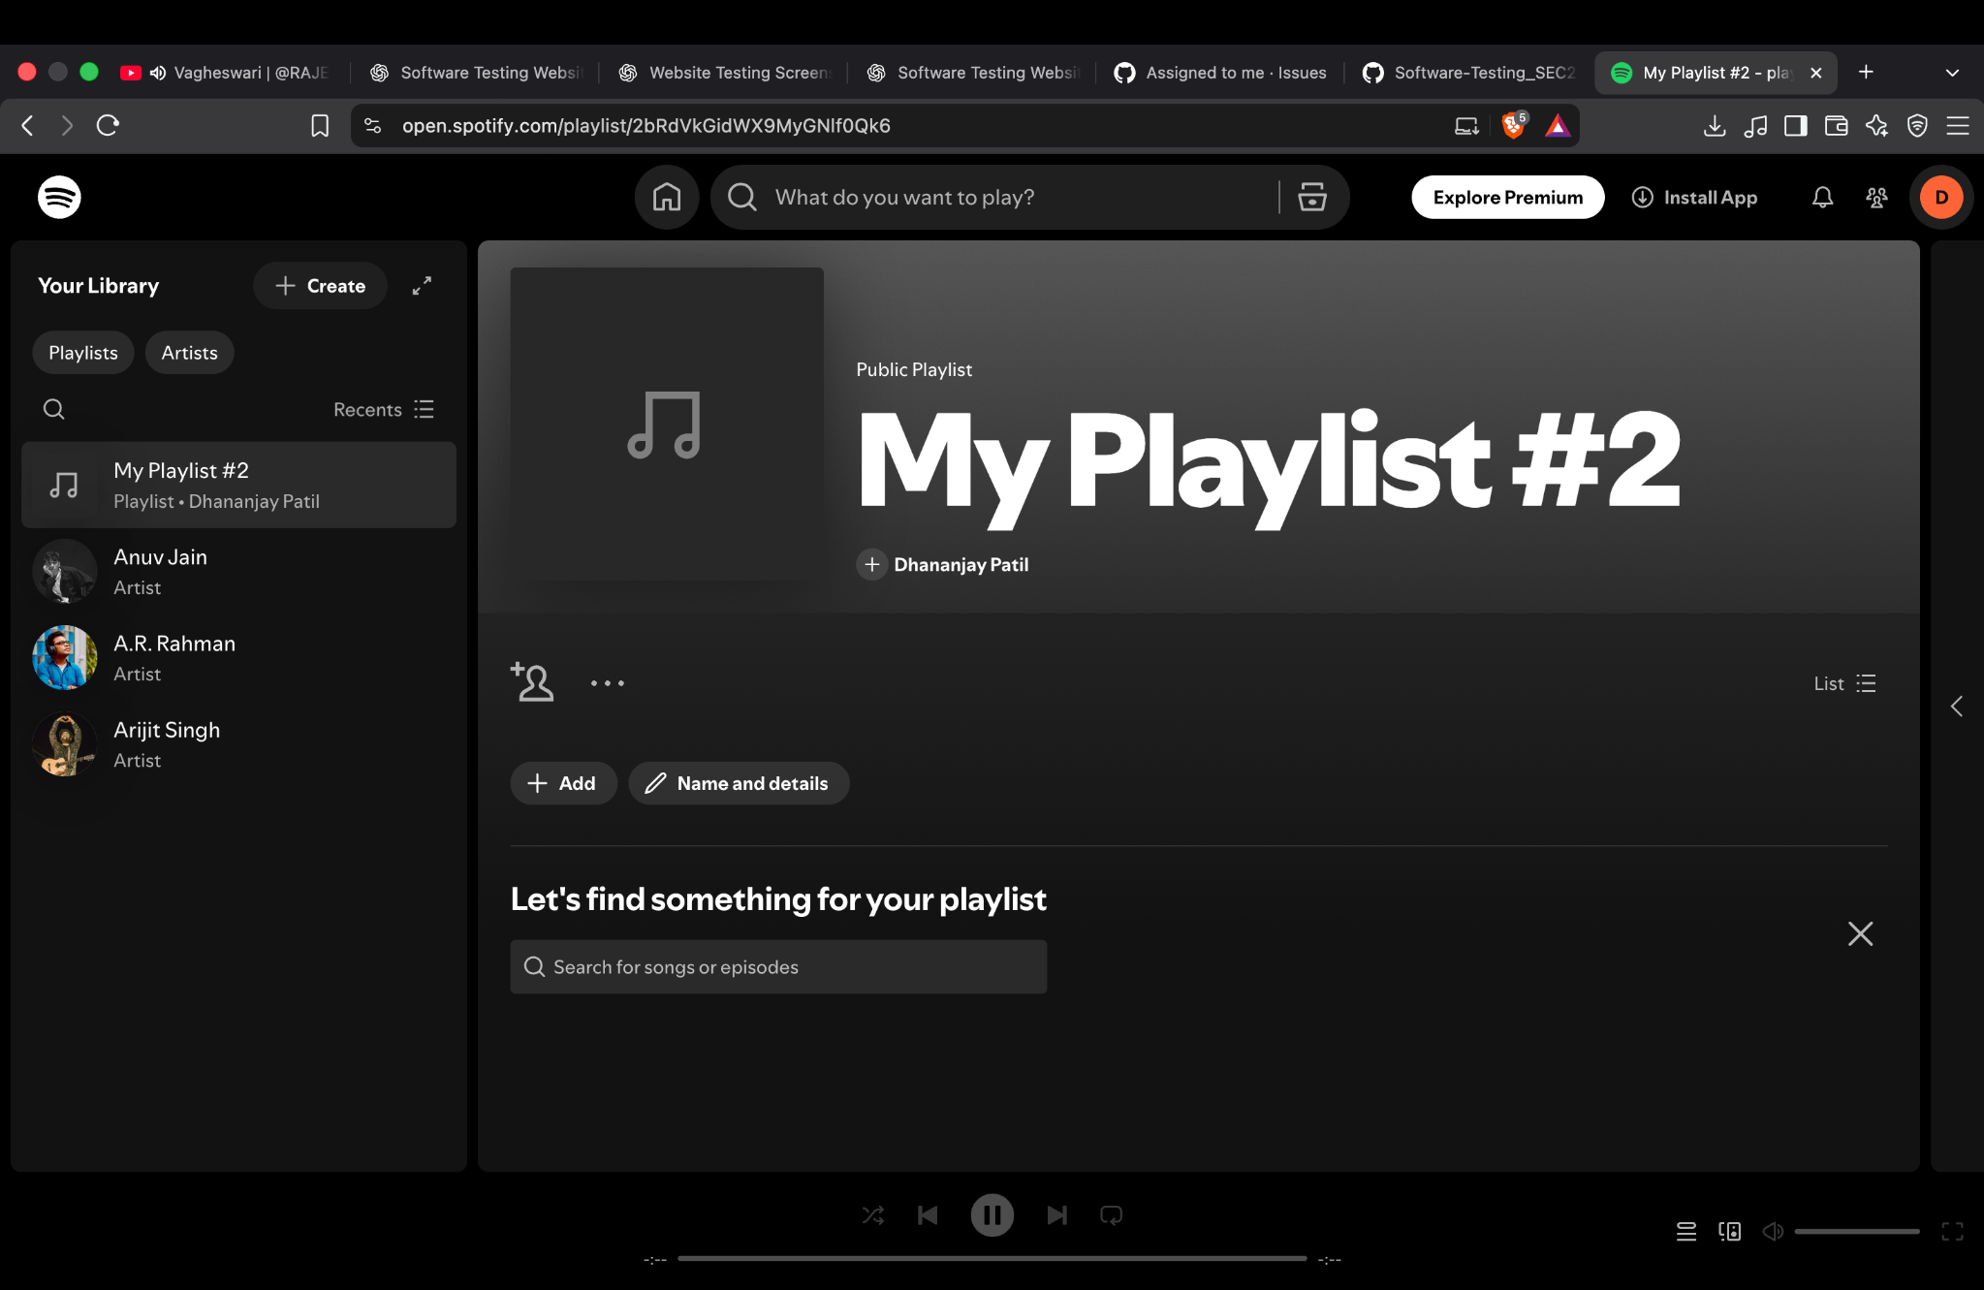

Screenshot 6 — Track details and lyrics
The track page displays song metadata, Play and save/download-style controls, and lyrics. The screenshot confirms the track details view rendered. Playback and save actions require separate interaction tests.
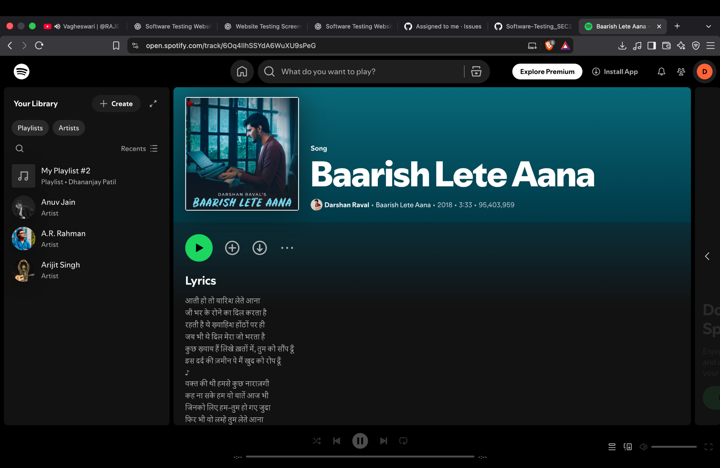

Screenshot 7 — Related content
The lower track page shows related artists and the track listing. This supports a content-display observation and provides evidence for page scrolling and related-content rendering.
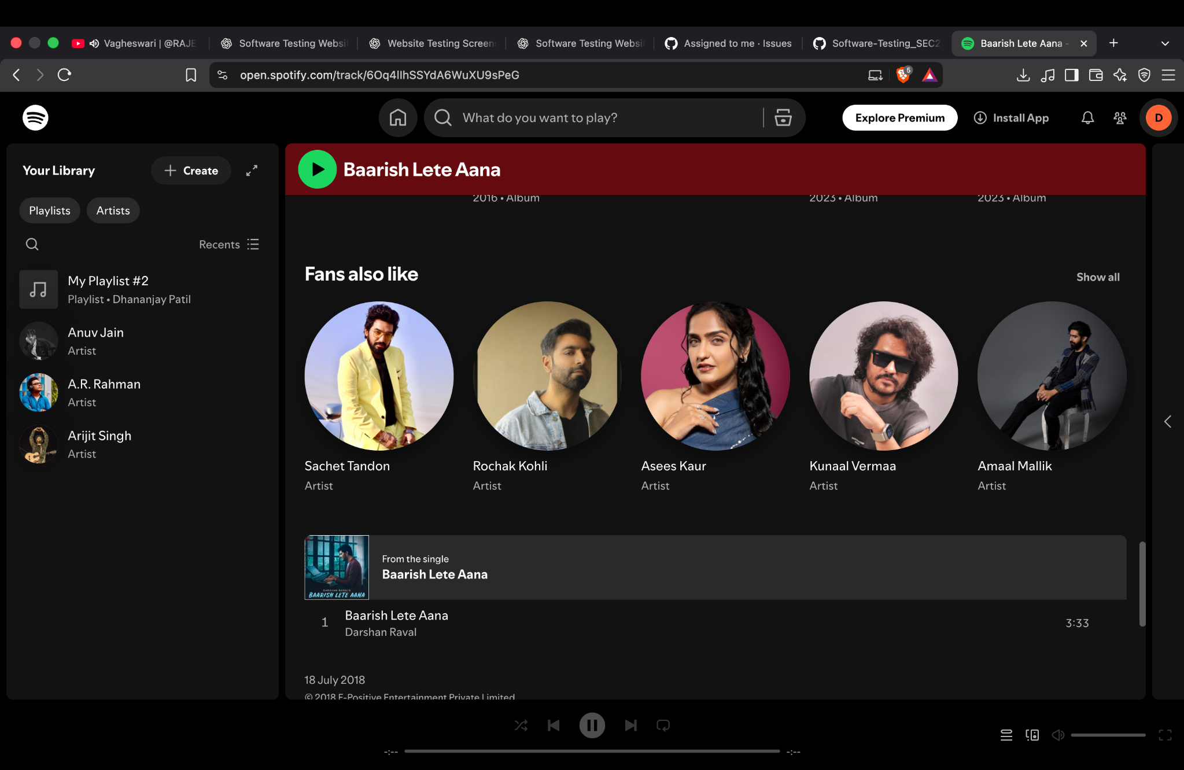

6. Defect Reporting Notes
No confirmed Spotify application defect is established by the supplied screenshots alone. The Widevine prompt is generated by the browser and is not, by itself, a Spotify defect. To raise a defect, reproduce unexpected behavior, capture the exact screen, record steps to reproduce, expected result, actual result, severity, priority, browser, and date.

7. Recommended Additional Tests
- Search for a known artist or track and compare the results with the query.
- Play and pause an available track; confirm the playback bar and audio state change.
- Use Next Track and Previous Track where available.
- Save a track to the library and verify that the state persists after navigation.
- Create or rename a playlist and verify the displayed result.
- Test sign-in with an intentionally invalid email only if appropriate; do not use or record a real password in the report.
- Check responsive layout at a narrower browser width.

8. Conclusion
The submitted screenshots provide evidence of Spotify Web Player page rendering across the homepage, sign-in, home, artist, playlist, and track views. The evidence is suitable for documenting basic manual UI/navigation testing. Further direct interaction tests are required before marking playback, search, saving, playlist editing, or authentication outcomes as passed or reporting any defect.
End of report.

