SOFTWARE TESTING REPORT
Lichess.org — Website Functional & Interface Testing

Student ID | 2504030100426
Student Name | Ms. Harshita Malviya
Website Under Test | https://lichess.org
Testing Type | Black-box functional observations and UI/navigation review
Evidence Set | 7 screenshots supplied by the student

Prepared from the supplied screenshots.

1. Executive Summary
This report records visible interface and navigation observations from seven screenshots of Lichess.org. The evidence shows the official-site search result, the main chess homepage, the sign-in page with a password-security warning, an email-link confirmation page, homepage game panels, the Learn chess page, and Lichess TV.
The screenshots support UI and navigation observations, but they do not establish that a valid login succeeded, that invalid credentials were rejected, or that internal source-code branches were tested. Accordingly, results are marked Observed where directly visible and Not Tested where the screenshots do not prove execution.

2. Scope and Objectives
- Confirm that key public pages are reachable and display their main interface elements.
- Review visible navigation to Play, Puzzles, Learn, Watch, Community, and Tools.
- Record the sign-in/security message and the email-link confirmation screen without exposing or repeating the password.
- Identify tests that require additional execution evidence, test accounts, or source-code access.

3. Test Environment and Evidence
Application | Lichess.org web application
Browser shown | Brave browser
Evidence | 7 screenshots captured on 10 October 2026
Limitations | No browser console/network logs, source-code inspection record, or independent credential test evidence supplied

4. Test Execution Summary
Test ID | Testing Step | Expected Result | Actual Result | Status | Comments / Suggestions
UI-01 | Open official site/search result | Lichess result and official domain visible | Search result identifies lichess.org | Observed | Screenshot 1; search result only, not a test of the app itself.
UI-02 | Open main homepage | Main page and game-time options visible | Play options, navigation, and game panels visible | Observed | Screenshot 2.
AUTH-01 | Inspect sign-in page | Sign-in form is displayed | Username/email, password, sign-in, and reset options visible; security warning displayed | Observed | Screenshot 3. Warning indicates password reuse/compromise concern; do not treat as invalid-password test.
AUTH-02 | Use email sign-in flow | Confirmation explains email link was sent | “Check your Email” confirmation displayed | Observed | Screenshot 4. Email delivery itself was not independently verified.
NAV-01 | Review homepage game/content panels | Game, puzzle, and news content visible | Chessboard panels and content cards visible | Observed | Screenshot 5.
NAV-02 | Open Learn section | Learning page and lesson categories visible | Chess pieces and fundamentals lessons visible | Observed | Screenshot 6.
NAV-03 | Open Watch/Lichess TV | Live/recorded chess interface displayed | Chessboard, clocks, moves, and rating information visible | Observed | Screenshot 7.
AUTH-03 | Verify successful login with valid credentials | Authenticated session/dashboard | Not demonstrated by supplied screenshots | Not Tested | Requires a safe test account and a screenshot of the authenticated state.
AUTH-04 | Verify invalid password handling | Clear rejection/error for incorrect password | Not demonstrated by supplied screenshots | Not Tested | Use only an account you own; record the actual message.
AUTH-05 | Verify empty-field validation | Required-field validation or rejection | Not demonstrated by supplied screenshots | Not Tested | Capture the actual form response after submitting empty fields.
WB-01 | Inspect internal source-code branches | Conditions, branches, and statements identified | No code-level evidence included | Not Tested | Lichess is open source, but these screenshots do not show source-code inspection or coverage.

5. Screenshot Evidence and Explanation

Screenshot 1 — Official-site search result
Shows a search result for Lichess and identifies lichess.org. Useful as context for the selected test website, but not evidence of a functional test.
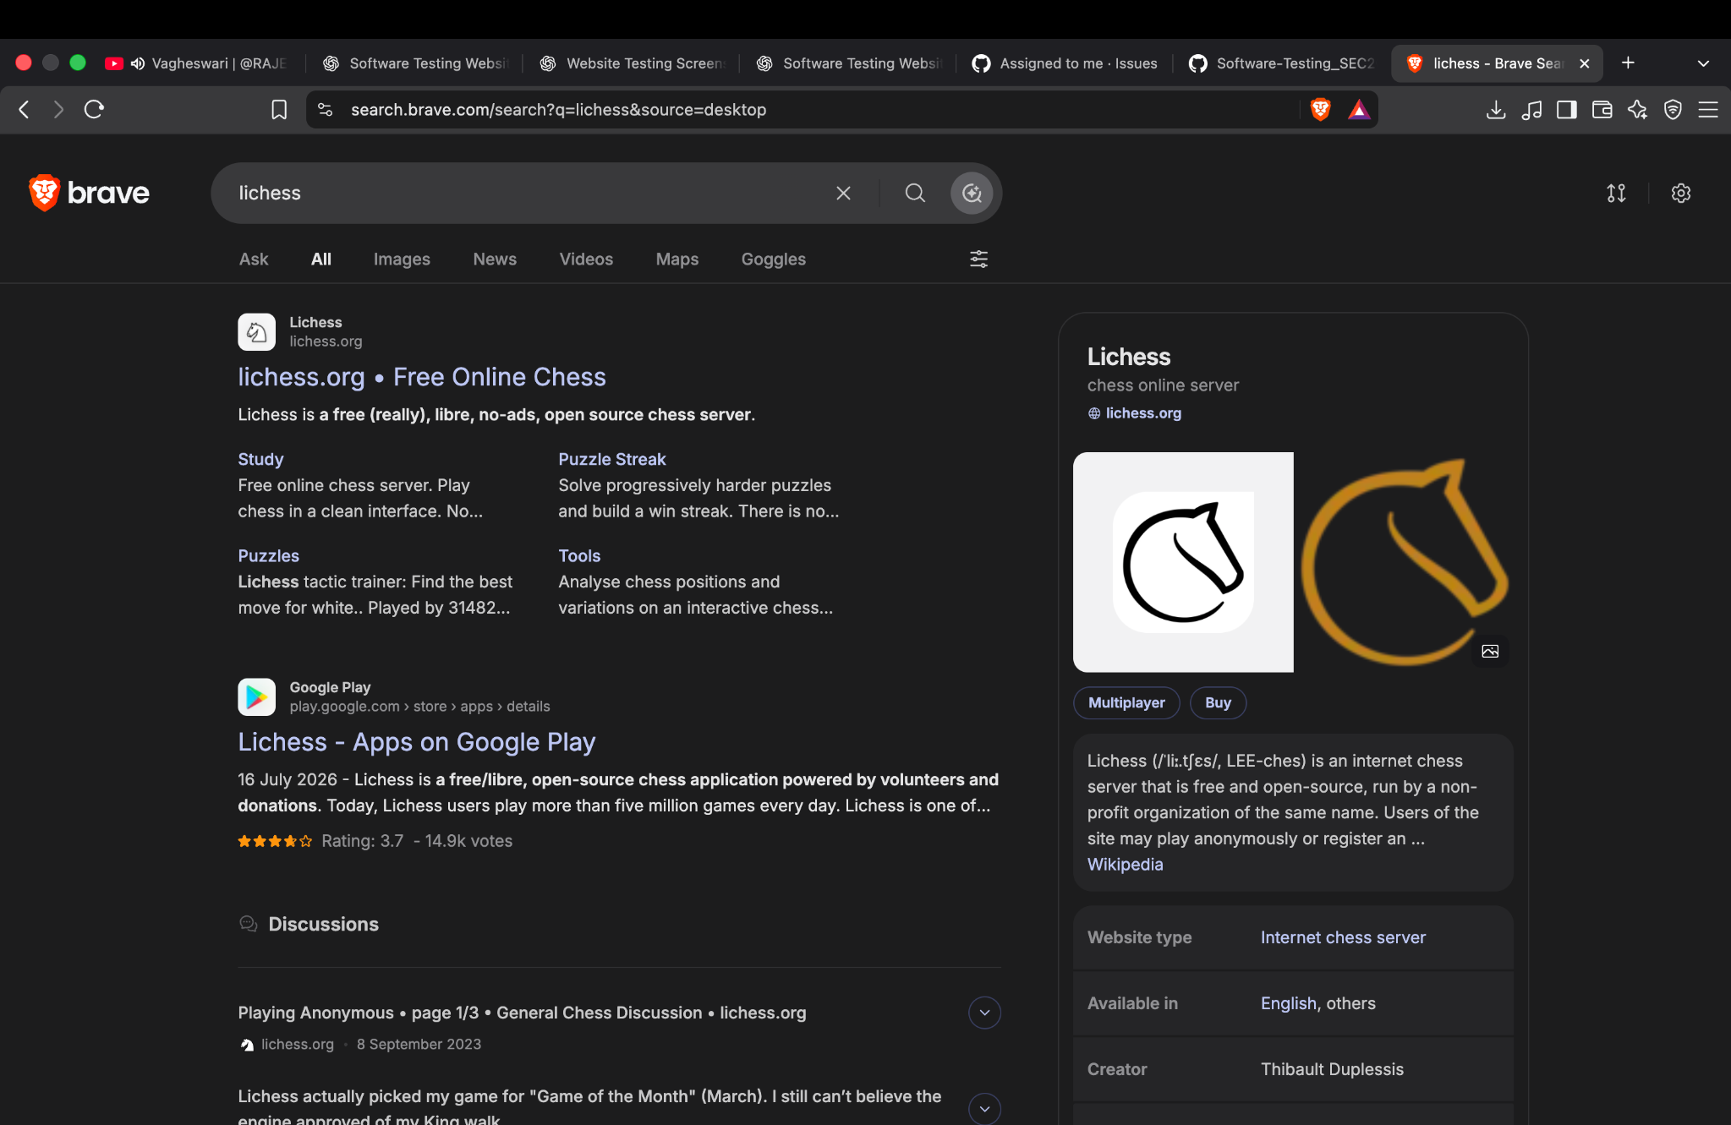

Screenshot 2 — Lichess homepage
Shows the main navigation and quick-pairing game-time options. Supports a UI presence/navigation observation.
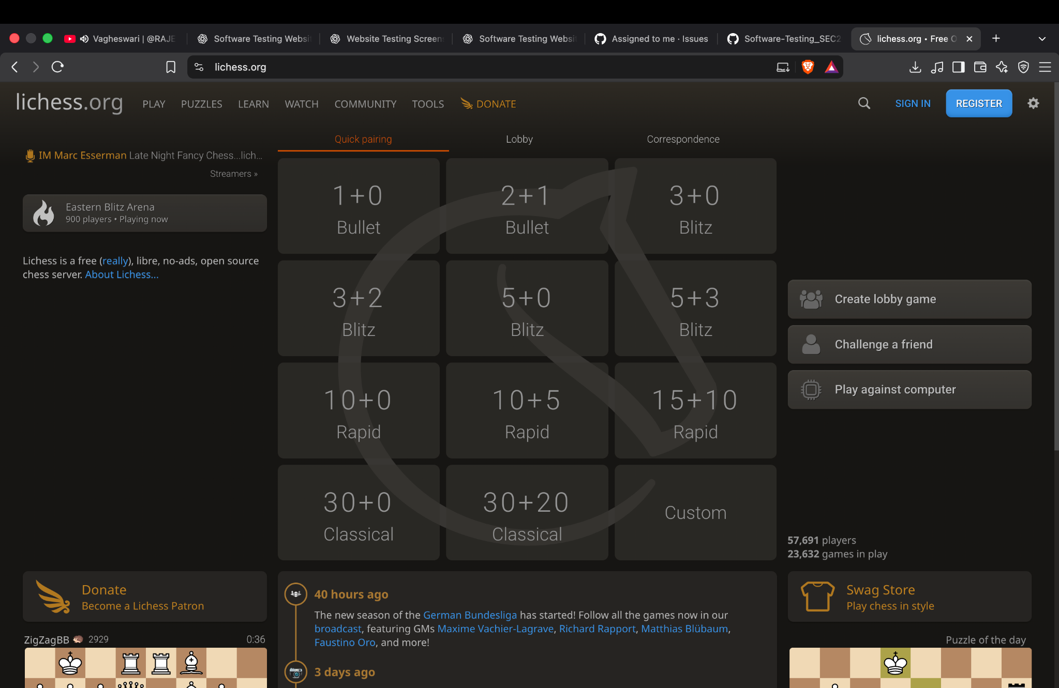

Screenshot 3 — Sign-in form and security warning
Shows the sign-in form and a warning asking the user to reset a password considered compromised due to reuse. This is a security warning, not proof that an invalid password was entered.
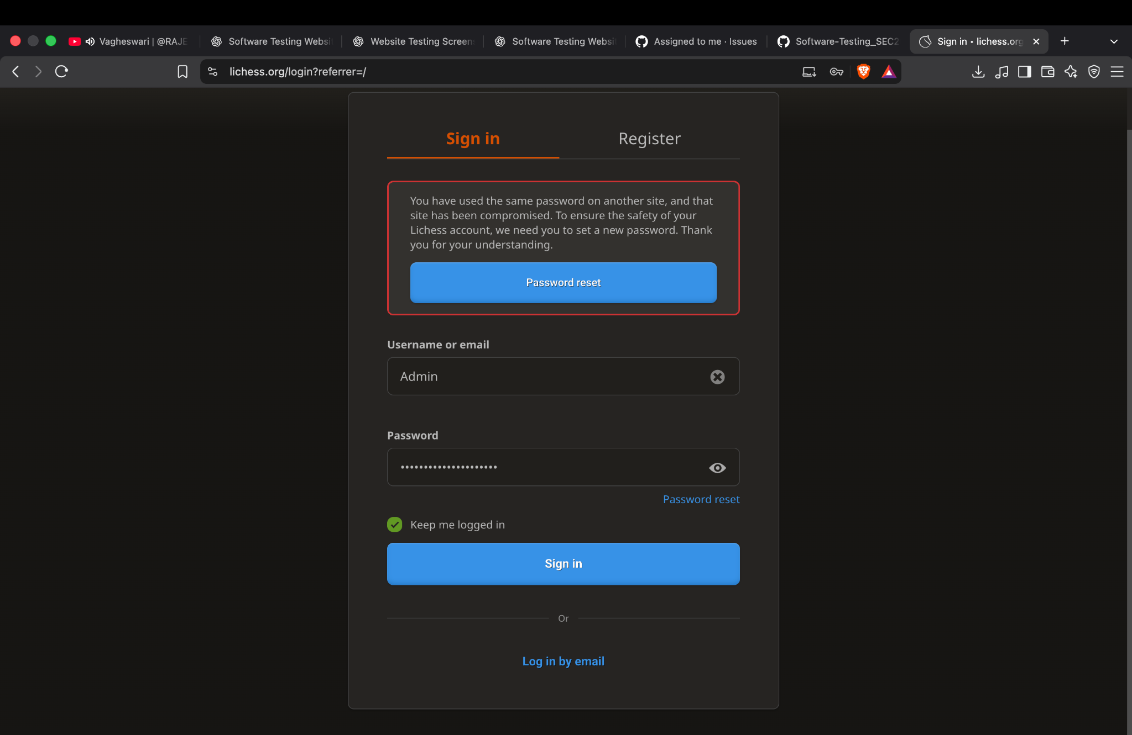

Screenshot 4 — Email sign-in confirmation
Shows a confirmation that an email with a link was sent. It supports that the confirmation screen appeared; actual email receipt was not verified in the screenshots.
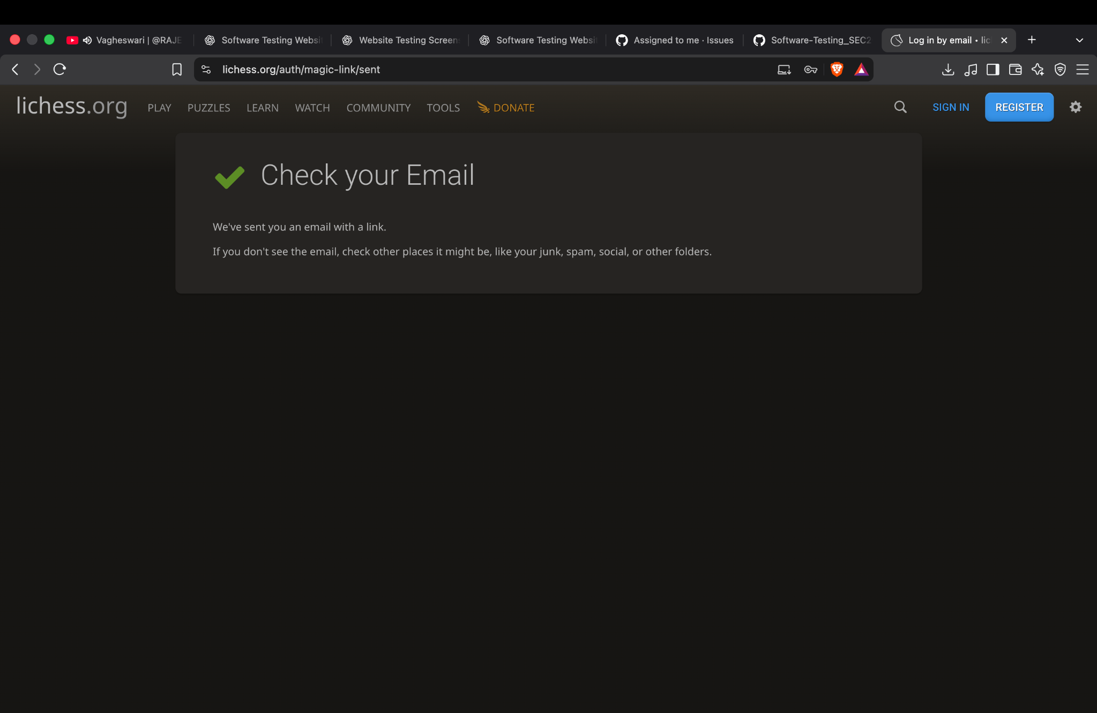

Screenshot 5 — Homepage content panels
Shows chessboard/game panels, puzzle content, and homepage content. Useful for UI layout and content visibility review.
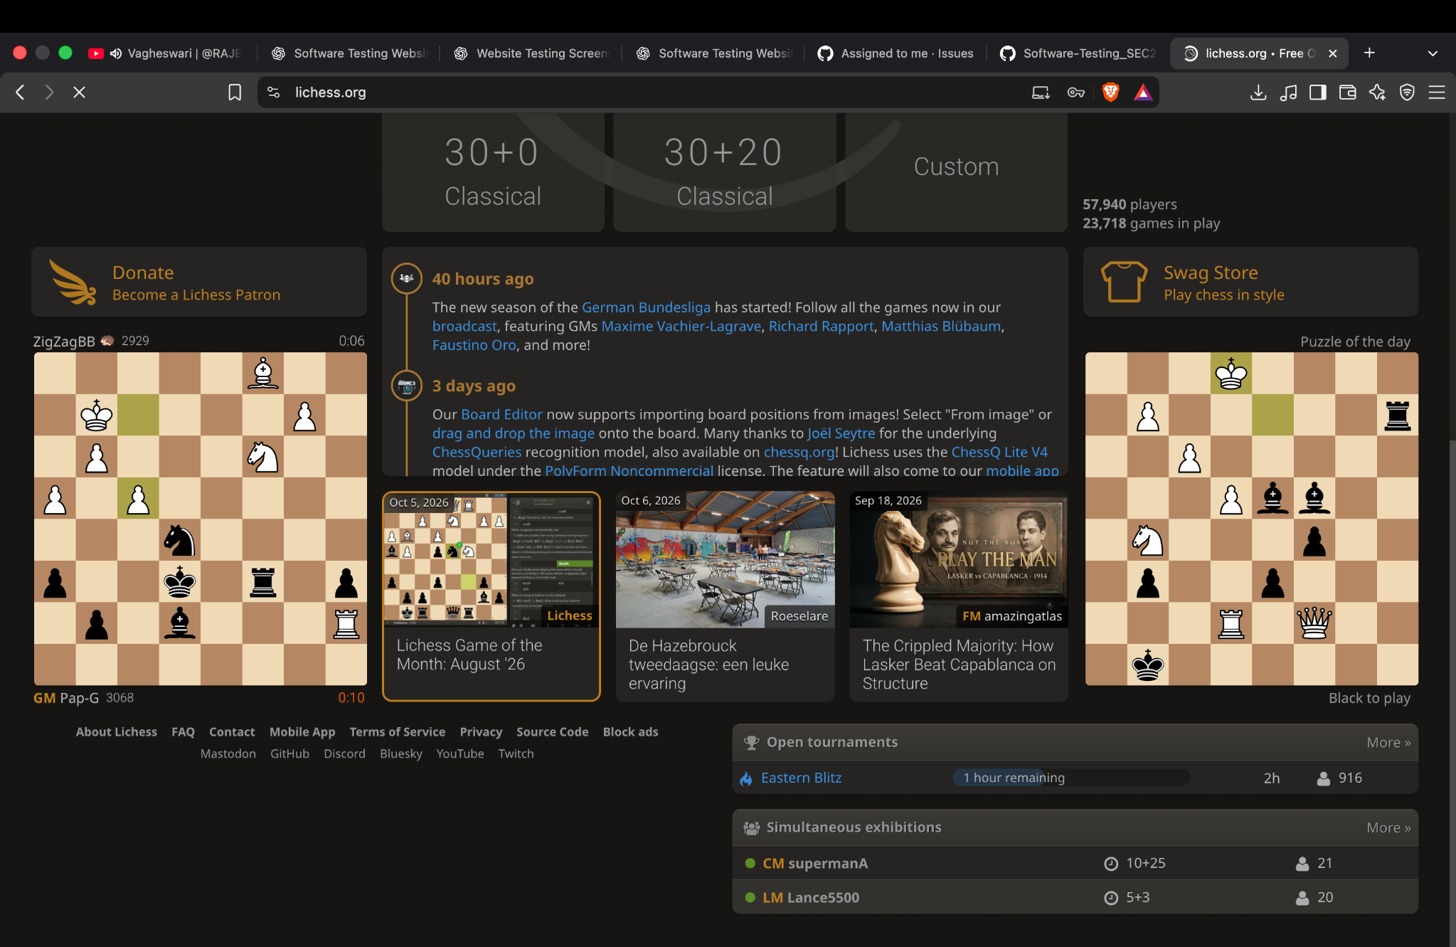

Screenshot 6 — Learn chess
Shows lesson categories such as chess pieces and fundamentals. Supports page-access and visible-content observations.
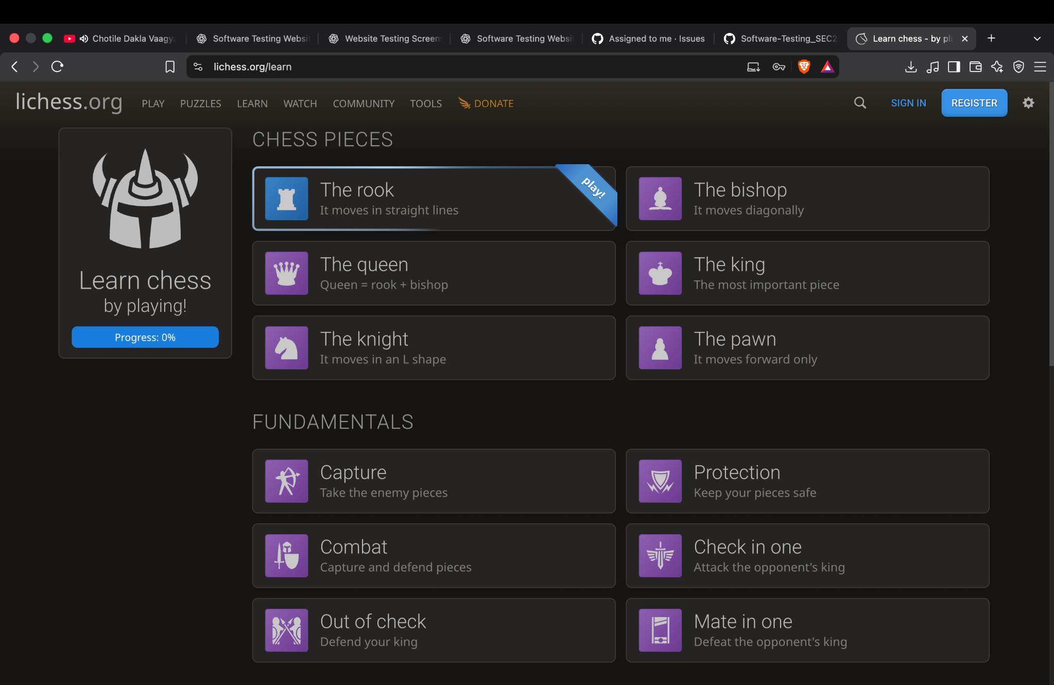

Screenshot 7 — Lichess TV
Shows a chessboard, clocks, move list, and player information. Supports an observation of the game-viewing interface.
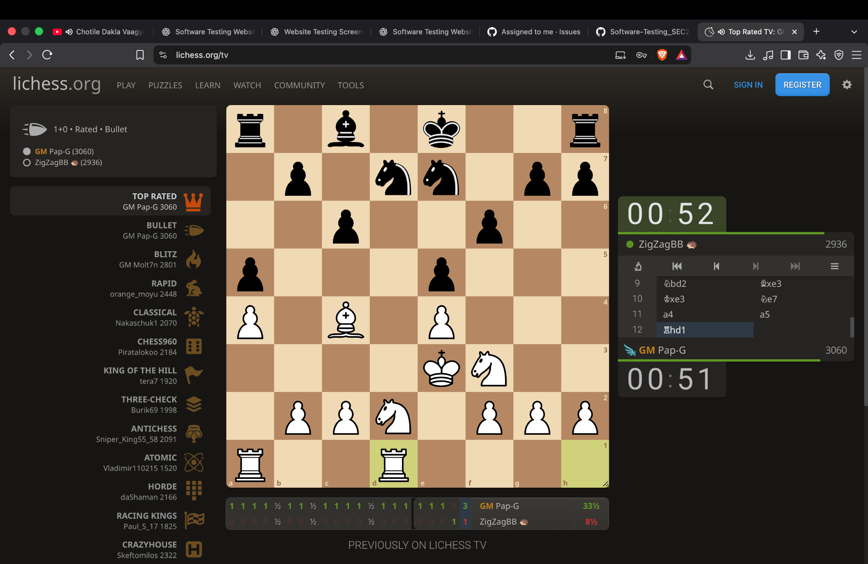

6. Defect and Improvement Notes
- No confirmed functional defect can be declared from these screenshots alone.
- The sign-in screen displays a password-security warning. Follow the website's official password-reset guidance if this warning relates to the account.
- For a complete login test, capture separate evidence for valid credentials, invalid credentials, and blank-field submission.
- For white-box testing, inspect the open-source code in a controlled local environment and document the exact file, conditions, branches, and coverage method used.
- Avoid including passwords, recovery codes, or personal email content in screenshots submitted with the report.

7. Conclusion
The supplied evidence is suitable for documenting Lichess.org's visible interface and several page-navigation/content observations. It is not sufficient to claim that authentication passed or failed, nor does it demonstrate white-box coverage. Those tests should remain Not Tested until the corresponding execution evidence is captured.
Prepared for: Ms. Harshita Malviya | Student ID: 2504030100426

