# 

Whitepaper

Anypoint Platform

# 

Anypoint Platform

Whitepaper



**Overview**

This document will let you know about the product, MuleSoft Anypoint Platform and how it changed the scenario from connecting point-to-point data services and applications to simply integrating them by light weight integrated service bus with its integration framework provided by MuleSoft. You will get to know how Anypoint Platform helps the developer to Design, Build, Deploy, Manage API’s and to connect applications easily, enabling data exchange. It solves most challenging connectivity problems across SOA, SaaS and API’s and allows enterprises to deliver and build their application network. This paper is all about getting started with API development cycle to API implementation which led connectivity with Anypoint Platform. Here, we discuss the component of Anypoint Platform which it relays on and they are:

* Anypoint Design Center
* Anypoint Management Center
* Anypoint Exchange
* Mule Runtime Engine
* Anypoint Connectors
* Runtime Services
* Hybrid Cloud

Further, the above elements will describe how well Anypoint Platform is enabling an Application Network. As well, you will get to know about the components of Anypoint Platform. How it connects and get integrated with different Applications and API’s.

MuleSoft provides building blocks for API lifecycle which helps to integrate easily to different modules, like Connectors, Components, Filters.

**Anypoint Platform**

Anypoint platform provides integration between B2B and led-connectivity to different applications, data-services, devices through Network Application in cloud, on-premises or Hybrid(both) using API’s. It allows to design API’s for the services and validates them prior building them. Anypoint platform totally works on API’s, it gets easily connected to any data source from mainframes, databases, SAP to ERP’s, SaaS apps, mobile apps and IoT devices.

**To understand Anypoint Platform first we need to understand What is API?**

API-Application Programming Interface acts as a juncture for two applications. It is a set of tool, protocol and subroutine, which allows to build different software applications and enables applications to exchange data within them or beyond.

Anypoint Platform takes API through complete lifecycle i.e. design, build, deploy, manage and govern. Below is the described Building Block of API lifecycle and how it works in Anypoint.

**Anypoint API Lifecycle Building Block**

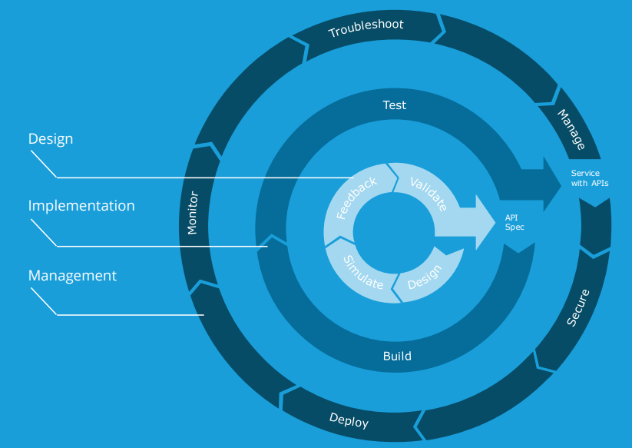

**DESIGN:**

It is the initial layer of the API Life Cycle module where we first initiate how the API is build and integrated. It deals with the backend data and fnctionality of the application. First layer contains four segments:

1. **Design:** To optimize for the best API experience “Design-First” is the basic approach. It helps in identifying processes and business requirements which allows us to build logical data models and converts into services or API groupings. Model is Implemented through API Designer for RAML language, the developer can write their code either in RAML, Swagger or simply Hand Coding, WSDL/XSD (Webservice Defination Language).
2. **Simulate:** Simulate calls to an API using mocking service in the API console to test how it visualize the API and troubleshoot the problems prior implementing it.
3. **Feedback:** After simulating callsfrom an API, spinning up a portal and adding it to exchange to visualize and discover the API. Once the simulation is performed a response is given by the developer as feedback.
4. **Validate:** Validate module willweather the flow matches to the specific criteria or not.Once the validation criteria are matched and verified we then further continue the process to the next level.

**IMPLEMENTATION:**

Once you have completed the Design module and validated it. Implement modules takes place to the next level where the developer tests and build their code. It is a critical part of enabling next generation enterprise. Implementation layer contains two sections

1. **Build:** To build API, Mulesoft Anypoint Platform uses API Studio. Once the API is designed developers will code it according to the requirement. In this segment connectivity is done through cloud, SaaS. It mostly deals with the back-end database calls.
2. **Test:** Once the API is built, test module is implemented. The code is tested through automation tool, for Anypoint Platform Mulesoft provide their own test unit i.e. MUnit (MuleSoft’s testing solution) which is incorporated into the full Application building block lifecycle. IT uses Postman as a testing tool which allows to call APi’s and validate.

**MANAGEMENT:**

1. **Secure:** It protects API from threats and vulnebralities. APIs are bit secured by API manager who doesn’t eliminate all threats, it can help protect you against some of the most common ones. And when used as a proxy, it can prevent malicious attacks from hitting your architecture.
2. **Deploy:** Once the application building block has been assembled and tested deployment takes place. Applications are deployed to an embedded Mule runtime in Anypoint Studio, during development. After words Mule Application will deploy it to cloud.
3. **Monitor:** ItOptimize API and app performance with analytics. It is critical to ensure your application building blocks are following best practices in security and architectural governance at runtime. Hence, monitoring all traffic is equally critical because it takes just one weak link to bring the ship down.
4. **Troubleshoot:** Test and permit APIs to target environment. There might be cases when your API doesn’t work or exhibits unexpected behavior. If you’re not getting any response, Postman will display a message about an error in connecting to the server. While troubleshooting you can come across many issues like firewall issues, proxy configuration, ssl certificate issue, client certificate issue etc.
5. **Manage:** ItOrchestrate and manage API operations at scale. It manages API throttling- rate limit, API metering, API analytics, API security. Hence, all the above segments of management are been managed and monitored by the API manage component.

**Components of Anypoint Platform**

Anypoint Platform is an integrated set of individual products with that it provides number of tools and services. The basic components in which Anypoint platform relays on are:

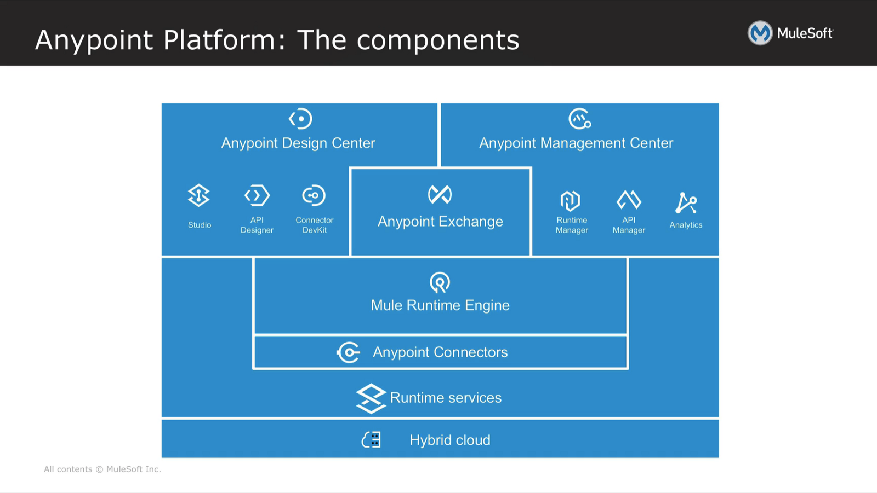

**Anypoint Design Center:**

Anypoint Platform is a unified collection of tools, enacts access to developer to perform task parallely and quickly to tackle complex API-led connectivity. It provides tools like:

* **API Designer:** **It** is a web-based application, developer operate it to design and document an API. A developer can also choose to reuse specific components of an API, such as security schema. API designer is a web-based IDE for writing out RAML specification.
* **API Studio:** Anypoint Studio is MuleSoft’s IDE (integration development environment) used for designing and testing Mule applications. It helps to design and edit the definitions of the applications, APIs, properties, and configuration files.
* **Connector DevKit:** Mulesoft uses Anypoint Connector DevKit to connect any endpoint from Mulesoft’s ecosystem by using dynamic connectivity and API specification. DevKit is used to build your own reusable connector.

**Anypoint Management Center:**

Anypoint Management Center is a centralized web interface to all Anypoint Platform either in cloud or on-premises. It manages API users, traffic, SLA’s (service layer agreement) and underlying integration flows.

* **Runtime Manager:** Runtime Manager helps in easy deployment of application and upgradating them fastly. If necessary, can roll back to the previous version easily. By using Mulesoft plugins we can easily atomate deployment to existing frameworks and runtime APIs.
* **API Manager:** API Manager is a component of Anypoint Platform for designing, building, managing, and publishing APIs. Anypoint Platform uses Mule as its core runtime engine. API Manager can be used on a public cloud, such as CloudHub, a private cloud, or a hybrid.
* **Analytics:** API Analytics can provide acuity, how APIs are performing and utilized. From API manager, an Analytics Dashboard is access to create custom dashboard, manage charts and reports. It allows you to showcase your business transactions and events of integration performed.

**Anypoint Exchange:**

Anypoint Exchange is a domain carrying connectors, templates and RAML APIs. It Discovers and use proven assets built by the MuleSoft ecosystem. And can increase productivity and accelerate on-ramp for new usersby grouping essential assets into modules. It can also add value to a private holder of Anypoint Exchange for collaboration and sharing of internal best practices.

**Mule Runtime Engine:**

To execute any application Runtime Engine is required. It is a unified platform that connects application, combines data and integrate them easily. It takes no effort to move the application from on-premises to cloud. Can deploy SaaS application and APIs with hybrid deployment option as an on-prem integration engine, hybrid iPaaS or API gateway.

**Anypoint Connectors:**

To connect an application from your reference point to the destination Connector is required. Mulesoft Anypoint Connector have their own pre-built library which provide dynamic connectivity to REST or SOAP APIs. It leverages Mule’s simplified connector model to build reusable connectors for any system with Anypoint Connector DevKit.

**Runtime Service:**

Reliability, resilience, availability, and scalability are the key functions of the strategic set of Runtime Services in Anypoint Platform. These runtime services improve operational efficiency while helping organizations maintain security and control. MQ Perform asynchronous messaging scenarios such as queueing and pub/sub with hosted and managed cloud message queues and exchanges. A runtime service of Anypoint Platform, Anypoint MQ also supports environments and multi-tenanted role-based access control.

**Hybrid Cloud:**

Anypoint Hybrid Cloud permits you to access the same APIs or applications across multiple cloud environments or on-premises. MuleSoft provides fully managed cloud solution and Dockerized containers for running and managing Mule apps, allowing organizations to encapsulate functionality, shift deployment targets with ease, and expand resources elastically in response to demand.

* **CloudHub:** CloudHub is a platform providing fully-managed, and fully hosted Mulesoft integration PaaS. It has Multi-tenancy for applications also helps developer in improving efficiency. It has a globally distributed architecture with cloud security and compliances available for integration and APIs.

**Key Capabilities of Mulesoft Anypoint Platform:**

* **ESB (Enterprise Service Bus):** With pre-built connectors and templates it will rapidly build integrations ranging from basic to advance.
* **APIs:** Enables organization with Experience APIs, System APIs and Process APIs.
* **B2B (Business to Business):** Build reusable services across multiple trading partners.
* **Microservices:** Enables new solutions in a manageable, reusable and governed way.
* **IoT (Internet of Things):** Connect and orchestrate data from cloud to the devices by using open standards, friendly tool and transport protocols.
* **Data Integration:** Combines batch and real-time processing for unified application and data integration.

**Benefits of Anypoint Platform:**

* Manage all resources from a single pane.
* Increase in productivity through open technologies that elevate reusability, modularity and collaboration.
* Increase value creation for the enterprise that enable faster development, testing and implementation of APIs.
* Unlock the legacy systems, of point-to-point connectivity to API led-connectivity approach.
* Easy to connect apps, data and gadgets anywhere on-premises or in cloud.
* With a flexible atrchitecture Anypoint Platform can evolves as your business does.



MuleSoft’s mission is to help organizations change and innovate faster by making it easy to connect the world’s applications, [data](https://www.mulesoft.com/integration-solutions/dataweave-integration) and [devices](https://www.mulesoft.com/integration-solutions/api/iot). With its [API-led approach](https://www.mulesoft.com/platform/api/manager) to connectivity, MuleSoft’s market-leading [Anypoint Platform™](https://www.mulesoft.com/platform/enterprise-integration) is enabling over 1,000 organizations in more than 60 countries to build [application networks](https://www.mulesoft.com/why-mulesoft). For more information, visit [https://www.mulesoft.com](http://ctt.marketwire.com/?release=1275976&id=9457705&type=1&url=https%3a%2f%2fwww.mulesoft.com).

*MuleSoft is a registered trademark of MuleSoft, Inc. All other marks are those of respective owners.*