**Smart measuring of water ,gas & energy consumption in a Smart Home**

**PROBLEM STATEMENT :**

To provide unified solution for smart IOT based measurement of water ,gas & energy consumption for smart homes.

**OBJECTIVE :**

With the advent of IOT era, a need was felt to upgrade the existing conventional & outdated personal premise solutions with their Electronic & centrally controllable counterparts. This includes but not limited to ELECTRICITY METER, WATER METER,GAS METER & SMART SWITCH technology for managing the resources to the best possibility .

**CURRENT SCENARIO :**

Many discrete IOT projects are currently under-development throughout the country which targets variety of application area mentioned above but there happens to none being actively projected to target Smart Home as a concept solution.

**OUR IMPROVISATION:**

Our project targets the Smart Home as a concept solution which states for a centrally controllable ,accountable & monitorable system solution which will provide the consumers a unified access interface to the below listed Smart Devices:

* Electricity Meter
* Water Meter
* Gas Meter
* Remote Controlled Switches cum Security devices

All the above listed smart devices will form a Smart GRID which will be useful in effective enhancement of living standards & efficient usage of valuable resources.

**CURRENT PROTOTYPE STAGE :**

The current prototype being developed is capable of providing the following functionalities:

* Totally IOT based solution so the data can be transmitted & used in any form desired or required.
* As a proof of concept , the current solution features an Android app based unified interface to control & monitor all the devices so mentioned at a Home Premise Setup.

**FUTURE PROPOSALS:**

Following are the future proposals regarding the extension of features :

* Availing the functionality of a Central Online based Control & Monitoring Panel which can be used by both Authorities & consumers to manage their Smart GRID.
* Using Data Analytics & Deep Learning to predict & propose the resource requirement of the future as well as to devise efficient usage strategies for the same.

**TECHNICAL DETAILS :**

General Specification :

* Every Smart Device in the solution currently uses a NodeMCU(ESP8266) as the master control unit availing full Wireless(IEEE 802.11) capabilities.
* The above mentioned MCU is capable of handling Cryptographic operations as well which are desired in the solution & is also compatible with the latest Programmatical trends(uses Python as the language of coding) ,hence future proof.

Smart Water Meter & Gas Meter:

* Apart from the general specification , these meters use Fluid Flow Sensor (YF-S201) .

Smart Electricity Meter :

* Apart from the general specification , the meter uses an optocoupler based circuitry as an extension to the current tradition Electricity meters to read their current reading feed back to MCU.

Smart Switch cum Security Device:

* Apart from the general specification , the module uses a 10A / 220V Relay Module controlled by MCU along with a Motion Sensor (HC-SR501 PIP) .

**BLOCK DIAGRAMS :**

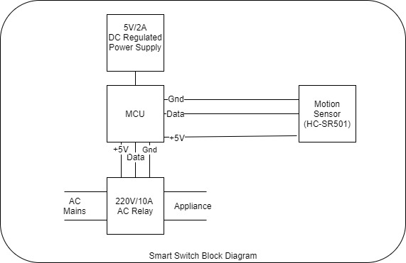

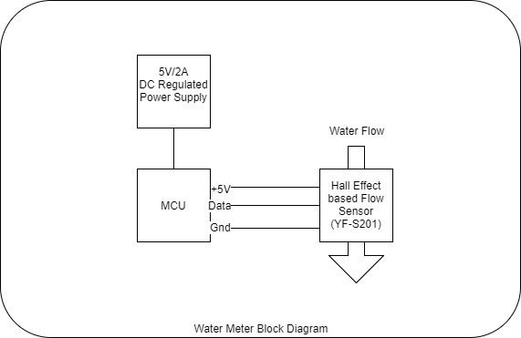

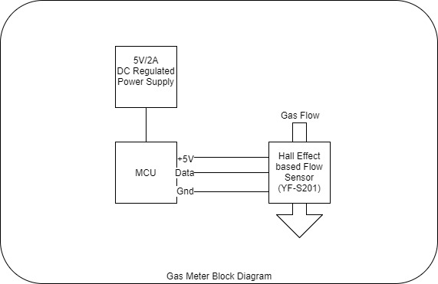

**SOFTWARE FLOW :**

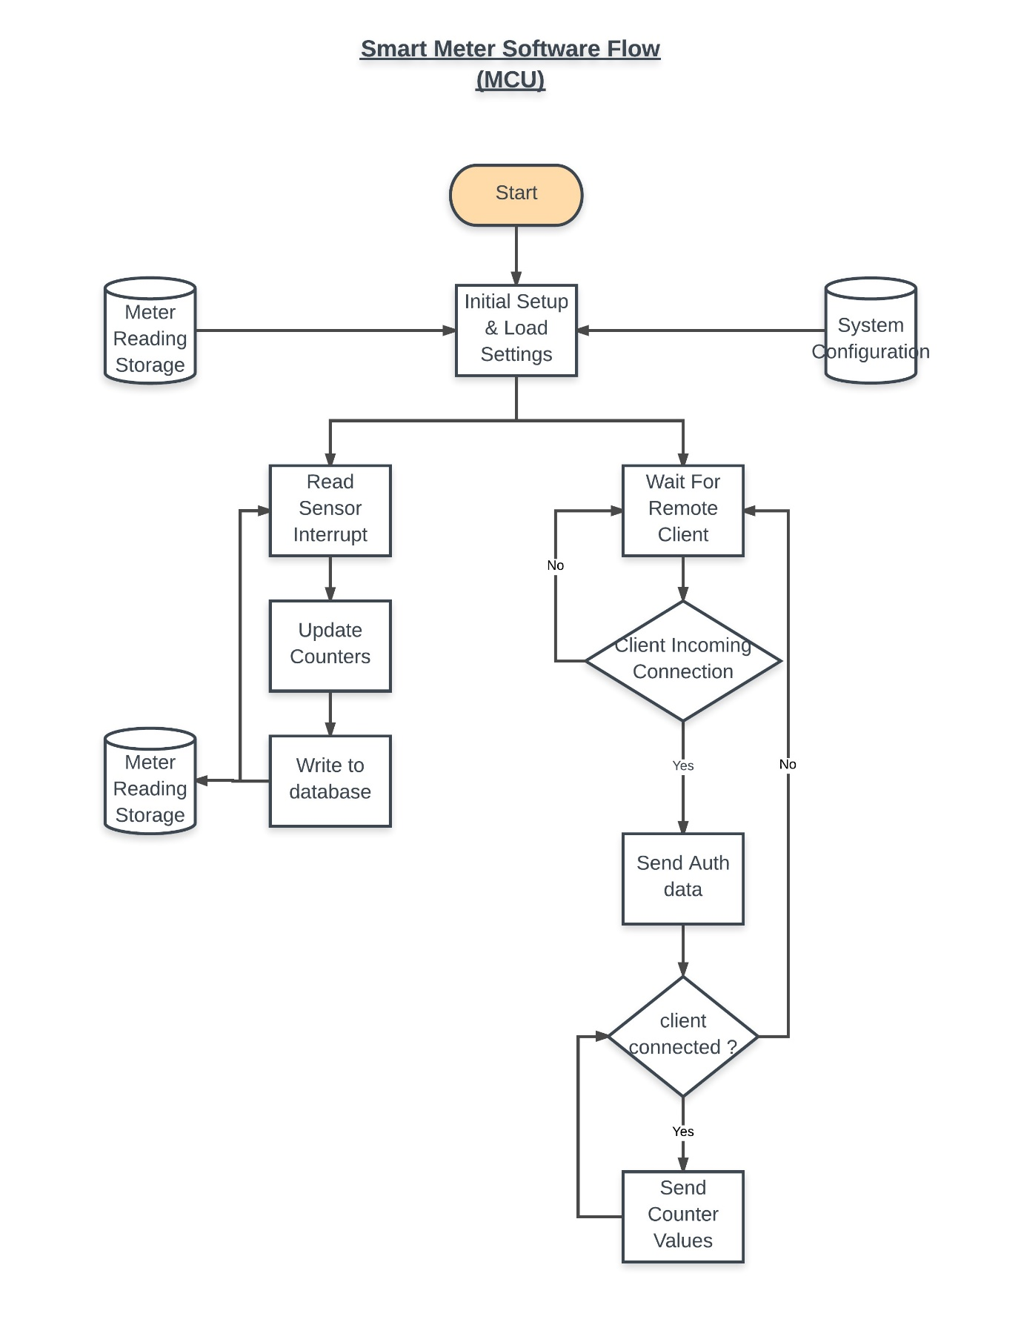

**ANDROID APPLICATION SCREEN SHOT :**

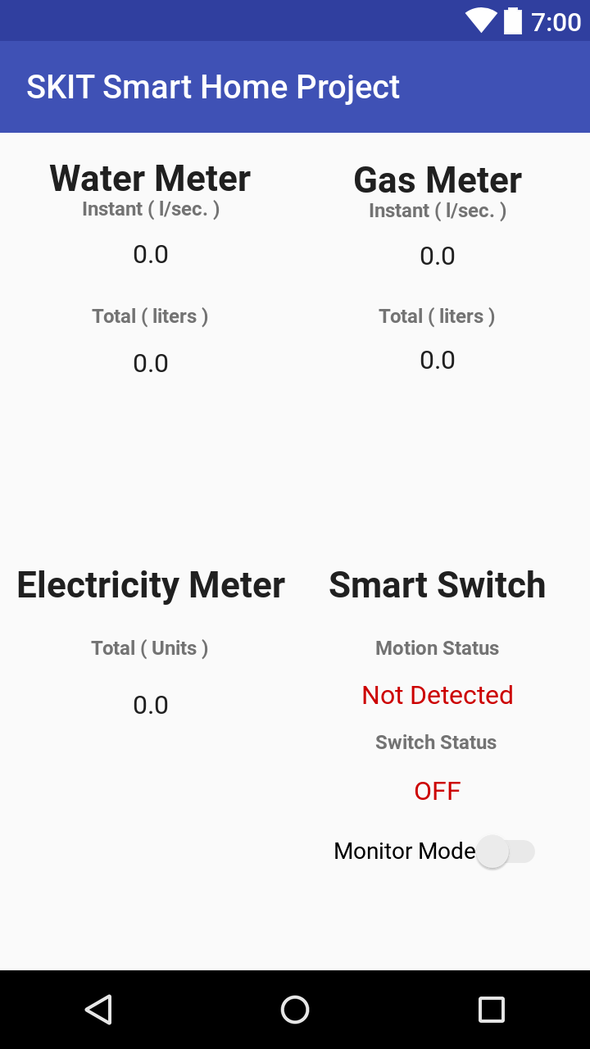

**PROJECT SOURCE CODE :**

* [Github Project Page](https://github.com/harshitandro/Smart-Home-Project)