Experiment 1

# Introduction to OS

• Definition: An Operating System (OS) is system software that manages computer hardware, software resources, and provides common services for computer programs.

• Role: Acts as an intermediary between the user and the hardware.

• Core Component: Kernel is the core of the OS, responsible for managing system operations.

# Functions of OS

• Process Management: Manages processes in the system including process creation, scheduling, and termination.

• Memory Management: Allocates and deallocates memory space as needed by programs.

• File System Management: Manages files and directories on the disk.

• Device Management: Controls and coordinates hardware devices (printers, disk drives).

• Security & Protection: Ensures that unauthorized access is prevented and that users and processes do not interfere with one another.

# Services of OS

• Program Execution: OS loads programs into memory and executes them.

• I/O Operations: Manages input/output operations such as reading and writing to files, interacting with peripherals.

• Error Detection: Constantly monitors system activities for errors and takes appropriate action.

• Resource Allocation: Allocates resources like CPU time, memory, and I/O devices to active processes.

• User Interface: Provides either a command-line interface (CLI) or graphical user interface (GUI) for users.

# Need for LinuxOS

• Open Source: Linux is open-source, allowing users to modify and distribute it freely.

• Security: Linux is considered more secure than many other operating systems due to its permission and user privilege system.

• Performance: Linux offers better performance and efficiency in resource management, especially for servers.

• Customization: Users can tailor the OS to their needs by modifying the kernel or adding packages.

• Community Support: Extensive support from the open-source community with many resources for learning and troubleshooting.

# History of LinuxOS

• Creation: Created by Linus Torvalds in 1991 as a free alternative to Unix.

• Early Development: It began as a personal project but quickly grew with contributions from the open-source community.

• Kernel Releases: The Linux kernel has gone through several updates, becoming more stable and powerful over time.

• Distribution: Various Linux distributions (distros) like Ubuntu, Fedora, and Debian have evolved, making Linux accessible to a wider audience.

# Services and application of LinuxOS

• Web Servers: Linux is widely used to run web servers due to its stability (e.g., Apache, NGINX).

• Development Platforms: Ideal for software development with support for many programming languages and frameworks.

• Security Applications: Used in cybersecurity for penetration testing and network security monitoring.

• Cloud Computing: Linux powers most cloud infrastructures due to its scalability and open-source nature.

• IoT and Embedded Systems: Linux is commonly used in embedded systems and IoT devices for its lightweight kernel and customizability.

Experiment 2

# Aim: To demonstrate the commands in Linux command line.

1. **ls** list directory content

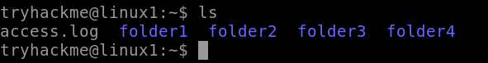

1. **ls-l**

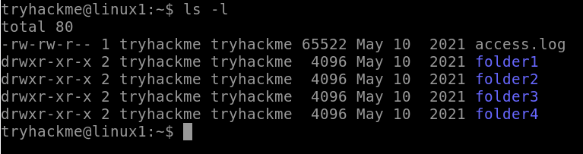

1. **date**

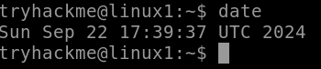

1. **man whoami**

