Module-IV
Lecture-III
Operations on Ordered Binary Decision Diagram

- Introduction
In the last two lectures we discussed that Reduced Ordered Binary Decision Diagrams (ROBDDs) are widely applied in verification because, they are canonical and for most of the Boolean functions they comprise much lower number of nodes compared to their DBT counterparts. Also we presented the construction of ROBDDs using Shannon’s expansion. Another important property of ROBDDs is that all Boolean operations can be performed on them. For example, consider the AND gate shown in Figure 1 (a). The ROBDDs for the inputs “a” and “b” are shown in Figure 1 (b). The ROBDD for the output of the AND gate is shown in Figure 1 (c), which is computed using AND operation on the ROBDDs of the two inputs. It may be noted that ROBDD for the AND gate (or any other circuit) can be constructed by first determining the Boolean function at output and then constructing the ROBDD using Shannon’s expansion. However, construction of ROBDD using Shannon’s expansion (of the output function) is more cumbersome compared to procedure of using Boolean operations on input ROBDDs. The reason is, determining Boolean function of a large circuit and then apply Shannon’s expansion iteratively is a complex task. In this lecture we will discuss operations on ROBDDs.

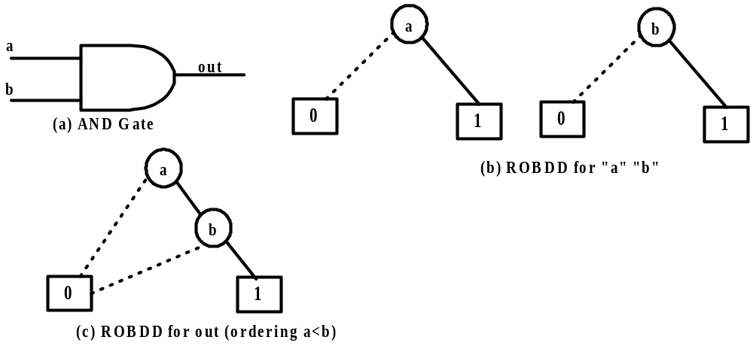
Figure 1. ROBDD AND gate with inputs “a” and “b”
- Operations of ROBDDs
Let there be two ROBDDs and representing Boolean expressions f and g, respectively. It is known that all Boolean operations can be done on f and g and the result is another Boolean expression. These operations can be performed on the ROBDDs and the resultant BDD (may not be ordered and reduced, as explained shortly) is the representation of the resultant Boolean expression.
Figure 2 shows the ROBDDs B_{f} and B_{g} of two functions f and g (internal nodes are not shown). Figure 3 represents the BDDs for the complement of f and g; it is very simple to get the BDD for the complement of a function, as we just need to reverse the values of leaf nodes. It may be noted that complement operation on ROBDD would result in a BDD that is ordered and reduced. However, this may not hold for other operations explained as follows.

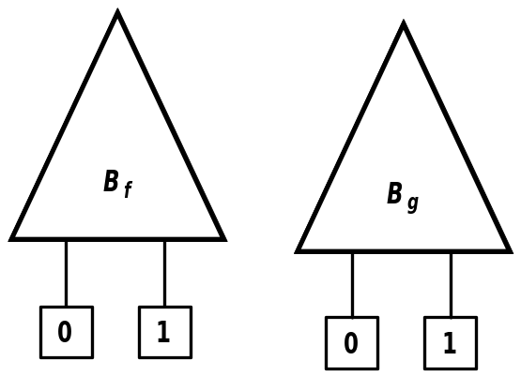

Figure 2. ROBDDs B_{f} and B_{g} of two functions f and g

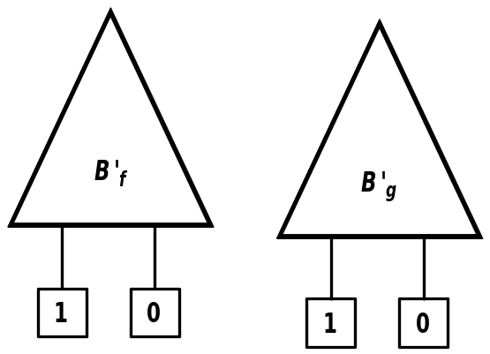

Figure 3. Complement of ROBDDs B_{f} and B_{g}

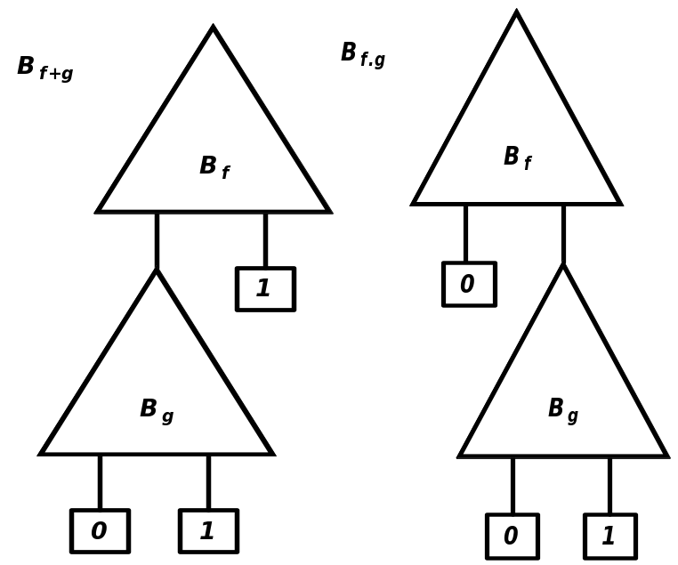

Figure 4. the BDDs for the function (f + g) and (f . g)

Figure 4 shows the BDDs for the function (f + g) and (f . g). The construction procedure is simple. In case of “f + g” if f is 1, then we need not evaluate g and if f is “0” the final result depends only on g. This is reflected in the final BDD for “f + g”. Similarly, in case of “f.g” if f is 0, then we need not evaluate g and if f is “1” the final result depends only on g. This is reflected in the final BDD for “f .g”. The way we are constructing the BDDs for OR and AND operation, it is clear that the resultant BDDs are not ordered or reduced.
So, we need a method where the resultant BDD (after Boolean operations on ROBDDs) is also a ROBDD.

  - Binary Operations on ROBDD to procedue ROBBD

To perform the binary operation on two ROBDD’s B_{f} and B_{g}, corresponding to the functions f and g respectively, we use the algorithm apply(op, B_{f} , B_{g}). The two ROBDDs B_{f} and B_{g} have compatible ordering.

Application of apply(op, B_{f} , B_{g}) will give a OBDD. The ordering of the resultant BDD is same as B_{f} or B_{g} but it may not be the reduced one. After constructing the resultant BDD, we may apply the reduce algorithm to get the ROBDD.

The function apply is based on the Shannon’s expansion for f and g:
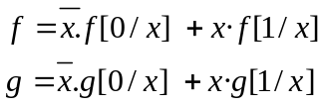
From the Shannon’s expansion of f and g :

This is used as a control structure of apply which proceeds from the roots of B_{f} and B_{g} downwards to construct nodes of the OBDD B_{f} op B_{g}. Let r_{f} be the root node of B_{f} and r_{g} be the root node of B_{g}.

apply(op,B_{f} , B_{g}) Algorithm :
- If both r_{f} and r_{g} are terminal nodes with labels l_{f} and l_{g}, respectively
compute the value l_{f} op l_{g} and the resulting OBDD is B₀ if the value is 0 and B₁ otherwise.

In the remaining cases, at least one of the root nodes is a non-terminal.

- If both nodes are x_{i}-nodes (i.e., non-terminal of same order),
create an x_{i}-node n (called r_{f},r_{g}) with a dashed line to apply (op, lo(r_{f}), lo(r_{g})) and a solid line to apply(op, hi(r_{f}), hi(r_{g})).
- If r_{f} is an x_{i}-node, but r_{g} is a terminal node or an x_{j}-node with j > i,
create an x_{i}-node n (called r_{f} ,r_{g}) with a dashed line to apply(op, lo(r_{f} ), r_{g}) and a solid line to apply(op, hi(r_{f} ), r_{g}).
- The case in which r_{g} is a non-terminal node, but r_{f} is a terminal or an x_{j}-node with
j > i, is handled symmetrically to case 3.

The example given in Figure 5 through Figure 7 illustrates the working of apply Algorithm. Figure 5 illustrates two ROBDDs which are ORed. Figure 6 illustrates the steps of the apply algorithm. Figure 7 illustrates the final OBDD after reduction; the result of apply(+, B_{f} , B_{g}) may not be reduced one.

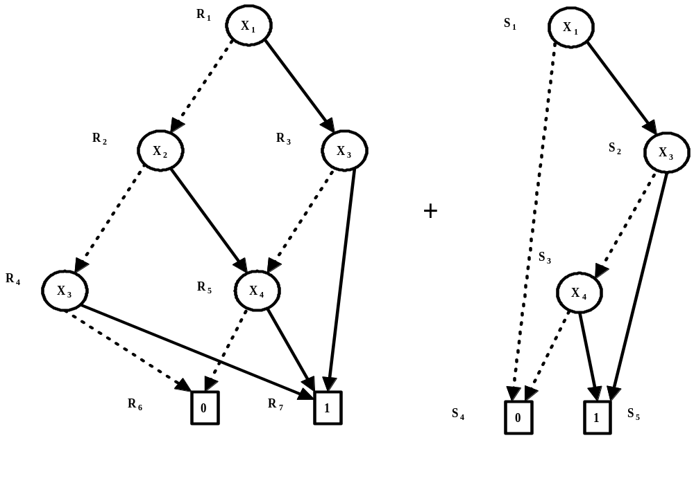
Figure 5. OR of two ROBDD’s with ordering [X₁,X₂,X₃,X₄]

Now we discuss construction of some of the nodes of the final OBDD shown in Figure 6 vis-a-vis steps of the apply algorithm. Construction of other nodes can be explained in a similar fashion.
- x₁ (R₁,S₁): According to Step-2 on R₁ and S₁--create an x_{i}-node n (called r_{f} ,r_{g} =R₁,S₁).
- x₂ (R₂,S₄): According to Step-2 on x₁ (R₁,S₁) -- If both nodes (R₁,S₁ in x₁) are x_{i}-nodes create dashed line from x₁ to apply (op, lo(r_{f}), lo(r_{g})) = apply (op, lo(R₁), lo(S₁)) = apply(OR, R₂,S₄), which is node x_{2.}
- x₄ (R₄,S₄): According to Step-3 on x₂ (R₂,S₄) -- If r_{f} (R₂ in x₂) is an x_{i}-node, but r_{g} (S₄ in x₂) is a terminal node or an x_{j}-node with j > i, create an x_{i}-node n (called r_{f} ,r_{g}=x₂) with a dashed line to apply(op, lo(r_{f} ), r_{g})=(OR,R₄,S₄), which is node x_{4.}
- Terminal node (R₆,S₄): According to Step-3 on x₄ (R₄,S₄)-- If r_{f} (R₄ in x₄) is an x_{i}-node, but r_{g} (S₄ in x₄) is a terminal node or an x_{j}-node with j > i , create an x_{i}-node n (called r_{f} ,r_{g}=x₄) with a dashed line to apply(op, lo(r_{f} ), r_{g})=(OR,R₆,S₄), which is Terminal node (R₆,S₄). The value of R₆,S₄ is 0; apply(OR, R₆=0,S₄=0)=0.

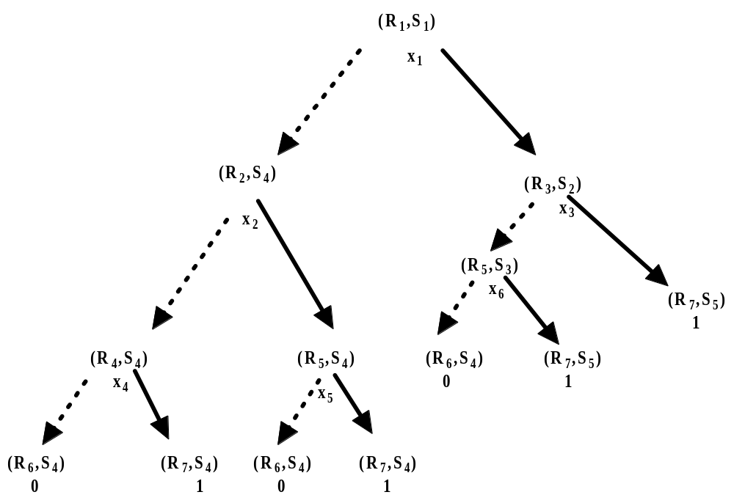
Figure 6. Steps of the apply algorithm for the example of Figure 5

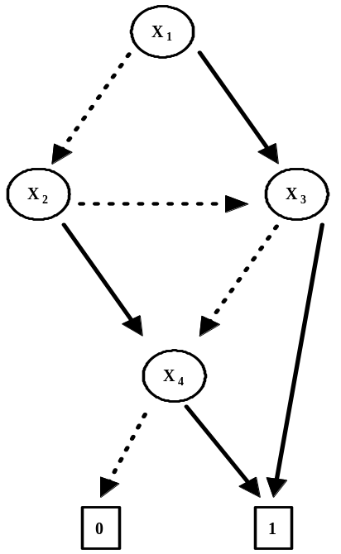
Figure 7. Final OBDD after reduction.

  - Restriction on ROBDD

The Boolean formula obtained by replacing all occurrences of x in f by 0 is denoted by f[0/x]. The formula f[1/x] is defined similarly. The expressions f[0/x] and f[1/x] are called restriction of f. Given an OBDD B_{f} for the function f, to get OBDD for restriction representing f[0/x] or f[1/x], using the same variable ordering as B_{f}, we need the algorithm restrict. Algorithm restrict is discussed below.

restrict (0/1, x, B_{f})
if f[0/x] (i.e., restrict(0, x, B_{f}))
- For each node n corresponding to x, remove n from OBDD and redirect incoming edges to lo(n)
if f[1/x] (i.e., restrict(1, x, B_{f}))
- For each node n corresponding to x, remove n from OBDD and redirect incoming edges to hi(n)
Applying Reduce operation on the OBDD thus obtained to generate the ROBDD for the restrict function.
We will explain restrict algorithm for the Boolean function f = x1.y1 + x2.y3 + x3.y3. After applying restrict(0, x3, B_{f}), f becomes, f[0/x3] = x1.y1 + x2.y3. Figure 8 illustrates the ROBDD for f. Figure 9 illustrates Step1 of restrict on ROBDD of Figure 8. Final ROBDD after restrict(0, x3, B_{f}) is shown in Figure 10.
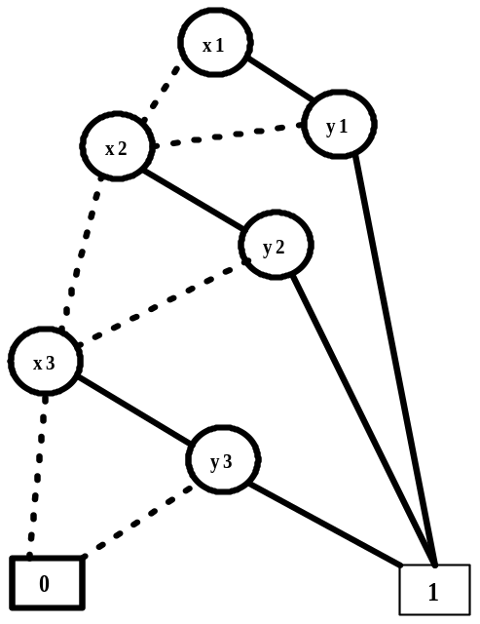
Figure 8. ROBDD for f = x1.y1 + x2.y3 + x3.y3

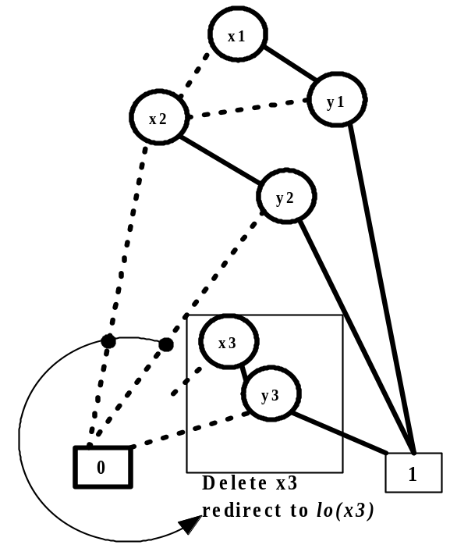
Figure 9. Illustration of Step1 of restrict
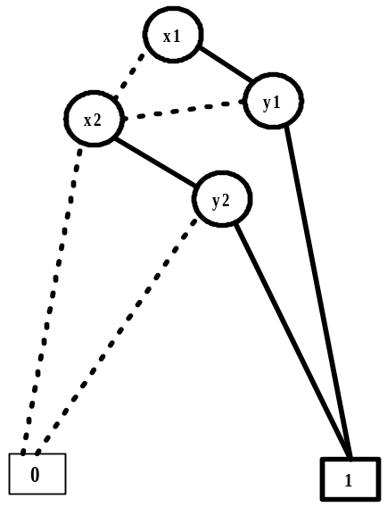
Figure 10. ROBDD after restrict(0, x3, B_{f})

After applying restrict(1, x3, B_{f}), f becomes, f [1/x3] = x1.y1 + x2.y3 + y3. The final ROBDD after restrict(1, x3, B_{f}) is shown in Figure 11.

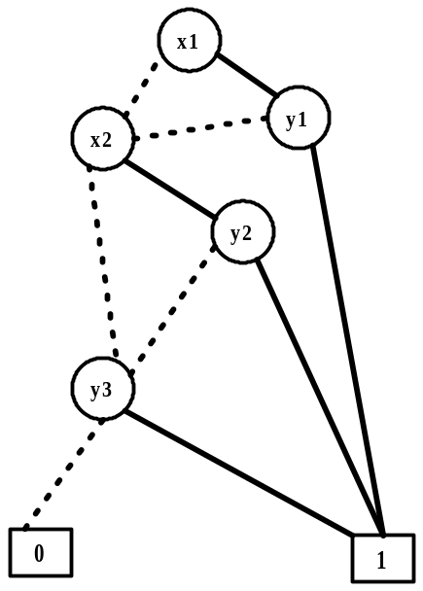
Figure 11. ROBDD after restrict(1, x3, B_{f})

  - Exists on ORBDD

A Boolean function can be thought of as putting a constraint on the values of its argument variables. In other words, a Boolean function determines the possible values of the variables for which it is true. Sometimes we need to express relaxation of the constraint on a subset of variables. If we relax the constraint on some variable x of a Boolean function f, then f could be made true by putting x to 0 or to 1.
We write (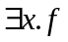) for the Boolean function f with the constraint on x relaxed and it can be expressed as: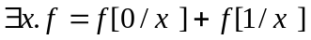, i.e., there exists x on which the constraint is relaxed.
The exists algorithm can be implemented in terms of the algorithms apply and restrict as
.
restrict operation on an OBDD gives an OBDD. Similarly, apply operation also gives an OBDD as output. Thus, we obtain an OBDD as output after applying exists operation. We can get a reduced OBDD after applying Reduce operation on the thus obtained OBDD.
Now we illustrate exists algorithm on the OBDD f shown in Figure 8. Applying + over above two calculated restricts (Figure 10 and Figure 11), gives the OBDD for .
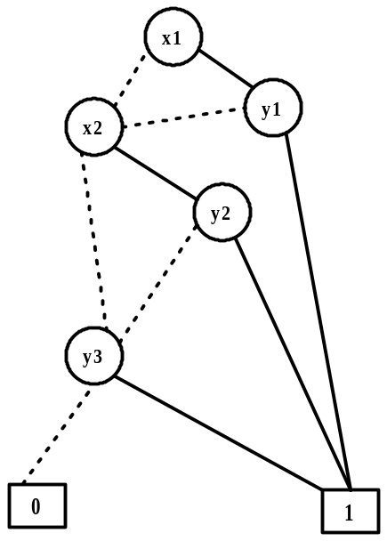
Figure 12. ROBDD after and reduction
Let is consider another function 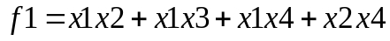; the OBDD for f1 is shown in Figure 13. OBDD for is shown in Figure 14.
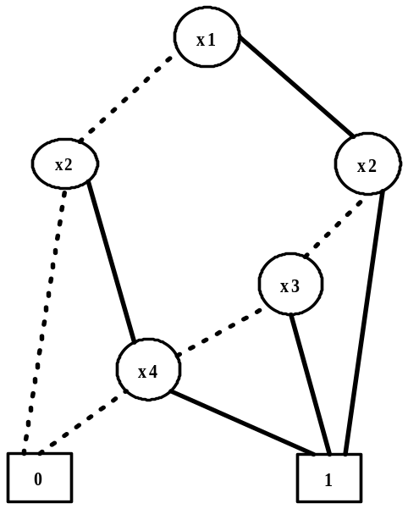
Figure 13. ROBDD for
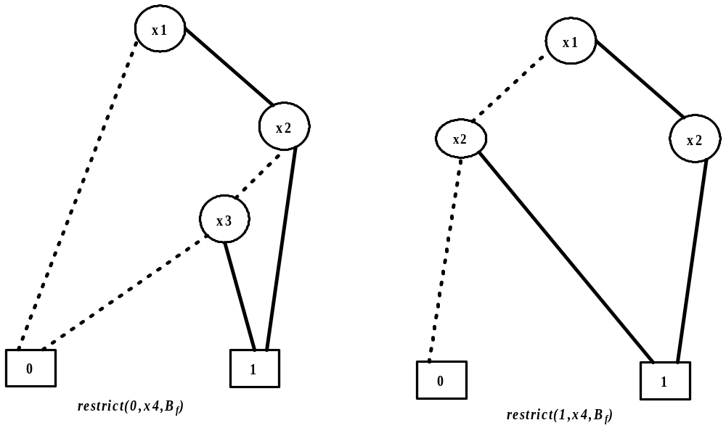
Figure 14. ROBDD for

The OBDD for 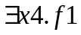 () is shown in Figure 15.
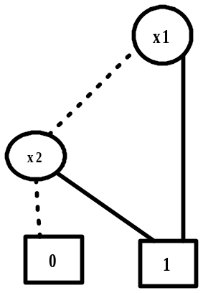

Figure 15. OBDD for

The OBDD for 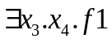 is also the same, because 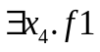 is independent of x3. The exists operation can be easily generalized to a sequence of exists operations 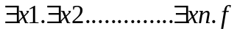.
The Boolean quantifier 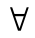is the dual of , 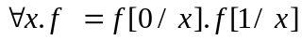 .

- Conclusions
In the lectures covered in this module till now we discussed ROBDDs with respect to Boolean functions. We know that Boolean functions can be directly represented using combinational digital circuits. So ROBDDs can be used for verification of combinational circuits. However most of the practical circuits are sequential ones. In the next lecture we will discuss ROBDDs for sequential circuits.

Question and Answers
Question:
Why resultant BDD after the apply operation may not be ordered or reduced ?
Answer:
The nodes of the resultant BDD in apply are generated by operations on nodes of the operand BDDs which may be of different orders. So ordering is not maintained. Similarly, results of operations may be same which lead to redundant nodes that are to be reduced.

