**21. Write a program to demonstrate Autoboxing of all primitive datatypes**

**Ans.**

public class WrapperExample1

{

public static void main(String[] args) {

int a=20;

char b='a';

boolean d=true;

byte e=10;

short f=20;

long l=40;

float fl=50.0F;

double dl=60;

Integer i=Integer.valueOf(a);

Integer j=a;

System.out.println(a+" "+i+" "+j);

Character c=b;

Boolean g=d;

Byte h=e;

Short k=f;

Long m=l;

Float n=fl;

Double o=dl;

System.out.println(b+" "+c);

System.out.println(d+" "+g);

System.out.println(e+" "+h);

System.out.println(f+" "+k);

System.out.println(l+" "+m);

System.out.println(fl+" "+n);

System.out.println(dl+" "+o);

}

}



**22. Write a program to demonstrate Unboxing of Wrapper type Objects**

**Ans**

public class WrapperExample2

{

public static void main(String[] args) {

Integer i=new Integer(3);

int a=i.intValue();

int b=i;

System.out.println(a+" "+i+" "+b);

Character ch=new Character('a');

char c=ch;

Boolean bl=new Boolean(true);

boolean d=bl;

Long l=new Long(40);

long g=l;

Float fl= new Float(50.0F);

float h=fl;

Double dl=new Double(60);

double j=dl;https://www.onlinegdb.com/online_java_compiler#tab-stdin

System.out.println(ch+" "+c);

System.out.println(d+" "+bl);

System.out.println(l+" "+g);

System.out.println(fl+" "+h);

System.out.println(dl+" "+j);

}

}



**23.*Write a program to demonstrate toString() method.***

**Ans**

class Student{

int rollno;

String name;

String city;

Student(int rollno, String name, String city){

this.rollno=rollno;

this.name=name;

this.city=city;

}

public static void main(String args[]){

Student s1=new Student(101,"priya","lndore");

Student s2=new Student(102,"prachi","Indore");

System.out.println(s1);//compiler writes here s1.toString()

System.out.println(s2);//compiler writes here s2.toString()

}

}



**24.Write a program to print Command line arguments as string.**

**Ans**

public class MyClass

{

public static void main(String[] args) {

for(int i=0;i<args.length;i++)

System.out.println(args[i]);

}

}

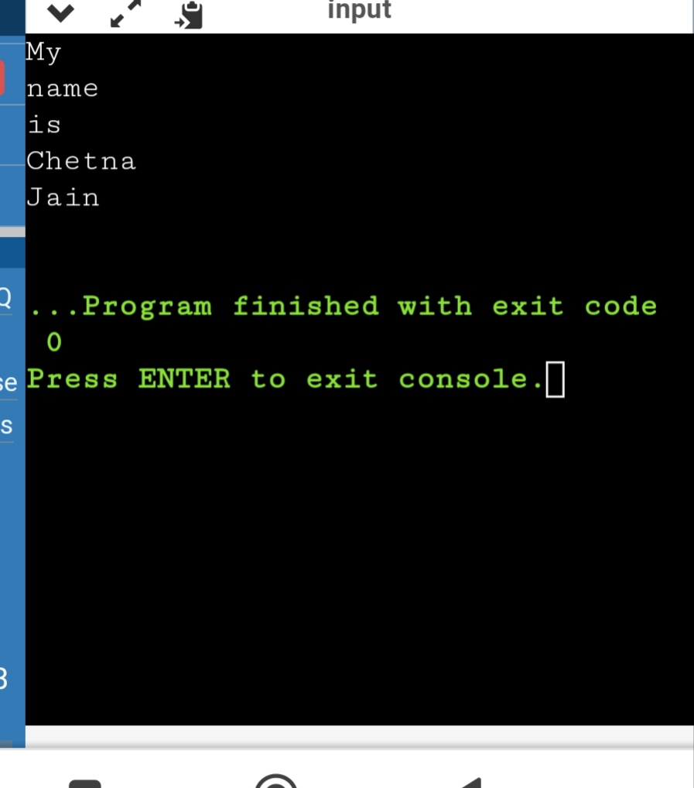

**25.Write a program to print the area and perimeter of a triangle having sides of 3, 4 and 5 units by creating a class named 'Triangle' without any parameter in its constructor.**

**Ans**

class Triangle{

int a,b,c;

public double getArea(){

double s = (a+b+c)/2.0;

return Math.pow((s*(s-a)*(s-b)*(s-c)),.5);

}

public double getPerimeter(){

return (a+b+c);

}

}

class Ans{

public static void main(String[] args){

Triangle t = new Triangle();

t.a = 2;

t.b = 5;

t.c = 6;

System.out.println(t.getArea());

System.out.println(t.getPerimeter());

}

}

**

**26. Write a program to print the area of two rectangles having sides (4,5) and (5,8) respectively by creating a class named 'Rectangle' with a method named 'Area' which returns the area and length and breadth passed as parameters to its constructor.**

**Ans**

class Rectangle{

int length;

int breadth;

public Rectangle(int l, int b){

length = l;

breadth = b;

}

public int getArea(){

return length*breadth;

}

public int getPerimeter(){

return 2*(length+breadth);

}

}

class Ans{

public static void main(String[] args){

Rectangle a = new Rectangle(4,5);

Rectangle b = new Rectangle(5,8);

System.out.println("Area : "+a.getArea()+" Perimeter is" +a.getPerimeter());

System.out.println("Area : "+b.getArea()+" Perimeter is" +b.getPerimeter());

}

}



**27. Print the sum, difference and product of two complex numbers by creating a class named 'Complex' with separate methods for each operation whose real and imaginary parts are entered by user.**

**Ans**

import java.util.*;

class Complex{

int real;

int imag;

public Complex(int r, int i){

real = r;

imag = i;

}

public static Complex add(Complex a, Complex b){

return new Complex((a.real+b.real),(a.imag+b.imag));

}

public static Complex diff(Complex a, Complex b){

return new Complex((a.real-b.real),(a.imag-b.imag));

}

public static Complex product(Complex a, Complex b){

return new Complex(((a.real*b.real)-(a.imag*b.imag)),((a.real*b.imag)+(a.imag*b.real)));

}

public void printComplex(){

if(real == 0 && imag!=0){

System.out.println(imag+"i");

}

else if(imag == 0 && real!=0){

System.out.println(real);

}

else{

System.out.println(real+"+"+imag+"i");

}

}

}

class Ans{

public static void main(String[] args){

Complex c = new Complex(4,5);

Complex d = new Complex(9,4);

Complex e = Complex.add(c,d);

Complex f = Complex.diff(c,d);

Complex g = Complex.product(c,d);

e.printComplex();

f.printComplex();

g.printComplex();

}

}



**28. Program to add two string – create a class named marriage, create a program to add the surname of groom with the bride’s name.**

class Marriage

{

String name;

String surname;

Marriage(String n, String s)

{

name=n;

surname=s;

}

static Marriage add(Marriage ob1, Marriage ob2)

{

return new Marriage(ob1.name, ob1.surname+ob2.surname );

}

}

public class Eg

{

public static void main(String []args)

{

Marriage ob1=new Marriage("Aishwarya", "Rai");

Marriage ob2= new Marriage("Abhishek", " Bacchan");

Marriage ob3=Marriage.add(ob1, ob2);

System.out.println(ob3.name+" "+ob3.surname);

}

}

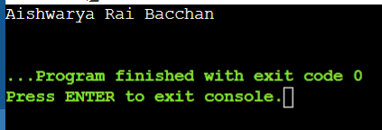

**29. Program to get a strings length.**

public class Main  
{  
public static void main(String[] args) {  
 String greet = "Hello! World";  
 System.out.println("String: " +greet);  
   
 int length = greet.length();  
 System.out.println("Length: " +length);  
}  
}

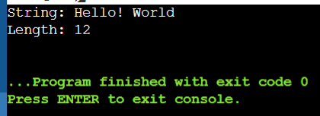

**30. Program to print strings.**

public class Main

{

public static void main(String[]args)

{

String first = "Java";

String second = "Python";

System.out.println(first);

System.out.println(second);

}

}

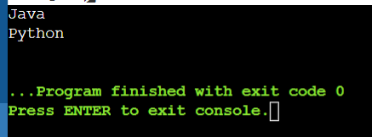

**31. Program to print whether a string is empty or not.**

class Empty

{

public static void main(String []args)

{

String s = "Hello!";

Boolean b = s.isEmpty();

System.out.println(b);

}

}

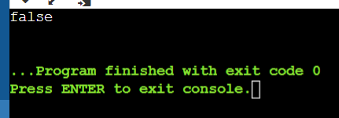

**32. Program to print any character from a string and to convert the whole string into upper case and lowercase.**

class Main

{

public static void main(String[]ars)

{

String s = "Hello";

System.out.println(s.charAt(3));

System.out.println(s.toUpperCase());

System.out.println(s.toLowerCase());

}

}

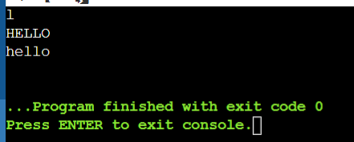

**33. Program to input a string from the user and turn it to upper or lower case according to the user.**

import java.util.Scanner;

public class ChangeCase

{

public static void main(String[] args)

{

System.out.println("Enter String ; ");

Scanner sc = new Scanner(System.in);

String s = sc.nextLine();

System.out.println("Enter choice:\n 0 for lowercase\n 1 for Uppercase");

int i = sc.nextInt();

switch(i)

{

case 0:

System.out.println(s.toLowerCase());

break;

case 1:

System.out.println(s.toUpperCase());

break;

default :

System.out.println("Error!");

}

}

}

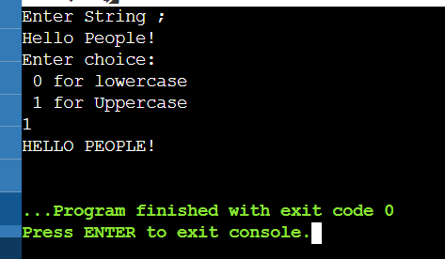

**34. Program to check whether the given strings are equal or not.**

class Comparable

{

public static void main(String[]args)

{

String n1 = "Java Programming";

String n2 = "Java Programming";

String n3 = "Python Programming";

boolean result = n1.equals(n2);

System.out.println("Strings 1 and 2 are equal."+result);

boolean result1 = n2.equals(n3);

System.out.println("Strings 2 and 3 are equal: "+result1);

}

}

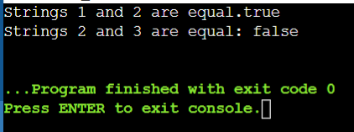

**35. Program to count the number of times ‘e’ occurs in the word ‘umbrella’.**

class Ans{

public static void main(String[]args)

{

String a = "Umbrella";

int count=0;

for(int i=0; i<a.length(); i++)

{

if(a.charAt(i) == 'e');

count++;

break;

}

System.out.println("count: "+count);

}

}

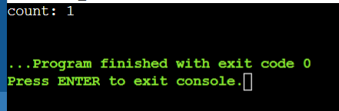

**36. Program to print your gmail account.**

class New{

public static void main(String[]args)

{

String name = "harshitapanwar";

String eroll = "059";

String year = "22";

String url = "@acropolis.in";

String a = name.concat(year);

String b = a.concat(eroll);

String d = b.concat(url);

System.out.println("ID: "+d);

}

}

