**School of Computer Science and Engineering**

**VIT-AP University**

**Artificial Intelligence: CSE 3002**

**Laboratory Assignment**

**Topic: Supervised Learning- Regression**

1. Write a program to derive the regression line which you consider more important from the following series of observations. Also, plot the series of observations along with regression line.

|  |  |  |  |  |  |  |  |
| --- | --- | --- | --- | --- | --- | --- | --- |
| **Output (in thousand)** | 5 |  | 7 | 9 | 11 | 13 | 15 |
| **Profit per unit of Output (in Rs)** | 1.70 |  | 2.40 | 2.80 | 3.40 | 3.70 | 4.40 |

**Input:**

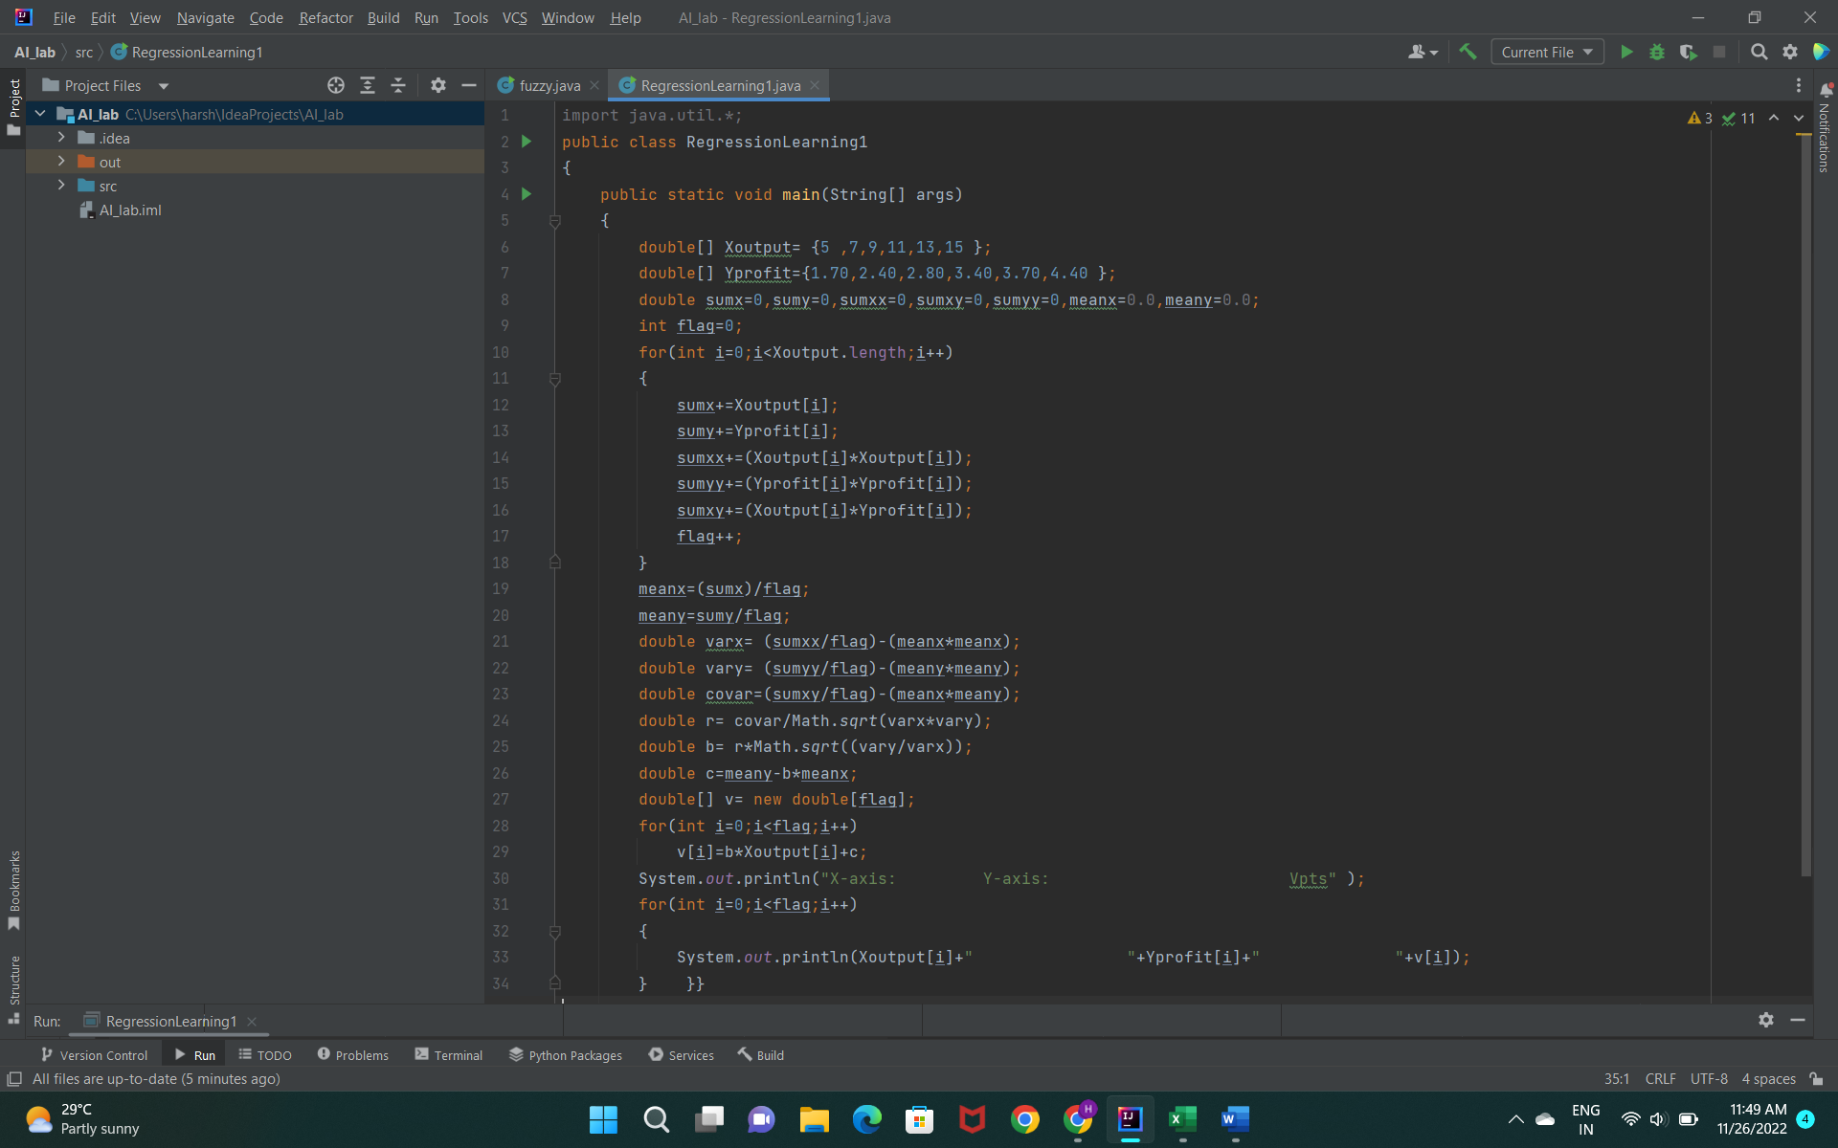

**Output:**

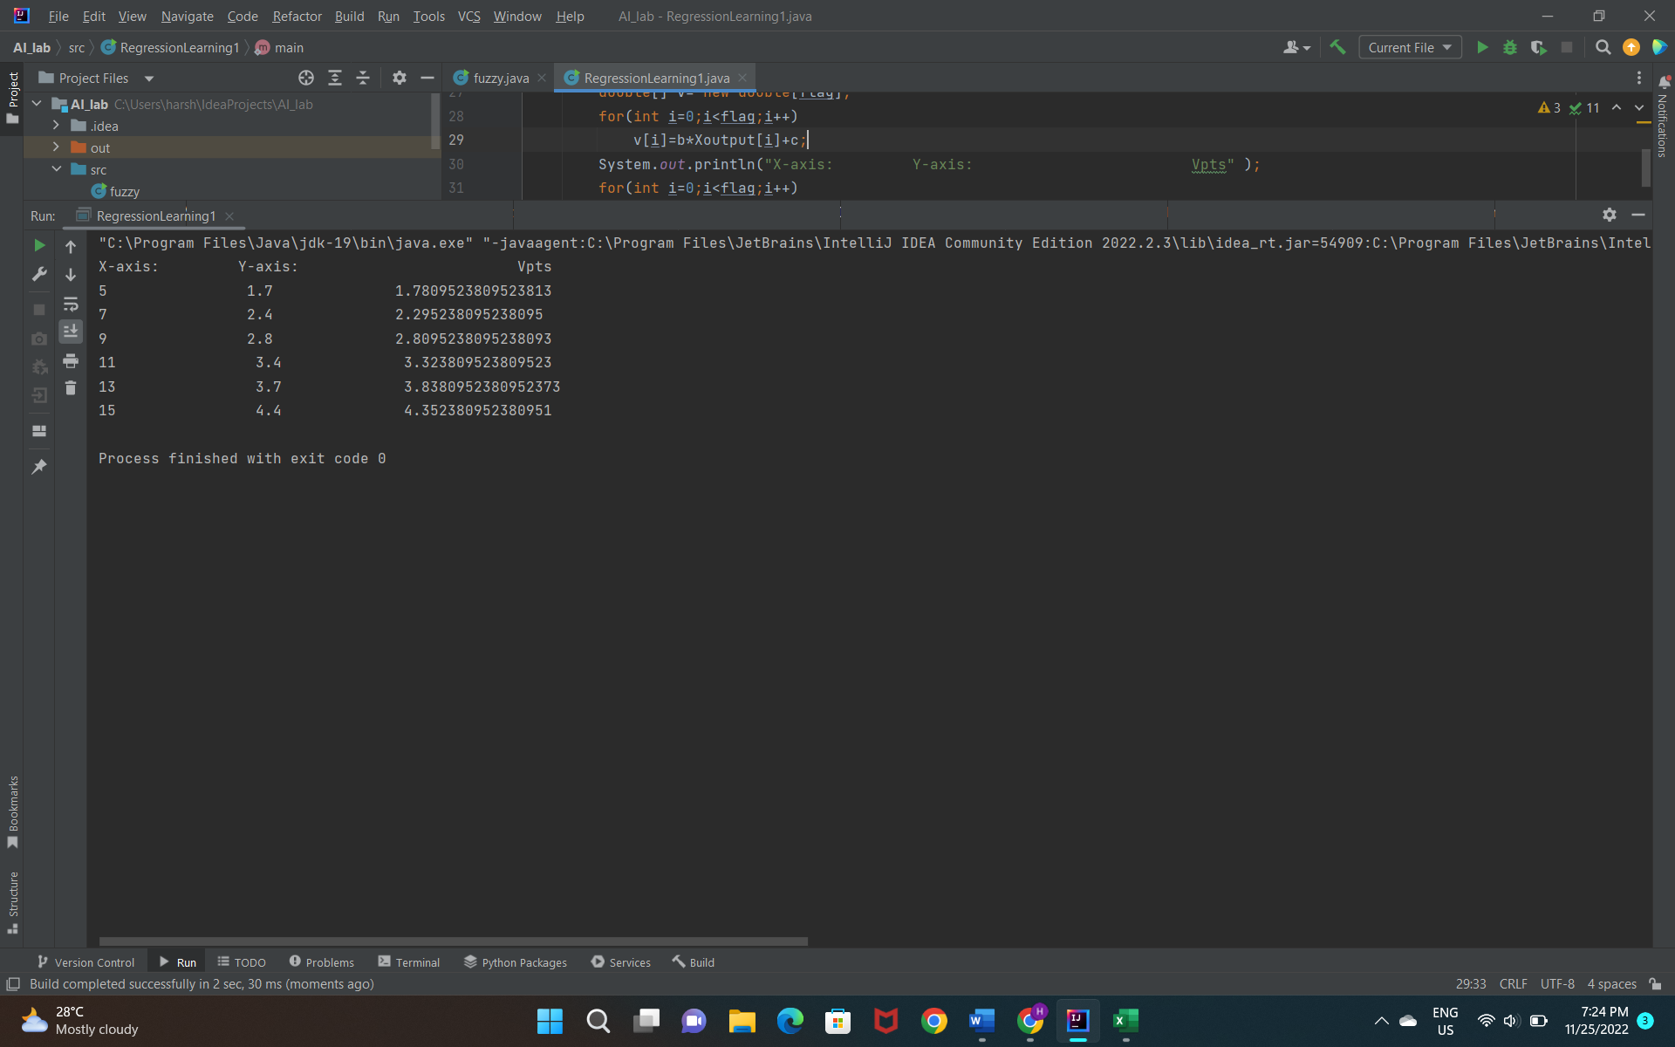

2. Write a program to find the equation of the line of regression of x on y for the following

data. Also, plot the series of observations along with regression line.

|  |  |  |  |  |  |  |  |  |  |
| --- | --- | --- | --- | --- | --- | --- | --- | --- | --- |
| **X** | 1.0 |  | 1.5 |  | 2.0 | 2.5 | 3.0 | 3.5 | 4.0 |
| **y** | 5.3 |  | 5.7 |  | 6.3 | 7.2 | 8.2 | 8.7 | 8.4 |

**Input:**

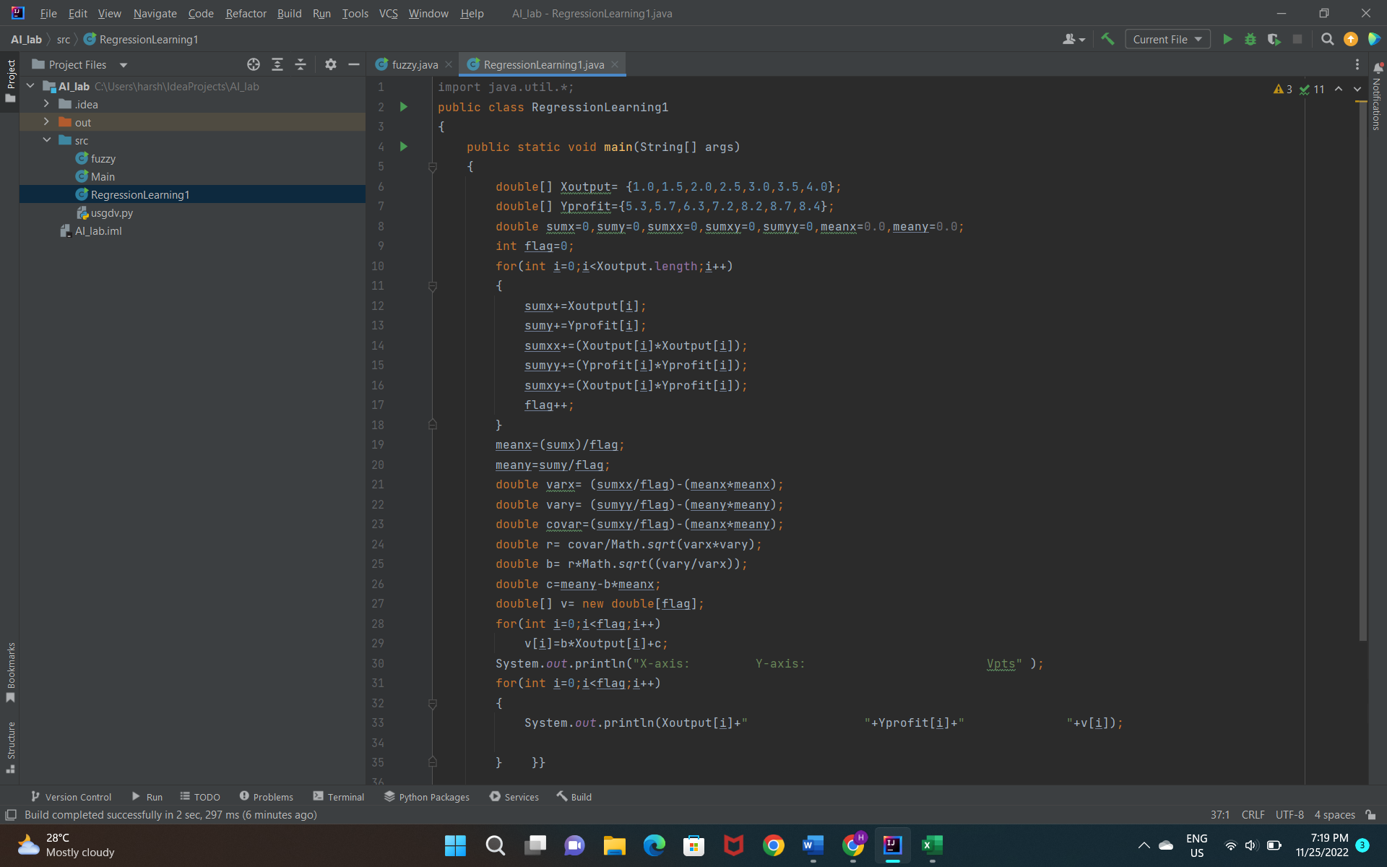

**Output:**

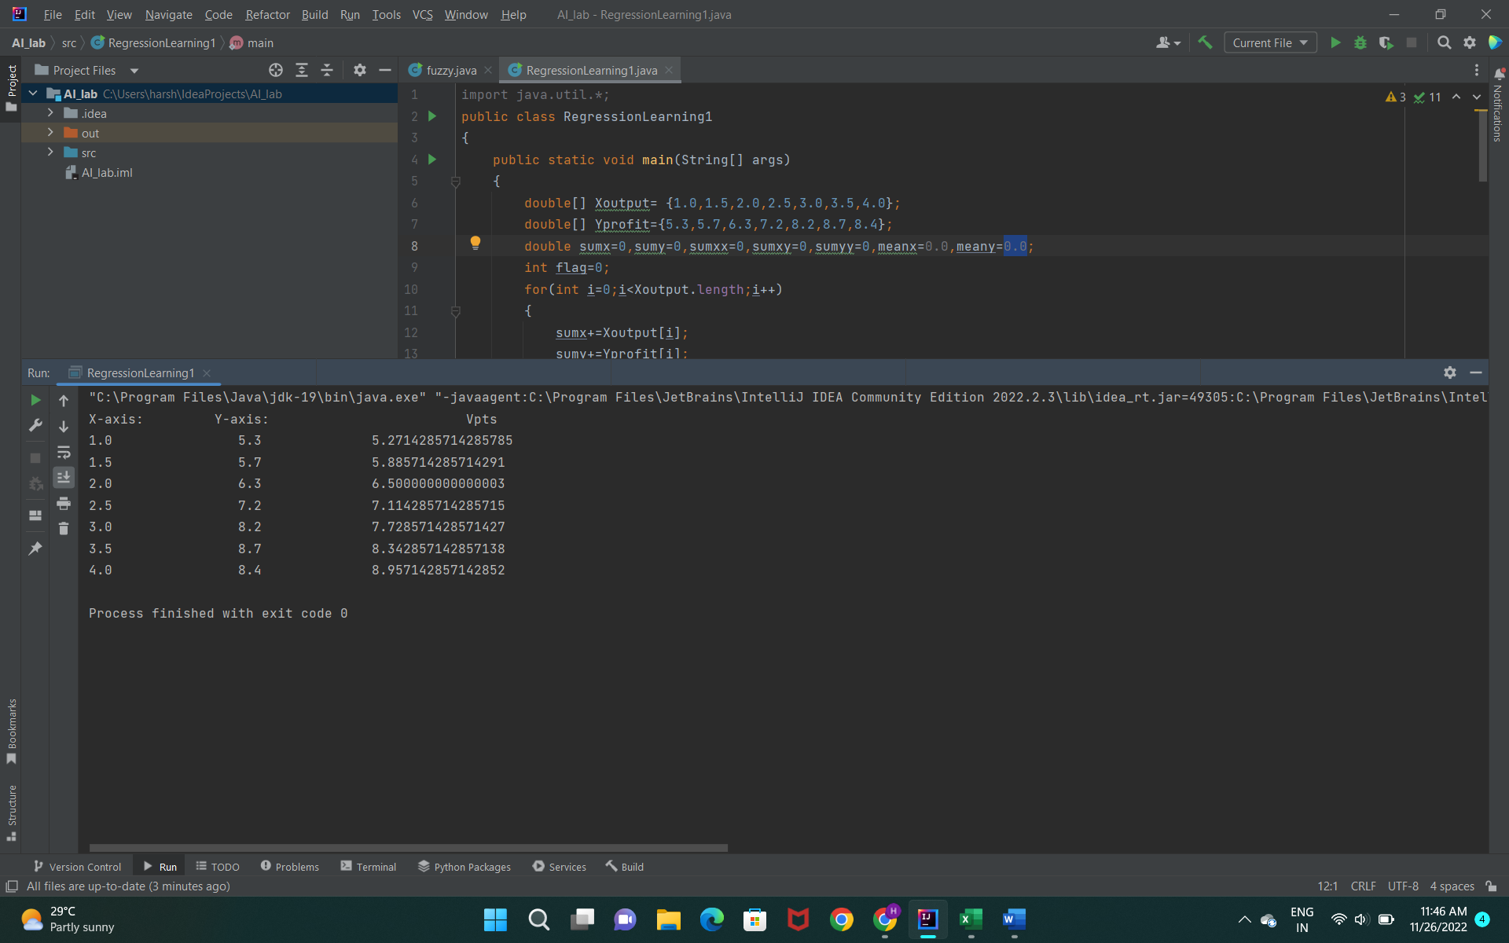

**Name :** Harshita Pasupuleti

**Reg No:** 21BCE8421