Project Summary Document

Title: NetSage AI: AI-Assisted Network Troubleshooting Assistant with Human Review

Submitted by : Harshita Pandey (Sole Developer & Researcher)
Team Members : Harshita Pandey, Manshi Kushwaha, Harshita Jain
College : Gyan Ganga Institute of Technology & Sciences
Technology Track : Applied AI + Networking
Date : August 25, 2026

1. Project Overview
NetSage AI is an intelligent troubleshooting assistant designed to help junior network engineers diagnose and resolve network issues in Cisco-style lab environments. The system combines artificial intelligence with mandatory human oversight to ensure accurate and safe network configurations.

One-Sentence Description:
NetSage AI reads network symptoms and show-command outputs, suggests likely root causes and fixes, but always requires a human expert to review and approve before any changes are applied.

2. Problem Statement
Junior network engineers often struggle to connect symptoms to root causes. When a PC cannot reach a server, the problem could be VLAN misconfiguration, routing issues, DHCP failure, DNS problems, ACL blocks, or NAT errors.
Traditional troubleshooting requires deep experience across multiple networking concepts. Our project addresses this by building an AI assistant that:
- Analyzes symptoms and command outputs
- Identifies the OSI layer affected
- Suggests the root cause with confidence scores
- Recommends next diagnostic commands
- Proposes evidence-backed fixes
- Requires human approval before implementation

3. Solution Architecture: Our solution consists of five integrated components

3.1 Case Dataset (cases.csv)
A comprehensive dataset of 30 real-world network troubleshooting scenarios covering:
- Layer 1: Physical connectivity issues (cable unplugged, interface shutdown)
- Layer 2: VLAN misconfigurations, trunking errors, MAC address issues
- Layer 3: IP addressing, subnetting, routing problems
- Layer 4: ACL blocks, port security
- Layer 7: DHCP failures, DNS resolution issues, wireless authentication
Each case includes:
- Symptom description
- Show-command outputs
- Expected fault
- OSI layer classification
- Concept tag
- Severity level

3.2 AI Prompt Library
Structured prompts that force the AI to output in strict JSON format:
- System Prompt: Defines the AI's role, rules, and provides worked examples
- User Prompt Template: Standardized format for submitting cases
The AI returns:
- {
- "root_cause": "Clear explanation of the problem",
- "confidence_score": 0-100,
- "evidence": "Specific command output proving the diagnosis",
- "next_command": "Recommended diagnostic command",
- "fix_steps": ["Numbered list of commands to resolve"]
- }

3.3 Python Rule Checker
A deterministic Python script that performs instant validation checks before AI diagnosis:
- Detects physical interface shutdowns
- Identifies APIPA addresses (169.254.x.x) indicating DHCP failure
- Flags ACL deny rules
- Catches VLAN mismatches
- Identifies blackhole routes (Null0)
This provides a safety net for obvious errors that don't require AI analysis.

3.4 Human Review System
Every AI diagnosis goes through mandatory human review:
- Accepted: AI diagnosis is 100% correct
- Edited: AI was close but missed details
- Rejected: AI diagnosis is incorrect

3.5 Visual Dashboard
An interactive HTML dashboard displaying:
- Total cases analyzed
- AI acceptance rate
- Issue distribution by OSI layer
- Severity breakdown
- Top fault categories
- Detailed log of human corrections

4. Tools and Technologies Used
Component | Tool/Technology | Purpose
Network Simulation | Cisco Packet Tracer | Building 30 lab scenarios
Dataset Management | Microsoft Excel / CSV | Storing case data
AI Engine | Microsoft Copilot / ChatGPT | Generating diagnoses
Rule Checker | Python 3.x | Deterministic validation
Dashboard | HTML5 + Chart.js | Visual analytics
Documentation | Microsoft Word | Project report
Video Recording | OBS Studio | Demo video

5. How It Works: Step-by-Step Workflow
- Step 1: Symptom Collection
Network engineer observes a problem (e.g., "PC1 cannot ping gateway") and captures show-command outputs.
- Step 2: Rule Checker Validation
Python script runs instant checks for obvious errors (interface down, APIPA address, etc.).
- Step 3: AI Diagnosis
If no obvious errors are found, the case is sent to AI with a structured prompt. AI analyzes evidence and returns JSON diagnosis.
- Step 4: Human Review
Senior engineer reviews AI's root cause, confidence score, and evidence. Decision: Accept, Edit, or Reject.
- Step 5: Implementation
If accepted, the engineer applies the fix steps. If rejected, the engineer provides the correct diagnosis for learning.
- Step 6: Verification
Engineer tests the fix (ping, traceroute, etc.) to confirm resolution.

6. Project Deliverables
Deliverables | File | Contents
Dataset File | cases.csv | 30 network troubleshooting cases with complete metadata
Prompt Files | system_prompt.md, user_prompt_template.md | Structured prompts for AI interaction
Python Rule Checker | rule_checker.py | Deterministic validation script with sample output
Human Review Log | review_log.csv, Responsible_AI_Log.docx | Tracking of all 30 cases + detailed analysis of 5 AI corrections
Visual Dashboard | dashboard.html | Interactive analytics dashboard with charts and correction log
Demo Video | Demo_Video.mp4 | 5-10 minute walkthrough showing broken case → AI diagnosis → human review → fix → verification

7. Results and Performance

7.1 AI Performance Metrics
- Total Cases Analyzed : 30
- AI Accepted : 25 cases (83.3%)
- AI Edited : 1 case (3.3%)
- AI Rejected : 4 cases (13.3%)
- Overall Agreement Rate : 83%

7.2 Issue Distribution by OSI Layer
- Layer 1 (Physical) : 5 cases
- Layer 2 (Data Link) : 7 cases
- Layer 3 (Network) : 10 cases
- Layer 4 (Transport) : 2 cases
- Layer 7 (Application) : 6 cases

7.3 Top Fault Categories
- Interface Status : (5 cases)
- VLAN/Trunking : (5 cases)
- IP Addressing : (4 cases)
- Routing : (4 cases)
- DHCP : (3 cases)

8. Responsible AI: Human Corrections Log
Our project demonstrates the critical importance of human oversight. Here are 5 cases where the AI failed and required human correction:

Case 08: Trunking vs VLAN Mismatch
- AI Diagnosis: VLAN mismatch on switch port (70% confidence)
- Human Correction: Trunk link incorrectly configured as access port
- Why AI Failed: Ignored empty show interfaces trunk output

Case 12: Encapsulation Mismatch
- AI Diagnosis: VLAN 10 deleted from database (80% confidence)
- Human Correction: Router encapsulating wrong VLAN ID (99 instead of 10)
- Why AI Failed: Confused Layer 2 switch issue with Layer 2/3 router issue

Case 17: Blackhole Route
- AI Diagnosis: Static route missing (60% confidence)
- Human Correction: Traffic routed to Null0 (blackhole)
- Why AI Failed: Didn't understand Null0 is a virtual drop interface

Case 22: DHCP Exhaustion
- AI Diagnosis: DHCP service turned off (50% confidence)
- Human Correction: Excluded-address range covers entire subnet
- Why AI Failed: Defaulted to common answer without reading config details

Case 26: ACL Block vs Physical Down
- AI Diagnosis: Interface physically down (40% confidence)
- Human Correction: ACL explicitly blocking ICMP
- Why AI Failed: Guessed Layer 1 while Layer 4 evidence was present
Conclusion: These corrections prove that while AI excels at pattern matching, it lacks contextual reasoning. Human review is essential for network safety.

9. Dashboard Screenshots

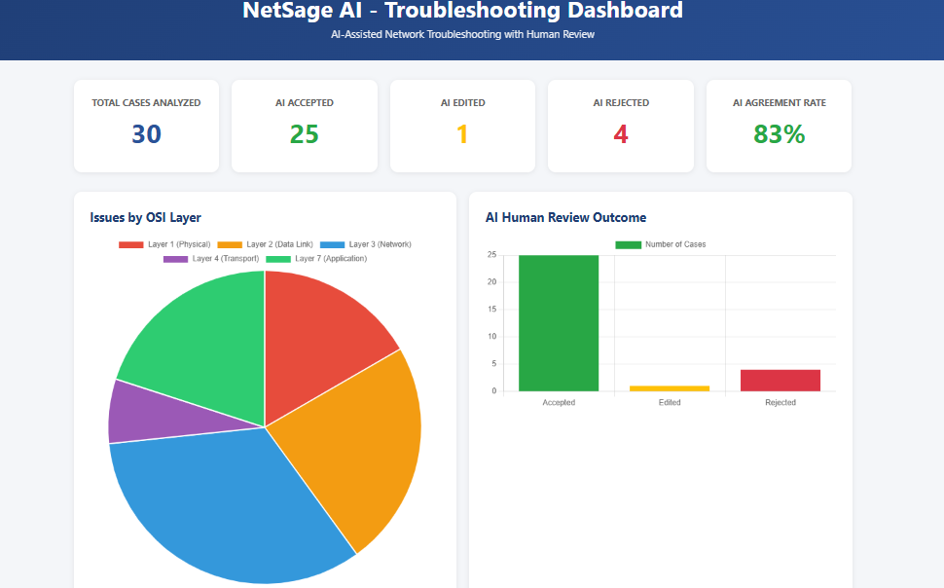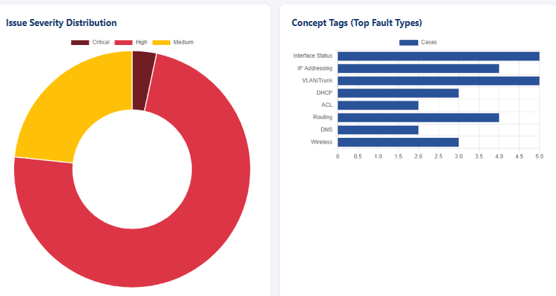
Figure 1: NetSage AI Dashboard showing issue distribution, AI performance metrics, and human corrections log.

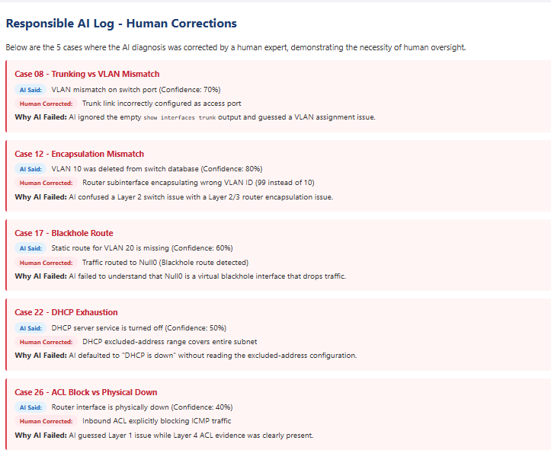

10. Challenges Faced
Challenge | Problem | Solution
AI Hallucination | AI sometimes invented details not present in the evidence | Implemented strict JSON formatting and required evidence citations
Context Confusion | AI confused similar-sounding issues (VLAN mismatch vs trunking) | Added worked examples in system prompt to clarify distinctions
Evidence Interpretation | AI missed subtle clues in command outputs | Mandatory human review catches these edge cases
Dataset Creation | Building 30 realistic scenarios required deep networking knowledge | Used Cisco Packet Tracer to create and test each scenario manually

11. Learnings and Insights

Technical Learnings
- Prompt Engineering: Learned how to structure prompts for consistent JSON output
- Network Troubleshooting: Gained deep understanding of OSI layer interactions
- Python Automation: Built deterministic rule checkers for instant validation
- Data Visualization: Created interactive dashboards using HTML and Chart.js

AI Safety Learnings
- AI is not infallible: Even with 83% accuracy, human review caught critical errors
- Context matters: AI struggles with nuanced distinctions between similar issues
- Evidence is key: Requiring AI to cite evidence prevents hallucination
- Human-in-the-loop is essential: No AI should auto-apply network changes

Team Collaboration
- Role Division: Clear separation of networking, AI, and UI responsibilities
- Iterative Testing: Continuous feedback loop between AI output and human review
- Documentation: Maintaining detailed logs of AI failures for learning

12. Future Enhancements

Phase 2: Enhanced AI Capabilities
- Integrate with real network devices via APIs
- Add machine learning to improve accuracy over time
- Implement multi-turn dialogue for complex troubleshooting

Phase 3: Advanced Analytics
- Predictive maintenance based on historical fault patterns
- Automated root cause analysis across multiple devices
- Integration with network monitoring tools (SolarWinds, PRTG)

Phase 4: Enterprise Features
- Multi-user collaboration with role-based access
- Compliance checking against security policies
- Automated remediation with approval workflows

13. Conclusion
NetSage AI successfully demonstrates that artificial intelligence can significantly assist network troubleshooting, but human oversight remains critical. Our system achieved an 83% agreement rate with human experts, but the 17% of cases requiring correction highlight the dangers of fully autonomous network management. The mandatory human review step ensures that no incorrect configuration is applied to production networks, making this approach both innovative and safe. As AI continues to evolve, the combination of machine intelligence with human judgment will be the gold standard for network operations.

14. References
- Cisco Networking Academy. (2024). CCNA Certification Study Guide.
- OpenAI. (2024). GPT-4 Technical Report.
- Python Software Foundation. (2024). Python 3.12 Documentation.
- Chart.js. (2024). Simple JavaScript Charting Library.

15. Appendix

Appendix A: Sample Case from Dataset
- Case_ID: Case_01
- Symptom: PC1 cannot ping gateway (192.168.10.1).
- Shows "Destination host unreachable" Show Output: PC1> ipconfig ... IP: 192.168.1.11, Mask: 255.255.255.0, Gateway: 192.168.10.1
- Expected Fault: PC1 has incorrect IP address not matching 192.168.10.0 subnet
- OSI Layer: Layer 3 (Network)
- Concept: IP Addressing
- Severity: High

Appendix B: Python Rule Checker Sample Output
==================================================
NetSage AI - Rule Checker Started
==================================================

[Case_06] Symptom: PC1 has no link light...
-> ALERT: Physical interface is down or disconnected (Layer 1 issue).

[Case_21] Symptom: PC1 gets 169.254.x.x address...
-> ALERT: Device has APIPA address. DHCP has failed.

==================================================
Rule Check Complete!
==================================================

