**Author:** Harshita Singh

**SECTION 1: Woodstock Temperature**

**Question 1.1**

|  |  |
| --- | --- |
|  | Temp |
| [1,] | -10.4898 |
| [2,] | -11.4422 |
| [3,] | -5.33372 |
| [4,] | 4.689901 |
| [5,] | 5.527647 |
| [6,] | 10.81049 |

**Question 2.1**

|  |  |
| --- | --- |
| Temp |  |
| Min. | -12.034 |
| 1st Qu.: | -2.585 |
| Median: | 6.022 |
| Mean: | 5.667 |
| 3rd Qu.: | 14.055 |
| Max.: | 21.494 |

**Question 2.2**

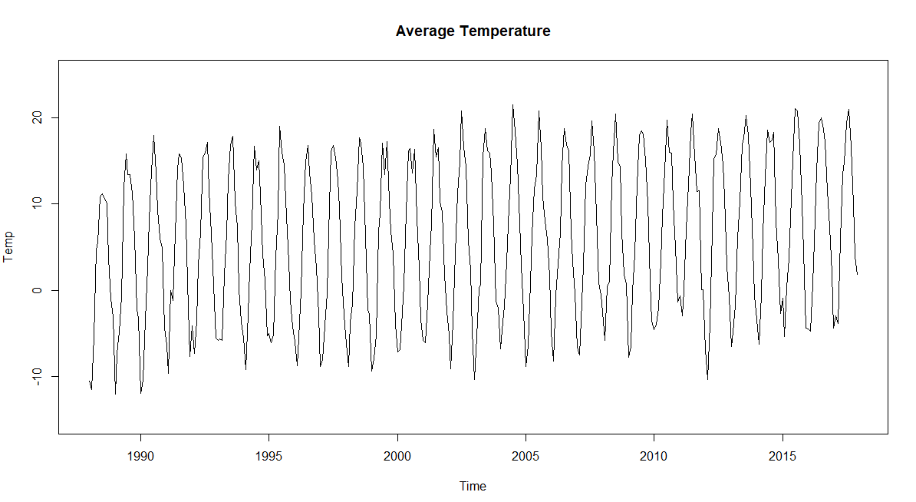

**Question 2.3**

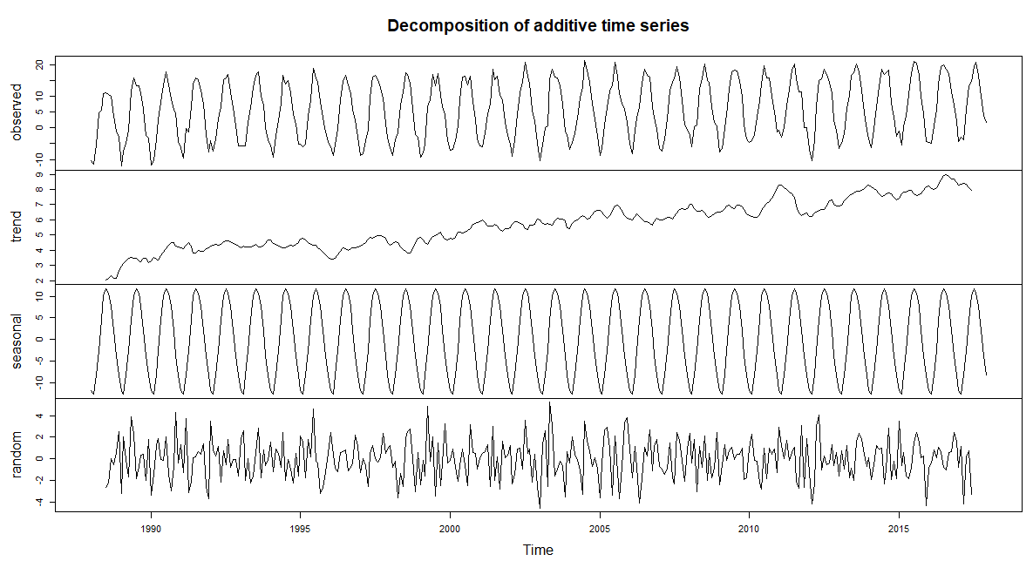**Conclusion:**

In trend, it is stationary series because it is going up with the time, which is one of the variable defined. In random, the pattern is non-stationary and cyclic because of the existence of a unit root or one-dimensional trend.

**Question 2.4**

**Output:** Augmented Dickey-Fuller Test

data: WoodStockTransform_HS

Dickey-Fuller = -16.18, Lag order = 7, p-value = 0.01; alternative hypothesis: stationary

**Conclusion:** p-value smaller than 0.05 of p-value (WoodStockTransform_HS), we can say it is likely stationary and reject the null hypothesis (non stationary)

**Question 2.5**

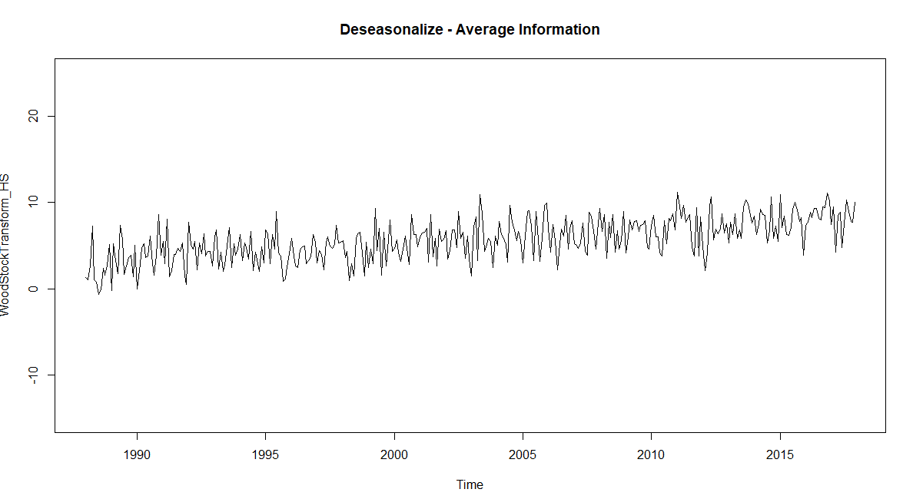

**Question 2.6**

**Comments:** The temperature remains stationary and in positive during seasonal season from the above graph.

**SECTION 2: Ayr Prescription**

**Question 1.1**

Time Series: Start = 1968; End = 2003; Frequency = 1

|  |  |
| --- | --- |
|  | Temp |
| [1,] | 10.96837 |
| [2,] | 12.35665 |
| [3,] | 12.0703 |
| [4,] | 11.63614 |
| [5,] | 12.41496 |
| [6,] | 12.35421 |

**Question 2.1**

|  |  |
| --- | --- |
| Temp |  |
| Min. | :10.97 |
| 1st Qu. | :12.07 |
| Median | :12.62 |
| Mean | :12.50 |
| 3rd Qu. | :12.92 |
| Max. | :13.44 |

**Question 2.2**

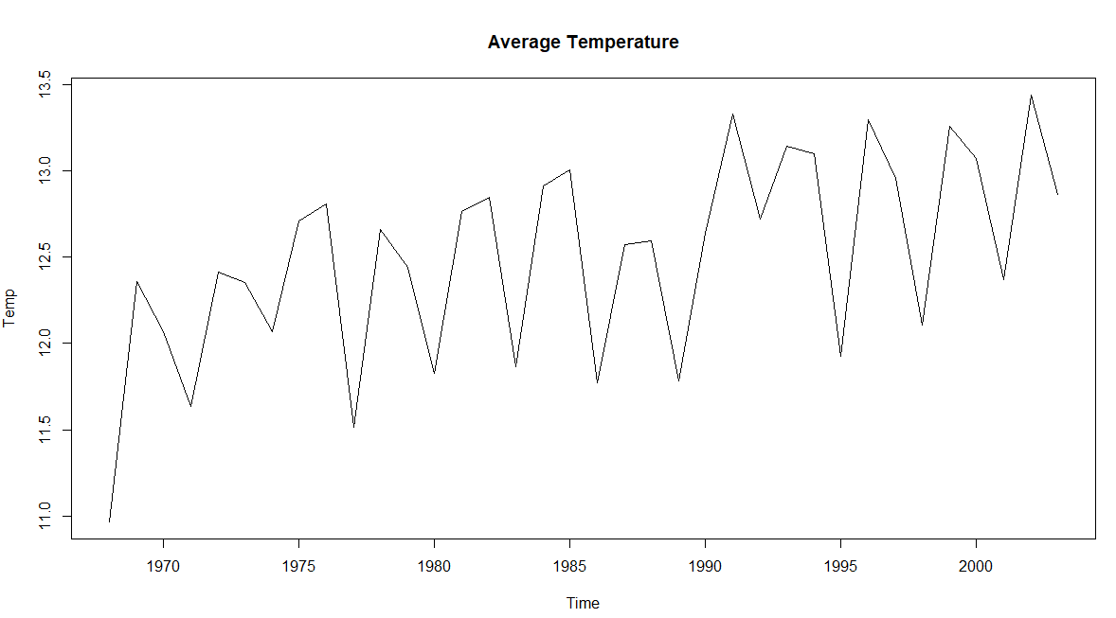

**Question 2.3**

**N=3**

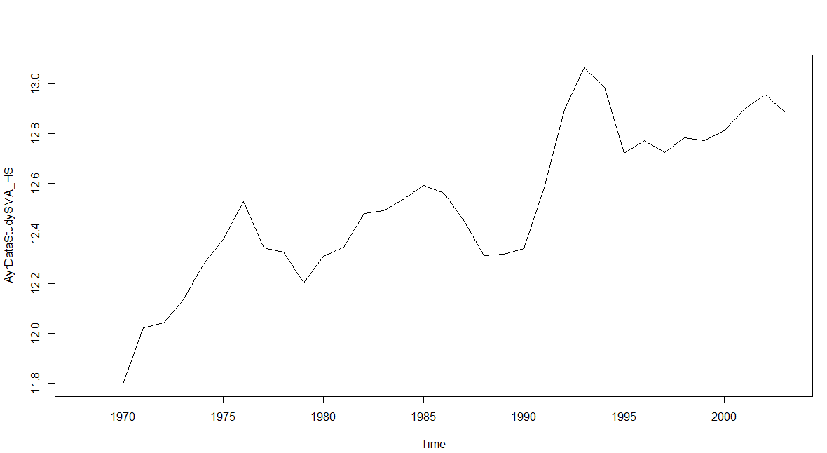

**N=5**

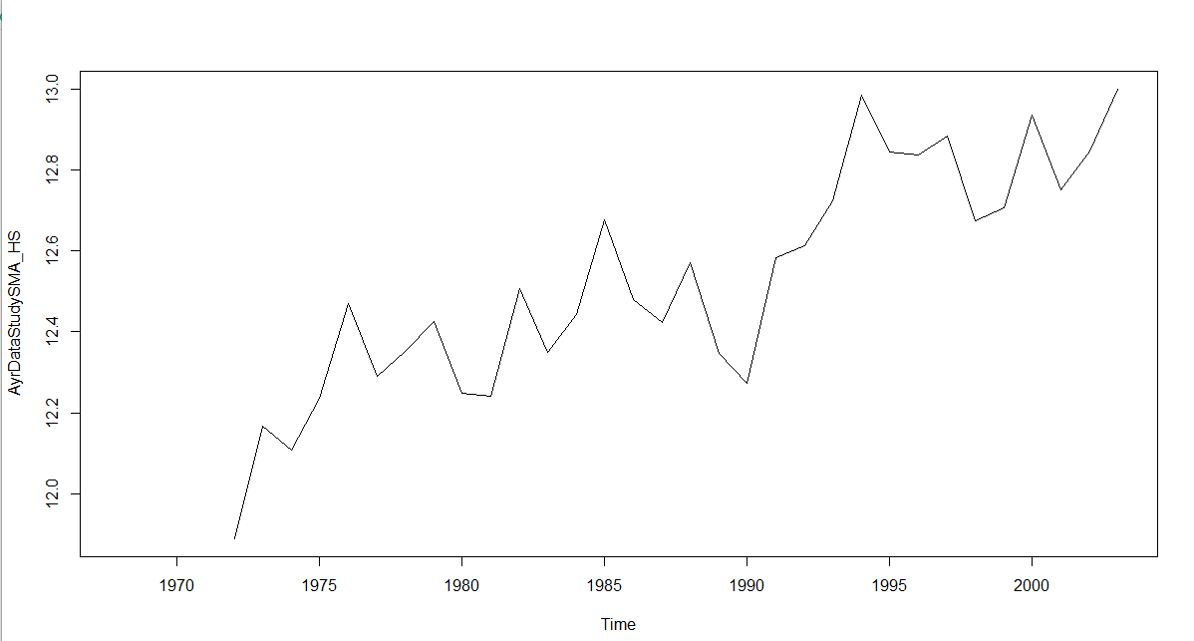

**N=7**

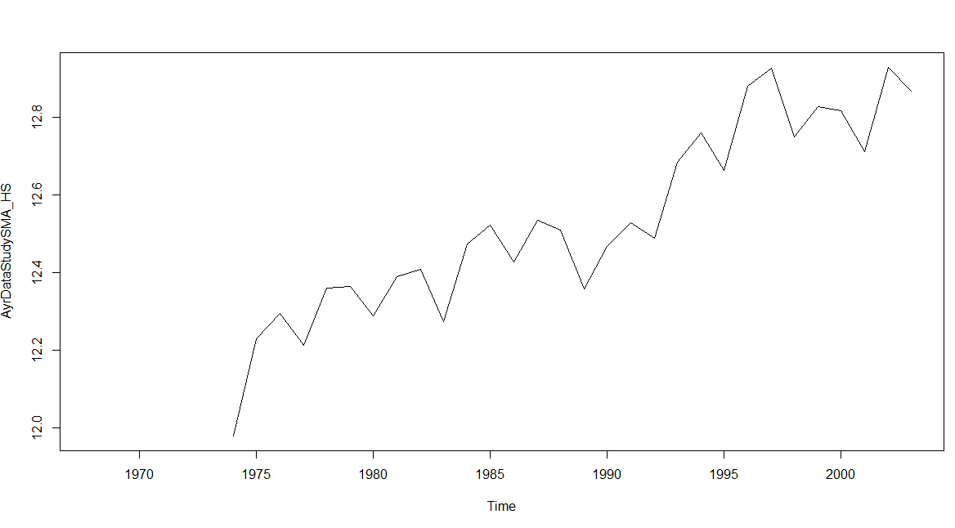

**Comments:**

In situation, where N=7 we are able to spot the trend using simple moving average without loosing the detail information. It is providing details to say that the data is consistent and the temperature is increasing over the year.

**Question 2.4**

**Output:** Augmented Dickey-Fuller Test

data: AyrDataTransform_HS

Dickey-Fuller = -3.6246, Lag order = 3, p-value = 0.0451

alternative hypothesis: stationary

**Conclusion:** p-value smaller than 0.05 of p-value (AyrDataTransform_HS), we can say it is likely stationary and reject the null hypothesis (non stationary)

**Question 2.5**

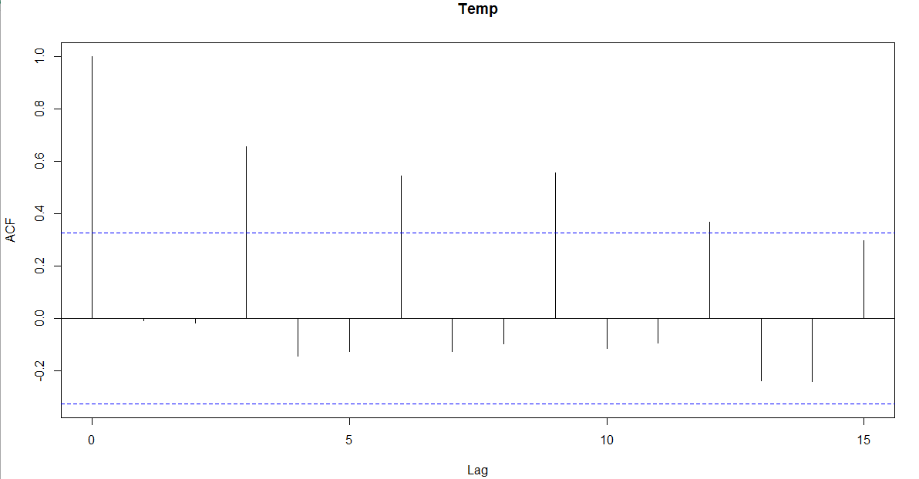

**Conclusion:** Lags are correlated to each other as each line indicates the year. Anything below the bottom and above the top blue line is significant and therefore, we can conclude that most of the lines are between these two lines so, we will consider this as not statically significant. This indicates that the temperature over the years are not highly correlated.

**Question 3.1**

Loss function type: MSE; Loss function value: 0.2737

Error standard deviation: 0.5383

Sample size: 36

Number of estimated parameters: 2

Number of degrees of freedom: 34

Information criteria:

AIC AICc BIC BICc

59.5126 59.8763 62.6797 63.3312

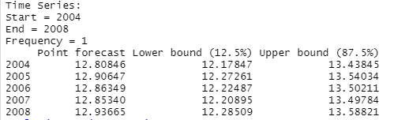

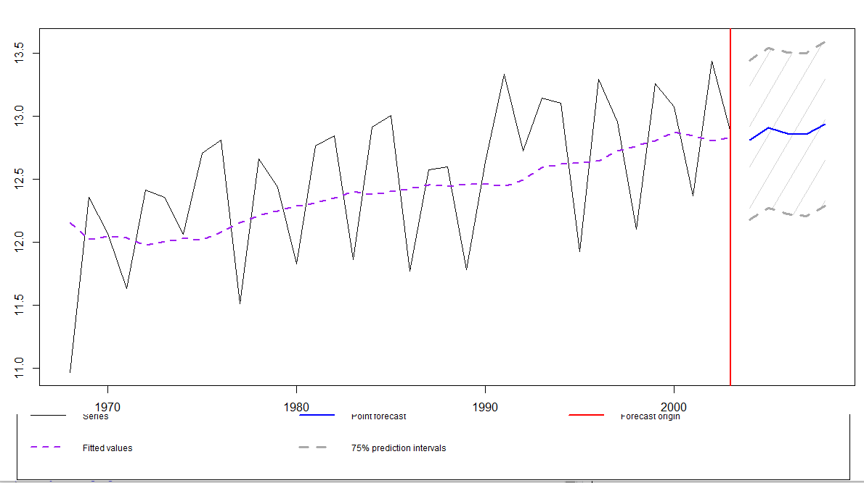

**Conclusion:**

Beyond red line is the forecast, and data average between the gray regions represents average data: 80% window of the forecast; Blue line: best forecast starting 2004 to 2008. Loss function type: MSE: Mean Square Error is great for make certain that our model has no outlier forecast with enormous errors.

**Question 3.2**

Loss function type: likelihood; Loss function value: 25.0713

Error standard deviation: 0.5071

Sample size: 36

Number of estimated parameters: 3

Number of provided parameters: 2

Number of degrees of freedom: 33

Information criteria:

AIC AICc BIC BICc

56.1425 56.8925 60.8931 62.2369

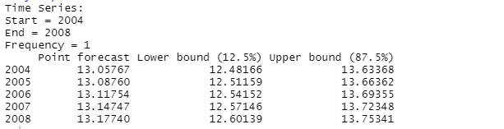

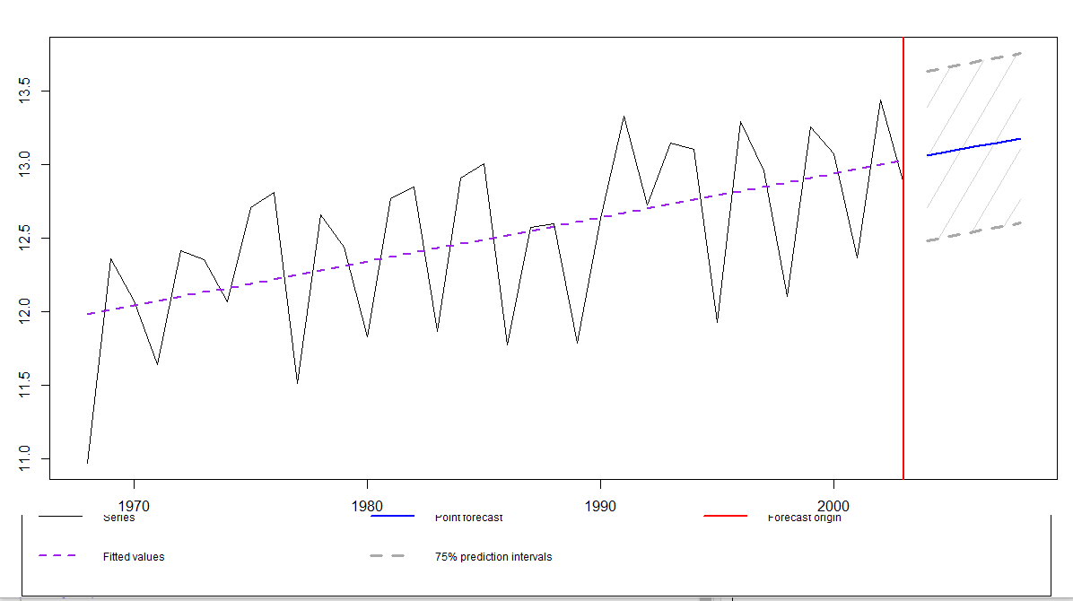

**Conclusion:** Loss function type: likelihood: which means that it calculate on the basis of the forecasted probability for each unit and multiplies them.

**Question 3.3-Comparison for part 1 and 2**

Exponentially moving average is always better to use and reflect the new market data and it is considered to be highly applicable for the fast growing.