WEEK_01

**Exercise 1: Implementing the Singleton Pattern**

**Scenario:**

You need to ensure that a logging utility class in your application has only one instance throughout the application lifecycle to ensure consistent logging.

Test.java :

public class Test {

    public static void main(String[] args) {

        Logger logger1 = Logger.getInstance();

        logger1.log("First log message.");

Logger logger2 = Logger.getInstance();

        logger2.log("Second log message.");

if (logger1 == logger2) {

            System.out.println("logger1 and logger2 are the same instance");

        } else {

            System.out.println("Different instances detected");

        }

    }

}

Logger.java:

public class Logger {

     private static Logger instance;

private Logger() {

System.out.println("Logger initialized");

    }

public static Logger getInstance() {

        if (instance == null) {

            instance = new Logger();

        }

        return instance;

    }

public void log(String message) {

        System.out.println(" " + message);

    }

}

Output:

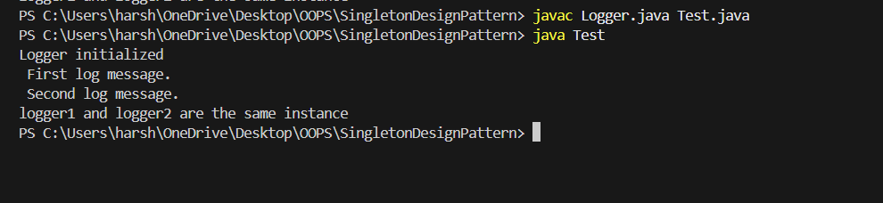

**Exercise 2: Implementing the Factory Method Pattern**

**Scenario:**

You are developing a document management system that needs to create different types of documents (e.g., Word, PDF, Excel). Use the Factory Method Pattern to achieve this.

Expand.java:

import java.util.Scanner;

abstract class Docs {

    public abstract String open();

}

class Words extends Docs {

    public String open() {

        return "Word Document is opened Successfully!";

    }

}

class Pdf extends Docs {

    public String open() {

        return "Pdf Document is opened Successfully!";

    }

}

class Excel extends Docs {

    public String open() {

        return "Excel Document is opened Successfully!";

    }

}

public class Expand {

    public static Docs getoption(char ch) {

        Docs d = null;

        if (ch == 'W')

            d = new Words();

        else if (ch == 'P')

            d = new Pdf();

        else if (ch == 'E')

            d = new Excel();

        return d;

    }

public static void main(String args[]) {

        Scanner sc = new Scanner(System.in);

        System.out.println("Enter document type (W for Word, P for PDF, E for Excel): ");

        char ch = sc.next().toUpperCase().charAt(0);

        Docs d = getoption(ch);

        if (d != null) {

            System.out.println(d.open());

        } else {

            System.out.println("Invalid document type!");

        }

    }

}

Output:

