WEEK: 2

**Exercise 1: Control Structures**

**Scenario 1:** The bank wants to apply a discount to loan interest rates for customers above 60 years old.

Table Creation:

CREATE TABLE CUSTOMERS (

CUSTOMER_ID NUMBER PRIMARY KEY,

AGE NUMBER,

NTEREST_RATE NUMBER(5,2),

BALANCE NUMBER,

STATUS VARCHAR2(20)

);

INSERT INTO CUSTOMERS VALUES (1, 65, 8.50, 500000, 'REGULAR');

INSERT INTO CUSTOMERS VALUES (2, 45, 9.00, 2000000, 'REGULAR');

INSERT INTO CUSTOMERS VALUES (3, 70, 7.75, 300000, 'REGULAR');

INSERT INTO CUSTOMERS VALUES (4, 62, 10.00, 1500000, 'REGULAR');

INSERT INTO CUSTOMERS VALUES (5, 30, 11.00, 100000, 'REGULAR');

COMMIT;

SET SERVEROUTPUT ON;

DECLARE

CURSOR cust_cur IS

SELECT CUSTOMER_ID, AGE, INTEREST_RATE

FROM CUSTOMERS

WHERE AGE > 60;

BEGIN

FOR cust_rec IN cust_cur LOOP

UPDATE CUSTOMERS

SET LOAN_INTEREST_RATE = INTEREST_RATE * 0.99

WHERE CUSTOMER_ID = cust_rec.CUSTOMER_ID;

DBMS_OUTPUT.PUT_LINE('Applied 1% discount for Customer ID: ' || cust_rec.CUSTOMER_ID);

END LOOP;

COMMIT;

END;

/

Output:

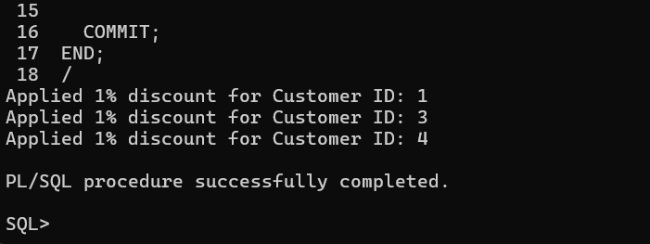

**Scenario 2:** A customer can be promoted to VIP status based on their balance.

**Question:** Write a PL/SQL block that iterates through all customers and sets a flag IsVIP to TRUE for those with a balance over $10,000.

CREATE TABLE CUSTOMERS (

CUSTOMER_ID NUMBER PRIMARY KEY,

NAME VARCHAR2(50),

AGE NUMBER,

BALANCE NUMBER(12,2),

ISVIP CHAR(1) DEFAULT 'N'

)

INSERT INTO CUSTOMERS (CUSTOMER_ID, NAME, AGE, BALANCE) VALUES (1, 'Harshita, 65, 5000);

INSERT INTO CUSTOMERS (CUSTOMER_ID, NAME, AGE, BALANCE) VALUES (2, 'Yagnya', 45, 25000);

INSERT INTO CUSTOMERS (CUSTOMER_ID, NAME, AGE, BALANCE) VALUES (3, 'Uday', 70, 15000);

INSERT INTO CUSTOMERS (CUSTOMER_ID, NAME, AGE, BALANCE) VALUES (4, 'Rahul', 30, 8000);

INSERT INTO CUSTOMERS (CUSTOMER_ID, NAME, AGE, BALANCE) VALUES (5, 'Phani', 55, 12000);

COMMIT;

SET SERVEROUTPUT ON;

DECLARE

CURSOR vip_cur IS

SELECT CUSTOMER_ID, BALANCE

FROM CUSTOMERS;

BEGIN

FOR rec IN vip_cur LOOP

IF rec.BALANCE > 10000 THEN

UPDATE CUSTOMERS

SET ISVIP = 'Y'

WHERE CUSTOMER_ID = rec.CUSTOMER_ID;

DBMS_OUTPUT.PUT_LINE('Promoted Customer ID: ' || rec.CUSTOMER_ID || ' to VIP');

END IF;

END LOOP;

COMMIT;

END;

/

SELECT CUSTOMER_ID, NAME, BALANCE, ISVIP FROM CUSTOMERS;

Output:

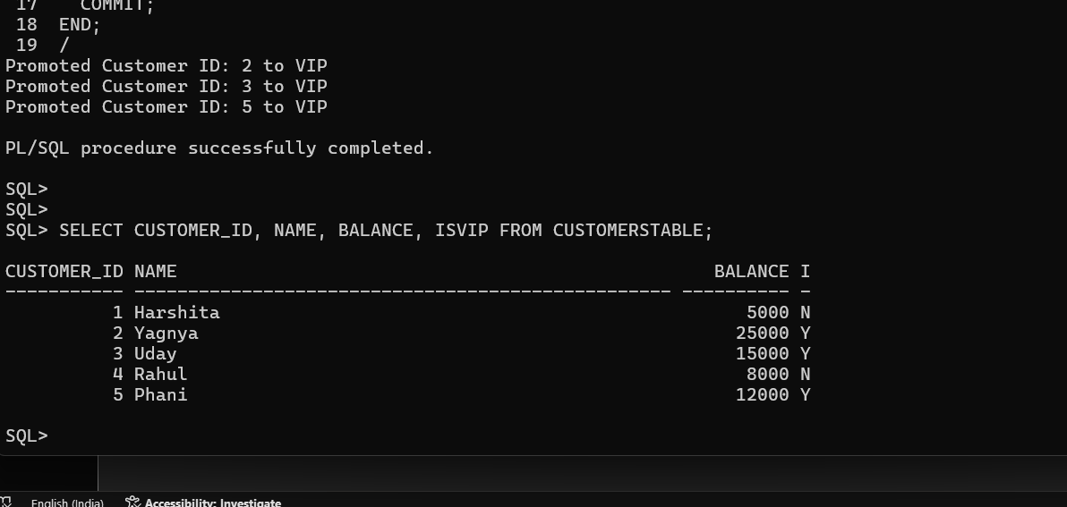

**Scenario 3:** The bank wants to send reminders to customers whose loans are due within the next 30 days.

**Question:** Write a PL/SQL block that fetches all loans due in the next 30 days and prints a reminder message for each customer.

CREATE TABLE LOANS (

LOAN_ID NUMBER PRIMARY KEY,

CUSTOMER_ID NUMBER,

DUE_DATE DATE

);

INSERT INTO LOANS (LOAN_ID, CUSTOMER_ID, DUE_DATE) VALUES (1, 101, SYSDATE + 10);

INSERT INTO LOANS (LOAN_ID, CUSTOMER_ID, DUE_DATE) VALUES (2, 102, SYSDATE + 25);

INSERT INTO LOANS (LOAN_ID, CUSTOMER_ID, DUE_DATE) VALUES (3, 103, SYSDATE + 40);

INSERT INTO LOANS (LOAN_ID, CUSTOMER_ID, DUE_DATE) VALUES (4, 104, SYSDATE - 5);

INSERT INTO LOANS (LOAN_ID, CUSTOMER_ID, DUE_DATE) VALUES (5, 105, SYSDATE + 30);

COMMIT;

SET SERVEROUTPUT ON;

DECLARE

CURSOR due_loans_cur IS

SELECT loan_id, customer_id, due_date

FROM loans

WHERE due_date BETWEEN SYSDATE AND SYSDATE + 30;

v_loan_id LOANS.LOAN_ID%TYPE;

v_customer_id LOANS.CUSTOMER_ID%TYPE;

v_due_date LOANS.DUE_DATE%TYPE;

BEGIN

OPEN due_loans_cur;

LOOP

FETCH due_loans_cur INTO v_loan_id, v_customer_id, v_due_date;

EXIT WHEN due_loans_cur%NOTFOUND;

DBMS_OUTPUT.PUT_LINE(

'Reminder: Customer ' || v_customer_id ||

', your loan ' || v_loan_id ||

' is due on ' || TO_CHAR(v_due_date, 'DD-MON-YYYY')

);

END LOOP;

CLOSE due_loans_cur;

END;

/

DROP TABLE LOANS;

Output:

