WEEK : 2

**Exercise 3: Stored Procedures**

**Scenario 1:** The bank needs to process monthly interest for all savings accounts.

* + **Question:** Write a stored procedure **ProcessMonthlyInterest** that calculates and updates the balance of all savings accounts by applying an interest rate of 1% to the current balance.

CREATE TABLE savings_accounts (

account_id NUMBER PRIMARY KEY,

balance NUMBER

);

INSERT INTO savings_accounts VALUES (1, 1000);

INSERT INTO savings_accounts VALUES (2, 2000);

INSERT INTO savings_accounts VALUES (3, 500);

COMMIT;

CREATE OR REPLACE PROCEDURE process_monthly_interest IS

BEGIN

UPDATE savings_accounts

SET balance = balance * 1.01;

END;

/

BEGIN

process_monthly_interest;

END;

/

SELECT account_id, balance

FROM savings_accounts;

Output:

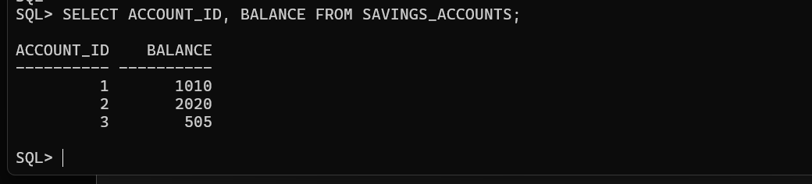

**Scenario 2:** The bank wants to implement a bonus scheme for employees based on their performance.

**Question:** Write a stored procedure **UpdateEmployeeBonus** that updates the salary of employees in a given department by adding a bonus percentage passed as a parameter.

CREATE TABLE employees (

emp_id NUMBER PRIMARY KEY,

dept_id NUMBER,

salary NUMBER

);

INSERT INTO employees VALUES (1, 10, 50000);

INSERT INTO employees VALUES (2, 10, 60000);

INSERT INTO employees VALUES (3, 20, 55000);

COMMIT;

CREATE OR REPLACE PROCEDURE update_employee_bonus (

p_dept_id NUMBER,

p_bonus_pct NUMBER

) IS

BEGIN

UPDATE employees

SET salary = salary + (salary * p_bonus_pct / 100)

WHERE dept_id = p_dept_id;

END;

/

BEGIN

update_employee_bonus(10, 5);

END;

/

SELECT emp_id, dept_id, salary

FROM employees;

Output:

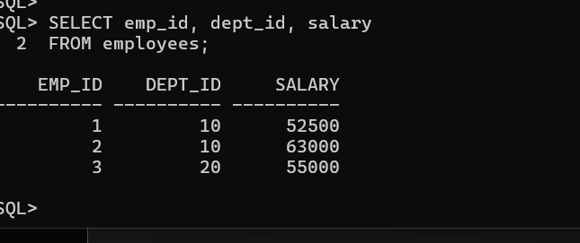

**Scenario 3:** Customers should be able to transfer funds between their accounts.

**Question:** Write a stored procedure **TransferFunds** that transfers a specified amount from one account to another, checking that the source account has sufficient balance before making the transfer.

CREATE TABLE accounts (

account_id NUMBER PRIMARY KEY,

balance NUMBER

);

INSERT INTO accounts VALUES (101, 1000);

INSERT INTO accounts VALUES (102, 500);

COMMIT;

CREATE OR REPLACE PROCEDURE transfer_funds (

p_from_acc NUMBER,

p_to_acc NUMBER,

p_amount NUMBER

) IS

v_balance NUMBER;

BEGIN

SELECT balance

INTO v_balance

FROM accounts

WHERE account_id = p_from_acc

FOR UPDATE;

IF v_balance < p_amount THEN

RAISE_APPLICATION_ERROR(-20001, 'Insufficient funds');

END IF;

UPDATE accounts

SET balance = balance - p_amount

WHERE account_id = p_from_acc;

UPDATE accounts

SET balance = balance + p_amount

WHERE account_id = p_to_acc;

END;

/

BEGIN

transfer_funds(101, 102, 300);

END;

/

SELECT account_id, balance

FROM accounts;

Output:

