NETWORK SECURITY AND TRAFFIC ANALYSIS

Network sniffing : Network sniffing is a process that involves capturing, examining, and observing data packets as they travel through a network.

Network sniffing tools are:

1.Wireshark

2.Auvik

Wireshark: Open source software tool designed to track network packets.

* Used to analyses network packets.
* Troubleshooting problems
* Check the malicious and hacking possibilities

The graph beside the network represents the amount of traffic passing over them.

We can even the particular website address which is using by us

* Command for it is

•tcp contains "simplilearn"

* We can see like this many protocol.

SAM SPADE:

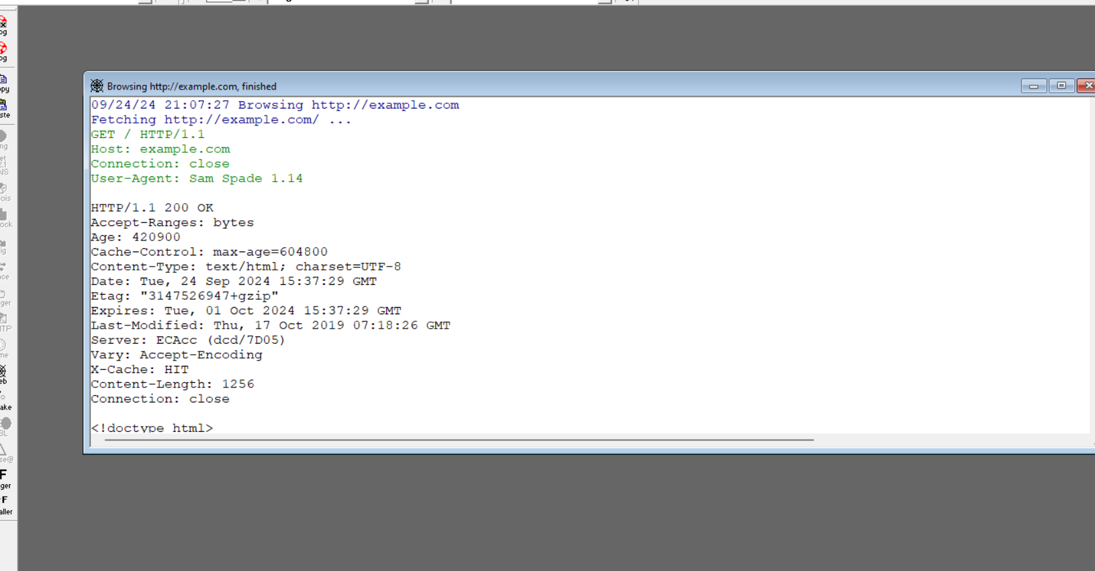

Network Sniffing: SpamSpade captures network traffic, allowing users to monitor packets and analyze data moving through the network.

Spam Detection: The tool is particularly focused on identifying spam emails and suspicious traffic patterns. It can be used to detect email-related traffic, which can help in understanding how spam is sent and received.

Protocol Analysis: SpamSpade helps in analyzing the details of specific protocols (like SMTP, POP3) involved in email communications. This is useful for identifying unwanted or harmful communications.

Security Testing: It is often used in security environments for testing how a network handles spam emails, as well as detecting potential vulnerabilities that spammers might exploit.