Procura: Scheduling Personal Tasks with Operating-System Policies, Grounded AI Diagnosis, and Self-Healing Recovery
System documentation and evaluation
Harshit Chhabi
[Department, Institution]
Source code: github.com/harshitchhabi/procura
Abstract
Personal task managers order work by static, user-assigned labels, never measure whether that ordering is fair, and cannot explain or repair a stalled task. Procura treats each task as an operating-system process and applies production scheduling, resource-management and self-healing techniques to a to-do list. It implements six CPU-scheduling policies, including EEVDF (the default Linux scheduler since kernel 6.6) and the Multi-Level Feedback Queue; a five-term effective-priority score with Slurm-style decaying fair-share; two fairness indices, one over CPU received and a new one over delay; a simulated resource manager with lock-order checking, timeout-based abort and wait-for-graph deadlock detection; and a detect-diagnose-recover loop that uses NIST statistical process-control detectors, a retrieval-augmented language model grounded in recorded incident facts, and deterministic recovery scripts that follow Kubernetes-style preemption rules. We evaluate the policies on 495 simulated workloads in three families, with 95% confidence intervals and paired comparisons against FCFS. SJF has a lower average wait than FCFS in all nine settings but a higher worst case; preemptive policies cut response time in all nine but lower average waiting time only on heavy-tailed workloads; and the usual fairness index cannot separate the policies while the delay-based index can. With the recorded incident facts in the prompt, 100% of a live model's incident answers pass labelled checks, against 11% with the facts removed. Fifteen defects, one of which inverted a published result, were found by running the system, and all are fixed and covered by a 99-test suite. The work is a simulation evaluated on synthetic workloads: no real archive trace could be obtained, and the results confirm known scheduling theory rather than overturning it.
Keywords: CPU scheduling; EEVDF; multi-level feedback queue; fairness; deadlock handling; AIOps; retrieval-augmented generation; self-healing systems.

Contents
1. Introduction 3
2. Background and related work 3
3. System overview 5
4. Process model 6
5. Scheduling 7
6. Resource management and deadlock handling 9
7. Detection, diagnosis and recovery 9
8. Interfaces and configuration 12
9. Verification 13
10. Evaluation 14
11. Limitations and threats to validity 20
12. Future work 21
13. Conclusion 21
References 23
Appendix A. Reproduction 24

1. Introduction
An operating system must repeatedly decide which of several runnable processes gets a scarce shared resource next, how to keep that decision fair over time, and what to do when processes contend for resources or fail. Decades of research have produced precise answers: scheduling policies with known fairness and starvation properties, metrics for comparing them, mechanisms for avoiding or breaking deadlock, and, more recently, automated detect-diagnose-remediate loops in site-reliability engineering.
Personal task management rarely borrows any of this. A typical tool asks the user to label tasks High, Medium or Low and sorts by the label. Nothing combines urgency, waiting time and cost into an order; nothing reports whether attention is distributed fairly; and when a task stalls because a shared resource (time, budget, a reviewer) is exhausted, the tool shows a flag rather than an explanation or a remedy.
Procura is a local-first web application that closes this gap by modelling each task as a process and running real scheduling, resource-management and recovery mechanisms over it. Its design was informed by a structured survey of production schedulers, AIOps practice and the statistics and concurrency-control literature, so that each subsystem corresponds to a documented real-world mechanism rather than a metaphor.
This paper is the system's technical documentation. Its contributions are:
- C1. A process model for tasks with an enforced six-state lifecycle, persisted in SQLite and exposed through a 16-endpoint REST API (Sections 3–4).
- C2. Six scheduling policies over the same task set — FCFS, SJF, Priority, Round Robin, EEVDF and MLFQ — with a uniform metric set including Jain's Fairness Index, and a five-term effective-priority score with Slurm-style fair-share decay (Section 5).
- C3. A simulated resource manager covering the practical spectrum of deadlock handling: lock-order checking, timeout-based abort, wait-for-graph cycle detection, and Banker's Algorithm as a textbook baseline (Section 6).
- C4. A detect-diagnose-recover engine with three NIST statistical detectors, retrieval-augmented diagnosis grounded in recorded incident facts, and deterministic recovery with Kubernetes-style preemption rules (Section 7).
- C5. A reproducible statistical study of all six policies on 495 simulated workloads in three families, with paired confidence intervals and a second fairness index over delay that distinguishes policies where the usual index cannot (Sections 5.1 and 10).
- C6. A verification account: fifteen defects found by exercising the running system, their root causes, and the tests that now guard them (Section 9); and two labelled evaluations, of knowledge-base search and of the assistant's answers with and without recorded incident facts (Sections 10.5 and 10.6).

2. Background and related work

2.1 Production CPU scheduling
Linux used the Completely Fair Scheduler (CFS) from kernel 2.6.23 (2007) until EEVDF replaced it in kernel 6.6 [1, 2]. CFS keeps runnable tasks in a red-black tree ordered by virtual runtime and always runs the task with the smallest; virtual runtime grows in inverse proportion to a weight derived from the nice value, approximately 1024 / 1.25^nice [3]. EEVDF (Earliest Eligible Virtual Deadline First) tracks each task's lag against an ideal fair-share schedule, treats tasks with non-negative lag as eligible, and dispatches the eligible task with the earliest virtual deadline [1, 2]. The Multi-Level Feedback Queue of Operating Systems: Three Easy Pieces infers a job's behaviour through five rules — strict priority between levels, round robin within a level, new jobs at the top, demotion after a time allotment, and a periodic priority boost that bounds starvation [4]. FCFS, SJF and static priority have no starvation bound, and non-preemptive policies suffer the convoy effect [5].

2.2 Fairness and job schedulers
Jain, Chiu and Hawe's fairness index, J = (Σxᵢ)² / (n·Σxᵢ²), ranges from 1/n to 1 [6, 7]. Slurm computes job priority as a weighted sum of normalised factors whose fair-share term penalises accounts that have consumed more than their share, with usage decaying over a configurable half-life [8], and backfills lower-priority jobs only when doing so delays no higher-priority job [9]. The Kubernetes scheduler is a pluggable framework that treats priority (which drives preemption) separately from placement, and its default preemption evicts only lower-priority pods [10, 11]. Celery's ecosystem favours a few discrete priority tiers over fine-grained numeric priority [12]. Bug-triage research and Google's Borg are precedents for applying OS-style scheduling to non-OS work [40]; WSJF in SAFe is a weighted shortest-job-first ranking [44].

2.3 AIOps, self-healing and LLM root-cause analysis
Google's SRE practice defines toil as manual, repetitive, automatable work and treats automating it as a core goal [13]. Kubernetes controllers formalise the underlying pattern as a non-terminating control loop that moves current state towards desired state [14]. Commercial platforms pair statistical anomaly detection with causal diagnosis: Datadog Watchdog [15], Dynatrace Davis AI [16] and New Relic's applied intelligence [17]. Recent work applies language models to root-cause analysis: RCACopilot [18], in-context learning with GPT-4 over more than 100,000 incidents [19], a ReAct-style agent [20], and SynergyRCA, which combines retrieval over graph-structured state with GPT-4o and criticises flat, topology-blind document retrieval [21]. Remediation in practice runs through named, auditable runbooks [22, 23], with AWS classifying each step's impact so that mutating steps can require review [24].

2.4 Statistical anomaly detection
The NIST/SEMATECH handbook specifies the exponentially weighted moving average (EWMA) control chart [25], the median-and-MAD-based modified Z-score, which it recommends over the naive Z-score rule [26], and the CUSUM change detector [27]. The same family underlies monitoring tools such as Prometheus [29]; applying it to IT metrics needs a rolling baseline because their mean is rarely stable [28].

2.5 Deadlock handling in practice
Banker's Algorithm requires advance knowledge of every process's maximum claim and a fixed population, and has essentially no production use [30]. Real systems span a cost-precision spectrum: wound-wait timestamp ordering in Spanner [31], fixed lock ordering checked by Linux's lockdep [32], timeout-based abort in MySQL InnoDB [33], and timer-gated wait-for-graph detection in PostgreSQL [34]. Chandy, Misra and Haas give the classic distributed detection algorithm [35].

2.6 Evaluating schedulers
The Parallel Workloads Archive defines the 18-field Standard Workload Format (SWF) and hosts about forty real logs [36]; the Lublin–Feitelson model is the standard synthetic generator [37]. Makespan, turnaround, waiting time and utilisation are the usual metrics [38, 39]; Google's cluster traces [41] and simulators such as CloudSim [42] are common in larger studies. Starvation has no canonical definition and is usually operationalised as a waiting-time threshold [43].

3. System overview
Figure 1 shows the architecture. A React frontend and a terminal dashboard (procura_top) both talk to a single FastAPI backend, which coordinates four subsystems and persists all state in one SQLite database. The RAG engine is called only by the error-and-recovery engine and the /ask endpoint.
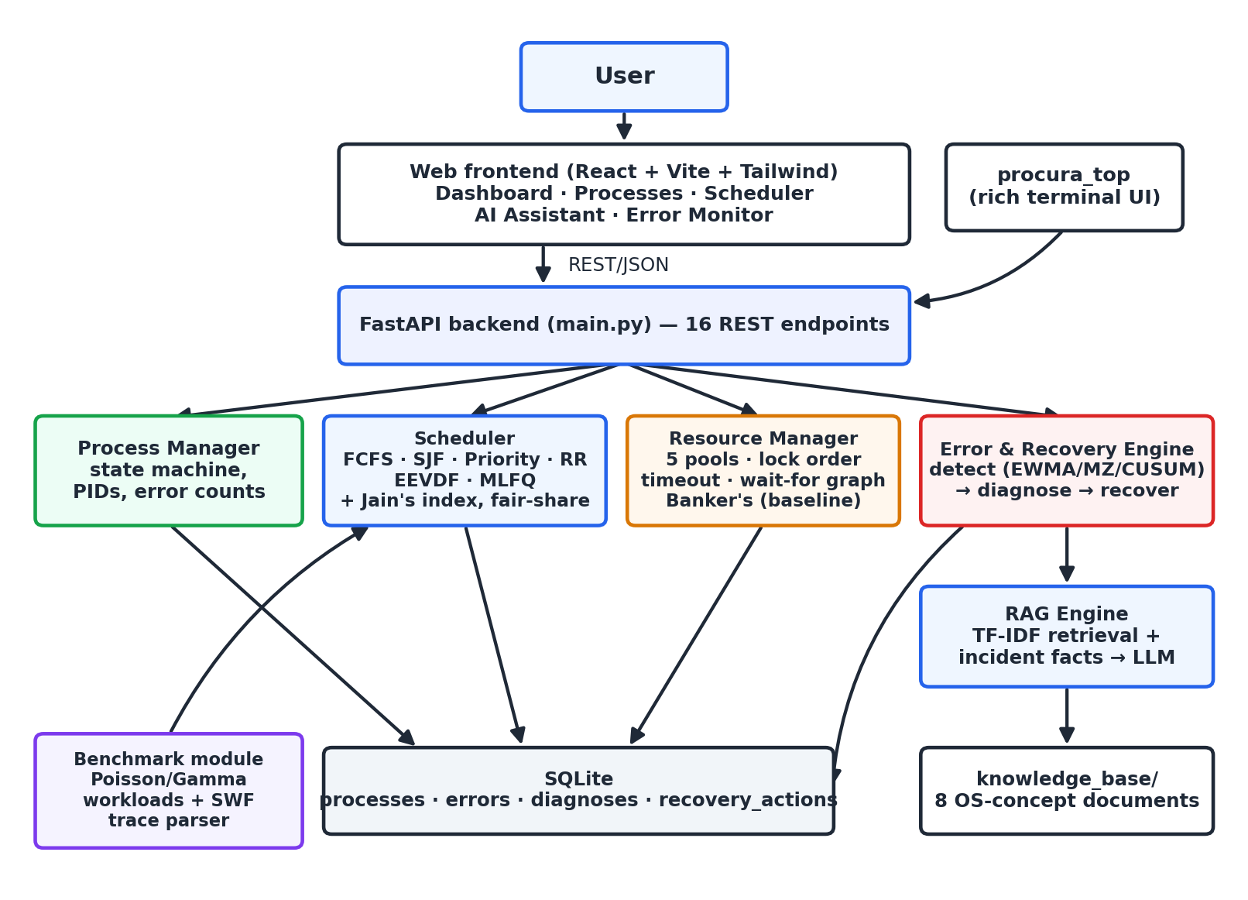
Figure 1. Procura architecture.
Table 1. Subsystems and their responsibilities.
Component | Module | Responsibility
Process Manager | os_sim/process_manager.py, states.py | PID assignment, the lifecycle state machine, error counts
Scheduler | os_sim/scheduler.py | Six policies, effective priority, fair-share, uniform metrics
Resource Manager | os_sim/resource_manager.py | Five resource pools, wait-for graph, lock order, timeouts, cycle detection, Banker's baseline
Error & Recovery Engine | recovery/detector.py, diagnosis.py, recovery.py | Detection, grounded diagnosis, deterministic recovery
RAG Engine | rag/ingestion.py, retrieval.py, assistant.py | TF-IDF index over the knowledge base; prompt assembly; LLM call or offline fallback
Benchmark | benchmark/ | Workload generation, SWF parsing, metric computation
Interfaces | main.py, frontend/, cli/procura_top.py | REST API, five-screen web UI, terminal dashboard

Four design principles run through the system. It is local-first: it needs no account and no network unless a language-model key is configured. It is offline-capable: without a key the assistant returns a clearly labelled extractive answer built from retrieved passages. Remediation is deterministic: the language model explains failures but never chooses or executes actions. And scope is deliberately narrow: there is no authentication, container orchestration or job queue, which keeps the system runnable by one developer in minutes but makes it unsuitable for exposure on a shared network as it stands.
The implementation is about 5,900 lines of Python and JavaScript, of which about 1,070 are tests. The backend uses Python 3, FastAPI and the standard-library sqlite3 module; the frontend uses React 18, Vite and Tailwind CSS; the terminal dashboard uses rich. The statistical detectors and Jain's index use only the Python standard library.

4. Process model
Each task is a process with a PID, name, description, priority (High, Medium, Low or a 0–100 score), optional deadline, burst time (estimated minutes of work), arrival time, memory and CPU requirements, state, and error count. The state machine in Figure 2 is enforced on the server: any transition not listed in Table 2 raises an error that the API returns as HTTP 409, and the web UI offers only the actions valid for each state.
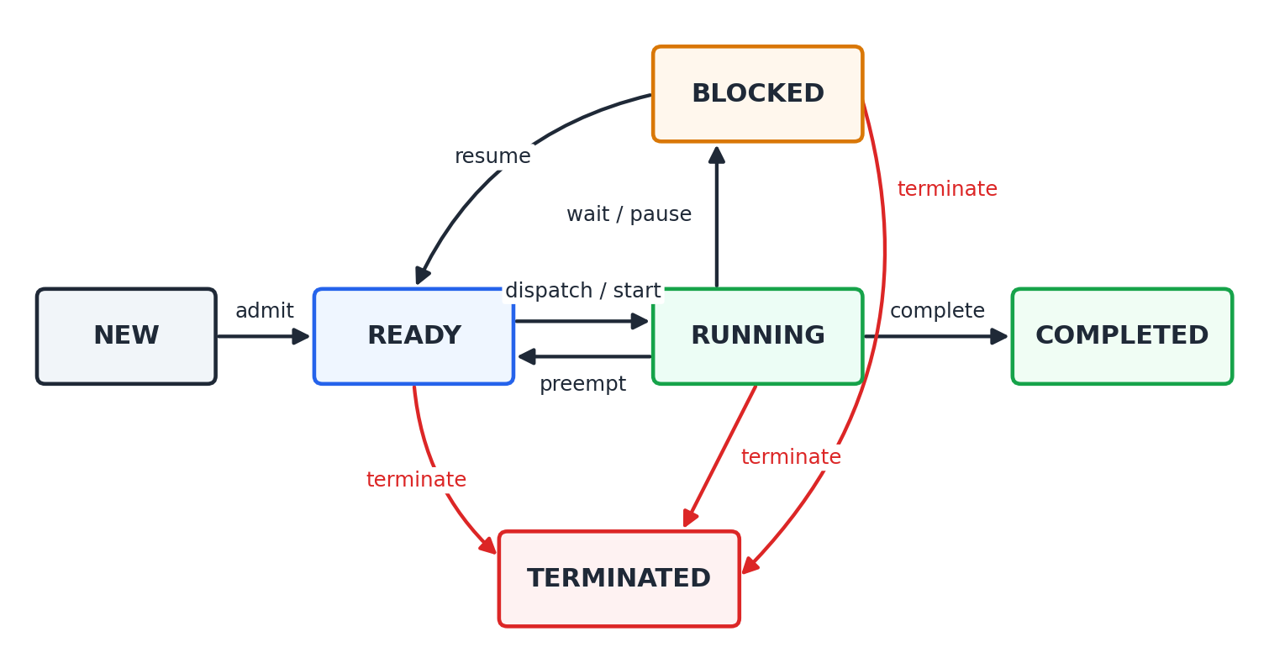
Figure 2. Process lifecycle state machine.
Table 2. Valid state transitions.
From | Allowed targets | Trigger
NEW | READY | Admission on creation
READY | RUNNING, TERMINATED | Dispatch or start; user or recovery termination
RUNNING | READY, BLOCKED, COMPLETED, TERMINATED | Preemption; wait or pause; completion; termination
BLOCKED | READY, TERMINATED | Resume; termination
COMPLETED | — | Terminal state
TERMINATED | — | Terminal state

State is persisted in four SQLite tables: processes; errors (one row per detected failure, with its raw details); diagnoses (the explanation generated for each error); and recovery_actions (the action type and target PID for each error). GET /errors joins the last three into the audit log behind the Error Monitor.

5. Scheduling
All six policies take the same list of processes, simulate a single CPU on a timeline measured in minutes, and return the same result: a dispatch order, a Gantt chart (a list of slices with PID, start and end), and the metrics below. Arrival times are taken relative to the earliest arrival in the set.

5.1 Metrics
For process i with arrival time Aᵢ, burst Bᵢ, completion time Cᵢ (end of its last slice) and first dispatch Fᵢ:
Turnaroundᵢ = Cᵢ − Aᵢ Waitingᵢ = Turnaroundᵢ − Bᵢ Responseᵢ = Fᵢ − Aᵢ
Utilisation = (Σ slice durations) / makespan × 100%, makespan = max end time
J(x) = (Σ xᵢ)² / (n · Σ xᵢ²), xᵢ = CPU time allocated to process i
Averages are taken over all n processes. Jain's index is computed for every policy over each process's total allocated CPU time. Because every work-conserving policy eventually gives each process exactly its burst time, this index is identical across such policies and cannot tell them apart. We therefore add two measures of delay. The bounded slowdown of a process is how many times longer it took than its own run time, with the denominator bounded below by one minute so that very short jobs do not dominate [45]:
Slowdownᵢ = max(Turnaroundᵢ / max(Bᵢ, τ), 1), τ = 1 minute
and the fairness of delay is Jain's index applied to 1/Slowdownᵢ, so that it equals 1 when every process is slowed by the same factor and falls as some processes are delayed far more than others. The bound τ = 1 minute was fixed before the study and not tuned; the construction is ours, not a standard metric.

5.2 FCFS, SJF and Priority
All three are non-preemptive. FCFS dispatches in arrival order. SJF and Priority choose, at each decision point, the best process among those that have already arrived — the shortest burst for SJF, the highest effective priority for Priority — and the CPU idles only if nothing has arrived. Ties are broken by arrival time and then PID. An earlier version sorted the whole list up front, which left the CPU idle waiting for late arrivals (Section 9).

5.3 Effective priority
The Priority policy ranks processes by a five-term score:
E = U + D + W + R + S
- User priority U: High 90, Medium 50, Low 20; a numeric priority is clamped to 0–100.
- Deadline urgency D: 0 with no deadline or more than 48 hours remaining; 100 once the deadline has passed; otherwise 100 × (1 − h/48) for h hours remaining.
- Waiting-time aging W: min(100, 2 × minutes in READY), which prevents indefinite starvation.
- Resource requirement R: min(60, mem/2048 × 60) + min(40, cpu/100 × 40); heavy tasks rank slightly higher because they block more of the system while they wait.
- Fair-share S: zero or negative, described next.

5.4 Slurm-style fair-share
Each process may carry the CPU time it has already consumed and when that was measured. Usage decays exponentially with a 60-minute half-life, by analogy with Slurm's PriorityDecayHalfLife [8]:
uᵢ = consumedᵢ × 0.5^(ageᵢ / 60)
With total decayed usage T over n processes, the fair share is T/n. A process using more than its share receives the penalty
Sᵢ = −min(100, ((uᵢ − T/n) / T) × 100 × n)
and a process with no recorded usage, the common case for new tasks, receives 0.

5.5 Round Robin
Processes enter a FIFO ready queue in arrival order; each dispatch runs for at most a quantum q (4 minutes by default), and processes arriving during a slice are queued before the preempted process is re-queued. The wait between consecutive turns is bounded by (n − 1)·q.

5.6 EEVDF
Priority maps to a kernel-style nice value (High −5, Medium 0, Low +5; a 0–100 score maps linearly to +10…−10) and then to a weight wᵢ = 1024 / 1.25^niceᵢ. Each process carries a virtual runtime vᵢ, initially zero. At every decision point the scheduler computes the weight-averaged virtual runtime of the active set; a process is eligible when its lag, the average minus vᵢ, is non-negative. Among eligible processes, a min-heap returns the one with the earliest virtual deadline:
deadlineᵢ = vᵢ + s · 1024 / wᵢ
The chosen process runs for the base slice s (the UI's quantum, floored at 3 minutes) or its remaining burst, whichever is shorter, after which
vᵢ ← vᵢ + run · 1024 / wᵢ
Every slice therefore has the same length in real time; weighting acts through virtual time, which advances more slowly for heavier processes, so they become eligible, and are dispatched, more often. Low-weight processes cannot starve because their lag grows until they become eligible. This is a faithful simulation of EEVDF's eligibility and deadline rules, not a port of the kernel; per-task requested slices are not modelled.

5.7 Multi-Level Feedback Queue
MLFQ uses three queues with quanta of q, 2q and 4q (4, 8 and 16 minutes by default) and implements OSTEP's five rules [4]. A process's allotment at a level equals that level's quantum and is accounted cumulatively: being preempted does not reset it, which closes the exploit in which a job yields just before its quantum expires to stay at high priority. Exhausting the allotment demotes the process one level, and every 50 minutes of simulated time all processes return to the top queue.

6. Resource management and deadlock handling
Table 3. Simulated resource pools.
Resource | Capacity | Unit
CPU | 100 | percent
Memory | 2048 | MB
File | 64 | handles
Database | 20 | connections
Network | 1000 | Mbps

An allocation request succeeds if the pool has enough free capacity. If it fails because another process holds the resource, the manager records a wait-for edge from the requester to the holder. Releasing resources removes the corresponding edges. Procura then provides four mechanisms that together reproduce the practical spectrum of Section 2.5:
- Lock-order checking (default on). Resources have a canonical order: CPU, memory, file, database, network. A process that requests a resource while holding one later in that order is logged as a lock-order violation, as Linux's lockdep does. Violations are logged, not blocked.
- Timeout-based abort. Any wait that exceeds 30 seconds is aborted and logged, in the manner of MySQL's innodb_lock_wait_timeout.
- Wait-for-graph cycle detection. A three-colour depth-first search returns the PIDs on any cycle. Recovery terminates the lowest-priority process in the cycle, releases its resources, and returns the other blocked members to READY.
- Banker's-style avoidance (default off). Retained as the textbook baseline: a request is granted only if, afterwards, at least one other process's declared need could still be met. It can be enabled through POST /resources/avoidance-mode.

7. Detection, diagnosis and recovery
POST /detect runs every detector once, records all findings, and then, for each finding in turn, generates a diagnosis, executes a recovery script, and logs all three. Because findings are recorded before any recovery runs, a later finding can be stale by the time it is handled; the recovery rules account for this.

7.1 Detection
Memory-allocation failure. For each process that is not COMPLETED or TERMINATED and does not already hold its full requirement, the detector reports a failure when the remaining requirement exceeds available memory.
Deadlock. A cycle in the wait-for graph, found as described in Section 6.
Burst-time anomaly. For each RUNNING process, the detector computes the ratio of elapsed running time to declared burst time and compares it with that process's last 30 ratios using one of three NIST methods. EWMA is the default.
EWMAₜ = λ·Yₜ + (1 − λ)·EWMAₜ₋₁, limits: EWMA₀ ± k·σ·√(λ / (2 − λ)), λ = 0.25, k = 3
Mᵢ = 0.6745 (xᵢ − median) / MAD, flag if |Mᵢ| > 3.5
S_hi = max(0, S_hi + x − μ − k), S_lo = max(0, S_lo − x + μ − k), flag if either exceeds h
For CUSUM, k corresponds to a one-standard-deviation shift and h to five standard deviations. The original rule — running time above 1.5 times the burst while CPU utilisation is at least 80% — is kept as a fixed_threshold mode for comparison.

7.2 Grounded diagnosis
The knowledge base consists of eight plain-text documents (Table 4). Ingestion splits each on paragraph boundaries into chunks of at most about 600 characters — 63 chunks in total — and builds a TF-IDF index over a vocabulary of 1,422 terms, with smoothed inverse document frequency
idf(t) = ln((1 + N) / (1 + df(t))) + 1
where N is the number of chunks. Tokenisation keeps numbers and identifiers, indexes the parts of hyphenated compounds, removes question filler and merges simple inflections; Section 10.5 measures the effect. A query is vectorised the same way and the three chunks with the highest cosine similarity are retrieved, optionally restricted to the documents relevant to the failure type (for example, Memory_Management and Error_Recovery for a memory failure).
Table 4. Knowledge-base documents.
Document | Chunks | Scope
CPU_Scheduling | 7 | FCFS, SJF, Priority, Round Robin, metrics
Advanced_Scheduling | 16 | CFS, EEVDF, MLFQ, aging, Jain's index, Slurm fair-share
Process_Management | 5 | Process states, PCBs, context switches
Memory_Management | 5 | Allocation, fragmentation, allocation failure
Deadlocks | 9 | Coffman conditions; prevention, avoidance, detection; production practice
File_System | 5 | File-system fundamentals
Error_Recovery | 9 | Detect-diagnose-recover, runbooks, Procura's preemption rules, grounding
Anomaly_Detection | 7 | Fixed thresholds versus EWMA, modified Z-score and CUSUM

The prompt has four parts: an instruction, the process record, an incident-facts section, and the retrieved passages. The incident facts list the error details and executed recovery actions recorded for the process, and the current memory state, explicitly labelled as current rather than as at the time of failure. The instruction tells the model to treat these facts as ground truth and to use the passages to explain concepts rather than to propose causes the facts do not show. The prompt is sent to the first configured provider — Groq (openai/gpt-oss-20b), Anthropic or OpenAI. Without a key, or if the call fails, the assistant returns the retrieved passages and the incident facts verbatim, labelled as an offline extractive answer.

7.3 Recovery
Table 5. Failure types and recovery scripts.
Failure | Script | Effect
memory_failure | retry / suspend_and_retry / memory_failure_no_victim | Decision flow of Figure 3
deadlock | terminate_and_resume | Terminate the lowest-priority process in the cycle, release its resources, return the others to READY
burst_anomaly, timeout | stop_and_retry | Move the process back to READY and increment its error count
crash | restart | Move the process back to READY and increment its error count

Memory-failure recovery follows the decision flow in Figure 3, modelled on Kubernetes preemption [11]. It first retries, because memory freed by an earlier recovery in the same pass may already suffice. Otherwise it considers the lowest-priority memory holder V, and suspends it only if V has strictly lower effective priority than the failing process F and releasing V's memory would actually let F's allocation fit. If either condition fails, F is left pending and nothing is evicted. Every memory failure increments F's error count.
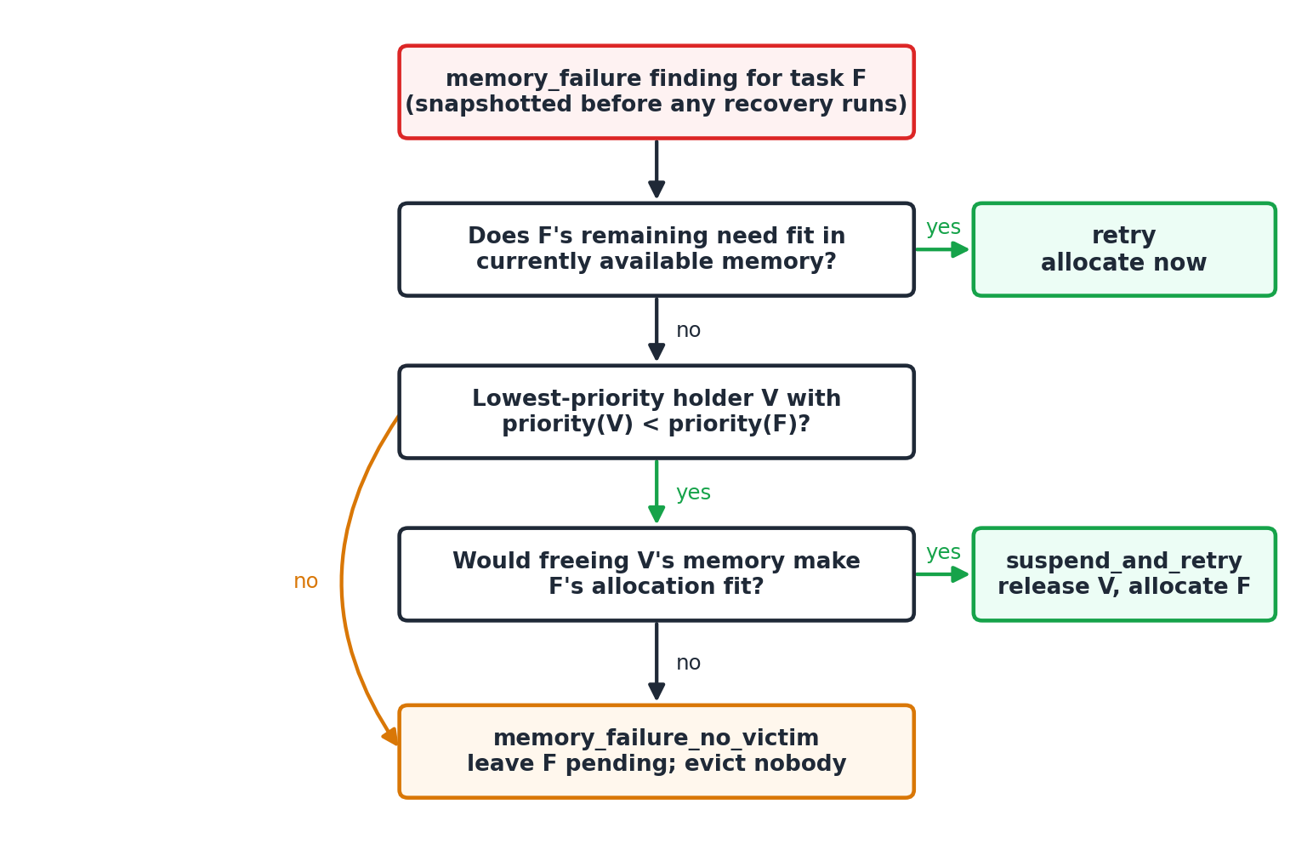
Figure 3. Recovery decision flow for a memory-allocation failure.

8. Interfaces and configuration
Table 6. REST API.
Method | Endpoint | Purpose
GET | /health | Liveness check
GET, POST | /processes | List processes; create a process
GET, PATCH, DELETE | /processes/{pid} | Read; transition (start, pause, resume, complete, terminate); delete
GET, POST | /schedule | Run a policy; returns order, Gantt data, metrics and Jain's index
GET | /benchmark | Run all six policies on a synthetic workload
GET | /resources | Utilisation per pool and the wait-for graph
POST | /resources/allocate, /resources/release | Allocate or release a resource for a process
POST | /resources/avoidance-mode | Enable or disable Banker's-style avoidance
POST | /detect | Run detection, diagnosis and recovery once
POST | /ask | Ask the assistant, optionally grounded on a PID
GET | /errors | Full audit log of errors, diagnoses and recovery actions

The web interface has five screens: a Dashboard (process table, resource bars and AI activity feed, refreshed every few seconds), Processes (creation form and state-driven actions), Scheduler (policy selector, Gantt chart with one lane per process, metrics), AI Assistant, and Error Monitor. procura_top renders the same process table, resource bars and activity feed in a terminal. Figure 4 shows the scheduler screen; the companion demo document contains screenshots of every screen.
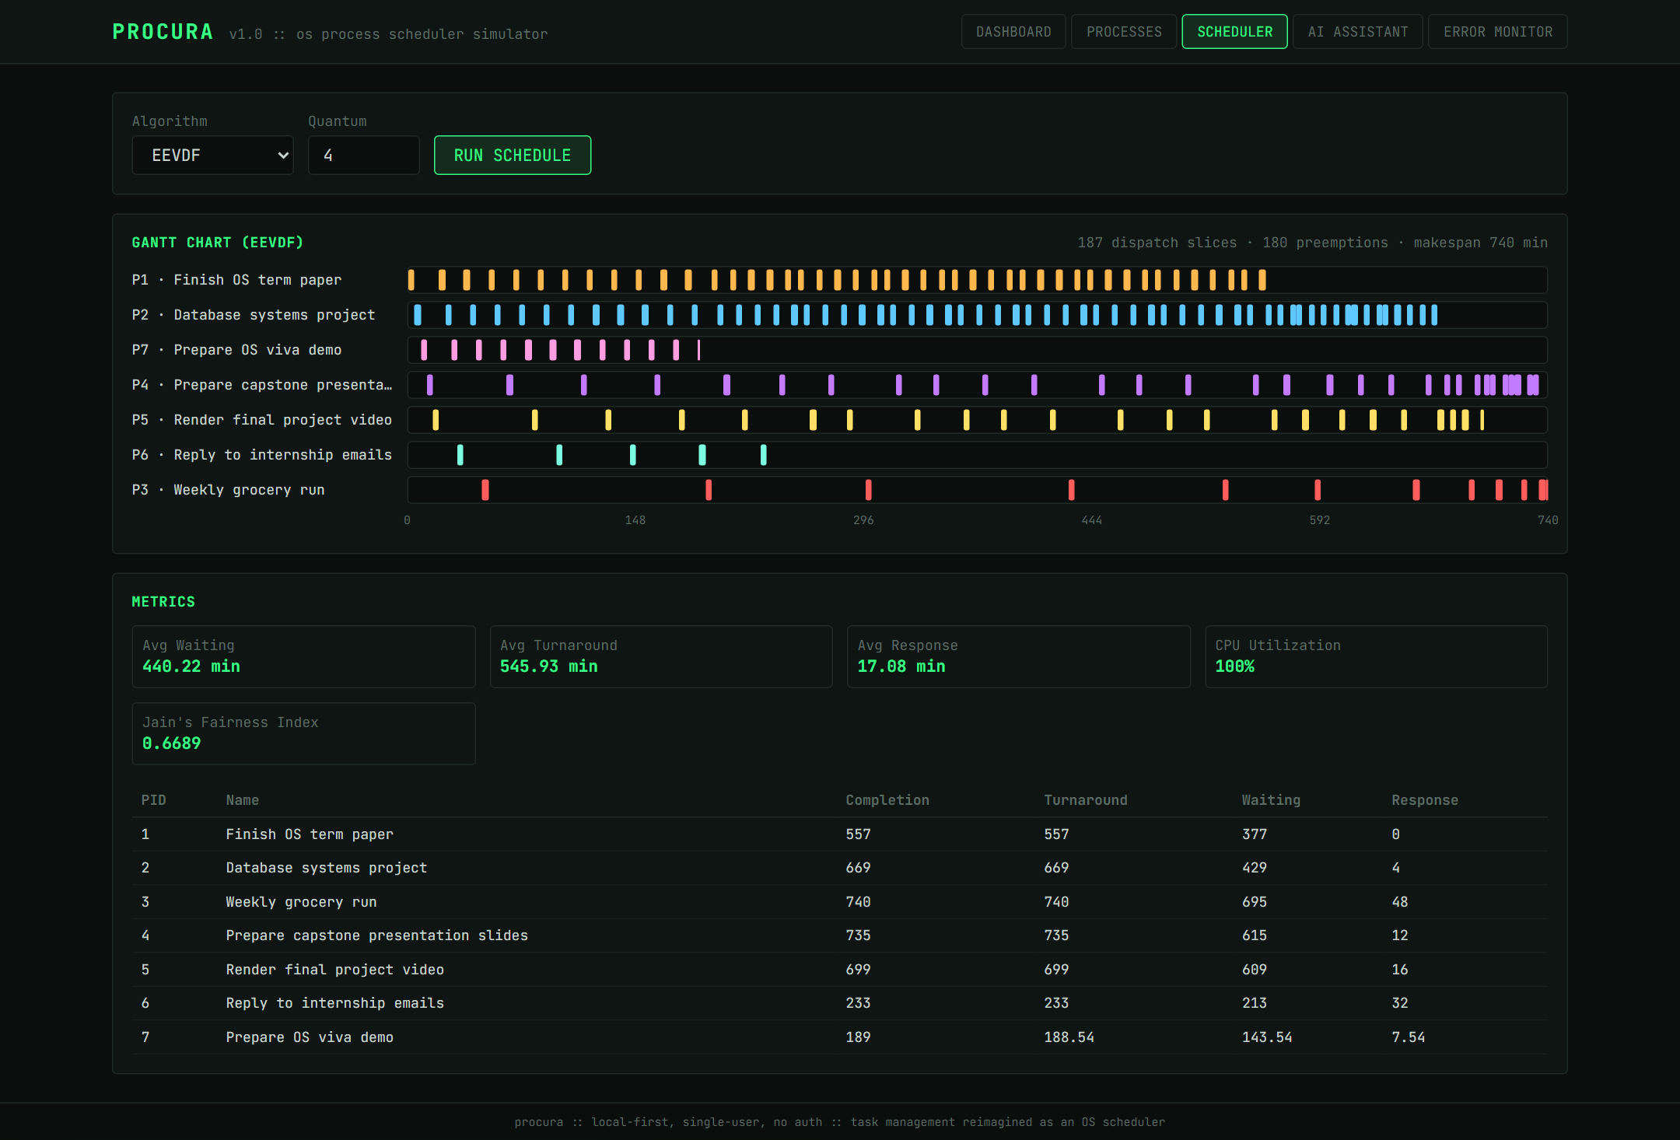
Figure 4. The Scheduler screen running EEVDF on seven tasks: 187 dispatch slices, with high-priority tasks (top lanes) dispatched far more often than the low-priority task in the bottom lane.
Table 7. Configuration.
Variable | Purpose | Default
GROQ_API_KEY, ANTHROPIC_API_KEY, OPENAI_API_KEY | Language-model provider, checked in this order | Unset (offline mode)
VITE_API_URL | Backend URL used by the web frontend | http://localhost:8000
PROCURA_API_URL | Backend URL used by procura_top | http://localhost:8000

9. Verification
Table 8. Automated test suite (99 tests, all passing).
Module | Tests | Coverage
test_scheduler.py | 21 | All six policies; hand-worked FCFS, SJF and Round Robin examples; arrival-aware SJF and Priority; effective priority; fair-share; both fairness indices and bounded slowdown against hand-computed values
test_recovery.py | 21 | Detectors (positive and negative cases for each method, and end to end through task state), recovery scripts, preemption rules, error counting, finished-process filtering, deadlock details
test_resource_manager.py | 13 | Allocation, over-capacity rejection, wait-for edges, cycles, lock order, timeouts, avoidance mode
test_api.py | 18 | Endpoint smoke tests, invalid-transition 409, grounding of answers in incident facts, units in facts, provider retry, rate-limit handling and fallback reporting
test_benchmark.py | 8 | SWF parsing, seeded generation, hand-computed makespan, utilisation and starvation
test_process_manager.py | 7 | Lifecycle transitions and error counting
test_retrieval.py | 11 | Each implemented concept retrieves the correct document; tokenizer behaviour; retrieval accuracy does not regress

Tests are hermetic: the test configuration blanks the provider keys before the application loads its environment file, so no test makes a network call. The SJF and Round Robin tests assert exact completion and waiting times from hand-worked examples. For four processes arriving at minutes 0, 1, 2 and 3 with bursts of 5, 3, 8 and 6, SJF must run P1 first (it is the only arrival at time 0) and then P2, P4 and P3, giving an average waiting time of 5.25 minutes. The new delay metrics are checked the same way: FCFS on those four processes gives slowdowns of 1, 7/3, 7/4 and 19/6, and a fairness-of-delay index of 0.8328, computed by hand.

9.1 Defects found by exercising the running system
Unit tests passed throughout, yet running the system and reading its output closely revealed fifteen defects (Table 9). Three lessons stand out. First, a test can encode a defect: the original SJF test asserted the idle-CPU behaviour (average wait 5.75) and so protected the bug; that defect also inverted the published benchmark conclusion, making SJF look worse than FCFS when it is in fact the best policy on average waiting time. Second, the assistant's errors were failures of grounding, not of the model: given the recorded facts and relevant passages, the same model gave correct answers. Third, measurement can be wrong as well as the system: our first run of the assistant evaluation graded correct answers as failures, because the model writes numbers with narrow no-break spaces ("pid 1"), and a free-tier rate limit made the product quietly serve its offline answer as if no key were configured. Both were found only by reading the failing outputs, which is why the evaluation harness now saves every raw answer and the product reports why a configured model did not answer.
Table 9. Defects found, root causes and fixes.
# | Symptom | Root cause | Fix and guard
1 | SJF and Priority makespan 314.6 and 304.0 vs 228.7 for FCFS; utilisation below 100% | Whole list pre-sorted; CPU idled waiting for late arrivals | Choose among arrived processes; corrected test; regression test
2 | Gantt chart had ~190 near-empty rows for preemptive policies | One chart row per slice instead of per process | One lane per process with slices positioned on a shared time axis
3 | Assistant blamed memory fragmentation; log showed 1600 MB requested, 248 MB free | Prompt contained the process record but no incident data | Incident facts injected as an authoritative prompt section; API test
4 | Assistant expanded EEVDF as 'Effective-Priority Earliest-Deadline-First' | Knowledge base predated EEVDF, MLFQ, fair-share and the SPC methods | Two new documents, two extended; retrieval tests
5 | Two processes evicted each other repeatedly | Victim chosen without comparing priorities | Evict only strictly lower-priority holders; test
6 | A process was suspended without freeing enough memory to help | No check that eviction makes the allocation fit | Fit check before eviction; test
7 | Failures handled after memory had already been freed | Findings recorded before recovery and acted on unchanged | Retry first; test
8 | Processes flagged although they already held their memory | Detector compared the full requirement with free memory | Compare only the unmet remainder; test
9 | Finished processes could be flagged and 'recovered' | Detector ran over every process | Skip COMPLETED and TERMINATED; test
10 | Error count stayed 0 after memory failures | Only timeout and crash recovery incremented it | Increment on every memory failure; test
11 | Test suite made live LLM calls | Keys removed from the environment were re-added by load_dotenv | Blank the keys instead of removing them
12 | Application unusable when port 8000 was taken | Backend URL hard-coded in frontend and CLI | VITE_API_URL and PROCURA_API_URL settings
13 | Assistant answered '[offline mode, no key]' although a key was set | HTTP 429 (free-tier token limit) and empty reasoning answers were swallowed | Bounded retry using the provider's own wait hint; reason reported as fallback_reason; tests
14 | Assistant called 64 file handles '64 MB' and 20 connections '20 MB' | Facts carried bare numbers with no units | Units on every pool in the facts and the prompt; tests
15 | Evaluation graded correct answers as wrong | Model output uses narrow no-break spaces; patterns assumed ordinary spaces | Normalise whitespace before grading; every answer saved; regrade script

10. Evaluation

10.1 Method
Three kinds of evidence are reported. A single seeded run shows one workload in full detail. A statistical study runs every policy on many independent workloads and reports each metric with a confidence interval. Two labelled evaluations measure the knowledge-base search and the assistant itself.
Workloads. The generator offers three families, all with the same mean run time of 8 minutes so that only the shape differs: Gamma run times with Poisson arrivals (the default); heavy-tailed run times (Pareto, α = 1.8, truncated at 40 times the mean), a few very long jobs among many short ones as real logs show [37]; and bursty arrivals (a two-phase hyperexponential with the same mean rate), in which jobs arrive in clumps. Offered load is set explicitly (0.9 for the main study, so the queue is busy but stable) and swept from 0.5 to 1.2.
Study design. Each family is run at 30, 100 and 300 jobs, with 25–50 independent workloads per setting (9 settings), plus a load sweep of 30 workloads at each of four loads: 495 workloads in all, each run through all six policies. Every metric is reported as a mean with a 95% confidence interval (Student's t, n − 1 degrees of freedom). Because every policy receives the identical workload, differences against FCFS are paired, which removes between-workload variance; a difference is called significant when its paired 95% interval excludes zero. No correction for multiple comparisons is applied, so one borderline call is flagged where it occurs.
Metrics. The metrics of Section 5.1, plus maximum waiting time, the share of jobs that waited more than 30 minutes (starvation has no standard definition [43]), bounded slowdown, and the fairness index over delay. The study is reproducible with python -m benchmark.study.
Real traces. We attempted to replay a real trace (NASA iPSC/860 from the Parallel Workloads Archive [36]). The archive's server answered automated requests with an error page, which we treated as a refusal and did not work around, and we found no public mirror. No result on a real archive trace is therefore reported; the parser is validated only on the hand-written sample, and Appendix A gives the command to run any trace downloaded by hand.

10.2 Single-run results
Table 10. Synthetic workload: 30 jobs, Poisson arrivals at 0.3 per minute, seed 42 (minutes). This workload is heavily overloaded, so every policy is busy throughout.
Policy | Makespan | Avg waiting | Max waiting | Waited > 30 min | Jain (CPU) | Jain (delay)
FCFS | 228.67 | 61.56 | 133.50 | 23 | 0.6711 | 0.3921
SJF | 228.67 | 34.03 | 163.10 | 8 | 0.6711 | 0.6902
Priority | 228.67 | 61.12 | 214.83 | 15 | 0.6711 | 0.5093
Round Robin | 228.67 | 75.09 | 161.05 | 27 | 0.6711 | 0.3757
EEVDF | 228.67 | 72.56 | 204.51 | 18 | 0.6711 | 0.4686
MLFQ | 228.67 | 80.38 | 175.10 | 27 | 0.6711 | 0.3525

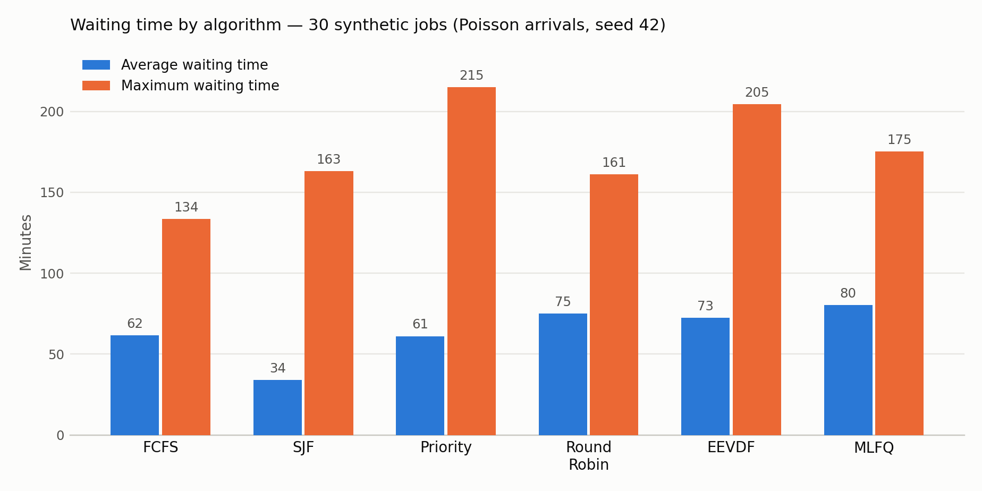
Figure 5. Average and maximum waiting time per policy on the synthetic workload (data in Table 10).
The single run already shows the point of the second fairness index: the index over total CPU is 0.6711 for all six policies, as it must be when every policy gives each job exactly its burst time, while the index over delay ranges from 0.35 to 0.69.
Table 11. SWF trace replay: the 15-job hand-written sample (minutes). Not a real trace.
Policy | Makespan | Avg turnaround | Avg waiting | Max waiting | Waited > 30 min
FCFS | 2305.0 | 1115.33 | 961.67 | 1905.0 | 14
SJF | 2305.0 | 493.33 | 339.67 | 1555.0 | 11
Priority | 2305.0 | 1553.67 | 1400.00 | 2170.0 | 14
Round Robin | 2305.0 | 878.60 | 724.93 | 1555.0 | 15
EEVDF | 2305.0 | 874.00 | 720.33 | 1555.0 | 12
MLFQ | 2305.0 | 884.47 | 730.80 | 1555.0 | 15

Table 12. Live demonstration: seven tasks, quantum 4 minutes (minutes; makespan 740 for every policy).
Policy | Slices | Preemptions | Avg waiting | Avg turnaround | Avg response
FCFS | 7 | 0 | 431.37 | 537.09 | 431.37
SJF | 7 | 0 | 173.51 | 279.23 | 173.51
Priority | 7 | 0 | 436.37 | 542.09 | 436.37
Round Robin | 187 | 180 | 348.94 | 454.66 | 11.94
EEVDF | 187 | 180 | 440.23 | 545.94 | 17.09
MLFQ | 110 | 103 | 368.37 | 474.09 | 11.94

10.3 Statistical study
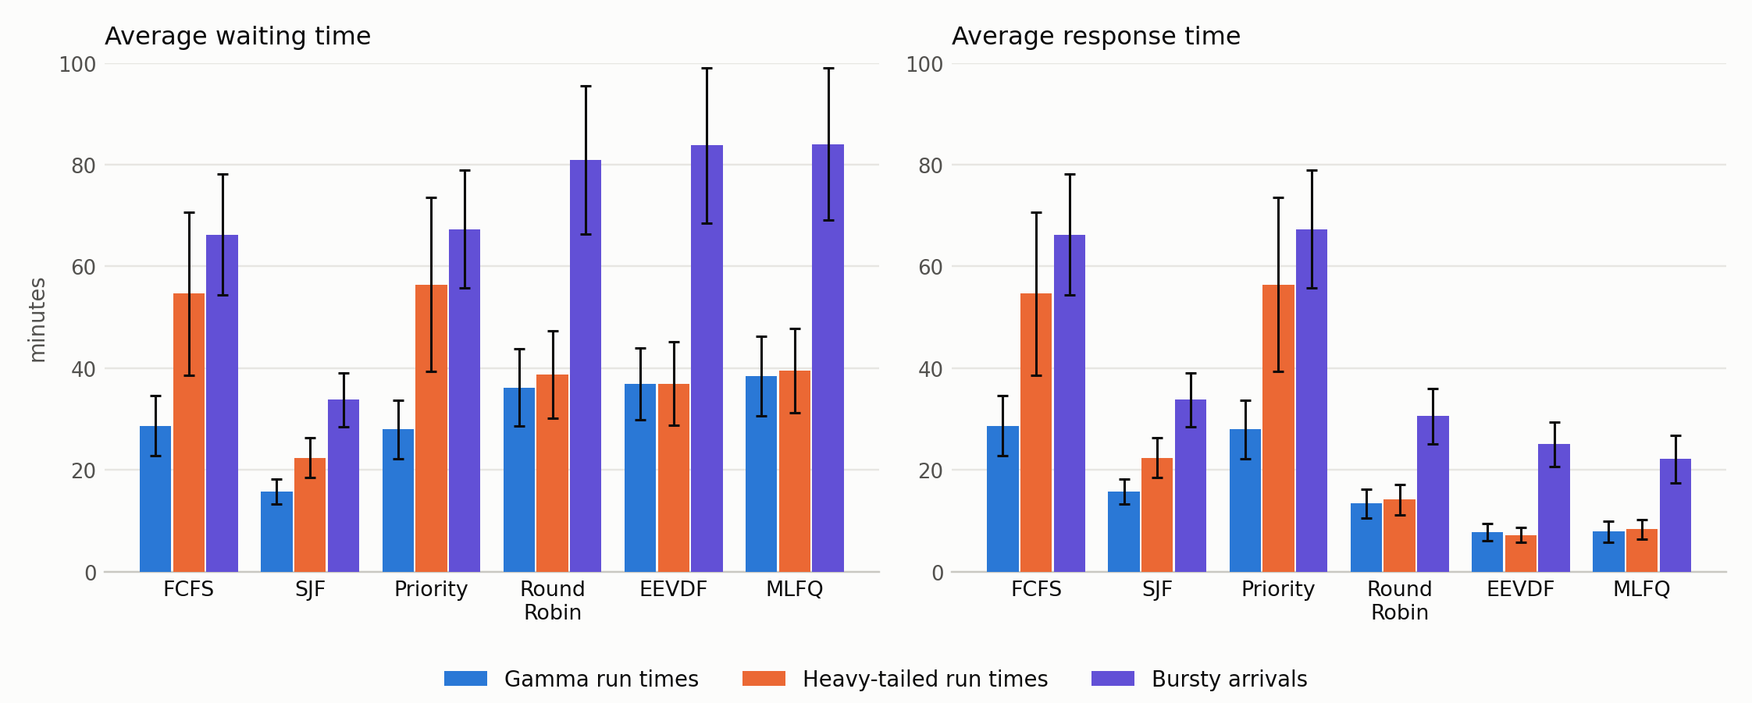
Figure 6. Mean waiting and response time with 95% confidence intervals, 100 jobs at load 0.9, 50 independent workloads per family (data in Tables 13 and 14).
Table 13. Average waiting time in minutes, mean ± 95% interval (100 jobs, load 0.9).
Policy | Gamma | Heavy-tailed | Bursty
FCFS | 28.7 ± 5.9 | 54.6 ± 16.0 | 66.2 ± 11.9
SJF | 15.7 ± 2.4 | 22.4 ± 4.0 | 33.8 ± 5.3
Priority | 27.9 ± 5.8 | 56.5 ± 17.1 | 67.3 ± 11.6
Round Robin | 36.2 ± 7.6 | 38.8 ± 8.6 | 80.9 ± 14.5
EEVDF | 36.9 ± 7.1 | 37.0 ± 8.2 | 83.8 ± 15.3
MLFQ | 38.4 ± 7.8 | 39.6 ± 8.3 | 84.0 ± 14.9

Table 14. Average response time in minutes, mean ± 95% interval (100 jobs, load 0.9).
Policy | Gamma | Heavy-tailed | Bursty
FCFS | 28.7 ± 5.9 | 54.6 ± 16.0 | 66.2 ± 11.9
SJF | 15.7 ± 2.4 | 22.4 ± 4.0 | 33.8 ± 5.3
Priority | 27.9 ± 5.8 | 56.5 ± 17.1 | 67.3 ± 11.6
Round Robin | 13.4 ± 2.8 | 14.1 ± 2.9 | 30.5 ± 5.5
EEVDF | 7.8 ± 1.7 | 7.2 ± 1.5 | 25.0 ± 4.3
MLFQ | 7.8 ± 2.1 | 8.3 ± 1.9 | 22.1 ± 4.6

Table 15. Maximum waiting time (minutes) and fairness of delay (Jain's index over 1/slowdown, higher is fairer), 100 jobs, load 0.9.
Policy | Max wait: Gamma | Heavy-tailed | Bursty | Delay fairness: Gamma | Heavy-tailed | Bursty
FCFS | 80 | 148 | 157 | 0.60 | 0.54 | 0.45
SJF | 219 | 245 | 371 | 0.78 | 0.75 | 0.71
Priority | 276 | 419 | 456 | 0.70 | 0.66 | 0.57
Round Robin | 157 | 271 | 290 | 0.61 | 0.61 | 0.48
EEVDF | 329 | 385 | 467 | 0.71 | 0.73 | 0.55
MLFQ | 196 | 291 | 326 | 0.61 | 0.61 | 0.48

Table 16. Paired difference in average waiting time against FCFS, in minutes, across all 9 settings. Negative is shorter than FCFS; * means the 95% interval excludes zero.
Policy | Gamma 30 | Gamma 100 | Gamma 300 | Heavy 30 | Heavy 100 | Heavy 300 | Bursty 30 | Bursty 100 | Bursty 300
SJF | −6.4* | −13.0* | −20.2* | −10.0* | −32.3* | −54.5* | −12.8* | −32.5* | −61.3*
Priority | −0.6 | −0.7 | 0.9 | −0.8 | 1.8 | −4.0 | 0.5 | 1.1 | 1.6
Round Robin | 4.4* | 7.5* | 9.7* | −3.7* | −15.9* | −30.0* | 6.0* | 14.7* | 25.8*
EEVDF | 4.5* | 8.2* | 14.7* | −3.9 | −17.7* | −37.8* | 7.0* | 17.5* | 36.4*
MLFQ | 5.7* | 9.7* | 12.6* | −2.6 | −15.1* | −31.2* | 7.5* | 17.8* | 30.1*

Table 17. Average waiting time in minutes by offered load (Gamma, 100 jobs, 30 workloads per load).
Load | FCFS | SJF | Priority | Round Robin | EEVDF | MLFQ
0.5 | 5.6 ± 0.7 | 4.4 ± 0.5 | 5.5 ± 0.7 | 7.2 ± 0.9 | 7.1 ± 0.8 | 7.3 ± 0.9
0.7 | 11.6 ± 2.0 | 7.8 ± 1.0 | 11.6 ± 2.0 | 14.6 ± 2.4 | 14.5 ± 2.2 | 15.3 ± 2.5
0.9 | 28.2 ± 7.1 | 15.5 ± 2.8 | 26.9 ± 6.0 | 35.2 ± 8.8 | 35.7 ± 7.5 | 37.5 ± 9.1
1.2 | 82.7 ± 14.9 | 38.5 ± 5.9 | 80.8 ± 13.0 | 102.3 ± 18.3 | 104.4 ± 15.4 | 106.9 ± 18.5

Shortest-job-first is the only policy that is better than FCFS on average waiting time in every setting. SJF's paired difference in mean wait is significantly negative in 9 of 9 settings, as are its response time and slowdown, and the gap widens with load (Table 17: at load 1.2, 38.5 against 82.7 minutes). It pays in the tail: its maximum wait is significantly higher than FCFS's in 9 of 9 settings, which is the starvation risk of Section 2.1 measured rather than asserted.
Whether preemption helps average waiting time depends on the shape of the workload. Round Robin, EEVDF and MLFQ have a significantly higher average wait than FCFS in 6 of 9 settings, all of them Gamma or bursty, and a significantly lower one only on heavy-tailed workloads (3, 2 and 2 of 9 settings respectively). Heavy-tailed run times are where FCFS suffers most from the convoy effect: a very long job at the head of the queue delays many short ones, and time-slicing lets the short ones finish. One of these heavy-tailed calls is marginal (Round Robin at 30 jobs: −3.7 ± 3.7 minutes); the 100- and 300-job results are not.
Responsiveness is where preemption wins everywhere. Mean response time is significantly lower than FCFS for Round Robin, EEVDF and MLFQ in 9, 9 and 9 of 9 settings, by 15 to 47 minutes at 100 jobs, and so is mean bounded slowdown. Priority, as configured here, is statistically indistinguishable from FCFS on average wait and response in all 9 settings: its ranking is built from labels and deadlines that carry no information about job length, so it does not reorder work in a way that helps these averages.
Fairness depends on what is measured. FCFS has the best worst case: all five other policies have a significantly higher maximum wait in 9 of 9 settings. Measured as fairness of delay instead (Jain's index over 1/slowdown), FCFS is the least fair policy and SJF the fairest (0.71 to 0.78 against 0.45 to 0.60 at 100 jobs), because FCFS makes short jobs wait behind long ones and so gives them far larger slowdowns. A policy can therefore be the worst for its longest-waiting job and the fairest for the typical job. This is a property of the two measures, not a contradiction, and it is the reason the second index was added: the index over total CPU received cannot distinguish the policies at all.
Effective priority behaves as specified but encodes value judgements. In the live run, a Medium-priority task ranked above a High-priority one because both deadlines had passed, giving each the maximum urgency, and the Medium task's larger resource requirement added more (225.9 against 218.0), while a High-priority task without a deadline ranked sixth. The behaviour is correct for the formula; whether these weights match what a user wants is a design question rather than a property of the scheduler.

10.4 Self-healing scenario
To exercise recovery, the low-priority errand (P3) was allocated 1200 MB and the High-priority term paper (P1) 600 MB, leaving 248 MB of 2048. One detection pass reported four memory failures, all recorded with 248 MB available because findings are recorded before any recovery runs. Table 18 shows how each was handled; the final state, 1880 MB allocated (600 + 768 + 256 + 256), matches what the dashboard reported.
Table 18. Recovery outcomes in the self-healing scenario.
Process | Needs | Outcome | Reason
P2 (High) | 768 MB | suspend_and_retry, victim P3 | P3 has strictly lower priority, and its 1200 MB makes P2 fit
P4 (Medium) | 256 MB | retry | 680 MB were free after P2's recovery
P5 (Medium) | 1600 MB | memory_failure_no_victim | No lower-priority holder could free enough memory; nothing evicted
P7 (High) | 256 MB | retry | 424 MB were free after P4's allocation

The deadlock scenario was run the same way. P1 takes all 64 file handles and P3 all 20 database connections, then each requests a little of what the other holds. The wait-for graph becomes {1: [3], 3: [1]}; detection reports the cycle together with who holds and waits for what; the fixed rule terminates P3, the lower-priority member, releases its connections and returns P1 to READY. Before the preemption rules of Section 7.3, the memory scenario produced a cascade in which tasks evicted each other and one was suspended without freeing enough memory to help.

10.5 Knowledge-base search
The assistant answers from the three passages its search returns, so search quality bounds answer quality. We measured it on a labelled set of 36 development questions, which guided the design of the second tokenizer, and 20 held-out questions that were written after the design was fixed and evaluated once. A result counts as correct when the retrieved passage comes from a document that actually answers the question; labels are the author's and were not edited to suit a result, with one exception noted below.
Table 19. Retrieval accuracy of the original and the revised tokenizer.
Question set | Tokenizer | Top-1 | Top-3 | MRR
Development (36) | original | 77.8% | 97.2% | 0.873
Development (36) | revised | 88.9% | 100% | 0.940
Held-out (20) | original | 90.0% | 100% | 0.950
Held-out (20) | revised | 95.0% | 100% | 0.967

The revised tokenizer keeps numbers and identifiers ("6.6", "innodb_lock_wait_timeout"), indexes the parts of hyphenated compounds, drops question filler ("what", "does", "how"), and merges simple inflections ("states" with "state") with a deliberately conservative suffix rule. On the development set the gain is 11 points of top-1 accuracy, but that set shaped the design and flatters it. On the held-out set top-1 rises from 18 to 19 questions of 20, a difference of one question that is well within noise; we do not claim a held-out improvement beyond that. We also removed two stopwords ("rule", "rules") that we had added immediately after seeing a development miss, because that was tuning to the test set and made no difference once removed. One regression test label was corrected: "when does recovery suspend a lower-priority process" was labelled with a single document, but a second document also describes suspending the lowest-priority holder under memory pressure, so either is accepted.

10.6 Assistant answers
The assistant was evaluated against a live model (Groq, openai/gpt-oss-20b) on 11 labelled questions, each asked 3 times because the wording varies. Six concern the two incidents of Section 10.4 and are asked twice, once with the incident facts in the prompt (as Procura works) and once with them removed; five are general concept questions. Each answer is graded automatically against patterns that must appear (the logged numbers and actions) and patterns that must not (invented causes such as fragmentation; file handles stated in megabytes; an invented expansion of EEVDF; the common misstatement that Jain's index ranges from 0 to 1; a claim that an action was the only one possible). Every trial received a model answer.
Table 20. Assistant evaluation: share of answers passing every check.
Question | Kind | With incident facts | Facts removed
Why did P5 fail, and what did the system do? | incident | 3/3 | 0/3
What did the system do for P2, and why was it allowed? | incident | 3/3 | 0/3
Why did P4's allocation succeed on retry? | incident | 3/3 | 2/3
Why was P3 terminated; was that right? | incident | 3/3 | 0/3
What happened to P1 after the deadlock? | incident | 3/3 | 0/3
Which resources were in the deadlock, and how much? | incident | 3/3 | 0/3
How is EEVDF different from Round Robin? | concept | 3/3 | n/a
How does MLFQ avoid starving long jobs? | concept | 3/3 | n/a
What is Jain's index and what values can it take? | concept | 1/3 | n/a
Why is Banker's algorithm rarely used? | concept | 3/3 | n/a
What does the modified Z-score use instead of the mean? | concept | 3/3 | n/a

Grounding is the largest effect in the system. On the incident questions 100% (18/18) of answers pass with the logged facts in the prompt and 11% (2/18) with them removed, using the same model, retrieval and questions. Without the facts the model cannot know that P5 asked for 1600 MB or that P3 was the deadlock victim, and it answers with plausible generalities. On the concept questions, which do not depend on incident facts, 87% (13/15) pass.
What this does and does not show. The effect of grounding is large and consistent across questions. The pass rate itself is a statement about these checks, not about answer quality in general: eleven questions, 3 trials each, one model, patterns written by the author, and regular expressions that detect the presence of facts and the absence of known mistakes but cannot judge whether an explanation is sound. We read the saved failing answers rather than only counting them; where a failure was caused by the grading rather than the model (the whitespace issue of defect 15) the check was fixed and the run repeated in full.

11. Limitations and threats to validity
- Simulation, not an operating system. Time is an abstract minute scale on a single simulated CPU; nothing schedules real threads, multi-core effects are not modelled, and the EEVDF and MLFQ implementations follow the published rules without reproducing kernel internals.
- Synthetic workloads only. The study uses three synthetic families (Gamma, Pareto and a hyperexponential arrival process), not the calibrated Lublin–Feitelson model, and no real archive trace could be obtained because the archive refuses automated downloads. The ranking of policies is known to depend on the workload, which Section 10.3 itself demonstrates, so the findings should not be assumed to transfer to real logs until the replay command in Appendix A has been run on one.
- The delay-fairness index is our construction. Jain's index applied to 1/bounded slowdown, with the bound set to one minute, is a reasonable and documented choice, not a standard metric; a different bound would change the numbers, though it was chosen before the study and not tuned.
- The assistant evaluation is small and pattern-graded. Eleven questions, three trials, one provider and model, regular-expression checks and author-written labels. It measures whether the logged facts appear and known mistakes are absent, not overall answer quality, and model output varies between runs.
- Search evaluation is small. The 20 held-out questions show an improvement of one question; the knowledge base is 63 passages and the method is lexical TF-IDF, which cannot match a question to a passage that uses different words for the same idea.
- The burst-time anomaly detector flags abrupt departures, not overruns. It tests whether a running task's elapsed-to-estimate ratio departs sharply from that task's own recent history. A task that runs steadily past its estimate raises no alarm, and since the simulation has no real execution clock the signal is only as meaningful as the wall-clock minutes between start and check.
- Suspension does not change state unless the victim was RUNNING; the victim's memory is released but it remains READY.
- No authentication. The system is designed for a single local user and must not be exposed on a shared network without adding access control.

12. Future work
- Replay full Parallel Workloads Archive traces by hand and implement the calibrated Lublin–Feitelson generator, to test whether the workload-shape findings of Section 10.3 hold on real logs.
- Sweep quanta, boost intervals and slice lengths and report sensitivity; extend the simulator to several CPUs.
- Build a larger labelled question set, grade with a second method (for example human review of a sample), and compare TF-IDF with embedding-based retrieval while keeping the offline path.
- Add multi-user operation with authentication so that fair-share applies across real users, and let tasks request their own EEVDF slice.
- Give the burst-time detector a baseline taken from completed tasks, so that it detects a true overrun, and make suspension a real state.
- Enforce lock ordering rather than only logging violations, and add a distributed detection algorithm such as Chandy–Misra–Haas as an option.

13. Conclusion
Procura shows that the scheduling, fairness, resource-management and self-healing mechanisms of production systems can be applied faithfully to personal task management, and that doing so makes their trade-offs measurable. Across 495 simulated workloads, SJF was the only policy with a lower average wait than FCFS in every setting, at the price of a worse worst case; preemption bought a much lower response time everywhere but lowered average waiting time only on heavy-tailed workloads; and the fairness of a policy turned out to depend on whether one measures the longest wait or the typical delay. These results confirm well-known scheduling theory rather than overturn it; what they add is a quantified, reproducible picture inside one implementation, and a fairness index over delay that distinguishes policies where the usual index cannot.
Two further findings concern the AI layer and the method. Giving the language model the recorded facts of an incident raised the share of correct incident answers from 11% to 100% with the same model, so most of the remaining quality lies in what the model is given, not in the model. And fifteen defects, one of which inverted a published result, survived a passing test suite and were found only by running the system and reading what it produced, including two faults in the measurement itself. The practice that follows is to check results against the running system and against theory, and to report what is found, including what could not be done: here, a real-trace replay.

References
[1] Linux kernel documentation, "EEVDF Scheduler." https://docs.kernel.org/scheduler/sched-eevdf.html
[2] LWN.net, article 925371 on the EEVDF scheduler. https://lwn.net/Articles/925371
[3] UC Berkeley CS162, Lecture 13, Fall 2023. https://inst.eecs.berkeley.edu/~cs162/fa23/static/lectures/13.pdf
[4] R. H. Arpaci-Dusseau and A. C. Arpaci-Dusseau, Operating Systems: Three Easy Pieces, ch. 8, "Scheduling: The Multi-Level Feedback Queue." https://fog.misty.com/perry/os/Chapters/08-cpu-sched-mlfq/all-notes.html
[5] UC Berkeley CS162, Lectures 10–11, Fall 2023. https://inst.eecs.berkeley.edu/~cs162/fa23/static/lectures/10.pdf
[6] R. Jain, D. Chiu and W. Hawe, "A Quantitative Measure of Fairness and Discrimination for Resource Allocation in Shared Computer Systems," DEC Technical Report TR-301, 1984. https://classes.engineering.wustl.edu/~jain/papers/fairness.htm
[7] R. Jain et al., fairness index (republished), arXiv cs/9809099. https://arxiv.org/pdf/cs/9809099
[8] University of Bayreuth HPC, "Scheduling and Priority" (Slurm multifactor priority). https://www.hpc.uni-bayreuth.de/advanced/schedandprio/
[9] SchedMD, "Slurm Scheduling Configuration Guide." https://slurm.schedmd.com/sched_config.html
[10] Kubernetes v1.33 documentation, "Scheduling Framework." https://v1-33.docs.kubernetes.io/docs/concepts/scheduling-eviction/scheduling-framework/
[11] Kubernetes v1.33 documentation, "Scheduler Configuration." https://v1-33.docs.kubernetes.io/docs/reference/scheduling/config
[12] Celery documentation, "Routing Tasks." https://docs.celeryq.dev/en/main/userguide/routing.html
[13] Google, Site Reliability Engineering, "Eliminating Toil." https://sre.google/sre-book/eliminating-toil/
[14] Kubernetes documentation, "Controllers." https://kubernetes.io/docs/concepts/architecture/controller/
[15] Datadog, "Watchdog." https://docs.datadoghq.com/watchdog/
[16] Dynatrace, "Davis AI root cause analysis." https://docs.dynatrace.com/docs/platform/davis-ai/root-cause-analysis
[17] New Relic, "Announcing New Relic AI general availability." https://newrelic.com/blog/news/announcing-new-relic-ai-general-availability
[18] Microsoft Research, RCACopilot: LLM-based root cause analysis for cloud incidents, EuroSys 2024, arXiv:2305.15778. https://arxiv.org/abs/2305.15778
[19] Microsoft Research, in-context learning with GPT-4 for root cause analysis over 100,000+ cloud incidents, arXiv:2401.13810. https://arxiv.org/pdf/2401.13810
[20] ReAct-style LLM agent for root cause analysis, arXiv:2403.04123. https://arxiv.org/pdf/2403.04123
[21] SynergyRCA: retrieval over graph databases with GPT-4o for Kubernetes root cause analysis, arXiv:2506.02490. https://arxiv.org/pdf/2506.02490
[22] PagerDuty, "Rundeck Runbook Automation." https://www.pagerduty.com/integrations/rundeck-runbook-automation/
[23] AWS, "Working with runbooks in Systems Manager Application Manager." https://docs.aws.amazon.com/systems-manager/latest/userguide/application-manager-working-runbooks.html
[24] AWS, "Remediation impact types." https://docs.aws.eu/systems-manager/latest/userguide/remediation-impact-type.html
[25] NIST/SEMATECH e-Handbook of Statistical Methods, §6.3.2.4, "EWMA Control Charts." https://www.itl.nist.gov/div898/handbook/pmc/section3/pmc324.htm
[26] NIST/SEMATECH e-Handbook of Statistical Methods, §1.3.5.17, "Detection of Outliers." https://www.itl.nist.gov/div898/handbook/eda/section3/eda35h.htm
[27] NIST/SEMATECH e-Handbook of Statistical Methods, §6.3.2.3, "CUSUM Control Charts." https://www.itl.nist.gov/div898/handbook/pmc/section3/pmc323.htm
[28] SolarWinds, "4 Statistical Process Control Rules That Detect Anomalies in Systems." https://www.solarwinds.com/blog/4-statistical-process-control-rules-that-detect-anomalies-in-systems
[29] Prometheus documentation, "Query functions." https://prometheus.io/docs/prometheus/latest/querying/functions/
[30] On the practical limitations of Banker's Algorithm, arXiv:2511.07071.
[31] Google Cloud, "Life of Cloud Spanner Reads & Writes." https://docs.cloud.google.com/spanner/docs/whitepapers/life-of-reads-and-writes
[32] LWN.net, "Wait/wound mutexes." https://lwn.net/Articles/548909
[33] MySQL 8.0 Reference Manual, "Deadlock Detection." https://dev.mysql.com/doc/refman/8.0/en/innodb-deadlock-detection.html
[34] PostgreSQL documentation, "Lock Management" (deadlock_timeout). https://www.postgresql.org/docs/current/runtime-config-locks.html
[35] K. M. Chandy, J. Misra and L. M. Haas, "Distributed Deadlock Detection," ACM TOCS, 1983. https://authors.library.caltech.edu/records/gsez6-b8b74
[36] D. Feitelson, Parallel Workloads Archive, "The Standard Workload Format." https://www.cs.huji.ac.il/labs/parallel/workload/swf.html
[37] U. Lublin and D. Feitelson workload model, as used in IPDPS 2006. https://www.cecs.uci.edu/~papers/ipdps06/pdfs/1568974798-IPDPS-paper-1.pdf
[38] Batsim documentation, "Output: schedule." https://batsim.readthedocs.io/en/main/output-schedule.html
[39] Scheduling metrics discussion, arXiv:2111.10200.
[40] A. Verma et al., "Large-scale cluster management at Google with Borg," EuroSys 2015. https://research.google/pubs/pub43438
[41] Google, cluster-data traces. https://github.com/google/cluster-data
[42] CloudSim toolkit for modelling and simulating cloud computing environments, arXiv:0903.2525. https://arxiv.org/pdf/0903.2525
[43] Starvation thresholds in GPU cluster scheduling, arXiv:2512.10980.
[44] Scaled Agile Framework, "WSJF." https://v5.scaledagileframework.com/?p=3408
[45] R. Jain, The Art of Computer Systems Performance Analysis, Wiley, 1991 (fairness and performance metrics); bounded slowdown follows D. Feitelson et al., "Metrics and Benchmarking for Parallel Job Scheduling," JSSPP 1998.

Appendix A. Reproduction
# backend
cd backend
pip install -r requirements.txt
python seed_data.py # six demo tasks
uvicorn main:app --port 8000 # or another port
# frontend (second terminal)
cd frontend && npm install
VITE_API_URL=http://localhost:8000 npm run dev
# terminal dashboard, benchmark, tests
PROCURA_API_URL=http://localhost:8000 python -m cli.procura_top
python -m benchmark.run_benchmark --n 30 --arrival-rate 0.3 --seed 42
python -m benchmark.run_benchmark --swf benchmark/sample_traces/sample.swf
python -m benchmark.run_benchmark --swf path/to/real_trace.swf # trace downloaded by hand
python -m benchmark.study # multi-seed study, writes benchmark/results/
python -m rag.eval_retrieval # search accuracy, dev and held-out
python -m rag.eval_grounding # live model; needs a key in backend/.env
python -m pytest tests/ -v
Companion documents in docs/: the screenshot-based demo walkthrough, the case-study report, and the review presentation.

