**DST PROJECT REPORT**

**Intelligent Car Parking System**

*An innovative project*

Submitted by:

*Gaurav Kanojia (2K19/IT/050)*

*Harshit Goel (2K19/IT/058)*

under the guidance of

**Ms. Swati Sharda**



**DEPARTMENT OF INFORMATION TECHNOLOGY**

**DELHI TECHNOLOGICAL UNIVERSITY**

(Formerly Delhi College of Engineering)

Bawana Road, Delhi-110042

DECEMBER, 2020

DELHI TECHNOLOGICAL UNIVERSITY

(Formerly Delhi College of Engineering)

Bawana Road, Delhi-110042

**CANDIDATES DECLARATION**

We solemnly declare that the project report titled **Intelligent Car Parking System** is based on our own work carried out during the course of our study under the supervision of **Ms Swati Sharda.**

We assert the statements made and conclusions drawn are an outcome of our research work. We further certify that

1. The work contained in the report is original and has been done by us under the general supervision of our supervisor.
2. The work has not been submitted to any other Institution for any other degree/diploma/certificate in this university or any other University of India or abroad.
3. We have followed the guidelines provided by the university in writing the report.
4. Whenever we have used materials (data, theoretical analysis, and text) from other sources, we have given due credit to them in the text of the report and giving their details in the references.

Place: Delhi

Date: 01-12-2020

Gaurav Kanojia

Harshit Goel

DEPARTMENT OF INFORMATION TECHNOLOGY

DELHI TECHNOLOGICAL UNIVERSITY

(Formerly Delhi College of Engineering)

Bawana Road, Delhi-110042

**CERTIFICATE**

This is to certify that *Gaurav Kanojia & Harshit Goel* , Roll No : 2K19/IT/050 & 2K19/IT/058 , Information Technology, Delhi Technological University, Delhi have successfully completed the project work entitled “**Intelligent Car Parking System**” as the 3rd semester Innovative project under the guidance of *Ms Swati Sharda.*

Place: Delhi **Ms Swati Sharda**

Date: 01-12-2020 Supervisor

DEPARTMENT OF INFORMATIONTECHNOLOGY

DELHI TECHNOLOGICAL UNIVERSITY

(Formerly Delhi College of Engineering)

Bawana Road, Delhi-110042

**ACKNOWLEDGEMENT**

We would like to express our sincere gratitude to our supervisor **Ms Swati Sharda** for her invaluable guidance and suggestions throughout the course of this project on “*Intelligent Car Parking System*”.

We are also very thankful to our college to have given us this opportunity to do this wonderful project.

Place: Delhi SUPERVISOR

Date: 01-12-2020 Ms. Swati Sharda

**ABSTRACT**

The main objective of this project is to develop a system which is used to manage the car parking bay .It helps the company to track all the vehicles , their locations, vehicles in and out details and also helps in accounting.

A new car can be added to the system if there is availability of parking space by searching the nearest empty slot. User can also view the parking slots or area using color representation of slots.

Hashmaps are maintained to store vehicle number and security key generated at the time of arrival.

A car can be deleted from the system using the exit model, first matching of security key is done then calculation of payment charges and payment of ticket then printing of ticket is done.

**TABLE OF CONTENTS**

|  |  |
| --- | --- |
| Abstract | 5 |
| Table of Contents | 6 |
| Chapter 1 : Introduction   * About project * Flow chart * Benefits | 7 |
| Chapter 2 : Methodology   * Features * Concepts of programming * How it works | 10 |
| Chapter 3 : Results & Analysis   * Output screenshots * Economic analysis | 12 |
| Chapter 4 : Conclusion   * Conclusion * Scope for Future work | 18 |
| Chapter 5 : References | 20 |

**INTRODUCTION**

The project titled Intelligent Car Parking System helps to minimize the space related issued which we are facing currently.

In order to add new car to the area, the system finds the nearest empty slot using breadth first search algorithm. He/she has to fill the details then he/she will get security key which will be used in the exit model.

The parking slots and the customer details are updated in the system.

For the exit model, the user has to enter his/her vehicle number and the security code which is generated at the entry gate, then the parking charges are calculated and the window displaying different payment options is displayed and printing of ticket is done.

Again the parking slots, customer details, and the total amount earned by system is updated.

There is also an option available to see customer details, employee details and total amount earned by system.



**Graphical Representation of Model**

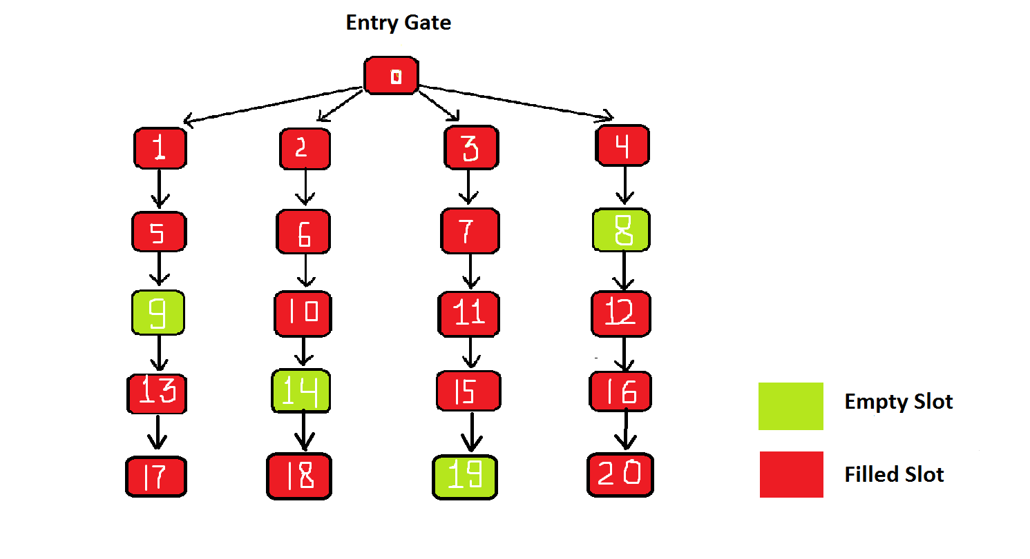

**BENEFITS OF INTELLIGENT CAR PARKING SYSTEM**

1. Havoc and waiting during parking is reduced.
2. Boon for old-age as nicely as beginner drivers who generally create problems while parking automobile.
3. Driving for search of a parking space is reduced, thereby reducing engine emissions.
4. The parked cars and their contents are more secure since there is no public access to parked cars.
5. Theoretically removes the need for parking assistance or labour.
6. It is highly feasible for extremely small sites that are unable to accommodate a conventional ramped parking structure.
7. There is high parking efficiency .
8. The patrons wait for their car in a highly controlled environment.
9. There are less chances for vehicle vandalism.
10. It is possible that the retrieval time is lower than the combined driving/parking/walking time in conventional ramped parking structures.

**METHODOLOGY**

**Features**

**Entry Model**

* Check for empty slot at the main entrance gate.
* Add a new car into the car parking system.
* Provides the user with nearest empty slot.
* Record of arrival and departure time.
  + - The system itself takes the real date and time.
    - There is no need for the user to enter the time.
* To search a car record in the parking system.
* To generate a security code at the entrance which will then be compared at the exit gate using hashmaps.

**Exit Model**

* Checking of security code.
* Different payment options
* Accounting
  + - Calculating the vehicle charges using real date and time feature.
    - Total income earned by the parking system itself.
* Display of Parking ticket.
* Exit and delete vehicle record from parking system .
* Exit - to end the program.

**CONCEPTS OF PROGRAMMING**

* Linked list
* Queues
* Tree(breadth first search)
* Logical operators.
* Hashmaps.

**HOW IT WORKS**

* Checking the empty slot by traversing the tree using breadth first search.
* Entering the details of the customer using customer class.
* Linking the customer details using linked list.
* Generation of security code using rand() function.
* Storing the security code as values with their respective vehicle number as keys using hashmaps.
* Recording on screen current date and time using GetLocalTime() function;
* Checking of security code in hashmap .
* If the security code does not match for the first time ,the user will have one more try left.
* If it doesn’t matches again it will alert the authority.
* Calculating of cost with the help of some predefined functions.
* Displaying parking area by printing the tree with colors using SetConsoleTextAttribute() function.
* Payment options displayed , using switch case and functions.
* Printing of parking slip.
* Vehicle exits.

**RESULT AND ANALYSIS**

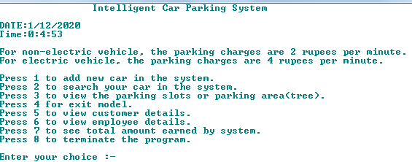

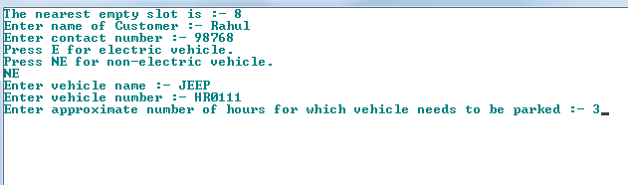

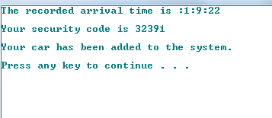

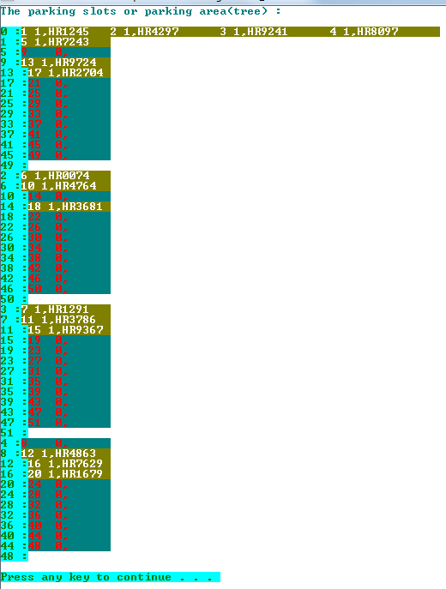 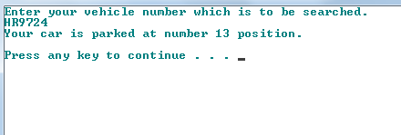

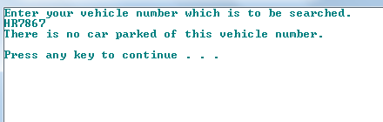

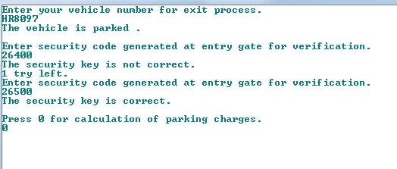

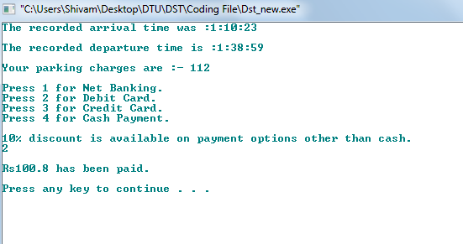

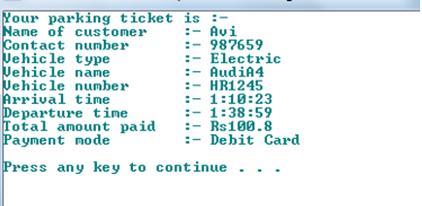

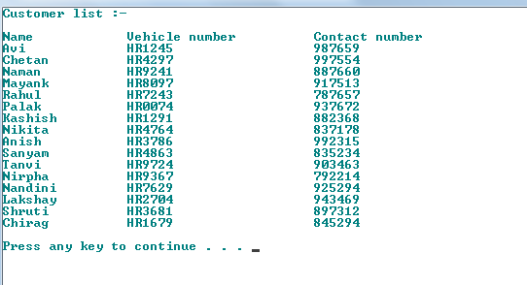

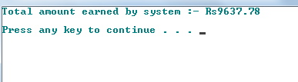

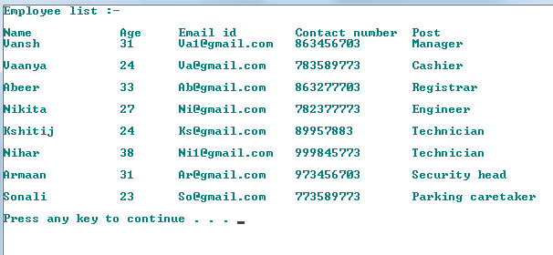

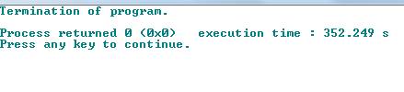

**The services which the Intelligent Parking System should provide in the future**

• The parking availability information system and parking reservation system should provide advanced navigation services.

• The mobile electric commerce system and a continuously working gate system should collect the toll charges electrically.

• An automated navigation system should assist in safe driving.

• An in-facility navigation system should provide the best possible traffic management.

• Provision of effective security for the safety of cars.

• Provision of strong functions for facilitating administrators and managers in management of the parking facility.

**Economic Analysis of Intelligent Car Parking System**

Economic analysis is the core study for assessing and exploring the project's feasibility. It plays an important role in deciding whether to start the project or not. Economic Analysis can be used to minimize risks and improve investment efficiency. The role of economic analysis is minimizing the risks and improving the investment efficiency. As intelligent parking service is a part of ITS, it can decrease the impact of uneven distribution of parking in different parking facilities. It uses the concepts of traffic impact analysis TIA for utilizing the engineering economy to analyze the advantages of regional parking guidance system. The economic analysis aims at:

* Reduction of negative impacts of parking services.
* Reduction of investment.
* Increasing the social, economic and environmental benefits of the parking facility.

One of the widely used economic analysis technique is [Cost-Benefit analysis](https://www.sciencedirect.com/topics/engineering/cost-benefit-analysis), which relies on discounted value benefits and cost for determination and evaluation of the resource allocation for both public and non-profit sector projects.

**CONCLUSION**

Various concepts of programming are used to make this car parking system which provides:

* Security of all the vehicles.
* This system helps to track all vehicles at the parking slots.
* It saves the time, space and tedious task of parking.

**Scope for future work**

In this project, various systems that provide intelligent parking services are discussed. Future work should be done for integrating different technologies together in order to achieve a system which is the most efficient, reliable, secure and inexpensive. The economic analysis should be done both quantitatively and qualitatively. After the economic analysis is done, then the project can be finalized.

**References**

* https://ijesc.org/upload/9b677bc3f024b6ede9a84a6ecb71cdbb.Intelligent%20Car%20Parking%20System.pdf

**Github Link**

* https://github.com/harshitgoel3/Intelligent-Car-Parking-System/blob/main/Dst_new.cpp