**Create a Spring Web Project using Maven**

**Code**

pom.xml:

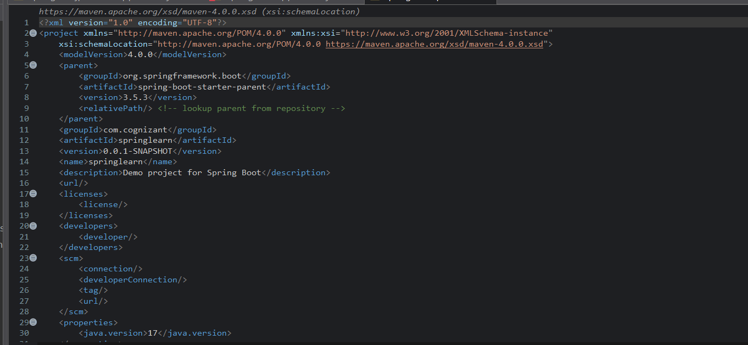

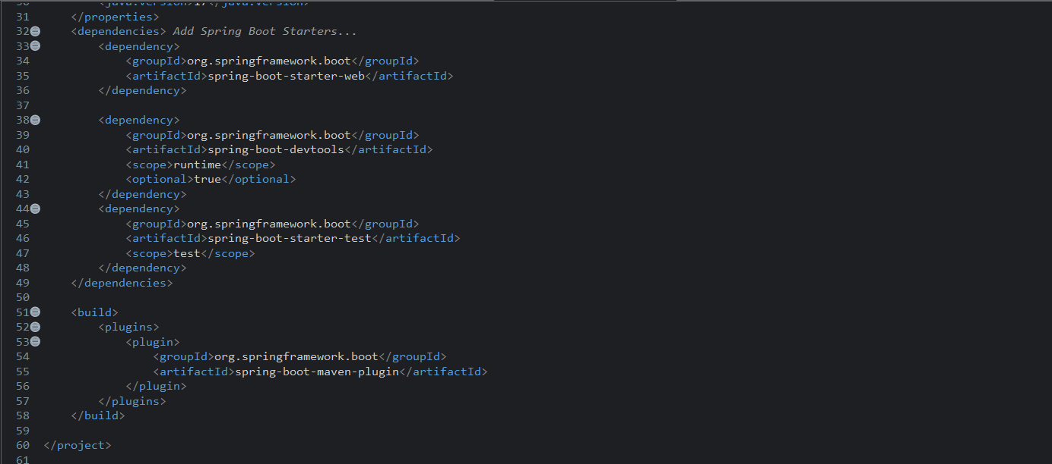

SpringlearnApplication.java

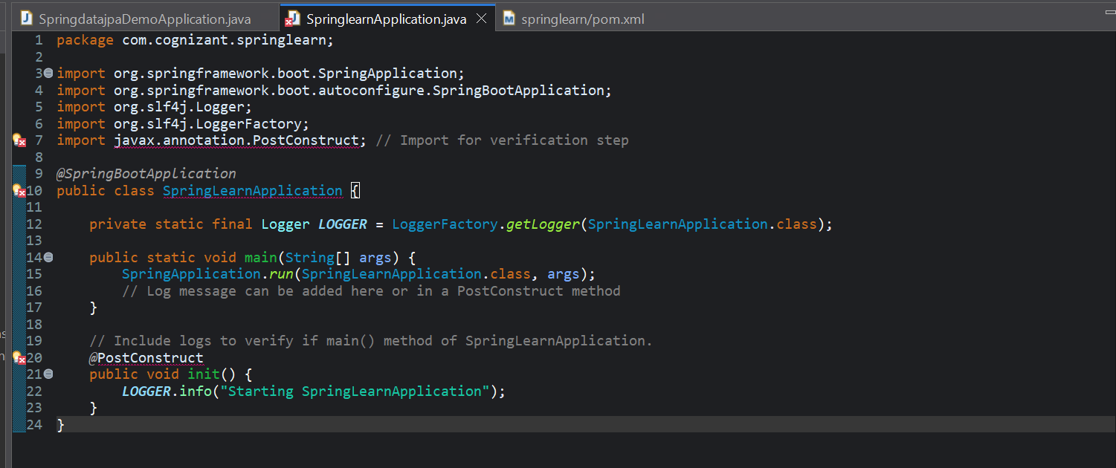

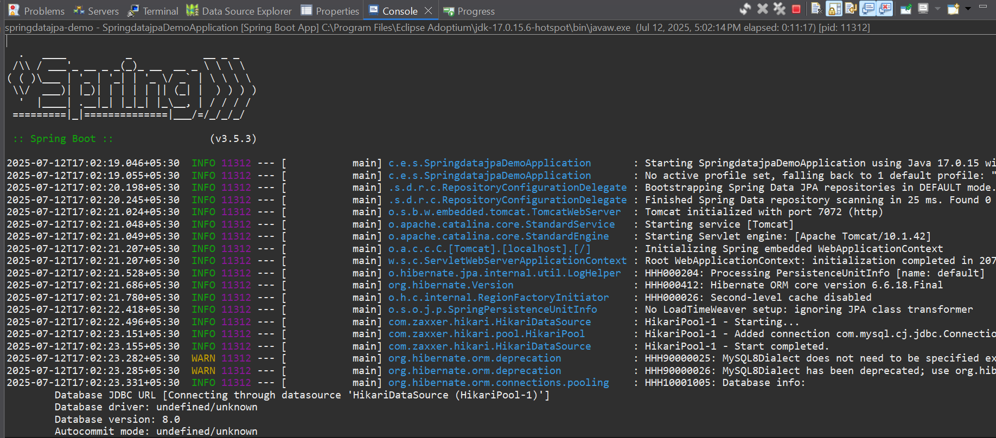

**Hands on 2**

**Spring Core – Load Country from Spring Configuration XML** 

**Code**

pom.xml:





application.properties

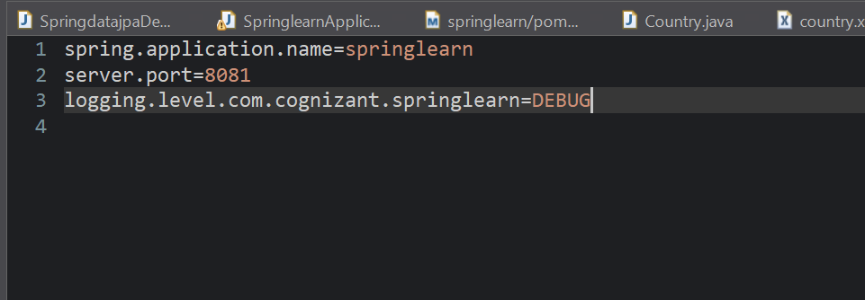

Country.xml

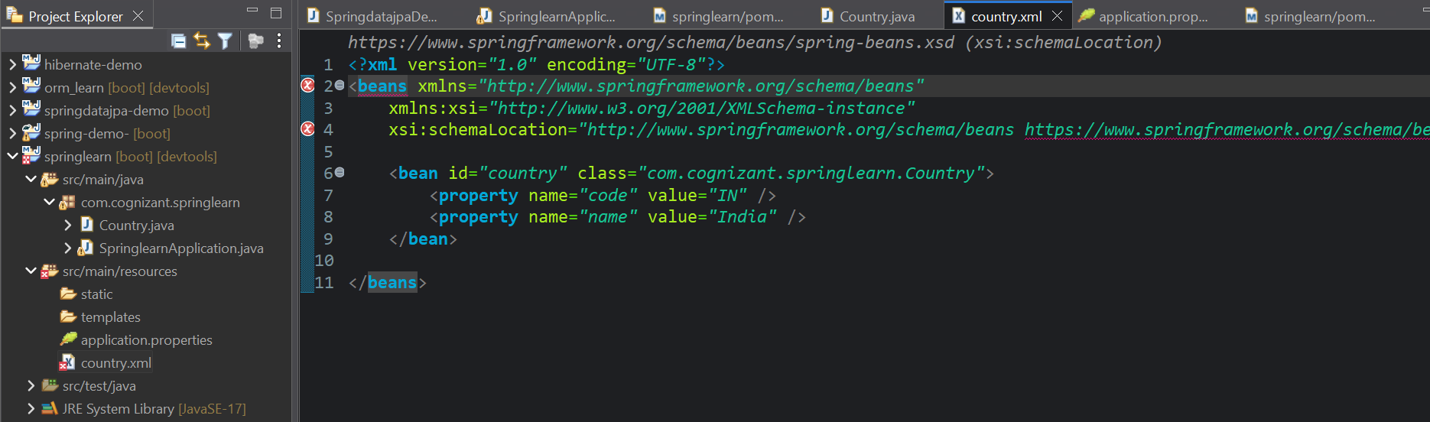

Country.java

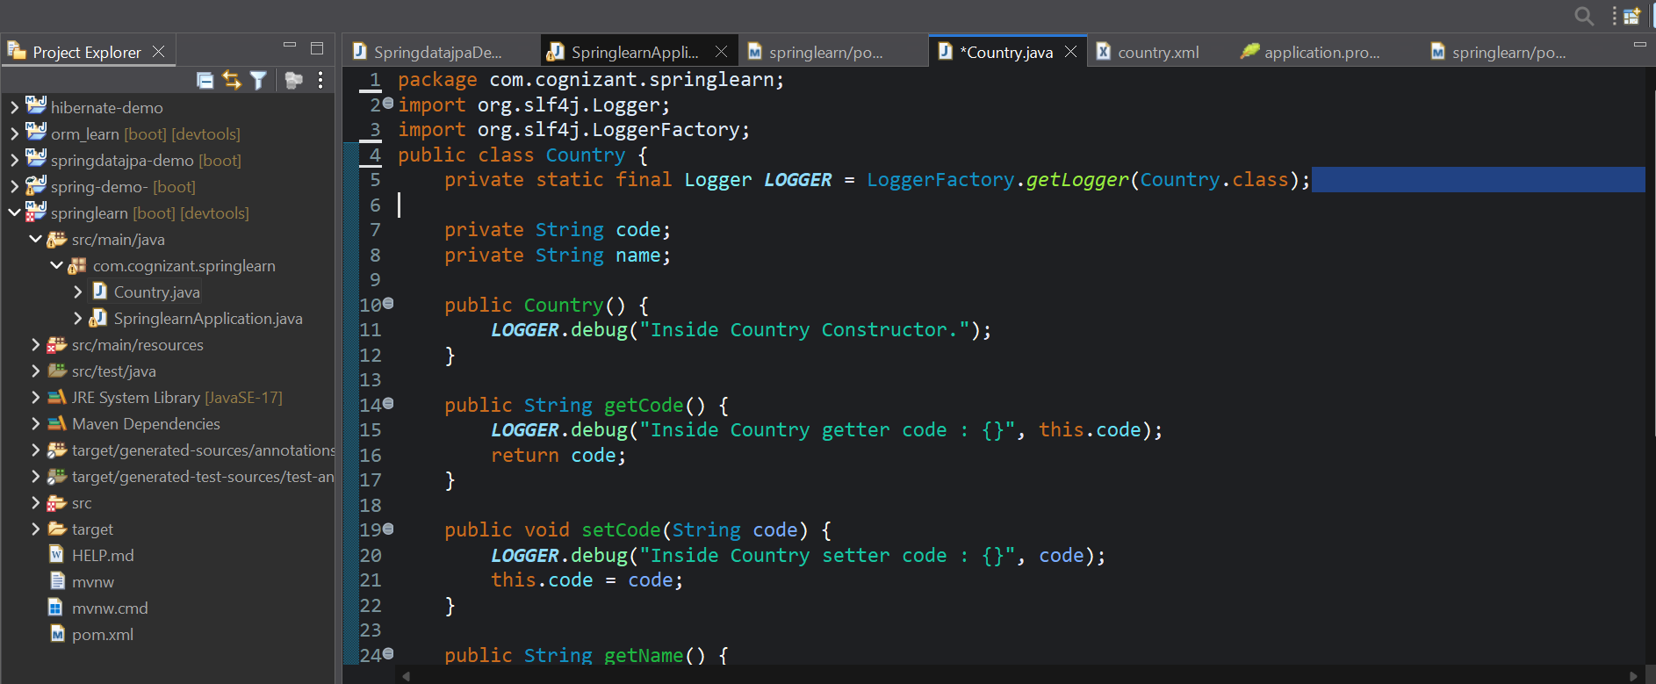

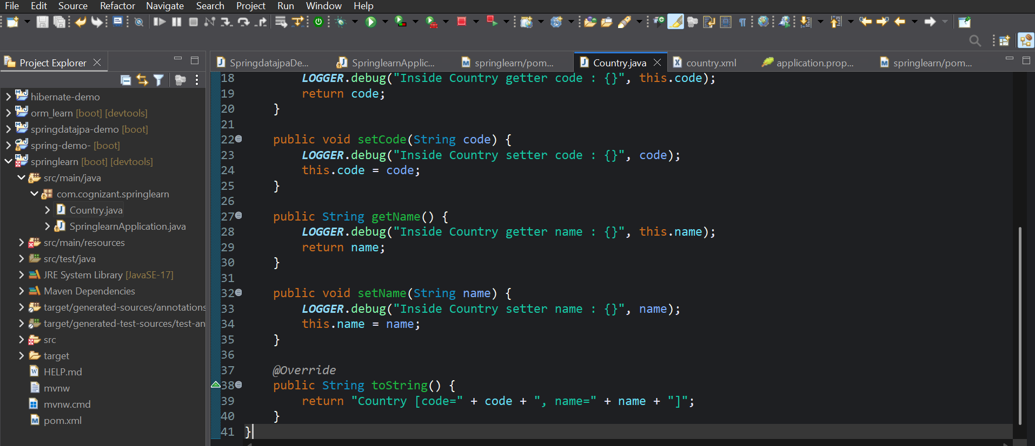

SpringlearnApplication.java

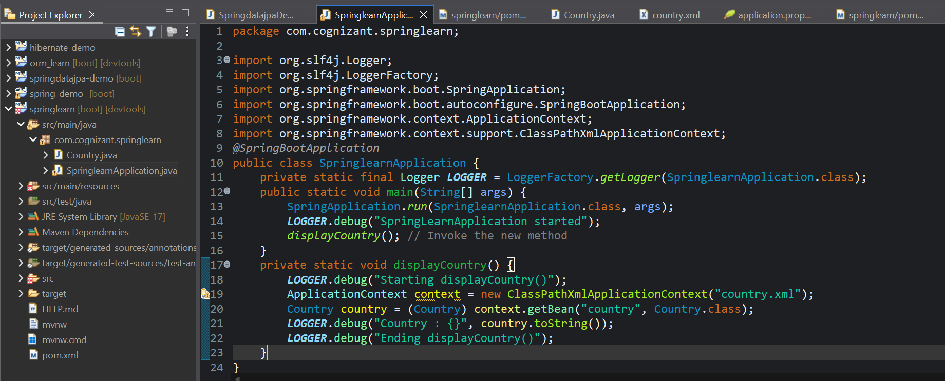

**Output**

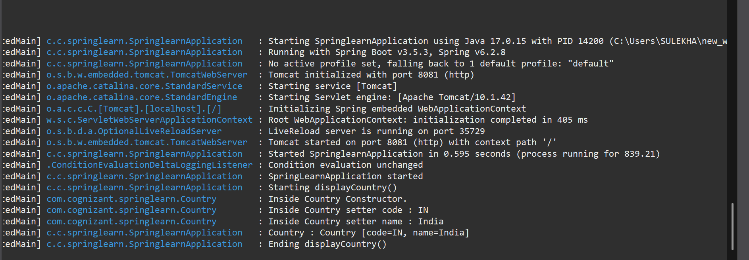

**Hands on 3**

**Hello World RESTful Web Service**

**Code**

pom.xml:





application.properties



HelloController.java

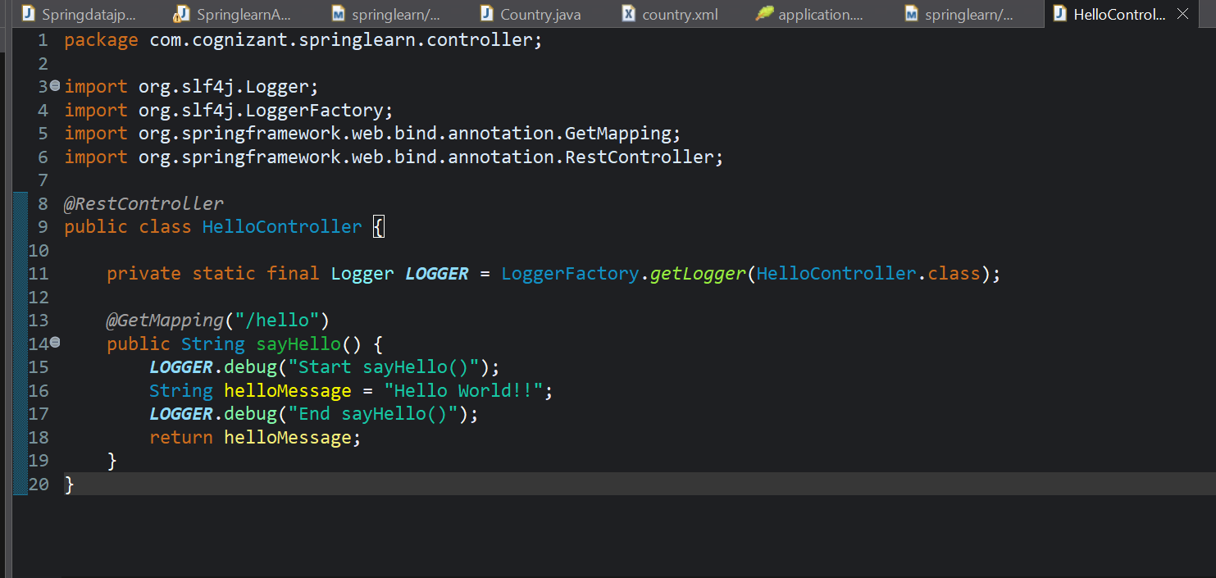

SpringlearnApplication.java



**Output**

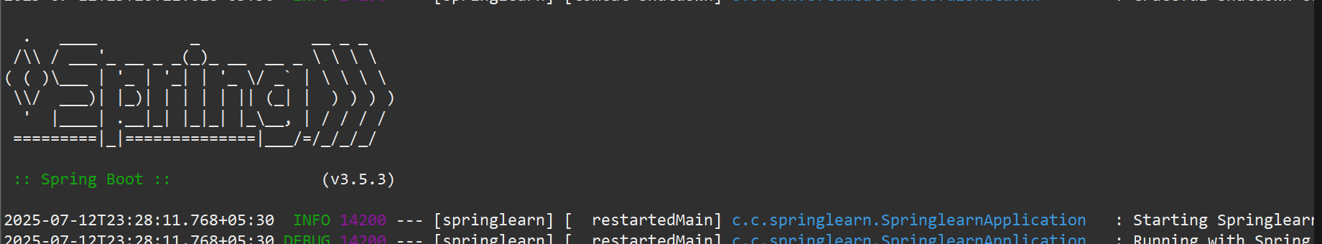 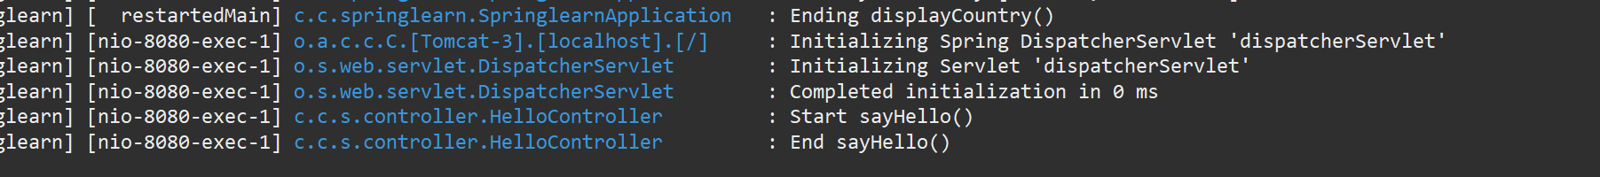

**Hands on 4**

**REST - Country Web Service**

**Code**

pom.xml:





application.properties

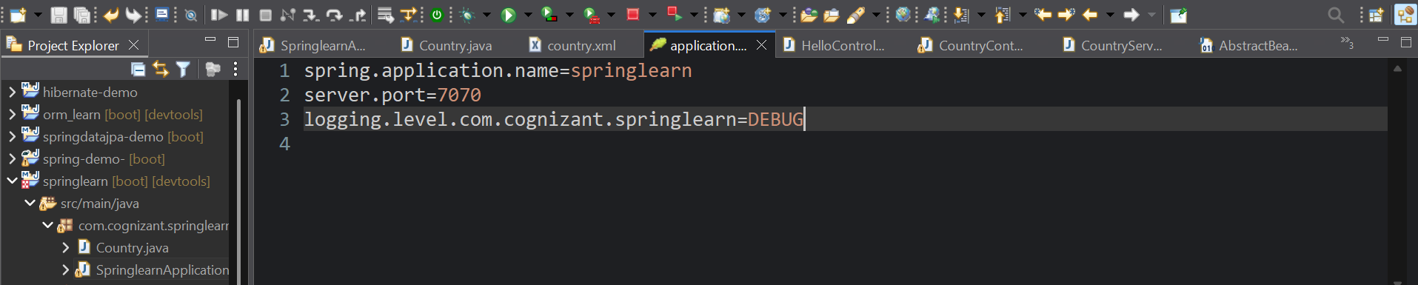

country.xml

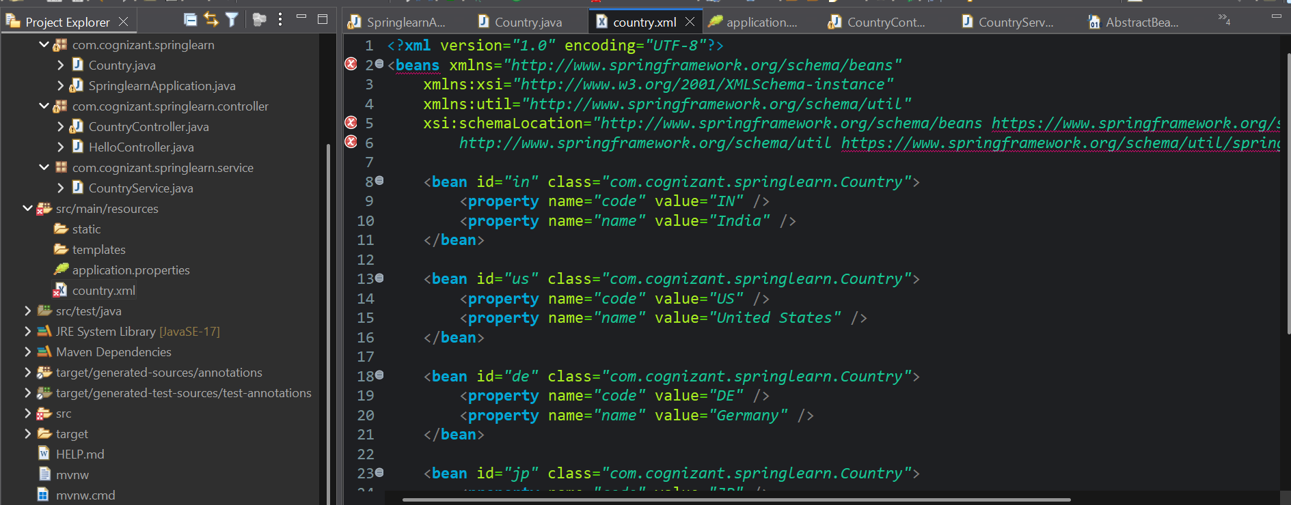 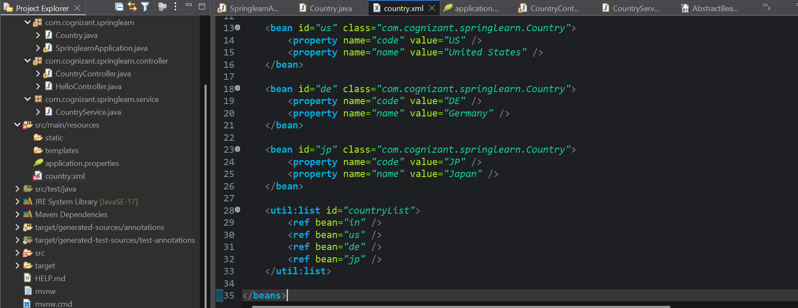

CountryController.java 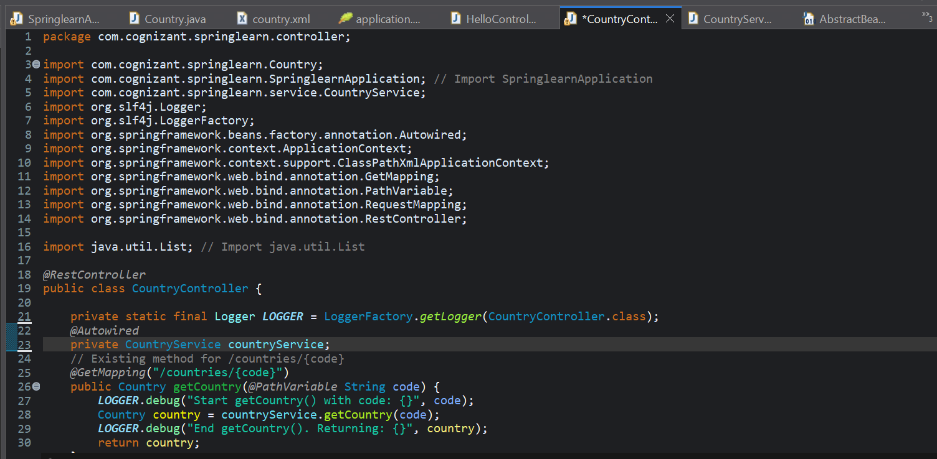 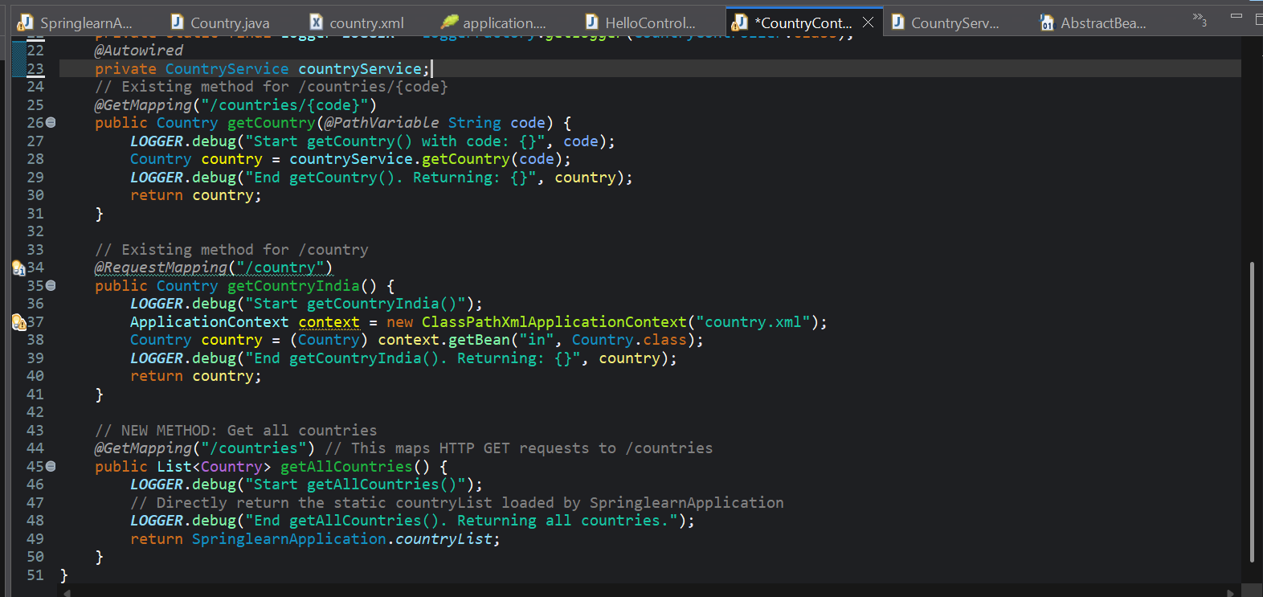

CountryService.java

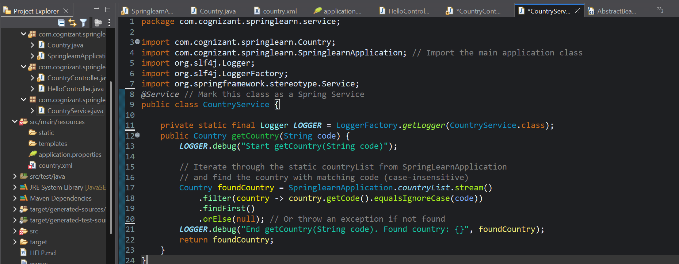

Country.java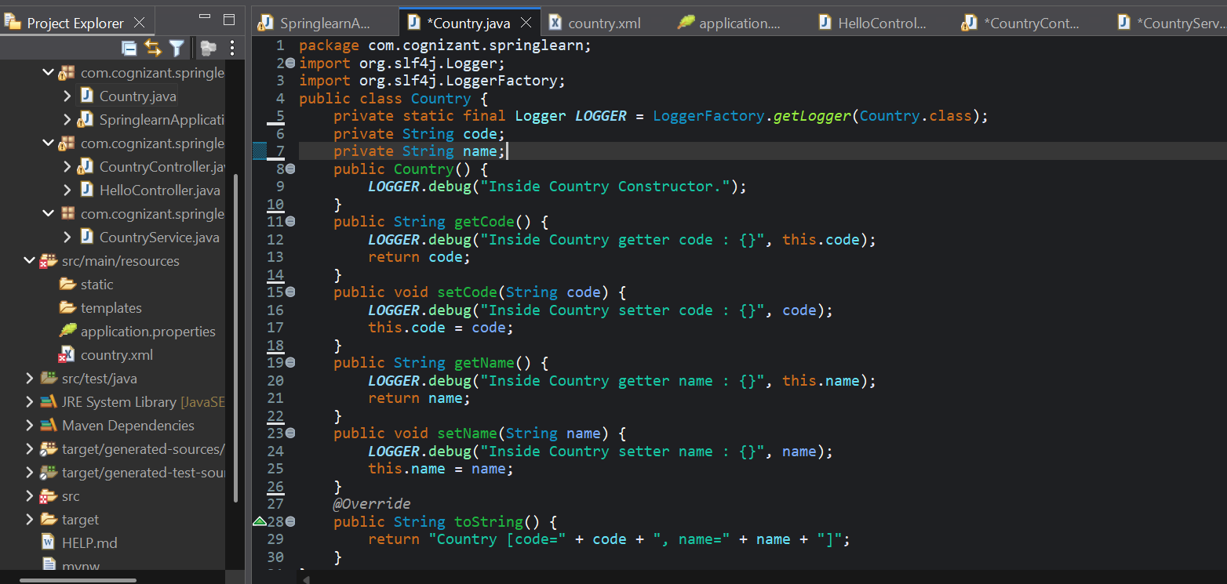

SpringlearnApplication.java

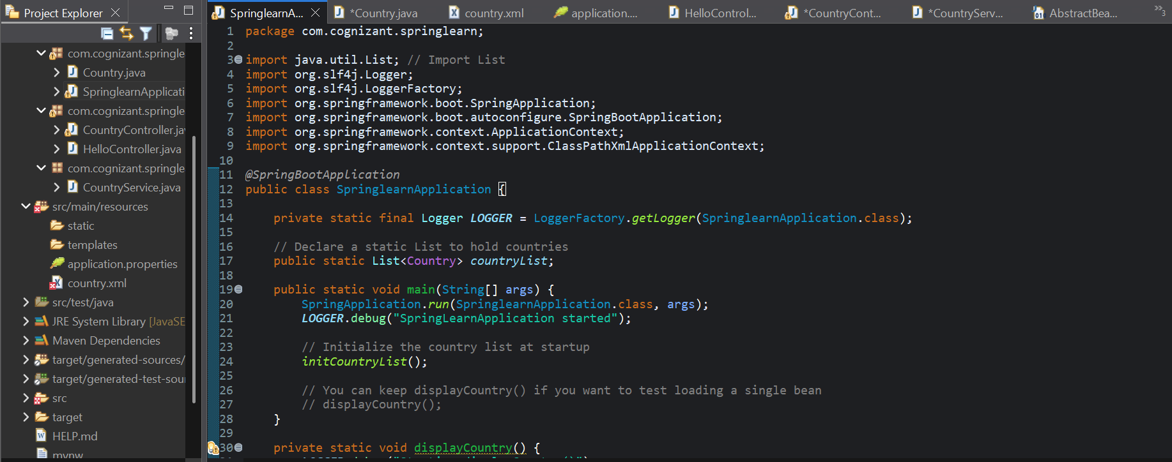 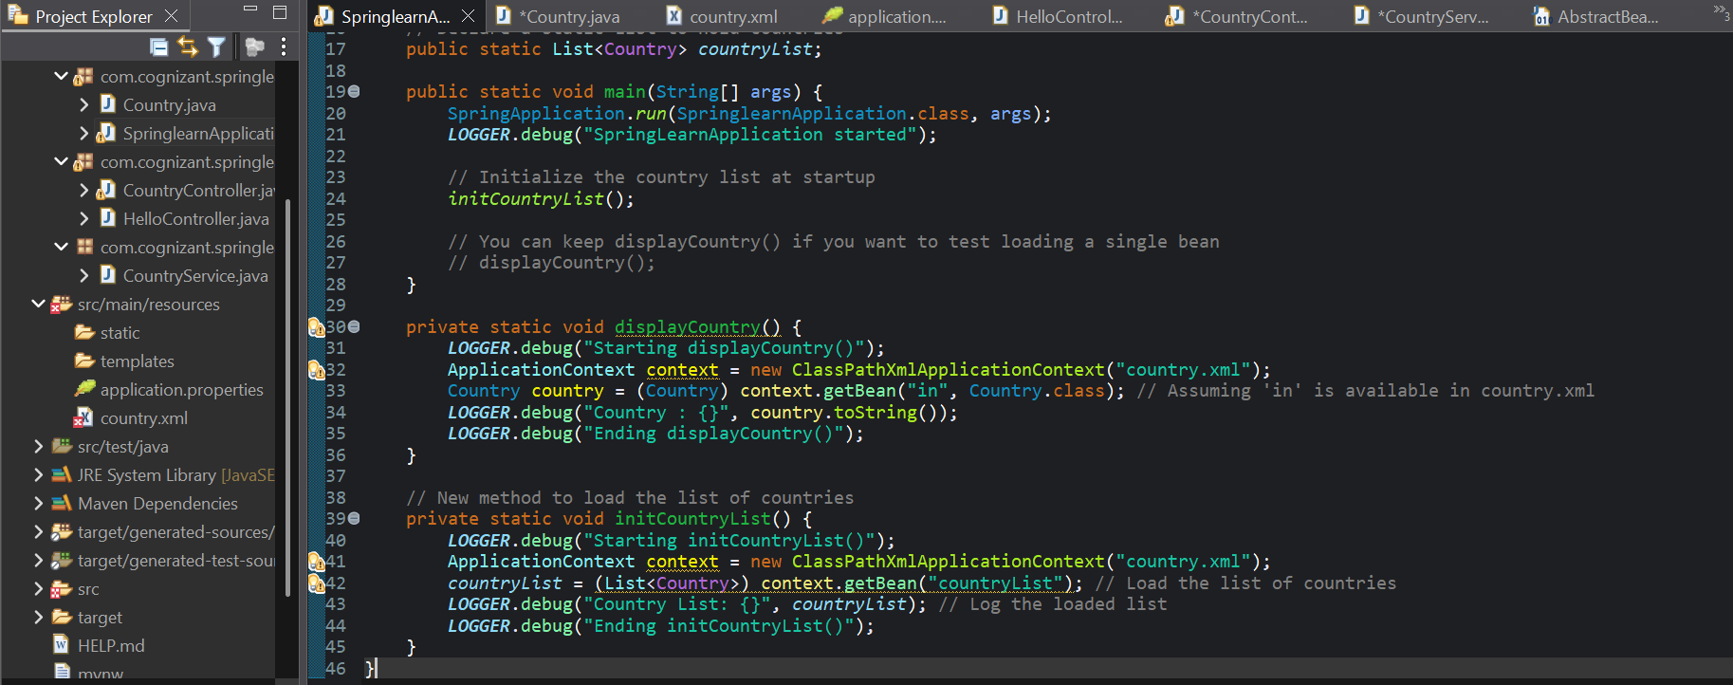

**Output**

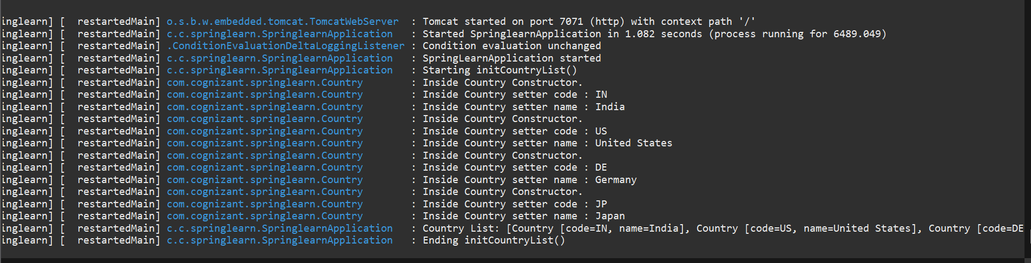

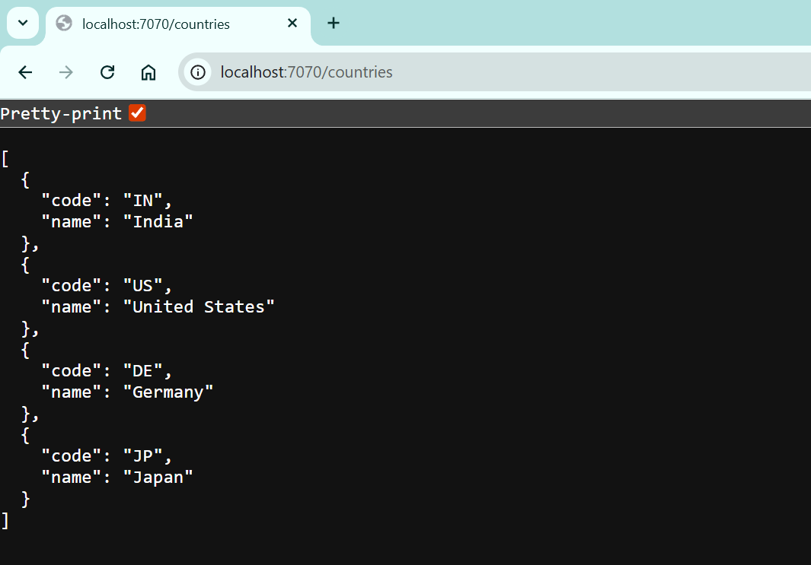

**Hands on 5**

**REST - Get country based on country code** 

**Code**

pom.xml:





application.properties

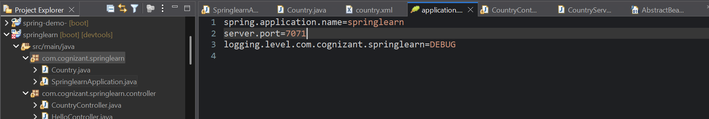

country.xml

 

CountryController.java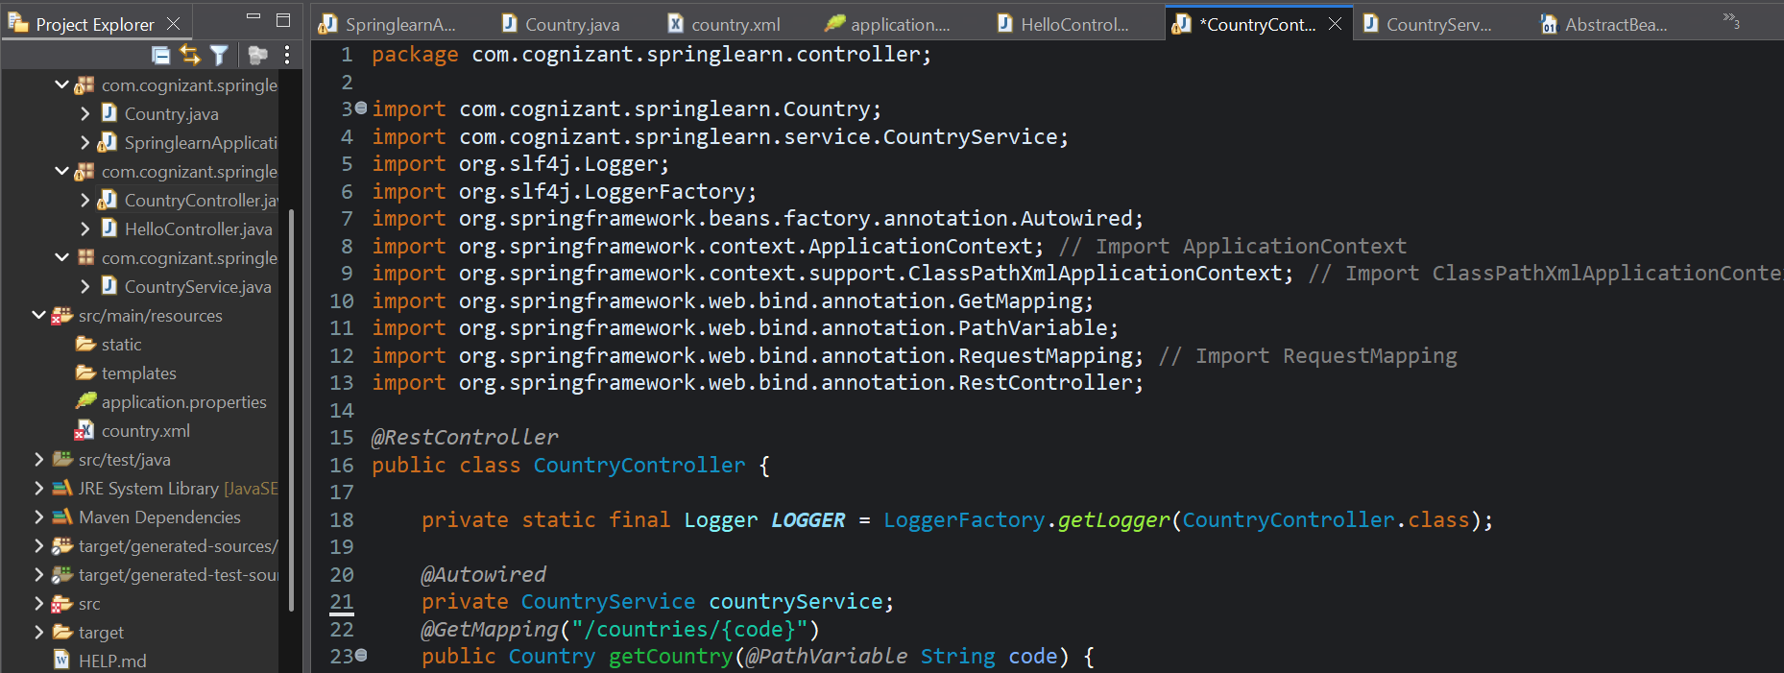 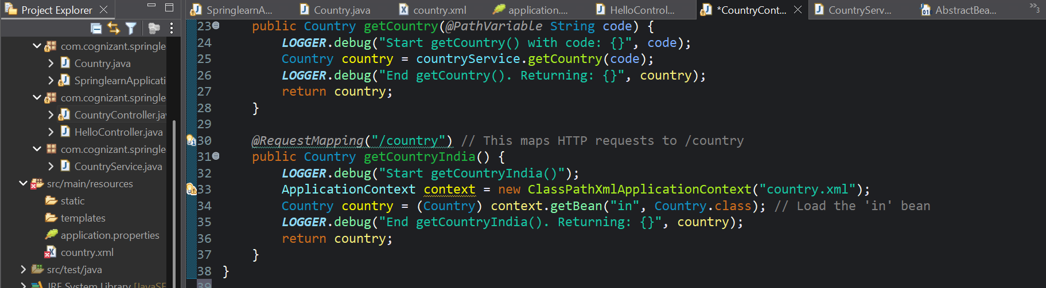

CountryService.java



Country.java



SpringlearnApplication.java

 

**Output**



