Shop Bridge

This project has four api's:

AddItem

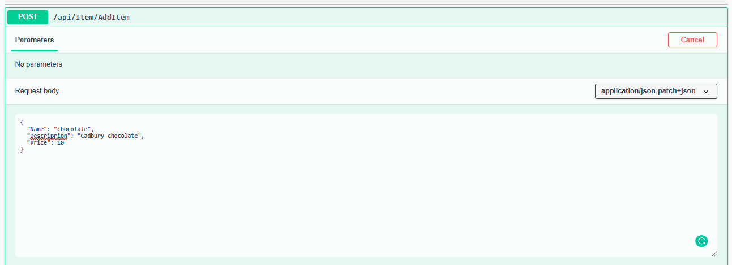
EditItem

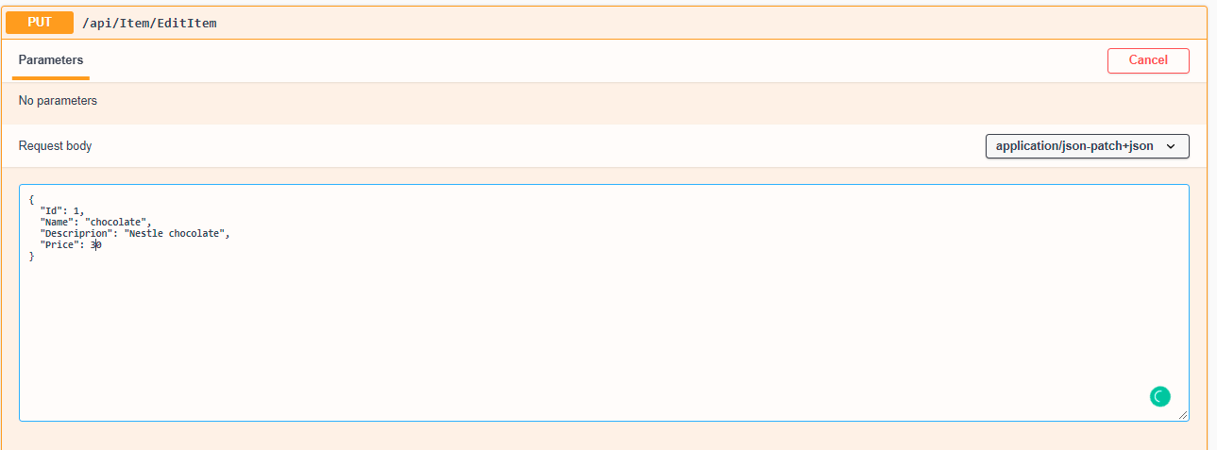
DeleteItem

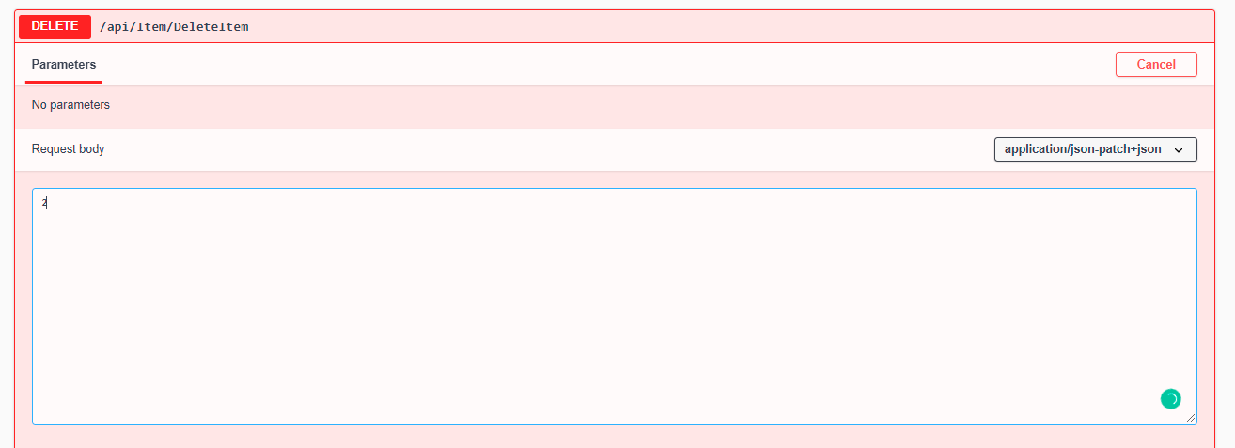

GetItems

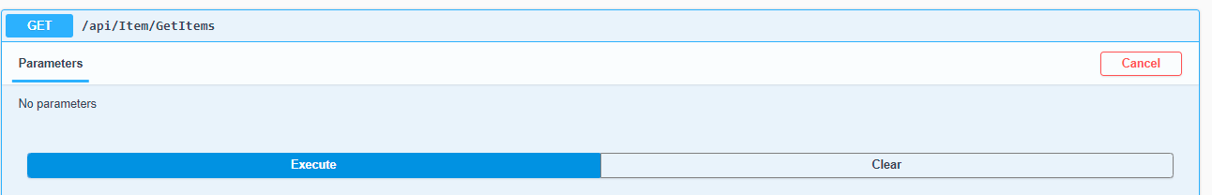

Nuget packages used in this app
- Dapper
- Nlog.Extension.Logging
- SwaggerUI

Steps to run this application

- Restore backup from DBBackup folder
- Change DB path from AppSetting.JSON
- Run the application
- Test it using /Swagger url or using postman

*Error will be logged in ShopBridge folder in C drive please create a folder.

