//CU_BEEE_EVALUATION//

**AIM :-**  **Design a system with two buttons such that**

**A. Red light when any button is pressed during night.**

**B. Green light when both buttons are pressed during night.**

**Circuit Diagram:-**

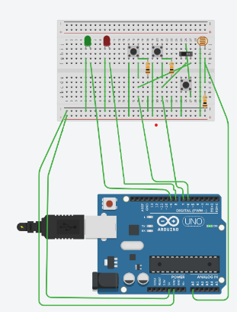

**COMPONENTS USED:-**

1. ARDUINO UNO.
2. BREADBOARD.
3. SWITCHES.
4. SLIDER SWITCH.
5. RESISTORS.
6. LED’S.
7. WIRES.
8. LDR.

**Ports of Arduino used:-**

1. **Digital pin :-** 9 ,8,7,6.
2. **Power:-5V,GND.**
3. **Analog in:-A0.**

**Concepts used:-**

## 1. A “Light Dependent Resistor (LDR) /

**Photoresistor” is a light-controlled variable resistor. The Resistance of a Photoresistor decreases with increasing incident light intensity.**

**2. A Switch is an**[**Electrical Component**](https://en.wikipedia.org/wiki/Electrical_component)**that can "make" or "break" an**[**Electrical Circuit**](https://en.wikipedia.org/wiki/Electrical_circuit)**, interrupting the**[**Current**](https://en.wikipedia.org/wiki/Electric_current)**or diverting it from one conductor to another.**

3. The Arduino Uno board can supply a power of 5V as digital output signals through 14 pins present in it as digital input or output pins.

4.Arduino also has five analog inputs(A0-A5) which are used to read the signals from a LDR.

**Learning and observations:-**

1. Learnt about different features and components of Arduino.

2.Learnt the use of LDR in context of resistance-light relation.

**Observations:-**

When we pass electrical signals from the Arduino through our Code , the LED glows and gets off accordingly.

**Sources of error:-**

1.The connecting wires had not be connected properly.

2.There may be some error in code in Arduino IDE .

3. Wrong insertion of wires in slots of breadboard.

**Precautions:-**

1.Attach the USB cable and connecting wires carefully with the system and with the Arduino.

2.Once the USB cable has been inserted then the Arduino connected to the USB cable should not be touched with bare hands , it can give you a shock.

**Learning outcomes:-**

1.Learnt how to make connections using breadboard and Arduino.

2.Learnt how to use LDR and control the LED along with using a switch and a slider switch.