**EXP.1 :- DESIGN AN LED FLASHER**

**CIRCUIT DIAGRAM:-**

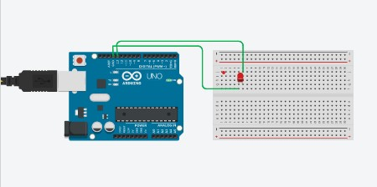

**Theory:**

**Concept Used:**

The entire circuit is built in the concept of output and input. We give an input and accordingly to the circuits give an output in the form of flashing of LED. The LED flashes according to the instruction uploaded in the Arduino board. The board is equipped with sets of Digital and Analog input and output pins. All the instruction given by the board are programmed using C programming. For this experiment we use digital pin 13 as output.

The positive terminal of the LED is connected to the digital pin 13 and the negative terminal is connected to the ground of the Arduino board.

**Learning & Observation:**

After doing this experiment I became familiar with circuit boards. Now I can distinguish between the input and output pins of a board easily. I learnt how to upload a program into a circuit board which I wasn’t familiar with before doing this experiment and also learnt how to blink an LED by uploading simple two line of C program. I also observed that how a simple change in code can affect the blinking of the LED.

**Problems & Troubleshooting:**

Basically I’d not encountered with so many problems doing this experiment but the one that I encountered was that I was unable to upload the program into the Arduino board though the program was correct. This occurred because of the board and port selection. Then I troubleshoot this problem by selecting the correct board from ‘Tools’ option and also the port in the Arduino software.

**Precautions:**

Precautions that one should take while doing his project are given below :

• Make sure you correctly select the board and port in the “Tools” option in Arduino

Software .

• Handle the Arduino board carefully as a simple damage can made the hardware

useless.

• Keep in mind that you should write program that is small in size as it came with

low inbuilt memory.

• Carefully connect the positive terminal to the output pin of the circuit as any

wrong connection would make flasher to not work.

**Learning Outcomes:**

Through this experiment I came to learn about the Arduino board and working of it. Before doing this experiment whenever I had seen a LED flasher I was always wondering how it works. But now as I gone through this experiment I know how it works. Now I can also do more advance thing related to this by writing some C program according to the outcomes I want from the board.