**Experiment :- Smartphone controlled light system.**

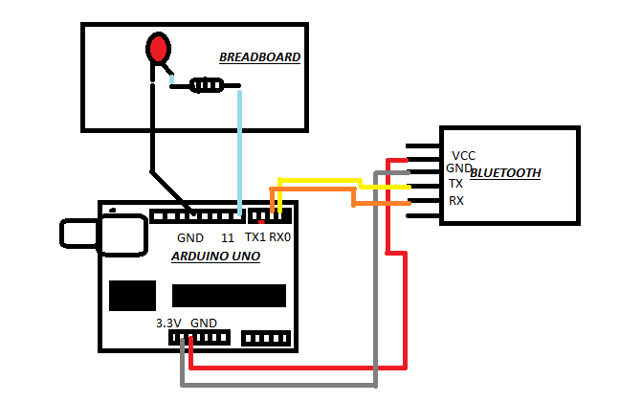

*Concept Used :-*

1) Bluetooth, Smartphone and LED Flasher.

2) In the Experiment we used a Bluetooth Integrated Circuit to glow the LED in Breadboard.

3) Concept Used in this experiment is how the Bluetooth IC is to be connected to the Arduino so that the signals can easily be transferred and received.

4) A circuit is made using Bluetooth and Arduino. TX of Bluetooth is connected to 0 of Arduino.

5) Ground of Bluetooth is connected to ground of

Arduino and VCC (high voltage) is connected 5V of Arduino.

*Learning and Observations : -*

1. Concept of Understanding of Transfer and Receiver.

2. Connection need to be made to execute the experiment.

3. Connecting Bluetooth to Arduino.

4. Ground of Bluetooth is connected to ground of Arduino

5. Signals are transmitted from Bluetooth to Arduino.

6. Bluetooth receives the signals by Rx(0) an abbreviation used for Receiver.

7. Coding to be done on Arduino.exe for stimulation of the experiment.

Problems and Troubleshooting:

* Making the circuit was not that challenging but the code understanding was more difficult than implementing it.

***Precautions :–***

1. Connection of the TX and RX pins.

2. Use of Multimeter for checking whether the device is damaged.

3. The coding done can be incorrect due to which stimulation can be processed.

4. Port Selection for Arduino can be incorrect due to which it won’t upload on Arduino Board and resulting in failure of experiment.

*Learning Outcomes****: –***

1. Making connection of Bluetooth and Arduino.

2. Connecting Bluetooth and Arduino.

3. Using and making connection of TX and RX.

4. Working and coding of Arduino.