***Experiment: Obstacle detector and distance measuring device.***

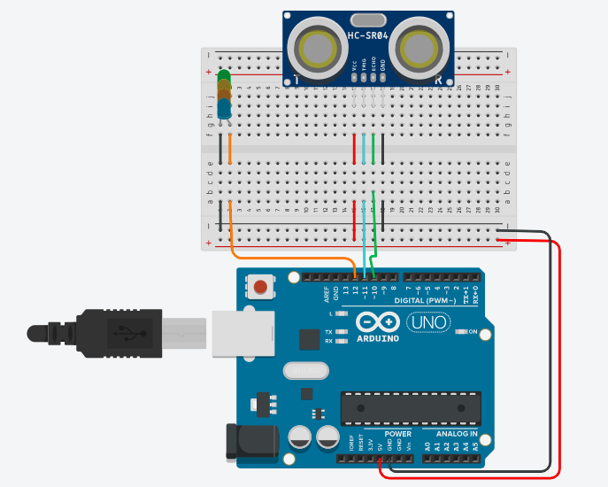

**Concept Used :-**

1. The obstacle detector works on the principle of transmitting and receiving the Ultrasonic signal, and calculating the distance by measuring the time between transmitting and receiving the signal.
2. VCC terminal of ultrasonic sensor is connected to the 5V supply to get voltage.
3. TRIG pin is connected to the 9 number digital pin and it produces ultrasonic wave.
4. ECHO pin is connected to the 10 number digital pin and it receives the reflected back wave.
5. If the distance is greater than 20cm then LED glows.

**Learning and Observations :-**

1. Connection between the Arduino and Ultrasonic signal transmitter IC.

2. Coding to be done for Arduino.

3. Basic understanding of Electrical Connections.

4. What’s inside the Ultrasonic Signal Transmitter Integrated circuit.

**Problems and Troubleshooting:**

* It was one of the easiest task that I ever performed in this wonderful lab.

**Precautions:-**

1. Using Multimeter to check whether the devices are damaged or not.
2. Port selection for Arduino.

**Learning and Outcomes:**

1) Learnt to make circuits using breadboard, Arduino board and other equipment.

2) Learnt to make other type of gadgets related to this concept.

3) Learnt how we can use the Arduino board for doing various tasks.

4) Learnt about the elements of Arduino board and its functions.