**Experiment Door Bell**

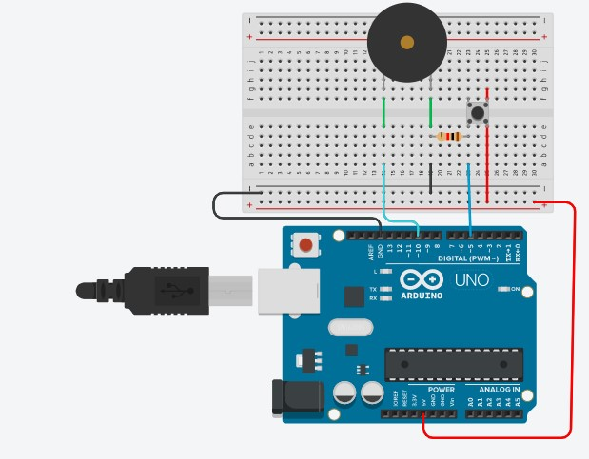

# Concept Used :-

This Experiment states the working of Doorbell using Buzzer with the help of Arduino.

The following circuit consists of 2 digital pins that are used where a pin7 making connection of buzzer with Arduino along with the ground. Another pin10 is connected to switch. One end of the switch is connected to 5V supply and intersection of pin 12 and switch is connected to resistor which is connected to ground from another end.

Value of resistance is kept high. The resistors are used to resist the flow of current.

# Learning and Observations : -

1. Understanding of connections in the respect with the given problem.
2. Making circuits using Arduino.
3. Connecting buzzer and switch on breadboard with arduino.
4. Coding to be done on Arduino.exe for stimulation of the experiment.
5. How does Toggling works.

# Problems & Troubleshooting: –

No problem occurred during the execution of the experiment.

# Precautions :-

* 1. Making Correct connection.
  2. Using Multimeter to check whether all the devices are in working condition or not.
  3. Correct sets of instructions are provided or not to perform the specific function
  4. Port Selection for Arduino can be incorrect due to which it won’t upload on

# Learning Outcomes: –

1. Setting up correct connections to the Arduino.
2. Connecting switch, buzzer and Arduino.
3. Using switch and buzzer.
4. Working and coding of Arduino.

# Result: –

Working of buzzer and switch verified after uploading the program. Doorbell is ready to ring.