**Experiment :- Switch**

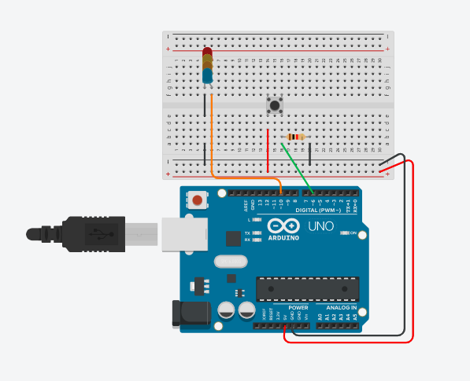

**Concept Used :-**

1) A circuit consists of 2 digital pins are used where a pin10 making connection with LED and to the ground.

2) Now one terminal of switch is connected to 5V supply and to resistor of 10K ohm and the same terminal is connected to the pin7 of digital pin.

3) Now the 10K ohm resistor is connected to ground.

4) When switch is pressed LED starts to glow.

**Learning and Observations: -**

1) Learnt to use Arduino Board and how the code will work whenever the switch is pressed LED glows.

2) How a circuit is placed on breadboard so that it can work properly.

3) Arduino board has Digital pins and Analog pins.

1. Digital pin provides Input as well as Output, but Analog pin provides only input.

4)The Arduino board has ~ sign in Digital pin side which is also known as “Pulse Width Modulation(PWM)”**.**

* These pins help’s in getting Analog signals with digital means.

**Problems and Troubleshooting:**

No major issues were faced during the wonderful experiment.

**Precautions :-**

1. Making Correct connection.

2. Using Multimeter to check whether all the devices are in working condition or not.

3. Correct sets of instructions are provided or not to perform the specific function

**Learning Outcomes: –**

1. Setting up correct connections to the Arduino

2. Connecting switch, LED and Arduino.

3. Using switch and LED.

4. Working and coding of Arduino.