SH-205 — Intelligent Shipment Piggybacking
Full Prototype Build Document — Product, UI, Architecture & ML Pipeline
Core engine status: fully specified (Predict → Price → Plan → Prove, engines E1–E8). This document adds: everything that has to exist around that engine for it to be a demoable, judgeable product — roles, screens, Maps integration, heatmap rendering, tech stack, data model, APIs, and how Colab-trained models actually get into your FastAPI backend.

0. One-line pitch (recap)
The system predicts where shipments will go missing and pre-buys cargo space against that risk; when a misplacement happens it prices the shipment's urgency as a rupees-per-hour figure, runs a reverse auction among vehicles already heading that way, plans the recovery across a time-expanded transport network, re-plans in milliseconds when the network changes, and justifies every rupee with a counterfactual audit trail.
Predict → Price → Plan → Prove.
Everything below exists to let a human — admin, dispatcher, or driver — see that loop happen and act on it.

1. Complete System Architecture
Four layers: Clients → API/Realtime → Core Engine + ML → Data. Colab is not a runtime component — it's where models are trained; the backend only ever loads exported artifacts.
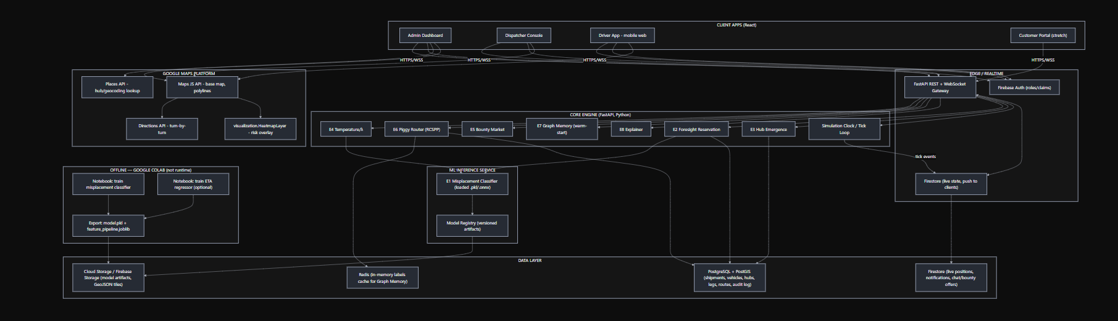
GOOGLE MAPS PLATFORM
DATA LAYER
OFFLINE — GOOGLE COLAB (not runtime)
ML INFERENCE SERVICE
CORE ENGINE (FastAPI, Python)
EDGE / REALTIME
CLIENT APPS (React)
HTTPS/WSS
HTTPS/WSS
HTTPS/WSS
HTTPS/WSS
tick events
Admin Dashboard
Dispatcher Console
Driver App - mobile web
Customer Portal (stretch)
FastAPI REST + WebSocket Gateway
Firebase Auth (roles/claims)
Firestore (live state, push to clients)
E4 Temperature/λ
E6 Piggy Router (RCSPP)
E5 Bounty Market
E7 Graph Memory (warm-start)
E8 Explainer
E2 Foresight Reservation
E3 Hub Emergence
Simulation Clock / Tick Loop
E1 Misplacement Classifier (loaded .pkl/.onnx)
Model Registry (versioned artifacts)
Notebook: train misplacement classifier
Notebook: train ETA regressor (optional)
Export: model.pkl + feature_pipeline.joblib
PostgreSQL + PostGIS (shipments, vehicles, hubs, legs, routes, audit log)
Firestore (live positions, notifications, chat/bounty offers)
Cloud Storage / Firebase Storage (model artifacts, GeoJSON tiles)
Redis (in-memory labels cache for Graph Memory)
Maps JS API - base map, polylines
Directions API - turn-by-turn
visualization.HeatmapLayer - risk overlay
Places API - hub/geocoding lookup
Why this shape:
- FastAPI is the single source of truth for the engine. React never talks to the ML model or Postgres directly — everything goes through the API/WebSocket gateway.
- Firestore is the "nervous system," not the "brain." It carries live ticks, notifications, and bounty offers to clients in real time. The actual optimization state (graph, labels, plans) lives in Postgres/Redis inside the FastAPI process, because the router needs transactional, queryable, relational data — Firestore is the wrong tool for RCSPP state.
- Colab is fully decoupled from production. You train in a notebook, export two files (model + preprocessing pipeline), upload them to Cloud/Firebase Storage, and the backend's model registry loads whichever version is tagged latest. Retraining never touches the running API — you just drop a new artifact in storage and hot-swap it.

2. Tech Stack — decisions and why
Layer | Choice | Why
Frontend | React + TypeScript + Vite, Tailwind, shadcn/ui | Fast to build dashboards, component reuse across Admin/Dispatcher/Driver
Maps | Google Maps JavaScript API (visualization, geometry libraries) | Native heatmap layer, click-on-polyline events, Directions API for driver turn-by-turn
Charts | Recharts | Metrics panel (SLA%, cost, vehicle-km, latency)
Realtime transport | FastAPI WebSocket for engine ticks + Firestore listeners for notifications/bounty offers | WS for high-frequency simulation ticks (sub-second), Firestore for durable, per-user event streams (offer received, plan changed)
Backend / core engine | FastAPI (Python 3.11) | Same language as the ML/optimization code (NetworkX-style graph, OR logic) — no serialization boundary between engine and API
Auth | Firebase Auth with custom claims (role: admin | dispatcher | driver | customer) | Free, fast to wire into React, role claims read directly in FastAPI via verified ID token
Relational data | PostgreSQL + PostGIS | Shipments/vehicles/hubs/legs are relational and geo-indexed; PostGIS gives you ST_DWithin for the geo-filter pruning step in the Piggy Router for free
Fast cache | Redis | Graph Memory's retained labels, dominance-pruned partial paths — needs sub-ms read/write
Live/document data | Firestore | Live vehicle positions, push notifications, bounty offer inbox — good fit for its strengths (fan-out to many listening clients)
ML training | Google Colab (offline only) | scikit-learn / XGBoost for E1 classifier — explainable, no GPU needed
Model artifacts | joblib/pickle, stored in Firebase Storage / GCS, loaded by a small ModelRegistry class in FastAPI at boot + hot-reload endpoint | Keeps Colab and production cleanly separated
Hosting | Frontend → Firebase Hosting; Backend → Cloud Run (containerized FastAPI); Postgres → Cloud SQL or Supabase for speed | Cheap, fast to deploy for a hackathon, autoscaling not needed but available
Background jobs | FastAPI BackgroundTasks or a simple asyncio loop driving the tick() function from the core engine spec | No need for Celery/Kafka at prototype scale (5,000 simulated shipments)
This keeps your stated preferences (React, Firebase, FastAPI) and slots Colab in purely as a training environment whose only contract with the backend is "produces a model.pkl and a feature_pipeline.joblib that the ModelRegistry can load."

3. Users & Roles
Role | Who | Core need
Admin | Ops head / network manager | Configure hubs/vehicles, set global Policy Mode, view Hub Emergence candidates, see full analytics
Dispatcher | Ops staff monitoring recoveries | Watch the misplaced-shipment queue (sorted by Temperature), inspect/approve/override recovery plans, read the Explainer
Driver | Vehicle operator (owned or third-party) | See own route, receive & respond to bounty offers within the countdown window, get turn-by-turn to the pickup
Customer (stretch, optional) | Shipment owner | Track shipment, see live ETA, optionally pay a premium to raise λ / expedite
Role is stored as a Firebase custom claim and re-verified server-side on every FastAPI request (never trust the client's stated role).

4. Workflows per role
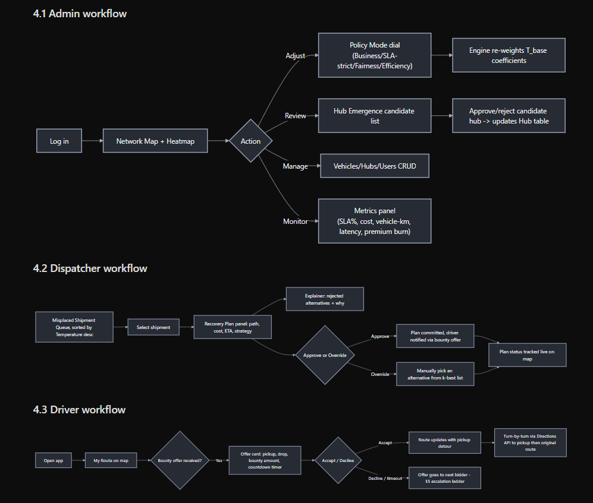
4.1 Admin workflow
Adjust
Review
Manage
Monitor
Log in
Network Map + Heatmap
Action
Policy Mode dial
(Business/SLA-strict/Fairness/Efficiency)
Hub Emergence candidate list
Vehicles/Hubs/Users CRUD
Metrics panel
(SLA%, cost, vehicle-km, latency, premium burn)
Engine re-weights T_base coefficients
Approve/reject candidate hub -> updates Hub table
4.2 Dispatcher workflow
Approve
Override
Misplaced Shipment Queue, sorted by Temperature desc
Select shipment
Recovery Plan panel: path, cost, ETA, strategy
Explainer: rejected alternatives + why
Approve or Override
Plan committed, driver notified via bounty offer
Manually pick an alternative from k-best list
Plan status tracked live on map
4.3 Driver workflow
Yes
Accept
Decline / timeout
Open app
My Route on map
Bounty offer received?
Offer card: pickup, drop, bounty amount, countdown timer
Accept / Decline
Route updates with pickup detour
Offer goes to next bidder - E5 escalation ladder
Turn-by-turn via Directions API to pickup then original route
4.4 Customer workflow (stretch)
flowchart LR
A[Track shipment] --> B[Timeline: origin -> current -> destination]
B --> C{Misplaced?}
C -->|Yes| D[Shown: "recovering, revised ETA X"]
C -->|No| E[Normal tracking]
D --> F["Pay to expedite (raises λ via customer premium input)"]

5. UI / Dashboards — screen by screen
5.1 Admin Dashboard
- Network Map (primary screen) — Google Map, base layer = hubs (pins) + active vehicle routes (polylines) + risk heatmap overlay (toggle on/off, time-of-day slider). Clicking any polyline opens an info panel (§6).
- Policy Mode selector — dropdown/dial: Business / SLA-strict / Fairness / Efficiency. Changing it live re-weights T_base coefficients server-side; next tick visibly changes recommended plans — this is your strongest "look, it's adaptive" demo control.
- Hub Emergence panel — ranked candidate list: location, usage_count, mean_risk, est. savings, Approve/Reject buttons.
- Vehicles / Hubs / Users tables — CRUD, filterable, with capacity/residual bars.
- Metrics dashboard — Recharts panels: SLA% vs baseline, cost/shipment vs baseline, % recovered via existing capacity, vehicle-km avoided, median re-plan latency, premium burn ratio (Foresight-specific — put this front and center, it's the number sharp judges ask for).
5.2 Dispatcher Console
- Misplaced Shipment Queue — table sorted by Temperature (hottest first), color-coded zones (Cold/Warming/Hot), live-updating via WebSocket tick.
- Recovery Plan Detail — selected shipment's chosen path drawn on the map, cost/ETA/strategy badges (PIGGYBACK / HYBRID / DEDICATED / PRE_RESERVED).
- Counterfactual Explainer panel — the rejected-alternatives block (§ core engine E8), rendered as a readable card, not raw JSON.
- Bounty Auction monitor — live view of an in-progress reverse auction: eligible vehicles, bids as they arrive, countdown, winner highlight.
- Override control — pick from k-best (top 5) alternative plans instead of the engine's top pick, with a required reason (logged to audit trail).
5.3 Driver App (mobile-first web view)
- My Route — current assigned route on the map.
- Offer Inbox — incoming bounty offers as cards: pickup point, drop point, payment, countdown ring. Accept/Decline.
- Active Pickup — turn-by-turn (Directions API) once an offer is accepted, with pickup instructions and shipment barcode/QR to scan on load.
- Earnings — simple ledger of bounty payments received.
5.4 Customer Portal (stretch)
- Track shipment — timeline + live map pin.
- Expedite — slider/input for "willing to pay up to ₹X to save time," feeds directly into MaxBounty as an input, not an override.

6. Google Maps Integration — the "click a route, get info" feature
Goal: clicking a rendered route (a Leg, drawn as a google.maps.Polyline) opens an info panel with everything a dispatcher or driver needs about that specific movement.
6.1 How it's built
- Each Leg from the core engine is rendered as a Polyline with a unique leg_id attached via polyline.set('legId', leg.id).
- A single click listener is attached per polyline (or delegated via a MarkerClusterer-style approach if the route count gets large):
polyline.addListener('click', (e) => {
const legId = polyline.get('legId');
fetchLegDetail(legId).then(detail => openInfoPanel(detail, e.latLng));
});
- fetchLegDetail calls GET /legs/{leg_id} on FastAPI, which returns:
  - vehicle id, type (owned/third-party), reliability score
  - capacity: total / residual (weight & volume), rendered as a bar
  - schedule: departure/arrival at each hub on the route
  - shipments currently aboard (list, with their Temperature badges)
  - live bounty status if this leg is mid-auction (window remaining, current best bid)
  - "Use this leg for recovery" button (dispatcher only) — triggers a manual override that constrains the Piggy Router to include this leg
6.2 Route info panel contents (what the user actually sees)
LEG: Truck 12 · Hub B → Hub D
Departs 17:10 · Arrives 18:40
Capacity: 500kg total · 85kg residual [███████░░░]
Reliability: 0.93
Aboard: S204 (Warming, λ=₹190/hr), S311 (Cold, λ=₹80/hr)
Bounty status: OPEN AUCTION · closes in 04:12 · best bid ₹480
[ View on Explainer ] [ Assign misplaced shipment here ]
6.3 Driver-side use of Maps
- Once a driver accepts a bounty offer, the app calls the Directions API with waypoints [current_location, pickup_point, original_destination] and renders turn-by-turn navigation, so the detour is visually obvious and driveable.

7. Heatmap Visualization
What it shows: P(misplace) aggregated by (from_hub, to_hub, hour_of_day) cell — exactly the E1 Foresight Heatmap output.
7.1 Rendering approach
Use google.maps.visualization.HeatmapLayer (load the visualization library):
const heatmapData = riskCells.map(cell => ({
location: new google.maps.LatLng(cell.lat, cell.lng),
weight: cell.mean_risk // 0-1
}));

const heatmap = new google.maps.visualization.HeatmapLayer({
data: heatmapData,
map: map,
radius: 28,
gradient: [
'rgba(0,255,0,0)', 'rgba(0,255,0,1)', 'rgba(255,255,0,1)',
'rgba(255,165,0,1)', 'rgba(255,0,0,1)'
]
});
- Backend endpoint GET /heatmap?hour=17 returns the current cell aggregation from E1, keyed by hub coordinates (hub centroid used as the point; for finer granularity, interpolate along the route polyline between two hubs and split the risk weight across several points).
- A time-of-day slider in the Admin UI re-fetches /heatmap?hour=X and swaps the HeatmapLayer.data, letting you scrub through the day and visibly show risk shifting — good demo beat.
- Hub Emergence candidate markers are drawn as a separate marker layer on top of the heatmap (gold pin), so the "usage frequency × local risk" story is visually obvious: hot cell + gold pin = "this is why we're proposing a hub here."
7.2 Data flow
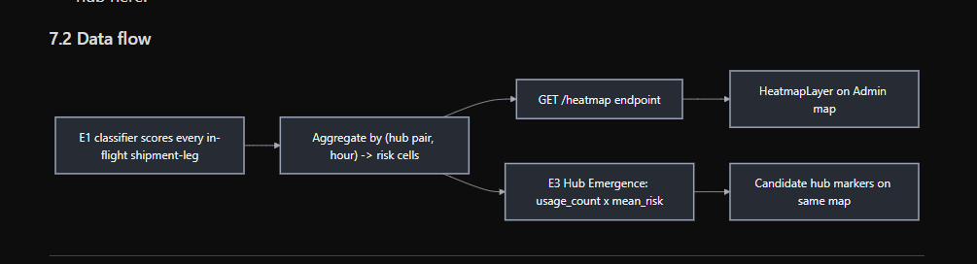
E1 classifier scores every in-flight shipment-leg
Aggregate by (hub pair, hour) -> risk cells
GET /heatmap endpoint
HeatmapLayer on Admin map
E3 Hub Emergence: usage_count x mean_risk
Candidate hub markers on same map

8. Data Model
Builds directly on the core engine's entities (Shipment, Vehicle, Hub, Leg, Option, Bid, RecoveryPlan — see engine spec), adding the product-layer tables needed for auth, UI, and audit.
8.1 New / extended tables (PostgreSQL)
User:
id, email, role # ADMIN | DISPATCHER | DRIVER | CUSTOMER
firebase_uid
vehicle_id # nullable, set for DRIVER role
created_at

AuditLog:
id, actor_user_id, action # OVERRIDE_PLAN | APPROVE_HUB | CHANGE_POLICY_MODE
target_type, target_id
reason_text
timestamp

PolicyMode:
id (singleton row), mode # BUSINESS | SLA_STRICT | FAIRNESS | EFFICIENCY
weights_json # coefficients consumed by E4
updated_by, updated_at

HubCandidate: # E3 output, persisted so admin can review over time
id, location(lat,lng)
usage_count, mean_risk, hub_score
est_setup_cost, est_annual_savings
status # PENDING | APPROVED | REJECTED

ModelArtifact:
id, name # "misplacement_classifier"
version, storage_path
trained_at, metrics_json # accuracy/AUC from the Colab run
is_active # only one active per name
8.2 Firestore collections (live/ephemeral)
/live_positions/{vehicle_id} # updated every tick, listened to by map clients
/notifications/{user_id}/items/{id} # bounty offers, plan-change alerts
/bounty_offers/{auction_id} # live auction state, listened to by eligible drivers
/tick_events/{tick_id} # lightweight event log clients can subscribe to
Firestore holds nothing that the optimizer needs to query relationally — it's purely a push channel to clients. The engine's actual state of truth stays in Postgres/Redis.

9. Backend API (FastAPI) — endpoint map
Auth (Firebase-verified, role checked per route)
All routes require a verified Firebase ID token; role enforced via dependency injection.

Shipments
GET /shipments list + filter (status, temperature range)
GET /shipments/{id}
GET /shipments/{id}/recovery-plan
GET /shipments/{id}/explainer
POST /shipments/{id}/override {chosen_plan_id, reason} [dispatcher]

Vehicles & Legs
GET /vehicles
GET /legs/{leg_id} -> route-click info panel data
GET /legs/{leg_id}/bounty-status

Hubs
GET /hubs
POST /hubs [admin]
GET /hub-emergence/candidates
POST /hub-emergence/candidates/{id}/approve [admin]

Heatmap & Foresight
GET /heatmap?hour={h}
GET /reservations list active Foresight options
GET /reservations/{id}

Bounty / Auctions
GET /auctions/{id}
POST /auctions/{id}/bid [driver — simulated in prototype]

Policy
GET /policy-mode
PUT /policy-mode [admin]

Simulation control (prototype-only)
POST /simulate/tick manually advance simulated clock
POST /simulate/inject-disruption {type, target_id} -- for live demo

Realtime
WS /ws/live tick stream, plan-change events

ML / Model registry
GET /model/status active model version + metrics
POST /model/reload [admin] hot-swap to latest artifact in storage

10. ML Pipeline — Colab to Backend, exactly how the handoff works
This is the piece you specifically flagged, so it's spelled out end-to-end.
10.1 Where Colab fits
Colab is used only to train E1's misplacement classifier (and optionally an ETA regressor). It never runs in the request path. The contract between Colab and the backend is two files:
- model.pkl (or model.onnx) — the trained classifier
- feature_pipeline.joblib — the exact preprocessing (encoders, scalers, column order) used at training time, so inference reproduces training-time feature construction precisely
10.2 Colab notebook structure (E1 classifier)
1. Generate/load synthetic historical data
- (route, hub, carrier, congestion_index, num_handoffs,
sorting_method, weather_flag, hour_of_day) -> label: misplaced (0/1)
2. Train/test split
3. Feature pipeline: ColumnTransformer (OneHot for categoricals, scaler for numerics)
4. Model: LogisticRegression or GradientBoostingClassifier
- kept explainable on purpose (coefficients/feature importances, no deep learning)
5. Evaluate: AUC, calibration curve (important — you need well-calibrated
probabilities for the critical-fractile math in E2, not just good AUC)
6. Export:
joblib.dump(pipeline, 'feature_pipeline.joblib')
joblib.dump(model, 'model.pkl')
7. Upload both files to Firebase Storage / GCS bucket, versioned path:
models/misplacement_classifier/v{N}/model.pkl
models/misplacement_classifier/v{N}/feature_pipeline.joblib
8. Insert a row into ModelArtifact table (via a small authenticated
POST /model/register call from the notebook itself, using a service
account key) marking v{N} as available.
10.3 Backend ModelRegistry
class ModelRegistry:
def __init__(self, storage_client, db):
self.storage = storage_client
self.db = db
self.active_model = None
self.active_pipeline = None

def load_active(self):
row = self.db.query(ModelArtifact).filter_by(
name="misplacement_classifier", is_active=True
).first()
self.active_model = joblib.load(
self.storage.download(row.storage_path + "/model.pkl"))
self.active_pipeline = joblib.load(
self.storage.download(row.storage_path + "/feature_pipeline.joblib"))

def predict(self, shipment_features: dict) -> float:
X = self.active_pipeline.transform([shipment_features])
return float(self.active_model.predict_proba(X)[0][1])
- Loaded once at FastAPI startup (@app.on_event("startup")).
- POST /model/reload (admin-only) re-runs load_active() against whichever ModelArtifact row is currently flagged is_active=True — this is how you hot-swap a newly trained Colab model into the running demo without a redeploy.
- E1.score(shipment) in the tick loop simply calls model_registry.predict(features).
10.4 Why this separation matters for the pitch
It's an honest, defensible answer to "how do you retrain / improve the model?" — you say: "we retrain in Colab, export two files, and hot-swap them into the running system via a registry — no redeploy, no downtime." That's a real MLOps pattern (offline training / online serving split), not just "we ran a notebook once."

11. Real-time & Notification Architecture
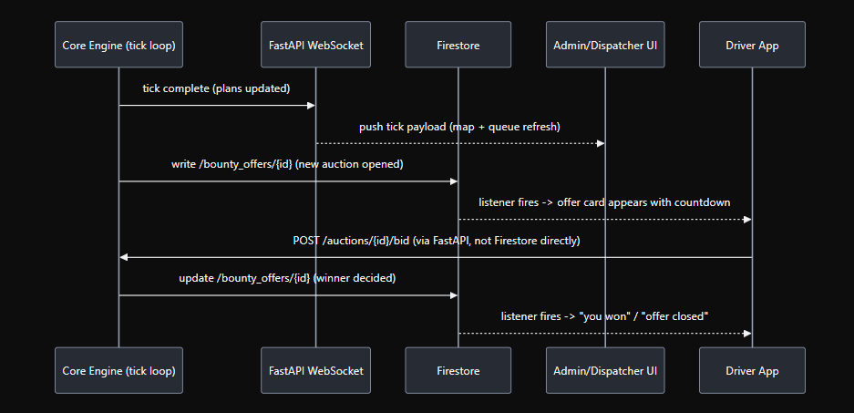
Driver AppAdmin/Dispatcher UIFirestoreFastAPI WebSocketCore Engine (tick loop)Driver AppAdmin/Dispatcher UIFirestoreFastAPI WebSocketCore Engine (tick loop)tick complete (plans updated)push tick payload (map + queue refresh)write /bounty_offers/{id} (new auction opened)listener fires -> offer card appears with countdownPOST /auctions/{id}/bid (via FastAPI, not Firestore directly)update /bounty_offers/{id} (winner decided)listener fires -> "you won" / "offer closed"
- WebSocket (/ws/live) is for high-frequency, session-scoped stream (map/queue refresh every tick) — used by Admin & Dispatcher who keep a screen open.
- Firestore listeners are for lower-frequency, per-user, offline-tolerant events (a driver's app might be backgrounded) — bounty offers and notifications.
- All writes that must be transactionally consistent with the engine's state (accepting a bid, committing a plan) go through FastAPI, never written directly to Firestore from the client — Firestore is a read/notify channel, not a source of truth for engine decisions.

12. Auth & Security (prototype-appropriate, not enterprise-grade)
- Firebase Auth handles login (email/password or Google sign-in is enough for a demo).
- Role assigned via Firebase custom claims, set by an admin action (POST /users/{id}/role), verified server-side on every request via verify_id_token.
- FastAPI dependency require_role(["admin"]) gates admin-only routes (policy mode, hub approval, model reload, user management).
- All destructive/overriding actions (/shipments/{id}/override, /hub-emergence/.../approve, /policy-mode) write to AuditLog — useful both for correctness and as a demo answer to "can this be misused?"

13. Deployment Architecture (prototype)
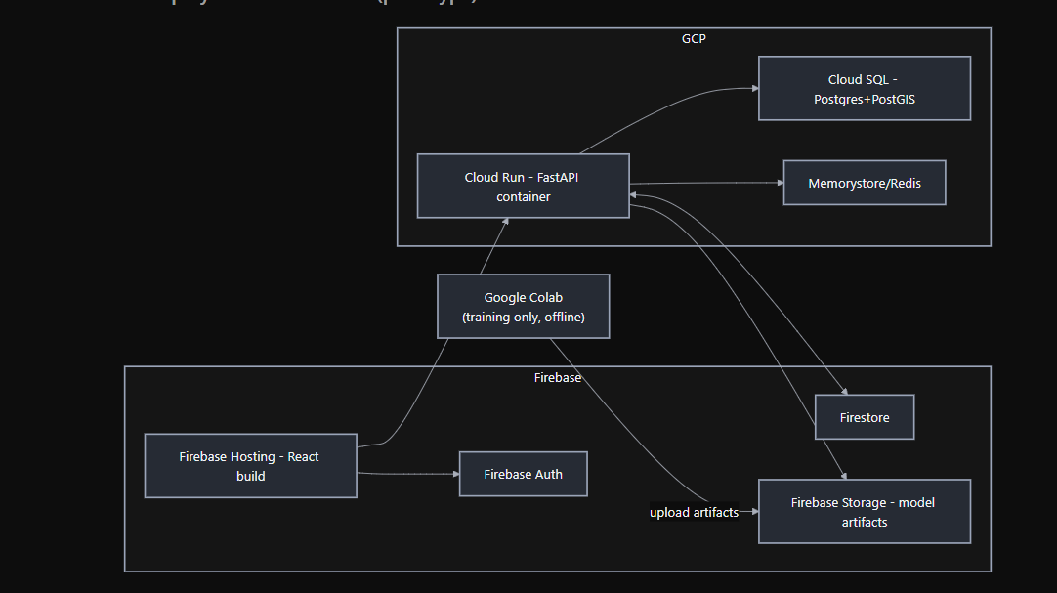
GCP
Firebase
upload artifacts
Firebase Hosting - React build
Firebase Auth
Firestore
Firebase Storage - model artifacts
Cloud Run - FastAPI container
Cloud SQL - Postgres+PostGIS
Memorystore/Redis
Google Colab
(training only, offline)
For a hackathon, Cloud SQL/Memorystore can be swapped for a single Docker Compose stack (Postgres + Redis containers) running alongside the FastAPI container if GCP setup time is a concern — architecture is identical, just self-hosted for the demo.

14. Build Plan — prototype timeline (team of 4, ~48h), UI + integration layered onto the engine plan
Block | Hours | Build | Owner
0 | 0–4 | Simulator (30 hubs, 200 vehicles, 5,000 shipments, fixed seed, scripted disruptions) + Postgres schema | Backend 1
1 | 4–10 | Time-expanded graph builder + geo/time pruning (PostGIS ST_DWithin) | Backend 1
2 | 6–12 | E4 Temperature/λ with cascade fixpoint | Backend 2
3 | 8–14 | Auth (Firebase) + role model + FastAPI dependency guards | Backend 2
4 | 10–20 | E6 Piggy Router (label-setting + dominance + k-best) | Backend 1
5 | 12–20 | E5 Bounty (simulated bidders, Vickrey, window gating) | Backend 2
6 | 14–22 | React shell: Admin/Dispatcher/Driver layouts, routing, Firebase Auth wiring | Frontend
7 | 18–26 | E8 Explainer (backend) + Explainer panel UI | Backend 1 + Frontend
8 | 20–28 | E1 Heatmap classifier trained in Colab, exported, loaded via ModelRegistry | ML
9 | 22–30 | Google Maps integration: base map, polylines, click → leg info panel | Frontend
10 | 26–34 | E2 Reservation (critical fractile) | ML + Backend 2
11 | 28–34 | HeatmapLayer + time slider + Hub Emergence markers on map | Frontend
12 | 30–36 | E7 Graph Memory warm-start + visible latency timer in UI | Backend 1
13 | 32–38 | Driver app: offer inbox, accept/decline, Directions API navigation | Frontend
14 | 34–40 | Metrics dashboard (Recharts): SLA%, cost, vehicle-km, latency, premium burn | Frontend
15 | 36–40 | E3 Hub Emergence (logging + threshold + candidate list + approve flow) | anyone free
16 | 38–44 | WebSocket live tick wiring across all three dashboards | Backend 2 + Frontend
17 | 44–48 | Rehearse demo ×10, freeze code, record video backup | all
Cut order if behind schedule: Customer Portal first, then Hub Emergence UI (keep the backend logic, drop the approve-flow screen), then the time-of-day heatmap slider (keep a static heatmap). Never cut the Explainer or the Maps click-for-info panel — they're your cheapest, highest-impact demo beats.

15. Demo script (extended with UI beats)
t | Beat | Screen shown
0–10s | Admin logs in, Network Map with heatmap live | Admin Dashboard
10–20s | Foresight buys an option quietly (toast notification) | Admin Dashboard
20–35s | Inject disruption (/simulate/inject-disruption), shipment appears in Dispatcher queue, Cold zone, auction runs | Dispatcher Console
35–65s | Cascade moment — click the shipment, Explainer shows λ jump 22→81, plan flips to dedicated | Explainer panel
65–80s | Foresight payoff — option exercised instantly, 0ms vs 60ms vs 2100ms shown | Dispatcher Console
80–90s | Truck delay injected, warm-start re-plan, latency timer visible | Admin Dashboard
90–100s | Click a route on the map — info panel shows vehicle/capacity/bounty | Network Map
100–110s | Switch Policy Mode dropdown live, plan recommendation changes | Admin Dashboard
110–120s | Metrics slide: SLA%, cost, premium burn vs baseline | Metrics panel

16. Appendix — Core Engine Formula Sheet (recap, unchanged)
TEMPERATURE
T(s) = clamp(0,100, T_base + T_time + T_delay + T_cascade)
λ(s) = sla_penalty_per_hour × (1 + T(s)/50) [₹/hr]

BOUNTY
MaxBounty = min(λ(s) × Δt_saved, C_dedicated − C_overhead)
Payment = min(second_lowest_bid, MaxBounty) [Vickrey]

ROUTER
w(e) = C_transit(e) + λ(s) × transit_hours(e) + handling_penalty(e)

FORESIGHT
Buy option ⟺ P(misplace) ≥ Premium / (Premium + C_dedicated − E[Bounty])

HUB EMERGENCE
HubScore(L) = usage_count(L, 30d) × mean_risk(cell(L))

Summary of what this document adds on top of the engine spec you already had
- Full architecture connecting React clients → FastAPI/WebSocket → the 8 engines → Postgres/Redis/Firestore → Google Maps.
- Tech stack locked in: React+TS, FastAPI, Firebase (Auth/Firestore/Hosting/Storage), Postgres+PostGIS, Redis, Google Maps Platform — Colab used strictly offline for training.
- Four user roles with distinct workflows and screens (Admin, Dispatcher, Driver, Customer-stretch).
- Google Maps: click-a-route info panel wired to /legs/{id}, Directions API for driver navigation.
- Heatmap: HeatmapLayer fed by /heatmap, tied directly to E1's risk cells and E3's Hub Emergence markers.
- Data model extended with Users, AuditLog, PolicyMode, HubCandidate, ModelArtifact tables plus Firestore's live/notification collections.
- Full API surface across shipments, legs, hubs, heatmap, auctions, policy, simulation control, and model registry.
- The Colab-to-backend handoff, exactly: two exported files, a versioned storage path, a ModelRegistry class, and a hot-reload endpoint — so training stays in Colab and inference stays in FastAPI with zero coupling.
- A 48-hour build plan that interleaves UI/integration work with the engine work from your existing plan.

