VISVESVARAYA TECHNOLOGICAL UNIVERSITY
"Jnana Sangama", Belgaum - 590014, Karnataka

MOBILE APPLICATION DEVELOPMENT REPORT
on
INTELLICOURSE: A FULL-STACK LEARNING MANAGEMENT SYSTEM MOBILE APPLICATION
Submitted by
Harshith M (1BM24CS113)
Harshith D (1BM24CS112)
Hanish S Adhi (1BM24CS109)
Under the Guidance of
Dr. Kavitha Sooda
Assistant Professor, Department of CSE
in partial fulfillment for the award of the degree of
BACHELOR OF ENGINEERING
in
COMPUTER SCIENCE AND ENGINEERING

B.M.S. COLLEGE OF ENGINEERING
(Autonomous Institution under VTU)
BENGALURU - 560019
Feb-2026 to June-2026

B. M. S. College of Engineering
Bull Temple Road, Bangalore 560019
(Affiliated to Visvesvaraya Technological University, Belgaum)

Department of Computer Science and Engineering
CERTIFICATE
This is to certify that the project work entitled "IntelliCourse: A Full-Stack Learning Management System Mobile Application" carried out by Harshith M (1BM24CS113), Harshith D (1BM24CS112) and Hanish S Adhi (1BM24CS109), who are bonafide students of B. M. S. College of Engineering, is submitted in partial fulfillment for the award of Bachelor of Engineering in Computer Science and Engineering during the academic semester Feb-2026 to June-2026.
Signature of the Guide | Signature of the HOD
Dr. Kavitha Sooda  Assistant Professor, Dept. of CSE  BMSCE, Bengaluru | Prof. & Head, Dept. of CSE  BMSCE, Bengaluru

External Viva
Sl. No. | Name of the Examiner | Signature with Date
1 | ____________________________ | ________________________
2 | ____________________________ | ________________________

B.M.S. COLLEGE OF ENGINEERING
DEPARTMENT OF COMPUTER SCIENCE AND ENGINEERING
DECLARATION
We, Harshith M (1BM24CS113), Harshith D (1BM24CS112) and Hanish S Adhi (1BM24CS109), students of 4th Semester, B.E., Department of Computer Science and Engineering, B. M. S. College of Engineering, Bangalore, hereby declare that this Mobile Application Development report entitled "IntelliCourse: A Full-Stack Learning Management System Mobile Application" has been carried out by us under the guidance of Dr. Kavitha Sooda.
We also declare that, to the best of our knowledge and belief, the work reported here is original and has not been submitted as part of any other report by any other students.
Signature
Harshith M (1BM24CS113)
Harshith D (1BM24CS112)
Hanish S Adhi (1BM24CS109)

Abstract
IntelliCourse is a full-stack Learning Management System designed to support online course discovery, enrollment, lecture delivery, instructor course management, secure media upload, payment processing and learner progress tracking. The system contains a Node.js and Express backend with MongoDB persistence, JWT-based authentication, role-based access control for students, instructors and administrators, and security middleware for CORS, rate limiting, HTTP headers, XSS mitigation and request sanitization. The mobile application is built using Expo, React Native and TypeScript with Expo Router navigation and Zustand state management. Students can browse published courses, enroll or purchase access, view lessons, stream videos through secure playback URLs and monitor completion percentage. Instructors can create courses, add lectures, upload thumbnails and videos through presigned S3 URLs, and manage their teaching catalogue. A React web client is also included for desktop course browsing, authentication, instructor dashboards and learning views. The project demonstrates a practical mobile-first LMS architecture with reusable components, well-defined REST APIs, payment workflow integration and database models for users, courses, lectures, purchases, media assets and progress records.

Table of Contents
Sl No | Topics | Page Nos
1 | Abstract
2 | Introduction
3 | Hardware and Software Requirements
4 | Design Layouts: Screen Shots of Mobile App / Webpages
5 | Database Table Screen Shots
6 | Testing Unit Testcases (module wise)
7 | Conclusion and Future Work
8 | References

Chapter 1

Introduction
IntelliCourse is an online learning platform that combines a mobile application, web client and secure API server to provide a complete LMS experience. The application helps learners discover courses, enroll in structured lessons, watch video content and track course completion. It also gives instructors a controlled workspace for creating and maintaining courses, adding lecture content and monitoring teaching activity.

1.1 Problem Statement
Many learning platforms separate course browsing, video delivery, payment status and progress tracking into disconnected workflows. IntelliCourse addresses this by integrating authentication, course management, payment, media upload and learner progress into one mobile-first platform.

1.2 Users Supported
- Student: browses the catalog, purchases or enrolls in courses, watches lessons and tracks completion.
- Instructor: creates courses, manages lectures, uploads media and monitors course activity.
- Administrator: has elevated access for protected course-management and system operations.

1.3 Student Functionalities
- Create an account and sign in using validated credentials.
- Browse published courses by category and search query.
- View course detail pages with instructor, price, level and lecture information.
- Enroll in free courses or complete the payment flow for paid courses.
- Stream lecture videos through authenticated playback URLs.
- Mark lessons complete and view course progress percentage.
- Edit profile information and avatar.

1.4 Instructor Functionalities
- Create new courses with title, subtitle, description, category, level and price.
- Upload thumbnails and lecture videos through presigned AWS S3 URLs.
- Add, list and delete lectures in owned courses.
- View instructor dashboard metrics and manage created courses.
- Update course metadata and control course availability.

1.5 System Architecture
The architecture connects the Expo mobile client and React web client to a secured Express API. MongoDB stores application data, AWS S3 stores media files, and Razorpay/Stripe workflows handle purchases.
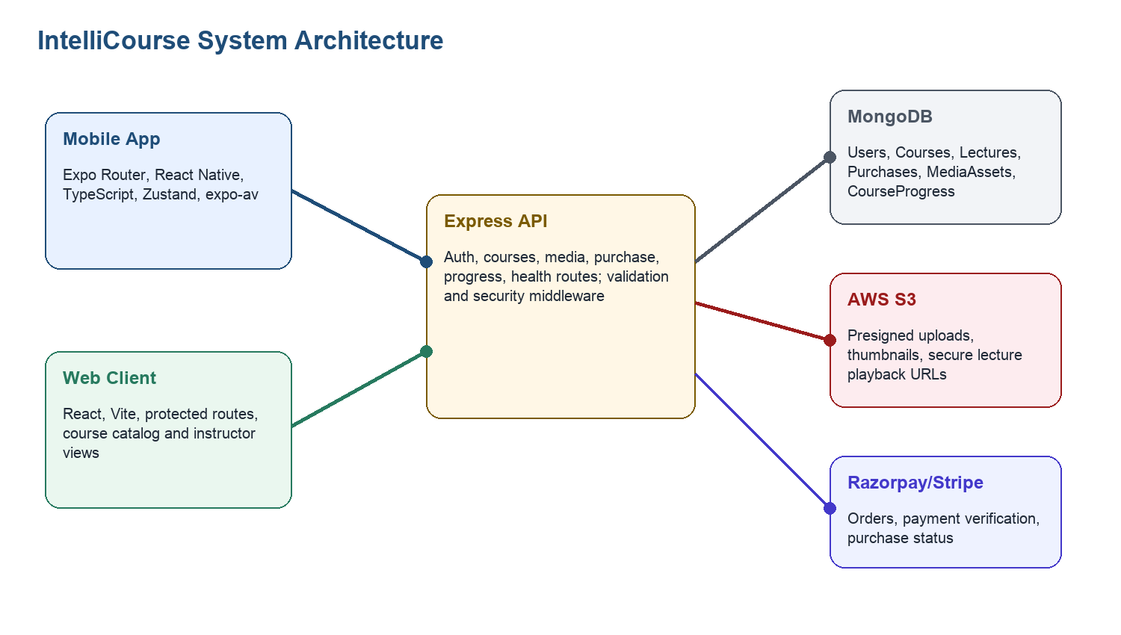
Fig 1.1 System architecture of IntelliCourse

Chapter 2

Hardware and Software Requirements

2.1 Hardware Requirements
Component | Minimum Requirement | Purpose
Development Machine | Intel i5 / Apple Silicon equivalent, 8 GB RAM | Run backend, web client, mobile simulator and build tools.
Mobile Device / Emulator | Android or iOS device with network access | Test Expo mobile app, video playback and profile/media flows.
Server Environment | Cloud VM or managed Node.js hosting | Host Express API and connect to MongoDB, AWS and payment providers.
Network | Stable broadband connection | Upload video media, fetch presigned URLs and test payment integrations.

2.2 Software Requirements
Layer | Technology | Description
Backend | Node.js, Express, Mongoose | REST API server, route handling, MongoDB data modelling and middleware.
Database | MongoDB | Stores users, courses, lectures, purchases, media assets and progress records.
Mobile | Expo, React Native, TypeScript | Cross-platform mobile screens, navigation, forms and video playback.
State/API | Zustand, Axios | Client-side state and backend communication with token injection.
Web Client | React, Vite, React Router | Desktop interface for catalog, authentication, dashboards and course learning.
Security | JWT, bcryptjs, Helmet, CORS, rate-limit | Authentication, password hashing and API hardening.
Media | AWS S3 SDK, Multer, Expo Image Picker | Thumbnail/video upload, presigned URLs and profile image selection.
Payments | Razorpay, Stripe | Course checkout and verification.

Chapter 3

Design Layouts: Screen Shots of Mobile App / Webpages

3.1 Login Screen
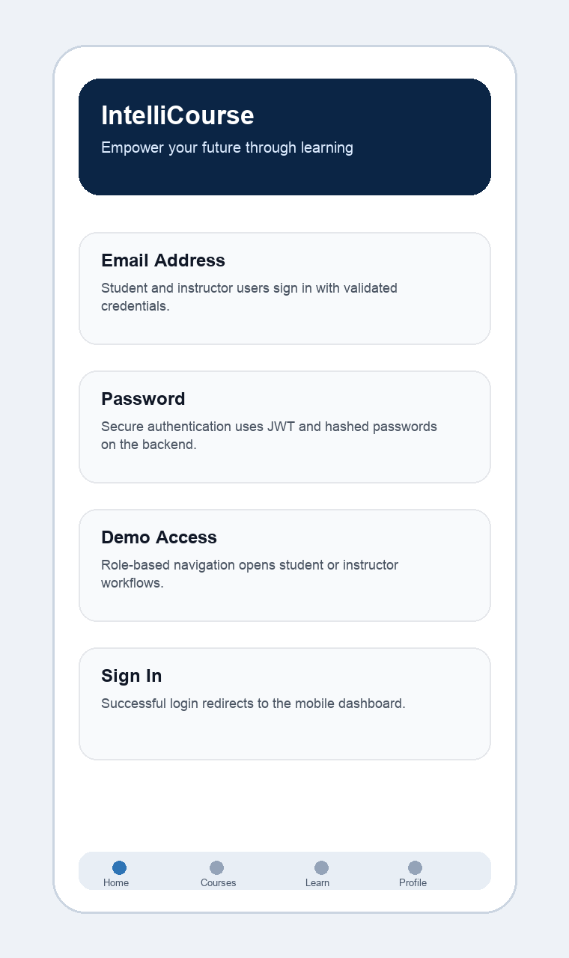
Fig 3.1 Login screen for student and instructor authentication

3.2 Student Home Screen
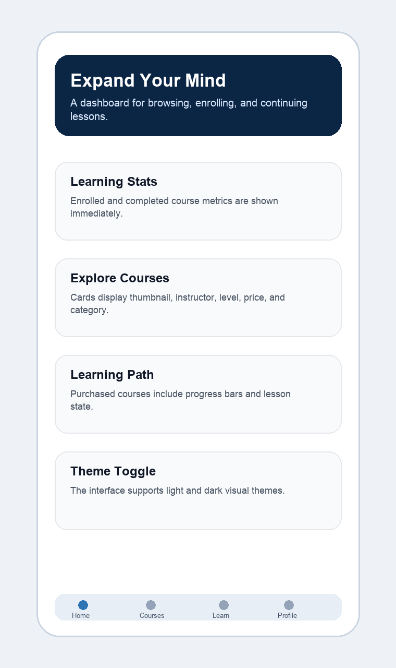
Fig 3.2 Student dashboard and course discovery screen

3.3 Instructor Management Screen
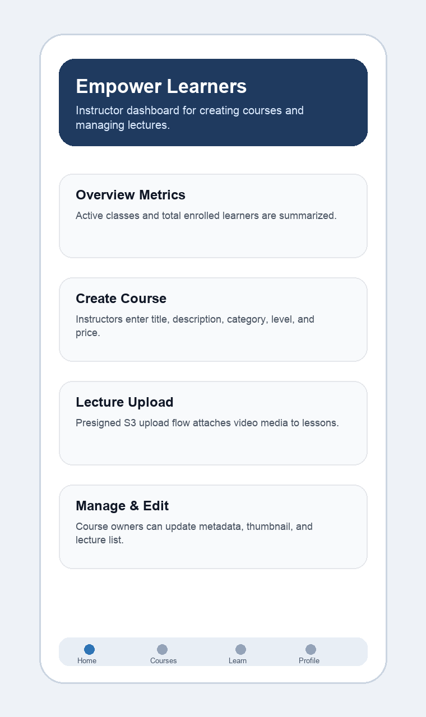
Fig 3.3 Instructor course creation and management screen

3.4 Web Client Pages
- Landing page: displays IntelliCourse branding, featured courses and category tracks.
- Courses page: supports catalog search, category filtering and course card display.
- Course detail page: displays instructor, price, lectures and purchase/access action.
- Instructor dashboard and course editor: support protected course management workflows.

Chapter 4

Database Table Screen Shots
The project uses MongoDB collections defined through Mongoose schemas. The following tables document the main collections and their fields.

4.1 User Collection: Description
Field | Type | Description
name | String | Required student/instructor name.
email | String | Unique login identifier with email validation.
password | String | Hashed password stored with select:false.
role | Enum | student, instructor or admin.
enrolledCourses | Array | Course references and enrollment date.
createdCourses | Array | Course references created by instructor.

4.2 Course Collection: Description
Field | Type | Description
title | String | Course title with max length validation.
category | String | Required catalog category.
level | Enum | beginner, intermediate or advanced.
price | Number | Non-negative course price.
instructor | ObjectId | Reference to User.
lectures | Array | References to Lecture documents.
isPublished | Boolean | Controls public visibility.

4.3 Lecture Collection: Description
Field | Type | Description
title | String | Lecture title.
videoUrl | String | Stored media playback/source URL.
duration | Number | Rounded lecture duration.
s3Key | String | AWS S3 object key.
mediaAsset | ObjectId | Reference to MediaAsset.
order | Number | Required lecture sequence order.

4.4 CourseProgress Collection: Description
Field | Type | Description
user | ObjectId | Learner reference.
course | ObjectId | Course reference.
completionPercentage | Number | Auto-calculated percentage between 0 and 100.
lectureProgress | Array | Per-lecture completion, watch time and timestamps.
isCompleted | Boolean | True when progress reaches 100 percent.

4.5 ER Diagram
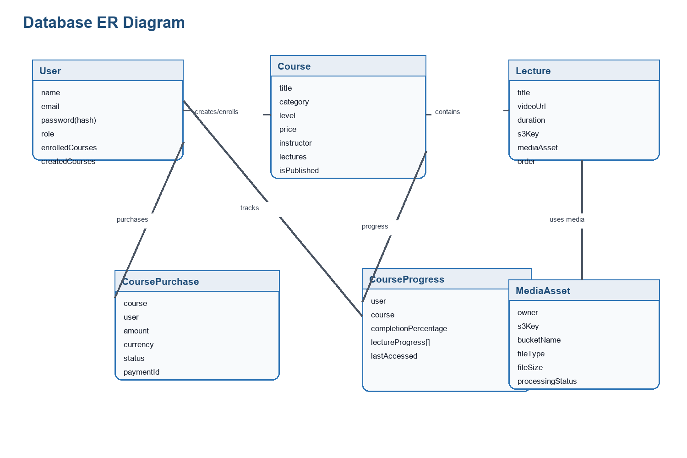
Fig 4.1 ER diagram of IntelliCourse database

Chapter 5

Testing
Testing focuses on authentication, course management, payment/enrollment, media upload and progress tracking. Backend model/controller checks are supported by the repository test file backend/tests/api.test.js.
TC ID | Module | Test Scenario | Input Data | Expected Result | Status
TC_001 | Auth | Valid login | Registered email and password | Token issued; dashboard opens. | Pass
TC_002 | Auth | Weak signup password | Password under 8 chars | Validation error displayed. | Pass
TC_003 | RBAC | Student opens create course | Student account | Access denied or redirected. | Pass
TC_004 | Courses | Instructor creates course | Title, category, level, price | Course appears in Manage Courses. | Pass
TC_005 | Catalog | Browse published courses | Published courses API | Course cards are returned. | Pass
TC_006 | Media | Request upload URL | Course ID and video metadata | Presigned S3 URL returned. | Pass
TC_007 | Payments | Enroll/purchase course | Course ID | Enrollment status becomes true. | Pass
TC_008 | Progress | Mark lecture complete | Course and lecture ID | Percentage recalculated. | Pass
TC_009 | Profile | Update profile | Name, email and avatar | Profile saved successfully. | Pass
TC_010 | Security | Invalid token request | Expired JWT | Authentication error returned. | Pass

Chapter 6

Conclusion and Future Work

6.1 Conclusion
IntelliCourse successfully demonstrates a mobile-first LMS with a secure backend, role-based workflows, course creation, lecture management, payment support and progress tracking. The system separates concerns cleanly across an Express API, MongoDB data layer, Expo mobile client and React web client. The implementation also includes reusable UI components, typed mobile models, media upload support through AWS S3 and purchase flows through Razorpay/Stripe integrations.

6.2 Future Work
- Add ratings, reviews and recommendation logic for personalized course discovery.
- Introduce certificates after course completion with downloadable PDF generation.
- Improve analytics for instructors with learner retention and completion dashboards.
- Add offline lesson metadata caching and resumable downloads where licensing permits.
- Expand automated test coverage with API integration tests and mobile UI tests.
- Deploy backend, web client and database using production CI/CD workflows.

References
- Node.js and Express official documentation.
- MongoDB and Mongoose schema/model documentation.
- Expo and React Native official documentation.
- React Router, Vite, Axios and Zustand project documentation.
- AWS SDK for JavaScript and Amazon S3 presigned URL documentation.
- Razorpay and Stripe payment integration documentation.
- Project source code: IntelliCourse repository, /Users/muralic/Desktop/Projects/IntelliCourse.

