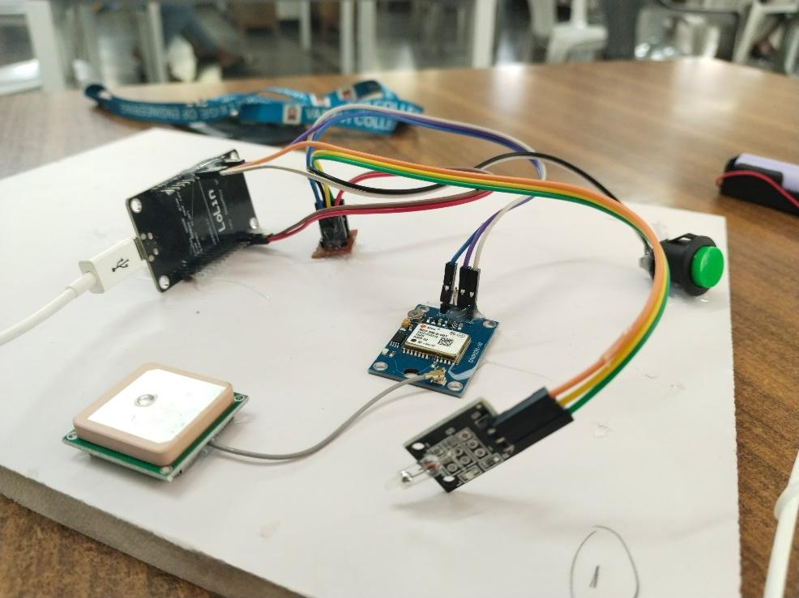**OUTPUT: (The System)**

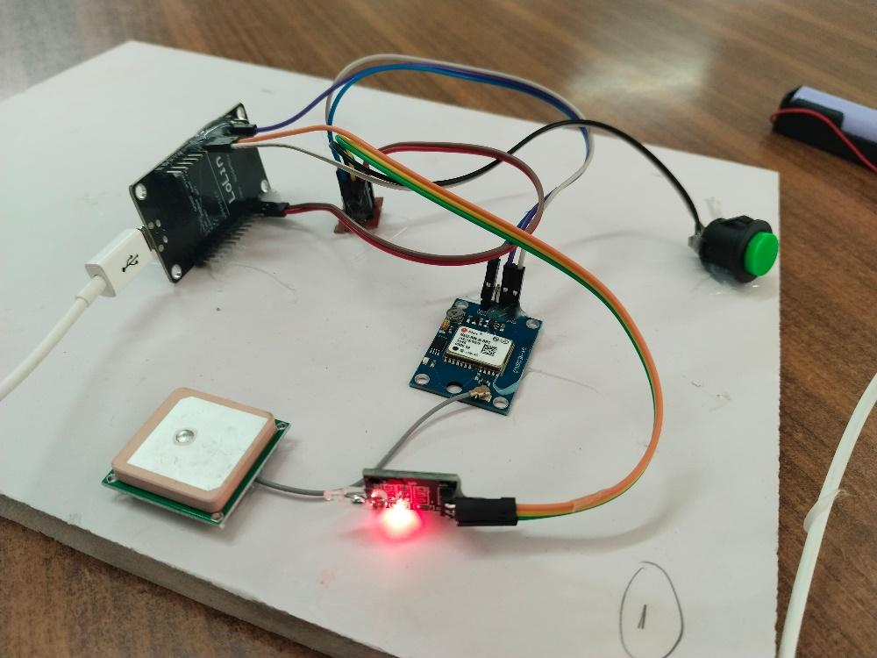**When a vibration detected (gives red-light warning)**