1. Server Initialization & Environment
Development environment startup showing concurrent execution of the Vite Frontend (Port 5173) and Node.js Backend (Port 5000).
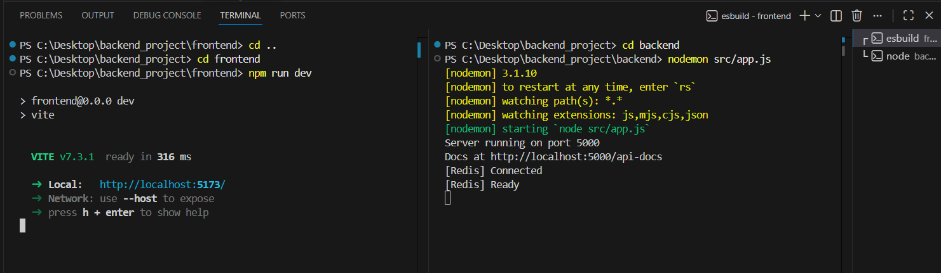
2. API Documentation (Auth & Users)
Interactive API documentation generated via Swagger UI.
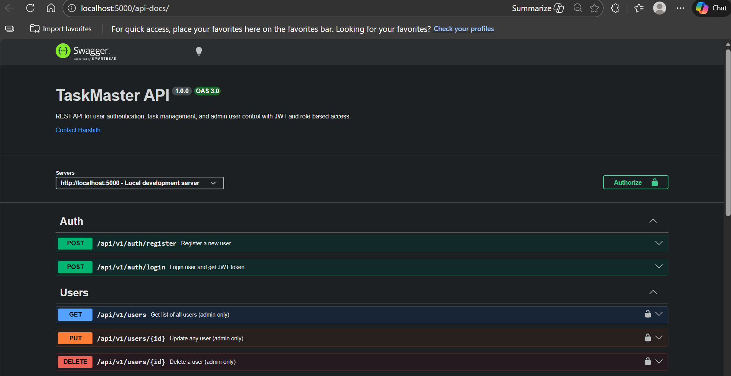
3. API Documentation (Tasks)
Task Management endpoints in Swagger UI. This demonstrates the full CRUD capabilities (Create, Read, Update, Delete) available to authenticated users.
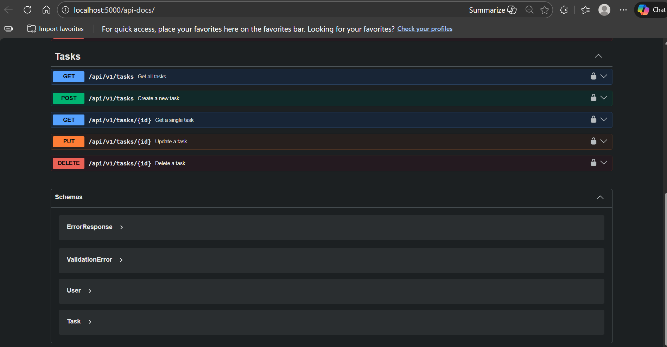
4. API Response: Registration
Successful POST /register response. The server returns a 201 Created status.
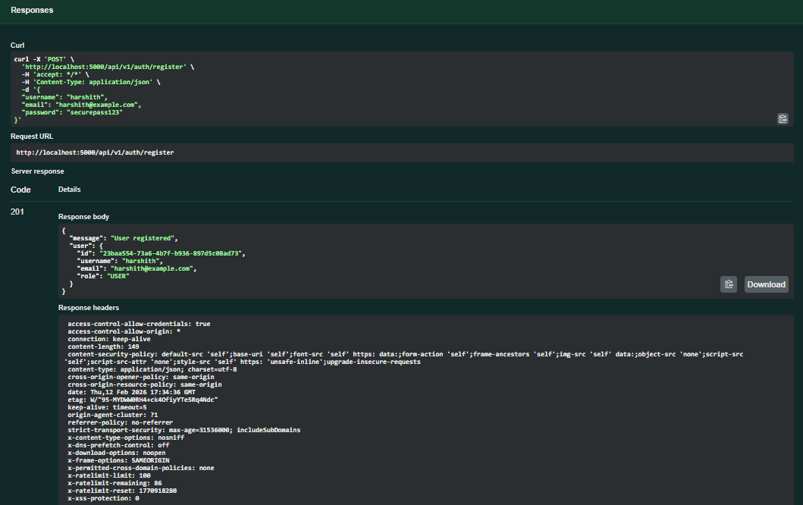
5. API Response: Login & JWT Issuance
Successful POST /login authentication flow. The server validates credentials and issues a JSON Web Token (JWT) for stateless session management.
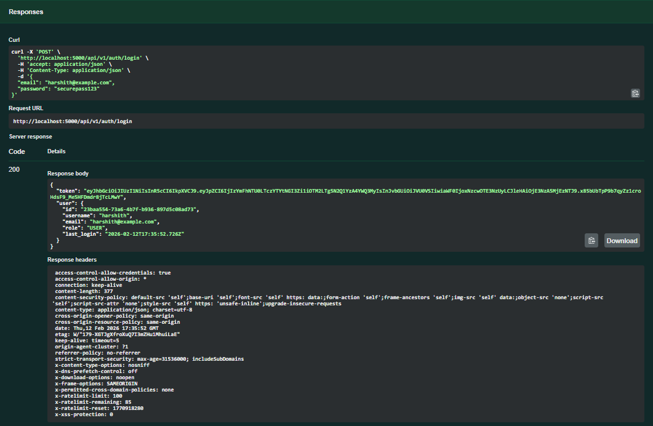
6. Database State: Users Table
PostgreSQL users table. Security best practices: passwords are stored as Bcrypt hashes.
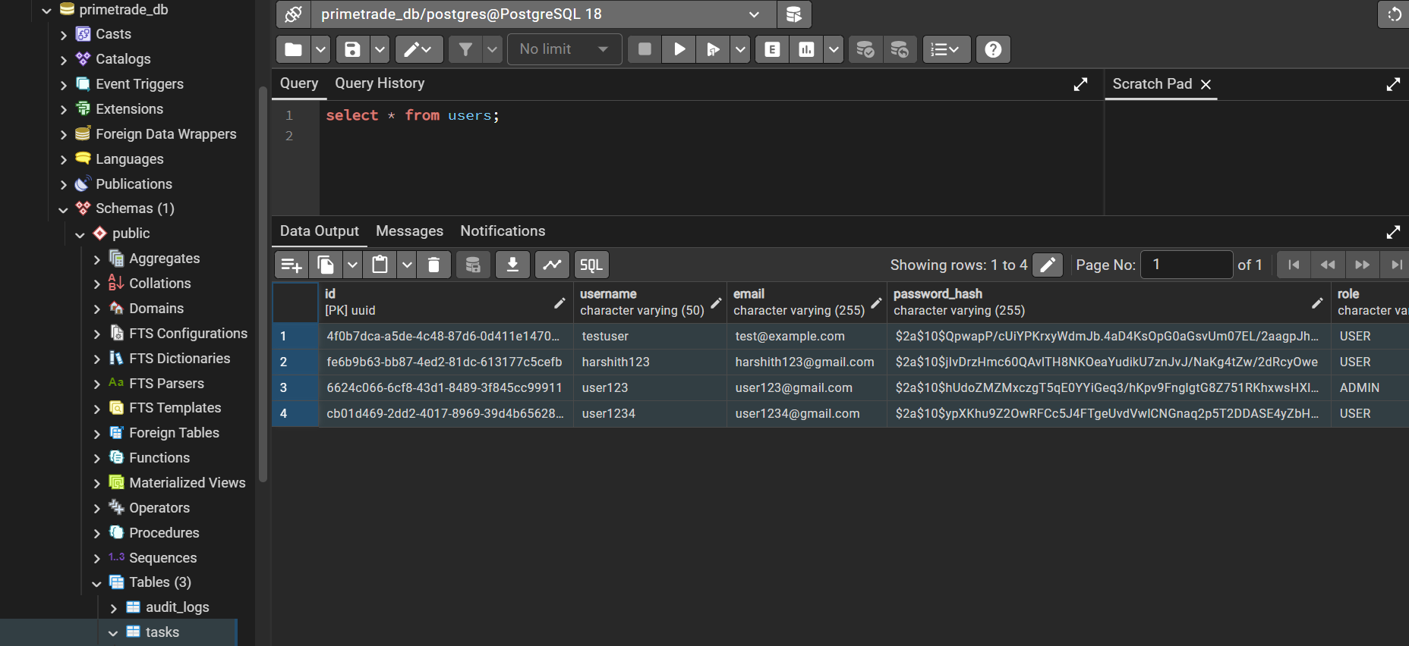

7. Database State: Tasks Table
PostgreSQL tasks table showing relational data integrity. Each task is successfully linked to a specific user_id, enforcing data ownership at the database level.
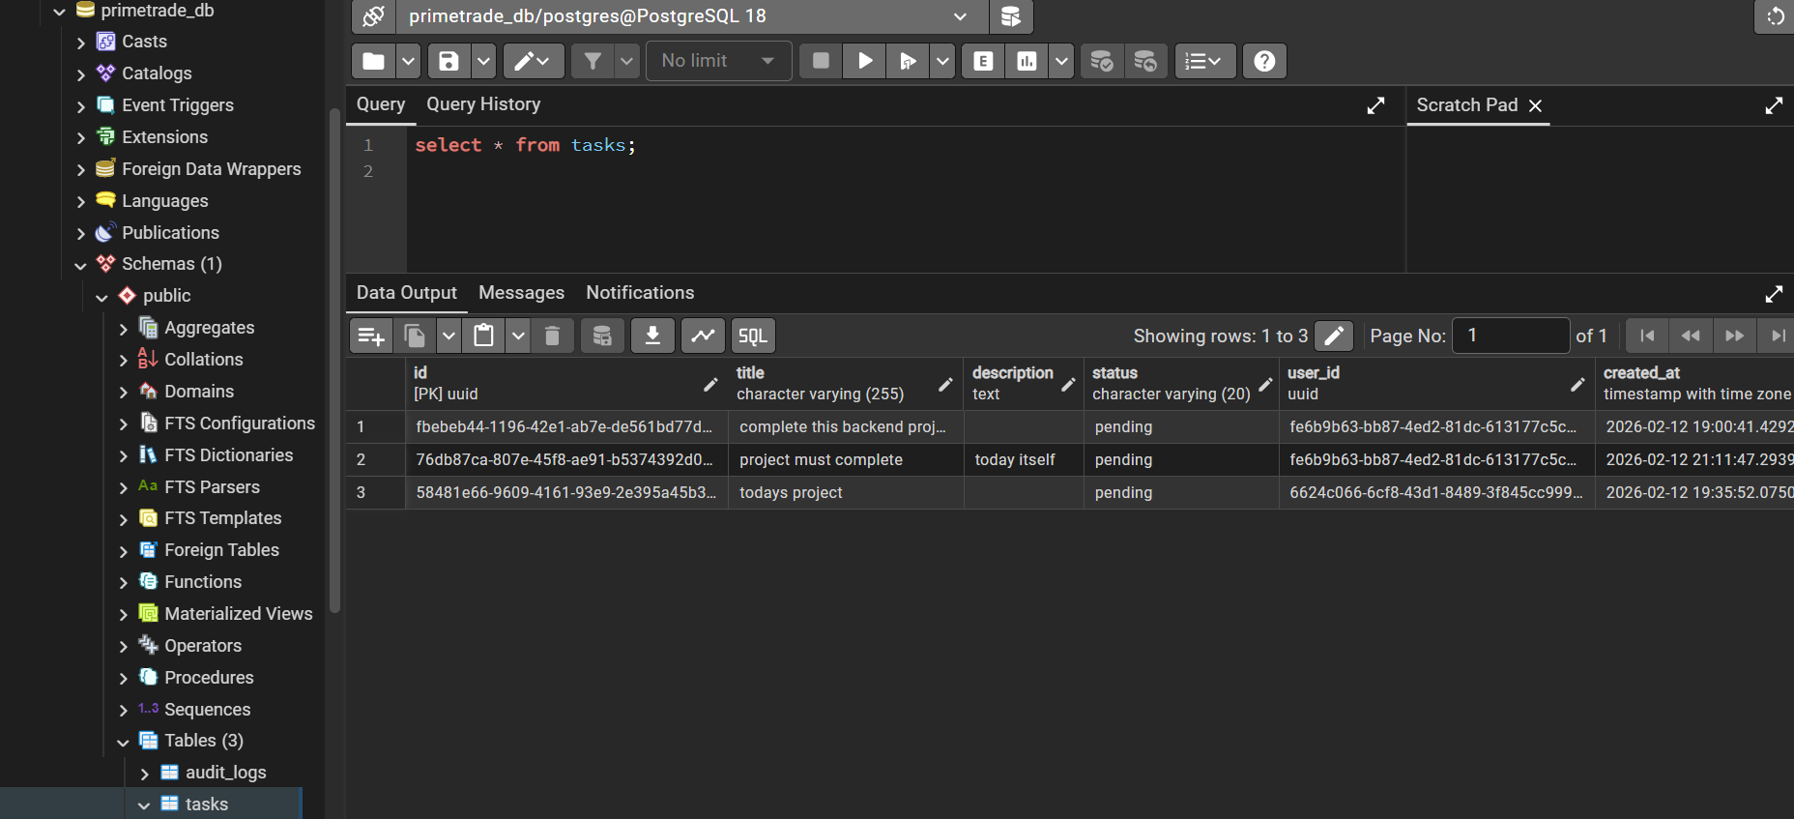

8. Frontend: Admin Dashboard
React-based Admin Dashboard. This view allows users with the 'ADMIN' role to view system-wide statistics and manage the user directory, demonstrating Role-Based Access Control (RBAC) on the frontend.
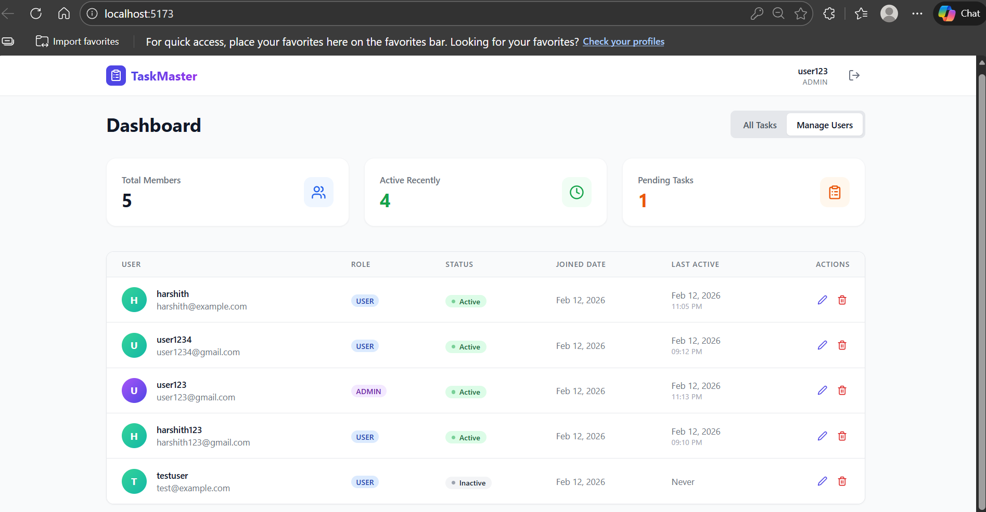

9. Frontend: User Task View
Standard User Interface for task management. This view fetches data from the backend to display the user's personal task list, including due dates and status indicators.
