REPORT OF DECS PROJECT PHASE-I
M.Harshith-25m0834
- GitHub Repository: https://github.com/harshith2302/KV-Server

- Description:
The Key-Value (KV) Store implemented as a C++ client-server application. supports Create, Read, and Delete (CRUD) operations over HTTP, using:
- PostgreSQL as the persistent database
- In-memory LRU cache for fast access
- cpp-httplib library for HTTP communication
The Server is a multithreaded C++ application that listens for HTTP requests. It manages data persistence by storing key-value pairs in a PostgreSQL database. To accelerate read operations, it uses an in-memory LRU (Least Recently Used) Cache. All database connections are managed by a custom Connection Pool to minimize latency.
The Client is a simple C++ command-line tool that provides a menu to interact with the server's API, allowing users to create, read, and delete key-value pairs.

- System Architecture:
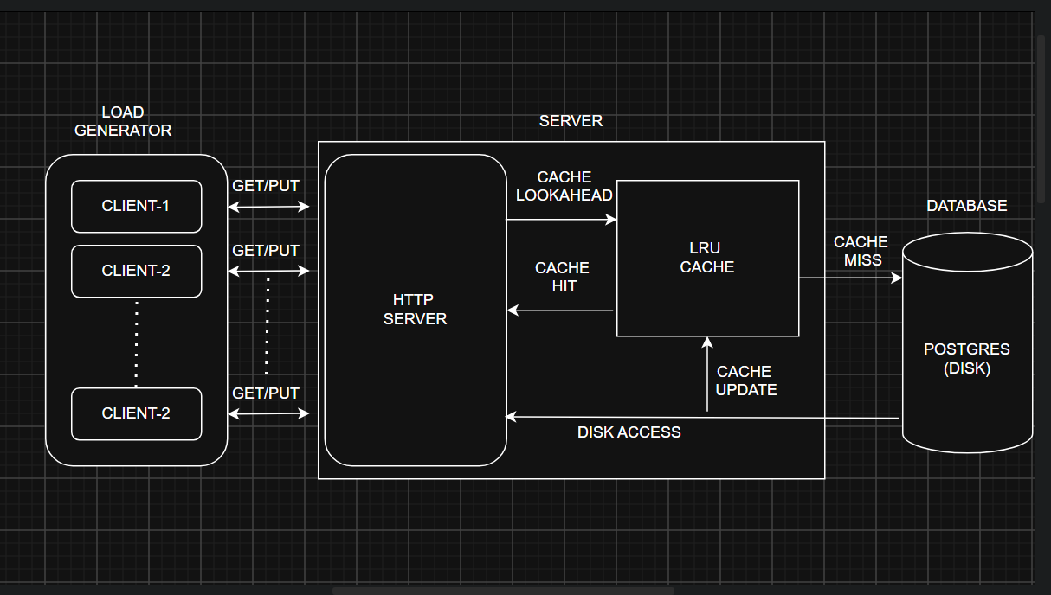
Fig : Overall flow of my system architecture

- Explanation of Operations:

  - Read Request (/read):

- The server first checks the LRUCache for the int key.
- Cache Hit: If the key is found, the value is returned immediately. This is very fast.
- Cache Miss: If the key is not in the cache, the server gets a connection from the DBPool, queries the PostgreSQL database, and (if found) stores the result in the cache before returning it to the client.

  - Write Request (/create):

- The server gets a connection from the DBPool.
- It executes an INSERT ... ON CONFLICT DO UPDATE command, which writes the data to the PostgreSQL database.
- If the database write is successful, the server then updates the LRUCache with the new value. This ensures the cache stays consistent with the database.

  - Delete Request (/delete):

- The server gets a connection from the DBPool.
- It executes a DELETE command in the PostgreSQL database.
- If the database delete is successful, the server removes the key from the LRUCache. This is crucial for preventing clients from reading "stale" data that no longer exists.

