Wish List Products Price Comparison Website Project

In this project we are designing web application which scrape online product details from various E-Commerce applications such as Amazon and Flipkart so user can compare prices and visit website with least prices.

To execute project install MYSQL and then copy content from ‘DB.txt’ file and then paste in MSYQL to create database.

We have designed following modules

1. User signup: using this module we will allow user to signup with the application
2. User Login: using this module we will allow user to login to application
3. Search Products & Compare Prices: using this module user can enter any product name and then application will scrape details from Amazon and Flipkart and then display list of products to user. User can view entire list and then visit website with least prices

SCREEN SHOTS

To run project double click on ‘run.bat’ file to start DJANGO server and get below screen

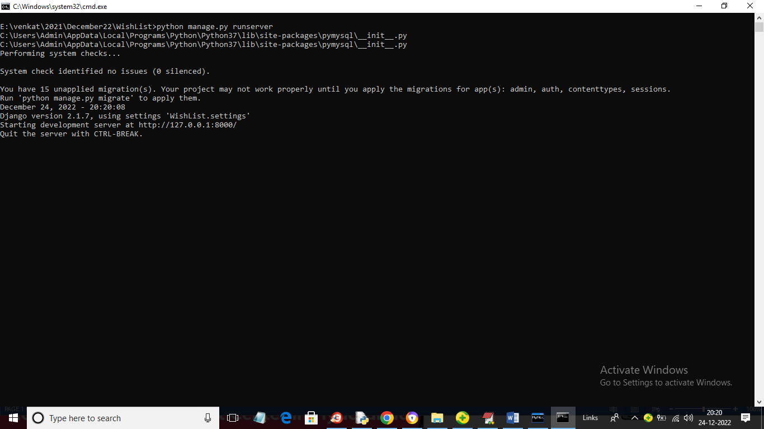

In above screen server is started and now open browser and enter URL as ‘http://127.0.0.1:8000/index.html’ and press enter key to get below page



In above screen click on ‘Register Here’ link to get below signup screen

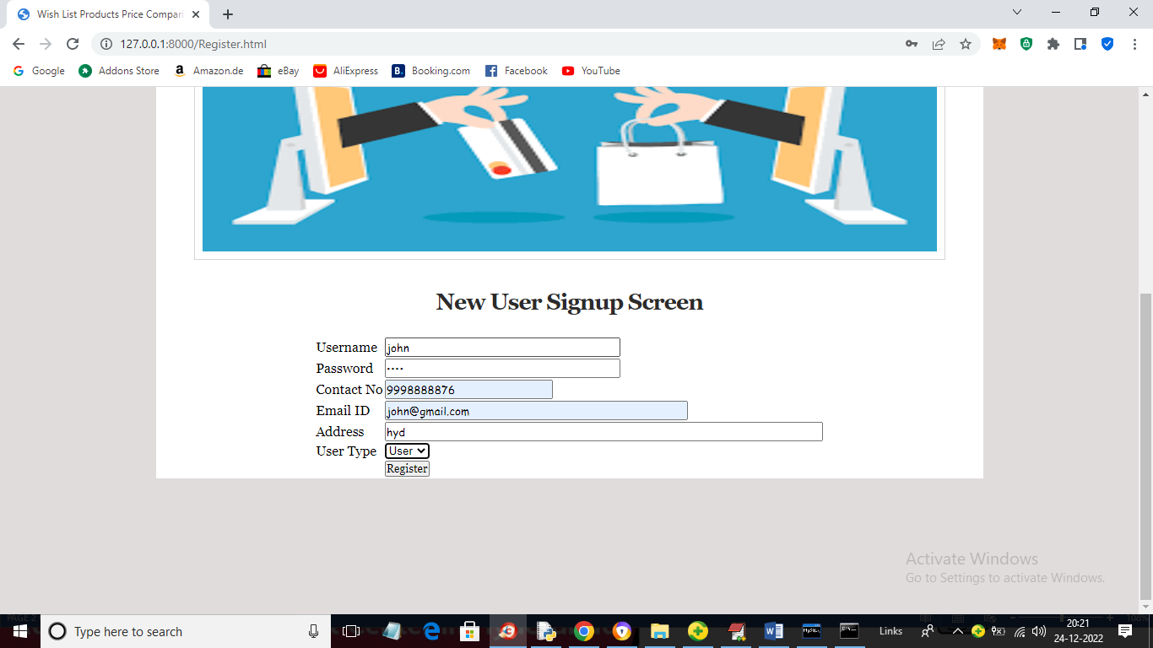

In above screen user is signing up and then press button to get below output

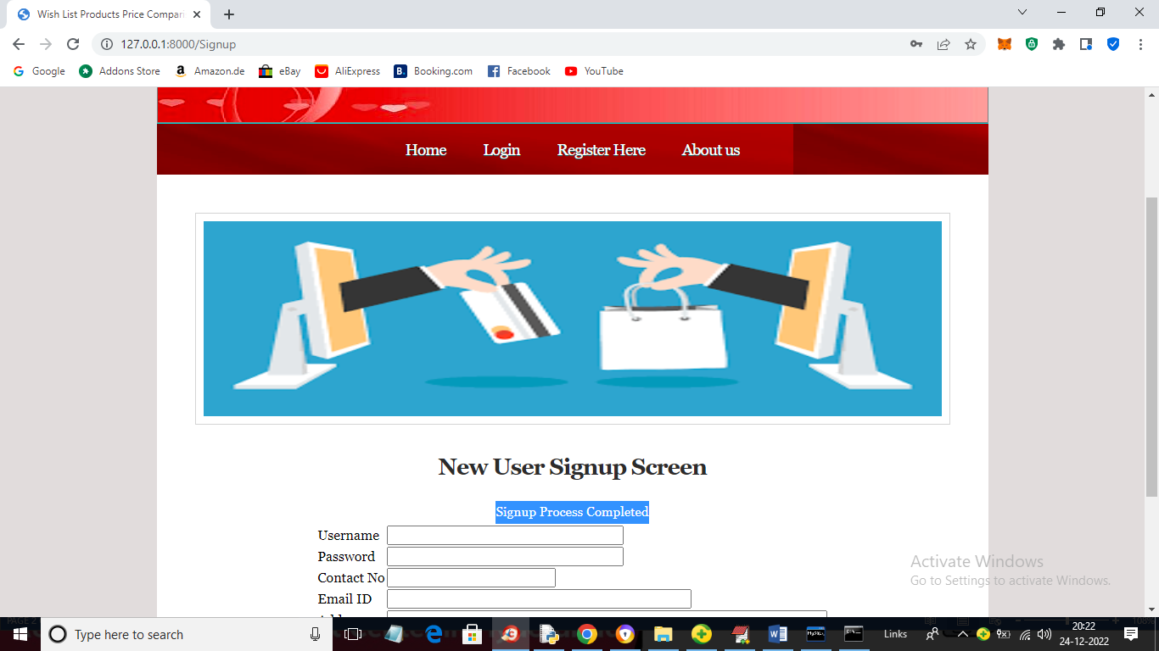

In above screen signup process completed and now click on ‘Login’ link to get below page

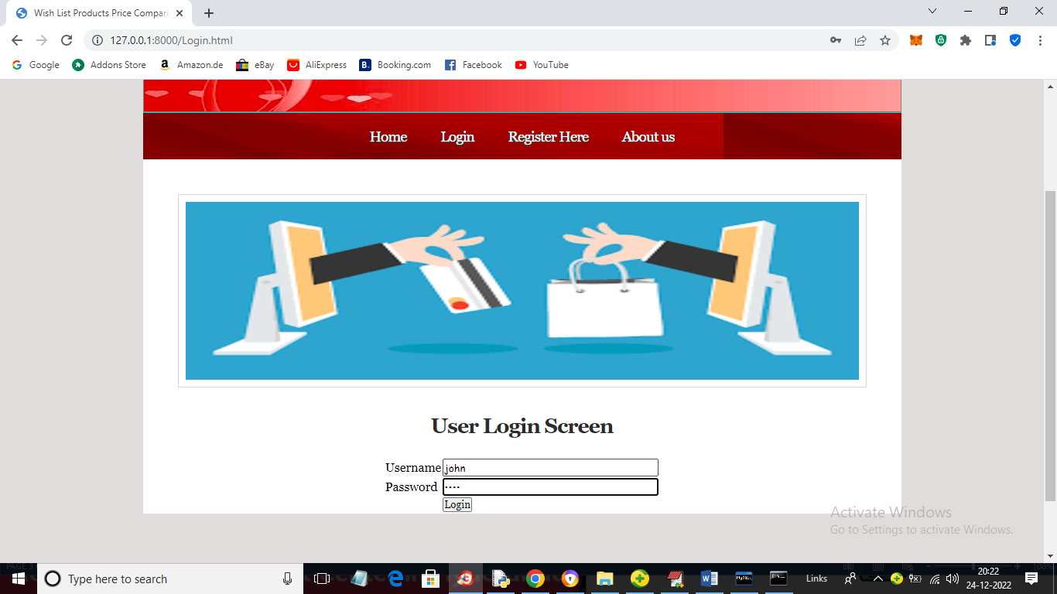

In above screen user is login and after login will get below page



In above screen user can click on ‘Search Products & Compare Prices’ link to get below screen

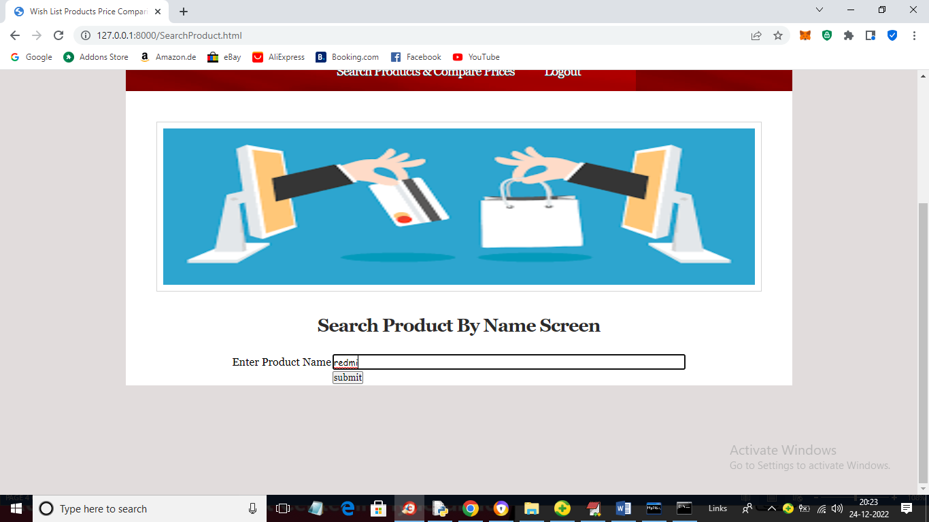

In above screen I entered product name as ‘redmi’ and then press button to get below search list from Amazon and Flipkart

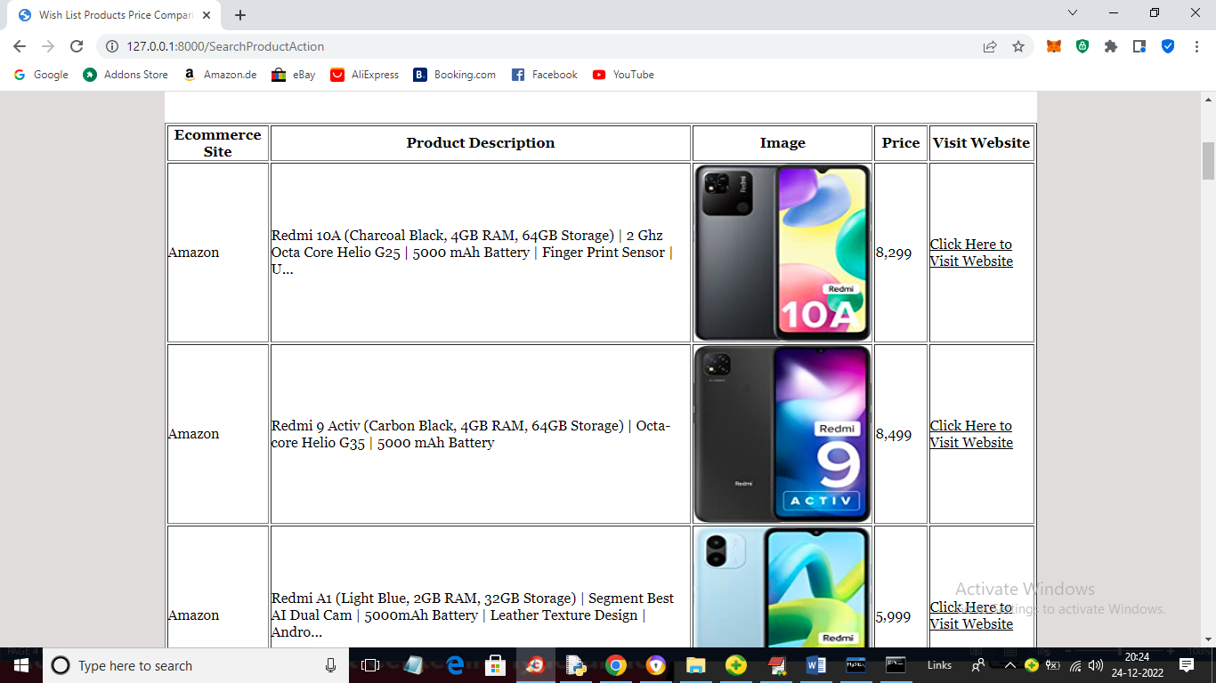

In above screen we got product details from Amazon with prices and you can click on ‘Click Here to Visit Website’ link to go to Amazon page and scroll down above page to view Flipkart details

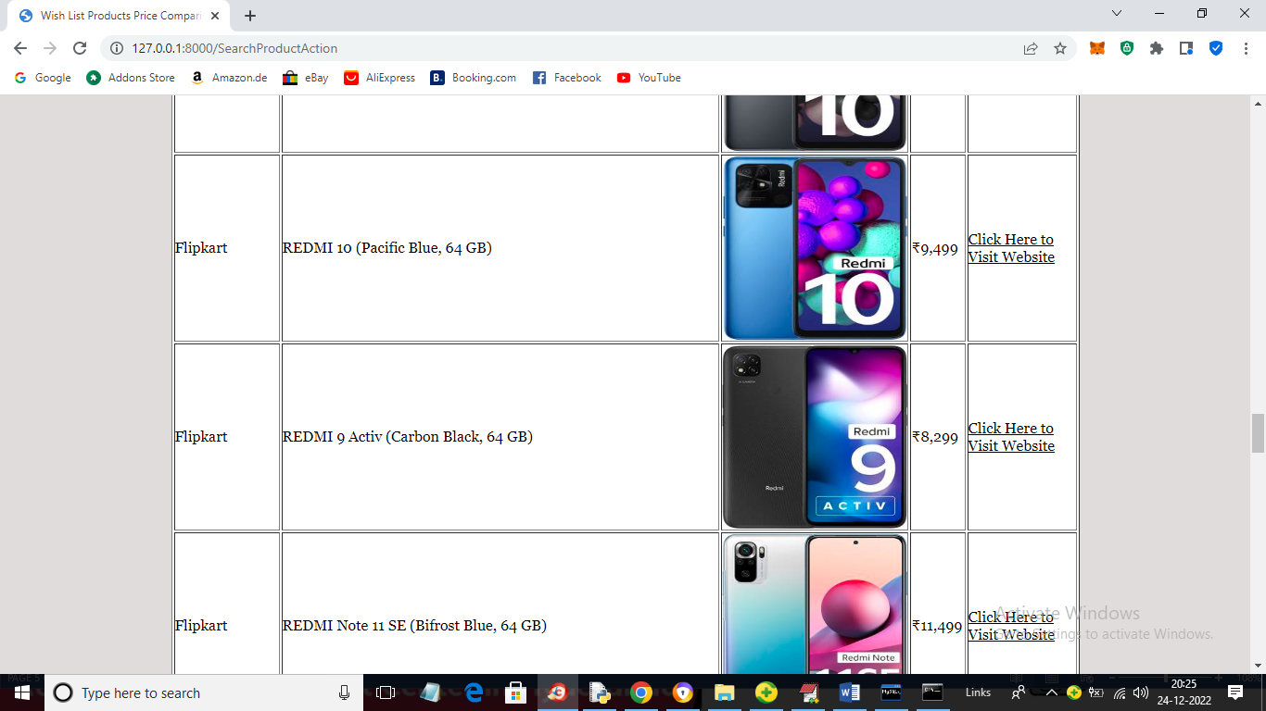

In above screen we can see details from Flipkart and now click on ‘Click Here’ link to visit page and get below output

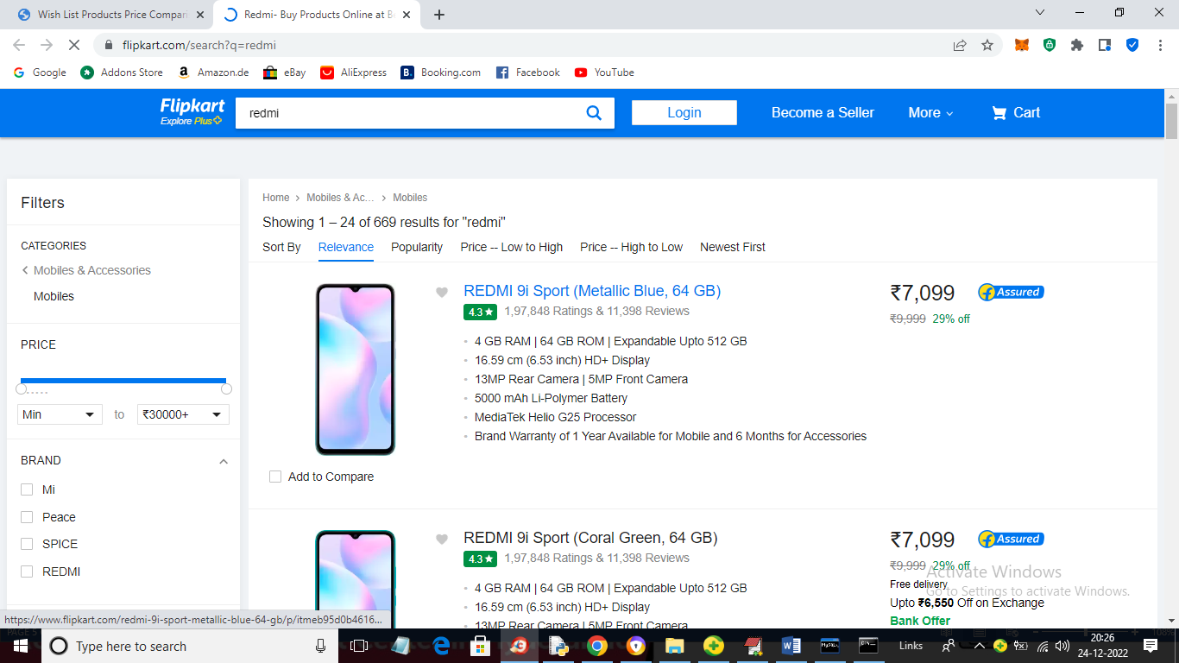

In above screen we can view Flipkart page and similarly we can see Amazon page also like below screen

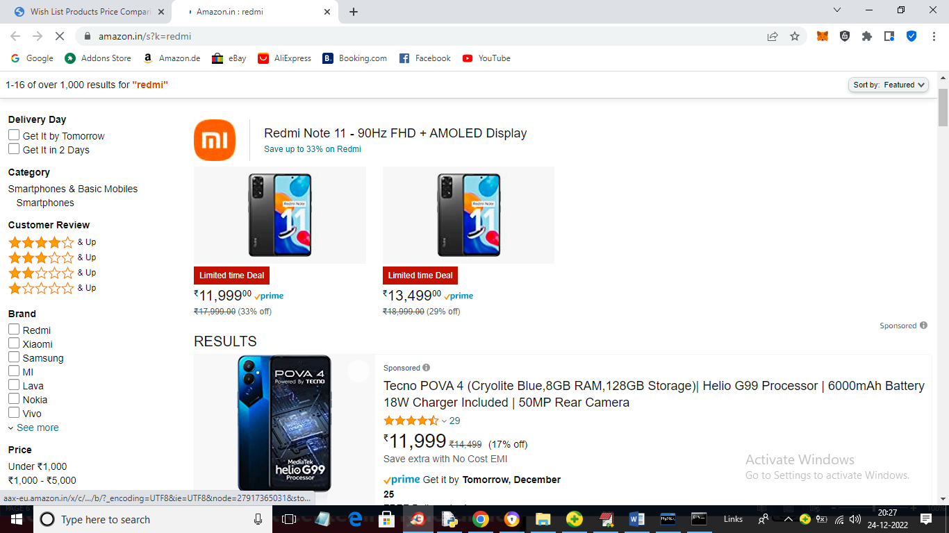

In above screen we get to Amazon page and now try other search

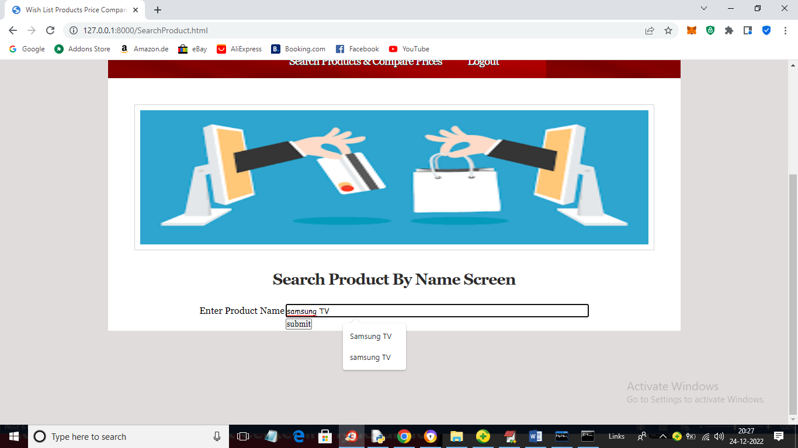

In above screen I entered product name as ‘Samsung TV’ and press button to get below page

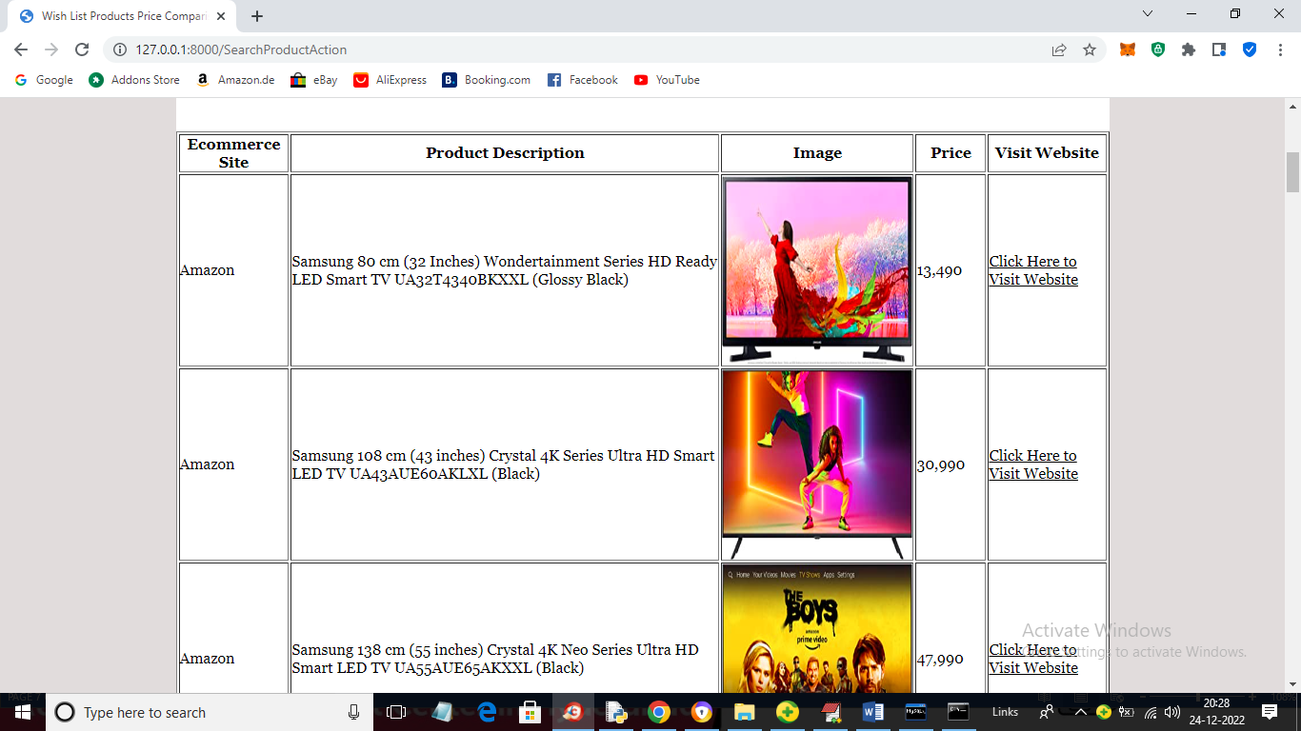

In above screen we can see details from Amazon and in below screen we can see details from Flipkart

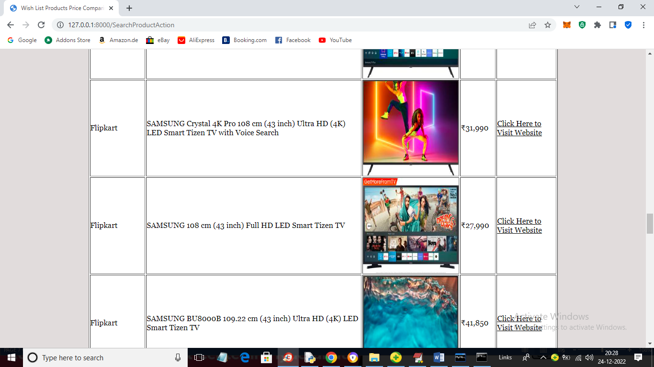

Similarly you can run for any products

Note: you ask to send notification but how this possible as we don’t know when Amazon or any other side will update prices so every time application has to search Amazon and Flipkart for updates which will consume lots of resources and searching prices for all products will take lakhs of iterations and server may get crash. So while writing modules see its possibility as automatic it cannot be possible.

Actually we are scrapping Amazon and Flipkart by using HTML attributes which is currently used by both websites and they continuously update website and if they update attributes also then application will not perform search