FINDING CONTRACTS

## **B.Harshith**

## **1602-19-737-073**

## **IT-B**

## **Assignment1**

# Abstract

FindingContracts is a console-based project that connects labourers who are looking for work with the contractors. Every user, either the labourer or the contractor has to login/register first. Contractors can publish their contracts by mentioning their required skilled labourers. The labourers can go through the contracts available and can apply for the contract they are interested in. Contractors can select the labourers based on their skills.

# Requirement Analysis

List of Tables :

* Labourers
* Contractors
* Contracts
* HiringRecords
* HiringRequests

List of Attributes with their Domain Types :

**Labourers**

* Lid varchar2(15)
* LName varchar2(20)
* LPhoneNumber number(10)
* Skills varchar2(50)

**Contractors**

* Cid varchar2(15)
* CName varchar2(20)
* CPhoneNumber number(10)

**Contracts**

* Contract_id varchar2(15)
* DailyWage number(4)
* Skills_required varchar2(25)

**HiringRecords**

* Cid varchar2(15)
* Contract_id varchar2(15)
* Lid varchar2(15)

**HiringRequests**

* Lid varchar2(15)
* Contract_id varchar2(15)

# ER Diagram

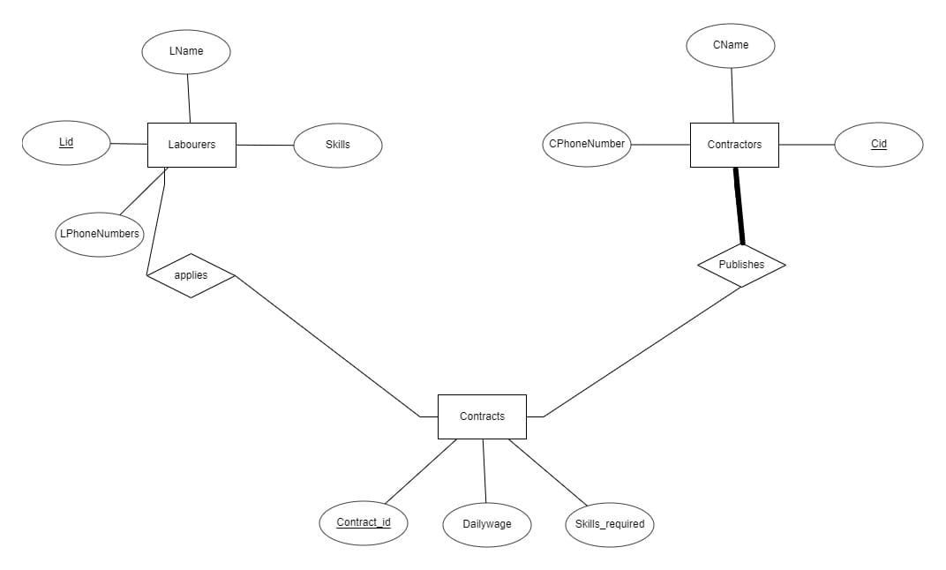

# Mapping Cardinality and Participation Constraints

A labourer can apply to any number of different contracts and at the same time one contract can be applied by many labourers, therefore, this is a many-to-many (or N-N) relationship

A contractor can publish any number of different contracts and at the same time one contract can be published by many contractors, therefore, this is a many-to-many (or N-N) relationship.

# DDL Commands

1. Create table labourers(

Lid varchar2(15),

LName varchar2(20) NOT NULL,

Skills varchar2(50),

CONSTRAINT pkey_labourers_mid PRIMARY KEY (Lid));

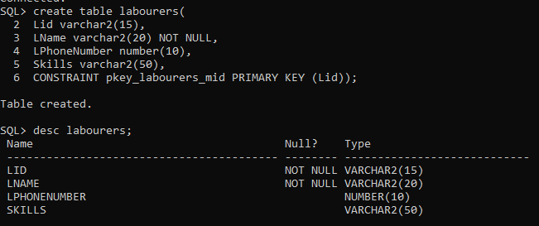

2. Create table contractors(

Cid varchar2(15),

CName varchar2(20) NOT NULL,

CPhoneNumber number(10),

CONSTRAINT pkey_contracts_cid PRIMARY KEY (Cid));

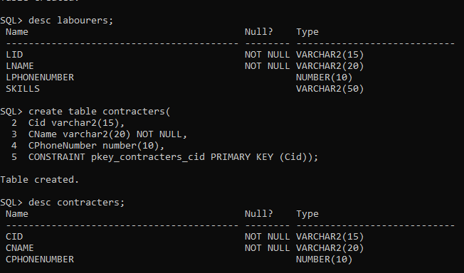

3. Create table contracts(

Contract_id varchar2(15),

DailyWage number(4),

Skills_required varchar2(25),

CONSTRAINT pkey_contracts_lid PRIMARY KEY (Contract_id));

CONSTRAINT fkey_contracts_cid PRIMARY KEY (Cid) References;

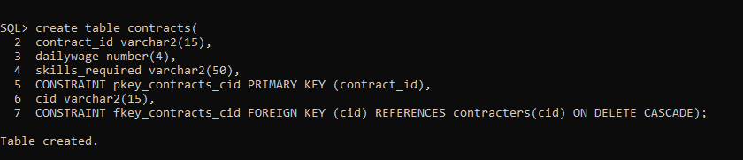

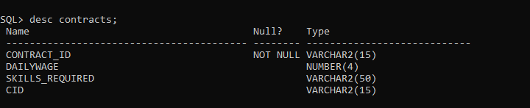

4.create table hiringrecords(

Cid varchar2(150,

Contract_id varchar2(15),

Lid varchar2(15),

CONSTRAINT fkey_hiringrecords_cid FOREIGN KEY (cid) REFERENCES contractors(cid) ON DELETE CASCADE,

CONSTRAINT fkey_hiringrecords_lid FOREIGN KEY (lid) REFERENCES labourers(lid) ON DELETE CASCADE,

CONSTRAINT fkey_contractid FOREIGN KEY (contract_id) REFERENCES contractss(contracts_id) ON DELETE CASCADE,

CONSTRAINT pkey_cid_mid_cid PRIMARY KEY (cid,lid,contract_id));

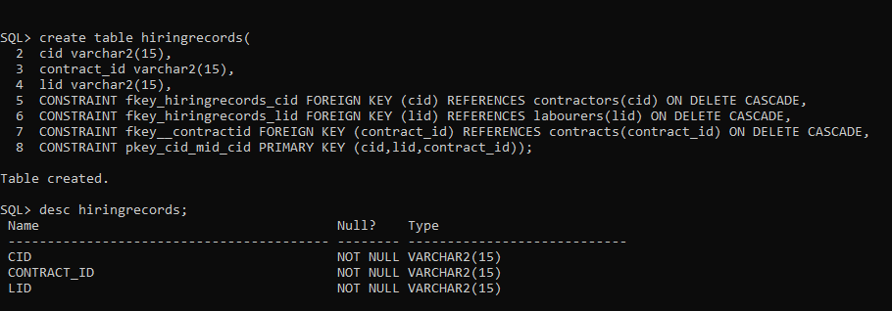

5.create table hiringrequests(

lid varchar2(15),

contract_id varchar2(15),

CONSTRAINT fkey_contractid FOREIGN KEY (contract_id) REFERENCES contracts(contract_id) ON DELETE CASCADE,

CONSTRAINT fkey_hiringrequests_lid FOREIGN KEY (lid) REFERENCES labourers(lid) ON DELETE CASCADE,

CONSTRAINT pkey_lid_contractid PRIMARY KEY (lid,contract_id));

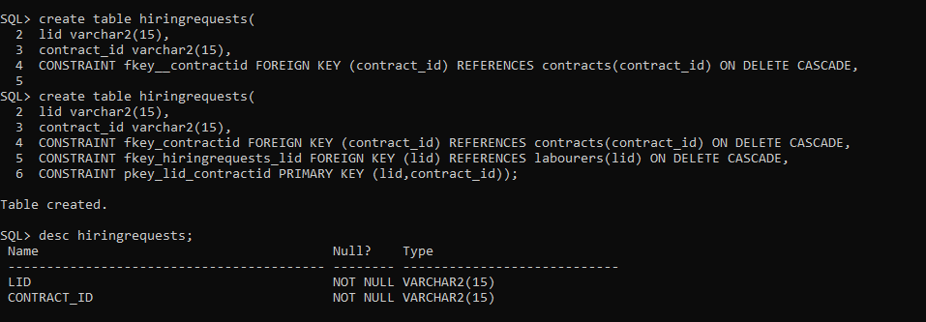

# DML COMMANDS

1.insert into labourers values(‘&lid’,’&lname’,&lphonenumber,’&skills’);

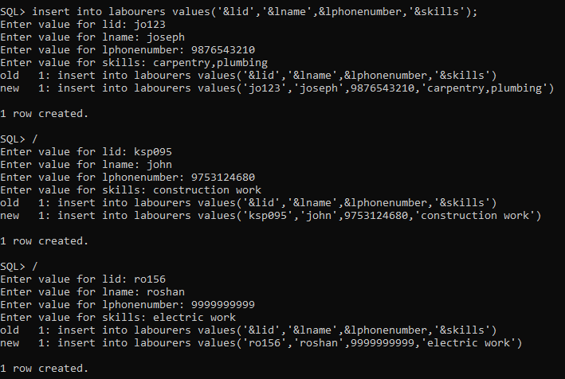

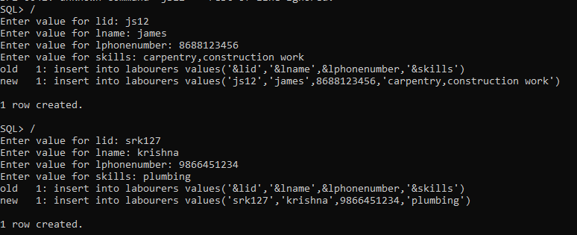

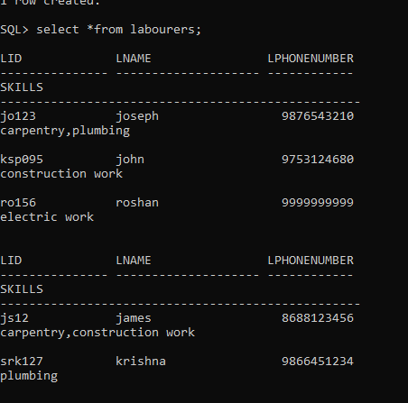

2.insert into contractors values(‘&cid’,’&cname’,&cphonenumber);

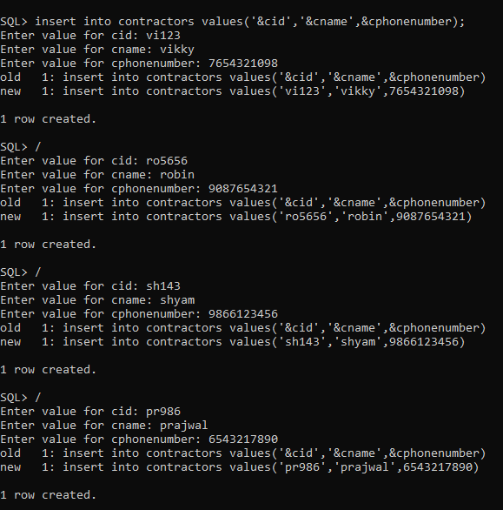

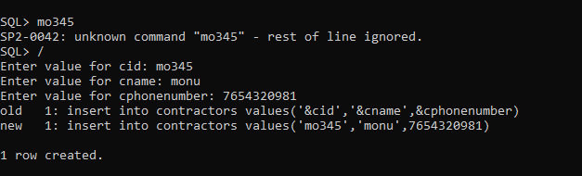

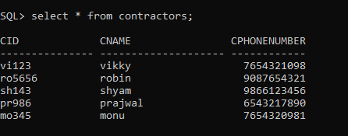

3.insert into contracts values(‘&contract_id’,’&dailywge’,’&skills_required’,’&’cid’);

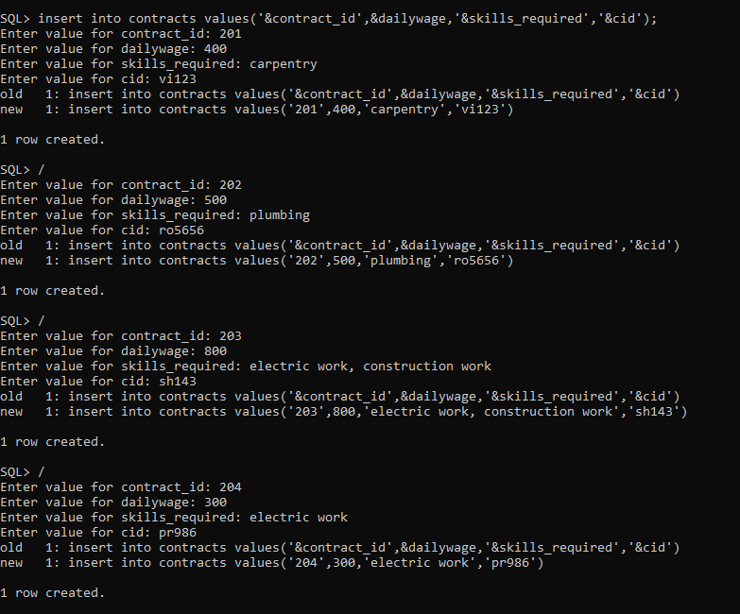

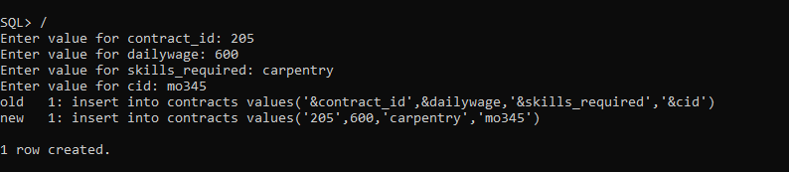

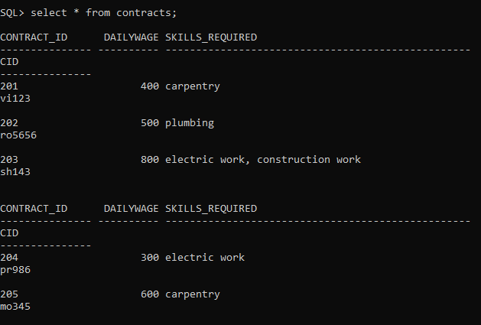

4.insert into hiringrequests values(‘&lid’,’&contract_id’);

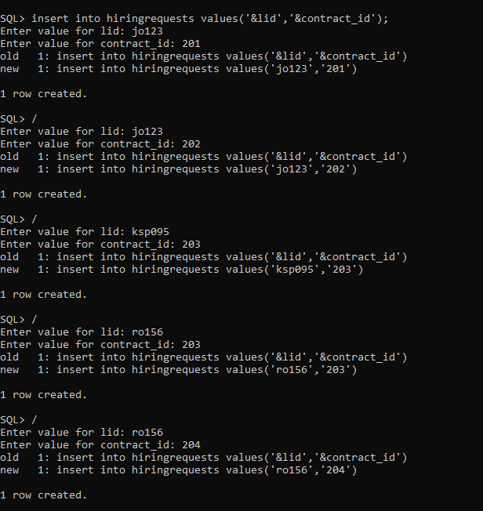

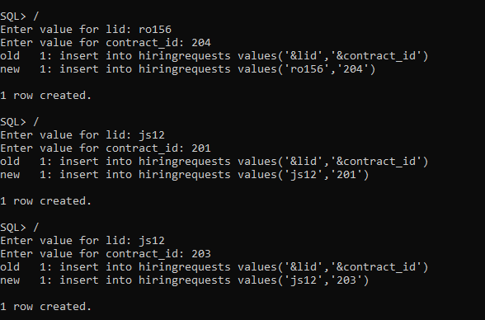

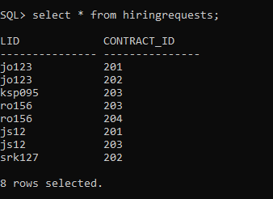

5.insert into hiringrecords values(‘&cid’,’&contract_id’,’&ild’);

