DBMS LAB ASSIGNMENT-4

**E. Harshith kumar yadav**

**19bcs041**

# **Write 5 Nested Queries for your respective database- the queries should not be very similar like just changing the where clause or just building all the queries on only one or two tables etc. The queries should make sense, it should cover most part of your database tables.**

**SQL-QUERY 1)**

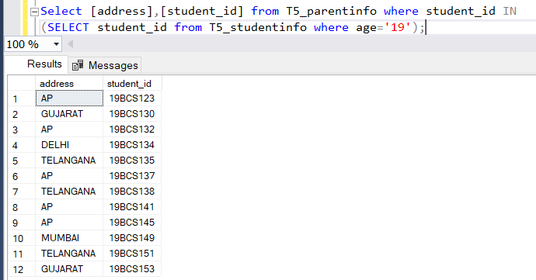

Select [address],[student_id] from T12_parentinfo where student_id IN (SELECT student_id from T12_studentinfo where age='19');

**SQL-QUERY 2)**

Select * from T12_staff where teacher_id IN

(Select teacher_id from T12_course_staff where student_id IN

(select student_id from T12_courses where course_id='CS201' or course_id='CS210'));

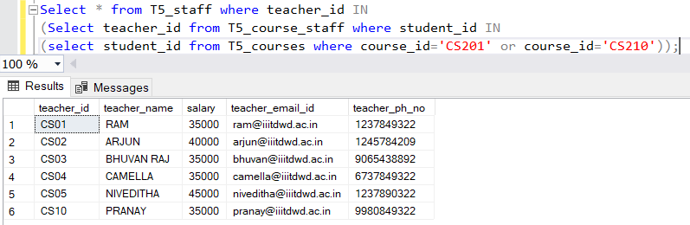

**SQL-QUERY 3)**

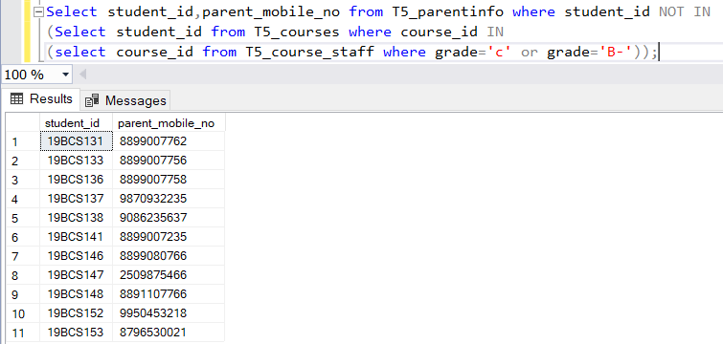

Select student_id,parent_mobile_no from T12_parentinfo where student_id NOT IN (Select student_id from T12_courses where course_id IN

(select course_id from T12_course_staff where grade='c' or grade='B-'));

**SQL-QUERY 4)**

Select teacher_name,teacher_id from T12_staff where NOT EXISTS ( select * from T12_course_staff where T12_staff.teacher_id=T12_course_staff.teacher_id);

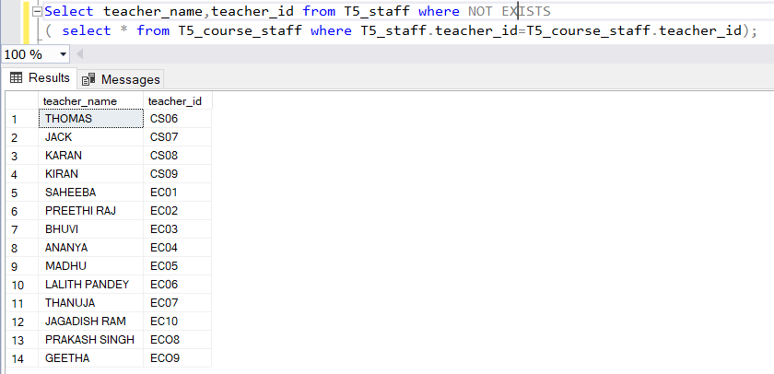

**SQL-QUERY 5)**

Select student_id,first_name,last_name from T12_studentinfo where student_id IN (Select student_id from T12_course_staff where EXISTS

( select * from T12_courses where T12_course_staff.course_id=T12_courses.course_id));

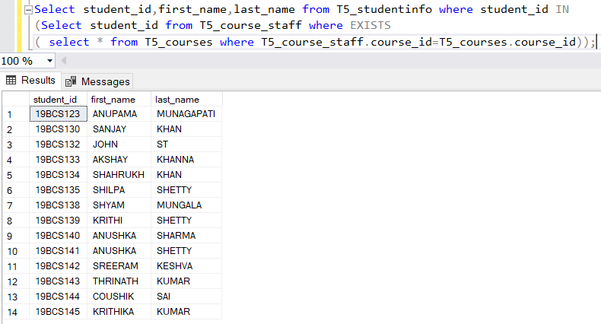

1. **Illustrate how we can use Concat and As operators in SQL (minimum 3 queries)**

**SQL-QUERY 1)**

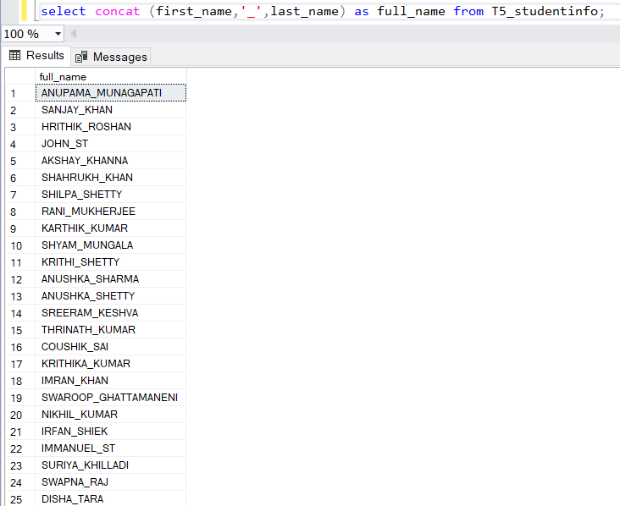

select concat (first_name,'_',last_name) as full_name from T12_studentinfo;

**SQL-QUERY 2)**

select concat (teacher_id,'_',teacher_name,'(ph:',teacher_ph_no,')')

as teacher_contact_details,salary,teacher_email_id from T12_staff

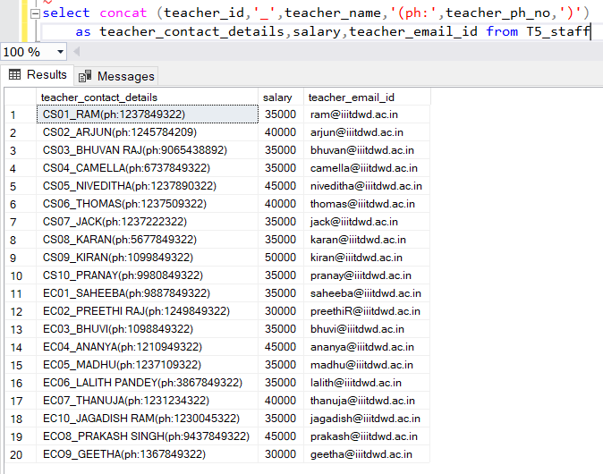

**SQL-QUERY 3)**

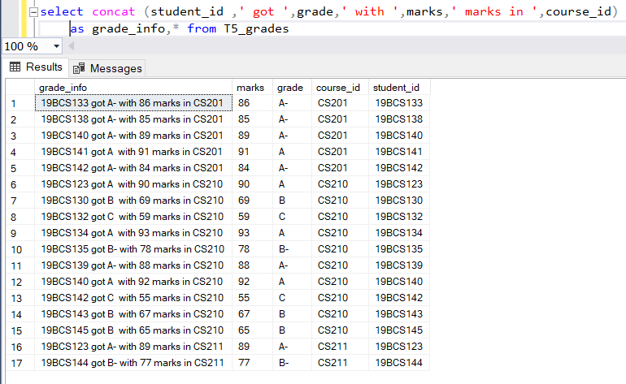

select concat (student_id ,' got ',grade,' with ',marks,' marks in ',course_id) as grade_info,* from T12_grades

1. **Illustrate all the Comparison operator. FOR ‘>’:**

**SQL-QUERY 1)**

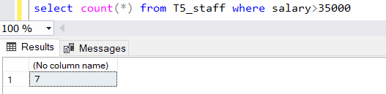

select count(*) from T12_staff where salary>35000

**SQL-QUERY 2)**

select * from T12_staff where teacher_id>'CS09'

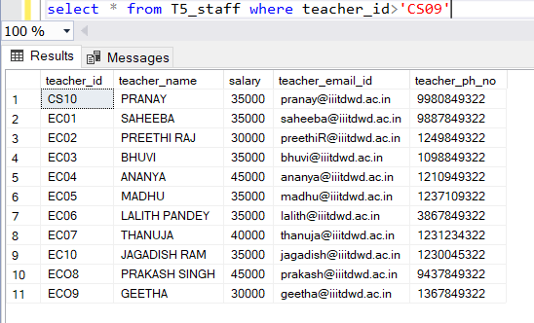

**FOR ‘<’: SQL-QUERY1)**

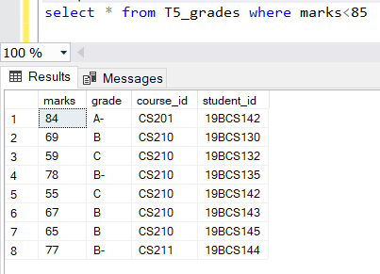

select * from T12_grades where marks<85

**SQL-QUERY 2)**

select course_year,student_id from T12_courses where course_year<3

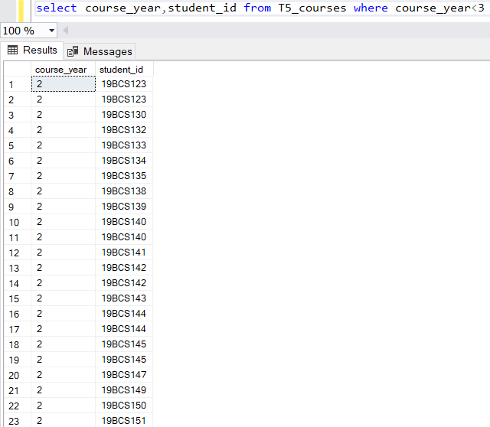

**FOR ‘>=’: SQL-QUERY 1)**

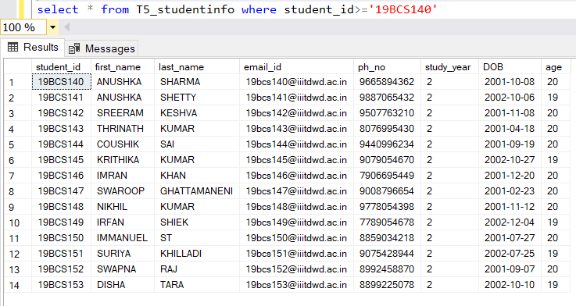

*select * from T12_studentinfo where student_id>='19BCS140'*

**SQL-QUERY 2)**

select parent_name,parent_mobile_no from T12_parentinfo where student_id>='19BCS145'

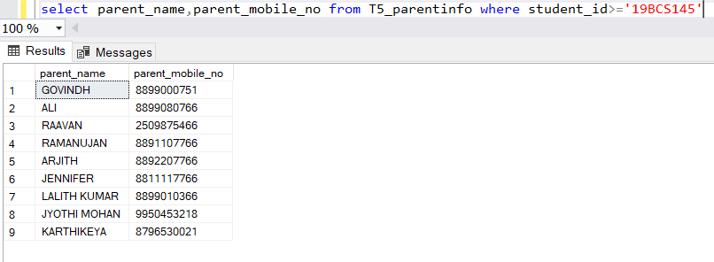

**FOR ‘<=’: SQL-QUERY 1)**

select course_id,course_name,student_id from T12_courses where course_year<='4'

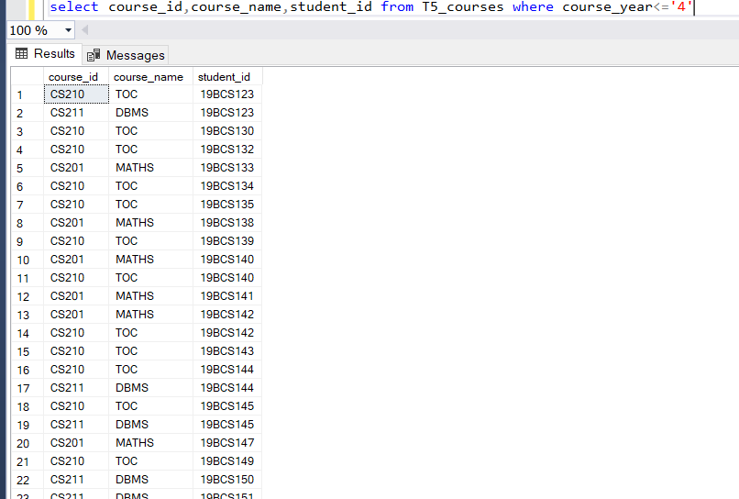

**SQL-QUERY 2)**

select count(*) from T12_staff where salary<=35000

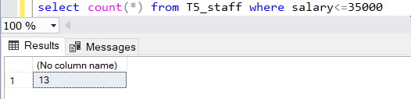

**SQL-QUERY 1)**

select * from T12_course_staff where grade='A-'

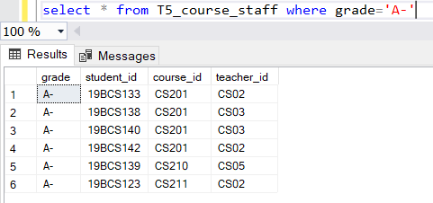

**SQL-QUERY 2)**

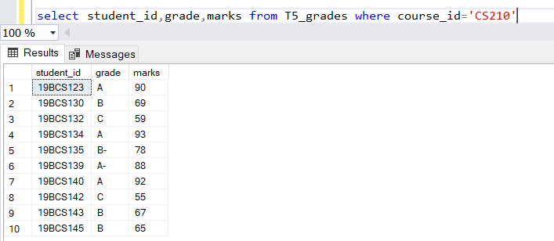

select student_id,grade,marks from T12_grades where course_id='CS210'

**FOR ‘<>’: SQL-QUERY 1)**

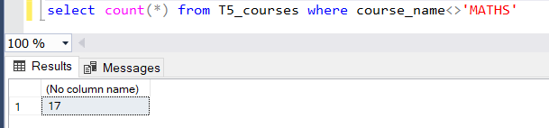

select count(*) from T12_courses where course_name<>'MATHS'

**SQL-QUERY 2)**

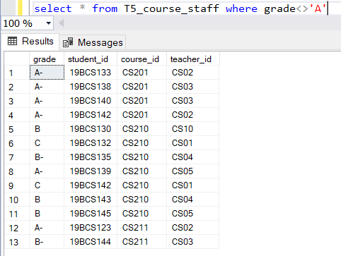

select * from T12_course_staff where grade<>'A'

1. **Illustrate Logical operators except ANY, ALL and Like (2 queries for each operator)**

**OR OPERATOR:**

**QUERIES:**

**i)**

select * from T12_grades where grade='A' OR course_id='CS210'

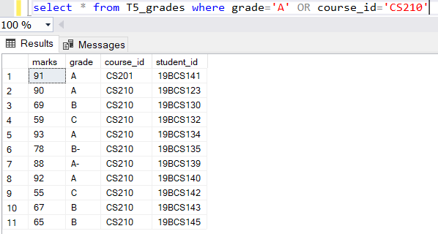

**ii)**

iselect * from T12_course_staff where teacher_id='CS02' OR course_id='CS201' OR grade='A'

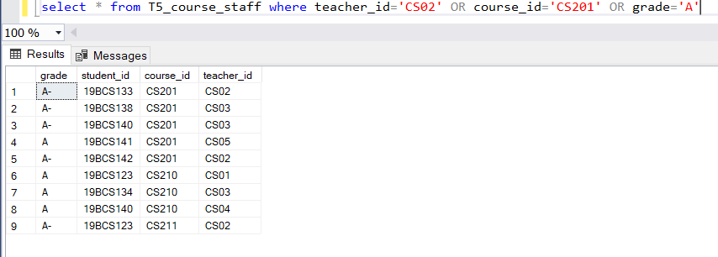

**iii)**

select first_name,last_name from T12_studentinfo where age='19' and

student_id in(select student_id from T12_parentinfo where student_id>'19BCS130')

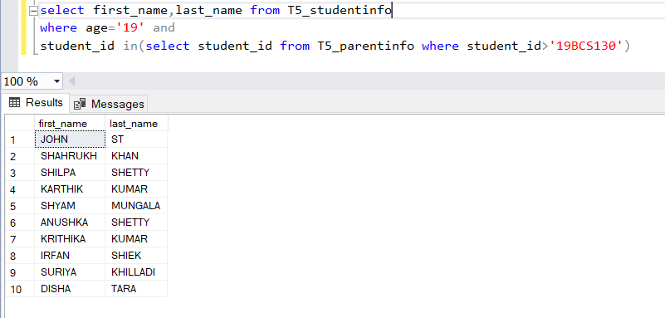

**iv)**

select * from T12_grades where marks NOT BETWEEN 80 and 90

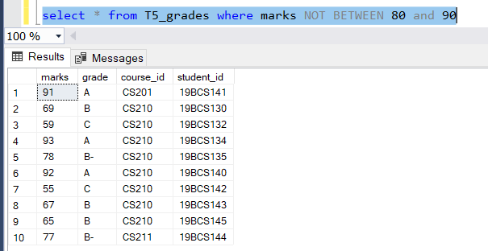

**v)**

select * from T12_course_staff where NOT course_id='CS210';

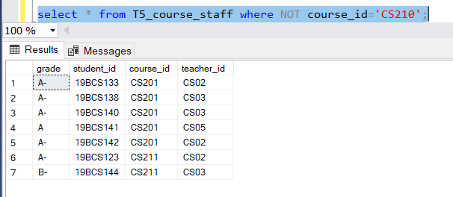

**vi)**

select * from T12_courses where student_id BETWEEN '19BCS130' and '19BCS140'

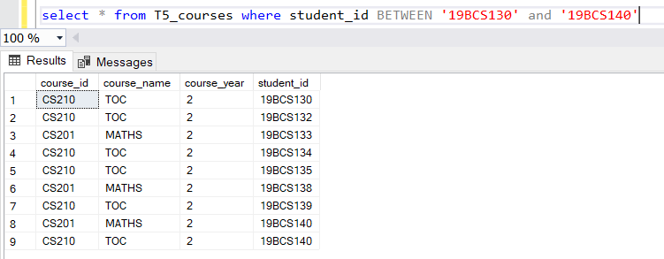

**vii)**

select student_id,marks,grade from T12_grades where marks BETWEEN 60 and 85

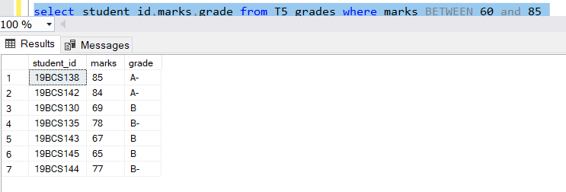

**viii)**

select student_id,DOB from T12_studentinfo where age=20 and student_id BETWEEN '19BCS140' and '19BCS150';

