Hospital Appointment Management and Patient Attendance Analysis Using R
Case Study report submitted in partial fulfillment of the Requirements for the Award of the Degree of
BACHELOR OF ENGINEERING
in
ARTIFICIAL INTELLIGENCE AND DATA SCIENCE
By
Harshit Srinivasa Prasad - 160124771033
Under the Mentorship of
________________________________
Faculty Mentor

DEPARTMENT OF ARTIFICIAL INTELLIGENCE AND DATA SCIENCE
CHAITANYA BHARATHI INSTITUTE OF TECHNOLOGY
HYDERABAD - 500075
October 2026

CHAITANYA BHARATHI INSTITUTE OF TECHNOLOGY
(AUTONOMOUS)
DEPARTMENT OF ARTIFICIAL INTELLIGENCE AND DATA SCIENCE
CERTIFICATE
This is to certify that the course case study report entitled Hospital Appointment Management and Patient Attendance Analysis Using R is submitted by
Harshit Srinivasa Prasad 160124771033
in partial fulfillment of the requirements for the award of the Degree of Bachelor of Engineering in Artificial Intelligence and Data Science at Chaitanya Bharathi Institute of Technology, Hyderabad, for the academic year 2026-27.
Mentor verification and signature
________________________________
Faculty Mentor

Hospital Appointment Management and Patient Attendance Analysis Using R
Hospital Appointment Attendance Analysis and Prediction Using R

1 Abstract
Missed hospital appointments create uncertainty in scheduling and can leave capacity unused. This study analyses historical appointment records and estimates attendance probabilities using Random Forest and XGBoost. The working file contains 53,978 appointments before cleaning and 53,976 afterward. Preparation includes checking records, correcting target labels, converting dates and calculating waiting days. Patients remain separate across training, validation and testing partitions. Validation F1 selects follow-up thresholds, while test evaluation includes precision, recall, F1 and Brier score. Random Forest obtains test F1 0.4450 and XGBoost obtains 0.4468. The final demonstration reports attending and missing probabilities for a fictional appointment. The results support reminder prioritisation as a research prototype. They do not establish that reminders improve attendance or that the model transfers to other hospitals. Incomplete source coverage and the absence of several personal and operational factors limit the findings.

2 Introduction

2.1 Background
Hospital staff must plan appointments despite uncertainty about patient attendance. Historical records can identify patterns and support estimates of missed-appointment risk.

2.2 Problem statement
How can historical patient and appointment information help identify appointments at higher risk of being missed, while reporting the probability of attendance?

2.3 Objectives
- Prepare appointment records for analysis.
- Compare attendance across age groups, gender, waiting periods and SMS status.
- Train Random Forest and XGBoost probability models.
- Select follow-up thresholds using validation data and evaluate test performance.
- Demonstrate attending and missing probabilities for a new fictional patient.

2.4 Scope
The implementation analyses attendance and predicts outcomes. It does not book, cancel or reschedule appointments, and it does not send SMS messages. The SMS indicator must already be available at the time a prediction is made.

3 Data

3.1 Source and variables
The working file is KaggleV2-May-2016.csv, associated with the Medical Appointment No Shows dataset. Each row represents an appointment; patients can appear more than once. Counts below describe the imported working file, which may be a subset of the original dataset.
Variable | Description
PatientId, AppointmentID | Patient and appointment identifiers
Gender, Age | Recorded demographic details
ScheduledDay, AppointmentDay | Booking and appointment dates
Neighbourhood | Recorded neighbourhood
Scholarship | Welfare programme indicator
Hipertension, Diabetes, Alcoholism | Recorded health indicators
Handcap | Recorded disability category
SMS_received | Recorded SMS reminder indicator; does not prove reading
verification | Target renamed from No-show, recoded as Attended or Missed
WaitingDays | Appointment date minus booking date in calendar days
The original No-show = Yes means Missed, while No means Attended.

3.2 Dataset size at each stage
Appointments at each stage
Stage | Appointments
Imported file | 53978
After cleaning | 53976
Model training | 34719
Validation | 8597
Testing | 10660

4 Methodology

4.1 Overall workflow
- Import and inspect the CSV.
- Clean records and calculate waiting days.
- Separate patients into training, validation and testing partitions.
- Fit Random Forest and XGBoost on model-training records.
- Select thresholds on validation records.
- Evaluate fixed models and thresholds on testing records.
- Interpret attendance patterns and demonstrate a new appointment prediction.
- Save models, results and report data.

4.2 Data cleaning
The notebook checks missing values, duplicate rows and data types. It removes negative ages, converts date fields and excludes invalid waiting periods. Age zero remains valid for infants. Repeated patients remain in the dataset because separate appointments are legitimate observations.
Missing values after cleaning
Column | Missing
PatientId | 0
AppointmentID | 0
Gender | 0
ScheduledDay | 0
AppointmentDay | 0
Age | 0
Neighbourhood | 0
Scholarship | 0
Hipertension | 0
Diabetes | 0
Alcoholism | 0
Handcap | 0
SMS_received | 0
verification | 0
WaitingDays | 0

4.3 Feature engineering
Waiting days uses calendar dates rather than timestamp subtraction. The target uses explicit outcome labels. Gender becomes indicator columns for XGBoost. Identifiers and the attendance target are excluded from the predictor matrix.
Selected predictors
Predictor
Age
Gender
Scholarship
Hipertension
Diabetes
Alcoholism
Handcap
SMS_received
WaitingDays

4.4 Training validation and testing
Approximately 80% of patients enter the outer training partition. Of those, approximately 20% enter validation. The remaining patients form the test set. Appointment proportions differ because patients have different record counts.
Patient overlap checks
Pair | Shared_patients
Training_Validation | 0
Training_Testing | 0
Validation_Testing | 0

4.5 Models and evaluation
Model | Configuration | Evaluation
Random Forest | 300 trees, mtry 3, minimum node size 20, probability forest | Precision, recall, F1, accuracy, Brier score
XGBoost | Binary logistic, eta 0.05, depth 4, child weight 10, row and column sampling 0.8 | Same test metrics; validation log loss for early stopping
Both models use seed 33. XGBoost allows up to 500 rounds and stops after 30 rounds without validation improvement. Thresholds from 0.01 to 0.99 maximise validation F1. The test set does not determine thresholds. Random Forest uses the method implemented in ranger (Wright and Ziegler, 2017); XGBoost follows the boosting system described by Chen and Guestrin (2016).

5 Exploratory data analysis

5.1 Outcome distribution
Attendance distribution
Outcome | Count | Percent
Attended | 42599 | 78.92
Missed | 11377 | 21.08
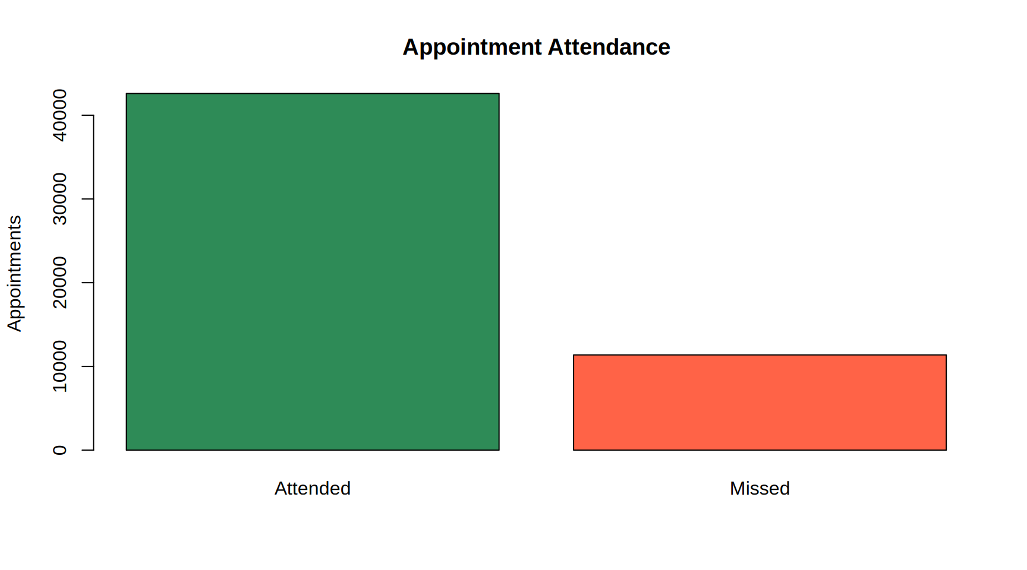
The missed rate is 21.08%. A model can obtain high accuracy by predicting the majority class, so missed-class recall matters.

5.2 Patient and appointment groups
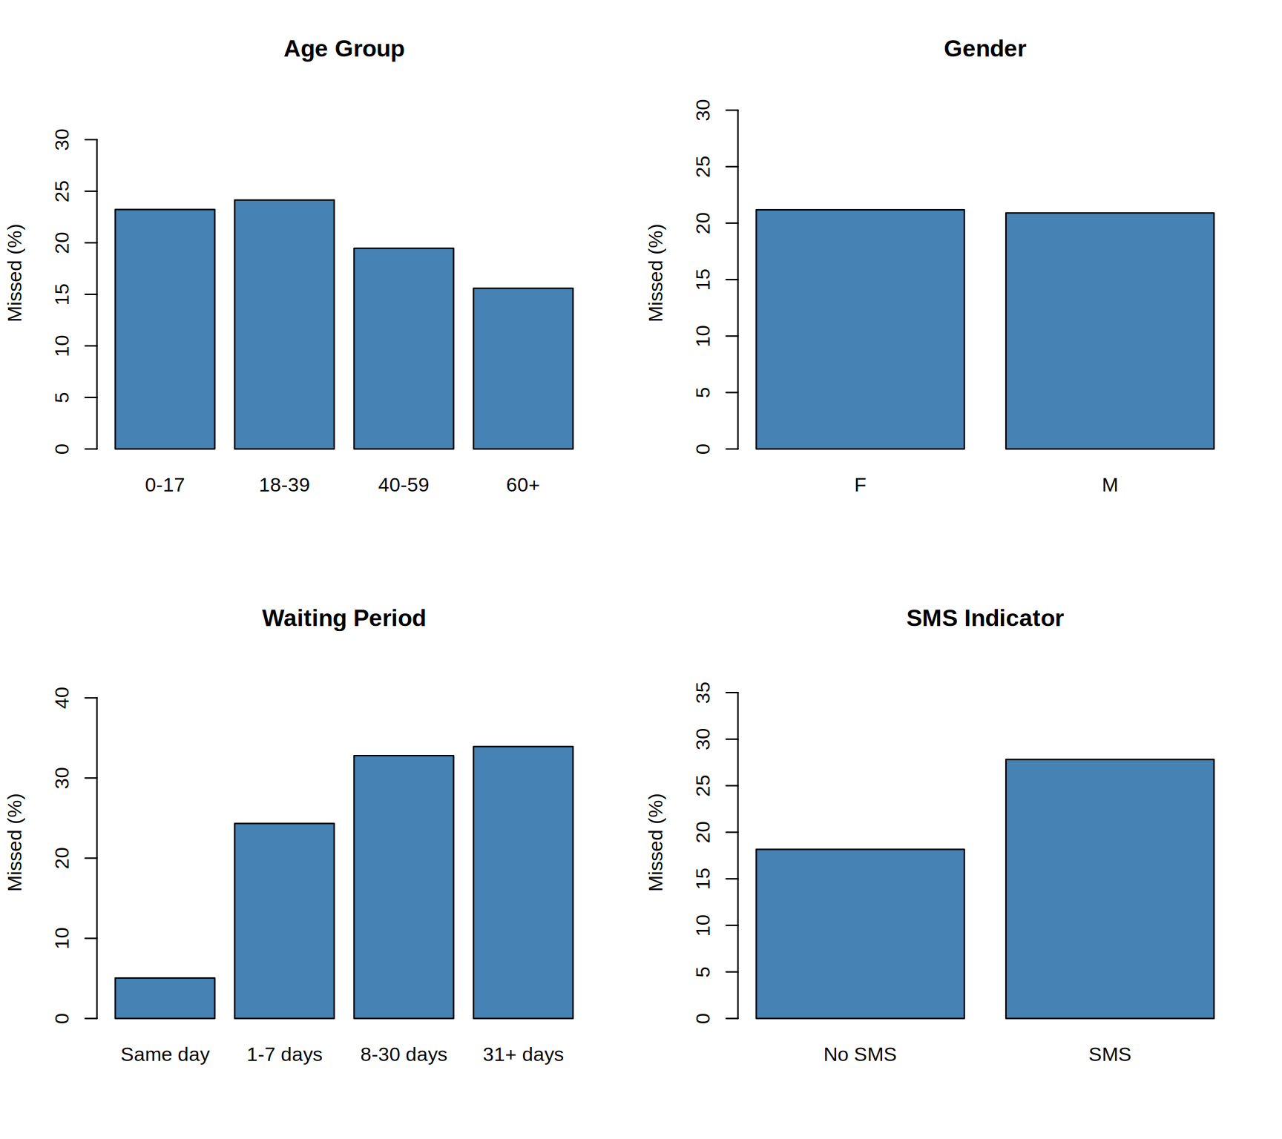
Percentages compare groups of unequal sizes. These are descriptive associations, not evidence that a characteristic causes missed appointments. SMS groups may differ in waiting periods and other factors.

6 Classification results

6.1 Validation thresholds
Validation threshold selection
Model | Threshold | Accuracy | Precision | Recall | F1
Random Forest | 0.22 | 0.5999 | 0.3142 | 0.7599 | 0.4446
XGBoost | 0.24 | 0.6242 | 0.3237 | 0.7191 | 0.4465
The follow-up thresholds are 0.22 for Random Forest and 0.24 for XGBoost. A follow-up flag can occur below 50% missing probability. It does not imply that missing is the more likely outcome.

6.2 Test metrics and baseline
Test performance
Model | Threshold | Accuracy | Precision | Recall | F1 | BrierScore
Random Forest | 0.22 | 0.6029 | 0.3160 | 0.7522 | 0.4450 | 0.1516
XGBoost | 0.24 | 0.6260 | 0.3252 | 0.7137 | 0.4468 | 0.1505

Simple baselines
Metric | Value
Always-attend accuracy | 0.7884
Constant-risk Brier score | 0.1668
Precision is the proportion of flagged appointments actually missed. Recall is the proportion of missed appointments identified. F1 balances both, while Brier score measures squared probability error. Lower Brier score is better.
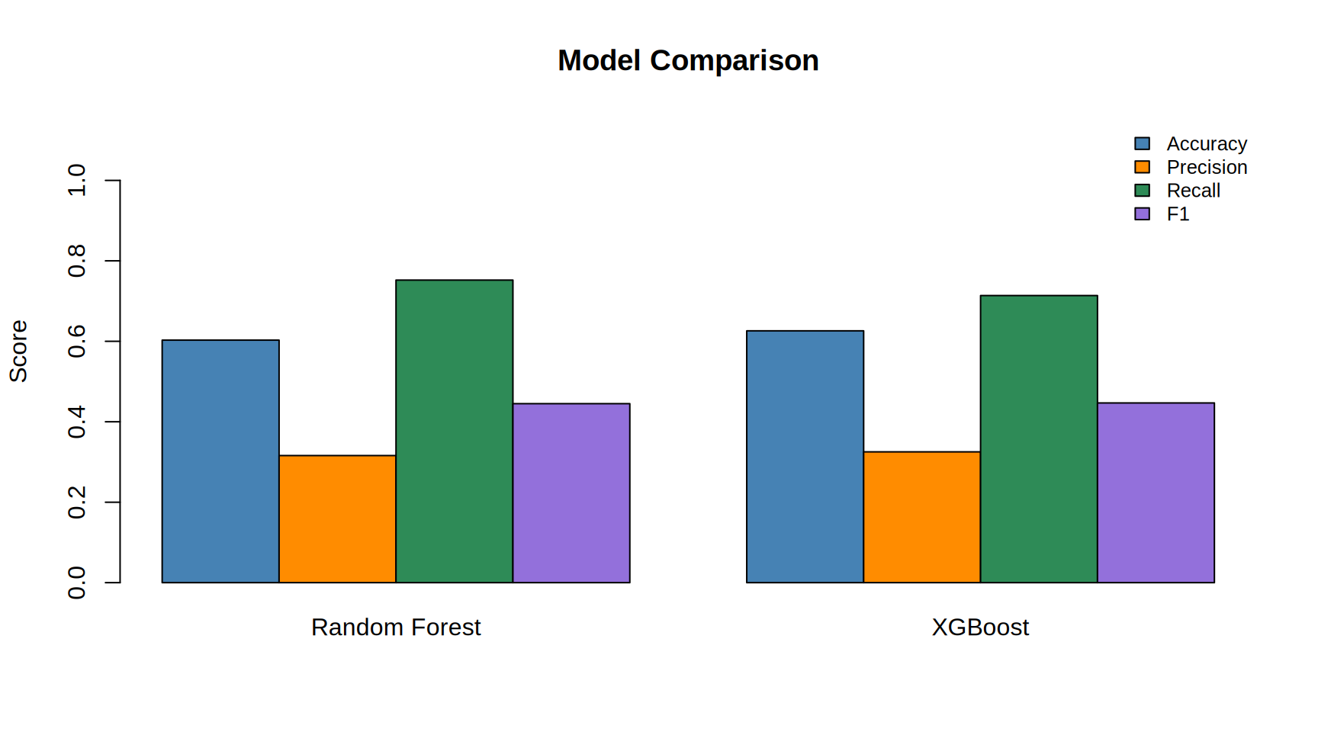

6.3 Confusion matrices
Rows are actual outcomes and columns are threshold-based predictions.
Random Forest
 | Attended | Missed
Attended | 4730 | 3674
Missed | 559 | 1697

XGBoost
 | Attended | Missed
Attended | 5063 | 3341
Missed | 646 | 1610

7 Important factors
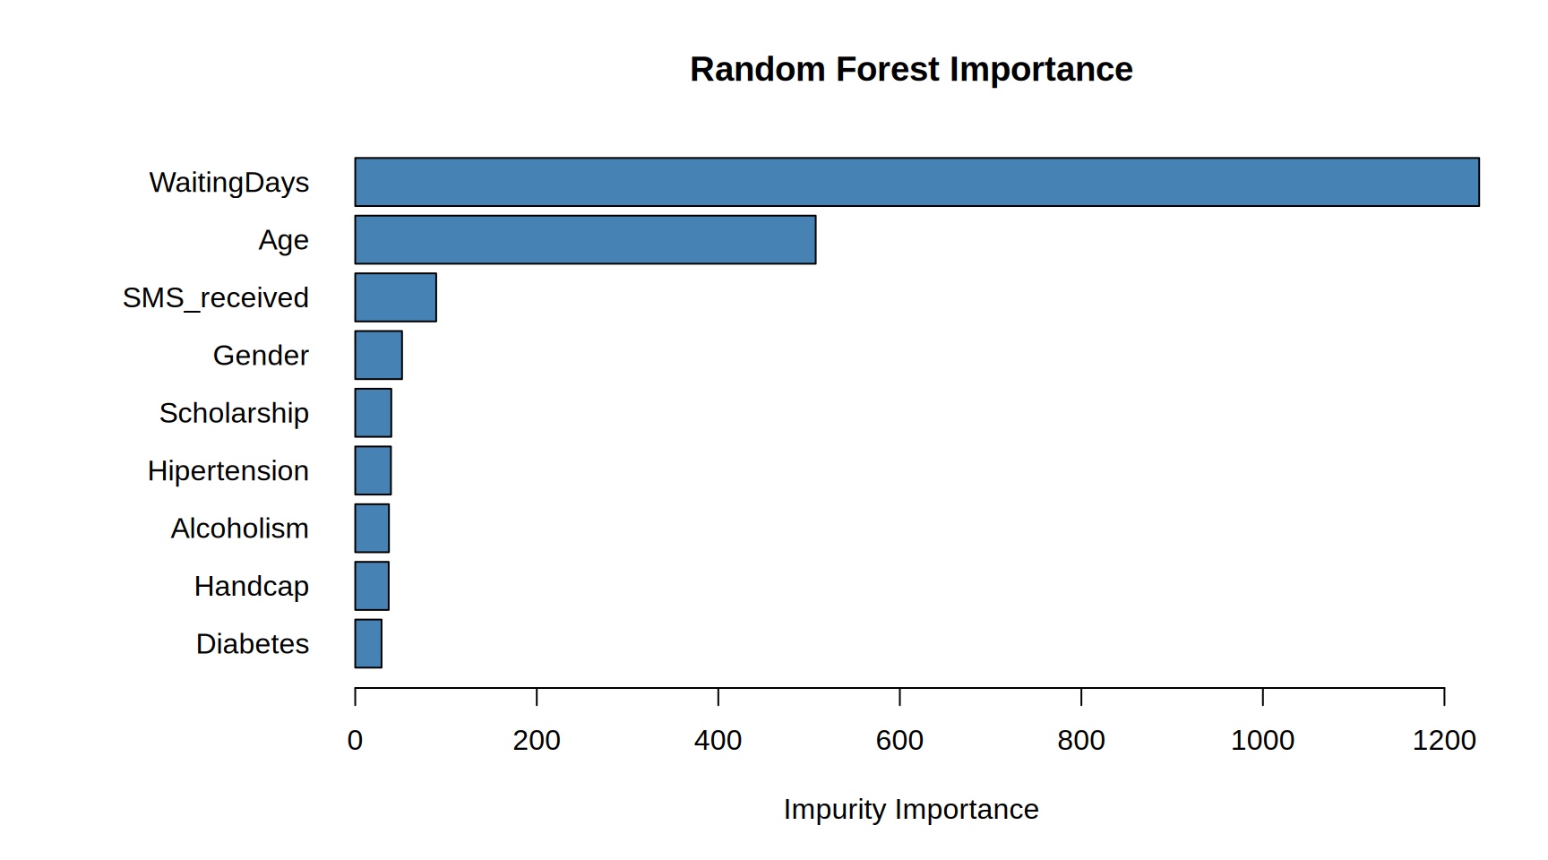
XGBoost importance
Feature | Gain | Cover | Frequency
WaitingDays | 0.7814 | 0.3890 | 0.2357
Age | 0.1487 | 0.3474 | 0.4256
SMS_received | 0.0213 | 0.0744 | 0.0598
Scholarship | 0.0141 | 0.0552 | 0.0633
GenderF | 0.0112 | 0.0296 | 0.0661
Alcoholism | 0.0095 | 0.0434 | 0.0410
Hipertension | 0.0063 | 0.0200 | 0.0487
Handcap | 0.0038 | 0.0218 | 0.0327
GenderM | 0.0023 | 0.0028 | 0.0097
Diabetes | 0.0015 | 0.0165 | 0.0174
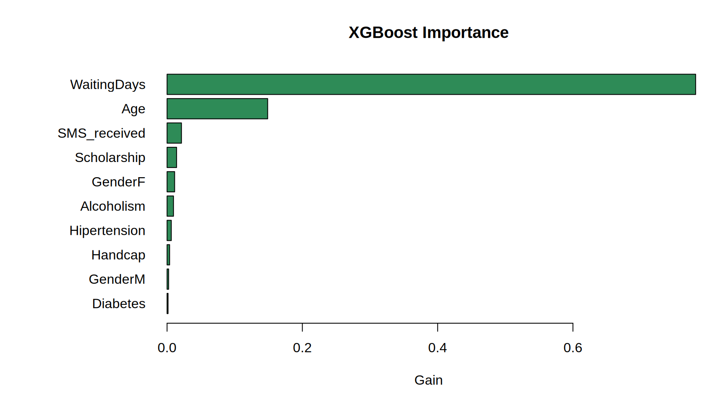
Importance describes how a model uses features. It does not establish causes or explain an individual prediction. The two importance scales differ.

8 New patient prediction
The following fictional-patient details and probability estimates are preserved from the supplied final report. They demonstrate model use; actual attendance is unknown.
New appointment details
Age | Gender | Scholarship | Hipertension | Diabetes | Alcoholism | Handcap | SMS | WaitingDays
28 | M | 0 | 0 | 1 | 0 | 4 | 0 | 20

Attendance probabilities and follow-up
Model | Attending % | Missing % | Predicted outcome | Follow-up flag
Random Forest | 72.36 | 27.64 | Attended | Prioritize reminder or confirmation
XGBoost | 60.60 | 39.40 | Attended | Prioritize reminder or confirmation
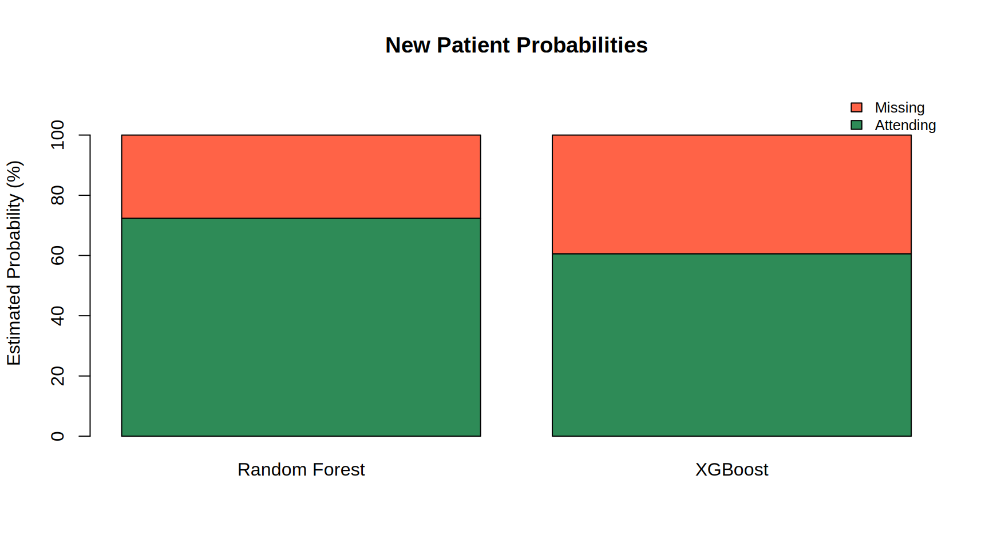
Attending and missing probabilities total approximately 100% after rounding. The more probable outcome uses 50%, while the reminder flag uses the selected validation threshold. Staff could use flags to prioritise confirmation calls. This demonstration does not validate the model or establish an operational benefit.

9 Model comparison and discussion
- Random Forest: precision 31.60%, recall 75.22%, F1 0.4450, Brier score 0.1516.
- XGBoost: precision 32.52%, recall 71.37%, F1 0.4468, Brier score 0.1505.
The analysis addresses attendance patterns and implements both probability models. Lower thresholds prioritise recall but create more unnecessary calls. The confusion matrices quantify this workload. Small differences in F1 do not establish a statistically reliable winner. The new-patient output demonstrates the interface between patient details, probability estimates and follow-up flags.

10 Limitations
- The working CSV may be a subset; its coverage must be documented.
- Patient-separated testing does not establish performance on future dates or other hospitals.
- Transport barriers, urgency and other relevant factors are absent.
- SMS status does not establish reading and must be known at prediction time.
- Threshold selection maximises F1 rather than hospital benefit or call capacity.
- Probability calibration and subgroup performance need further assessment.
- The test set was inspected during development; external evaluation would provide stronger evidence.
- Feature importance and descriptive graphs show associations, not causation.

11 Conclusion
The project prepares appointment records, analyses attendance patterns and fits Random Forest and XGBoost. Validation selects follow-up thresholds, and test results quantify probability quality and missed-appointment detection. The final output provides attending and missing probabilities with a separate reminder flag. This is a research prototype; practical use needs external validation and an assessment of follow-up costs and benefits.

11.1 Future work
- Verify complete source coverage and evaluate later appointments.
- Assess calibration and performance across patient groups.
- Choose thresholds according to reminder capacity and costs.
- Add an input interface and test whether targeted reminders improve attendance.

12 Reproducibility
The experiment used R in Google Colab. The standalone archived R Markdown file rebuilds the saved report without retraining. Full training reproduction requires the original notebook, exact working CSV, split seed and package versions. Project repository: https://github.com/harshith5961/Hospital-Attendance-Analysis-R
The archived report embeds saved tables and graphs. It does not recalculate results. The original executable report source additionally requires report_data.rds.
Recorded software: R 4.6.1; ranger 0.18.0; XGBoost 3.2.1.1; rmarkdown 2.32; knitr 1.52. Analysis ran in Google Colab on Linux.

13 References
- Wright, M. N., and Ziegler, A. (2017). ranger: A Fast Implementation of Random Forests for High Dimensional Data in C++ and R. Journal of Statistical Software, 77(1), 1-17. https://doi.org/10.18637/jss.v077.i01
- Chen, T., and Guestrin, C. (2016). XGBoost: A Scalable Tree Boosting System. Proceedings of the 22nd ACM SIGKDD International Conference on Knowledge Discovery and Data Mining. https://doi.org/10.1145/2939672.2939785
- Medical Appointment No Shows dataset. Working CSV: KaggleV2-May-2016.csv. Record the original download source and access date with the submitted dataset.

13.1 R and package citations
Software documentation: R Core Team, R: A Language and Environment for Statistical Computing (2026), https://www.R-project.org/; rmarkdown: Dynamic Documents for R, https://rmarkdown.rstudio.com/; knitr, https://yihui.org/knitr/.

