**LAB – 9**

**AI Navmesh - Path Finding**

**AIM:** Path Finding using NAVMESH component

**Video Link:** [**https://drive.google.com/file/d/1gjipdAvBOCxyPu0RvirF4VoDLSknv8NF/view?usp=sharing**](https://drive.google.com/file/d/1gjipdAvBOCxyPu0RvirF4VoDLSknv8NF/view?usp=sharing)

1. **Maze**

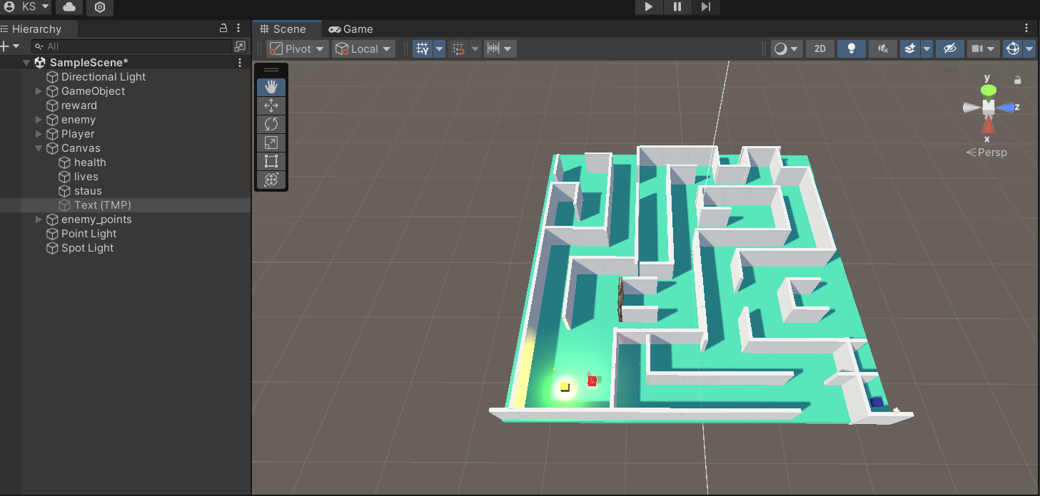

1. Install AI navigation package

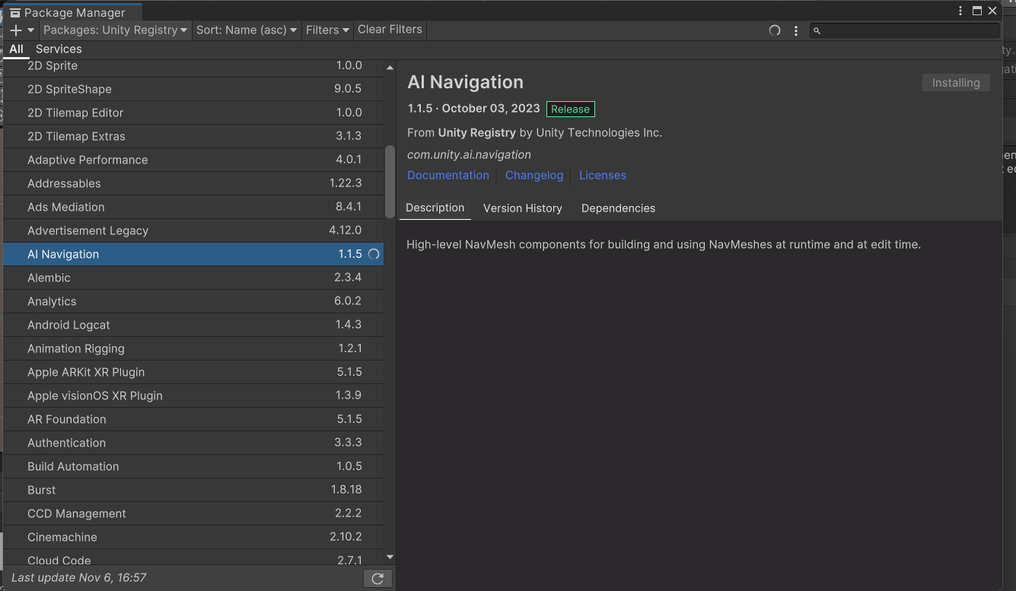

1. Add Empty game object NavMesh and Add Nav mesh Surface to the inspector and click on bake

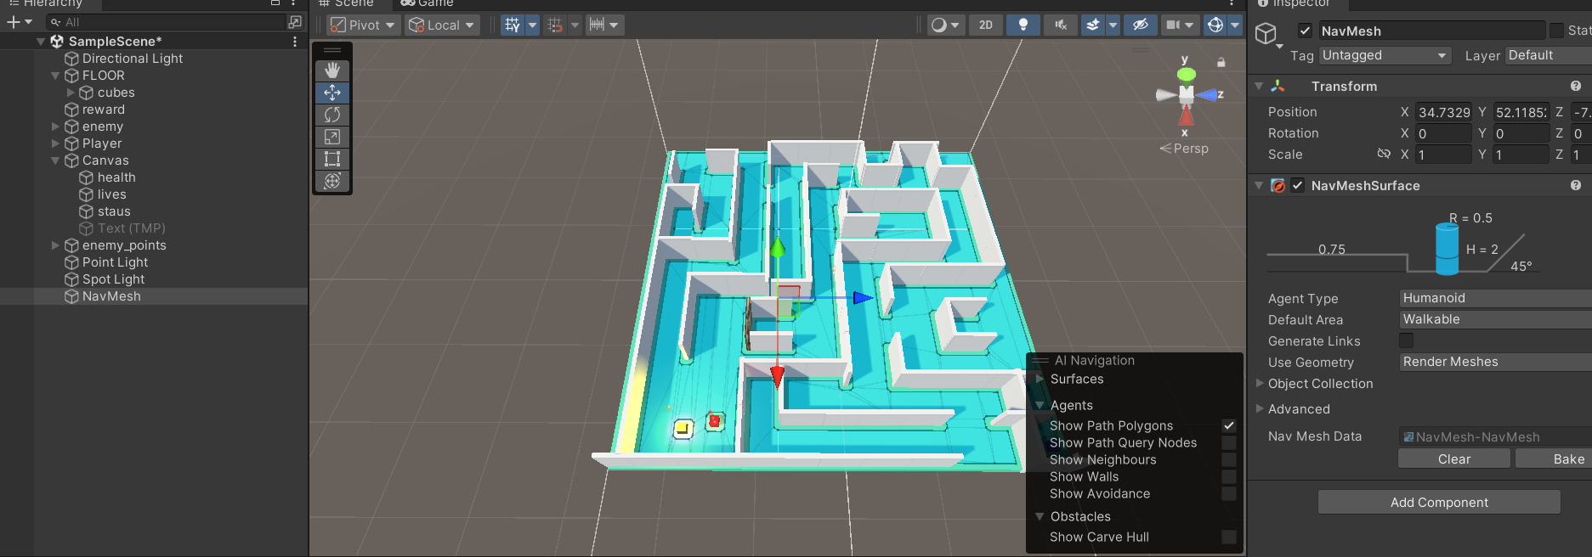

1. Change Layer to Player for Layer for Player game object

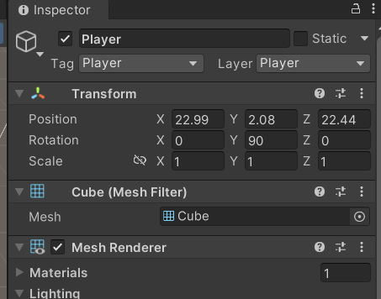

1. Add navmeshmodifier for the ground and make Area Type to Walkable

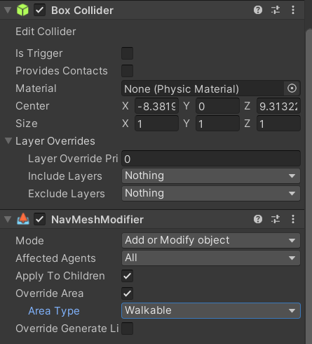

1. For the obstacles add Navmeshmodifier and make Area Type as Not Walkable

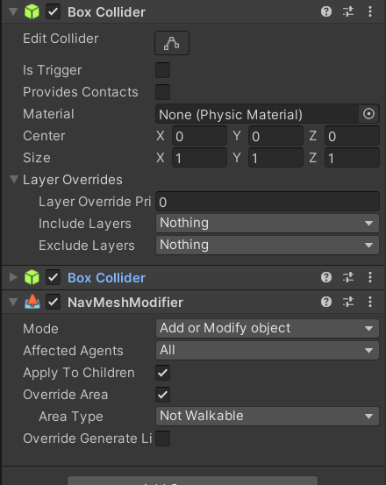

1. Add the following code to Player to make player move to the point where right mouse button is clicked.

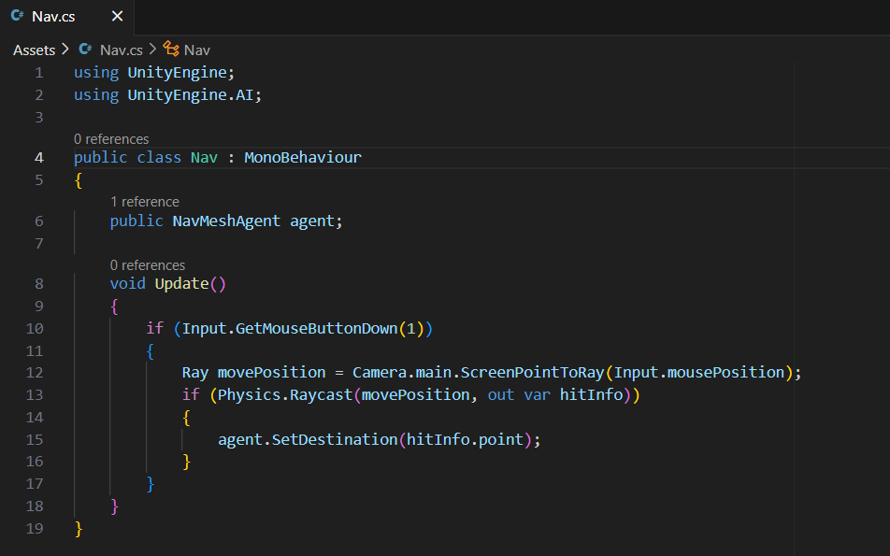

1. Add Nav mesh agent to the player

