**TILE BASED Game**

1. Select GAME OBJECTS; Add Polygon collider 2D, RigidBody 2D to all the selected game objects

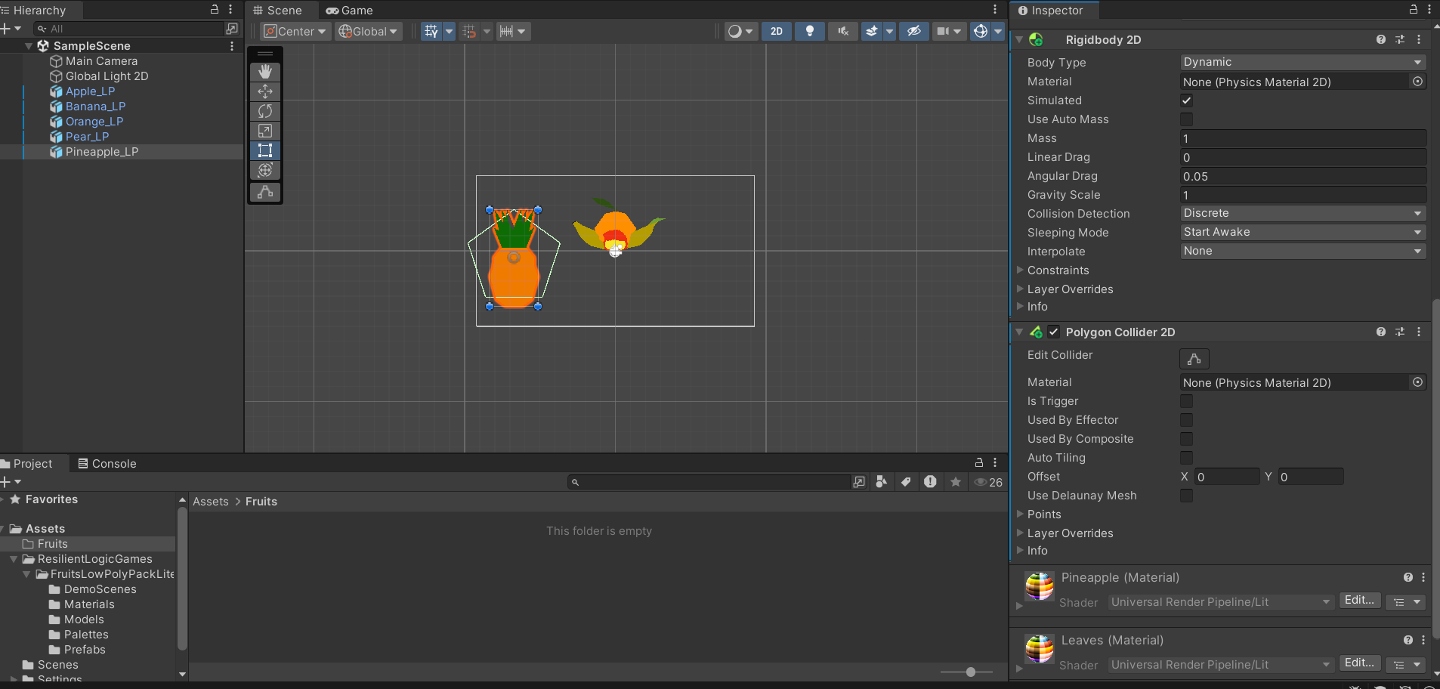

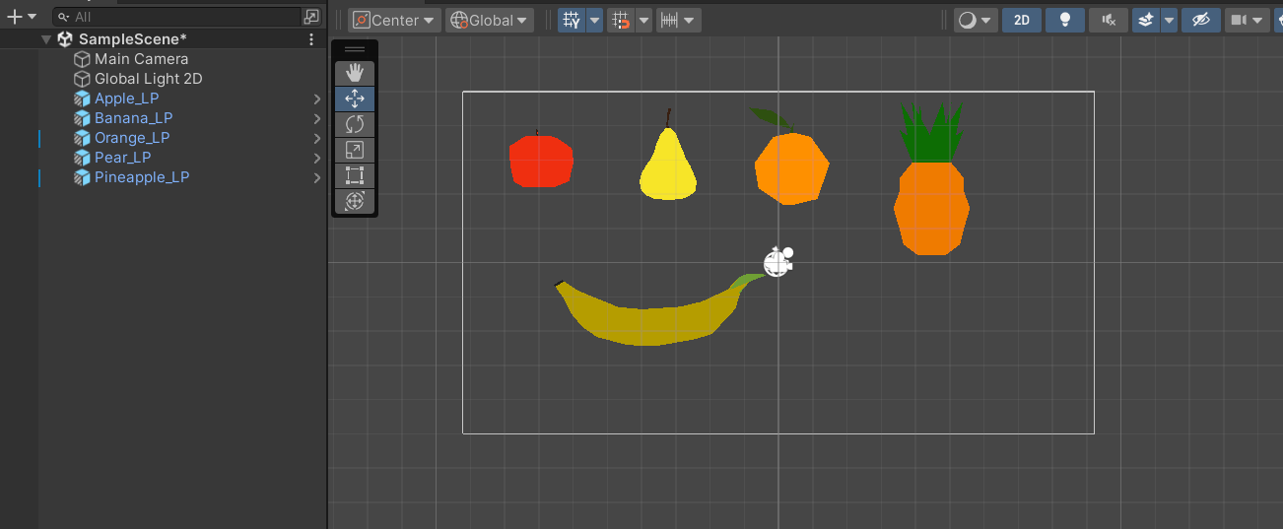

1. Add walls, to keep game objects within that container. Add Polygon 2d Collider to the Walls. ( so fruits will remain within that container)

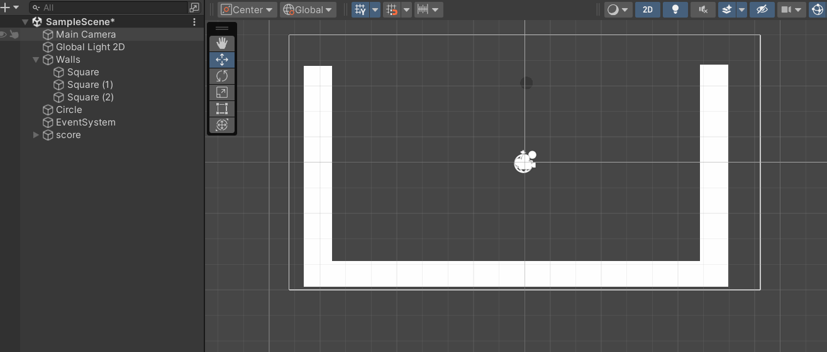

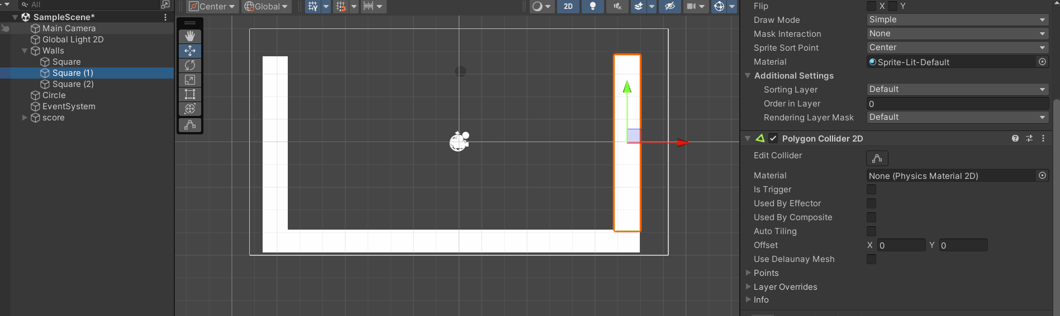

1. Add a sprite circle where next object that would fall will appear. Add Code where to spawn next object and move the circle
2. using System.Collections;
3. using System.Collections.Generic;
4. using UnityEditor;
5. using UnityEngine;
6. public class Circlemov : MonoBehaviour
7. {
8. // Start is called before the first frame update
9. public Transform[] fruitobj;
10. static public string spawnedYet = "n";
11. static public Vector2 cloudxPos;
12. static public Vector2 spawnPos;
13. static public string newfruit="n";
14. static public int whichfruit=0;
15. void Start()
16. {
18. }
19. void Update()
20. {
21. SpawnFruit();
22. ReplaceFruit();
23. if (Input.GetKey("a")){
24. GetComponent<Rigidbody2D>().velocity = new Vector2(-2,0);
25. }
26. if (Input.GetKey("d")){
27. GetComponent<Rigidbody2D>().velocity = new Vector2(2,0);
28. }
29. if ((!Input.GetKey("a")) && (!Input.GetKey("d"))){
30. GetComponent<Rigidbody2D>().velocity = new Vector2(0,0);
31. }
32. cloudxPos = transform.position;
33. // if (cachedTransform.position.y >= 3.11f) // Check if fruit is above the threshold
34. // {
35. //     GameOver();
36. // }
37. }
38. void SpawnFruit()
39. {
40. if (spawnedYet =="n")
41. {
42. StartCoroutine(Spawntimer());
43. spawnedYet="y";
44. }
45. }
46. void ReplaceFruit(){
47. if (newfruit=="y"){
48. newfruit="n";
49. Instantiate(fruitobj[whichfruit+1], spawnPos, fruitobj[0].rotation);
50. }
51. }
52. IEnumerator Spawntimer()
53. {
54. yield return new WaitForSeconds(.75f);
55. Instantiate(fruitobj[Random.Range(0,4)], transform.position, fruitobj[0].rotation);
56. }
57. }

4. Add Tags to all the game objects so when similar Tagged Objects collide they will destroy and spawn new object with tag 1 more than this object

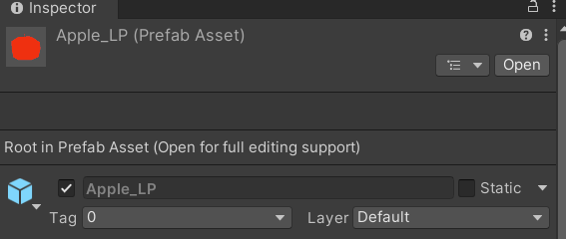

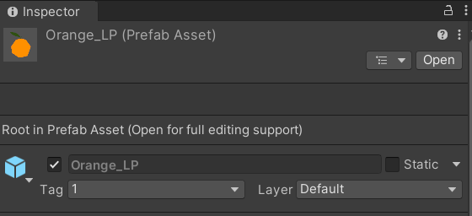

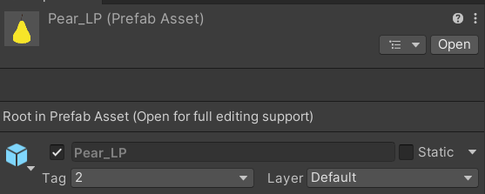

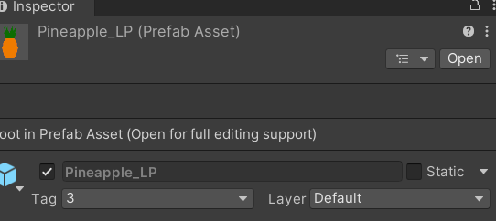

5. Add code to all the fruit game objects to detect Collision, increase Score.

using System.Collections;

using System.Collections.Generic;

using UnityEngine;

public class Fruitfall : MonoBehaviour

{

    // Start is called before the first frame update

    private string inthecloud = "y";

    void Start()

    {

        if (transform.position.y< 3.10){

            inthecloud = "n";

            GetComponent<Rigidbody2D>().gravityScale = 1;

        }

    }

    // Update is called once per frame

    void Update()

    {

        if (inthecloud == "y"){

            GetComponent<Transform>().position = Circlemov.cloudxPos;

        }

        if(Input.GetKeyDown("space")){

            GetComponent<Rigidbody2D>().gravityScale = 1;

            inthecloud = "n";

            Circlemov.spawnedYet = "n";

        }

    }

    private void OnCollisionEnter2D(Collision2D collision) {

        if (collision.gameObject.tag==gameObject.tag){

            Circlemov.spawnPos = transform.position;

            Circlemov.newfruit = "y";

            Circlemov.whichfruit = int.Parse(gameObject.tag);

            Destroy(gameObject);

            ScoreManager scoreManager = FindObjectOfType<ScoreManager>();

            if (scoreManager != null)

            {

                int pointsToAdd = 0;

                switch (gameObject.tag)

                {

                    case "0":

                        pointsToAdd = 1;

                        break;

                    case "1":

                        pointsToAdd = 2;

                        break;

                    case "2":

                        pointsToAdd = 3;

                        break;

                    case "3":

                        pointsToAdd = 5;

                        break;

                    // Add more cases if needed

                }

                scoreManager.IncreaseScore(pointsToAdd);

            }

        }

    }

}

6. Add Score code to any empty game object to keep track of score

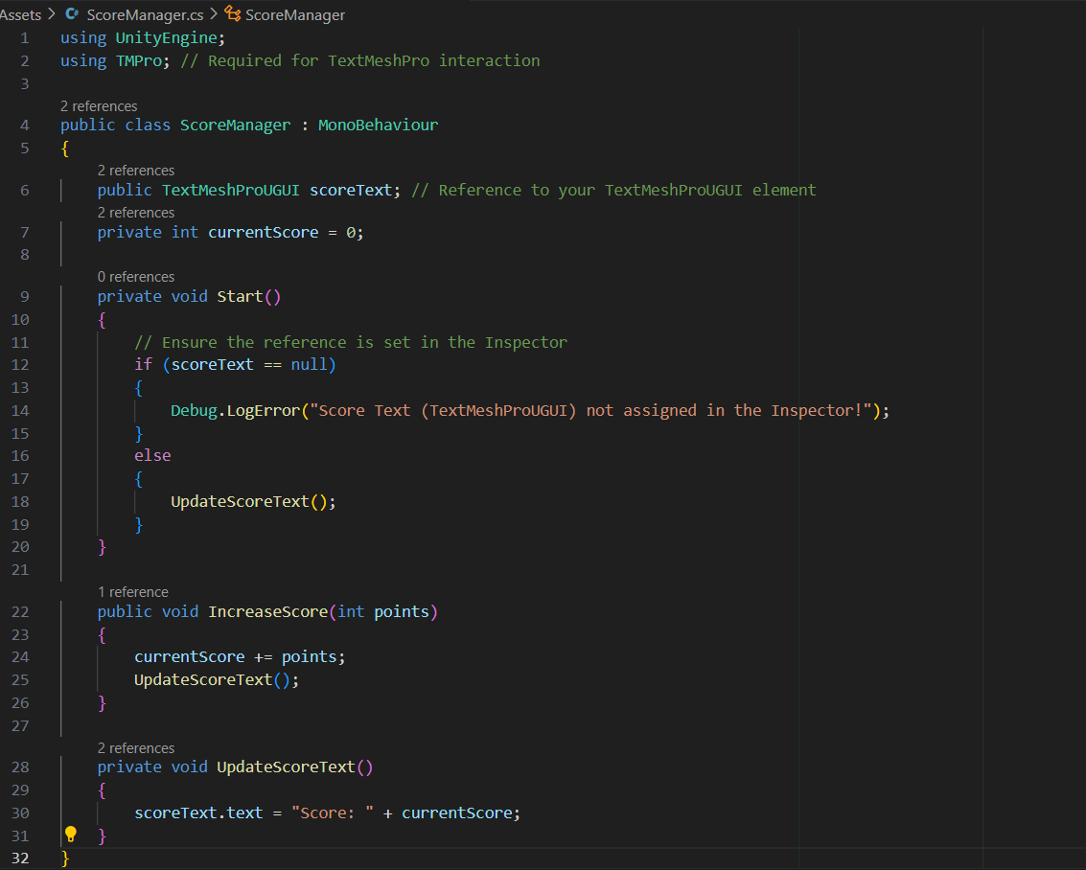

6. Add Condition to win (if score is 70)

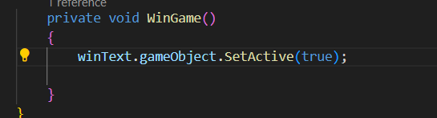

7. Add Condition for losing the game

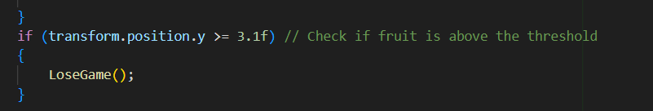

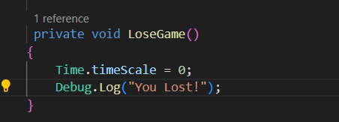

VIDEO: <https://drive.google.com/file/d/1iLHh8BaYlJ0EyEmShnU6dWST9jO9tZL5/view?usp=sharing>