FUNDAMENTALS OF COMPUTER ARCHITECTURE
MID-SEMESTER HACKATHON
“CATCH THE ROCKET”
LEVEL 3 REPORT
DEPLOYMENT + ALTITUDE QUERY

Item | Details
Team Name | BIT BY BIT
Team Member 1 | Harshitha – 24UG00551
Team Member 2 | Varshitha – 24UG00549
Team Member 3 | Shakuntala H M – USN not provided
Course | Fundamentals of Computer Architecture
Hardware | ESP32 Dev Board + USB Cable
Software | Arduino IDE + Arduino Serial Monitor
Level | Level 3 – Deployment and ALT
Prepared from the authoritative Catch the Rocket instructions, the Level 3 implementation work, and the actual ESP32 Serial Monitor evidence.

1. Level 3 Objective
Level 3 extends the Level 0–2 ground-station implementation by determining when the rocket leaves the coast phase and the parachute deployment occurs. The new commands are DEPLOY and ALT t. At the same time, the Level 1 and Level 2 calculations must continue to work with the tighter accuracy expected at this stage.
The physical guarantees used by the Level 3 design were:
- Parachute deployment occurs between 8 s and 45 s.
- Apogee occurs at least 1 s before deployment.
- Parachute descent velocity is between -15 m/s and -2 m/s.
- At deployment, the rocket is falling at least 10 m/s faster than the post-deployment descent speed.
- The first 8 seconds provide a guaranteed coast region for the quadratic model.

2. Requirements and Instruction Compliance
Requirement | How it was handled | Status
Exactly 100,000 nextAltitude() calls | Receiving loop covers indices 0 to 99,999. | PASS
No nextAltitude() after receiving | All tracker calls finish before command mode. | PASS
Tracker unchanged | Tracker supplied as a header and not rewritten. | PASS
One persistent state struct | GroundStationState holds the remembered processing state. | PASS
State <= 4096 bytes | Measured Level 3 state = 200 bytes. | PASS
Streaming processing | Regression statistics updated as readings arrive. | PASS
No 100,000-reading array | Readings are processed immediately. | PASS
RAM only | No Flash, SPIFFS, LittleFS, NVS or Preferences used. | PASS
No Wi-Fi/Bluetooth | Only ESP32 local computation and Serial Monitor used. | PASS
Generalization | No official deployment time or flight constants hard-coded. | PASS
Per-reading timing | ESP.getCycleCount() used to measure worst reading. | PASS
Required commands | DEPLOY, ALT, DESCENT, LAND, G, APOGEE and STATS tested. | PASS
Important scope note: the report claims Level 3 completion based on the actual ESP32 tests. No separate instructor acceptance message for Level 3 is being invented or claimed here.

3. Problem We Faced in Level 3
The main difficulty was that deployment is not directly supplied to the program. The data arrives one reading at a time, while the memory rule prevents storing the complete trajectory. Therefore, the program has to estimate the transition between two different physical models using compact streaming state.
- The coast model is valid before deployment.
- The descent model is valid after parachute deployment.
- A transition reading can be ambiguous because the program does not initially know the exact deployment time.
- ALT t must choose the correct model depending on whether t is before or after deployment.
- The same algorithm must work for the Official Tracker and Practice Tracker B, whose flight parameters are different.
- The implementation must stay within the 4096-byte state limit and the 12,000-cycle per-reading budget.

3.1 How We Cleared the Problem
We retained the guaranteed first 8 seconds as the clean coast region and used the quadratic least-squares model developed in Level 2. The descent model continued to use streaming linear regression over the guaranteed parachute region. In the transition interval, incoming altitude was compared against the fitted coast trajectory to obtain a deployment candidate. The final deployment time was then obtained from the intersection of the coast quadratic and the descent line, with the valid root selected inside the guaranteed 8–45 s interval.

4. Mathematical Model

4.1 Coast Model
The initial flight was modeled using a centered quadratic:
h(t) = a + b x + c x²
where x = t − t_center. Centering keeps the regression variables smaller and improves numerical stability.
The streaming sums required were:
- N
- Σx
- Σx²
- Σx³
- Σx⁴
- Σh
- Σxh
- Σx²h
The quadratic coefficient gives gravity through:
G = −2c
Apogee occurs when fitted vertical velocity becomes zero:
x_apogee = −b / (2c)

4.2 Descent Model
The parachute region was modeled as a straight line using centered time:
h(t) = A + B(t − 50)
The slope B is the descent velocity. Streaming quantities were:
- N
- Σx
- Σh
- Σx²
- Σxh
The landing time is obtained by solving the fitted descent line for h = 0.

4.3 Deployment Estimation
The fitted coast curve and descent line are intersected. In centered form the equation can be written as:
a + b(t − tc) + c(t − tc)² = A_d + B_d(t − 50)
This produces a quadratic equation in time. The roots are checked against the guaranteed deployment interval 8–45 s. When both roots are mathematically possible, the root closest to the streaming transition candidate is used.

4.4 ALT t
ALT t does not require storing the trajectory. If t is before the estimated deployment time, the fitted coast quadratic is evaluated. If t is after deployment, the fitted descent line is evaluated.

5. Streaming State and Memory
The implementation did not store the 100,000 readings. Instead, one GroundStationState structure stored counters, recent altitude history, regression sums, solved coefficients, deployment state, final results and the Serial command buffer.
Field/group | Type | Purpose
readingCount | uint32_t | Total readings received
validCount | uint32_t | Readings accepted for model updates
glitchCount | uint32_t | Reserved for later glitch-enabled stages; Level 3 tests used the Level 3 logic
worstReadingCycles | uint32_t | Maximum measured per-reading cycle count
previousAltitude / previousPreviousAltitude | float | Recent trajectory history for transition checks
previousIndex / previousPreviousIndex | uint32_t | Indices corresponding to recent history
validHistory | uint8_t | Number of valid history samples
coastN, coastSx...coastSx2h | double | Streaming quadratic regression statistics
coastA, coastB, coastC | double | Solved coast coefficients
coastSolved | bool | Indicates that the coast model is available
descentN, descentRefH, descentSx...descentSxy | float | Streaming descent regression statistics
deploymentDetected | bool | Transition detection state
deploymentCandidateIndex | uint32_t | Candidate transition sample
deploymentConfirmCount | uint8_t | Consecutive confirmation count
deploymentTime | float | Final deployment estimate
apogeeTime / apogeeHeight / gravity | float | Final coast-derived results
descentVelocity / landTime | float | Final descent-derived results
command / commandLength | char[32] / uint8_t | Serial command buffer
Measured Level 3 state size: 200 bytes, which is far below the 4096-byte limit.

6. Code Used: Important Level 3 Logic
The Level 3 Arduino sketch retained the Level 1 and Level 2 calculations and added deployment estimation and ALT queries. The following are the important code sections used in the ESP32 implementation.

6.1 Coast altitude evaluation
float coastAltitude(float t)
{
float x =
t - CENTER_TIME;

return
coastAf +
coastBf * x +
coastCf * x * x;
}

6.2 Deployment-region processing
if (index >= COAST_READINGS &&
index < DESCENT_START &&
!state.deploymentDetected)
{
updateDeployment(
altitude,
index
);
}

6.3 Deployment candidate detection
float t =
(float)index * 0.001f;

float predicted =
coastAltitude(t);

float difference =
altitude - predicted;

if (difference * difference >
DEPLOY_THRESHOLD * DEPLOY_THRESHOLD)
{
if (state.deploymentConfirmCount == 0)
{
state.deploymentCandidateIndex =
index;
}

state.deploymentConfirmCount++;

if (state.deploymentConfirmCount >=
DEPLOY_CONFIRM)
{
state.deploymentDetected = true;
}
}
else
{
state.deploymentConfirmCount = 0;
}

6.4 Streaming descent update
if (index >= DESCENT_START)
{
float t =
(float)index * 0.001f;

float x =
t - 50.0f;

if (state.descentN == 0.0f)
{
state.descentRefH =
altitude;
}

float y =
altitude -
state.descentRefH;

state.descentN += 1.0f;
state.descentSx += x;
state.descentSy += y;
state.descentSxx += x * x;
state.descentSxy += x * y;
}

6.5 Final deployment root selection
float x1 =
(-qb + root) /
(2.0f * qa);

float x2 =
(-qb - root) /
(2.0f * qa);

float t1 =
CENTER_TIME + x1;

float t2 =
CENTER_TIME + x2;

bool valid1 =
t1 >= 8.0f &&
t1 <= 45.0f;

bool valid2 =
t2 >= 8.0f &&
t2 <= 45.0f;
The complete sketch also contained the receiving loops, least-squares solver, result calculations and Serial Monitor command interface. The full source should be submitted separately if the instructor asks for the complete Arduino file.

7. ESP32 Testing Procedure
- Connect the ESP32 Dev Board to the computer using USB.
- Open the Level 3 Arduino sketch in Arduino IDE.
- Select the appropriate tracker header without modifying the tracker implementation.
- Compile and upload the sketch.
- Open Arduino Serial Monitor at 115200 baud.
- Wait until “Receiving complete” appears.
- Run STATS to verify 100,000 readings, phase counts, state size and worst cycles.
- Run DEPLOY, ALT t, DESCENT, LAND, G and APOGEE.
- Repeat the same procedure with Practice Tracker B.
- Compare the measured outputs with the Level 3 requirements and the previously verified Level 1/2 outputs.

8. Final Official Tracker Results
Measurement / Command | Measured result
Total readings | 100,000
Coast readings | 8,000
Descent readings | 87,886
State size | 200 bytes
Worst reading | 9,084 cycles
DEPLOY | 11.9970 s
ALT 0 | 311.9768 m
ALT 2 | 449.3821 m
ALT 8 | 626.0662 m
ALT 12 | 547.6848 m
ALT 20 | 511.6836 m
ALT 50 | 376.6790 m
DESCENT | -4.5002 m/s
LAND | 133.7036 s
G | 9.8138 m/s²
APOGEE | 8.0006 s, 626.0662 m

8.1 Official Tracker Evidence
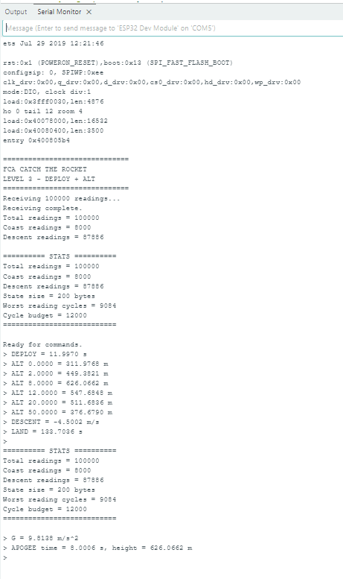
Figure 1. Final Official Tracker Level 3 ESP32 Serial Monitor run. The screenshot shows 100,000 readings, 8,000 coast readings, 87,886 descent readings, 200-byte state, 9,084 worst cycles and the required command results.

9. Final Practice Tracker B Results
Measurement / Command | Measured result
Total readings | 100,000
Coast readings | 8,000
Descent readings | 75,861
State size | 200 bytes
Worst reading | 9,087 cycles
DEPLOY | 24.0887 s
ALT 0 | 1499.9480 m
ALT 2 | 1576.5428 m
ALT 8 | 1717.3065 m
ALT 12 | 1736.9649 m
ALT 20 | 1598.2400 m
ALT 50 | 1218.5170 m
DESCENT | -8.5001 m/s
LAND | 193.3526 s
G | 3.7092 m/s²
APOGEE | 11.3250 s, 1737.8100 m

9.1 Practice Tracker B Evidence
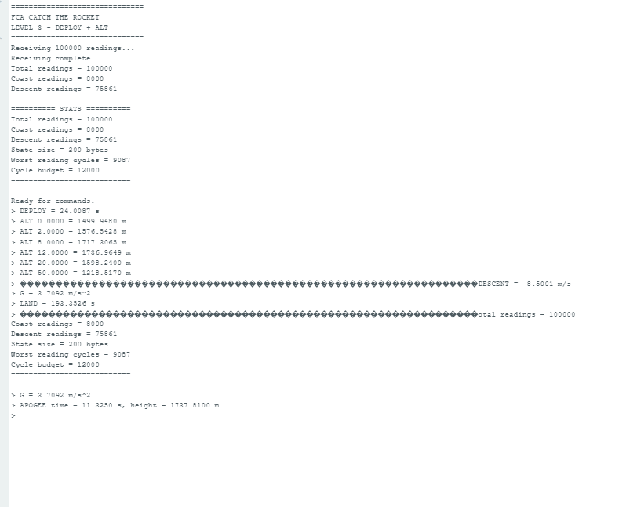
Figure 2. Final Practice Tracker B Level 3 ESP32 Serial Monitor run. The screenshot shows 100,000 readings, 8,000 coast readings, 75,861 descent readings, 200-byte state, 9,087 worst cycles and the required command results.

10. Development Problems and How We Cleared Them
Problem | Why it happened | How it was cleared
Deployment was unknown while readings streamed | The program only saw one reading at a time. | Used the guaranteed 8–45 s deployment interval and a coast-model residual transition candidate.
Transition could affect the coast/descent boundary | The program could not know the exact transition immediately. | Kept the guaranteed first 8 s as the clean coast basis and used final coast/descent intersection for DEPLOY.
ALT needed to work on both sides of deployment | One model is not valid for the complete flight. | ALT selects the coast quadratic before deployment and descent line after deployment.
Practice B has different flight parameters | Official constants cannot be assumed. | Used fitted coefficients from the incoming readings instead of hard-coded flight answers.
Memory restriction | 100,000 readings cannot be stored. | Used streaming regression sums and a compact state structure.
Performance increased after adding Level 3 logic | Deployment checks added work inside the receiving loop. | Measured the worst reading with ESP.getCycleCount() and iterated on the implementation.

10.1 Performance Iterations Captured During Level 3
The conversation contains earlier ESP32 runs before the final Level 3 optimization. These are useful evidence of the debugging process rather than final results.
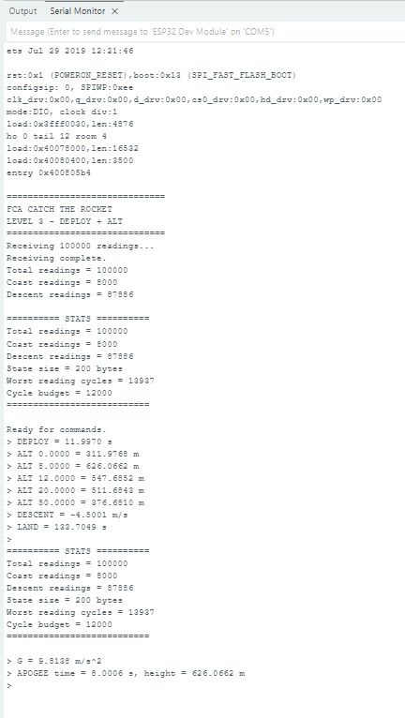
Figure 3. Earlier Official Tracker Level 3 attempt. The run produced a worst reading of 13,937 cycles, above the 12,000-cycle budget.
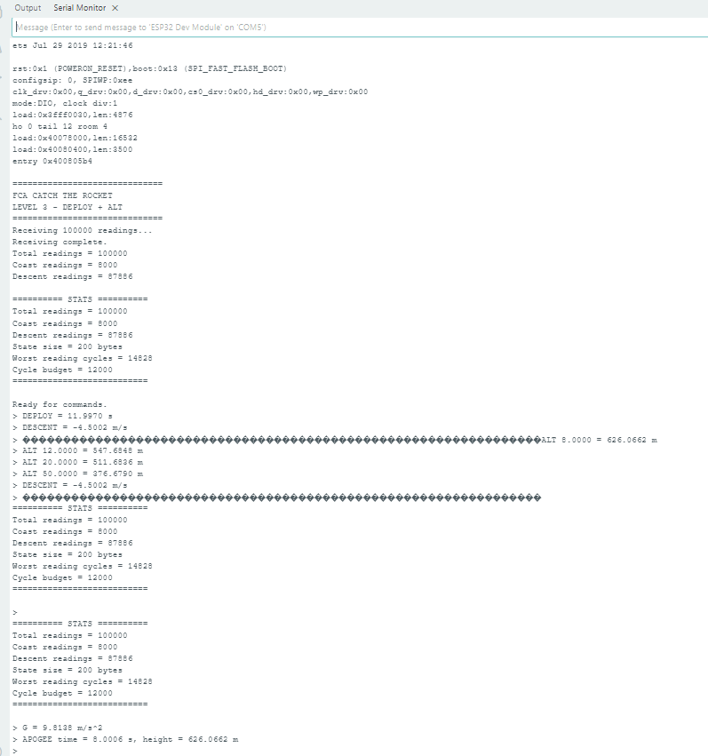
Figure 4. Another intermediate Official Tracker Level 3 attempt. The run produced a worst reading of 14,828 cycles, still above the budget.
These intermediate runs were not used as the final Level 3 result. The implementation was changed and measured again. The final Official result reached 9,084 cycles and the final Practice B result reached 9,087 cycles.

11. Did We Solve Level 3 According to the Instructions?
Instruction check | Evidence | Status
100,000 readings | 100,000 on Official and Practice B | PASS
8,000 coast region | 8,000 on both trackers | PASS
State <= 4096 B | 200 B on both trackers | PASS
Worst reading <= 12,000 cycles | 9,084 and 9,087 cycles | PASS
DEPLOY within 8–45 s | 11.9970 s and 24.0887 s | PASS
DESCENT remains correct | -4.5002 and -8.5001 m/s | PASS
LAND remains correct | 133.7036 s and 193.3526 s | PASS
G remains correct | 9.8138 and 3.7092 m/s² | PASS
APOGEE remains correct | 8.0006 s / 626.0662 m and 11.3250 s / 1737.8100 m | PASS
ALT t tested across trajectory | 0, 2, 8, 12, 20, 50 tested on both | PASS
No tracker-specific deployment hard-coding | Deployment derived from fitted trajectory | PASS
Practice B generalization | Same implementation produced correct different results | PASS
Conclusion of this audit: based on the tests actually performed and the authoritative Level 3 requirements, the Level 3 problem was solved and verified on the ESP32. The final measurements satisfy the memory and per-reading performance limits. Level 4 and Level 5 are separate later stages and are not used to claim Level 3 completion.

12. Final Level 3 Result Summary
Tracker | Worst cycles | State | DEPLOY | DESCENT | LAND | G | APOGEE
Official Tracker | 9,084 | 200 B | 11.9970 s | -4.5002 m/s | 133.7036 s | 9.8138 | 8.0006 s / 626.0662 m
Practice Tracker B | 9,087 | 200 B | 24.0887 s | -8.5001 m/s | 193.3526 s | 3.7092 | 11.3250 s / 1737.8100 m
Both final worst-case measurements are below the 12,000-cycle limit. The deployment estimates are inside the required 8–45 second interval. The different values for Official and Practice B demonstrate that the implementation is fitting the incoming flight data rather than returning a hard-coded official answer.

13. Command Interface Verified
Command | Purpose | Level 3 evidence
STATS | Reading count, phase count, memory and worst cycles | Tested on both trackers
DEPLOY | Estimated parachute deployment time | 11.9970 s / 24.0887 s
ALT t | Altitude estimate at arbitrary time | 0, 2, 8, 12, 20, 50 tested
DESCENT | Post-deployment descent velocity | -4.5002 / -8.5001 m/s
LAND | Estimated landing time | 133.7036 / 193.3526 s
G | Estimated gravity | 9.8138 / 3.7092 m/s²
APOGEE | Apogee time and height | Both trackers verified

14. LLM Usage and Development Workflow
ChatGPT was used as a coding and reasoning assistant. The workflow was iterative rather than treating the generated code as automatically correct. The authoritative hackathon material was used as the requirements source; code was then uploaded to the ESP32, Serial Monitor outputs were captured, and the measured outputs were reviewed.
Stage | LLM contribution | Team action
Requirement understanding | Explained the Level 3 deployment problem and constraints. | Team checked the explanation against the hackathon material.
Algorithm design | Suggested streaming coast/descent models and deployment estimation. | Team implemented and tested on ESP32.
Code generation | Provided Arduino C/C++ code and incremental changes. | Team compiled, uploaded and ran it.
Debugging | Interpreted Serial Monitor results and helped identify performance/correctness issues. | Team captured actual measurements and changed the code.
Verification | Compared outputs with the requirements and previous levels. | Team made the final PASS/FAIL decision from hardware evidence.
Important: all numerical results in this report are the team's actual ESP32 Serial Monitor measurements. They were not generated by ChatGPT.
One clear lesson from the iterative process was that a proposed implementation could be logically plausible but still fail the cycle budget. The ESP32 measurements were therefore treated as the authority for performance.

15. What We Learned
- A streaming algorithm can solve a large-data problem without storing the complete trajectory.
- Least-squares regression can be implemented using running sums.
- Centered time improves numerical behavior for polynomial regression.
- Deployment detection is a model-transition problem, not simply a fixed timestamp.
- Physical guarantees can be converted into algorithmic constraints.
- Different trackers must be handled through fitted parameters rather than hard-coded answers.
- ESP.getCycleCount() allows worst-case embedded execution time to be measured directly.
- Correct mathematics is not enough: memory and cycle limits must also be satisfied.

16. Conclusion
Level 3 successfully extended the Catch the Rocket ground station from fixed coast/descent calculations to deployment detection and arbitrary-time altitude queries. The final implementation operated in streaming form, used a 200-byte persistent state, and stayed within the measured per-reading cycle budget.
For the Official Tracker, the final ESP32 run measured DEPLOY = 11.9970 s, DESCENT = -4.5002 m/s and LAND = 133.7036 s. For Practice Tracker B, it measured DEPLOY = 24.0887 s, DESCENT = -8.5001 m/s and LAND = 193.3526 s. The ALT queries were tested across both the coast and post-deployment regions.
Therefore, based on the actual evidence captured during the work, Level 3 was completed and verified on the ESP32.

Appendix A – Evidence Checklist
- Final Official Tracker screenshot included.
- Final Practice Tracker B screenshot included.
- Earlier performance screenshots included to document debugging and optimization.
- Final Official state size = 200 bytes.
- Final Practice B state size = 200 bytes.
- Final Official worst cycles = 9,084.
- Final Practice B worst cycles = 9,087.
- DEPLOY tested on both trackers.
- ALT tested at 0, 2, 8, 12, 20 and 50 seconds on both trackers.
- DESCENT, LAND, G and APOGEE tested on both trackers.

Appendix B – Source/Evidence Basis
Primary requirements source: the supplied Catch the Rocket hackathon instructions (Pasted text.txt). Report structure and checkpoint style were aligned with the supplied checkpoint report. The measured Level 3 results were taken from the team's ESP32 Serial Monitor screenshots in this conversation.

