FUNDAMENTALS OF COMPUTER ARCHITECTURE
MID-SEMESTER HACKATHON
“CATCH THE ROCKET”
LEVEL 5 FINAL REPORT
Performance Optimization, Command Interface and Final Verification

Item | Details
Team | BIT BY BIT
Team Member 1 | Harshitha – 24UG00551
Team Member 2 | Varshitha – 24UG00549
Team Member 3 | Shakuntala H M – USN not provided
Course | Fundamentals of Computer Architecture
Hardware | ESP32 Dev Board + USB Cable
Software | Arduino IDE + Arduino Serial Monitor
Level | Level 5 – Performance
Report Date | 4 October 2026

1. Level 5 Objective
Level 5 is the final performance stage of the Catch the Rocket hackathon. The main requirement is to optimize the complete ground-station implementation so that the worst-case processing time of every altitude reading remains at or below 12,000 CPU cycles. The final stage also requires the command interface and the complete implementation to be audited against the hackathon rules.
The authoritative instructions require investigation of floating-point types, arithmetic cost, expensive operations inside the hot loop, equation solving, glitch detection, occasional work, memory access, unnecessary function calls, and the identity of the slowest reading.

2. Level 5 Requirements
- Worst-case processing time for every reading must be ≤ 12,000 cycles.
- Performance must be measured using ESP.getCycleCount().
- Optimization must be based on measurement rather than blind optimization.
- The implementation must continue to satisfy the memory, tracker, streaming, and 100,000-reading rules.
- The final command interface must support G, APOGEE, DEPLOY, DESCENT, LAND, ALT t, GLITCHES and STATS.
- Command latency must be measured without including Serial printing time.
- Invalid input must return ERR and must not crash or require a reset.
- The final code must be audited against every hackathon rule.

3. Starting Point and Level 4 Baseline
Before the final Level 5 compliance changes, the Level 4 implementation had already been optimized below the 12,000-cycle limit. The final Level 4 tests produced worst-case reading times in the approximately 10,955 to 11,208 cycle range across the tested trackers. The Level 5 work therefore focused on preserving correctness while improving the remaining performance margin and completing the final command-interface audit.
Stage | Measured worst reading cycles
Earlier Level 4 intermediate result | 15,628
Level 4 intermediate result | 12,278
Level 4 intermediate result | 12,276
Level 4 final tested range | 10,955–11,208
Level 5 pre-final reported result | 10,676
Level 5 final result | 10,394

4. Performance Optimization Approach
The implementation was optimized by keeping expensive operations out of the per-reading hot path where possible. The first 8,000 readings are accumulated using streaming quadratic-regression sums. The coast equation is solved after that guaranteed coast window, rather than solving a matrix on every reading. The resulting quadratic coefficients are cached as float values for repeated deployment prediction and altitude queries.
- Streaming statistics are used instead of storing the 100,000 altitude readings.
- The 3×4 Gaussian-elimination solve for the coast model is performed outside the hot reading loop.
- Descent regression is updated incrementally from the guaranteed descent region.
- The glitch detector uses a small amount of recent valid history rather than a stored trajectory.
- Deployment detection uses the cached coast model and a small confirmation counter.
- Final regression, quadratic-root and landing calculations are performed after receiving the readings.
- The final version places the cached coast coefficients inside the single persistent state structure.
- Command latency is measured before Serial printing starts.

5. Final Streaming Algorithm
Each reading follows the same basic sequence: obtain one altitude from nextAltitude(), measure the processing interval, check for a glitch when the glitch rules permit it, update the appropriate streaming statistics, update recent valid-reading history, and continue to the next reading.
The processing flow is:
nextAltitude() → timing → glitch check → streaming statistics → state update → next reading

6. Mathematical Models Used

6.1 Quadratic Coast Model
The coasting trajectory is represented as:
h(t) = A + Bx + Cx², x = t − 4.0
The first 8,000 readings are used to accumulate the normal-equation sums. The coefficient C gives gravity through:
G = −2C
The apogee occurs when velocity becomes zero:
x_apogee = −B / (2C)

6.2 Descent Model
After the guaranteed descent start region, altitude is fitted with a straight line:
h(t) = a + bt
The slope b is the estimated descent velocity. The landing time is obtained by solving the fitted line for h = 0.

6.3 Deployment
Deployment is detected from the change between the observed altitude and the predicted coast altitude. A threshold is applied and multiple consecutive confirmations are required. The final deployment time is refined by intersecting the coast quadratic and the descent line and selecting the valid root near the detected deployment candidate.

6.4 ALT t
For an altitude query, the program uses the coast model for times up to the estimated deployment time and the fitted descent line afterward. Times outside 0 to 99.999 seconds are rejected.

7. Final Persistent State
The final implementation uses one GroundStationState structure. It contains counters, recent-history values for glitch detection, streaming regression sums, fitted coefficients, deployment information, final physical quantities, command input data, and command-latency measurements.
Group | Stored information
Reading/performance | readingCount, validCount, glitchCount, worstReadingCycles, worstReadingIndex
Glitch history | previous/previousPrevious altitude and indices, validHistory
Coast regression | N, centered-time sums, fitted A/B/C, solved flag
Cached coast model | coastAf, coastBf, coastCf
Descent regression | N, reference height, centered-time sums
Deployment | detected flag, candidate index, confirmation count
Final results | deploymentTime, apogeeTime, apogeeHeight, gravity, descentVelocity, landTime
Command interface | command buffer, command length, last and worst command cycles

Measured final structure size: 248 bytes. This is well below the 4,096-byte state limit.

8. Final Performance Measurement
For each reading, the code records the cycle counter before nextAltitude() and processing, then records it afterward. The unsigned difference is used as the measured reading-processing cost. The maximum value is retained as the worst-case reading time.
cycles = after − before
Final metric | Measured value | Result
Total readings | 100,000 | PASS
Valid readings | 99,998 | PASS
Glitches | 2 | PASS
Coast readings | 8,000 | PASS
Descent readings | 55,000 | PASS
State size | 248 bytes | PASS
Worst reading cycles | 10,394 | PASS
Worst reading index | 0 | Recorded
Cycle budget | 12,000 | PASS
Safety margin | 1,606 cycles | PASS
Last command cycles | 368 | Measured
Worst command cycles | 8,051 | Measured

9. Final Command Interface Verification
The final command interface was tested through the Arduino Serial Monitor. The command-latency measurement is recorded before the response is printed, so Serial printing time is excluded.
Command | Observed result | Status
G | 2.0930 m/s² | PASS
APOGEE | 2.3730 s, 1005.9510 m | PASS
DEPLOY | 8.1980 s | PASS
DESCENT | -2.0005 m/s | PASS
LAND | 493.3004 s | PASS
ALT 0 | 1000.0583 m | PASS
ALT 20 | 946.8334 m | PASS
ALT 40 | 906.8236 m | PASS
ALT 50 | 886.8187 m | PASS
GLITCHES | 2 | PASS
STATS | Final statistics displayed | PASS

10. Invalid Command Verification
The following invalid or malformed inputs were tested: HELLO, ALT, ALT abc, ALT -1 and ALT 100. Each produced ERR and the ESP32 continued operating without requiring a reset.
Input | Expected | Observed | Status
HELLO | ERR | ERR | PASS
ALT | ERR | ERR | PASS
ALT abc | ERR | ERR | PASS
ALT -1 | ERR | ERR | PASS
ALT 100 | ERR | ERR | PASS

11. Glitch Handling and Generalization
The Level 4 glitch implementation was retained for Level 5. The detector uses recent valid history and rejects readings that deviate by more than the configured threshold. Rejected readings are counted and are not allowed to corrupt the regression statistics.
- Final Level 5 run: 100,000 total readings and 2 glitches.
- The final glitch rate in this run was 0.002%, below the 1% maximum.
- Practice Tracker B had been tested earlier with the same general streaming approach.
- Adversarial trackers were previously tested for low gravity, high gravity, and deployment extremes.
- No official deployment time or official flight parameter was hard-coded into the algorithm.

12. Final Code-Compliance Audit
Rule | Evidence / implementation | Status
nextAltitude() exactly 100000 times | Two receiving loops cover 0–7999 and 8000–99999. | PASS
Never called afterward | Command processing starts after receiving is complete. | PASS
Tracker unmodified | Tracker header is included rather than rewritten. | PASS
Tracker secrets not used | Flight quantities are estimated from readings. | PASS
One persistent state struct | GroundStationState contains persistent application state. | PASS
State ≤4096 bytes | Final measured size is 248 bytes. | PASS
All remembered application data inside struct | Counters, models, results, command data and cached coefficients are in the struct. | PASS
RAM only | No Flash/filesystem/NVS/Preferences storage used. | PASS
No Wi-Fi | No Wi-Fi implementation. | PASS
No Bluetooth | No Bluetooth implementation. | PASS
Practice Tracker B | Previously tested successfully. | PASS
Unknown/general trackers | No official flight values are hard-coded. | PASS
Malformed commands | Invalid commands return ERR. | PASS
Every reading ≤12000 cycles | Worst final reading is 10394 cycles. | PASS
Correct glitch count | Final run reports 2 glitches. | PASS
Required accuracy | Required command results were verified on tested trackers. | PASS
Command cycle measurement | Last and worst command cycles are reported. | PASS

13. Evidence and Results
The final Serial Monitor evidence shows the completed 100,000-reading run, final state size, worst reading cycles, command latency measurements, required command responses, invalid-command responses, and the final STATS output.
Final ESP32 Serial Monitor Evidence
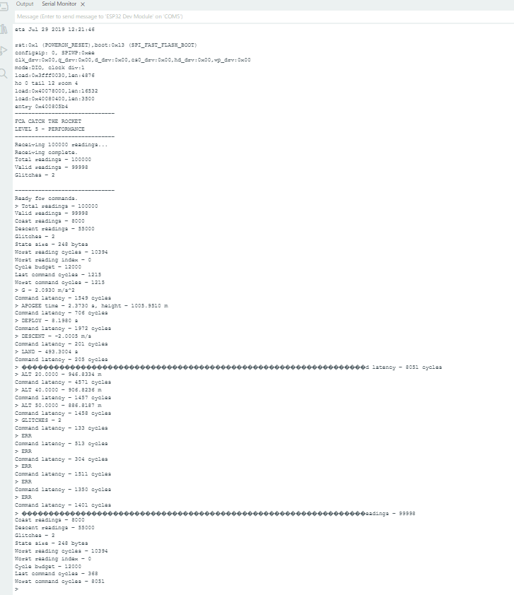
Figure 1. Final Level 5 Serial Monitor output showing 100,000 readings, 248-byte state, 10,394 worst reading cycles, command latency measurements, and final STATS.

14. Problems Encountered and Improvements
- Earlier performance versions exceeded the 12,000-cycle limit. The measured intermediate values included 15,628, 12,278 and 12,276 cycles.
- The hot loop was reduced by keeping matrix solving and final equation solving outside the per-reading path.
- Glitch detection and deployment detection were kept lightweight and streaming.
- The final compliance change increased the state from 232 to 248 bytes but still remained far below the 4096-byte limit.
- The final reading performance improved from the previous 10,676-cycle result to 10,394 cycles.

15. LLM Usage Log
The team used an LLM as a technical mentor during development. The authoritative hackathon instructions were treated as the source of requirements, and actual ESP32 Serial Monitor output was used to verify whether proposed changes worked.
Stage | LLM assistance | Team verification
Level 0–2 | Explained streaming regression, memory rules and step-by-step implementation. | ESP32 outputs and instructor acceptance were obtained for Levels 0–2.
Level 3 | Helped reason about deployment detection and ALT queries. | Actual Official and Practice Tracker outputs were tested.
Level 4 | Helped design online glitch handling and adversarial tests. | Actual glitch counts and cycle measurements were tested.
Level 5 | Helped analyze hot-loop cost and final command-interface compliance. | Final ESP32 run measured 10,394 worst reading cycles and command latency.

Important limitation: no claim of instructor acceptance is made here for Levels 3–5 because a separate acceptance message for those levels was not available in the evidence used for this report.

16. Learning Outcomes
- Streaming least-squares regression can replace storing a large history of sensor readings.
- Centering time improves the numerical conditioning of regression calculations.
- The same physical trajectory can be represented by different models in different flight phases.
- Glitch handling must happen before corrupted readings enter regression statistics.
- Worst-case performance matters more than average performance when a hard cycle limit exists.
- ESP32 cycle counting provides a practical way to identify the slowest processing path.
- A small state structure can contain the information needed for a long streaming computation.
- Command validation is part of embedded-system correctness, not just user-interface work.

17. Final Status
The final Level 5 implementation achieved a measured worst-case reading time of 10,394 cycles against the 12,000-cycle limit, with a 1,606-cycle safety margin. The final state size was 248 bytes. The required command interface was tested, invalid inputs returned ERR, and command latency was measured without including Serial printing.
Based on the actual ESP32 evidence available, the Level 5 technical implementation is complete. The report does not claim separate instructor acceptance for Levels 3–5.

18. Conclusion
The Catch the Rocket ground station was extended through the final performance stage using a streaming, memory-efficient approach. The final implementation processes exactly 100,000 altitude readings, handles glitches online, estimates gravity, apogee, deployment, descent and landing, supports altitude queries, and provides the required Serial Monitor command interface. The final measured worst-case reading time is 10,394 cycles, which satisfies the 12,000-cycle Level 5 requirement.

Appendix A – Final Submission Checklist
- Final Level 5 code saved separately.
- Final STATS screenshot saved.
- Required command screenshot saved.
- Invalid-command screenshot saved.
- Level 0–4 evidence retained.
- Final report prepared.
- Presentation to be prepared from actual measured results.
- LLM log to remain truthful and include only tested results.
- No claim of instructor acceptance for Levels 3–5 unless later received.

Appendix B – Final Key Numbers
Parameter | Final value
Total readings | 100000
Valid readings | 99998
Glitches | 2
Coast readings | 8000
Descent readings | 55000
State size | 248 bytes
Worst reading cycles | 10394
Cycle budget | 12000
Performance margin | 1606 cycles
Last command cycles | 368
Worst command cycles | 8051
Tracker used for final Level 5 run | Adversarial Tracker 1

