

THE SPEED OF NUMBERS
Fundamentals of Computer Architecture (FCA)

Team Numerix

Team Members:

Harshitha P – 24UG00551
Varshitha T – 24UG00549
Shakuntala H M – 24UG00375
- Report Structure
This assignment, “The Speed of Numbers,” investigates how different data representations and operations affect computational performance on the ESP32. The experiments measure the cycle cost of integer arithmetic, floating-point operations, bit manipulation, fixed-point arithmetic, and number-to-text conversion. The team follows a Predict → Measure → Explain approach, using the ESP32 as the final authority for actual performance. The assignment also examines compiler optimization, timing overhead, numerical accuracy, and the hidden cost of Serial communication. Finally, a sensor-processing challenge compares double, float, and integer implementations under different sampling-rate requirements.
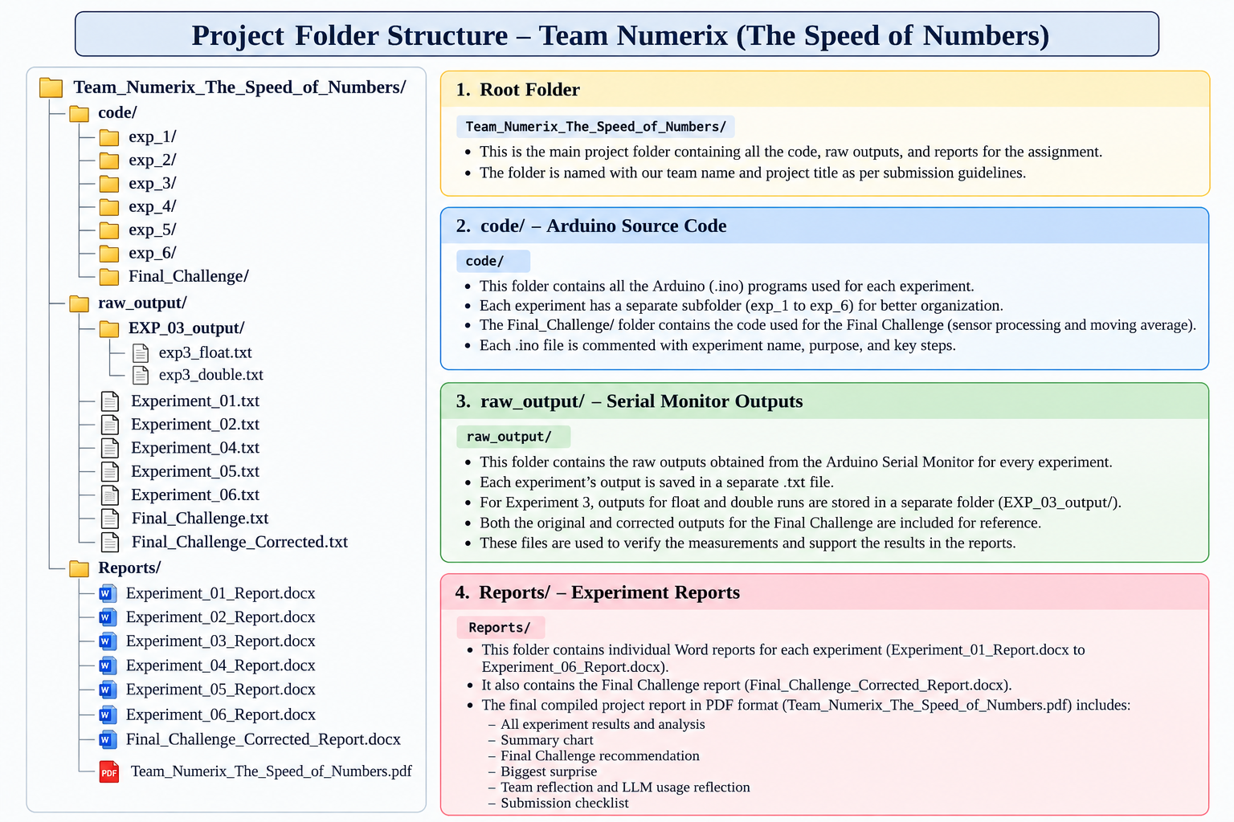

The project was organized into three main folders: code, raw_output, and Reports. The code folder contains the Arduino .ino programs, with a separate subfolder for each experiment and the Final Challenge. The raw_output folder stores the original Serial Monitor results collected from the ESP32, which act as evidence for the measured values. Experiment 3 outputs are grouped separately because multiple floating-point tests were performed. The Reports folder contains the individual experiment reports and the final compiled report. This structure keeps the source code, experimental evidence, and analysis separate and makes it easy to trace each reported result back to its corresponding experiment.
This report follows the Every experiment, including the Final Challenge, uses the same eight sections: Aim, Background, Prediction, Method, Observations, Analysis, What we learnt, and LLM Log. The observations use the actual ESP32 measurements collected by the team.
The assignment follows the cycle Predict → Measure → Explain. Predictions are kept separate from measured results, and the ESP32/Serial Monitor is treated as the authority for hardware measurements.
The .ino sketches and raw Serial Monitor text files are submitted separately in the final ZIP. This Word document is the editable report version.

2. Experiment 1 — 32-bit Integer Addition

1. Aim
To build a trustworthy cycle-counting stopwatch on the ESP32 and measure the cost attributed to a 32-bit integer addition. The experiment also examines 10 versus 1000 repetitions and the effect of removing volatile.

2. Background
The ESP32 was configured for 240 MHz. A single addition is very short, so timing overhead can be large. An empty-loop baseline was measured and subtracted from the total. volatile was used to reduce compiler elimination of the repeated calculation.

3. Prediction
We expected a 32-bit integer addition to require only a small number of cycles. We expected more repetitions to make the measurement more useful because fixed overhead would be less significant. We also expected removing volatile could allow compiler optimisation and make timing unreliable.

4. Method
The CPU frequency was confirmed using getCpuFrequencyMhz(). Volatile int32_t variables were used. An empty loop was timed first, followed by the addition loop. Three trials were performed for 1000 repetitions and three for 10 repetitions. A separate non-volatile test was also run.

5. Observations

Test | Trial 1 | Trial 2 | Trial 3 | Average
1000 repetitions — baseline | 4999 | 4999 | 4999 | 4999
1000 repetitions — total | 13284 | 13284 | 13284 | 13284
1000 repetitions — cycles/add | 8.28 | 8.28 | 8.28 | 8.28
10 repetitions — baseline | 49 | 49 | 49 | 49
10 repetitions — total | 129 | 129 | 129 | 129
10 repetitions — cycles/add | 8.00 | 8.00 | 8.00 | 8.00

Non-volatile test: baseline 5282 cycles; total 2 cycles; operation cycles 4294962016; displayed cycles/addition 4294962.00; final a = 20010. This timing is treated as invalid because unsigned subtraction wrapped around.

6. Analysis
The volatile measurements were repeatable: 8.28 cycles/addition for 1000 repetitions and 8.00 for 10 repetitions. The non-volatile run produced an impossible-looking result because total timing was below the baseline, causing unsigned subtraction to wrap. This confirmed that compiler optimisation must be considered in short benchmarks.

7. What we learnt
We learnt that timing code needs its own baseline and that volatile can matter when the compiler sees that a calculation does not need to be preserved. We also learnt to investigate an impossible measurement rather than hiding it.

8. LLM Log
Prompt: Why did the non-volatile timing become an enormous cycle count? Suggestion: compiler optimisation may have removed/simplified the work and unsigned subtraction can wrap. Test: the non-volatile sketch was run on the ESP32. Board result: total = 2 while baseline = 5282. Conclusion: the explanation matched the observed failure; the board result was kept as evidence.

3. Experiment 2 — Is Smaller Faster?

1. Aim
To compare addition, multiplication and division across integer widths and determine whether a smaller integer type is automatically faster on the ESP32.

2. Background
The ESP32 is a 32-bit processor. Smaller C types do not necessarily produce narrower instructions for the whole expression; values may be extended or truncated. 64-bit arithmetic can require extra work, and division is generally more expensive than addition.

3. Prediction
We expected 32-bit operations to be efficient. We expected smaller types not to automatically be faster, 64-bit operations to cost more, especially division, and signed and unsigned 32-bit division to be potentially different.

4. Method
The CPU frequency was confirmed at 240 MHz. Each operation was repeated 1000 times for three trials. An empty-loop baseline was measured and subtracted. volatile operands/results were used. Addition and multiplication were tested with int8_t, int16_t, int32_t and int64_t; division was also tested with uint32_t.

5. Observations

Operation | int8_t | int16_t | int32_t | int64_t
Addition | 9.09 | 9.69 | 8.00 | 29.49
Multiplication | 10.09 | 10.10 | 8.39 | 47.28
Division | 16.49 | 16.19 | 11.09 | 108.79

All values are average cycles per operation after the benchmark's baseline adjustment.

6. Analysis
Smaller did not mean faster. int32_t addition averaged 8.00 cycles/op versus 9.09 for int8_t and 9.69 for int16_t. The same pattern appeared in multiplication. 64-bit operations were much more expensive, especially division at 108.79 cycles/op. Signed and unsigned 32-bit division were almost identical at 11.09 and 11.00 cycles/op.

7. What we learnt
We learnt that choosing a smaller C type does not automatically improve execution speed. The 32-bit type matched the processor's natural width well in this benchmark, while 64-bit division was much more expensive.

8. LLM Log
Prompt: Is an 8-bit or 16-bit integer automatically faster on a 32-bit ESP32? Suggestion: not necessarily; wider registers and type promotion can matter. Test: all four signed widths were measured. Board result: int32_t was fastest among the signed types for addition. Conclusion: the prediction was supported.

4. Experiment 3 — Float versus Double

1. Aim
To compare float and double arithmetic on the ESP32, including addition, multiplication, division, square root and x*0.5f versus x*0.5.

2. Background
The board ran at 240 MHz. Timing used ESP.getCycleCount() with baseline subtraction. 0.5f is a float literal while 0.5 is a double literal. sqrtf() was used for float and sqrt() for double.

3. Prediction
We expected float to be faster than double, especially for division and square root. We expected multiplication to be faster than division. We expected the two literal forms to potentially differ.

4. Method
Each test used 1000 repetitions and three trials. A baseline loop was measured and subtracted. Volatile values/results were used. Separate sketches were used for addition, multiplication, division, square root and literal comparison.

5. Observations

Operation | Average cycles/op
Float addition | 7.28
Double addition | 61.19
Float multiplication | 8.28
Double multiplication | 117.10
Float division | 52.96
Double division | 642.90
Float sqrtf() | 89.64
Double sqrt() | 1096.48
x * 0.5f | 6.18
x * 0.5 | 6.31

Measured int32 references: addition 7.70 cycles/op, multiplication 8.10 cycles/op, division 10.20 cycles/op.

6. Analysis
The prediction was strongly supported. Double addition, multiplication, division and square root were much more expensive than their float counterparts. The literal comparison was close: 6.18 versus 6.31 cycles/op. Operation type also mattered; float division and square root were much more expensive than float addition and multiplication.

7. What we learnt
We learnt that double precision can have a large performance cost on this ESP32 benchmark. Division and square root are substantially more expensive than simple arithmetic.

8. LLM Log
Prompt: What should we expect for float versus double on the ESP32? Suggestion: float should be cheaper, while double may require more work. Test: separate timing sketches were run. Board result: double division and sqrt were dramatically slower. Conclusion: the qualitative prediction was supported; exact counts came from the board.

5. Experiment 4 — Are Bit Tricks Really Faster?

1. Aim
To compare division/remainder with shift/mask operations, test volatile divisors, and check whether the bit tricks preserve signed arithmetic meaning.

2. Background
For suitable non-negative values, division by a power of two can correspond to a right shift, and remainder by a power of two can correspond to masking. The compiler may already perform these transformations for constants. Signed negative values are a special case.

3. Prediction
We expected x >> 3 to be faster than x / 8 and x & 15 to be faster than x % 16. We expected volatile divisors to reduce compile-time simplification. We expected -9/8 and -9>>3 could differ.

4. Method
Each test used 1000 repetitions and three trials. Constant and volatile versions were timed. Negative-number results were printed, and generated assembly was inspected.

5. Observations
Expression | Average cycles/op
x / 8 | 8.09
x >> 3 | 6.09
x % 16 | 10.19
x & 15 | 6.09
x / volatile 8 | 11.10
x % volatile 16 | 12.10
Signed test | ESP32 result
-9 / 8 | -1
-9 >> 3 | -2
-9 in 32-bit two's complement | 11111111111111111111111111110111

6. Analysis
The constant shift and mask were faster in the benchmark. Assembly showed that the compiler already transformed constant power-of-two arithmetic. Volatile versions were slower because the divisor could not be treated as a compile-time constant. The signed test showed -9/8 = -1 but -9>>3 = -2, so the expressions are not interchangeable for all signed values.

7. What we learnt
We learnt that a bit trick is useful only when it preserves program meaning. Compiler optimisation, signedness and edge cases must be checked before replacing arithmetic with shifts or masks.

8. LLM Log
Prompt: Do shifts and masks always safely replace division and remainder? Suggestion: only for suitable cases; signed values and compiler optimisation matter. Test: timing, negative values and disassembly were checked. Board result: speed advantage appeared, but the negative-number results differed. Conclusion: correctness must come before a small speed gain.

6. Experiment 5 — Invent Your Own Fractions (Q16.16)

1. Aim
To represent fractional values using Q16.16 fixed-point, implement addition, multiplication and division, and compare with float for speed and accuracy.

2. Background
Q16.16 uses 16 bits for the whole-number part and 16 bits for the fractional part. The scale factor is 65536. Multiplication needs a wider intermediate and a shift right by 16. Double was used as the accuracy reference.

3. Prediction
We expected fixed-point arithmetic to be faster than floating-point arithmetic, with some rounding error. We also expected multiplication to require a wider intermediate before shifting back to Q16.16.

4. Method
The team encoded 3.75 and -1.25, checked the range, and timed fixed-point and float addition, multiplication and division using 1000 repetitions and three trials. A double calculation was used as the accuracy reference. Fixed-point multiplication used a 64-bit intermediate.

5. Observations

Item |  | Recorded result
3.75 encoded |  | 245760
-1.25 encoded |  | -81920
Minimum |  | -32768.00000000
Maximum |  | 32767.99998474
Fixed addition |  | 0.91 cycles/op
Fixed multiplication |  | 1.01 cycles/op
Fixed division |  | 1.10 cycles/op
Float addition |  | 1.09 cycles/op
Float multiplication |  | 1.10 cycles/op
Float division |  | 1.05 cycles/op
Operation | Fixed-point error |  | Float error
Addition | 0.0000006612 |  | 0.0000000595
Multiplication | 0.0000133172 |  | 0.0000000343
Division | 0.0000136767 |  | 0.0000000324

Validation note: the recorded fixed-point timing averages are below one CPU cycle per operation. They are preserved exactly as recorded, but should not be interpreted as literal isolated-instruction latency. The timing comparison is therefore provisional.

6. Analysis
The Q16.16 representations and range are mathematically consistent. Float was closer to the double reference in all three accuracy tests. The recorded fixed-point values are slightly faster for addition and multiplication and slightly slower for division, but the below-one-cycle results require cautious interpretation.

7. What we learnt
We learnt how fractional values can be represented using an integer and scale factor. We also learnt why multiplication may need a wider intermediate and why fixed-point speed and accuracy should be measured separately.

8. LLM Log
Prompt: How should 3.75 and -1.25 be represented in Q16.16, and why is a wider multiply intermediate needed? Suggestion: multiply by 65536, use a wider intermediate, then shift right 16. Test: encoding, range and arithmetic were run on the ESP32. Board result: 3.75 = 245760 and -1.25 = -81920. Conclusion: the mathematical explanation agreed; timing was kept provisional.

7. Experiment 6 — The Hidden Cost of Printing

1. Aim
To measure the cost of converting numbers to text and sending them through Serial, and compare decimal, hexadecimal and binary output at 115200 baud.

2. Background
A stored number must be converted into characters before display. Conversion is separate from transmission. At 115200 baud, an ideal 8-data-bit, 1-start-bit, 1-stop-bit character takes about 86.81 µs.

3. Prediction
We expected number-to-text conversion to cost much more than simple arithmetic, float-to-text conversion to be more expensive than integer conversion, Serial transmission to be slow, and the three formats to have different costs.

4. Method
snprintf() was used to convert integer and float values without transmission. Each conversion was repeated 1000 times. A single character was sent using Serial.write('A'), with Serial.flush() and micros(). The value 123456 was printed ten times in decimal, hexadecimal and binary. Theoretical character time was calculated using 10 bits per character at 115200 baud.

5. Observations

Measurement | Recorded result
CPU frequency | 240 MHz
Integer-to-text | 1934 cycles/op
Float-to-text | 6030 cycles/op
Measured one-character transmission | 101 µs
Theoretical one-character time | 86.81 µs
10 decimal values | 6915 µs
10 hexadecimal values | 6051 µs
10 binary values | 16402 µs
Program-reported decimal count | 7
Program-reported hexadecimal count | 6
Program-reported binary count | 18
CPU cycles in theoretical character time | 20,833.33
Approx. 32-bit additions in that interval | 20.83

The raw Serial output contains the captured text A101 around the one-character measurement because Serial.write('A') occurred immediately before the numeric timing output. Keep the raw file unchanged.

6. Analysis
Float-to-text conversion took 6030 cycles/op versus 1934 for integer conversion, about 3.12 times as much. The measured one-character time was 101 µs, higher than the ideal 86.81 µs because real Serial handling adds overhead. Binary printing was slowest at 16402 µs, while hexadecimal was fastest at 6051 µs.

7. What we learnt
We learnt that text conversion and Serial output can cost far more than arithmetic. Frequent printing can become a major performance cost in embedded programs.

8. LLM Log
Prompt: How can conversion cost be measured separately from Serial transmission? Suggestion: use snprintf() for conversion and Serial.flush()/micros() for transmission. Test: the corrected sketch was run on the physical ESP32. Board result: integer 1934, float 6030, one character 101 µs. Conclusion: the main prediction was supported.

8. Final Challenge — Meet a Latency Budget

1. Aim
To compare double, float and integer implementations of a sensor workload containing a 12-bit ADC read, conversion to millivolts using raw × 3300/4095, and an eight-sample moving average.

2. Background
At 240 MHz, 10 kHz gives 24,000 cycles/sample, 50 kHz gives 4,800 and 100 kHz gives 2,400. The corrected run measures an empty-loop baseline and subtracts it.

3. Prediction
We expected integer to be fastest, float to be faster than double, double to be the most accurate reference, and all three to fit 10 kHz while higher rates would be more difficult.

4. Method
The corrected sketch used 1000 repetitions and three trials. Baseline, analogRead(), double/float/integer pipelines and the complete workload were measured. Accuracy was checked for every raw ADC value from 0 to 4095 against double.

5. Observations

Component | Trial 1 |  | Trial 2 |  | Trial 3 |  | Average
Empty-loop baseline | 4999 |  | 4999 |  | 4999 |  | 4999.00
analogRead() | 10299 |  | 10246 |  | 10241 |  | 10262.00
Double pipeline | 1666 |  | 1665 |  | 1665 |  | 1665.33
Float pipeline | 132 |  | 128 |  | 129 |  | 129.67
Integer pipeline | 23 |  | 22 |  | 22 |  | 22.33
Version | Complete workload cycles/sample |  | 10 kHz |  | 50 kHz |  | 100 kHz
Double | 11927.33 |  | Meets |  | Does not meet |  | Does not meet
Float | 10391.67 |  | Meets |  | Does not meet |  | Does not meet
Integer | 10284.33 |  | Meets |  | Does not meet |  | Does not meet
Accuracy comparison |  | Maximum error |  |  |  | Raw input
Float vs double |  | 0.000121623 mV |  |  |  | 2542
Integer vs double |  | 0.996336996 mV |  |  |  | 716
Final moving average |  |  |  | Recorded value
Double |  |  |  | 487.142857143
Float |  |  |  | 487.141876221
Integer |  |  |  | 486

6. Analysis
The prediction was mostly supported. Integer had the lowest arithmetic pipeline cost, float was much faster than double, and all three complete workloads fit 10 kHz. None fit 50 or 100 kHz. ADC acquisition itself averaged 10,262 cycles. Float's maximum error was only 0.000121623 mV, while integer's was 0.996336996 mV.

7. What we learnt
We learnt that the fastest representation is not automatically the best system choice. Float gives the best balance for the tested 10 kHz requirement. Higher-rate operation would require major optimisation of the acquisition path.

8. LLM Log
Prompt: Which representation best balances speed and error, and what must be included in the timing budget? Suggestion: include ADC cost, compare all versions, exhaustively check error and compare complete workload with the rate budget. Test: corrected baseline-subtracted run and 0–4095 accuracy check. Board result: integer fastest, float much more accurate, all meet 10 kHz but none meet 50/100 kHz. Conclusion: float is recommended.

9. Summary of Measured Operation Costs
The summary chart below collects the cycle-based measurements from the experiments. Experiment 5 values marked with * are the recorded board outputs and are treated as provisional because several averages are below one CPU cycle per operation.
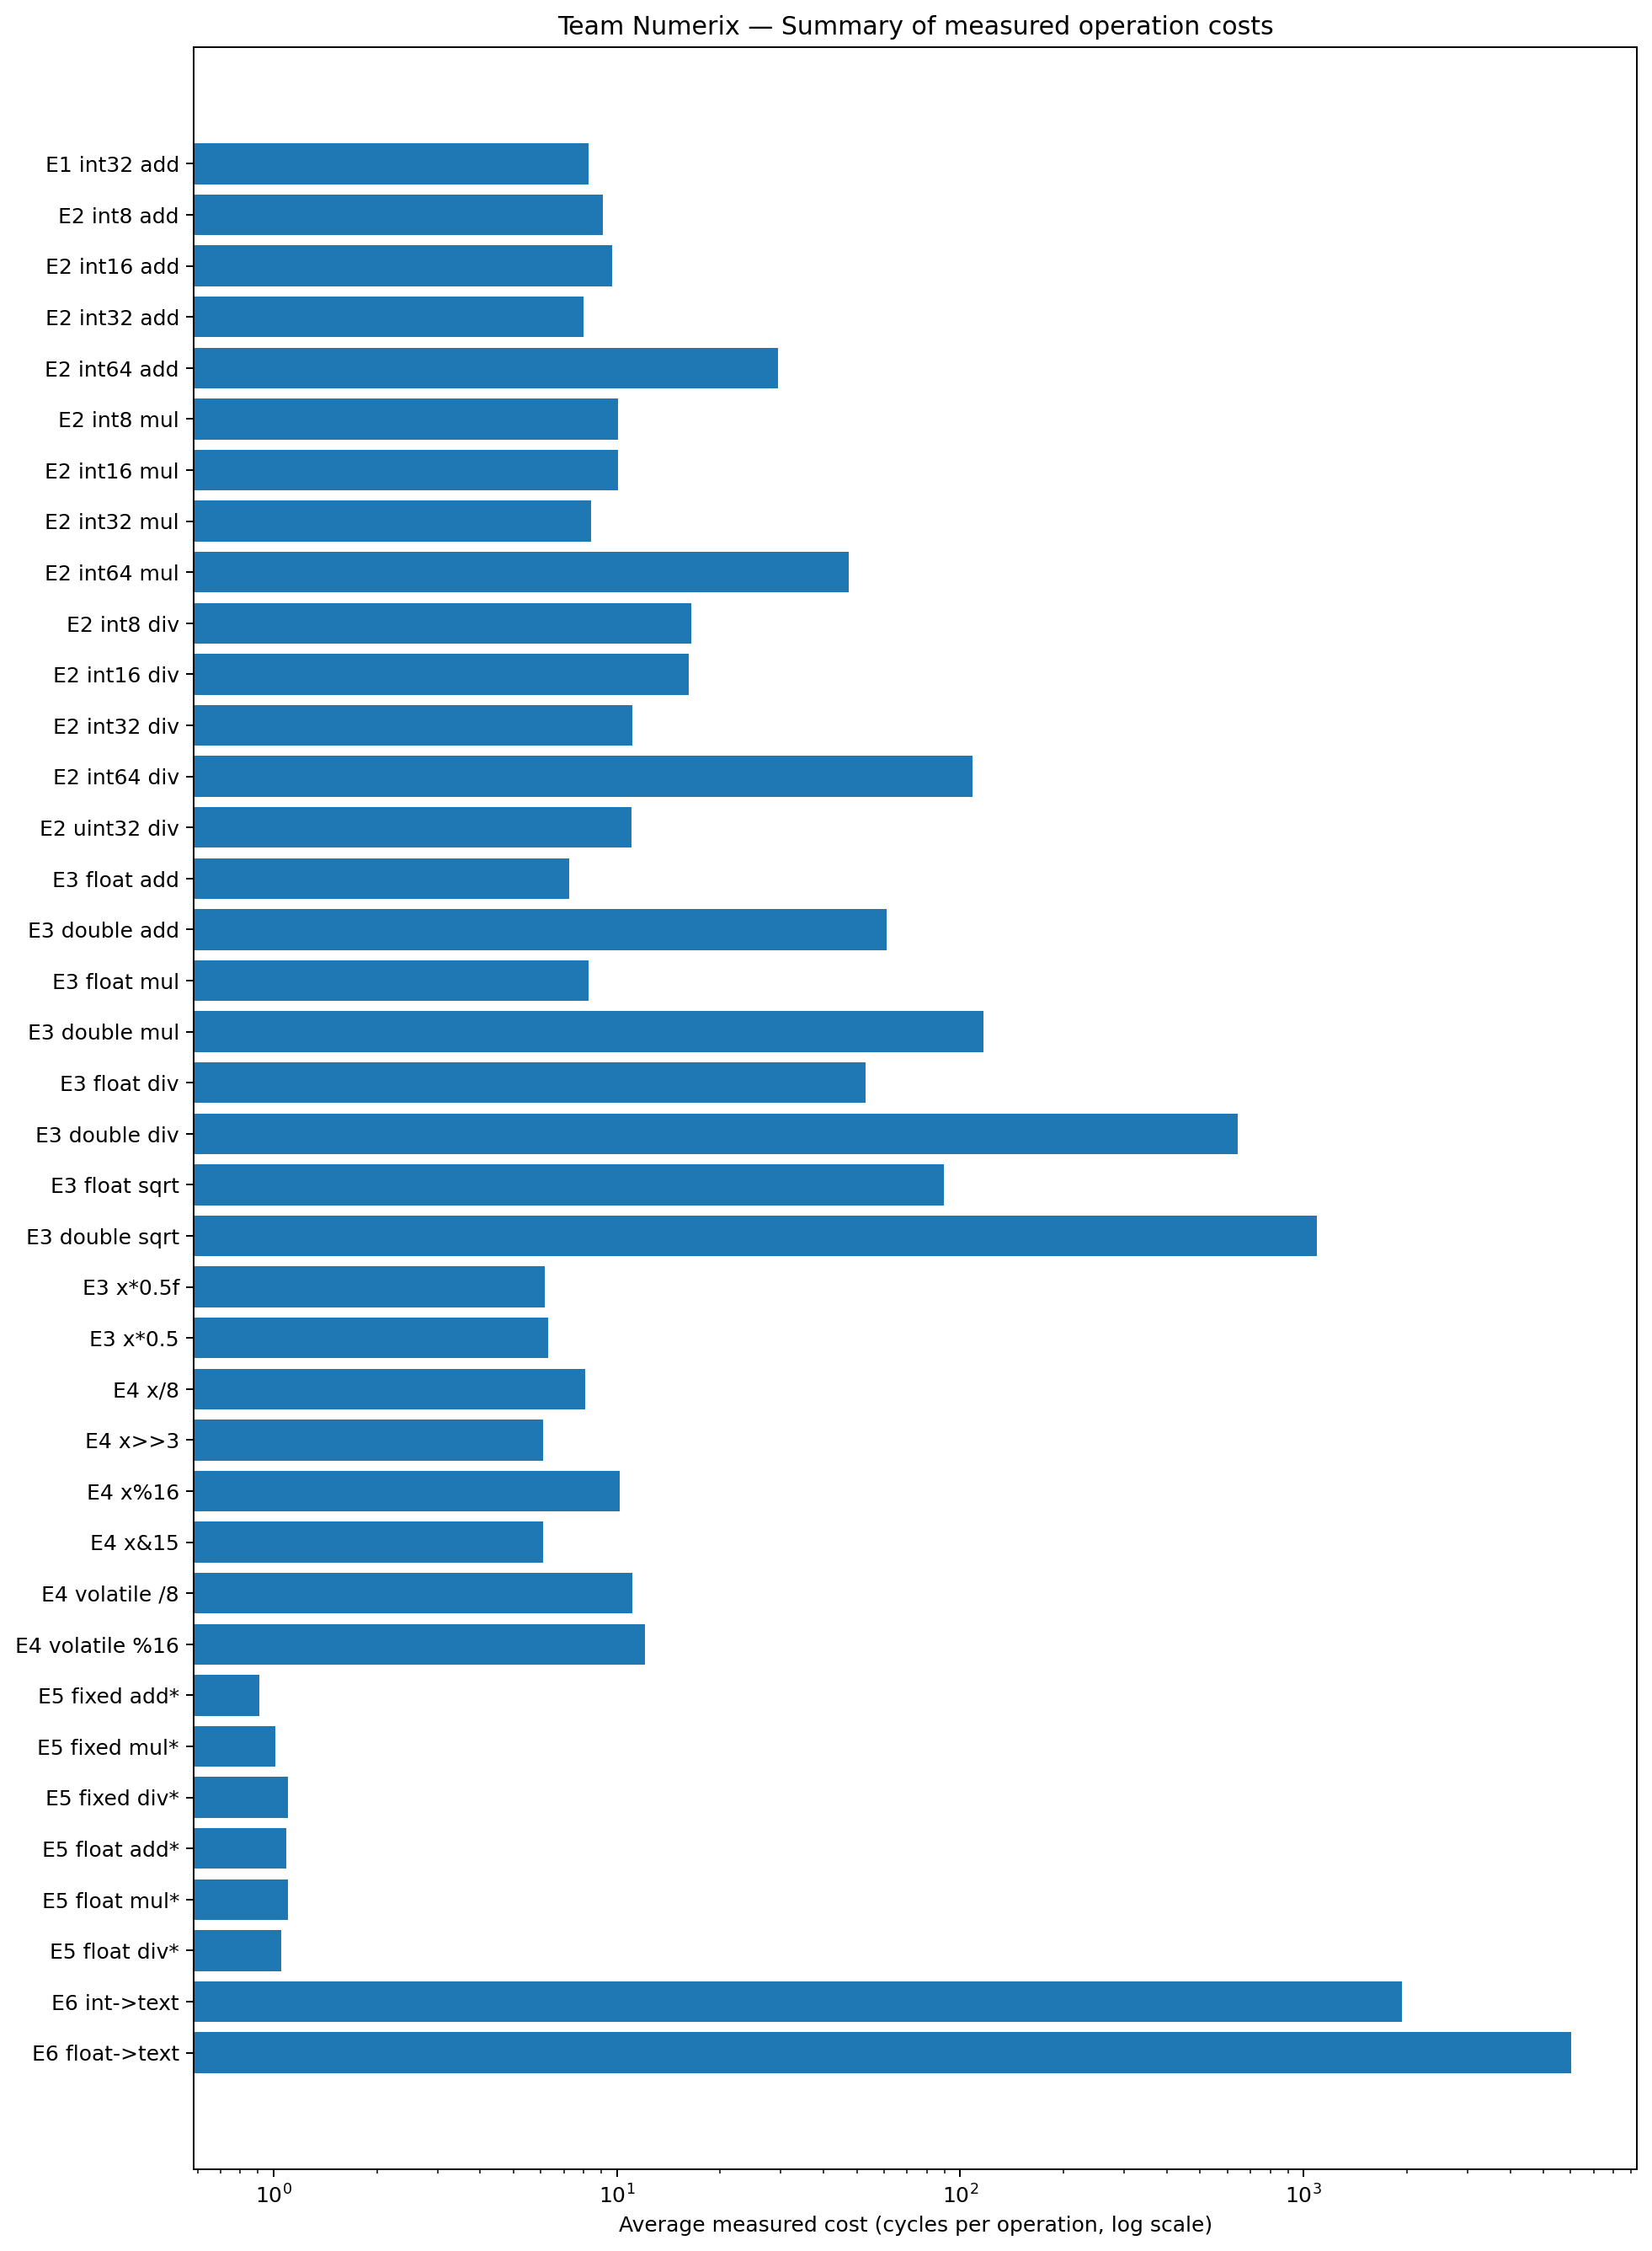
10. Final Challenge Recommendation:
Recommended implementation: float. For the required 10 kHz workload, float provides the best balance of timing and numerical accuracy. Its complete measured cost was 10,391.67 cycles/sample, below the 24,000-cycle budget, and its maximum measured error against the double reference was 0.000121623 mV.
Integer was slightly faster at 10,284.33 cycles/sample, but its maximum measured error was 0.996336996 mV. It is a reasonable alternative if that rounding behaviour is acceptable. Double was the slowest at 11,927.33 cycles/sample.
At 50 kHz and 100 kHz, none of the complete workloads meets the timing budget. analogRead() alone averaged 10,262 cycles/sample, so higher-rate operation would require a different acquisition/timing approach.

11. Biggest Surprise
The result furthest from our recorded prediction was in Experiment 2: smaller integer types were not automatically faster. We expected 8-bit and 16-bit operations might benefit from their smaller width. Instead, int32_t addition averaged 8.00 cycles/op, while int8_t and int16_t averaged 9.09 and 9.69 cycles/op. This showed that processor register width, compiler-generated instructions and type handling can matter more than nominal storage size.

12. Team Reflection
The work was divided into Builder, Measurer, Skeptic and Scribe roles. The Builder handled the sketch and upload, the Measurer collected repeated Serial Monitor results, the Skeptic questioned surprising values and checked timing/compiler issues, and the Scribe maintained the experiment record.
The Skeptic step was particularly useful. The non-volatile Experiment 1 result looked impossible, Experiment 4 required assembly inspection, Experiment 5 produced suspiciously low timing averages, and the first Final Challenge run needed a corrected baseline. In each case, the team investigated the result instead of changing it to fit an explanation.

13. LLM Usage Reflection
The LLM was used as a thinking and troubleshooting partner, not as the authority for measurements. It helped explain the experiment questions, suggest timing structures, clarify integer widths and floating-point behaviour, explain Q16.16 scaling, troubleshoot ESP32 code and organise observations.
The most important lesson was verification. Suggestions were treated as hypotheses and tested on the ESP32. When the board disagreed with a prediction or a result looked suspicious, the measurement was questioned instead of being changed. The final report therefore separates prediction, measurement and inference.

14. Final Submission Checklist

Required item | Status
A .ino file for each experiment/final challenge | DONE
Raw Serial Monitor output saved as .txt | DONE
PDF report with the eight-section structure | DONE
Summary chart | DONE
Final Challenge recommendation | DONE
Biggest Surprise | DONE
Team Reflection | DONE
LLM log for each experiment | DONE
ZIP name TeamName_SpeedOfNumbers.zip | READY Team_Numerix_SpeedOfNumbers.zip

Team roles:

The assignment asks the team to rotate Builder, Measurer, Skeptic and Scribe. The table below is the role allocation included in this report; edit it if your team's actual role history was different.

Activity | Builder | Measurer | Skeptic | Scribe
Experiment 1 | Harshitha | Varshitha | Sakuntala | Harshitha
Experiment 2 | Varshitha | Sakuntala | Harshitha | Varshitha
Experiment 3 | Sakuntala | Harshitha | Varshitha | Sakuntala
Experiment 4 | Harshitha | Varshitha | Sakuntala | Harshitha
Experiment 5 | Varshitha | Sakuntala | Harshitha | Sakuntala
Experiment 6 | Sakuntala | Harshitha | Varshitha | Varshitha
Final Challenge | Harshitha | Sakuntala | Varshitha | Sakuntala

Final conclusion
The experiments show that number representation changes both execution cost and numerical behaviour. The ESP32 measurements did not support the simple idea that fewer bits always means faster execution. They showed a substantial cost for 64-bit integer operations and double-precision operations, useful speedups from appropriate bit operations, rounding trade-offs in fixed-point arithmetic, and a surprisingly large cost for text conversion and Serial output. For the tested 10 kHz sensor workload, float is the most practical balance of speed and accuracy.

