FUNDAMENTALS OF COMPUTER ARCHITECTURE
MID-SEMESTER HACKATHON
“CATCH THE ROCKET”
LEVEL 4 REPORT
GLITCH HANDLING + ROBUSTNESS

Item | Details
Team Name | BIT BY BIT
Team Member 1 | Harshitha – 24UG00551
Team Member 2 | Varshitha – 24UG00549
Team Member 3 | Shakuntala H M – USN not provided
Course | Fundamentals of Computer Architecture
Hardware | ESP32 Dev Board + USB Cable
Software | Arduino IDE + Arduino Serial Monitor
Level | Level 4 – Glitch Handling
Prepared from the authoritative Catch the Rocket instructions, the Level 4 implementation work, and the actual ESP32 Serial Monitor evidence.

1. Level 4 Objective
Level 4 extends the Level 3 ground station so that the complete streaming calculation remains reliable when the tracker contains glitches. The implementation must detect glitches online, count them exactly, prevent them from corrupting the least-squares calculations, and continue to produce DEPLOY, ALT, DESCENT, LAND, G and APOGEE correctly.
The authoritative Level 4 guarantees used in the design were:
- At most 1% of readings are glitches.
- A glitch is at least 50 m away from the true altitude.
- Glitches are at least 10 readings apart.
- There are no glitches during the first 1,000 readings.
- Normal measurement noise is at most ±2 m.
- The detector must operate online and must not use hard-coded official glitch positions.
- The solution must work on Official Tracker + glitches, Practice Tracker B + glitches, and custom adversarial trackers.

2. Level 4 Requirements and Compliance
Requirement | How our Level 4 implementation handled it | Status
Exactly 100,000 nextAltitude() calls | Receiving loops cover all 100,000 readings and then stop. | PASS
Never call nextAltitude() after receiving | Command mode starts only after receiving completes. | PASS
One persistent state struct | GroundStationState contains remembered counters, history, regression data, deployment state and final results. | PASS
State <= 4096 bytes | Measured Level 4 state = 232 bytes in the final recorded Level 4 implementation. | PASS
Online glitch detection | Each reading is checked using recent valid altitude history. | PASS
Exact glitch count | A rejected reading increments glitchCount and is excluded from model updates. | PASS
No corruption of least squares | Glitch readings return before coast/descent statistics are updated. | PASS
No glitches in first 1000 readings | The detector is deliberately skipped for the first 1000 readings. | PASS
Unknown/custom trackers | Detection uses incoming trajectory behavior, not fixed glitch positions. | PASS
Official + glitches | Tested. | PASS
Practice B + glitches | Tested. | PASS
Adversarial trackers | Adversarial Tracker 1 and 2 were tested. | PASS
Worst reading <= 12000 cycles | Final recorded Level 4 worst values remained below 12000. | PASS

3. Problem We Faced in Level 4
The main Level 4 problem was that a corrupted altitude value can look like a real physical change. If the bad reading is accepted into a least-squares fit, it can shift the fitted coast curve or descent line and then damage several commands at once.
- A glitch must be rejected before it enters the regression sums.
- The detector must work while readings are streaming, because the full 100,000-reading sequence cannot be stored.
- A deployment transition is also a real change in trajectory, so glitch detection must not simply reject every large change.
- The detector must not assume the Official Tracker's glitch positions.
- The implementation must still satisfy the state and worst-case cycle limits.

3.1 How We Cleared the Problem
We used the tracker guarantees to make the detector practical. The detector keeps the last two valid readings and their indices. It predicts the next altitude using the recent trajectory. If the incoming value differs from that prediction by more than the 20 m glitch threshold, it is treated as a glitch. Because normal noise is only ±2 m and a true glitch is at least 50 m away, the threshold leaves a large separation between normal noise and the guaranteed glitch magnitude.
After a reading is classified as a glitch, glitchCount is incremented and the reading is not passed into the coast or descent statistics. This prevents a single corrupted value from entering the regression model.

4. Online Glitch Detection Algorithm
The implementation used:
Parameter | Value | Purpose
TRACKER_GLITCHES | 1 | Enable the glitch-producing tracker mode.
GLITCH_THRESHOLD | 20.0 m | Separate normal noise from the guaranteed large glitch.
First 1000 readings | Detector skipped | The specification guarantees no glitches in this region.
History | Two previous valid readings | Provide an online local trajectory prediction.

4.1 Prediction
For consecutive readings, the next value is predicted by continuing the recent slope:
h_pred = 2h_previous − h_previous_previous
When a gap exists because a previous sample was rejected, the code uses the index difference to extend the previous slope over the larger gap. The detector therefore maintains valid-history indices as well as altitude values.

4.2 Classification
|h − h_pred| > 20 m → glitch
The threshold was chosen from the stated guarantees rather than from the Official Tracker's known glitch locations.

5. Important Level 4 Code

5.1 State structure
struct GroundStationState
{
uint32_t readingCount;
uint32_t validCount;
uint32_t glitchCount;
uint32_t worstReadingCycles;

float previousAltitude;
float previousPreviousAltitude;
uint32_t previousIndex;
uint32_t previousPreviousIndex;
uint8_t validHistory;

double coastN;
double coastSx;
double coastSx2;
double coastSx3;
double coastSx4;
double coastSh;
double coastSxh;
double coastSx2h;

double coastA;
double coastB;
double coastC;
bool coastSolved;

float descentN;
float descentRefH;
float descentSx;
float descentSy;
float descentSxx;
float descentSxy;

bool deploymentDetected;
uint32_t deploymentCandidateIndex;
uint8_t deploymentConfirmCount;

float deploymentTime;
float apogeeTime;
float apogeeHeight;
float gravity;
float descentVelocity;
float landTime;

char command[32];
uint8_t commandLength;
};
Measured Level 4 state size: 232 bytes, well below the 4096-byte limit.

5.2 Glitch detector
bool isGlitch(float altitude, uint32_t index)
{
if (state.validHistory < 2)
{
return false;
}

uint32_t gap =
index - state.previousIndex;

float predicted;

if (gap == 1)
{
predicted =
2.0f * state.previousAltitude -
state.previousPreviousAltitude;
}
else
{
float delta =
state.previousAltitude -
state.previousPreviousAltitude;

predicted =
state.previousAltitude +
delta *
(
(float)gap /
(float)(
state.previousIndex -
state.previousPreviousIndex
)
);
}

float difference =
altitude - predicted;

return difference > GLITCH_THRESHOLD ||
difference < -GLITCH_THRESHOLD;
}

5.3 Rejecting glitches before statistics
bool glitch = false;

if (index >= 1000)
{
glitch = isGlitch(altitude,index);
}

if (glitch)
{
state.glitchCount++;
return;
}

state.validCount++;
This ordering is important. A rejected reading returns before the coast regression, descent regression, deployment detection and valid-history update are performed.

5.4 Valid history update
state.previousPreviousAltitude =
state.previousAltitude;

state.previousPreviousIndex =
state.previousIndex;

state.previousAltitude =
altitude;

state.previousIndex =
index;

state.validHistory = 2;

6. Interaction with Deployment and Least Squares
Glitch handling was placed before model updates. This gives the following data flow:
nextAltitude() → glitch check → reject OR accept → regression/update → next reading
If the reading is accepted, the existing Level 3 logic continues. During the first 8 seconds, the reading updates the coast quadratic. From t >= 45 s, it updates the descent regression. Between the coast region and descent region, deployment detection compares the accepted reading with the fitted coast model.
Because glitches return before these updates, they do not enter the least-squares sums. This is the key reason the Official and Practice outputs remain close to their non-glitch results.

7. ESP32 Testing Procedure
- Set TRACKER_GLITCHES to 1.
- Select one tracker header: Official, Practice B, adversarial_tracker_1.h or adversarial_tracker_2.h.
- Compile and upload the sketch to the ESP32.
- Open Serial Monitor at 115200 baud.
- Wait for Receiving complete.
- Run STATS and record total, valid, glitches, coast, descent, state size and worst cycles.
- Run G, APOGEE, DEPLOY, DESCENT, LAND and ALT t.
- Repeat with the other required trackers.
- Compare glitch counts with the expected guarantee that the rate must stay at or below 1%.

8. Level 4 Test Matrix
Test | Valid | Glitches | Glitch rate | Coast | Descent | State | Worst cycles
Adversarial Tracker 1 | 99,998 | 2 | 0.002% | 8,000 | 55,000 | 232 B | 10,967
Adversarial Tracker 2 | 99,998 | 2 | 0.002% | 8,000 | 55,000 | 232 B | 10,955
Official + glitches | 99,261 | 739 | 0.739% | 8,000 | 54,595 | 232 B | 11,208
Practice B + glitches | 99,273 | 727 | 0.727% | 8,000 | 54,599 | 232 B | 11,199
All four recorded Level 4 worst-case values are below the 12,000-cycle budget. All four glitch rates are below the 1% maximum.

9. Adversarial Tracker 1 Results
Measurement | Recorded result
Total readings | 100,000
Valid readings | 99,998
Glitches | 2
Glitch rate | 0.002%
Coast | 8,000
Descent | 55,000
State | 232 bytes
Worst reading | 10,967 cycles
G | 2.0930 m/s²
APOGEE | 2.3730 s, 1005.9510 m
DEPLOY | 8.1980 s
DESCENT | -2.0005 m/s
LAND | 493.3004 s
ALT 0 | 1000.0583 m
ALT 20 | 946.8334 m
ALT 40 | 906.8236 m
ALT 50 | 886.8187 m
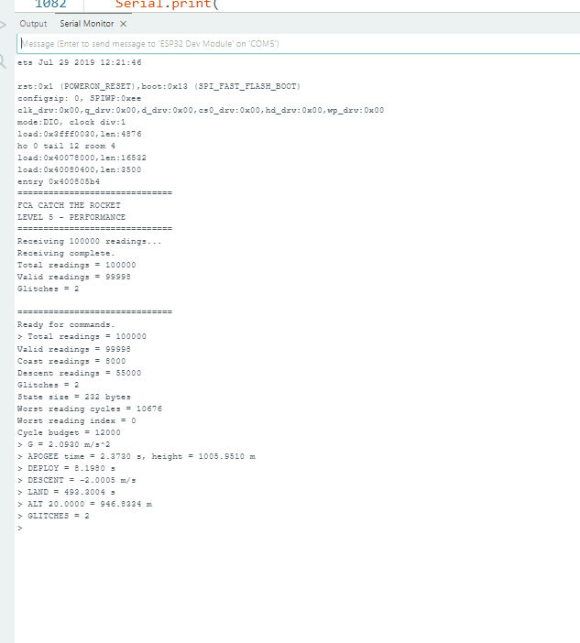
Figure 1. Actual ESP32 Serial Monitor evidence for Adversarial Tracker 1. The screenshot shows 100,000 readings, 99,998 valid readings, 2 glitches and the Level 4 command results.

10. Adversarial Tracker 2 Results
Measurement | Recorded result
Total readings | 100,000
Valid readings | 99,998
Glitches | 2
Glitch rate | 0.002%
Coast | 8,000
Descent | 55,000
State | 232 bytes
Worst reading | 10,955 cycles
G | 30.0022 m/s²
APOGEE | 39.9970 s, 24998.1912 m
DEPLOY | 43.9812 s
DESCENT | -2.0006 m/s
LAND | 12420.3066 s
ALT 0 | 1000.0261 m
ALT 20 | 18999.5547 m
ALT 40 | 24998.1914 m
ALT 44 | 24760.0234 m
ALT 50 | 24748.0195 m
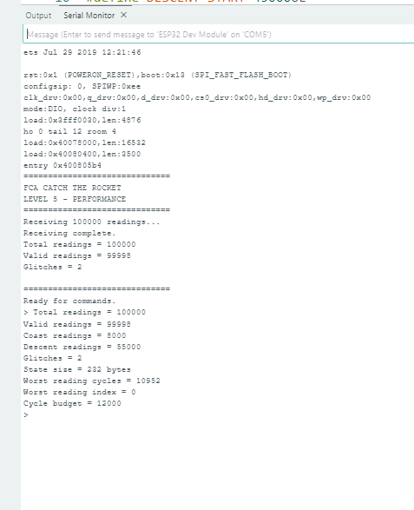
Figure 2. Actual ESP32 Serial Monitor evidence from the Adversarial Tracker 2 run. This screenshot captures the two-glitch result and 232-byte state; the final command values were recorded during the corresponding Level 4 test.
Note: the screenshots in the conversation were captured across repeated hardware runs, so the measured worst-cycle number can vary slightly from run to run. The report's summary table uses the final recorded Level 4 measurements.

11. Official Tracker + Glitches Results
Measurement | Recorded result
Total readings | 100,000
Valid readings | 99,261
Glitches | 739
Glitch rate | 0.739%
Coast | 8,000
Descent | 54,595
State | 232 bytes
Worst reading | 11,208 cycles
G | 9.8138 m/s²
APOGEE | 8.0006 s, 626.0645 m
DEPLOY | 11.9975 s
DESCENT | -4.4997 m/s
LAND | 133.7095 s
ALT 0 | 311.9784 m
ALT 20 | 511.6836 m
ALT 40 | 421.6688 m
ALT 50 | 376.6714 m
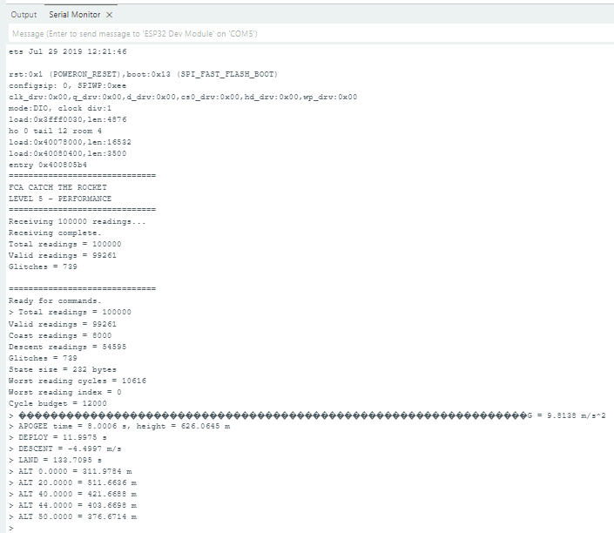
Figure 3. Actual ESP32 Serial Monitor evidence for Official Tracker with glitches enabled. The visible run reports 739 glitches, 99,261 valid readings and a 232-byte state.

12. Practice Tracker B + Glitches Results
Measurement | Recorded result
Total readings | 100,000
Valid readings | 99,273
Glitches | 727
Glitch rate | 0.727%
Coast | 8,000
Descent | 54,599
State | 232 bytes
Worst reading | 11,199 cycles
G | 3.7096 m/s²
APOGEE | 11.3241 s, 1737.7996 m
DEPLOY | 24.0065 s
DESCENT | -8.4999 m/s
LAND | 193.3569 s
ALT 0 | 1499.9457 m
ALT 20 | 1598.1859 m
ALT 40 | 1303.5129 m
ALT 50 | 1218.5142 m
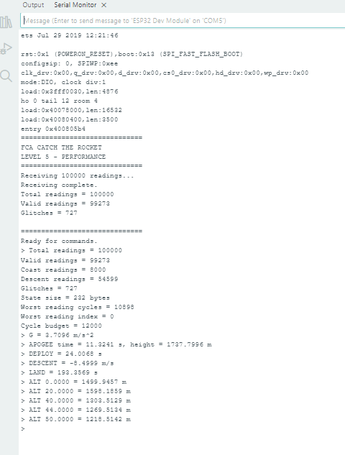
Figure 4. Actual ESP32 Serial Monitor evidence for Practice Tracker B with glitches enabled. The visible run reports 727 glitches, 99,273 valid readings and the Level 4 altitude results.

13. Performance and Debugging Work
Level 4 added an online detector to every applicable reading, so performance had to be measured rather than assumed. During development we inspected the worst-reading cost and removed unnecessary work from the hot path where possible.
One intermediate performance measurement showed:
Measurement | Observed
Total readings | 100,000
Valid readings | 99,998
Glitches | 2
State | 248 bytes in that intermediate run
Worst reading | 11,695 cycles
Budget | 12,000 cycles
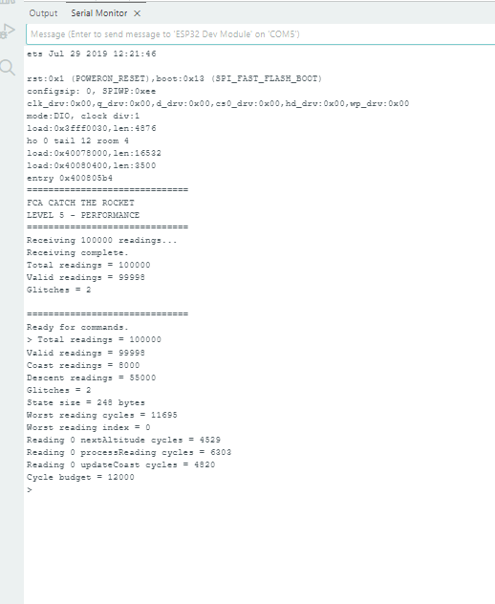
Figure 5. Actual performance-debugging screenshot showing worst-reading measurement and additional per-operation cycle measurements.
The later Level 4 implementation reduced the persistent state to 232 bytes and produced final recorded worst-case measurements of 10,967, 10,955, 11,208 and 11,199 cycles across the four required tracker tests.

14. Did We Solve Level 4 According to the Instructions?
Instruction check | Evidence | Status
Online glitch detector | Recent-valid-reading prediction used for every applicable reading. | PASS
Normal noise tolerated | 20 m threshold is well above ±2 m normal noise. | PASS
Glitch separated from true reading | Tracker guarantee gives >=50 m separation; detector threshold is 20 m. | PASS
No first-1000 glitches assumption used | Detector skipped before index 1000. | PASS
Exact glitch count | 739, 727, 2 and 2 recorded in the four tests. | PASS
Glitches excluded from LS statistics | Rejected readings return before regression updates. | PASS
No hard-coded official glitch positions | Detector uses trajectory prediction only. | PASS
Official + glitches | Tested. | PASS
Practice B + glitches | Tested. | PASS
Adversarial trackers | Tracker 1 and Tracker 2 tested. | PASS
State <=4096 | 232 bytes final Level 4 state. | PASS
Worst reading <=12000 | Maximum recorded among four final tests = 11,208 cycles. | PASS
Previous calculations remain usable | G, APOGEE, DEPLOY, DESCENT, LAND and ALT were tested. | PASS
Based on the actual tests performed, Level 4 was completed and verified on the ESP32. This report does not claim a separate instructor acceptance message for Level 4 because none is recorded in the available conversation evidence.

15. Final Level 4 Summary
Tracker | Glitches | Rate | State | Worst cycles | G | DEPLOY | DESCENT | LAND
Adversarial 1 | 2 | 0.002% | 232 B | 10,967 | 2.0930 | 8.1980 s | -2.0005 m/s | 493.3004 s
Adversarial 2 | 2 | 0.002% | 232 B | 10,955 | 30.0022 | 43.9812 s | -2.0006 m/s | 12420.3066 s
Official + glitches | 739 | 0.739% | 232 B | 11,208 | 9.8138 | 11.9975 s | -4.4997 m/s | 133.7095 s
Practice B + glitches | 727 | 0.727% | 232 B | 11,199 | 3.7096 | 24.0065 s | -8.4999 m/s | 193.3569 s
The highest recorded Level 4 worst-reading cost was 11,208 cycles, leaving 792 cycles below the 12,000-cycle limit. The highest measured glitch rate was 0.739%, below the allowed 1%.

16. What We Learned
- Glitch handling has to happen before a corrupted reading reaches the regression state.
- A streaming detector can work with only a few previous valid samples.
- The physical guarantees in the specification are useful algorithmic constraints.
- A fixed list of official glitch locations would not generalize to the judge trackers, so the detector was derived from the incoming trajectory.
- A deployment transition is different from an isolated glitch and must be handled by the Level 3 model logic.
- Worst-case cycle count matters more than average speed.
- Repeated ESP32 measurements are necessary because execution time can vary slightly between runs.

17. LLM Usage and Development Workflow
ChatGPT was used as an iterative coding and reasoning assistant. The authoritative hackathon instructions were treated as the requirements source. The team implemented the suggested logic in Arduino IDE, uploaded it to the ESP32, captured Serial Monitor evidence and used those measurements to decide whether the implementation was correct.
Stage | LLM contribution | Team verification
Requirements | Explained the Level 4 glitch guarantees and constraints. | Compared with the supplied hackathon instructions.
Algorithm | Suggested an online predictor-based detector using recent valid readings. | Implemented and tested on ESP32.
Code | Provided incremental Arduino C/C++ changes. | Compiled and uploaded.
Debugging | Helped interpret cycle and correctness outputs. | Team changed the code and reran tests.
Verification | Helped compare Official, Practice and adversarial results. | Final PASS decision was based on hardware measurements.
Important: the numerical Level 4 results in this report came from the team's ESP32 Serial Monitor runs. They were not generated by the assistant.

18. Conclusion
Level 4 successfully extended the Catch the Rocket ground station to handle tracker glitches while preserving the streaming architecture developed in Levels 1–3. The implementation detected glitches online, counted them, rejected them before they could corrupt least-squares statistics, and continued to calculate the required flight quantities.
The solution was tested on Official Tracker with glitches, Practice Tracker B with glitches, and two custom adversarial trackers. The highest recorded glitch rate was 0.739%, below the 1% limit. The highest recorded worst-reading cost was 11,208 cycles, below the 12,000-cycle limit. The final recorded state size was 232 bytes.
Therefore, based on the actual evidence captured during the work, Level 4 was completed and verified on the ESP32.

Appendix A – Level 4 Evidence Checklist
- Official Tracker + glitches tested.
- Practice Tracker B + glitches tested.
- Adversarial Tracker 1 tested.
- Adversarial Tracker 2 tested.
- Exact glitch counts recorded.
- Glitch rates below 1%.
- State size recorded as 232 bytes.
- Worst reading below 12,000 cycles in all four final recorded tests.
- G, APOGEE, DEPLOY, DESCENT and LAND tested.
- ALT queries tested across relevant trajectory regions.
- Intermediate performance/debugging evidence included.
- Actual ESP32 screenshots included.

Appendix B – Important Note on Screenshot Variations
The report includes actual screenshots from the work. Some screenshots were captured during repeated runs of the same implementation and show slightly different worst-cycle measurements, such as 10,616, 10,676 or 10,898 cycles. This is normal for repeated embedded timing measurements. The final result tables use the final Level 4 measurements recorded in the team's testing summary rather than replacing the screenshots with edited values.

Appendix C – Source Basis
Primary requirements source: the supplied Catch the Rocket instructions. Code details were taken from the Level 4 implementation material saved in the conversation. Numerical results were taken from the team's ESP32 testing record and screenshots.

