**SAFETY SYSTEM FOR MINERS**

By

NAMRATA CHAKKA 15BEC1007

MADHURIMA MUKHERJEE 15BEC1062

PATURI HARSHITHA 15BEC1243

ANKITA NEGI 15BEC1087

AYUSHI 15BEC1190

ANJALI SINGH 15BEC1218

A project report submitted to

**DR. SRS PRABAHARAN**

**SCHOOL OF ELECTRONICS ENGINEERING**

in partial fulfilment of the requirements for the course of

**ECE3999 – TECHNICAL ANSWERS FOR REAL WORLD PROBLEMS**

in

**B.Tech. ELECTRONICS AND COMMUNICATION ENGINEERING**



**VIT UNIVERSITY, CHENNAI**

**Vandalur – Kelambakkam Road**

**Chennai – 600127**

**NOVEMBER 2015**

**TABLE OF CONTENTS**

|  |  |  |  |
| --- | --- | --- | --- |
| **SERIAL NO.** |  | **NAME** | **PAGE NO.** |
|  |  | BONAFIDE CERTIFICATE | 3 |
|  |  | ACKNOWLEDGEMENT | 4 |
|  |  |  |  |
| 1 |  | INTRODUCTION | 6 |
|  |  |  |  |
|  | 1.1  1.2 | OBJECTIVES AND GOALS  BENEFITS | 6 |
|  |  |  | 6 |
|  |  |  |  |
| 2 |  | COMPONENT SPECIFICATION | 7-8 |
|  |  |  |  |
|  |  |  |  |
| 3 |  | BASIC CROSS SECTION OF HELMET | 9 |
|  |  | PROTOTYPE OF THE HELMET |  |
| 4 |  | BLOCK DIAGRAM | 10 |
| 5 |  | DESIGN OF PATCH ANTENNA | 11-13 |
| 6  7 | 7.1  7.2  7.3 | WORKING OF THE SYSTEM  OUTPUTS  SENSOR OUTPUTS  BASIC PATCH ANTENA OUTPUT  MIMO ANTENNA OUTPUT | 14  15-17 |
|  |  |  |  |

8 8.1 CONCLUSION 18

8.2 FUTURE WORK

**BONAFIDE CERTIFICATE**

Certified that this project report entitled **“SAFETY SYSTEM FOR MINERS”** is a bonafide work of **NAMRATA CHAKKA (15BEC1007), MADHURIMA MUKHERJEE (15BEC1062), ANKITA NEGI (15BEC1087), AYUSHI (15BEC1190), PATURI HARSHITHA (15BEC1243), ROHIT RAVINDRANATH JOSHI(15BEC1051), ANISH ANDREWS KINGSLEY(15BEC1071)** and **ANJALI SINGH (15BEC1218)** who carried out the Project work under my supervision and guidance.

**Signature of Students**:

**AYUSHI-15BEC1190**

**ANKITA NEGI-15BEC1087**

**ANJALI SINGH-15BEC1218**

**PATURI HARSHITHA-15BEC1243**

**NAMRATA CHAKKA-15BEC1007**

**MADHURIMA MUKHERJEE-15BEC1062**

**ROHIT RAVINDRANATH JOSHI-15BEC1051**

**ANISH ANDREWS KINGSLEY-15BEC1071**

**Signature of Faculty:**

(**DR. SRS PRABAHARAN)**

**ACKNOWLEDGEMENT**

We wish to express our sincere thanks and deep sense of gratitude to our project guide **DR. SRS PRABAHARAN,** Associate Professor, School of Electronics Engineering, for his consistent encouragement and valuable guidance offered to us in a pleasant manner throughout the course of the project work.

We are extremely grateful to **Dr. Sreedevi. V.T,** Dean of the School of Electronics Engineering, VIT Chennai, for extending the facilities of the School towards our project and for her unstinting support.

We express our thanks to our Programme Chair **Dr. Vetrivelan.P** and Co-Programme Chair **Prof.Reena Monica P** for their support throughout the course of this project.

We also take this opportunity to thank all the faculty of the School especially **DR. USHAKIRAN** for her support throughout the course. We thank our parents, family, and friends for bearing with us throughout the course of our project and for the opportunity they provided us in undergoing this course in such a prestigious institution.

**ABSTRACT**

This project designs a monitoring system embedded inside a helmet for mine safety based on RF sensor network along with a self-designed antenna. The monitoring system collects the pulse or heartbeat and methane values underground of the mine through RF nodes inside the helmets, and then transmits the data to information processing terminal. In order to obtain the data values, gas and pulse sensors are interfaced into the helmet. If the data is ultra-limit, the system can send an alert in the form of buzzer to related personnel of safety. The mining authority can then recover the miner from the condition of emergency. This project is designed with a clear purpose of saving the life of miners during mine collapse and extreme methane gas emissions.

1. **INTRODUCTION**

**1.1 OBJECTIVES AND GOALS**

* Designing an intelligent helmet that aims to save the life of miners during

mine collapse and excessive methane gas emissions.

**1.2 BENEFITS**

The system designed in this project is made with a view to solve the two most prominent challenges that any miner would have to face while working in an open mine namely, mine collapse and excessive methane gas emissions. The project aims to benefit the miners by incorporating the use of a smart helmet system that provides information about the miner’s condition during such emergencies. The sensors embedded inside the helmet helps to obtain accurate data and transmit it to the receiver through a self-designed patch antenna with a substantially appreciable range. Moreover, the cost of the entire system is minimal so as to make it a feasible product that can be bought without hesitation. Overall, the helmet made incorporates a well embedded system that would not harm any miner and is solely beneficial to their needs.

**2. COMPONENTS SPECIFICATION**

* **PULSE SENSOR:**

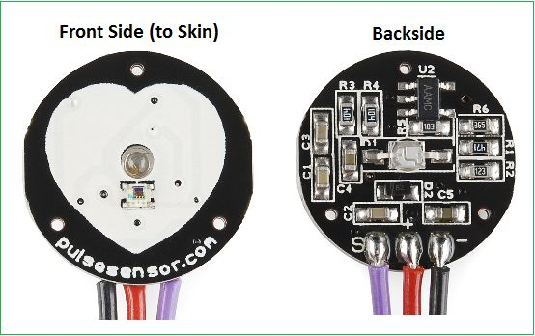

* PIN CONFIGURATION:

1. Positive terminal of the sensor to +5V
2. Negative terminal of the sensor to GND
3. S to A0

* “0.625" Diameter and 0.125" Thick
* **GAS SENSOR (MQ6):**

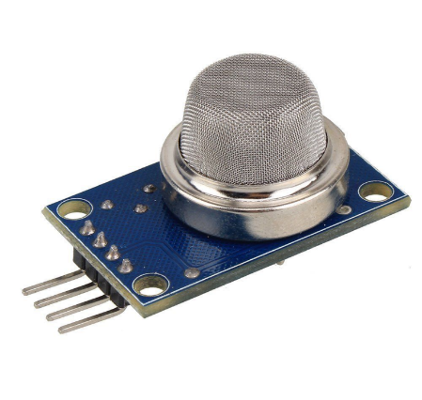

* PIN CONFIGURATION:

1. Positive terminal of the sensor to +5V
2. Negative terminal of the sensor to GND
3. S to A0

* High sensitivity to methane, LPG
* Small sensitivity to alcohol, smoke.
* Fast response
* Stable and long life
* Simple drive circuit
* **RF MODULE:**

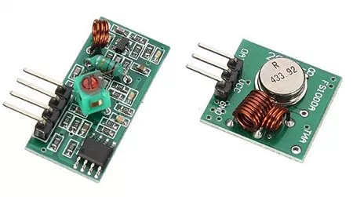

* FEATURES:

1. Receiver frequency 433MHz
2. Receiver typical frequency 105Dbm
3. Receiver supply current 3.5mA
4. Low power consumption
5. Receiver operating voltage 5v
6. Transmitter frequency range 433.92MHz
7. Transmitter supply voltage 3v~6v
8. Transmitter output power 4v~12v

**3. BASIC CROSS SECTION OF THE HELMET**

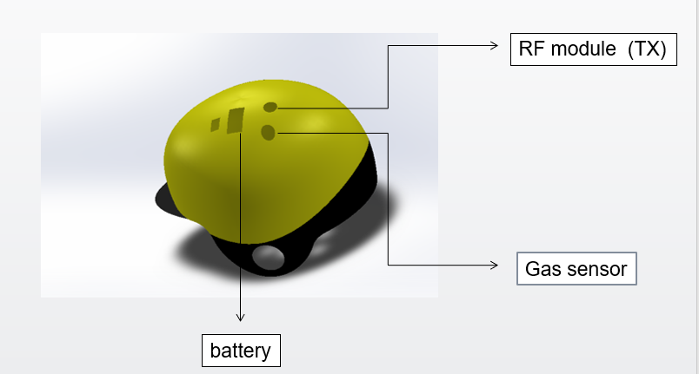

**PROTOTYPE OF THE HELMET**

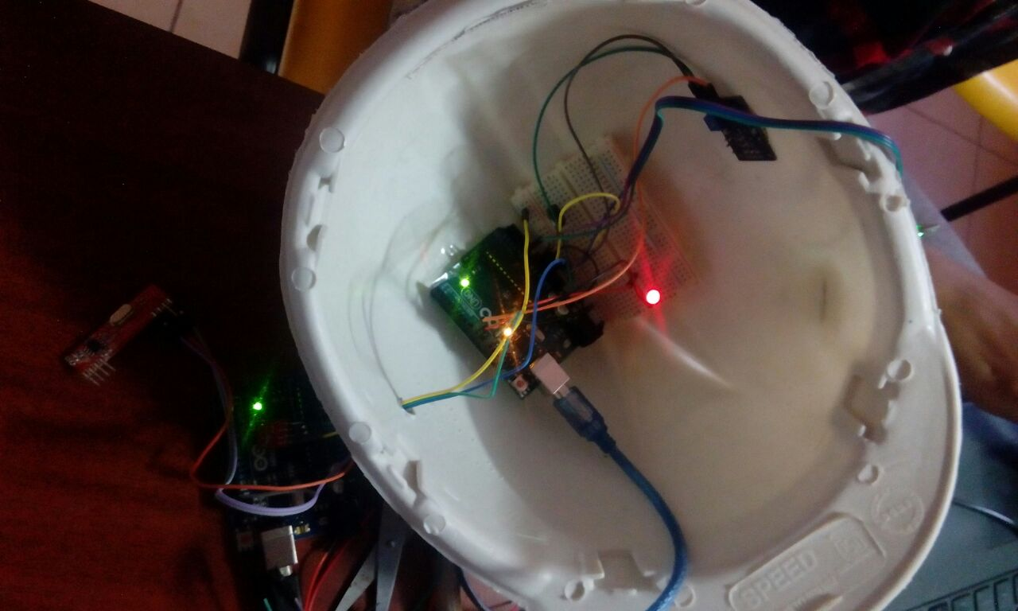

**4. BLOCK DIAGRAM**

**TRANSMITTER SIDE:**

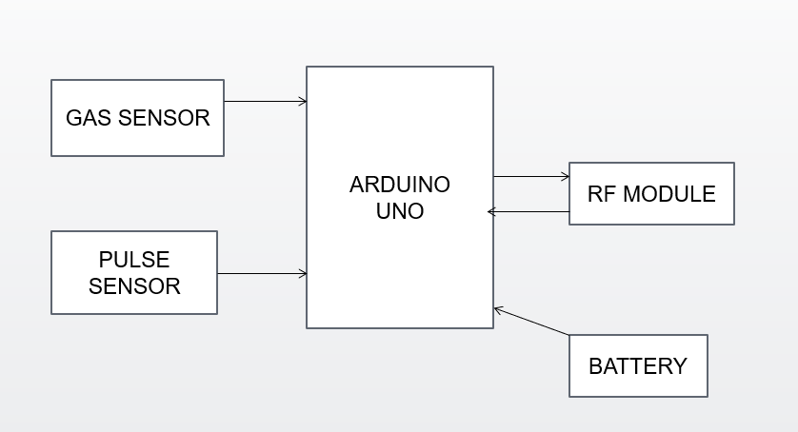

**RECEIVER SIDE:**

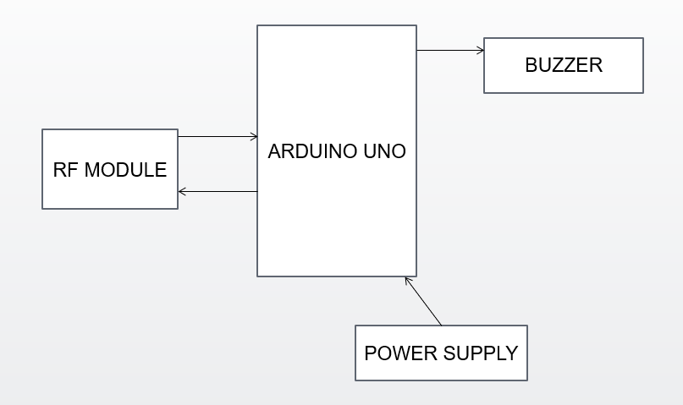

**5. DESIGN OF THE PATCH ANTENNA**

**BASIC DESIGN:**

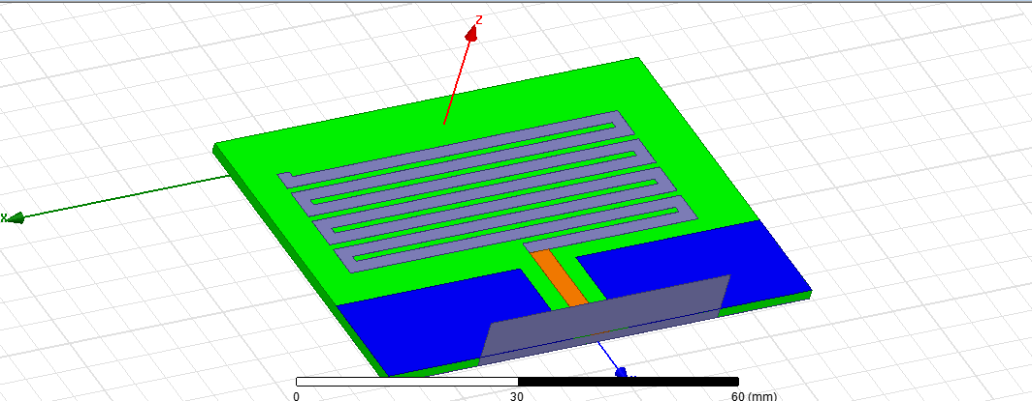

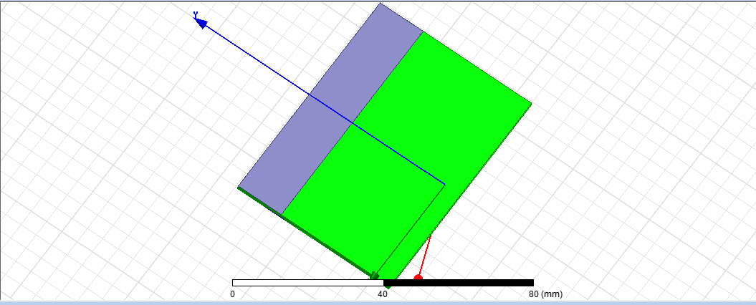

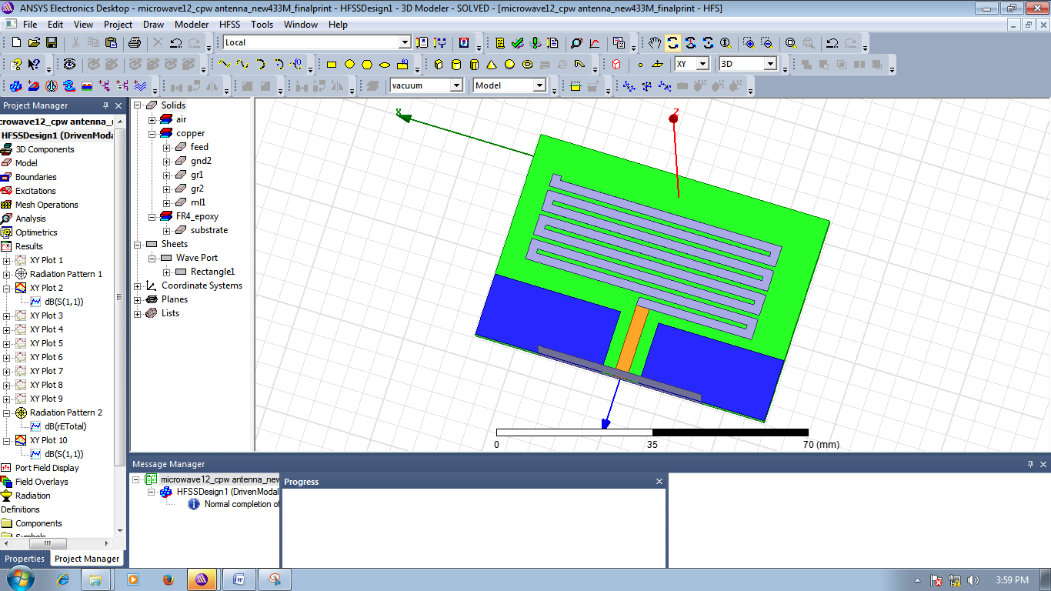

**MULTIPLE INPUT MULTIPLE OUTPUT (MIMO) DESIGN:**

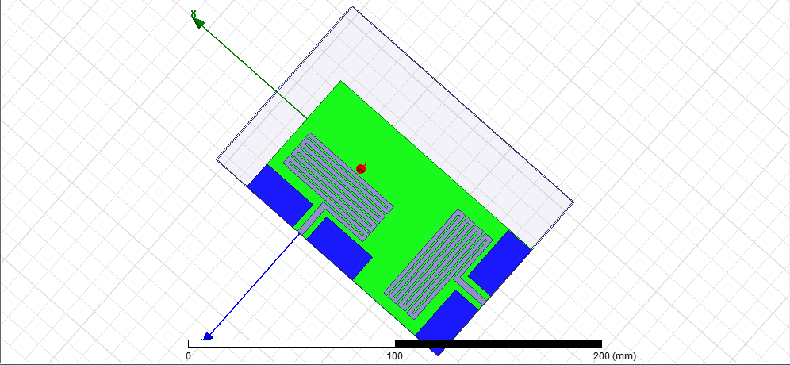

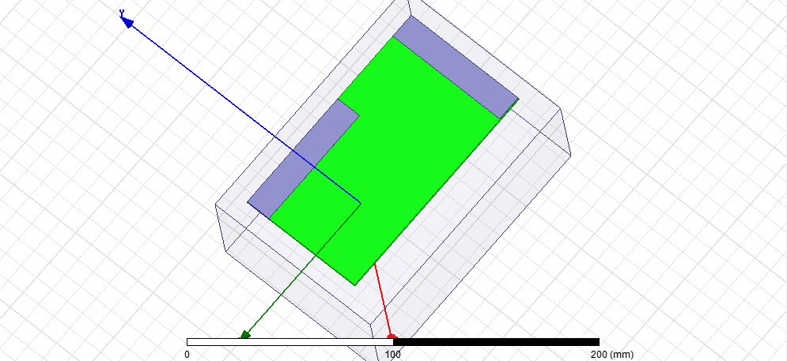

**6. WORKING OF THE SYSTEM**

1. When the worker enters the mine, he turns the helmet circuitry ON. The connection between helmet and control room is established through RF communication and is tested for proper communication.
2. The gas sensor detects poisonous gases like ethane, methane, butane, etc. and if such gases cross the set value, buzzer is turned ON. The values detected by the sensor are continuously transmitted through TX of RF module.
3. Similarly, the pulse sensor transmits the heart beat rate of the miner through the rf module and the heart beat is monitored on the receiver side.
4. Once a case of emergency occurs, the mining authority gets alert and monitors the current condition of the miners in order to take necessary steps to save their lives.

**7. OUTPUTS**

**7.1 SENSOR OUTPUTS:**



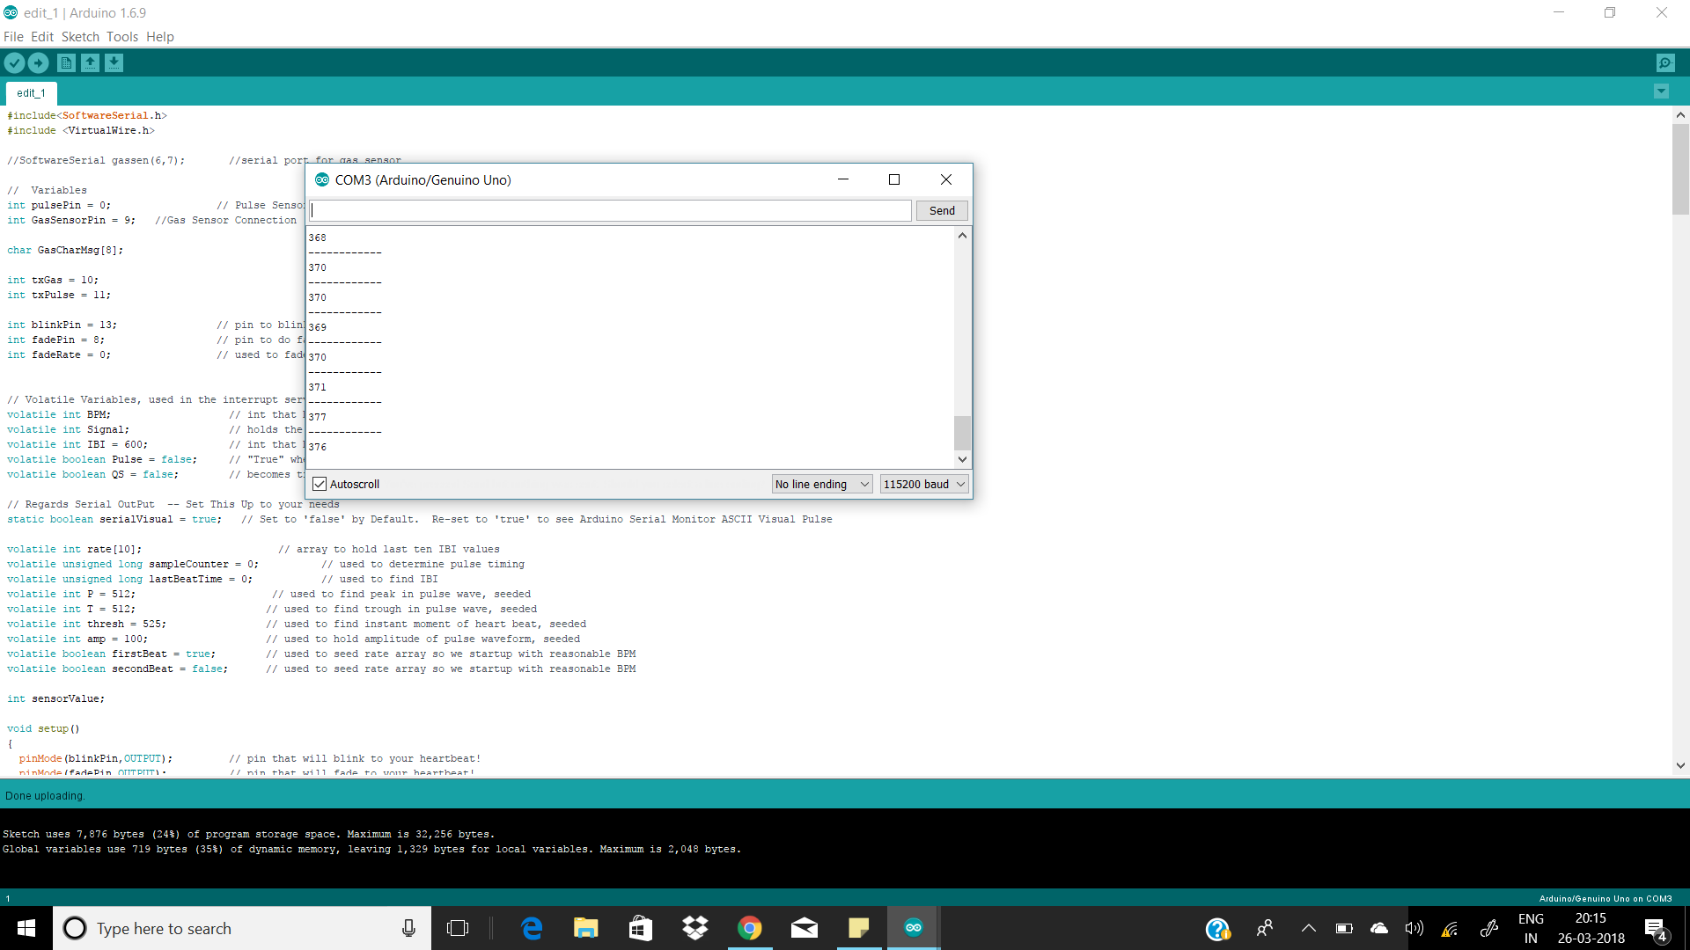

**7.2 BASIC ANTENNA SIMULATION OUTPUTS:**

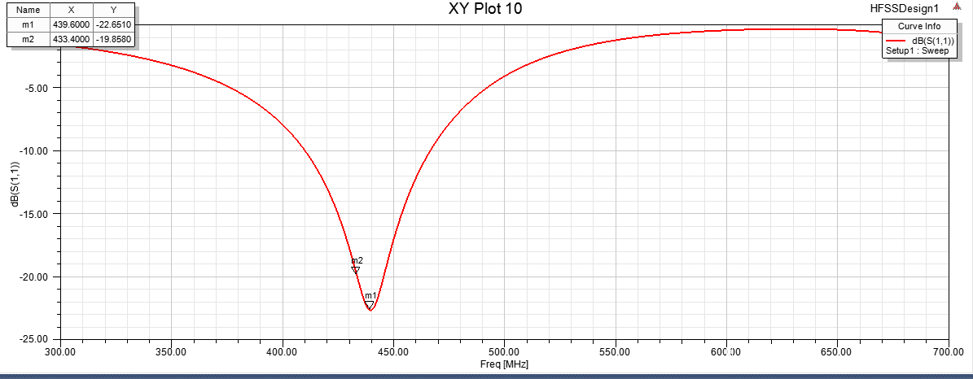

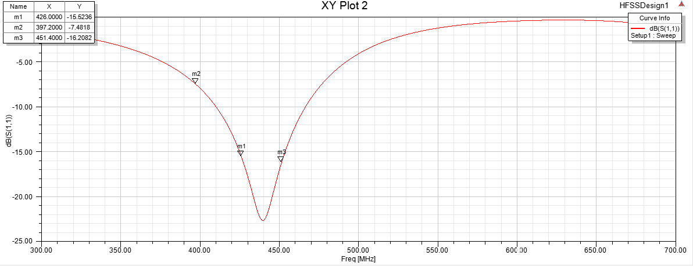

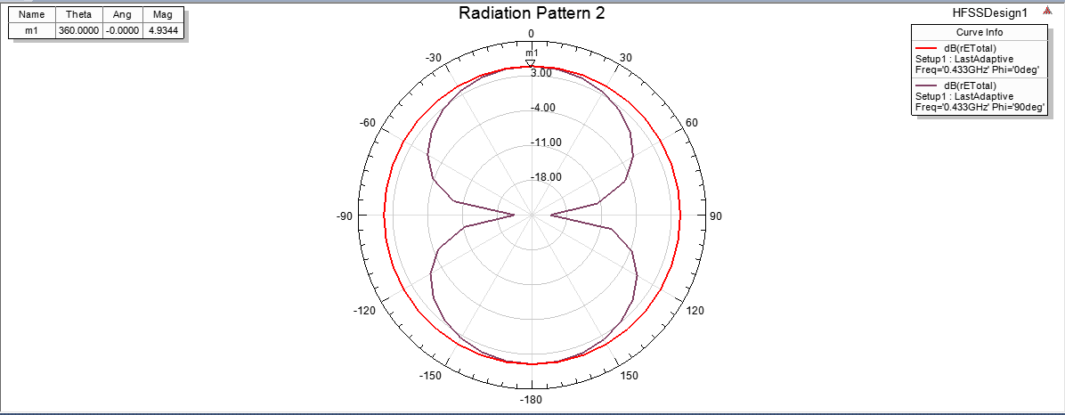

**7.3 MIMO ANTENNA OUTPUTS:**

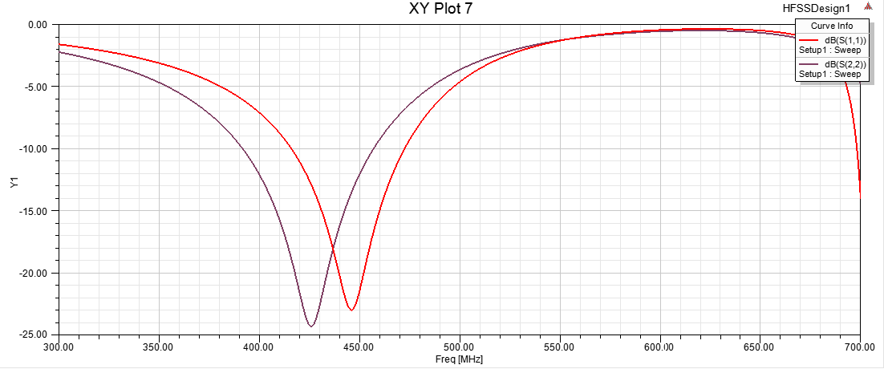

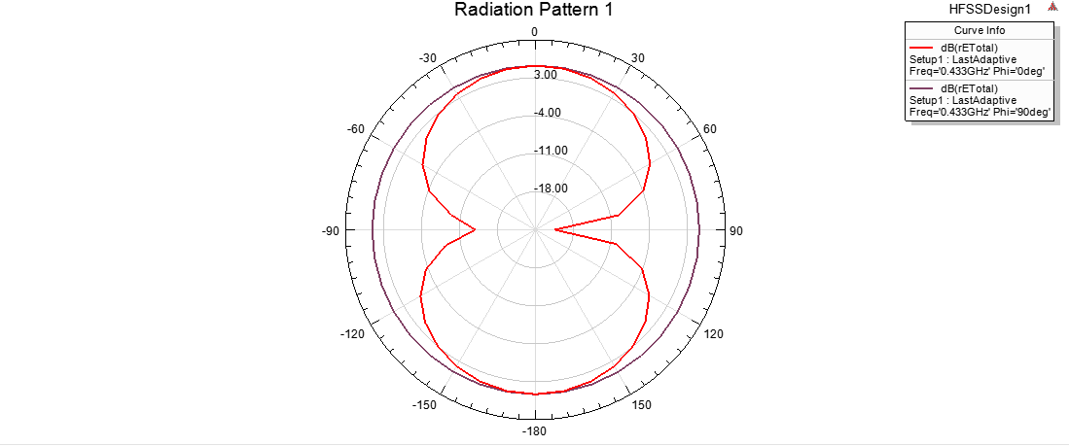

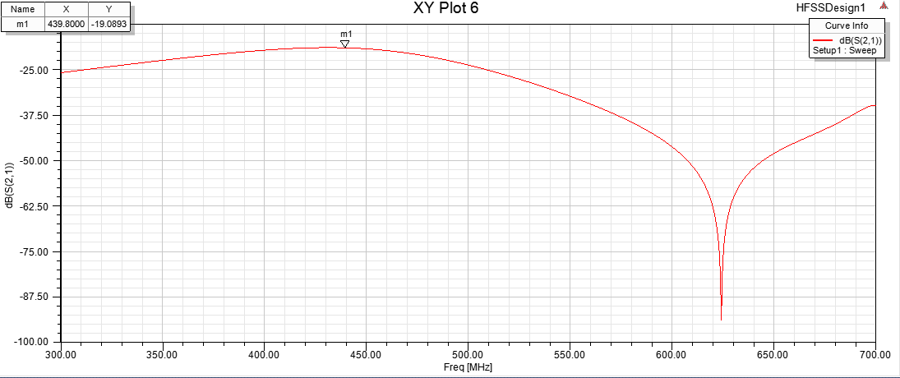

**8. CONCLUSION AND FUTURE WORK**

**8.1 CONCLUSION**

We hereby conclude that the system designed has been tested and can be used in real time. We also conclude that the cost effectiveness and intricate embedding of the sensors would provide the comfort of both purchasing and wearing it. The fulfilment of the project is in the satisfaction of the subject, the miners here and the results obtained so far give us a positive sense of achievement.

**8.2 FUTURE WORK**

The future work is a question of solving further related obstacles in the area of work taken. Since, the basic issues have been looked into and solved to a considerable extent, we promise to further seek to feasible solutions if necessary.