OBJECT COUNTER USING IR SENSOR AND ARDUINO
A
Real Time project / Field Based Project
Submitted in the Partial Fulfillment of the Academic Requirements for the Award of the Degree of

Bachelor of Technology
In

Electronics and Communication Engineering
By
- HARSHITHA | 23AG1A0401
B. NAVEEN YADAV | 23AG1A0410
K. AKSHAYA | 23AG1A0426

Under the esteemed guidance of
Mr. M. MYSAIAH

Associate Professor-ECE

DEPARTMENT OF ELECTRONICS AND COMMUNICATION

ENGINEERING

ACE Engineering College
(An UGC Autonomous Institution)
(Sponsored by YadalaSatyanarayana Memorial Educational Society, Hyderabad)

Approved by AICTE & Affiliated to JNTUH
Accredited by NBA & NAAC ‘A’ Grade
Ankushapur (V), Ghatkesar (M), Medchal-501301 2024-25

ACE Engineering College
(An UGC Autonomous Institution)
Ankushapur (V), Ghatkesar (M), R.R.Dist – 501 301
(Approved by AICTE, New Delhi and Affiliated to JNTUH)
NBA Accredited B.Tech Courses: EEE, ECE, CSE,CIVIL & ME

Accredited by NAAC ‘A’ Grade

CERTIFICATE

This is to certify that the Real Time / Field Based Research Project entitled “ OBJECT COUNTER USING IR SENSOR AND ARDUINO ” done by

- HARSHITHA | 23AG1A0401
- NAVEEN YADAV | 23AG1A0410
K. AKSHAYA | 23AG1A0426

Of Department of Electronics and Communication Engineering, is a record of bonafide work carried out by them. This Real Time Project/ Field Based Project is done as a partial fulfillment of obtaining Bachelor of Technology Degree to be awarded by Jawaharlal Nehru Technological University, Hyderabad.

Mr. M. MYSAIAH Dr. Y. Chakarapani
Associate Professor of ECE Professor & Dean of ECE

ACKNOWLEDGEMENT

We are happy for being guided by Mr. M. MYSAIAH, Associate Professor of ECE for his able guidance given to us to complete our Real Time Project / Field Based Project work successfully.

We wish to express our deep sense of gratitude to our Project coordinator CH. SARITA, Assistant Professor for giving us an opportunity to present the technical project work.

We are grateful to thank Dr Y.Chakrapani, Dean of the Department of ECE, for his thought provoking suggestions and constant encouragement that led us to this success.

We would like to convey our heartfelt thanks to Principal for his wonderful guidance and encouragement given to us to move ahead in the execution of this project and Prof. Y. V. GOPALA KRISHNA MURTHY, for his moral support and providing infrastructure.

Above all, we are very much thankful to the management of ACE Engineering
College which was established by the high-profiled intellectuals for the cause of Technical Education in the modern era.
We are thankful to JNTUH for giving us this opportunity to work on a project as a part of our curriculum.
We take this opportunity to thank one and all who have helped in making this Real Time Project/ Field Based Project possible.
With regards,
A. HARSHITHA - 23AG1A0401
B. NAVEEN YADAV - 23AG1A0410
K. AKSHAYA - 23AG1A0426
ABSTRACT

OBJECT COUNTER USING IR SENSOR AND ARDUINO

This project counts the number of obstacles that pass in front of the IR sensor in one direction only. The value of the total counts or the count number is displayed on a 16*2 LCD display module. The module has an emitter which is an IR LED and a detector which is an IR photodiode. The IR sensor that we are using in the project is an active IR sensor. Whenever it detects an object inside its range the output generated by it is high otherwise the output is low. You can also adjust the range of the sensor by rotating the inbuilt trim pot. The count is zero initially and then incremented by one whenever something passes in front of it. Automated counter system is an efficient solution for counting the number of people or objects, leaving a room. Its also used to count the number of people. It intelligently discovers and counts the number of people with help of internal code from the Arduino UNO. This has been achieved by using an Infrareded sensors and the development board Arduino UNO. Two infrared sensors are placed at entry and exit of a room. The sensors acquire the data and sends to the Arduino which maintains the count. The system requires low voltage and minimum maintenance to continue the operation. .
Block Diagram:
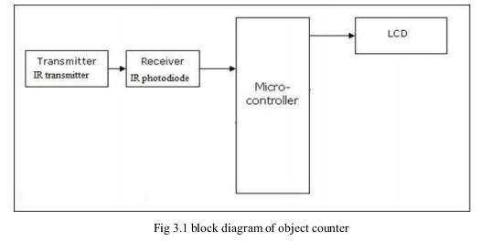
Arduino

CONTENTS

TITLE PAGE NO

Abstract 4

Content 5

List of Figures 6

Chapter 1: Introduction
1.1. Introduction to the Project 7 - 8

Chapter 2: Components of Proposed system
2.1. Hardware Components 9 - 15
2.2. Software Tools 15 - 17

Chapter 3: Working of the Project
3.1. Block diagram 18
3.2. Flow chart 19
3.3. Explanation of working from Input to Output
Chapter 4: Results
(Images of the Project module in different cases with explanation) 21

Chapter 5: Advantages, Disadvantages and Applications
5.1. Advantages 22
5.2. Disadvantages 23
5.3. Applications 24

Chapter 6: Conclusion and Future Scope
6.1. Conclusion 25
6.2. Future Scope 26

References 27

LIST OF THE FIGURES

SNO | FIGURE NO : | LIST OF FIGURES | PAGE. NO.
1 | 2.1 | Arduino UNO | 9
2 | 2.2 | IR Sensor | 10
3 | 2.3 | 16*2 LCD Display | 12
4 | 2.4 | Jumper Wires | 12
5 | 2.5 | I2C Module | 13
6 | 2.6 | Arduino IDE | 15
7 | 3.1 | Block Diagram | 17
8 | 3.2 | Flow Chart | 18
9 | 4.1 | Result | 20

CHAPTER -1
INTRODUCTION :

Automated counter system is an efficient solution for counting the number of people entering or leaving a room. It’s also use to count the number of packages or objects, leaving or entering the Industry. This attempts to provide a unique solution which can automatically count the number of people. It intelligently discovers and counts the number of people with the help of internal code from the Arduino UNO. This has been achieved by using an Infrared sensor and the development board Arduino UNO. Two Infrared sensors are placed at entry and exit of a room. The sensors acquire the data and sends to the Arduino which maintains the count. The system requires low voltage and minimum maintenance to continue the operation. An IR sensor, or motion detector is a electronic device that uses a sensor to detect nearby people or objects. The IR emitter LED continuously emits infrared. when any object comes within the range, some amount of infrared reflects from the object surface and that reflected infrared can be detected by the IR receiver LED. This motion sensors are used primarily in home, mobile phones, game consoles and virtual reality system.
This research project of “Object Counter and Sensor” is based on the interfacing of some components such as sensors, motors etc. with Arduino microcontroller. This counter can count people in both directions. This circuit can be used to count the number of persons entering a hall/mall/home/office in the entrance gate and it can count the number of persons leaving the hall by decrementing the count at same gate or exit gate and it depends upon sensor placement in mall/hall. It can also be used at gates of parking areas and other public places. The main objective of this work is in our home, school, colleges or industry we see that fan and lighting point are kept on even if there is nobody in the room or area and passage. This happens due to negligence or because we forgot to turn lights off or we are in a hurry. To avoid all such situations this “Object Sensor and Counter” is designed.
The project “Object sensor and counter” is divided in four parts: Arduino Uno, IR sensors, micro controller and counter display. Arduino is a microcontroller-based open source electronic prototyping board which can be programmed with an easy-to-use Arduino IDE The board is equipped with sets of digital and analog input/output (I/O) pins that may be interfaced to various expansion boards (shields) and other circuits. The board has 14 Digital pins, 6 Analog pins, and programmable with the Arduino IDE (Integrated Development Environment) via a type B USB cable. It can be powered by the USB cable or by an external 9-volt battery, though it accepts voltages between 7 and 20 volts. It is also similar to the Arduino Nano and Leonardo. We have used two IR sensor modules which contain IR diodes, potentiometer, Comparator (OpAmp) and LED‟s. Potentiometer is used for setting reference voltage at comparator sone terminal and IR sensors sense the object or person and provide a change in voltage at comparator s second terminal. A microcontroller is the most prominent black rectangular chip with 28 pins. Think of it as the brains of your Arduino. The microcontroller used on the UNO board is Atmega328P by Atmel (a major microcontroller manufacturer). A 16x2 LCD display is very basic module and is very commonly used in various devices and circuits.
In this project we have used circuit, which is consists of IR pair at input section and LCD at output section. With the help of this system we can count the visitors, at Banks, shops, temples, malls etc. [3] IR pair is the input section of this circuit. When some individual goes into the room then the counter is increased by one when any one leaves the room then the counter is decremented by one the aggregate number of people inside the room is likewise shown on the16x2 LCD shows. Then this input of LCD for displaying and finally we get the display of count on LCD.
In this way the circuit of visit counter can works on such simple principle We also add automatic room lighting system in this project to count number of persons visiting particular room and accordingly light up the room? So, when somebody enters into the room then the counter is incremented by one and the light in the room will be switched ON and when any one leaves the room then the counter is decremented by one. The light will be only switched OFF until all the persons in the room go out. The total number of persons inside the room is also displayed on the 16x2 LCD displays [4]. In today’s world, there is a continuous need for automatic appliances with the increase in standard of living; there is a sense of urgency for developing circuits that would ease the complexity of life. Also if at all one wants to know the number of people present in room so as not to have congestion.

Chapter – 2
Components of proposed system
2.1 Hardware components :
1. ARDUINO UNO
2. IR SENSOR (INFRARED SENSOR)
3. 16x2 LCD DISPLAY
4. CONNECTERS AND JUMPERS
5. I2C MODULE
6. USB CABLE
1. Arduino uno :
Arduino Uno is a microcontroller board based on the ATmega328P (datasheet). It has 14 digital input/output pins (of which 6 can be used as PWM outputs), 6 analog inputs, a 16 MHz quartz crystal, a USB connection, a power jack, an ICSP header and a reset button. It contains everything needed to support the microcontroller; simply connect it to a computer with a USB cable or power it with an AC-to-DC adapter or battery to get started. You can tinker with your UNO without worrying too much about doing something wrong, in worst case scenario you can replace the chip for a few dollars and start over again.

"Uno" means one in Italian and was chosen to mark the release of Arduino Software (IDE) 1.0. The Uno board and version 1.0 of Arduino Software (IDE) were the reference versions of Arduino, now evolved to newer releases. The Uno board is the first in a series of USB Arduino boards, and the reference model for the Arduino platform; for an extensive list of current, past or outdated boards see the Arduino index of boards.

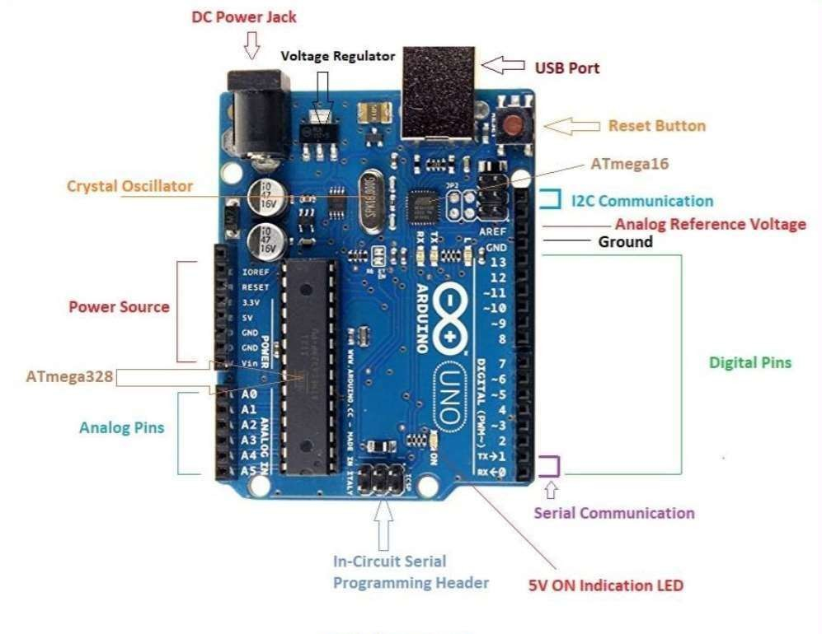
Fig: 2.1 Arduino UNO

2. IR Sensor (Infrafed sensor) :
In the electromagnetic spectrum, the infrared portion divided into three regions: near infrared region, mid infrared region and far infrared region. IR sensor is an electronic device, that emits the light in order to sense some object of the surroundings. An IR sensor can measure the heat of an object as well as detects the motion. Usually, in the infrared spectrum, all the objects radiate some form of thermal radiation. These types of radiations are invisible to our eyes, but infrared sensor can detect these radiations. The emitter is simply an IR LED (Light Emitting Diode) and the detector is simply an IR photodiode .
Photodiode is sensitive to IR light of the same wavelength which is emitted by the IR LED. When IR light falls on the photodiode, the resistances and the output voltages will change in proportion to the magnitude of the IR light received.
There are five basic elements used in a typical infrared detection system: an infrared source, a transmission medium, optical component, infrared detectors or receivers and signal processing.
Infrared lasers and Infrared LED’s of specific wavelength used as infrared sources. The three main types of media used for infrared transmission are vacuum, atmosphere and optical fibers.
Optical components are used to focus the infrared radiation or to limit the spectral response.

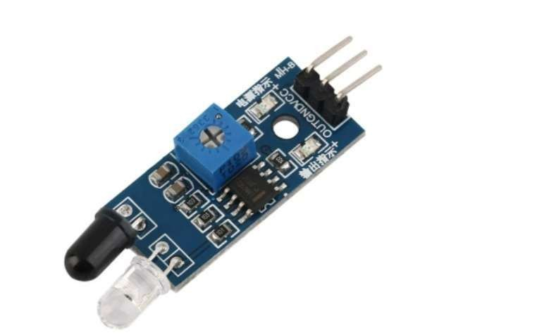
Fig: 2.2 IR Sensor

3. LCD display :
The term LCD stands for liquid crystal display. It is one kind of electronic display module used in an extensive range of applications like various circuits & devices like mobile phones, calculators, computers, TV sets, etc. These displays are mainly preferred for multisegment light-emitting diodes and seven segments. The main benefits of using this module are inexpensive; simply programmable, animations, and there are no limitations for displaying custom characters, special and even animations,
The operating voltage of this LCD is 4.7V-5.3V. It includes two rows where each row can produce 16-characters.
The utilization of current is 1mA with no backlight every character can be built with a 5×8 pixel box. The alphanumeric LCDs alphabets & numbers is display can work on two modes like 4bit & 8-bit. these are obtainable in Blue & Green Backlight. It displays a few custom generated characters.
A 16×2 LCD has two registers like data register and command register. The RS (register select) is mainly used to change from one register to another. When the register set is ‘0’, then it is known as command register. Similarly, when the register set is ‘1’, then it is known as data register.
The main function of the command register is to store the instructions of command which are given to the display. So that predefined tasks can be performed such as clearing the display, initializing, set the cursor place, and display control. Here commands processing can occur within the register.
The main function of the data register is to store the information which is to be exhibited on the LCD screen. Here, the ASCII value of the character is the information which is to be exhibited on the screen of LCD. Whenever we send the information to LCD, it transmits to the data register, and then the process will be starting there. When register set =1, then the data register will be selected.
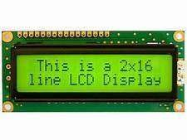

Fig: 2.3 16*2 LCD Display

4. Connectors and Jumper wires :
A jump wire (also known as jumper, jumper wire, jumper cable, DuPont wire or cable) is an electrical wire, or group of them in a cable, with a connector or pin at each end (or sometimes without them – simply “tinned”), which is normally used to interconnect the components of a breadboard or other prototype or test circuit, internally or with other equipment or components, without soldering.
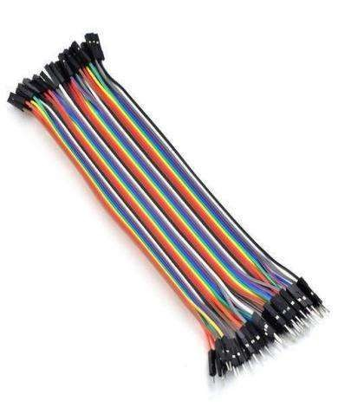
Fig: 2.4 Jumper Wires

Stranded 22AWG jump wires with solid tips. Individual jumper wires are fitted by inserting their “end connectors” into the slots provided in a breadboard, the header connector of a circuit board, or a piece of test equipment.
5. I2C MODULE :
The I2C (Inter-Integrated Circuit) module is a communication protocol that allows multiple devices to communicate with a microcontroller using just two lines: SDA (Serial Data Line) and SCL (Serial Clock Line). It is a master-slave communication protocol, where the master (usually the microcontroller like Arduino) controls the communication, and the slaves (such as sensors or displays) respond. Each device on the I2C bus has a unique address, allowing the master to communicate with many devices individually without needing separate data lines for each. This makes I2C particularly useful in projects where many components need to be connected to a single microcontroller with limited pins.
In Arduino-based projects, the I2C module is commonly used to control a 16x2 LCD display. Without I2C, connecting an LCD to an Arduino typically requires six or more digital pins, which can be a limitation in complex circuits. By using an I2C interface board attached to the LCD, the communication is reduced to just two data lines (SDA and SCL), significantly simplifying wiring and freeing up the other digital pins for additional sensors or modules. The I2C module also includes a small onboard potentiometer to adjust the contrast of the LCD screen, further enhancing its usability and convenience.
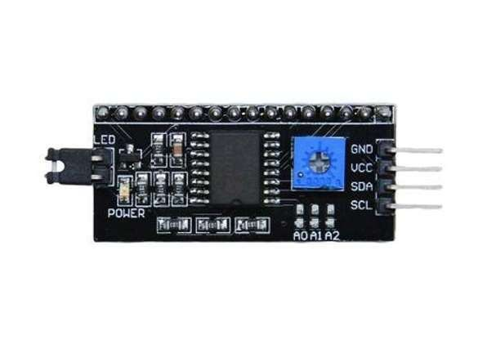
Fig 2.5 I2C Module

6. USB CABLE :
An Arduino typically only requires a USB cable to be used as a power source and to connect to a computer for programming. A USB Type B cable can be used for the most popular Arduino model (Uno), however other Arduino boards may require Type Bmini or micro connectors. A power adapter cable can also be plugged into the Arduino to power the board when separate from a USB power source. As a general rule, the length of cable used to connect the Arduino should be no longer than 5 meters though it is recommended to keep the cable under 3 meters of length. To power the Arduino over a longer distance a regular AC power cable can be used in conjunction with a suitable power adapter. The easiest cable for programming the Arduino is the USB cable An Arduino can be powered using a USB cable or a power adapter. An Arduino can be powered from any standard USB power source, including the following:
- Mobile phone charger
- Portable power bank
- Computers and laptops

2.2 Software tools :
Arduino IDE

The Arduino IDE plays a pivotal role in developing radar detection systems using Arduino boards, providing a robust platform for programming and integrating various components. It serves as a comprehensive environment where developers can write, compile, and upload code to Arduino microcontrollers effortlessly. In the context of radar detection, the IDE facilitates the implementation of sensor interfaces, data processing algorithms, and control logic necessary for interpreting radar signals. Engineers and hobbyists utilize its built-in libraries and extensive community-contributed resources to manage sensor data acquisition, adjust servo motor positions for scanning, and execute real-time responses such as activating LEDs or sounding alarms based on detected movements.
Moreover, the IDE’s serial monitor aids in debugging by displaying sensor readings and system status, ensuring the reliability and functionality of radar detection systems across different applications—from security systems to robotics and beyond.
The Arduino Integrated development Environment (IDE) is an open-source software platform used to write, compile, and upload code to Arduino microcontroller boards. It provides a simple and user-friendly interface for beginners and professionals to develop electronics projects.
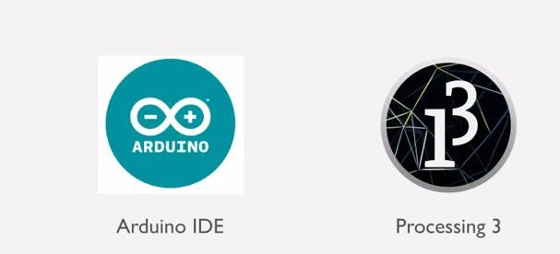

Fig: 2.6 Arduino IDE
Code :
#include <Wire.h> // Library for I2C Communication
#include <LiquidCrystal_I2C.h> // Library for LCD
int x = 0; //declare variable x as integer 0
int input = A0; //declare input comment to A0
int state = 0; // declare the state as 0
LiquidCrystal_I2C lcd(0x27, 16, 2);
void setup() {
lcd.init(); // initiate the LCD
lcd.backlight(); //turn on the black light
lcd.setCursor(0,0); //set the cursor on the first column and first row
lcd.print(" Object = ");// print the string “ object counter” on first line
lcd.setCursor(0, 1);// set the cursor on the first column second line
//lcd.print("objects= ");// print the string “objects=”
//lcd.print(x); // print the string ‘X’
}
void loop() {
int counter = digitalRead(A0);//declare counter as digital read A0
if (state == 0) //when state is 0
{
switch (counter) {
case 1 : state = 1;
lcd.setCursor (0, 1);
x = x + 1;
lcd.print(x-1);
break; //declare state as 0
case 0 : state = 0;
break;//declare state as 0
}
}
if (counter == LOW){ //when the counter set to low
state = 0; //declare state as 0
}
}

Chapter -3
Working of the Project

3.1 Block Diagram :

Arduino

Fig: 3.1 Block Diagram

3.2 Flow Chart :

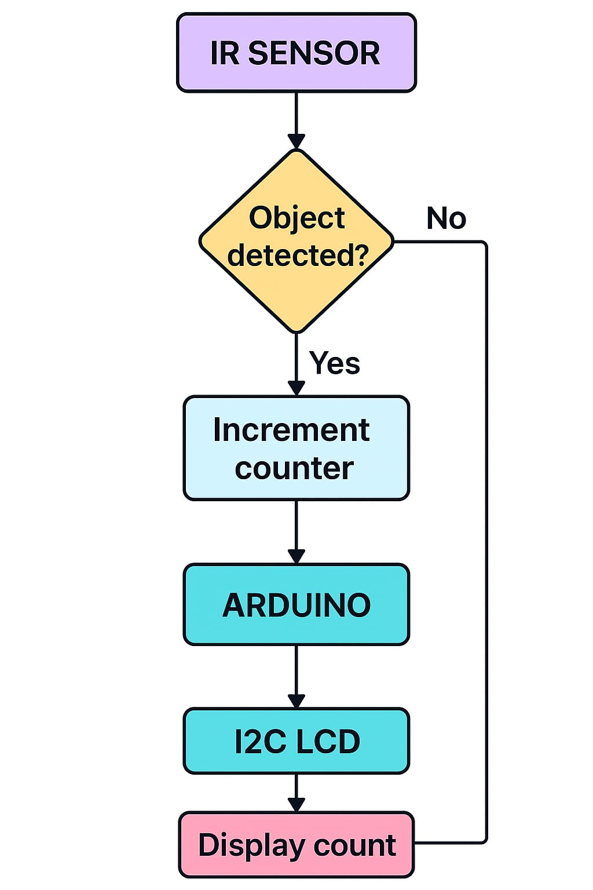

Fig: 3.2 Flow Chart

3.3 Explanation of Working from Input to Output :
Input – IR Sensor Detection
The system starts with the IR (Infrared) sensor, which continuously emits infrared light. When there is no object in front of the sensor, the light goes undetected. When an object passes by, the infrared light reflects off the object and hits the photodiode, changing the sensor’s output from HIGH to LOW. This change in signal acts as a trigger, indicating that an object has been detected.
Processing – Arduino Microcontroller
The Arduino Uno reads the digital output from the IR sensor through one of its GPIO (digital) pins. When the signal goes LOW, the Arduino understands that an object has passed. It then increments a counter variable in its memory. To avoid counting the same object more than once, a short delay (debounce logic) is used in the code. The entire process runs inside the Arduino’s loop() function, allowing it to work continuously.
Output – LCD
After updating the count, the Arduino sends the new count value to an output device. This is usually a 16x2 LCD display, which may be connected via an I2C module to reduce wiring. The LCD shows the number of objects that have passed. Alternatively, the count can also be sent to the serial monitor on a computer for display and logging via USB connection.
Power Supply
The system is powered by either a USB cable connected to a computer or a battery pack. The Arduino also supplies power to the IR sensor and the LCD display through its 5V and GND pins, making the system compact and portable.
Summary
In summary, the object counter works by detecting object presence with an IR sensor (input), counting the events with an Arduino (processing), and displaying the total number on an LCD or serial monitor (output). This type of system is ideal for use in production lines, educational projects, or anywhere automated object counting is needed.
Chapter – 4
Result
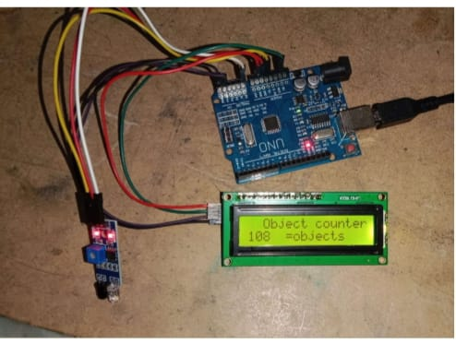
Fig: 4.1 Result

Chapter – 5
Advantages , Disadvantages and Applications

5.1 Advantages :
Low Cost – Uses affordable and widely available components like IR sensors and Arduino boards.
Easy to Build – Simple circuit design and basic programming make it ideal for beginners and students.
Real-Time Counting – Provides instant and continuous object detection and counting.
Compact and Portable – Can be powered by USB or battery, making it easy to deploy in various environments.
Accurate for Controlled Conditions – Delivers good accuracy when objects pass one at a time in a fixed position.
Reduces Manual Work – Automates the counting process, reducing human effort and the chance of manual errors.
Expandable – Can be enhanced with additional features like wireless communication, storage, or multi-direction detection.
Educational Value – Great for learning about sensors, embedded systems, programming, and real-world automation.
Energy Efficient – Consumes very little power, suitable for long-term or battery-powered operation.
Clean User Interface – Displays the object count clearly on an LCD or serial monitor, making it user-friendly.

5.2 Disavantages :

Limited Range – IR sensors work best at short distances and may not detect distant or fast-moving objects.
Single Direction Detection – Basic setup can only detect objects from one direction unless modified.
Affected by Ambient Light – Bright sunlight or other IR sources may interfere with sensor accuracy.
Can’t Identify Object Type – The system counts objects but cannot distinguish between different objects.
False Counting Possible – Vibrations or overlapping objects can cause inaccurate counts.
Slower Response Time – Not ideal for high-speed counting without advanced debouncing and faster sensors.
Limited to One Object at a Time – Designed for one object passing at a time; multiple objects close together may be missed.
No Data Storage – By default, it doesn’t store past data unless additional memory modules or logging are added.
Manual Reset Required – The count must be manually reset unless reset logic or buttons are added.

5.3 Applications :
Product Counting in Assembly Lines – Automatically counts items on conveyor belts in manufacturing.
People Counting at Entrances/Exits – Monitors the number of people entering or exiting a room or event.
Inventory Management Systems – Helps track stock levels by counting items being added or removed.
Library Book Tracking – Can be used to count books as they are returned or borrowed.
Parking Lot Management – Counts vehicles entering or leaving to monitor available parking slots.
Queue Management Systems – Used in banks, hospitals, or ticket counters to count people in line.
Packaging Units – Ensures a specific number of products are packed in each box or container.
Educational Demonstrations – Useful for teaching students about sensors, automation, and embedded systems.
Smart Waste Bins – Counts how many items are disposed of to manage fill levels.
Access Control Systems – Works with gates or doors to allow entry based on a set count.

Chapter – 6
Conclusion and future scope
6.1 Conclusion :
A successful “OBJECT COUNTER CIRCUIT" is illustrated .This circuit not only sense the objects but also counts them.It is a system to count the number of persons entering the room. According to our motto of the project “sensing the object and counting the number of object entering and yet providing a desired output smartly”. IR sensors will detector the object ,will display entry and accordingly manipulate the visitors counter. As the individual enters in the auditorium, accordingly the IR sensors present at the entry displays the count of the persons on the LCD display.We just took up this project as we were interested in electronics and wanted to learn about it. Through this project, we learnt a lot about the functioning and use of different electronic components and their applications in real life. We were able to correlate what we studied in our course to real life Also this is very simple and effective idea which can be used in many places like hostel and hotel rooms to save energy.

6.2 Future Scope :

- This project gives us an opportunity to do a big project in future. The applications stated above are some demo applications that are absolutely possible with its future development. The system will also work using IR sensor.
- It is more efficient then Laser light and Photodiode. So, we have a big work scope in this sector.
- We can send this data to remote location using mobile or internet.
- Voice alarm system can be added to indicate that room is full and person cannot enter inside.
- Lights can be turned ON or OFF according to the number of people inside the room.
- We can check the ambient light intensity and then decide if the light needs to be turned ON or not in a room.
- Metal detectors can be added for security reasons.

Reference :

- [1] Carvalho, Bruno & Silva, Caio & Silva, Alessandra & Buiati, Fábio & de Sousa Junior, Rafael. (2016). Evaluation of an Arduino-based IoT Person Counter. 129136. 10.5220/0005954601290136.
- [3] Jothibasu M, Aakash B, Shanju Ebanesh K, Gokul Vinayak L, “Automatic Room Monitoring with Visitor Counter (ARM – VC)”, IJITEE, Volume-8 Issue-7, May, 2019

- [5] K. Madhira and A. Shukla, "Pedestrian flow counter using image processing," 2017 International Conference on Energy, Communication, Data Analytics and Soft Computing(ICECDS),Chennai,2017,pp.1911-1915,doi: 10.1109/ICECDS.2017.8389782.
- [6] S. Mathur, B. Subramanian, S. Jain, K. Choudhary and D. R. Prabha, "Human detector and counter using raspberry PI microcontroller," 2017 Innovations in Power and Advanced Computing Technologies (i-PACT), Vellore, 2017, pp. 1-7, doi:
      - 10.1109/IPACT.2017.8244984.

