**Harshitha Yendapally**

**Explanation: XOR,FULL ADDER,8 BIT ADDER,16 BIT ADDER**

Task1: To create a xor gate.

Procedure: XOR gate is created by using nand gates.

Schematic:

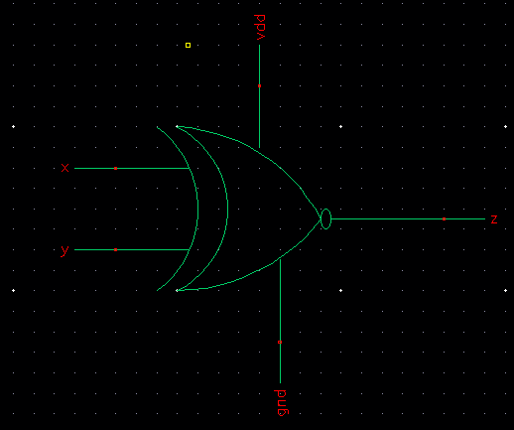

Layout:

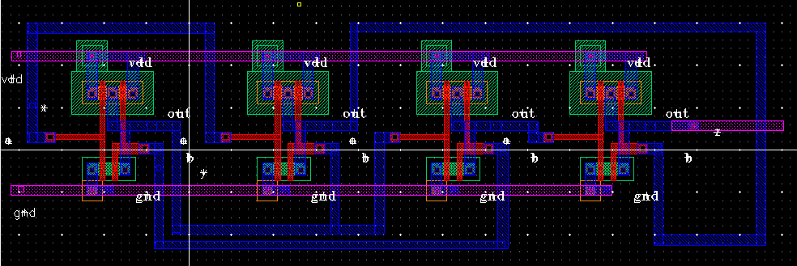

Simulation:

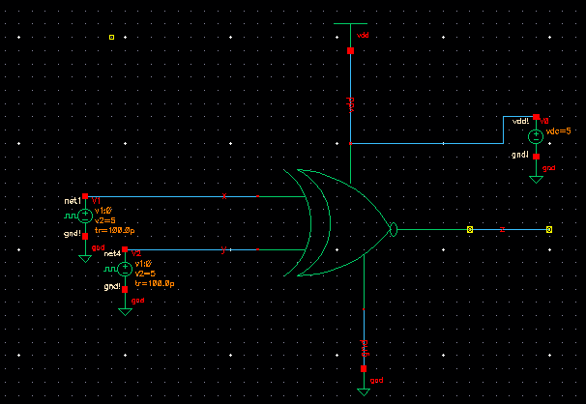

Output Waveforms:

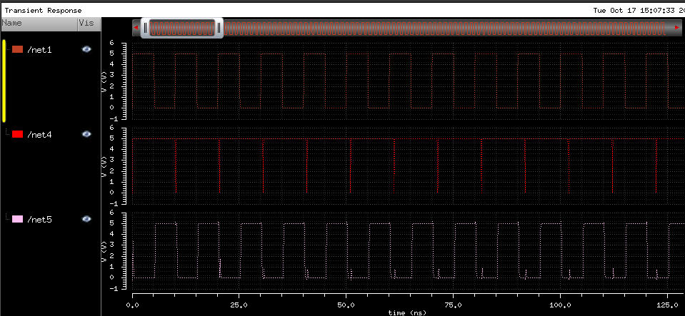

Task2: Full adder

Description: Full adder is created by using xor gates which are created in Task1.

Symbol:

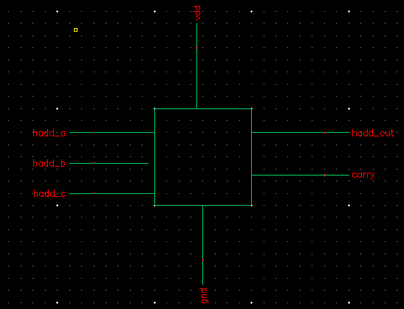

Layout:

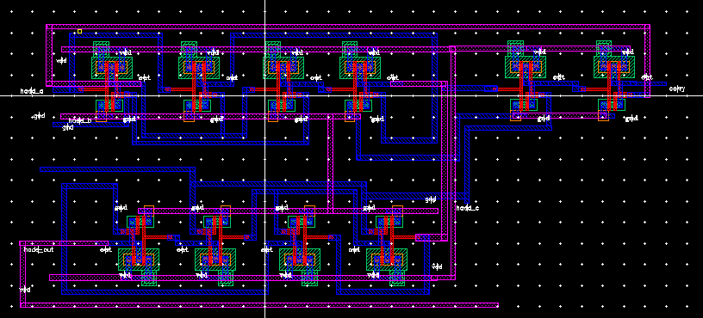

Schematic

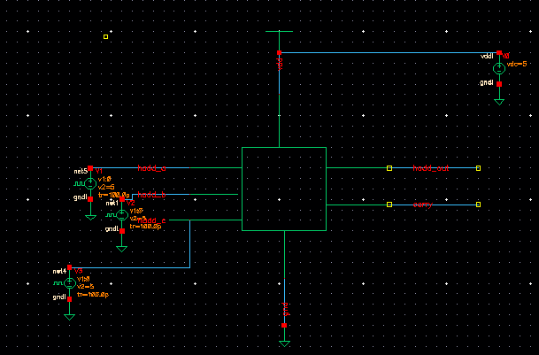

Output waveform:

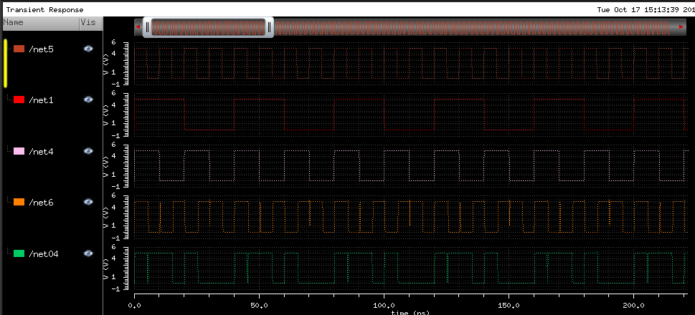

Task-3:

8 bit adder is designed using 1 bit full adders created in task2

Symbol:

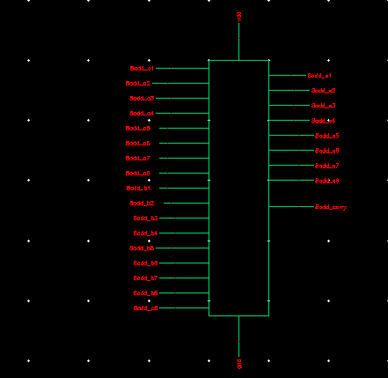

Layout:

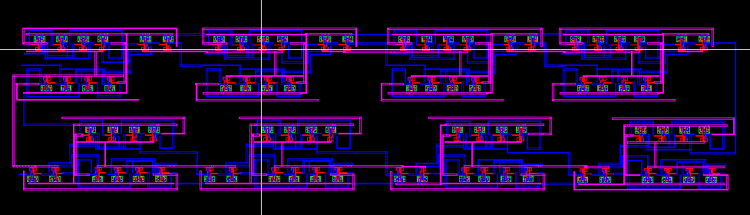

Schematic:

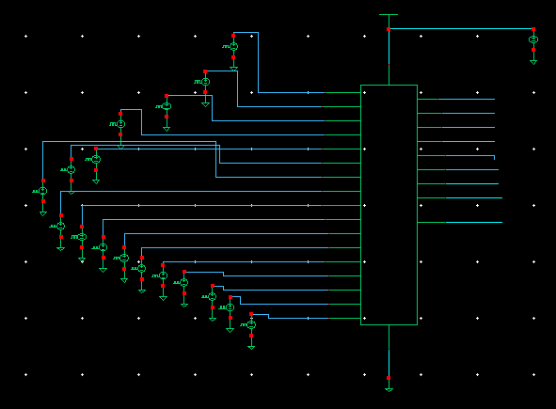

Output waveform:

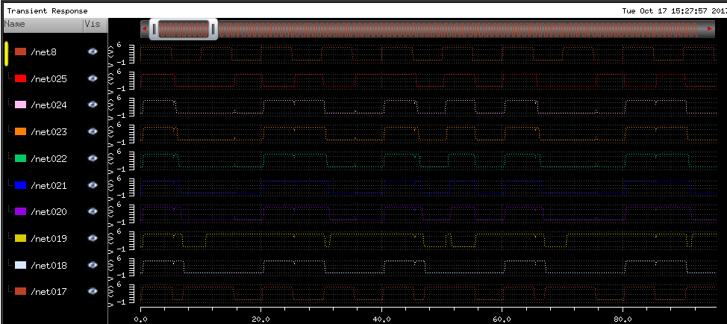

**Task-5: 16 bit adder.**

**16 bit adder is created by using two 8 bit adders.**

**Symbol:**

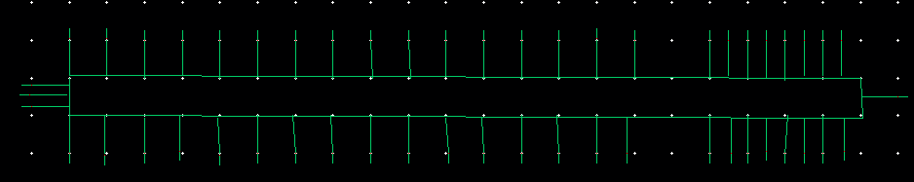

**Layout:**

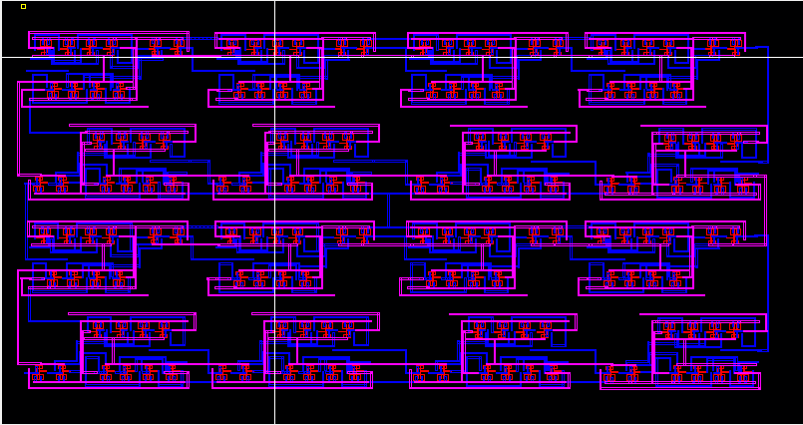

**Schematic:**

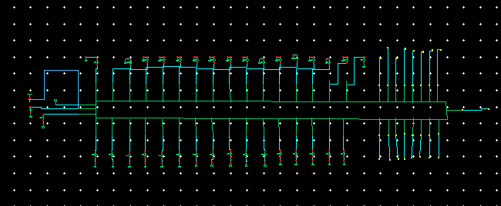

**Output waveforms:**

