TASK 1: Write a Python program to extract all URLs (web links) from a block of text usingregular expressions. Use the Cursor AI tool with zero-shot prompting to generate the solution

PROMPT: write a python program to extract all urls from a block of text using regular expressions

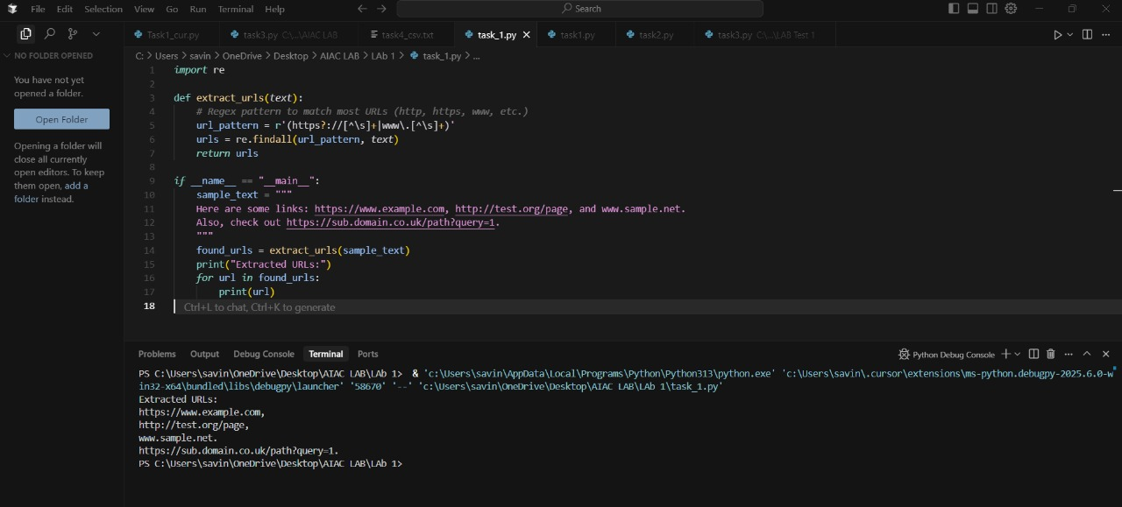
TASK 2: Given a list of books with their genres, write a Python function that recommends books based on a user’s preferred genre. Use the Cursor AI tool. Use few shot prompting.
PROMPT: Write a Python function that takes a list of books with their genres from the user and recommends books based on a user’s preferred genre.
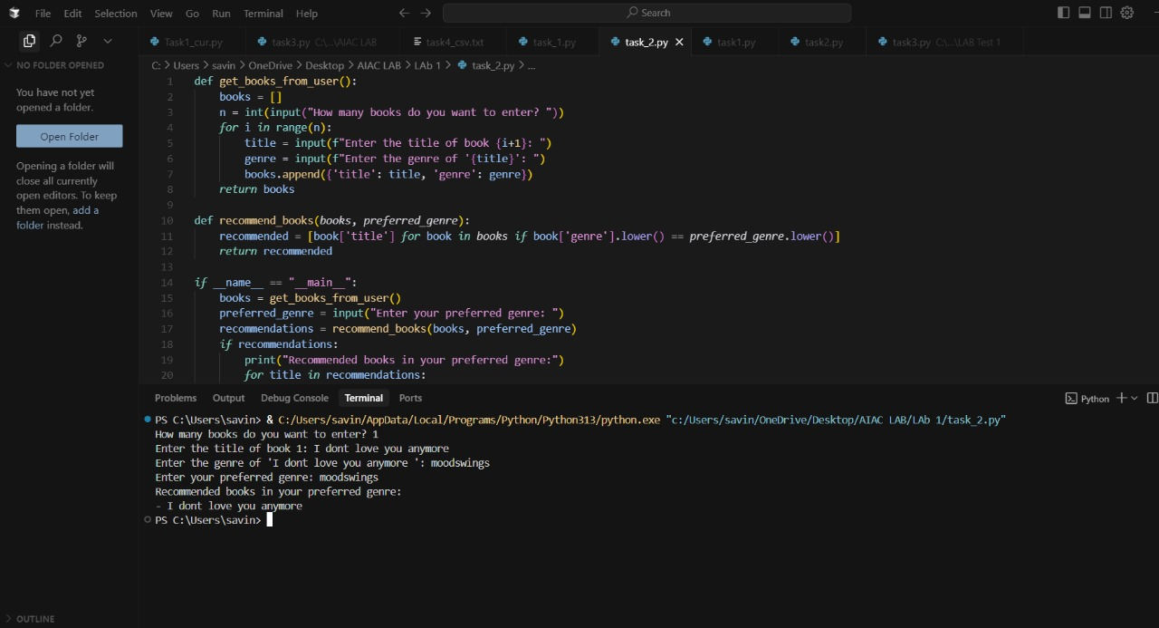

TASK 3: Write a Python program that generates all prime numbers between start and end(both inclusive) entered by the user. Use GitHub Copilot along with VS Code. Use few shotprompting.

PROMPT: Write a python program that generates all prime numbers between start and end by the user take examples input:2 ,5 output :3Input:5,10 output:7,take input from user
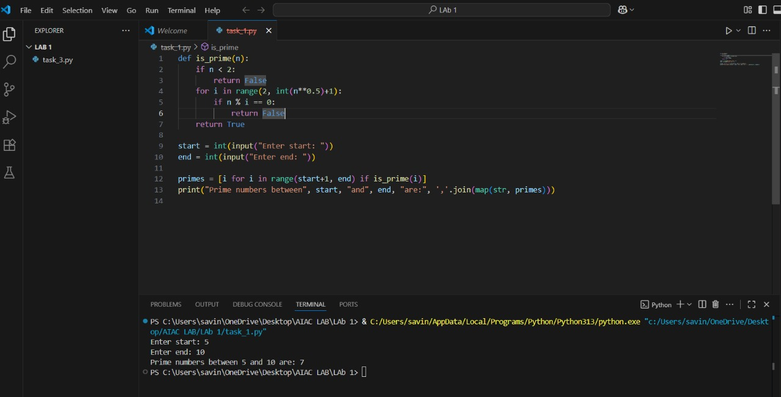

TASK 4: Write Python code that takes a list of student names and generates institutionalemail IDs in the format: <firstletter><lastname>@sru.edu.in Example: "Anita Sharma"asharma@sru.edu.in. Use GitHub Copilot along with VS Code. Use few shot prompting.

PROMPT: Write a python code that takes a list of student names and generates institutional email ids inthe format <firstletter><last name>@sru.edu.in example:input amita,sharma output:asharma @sru.edu.in take input from the user