SCHOOL OF COMPUTER SCIENCE AND ARTIFICIAL INTELLIGENCE |  |  |  |  | DEPARTMENT OF COMPUTER SCIENCE ENGINEERING
ProgramName:B. Tech |  |  |  | Assignment Type: Lab |  |  | AcademicYear:2025-2026
CourseCoordinatorName |  |  |  | Venkataramana Veeramsetty
Instructor(s)Name |  |  |  | Dr. V. Venkataramana (Co-ordinator)  Dr. T. Sampath Kumar  Dr. Pramoda Patro  Dr. Brij Kishor Tiwari  Dr.J.Ravichander  Dr. Mohammand Ali Shaik  Dr. Anirodh Kumar  Mr. S.Naresh Kumar  Dr. RAJESH VELPULA  Mr. Kundhan Kumar  Ms. Ch.Rajitha  Mr. M Prakash  Mr. B.Raju  Intern 1 (Dharma teja)  Intern 2 (Sai Prasad)  Intern 3 (Sowmya)  NS_2 ( Mounika)
CourseCode |  |  | 24CS002PC215 | CourseTitle |  | AI Assisted Coding
Year/Sem |  |  | II/I | Regulation |  | R24
Date and Day  of Assignment |  |  | Week3 - Wednesday | Time(s)
Duration |  |  | 2 Hours | Applicableto  Batches
AssignmentNumber:6.3(Present assignment number)/24(Total number of assignments)
 | Q.No. | Question |  |  |  |  |  | ExpectedTime  to complete
 | 1 | Lab 6: AI-Based Code Completion – Classes, Loops, and Conditionals  Lab Objectives:  - To explore AI-powered auto-completion features for core Python constructs.  - To analyze how AI suggests logic for class definitions, loops, and conditionals.  - To evaluate the completeness and correctness of code generated by AI assistants.  Lab Outcomes (LOs):  After completing this lab, students will be able to:  - Use AI tools to generate and complete class definitions and methods.  - Understand and assess AI-suggested loops for iterative tasks.  - Generate conditional statements through prompt-driven suggestions.  - Critically evaluate AI-assisted code for correctness and clarity.  Task Description#1 (Classes)  - Use AI to complete a Student class with attributes and a method.  - Check output  - Analyze the code generated by AI tool  Instructions:  - Initialize class with attributes like name, roll no, marks  - Method to display student details  - Method to calculate grade based on marks (A:>=90, B: >=75, C: >=60, else Fail)  Start Writing code and auto complete using any AI tool  Expected Output#1  - Class with constructor and display_details() method  Task Description#2 (Loops)  - Prompt AI to complete a function that prints the first 10 multiples of a number using a loop.  - Analyze the generated code  - Ask AI to generate code using other controlled looping  Write code using For Loop, later complete code using While Loop  Expected Output#2  - Correct loop-based implementation  Task Description#3 (Conditional Statements)  - Ask AI to write nested if-elif-else conditionals to classify age groups.  - Analyze the generated code  - Ask AI to generate code using other conditional statements  - 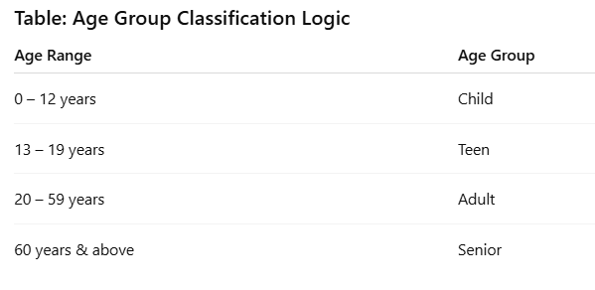  Expected Output#3  - Age classification function with appropriate conditions and with explanation  Task Description#4 (For and While loops)  - Generate a sum_to_n() function to calculate sum of first n numbers  - Analyze the generated code  - Get suggestions from AI with other controlled looping  Expected Output#4  - Python code with explanation  Task Description#5 (Class)  - Use AI to build a BankAccount class with deposit, withdraw, and balance methods.  - Analyze the generated code  - Add comments and explain code  Instructions  - Initialize BankAccount class with attributes like name, balance  - Method to deposit amount  - Method to withdraw amount  - Method to check balance  Expected Output#5  - Python code with explanation  Note: Report should be submitted a word document for all tasks in a single document with prompts, comments & code explanation, and output and if required, screenshots  Evaluation Criteria:  Criteria Max Marks  Class 1.0  Loops 1.0  Conditional Statements 0.5  Total 2.5 Marks |  |  |  |  |  | Week3 - Wednesday
Task Description#1 (Classes)
- Use AI to complete a Student class with attributes and a method.
- Check output
- Analyze the code generated by AI tool

Instructions:
- Initialize class with attributes like name, roll no, marks
- Method to display student details
- Method to calculate grade based on marks (A:>=90, B: >=75, C: >=60, else Fail)

Start Writing code and auto complete using any AI tool

Expected Output#1
- Class with constructor and display_details() method

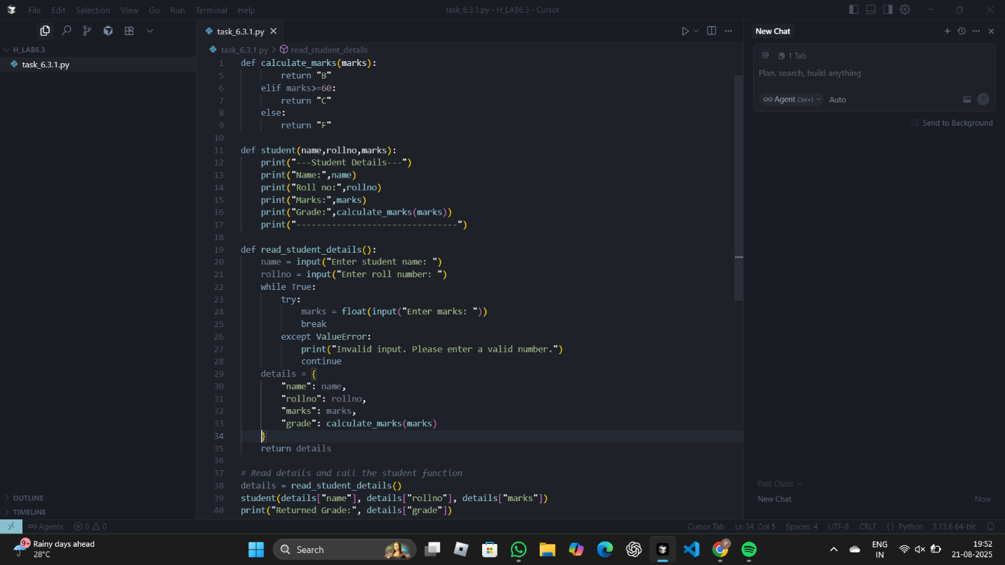
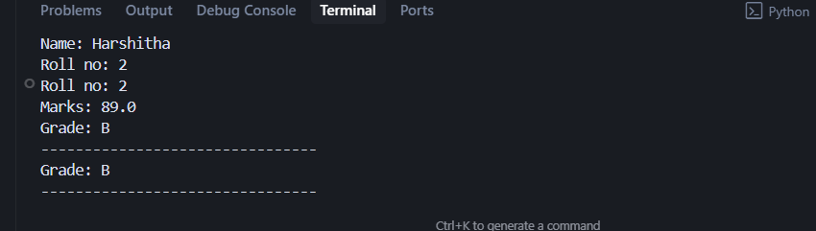

Task Description#2 (Loops)
- Prompt AI to complete a function that prints the first 10 multiples of a number using a loop.
- Analyze the generated code
- Ask AI to generate code using other controlled looping

Write code using For Loop, later complete code using While Loop

Expected Output#2
- Correct loop-based implementation

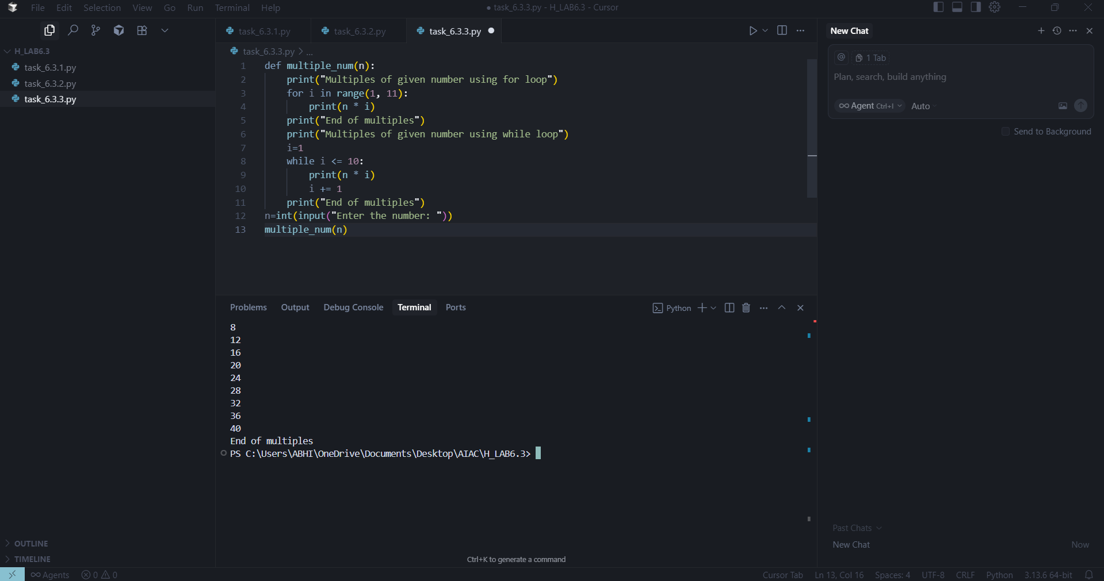

Task Description#3 (Conditional Statements)
- Ask AI to write nested if-elif-else conditionals to classify age groups.
- Analyze the generated code
- Ask AI to generate code using other conditional statements

- 
Expected Output#3
- Age classification function with appropriate conditions and with explanation

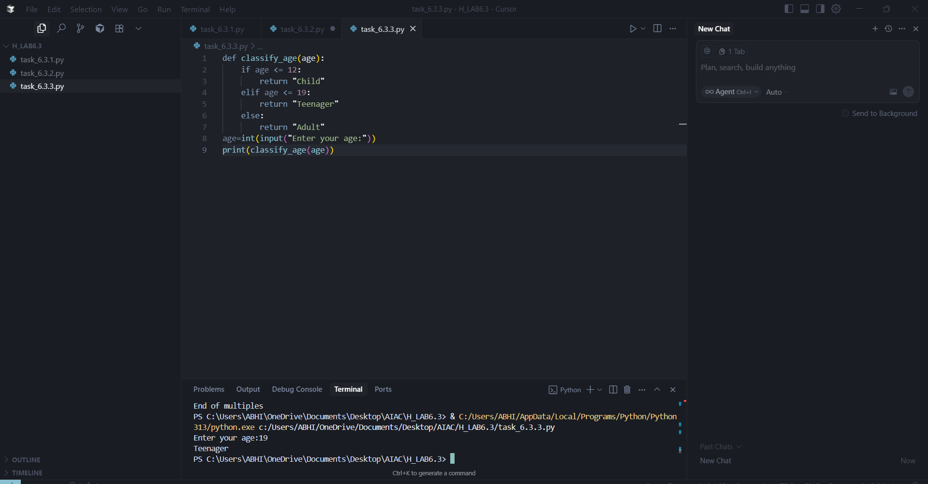

Task Description#4 (For and While loops)
- Generate a sum_to_n() function to calculate sum of first n numbers
- Analyze the generated code
- Get suggestions from AI with other controlled looping

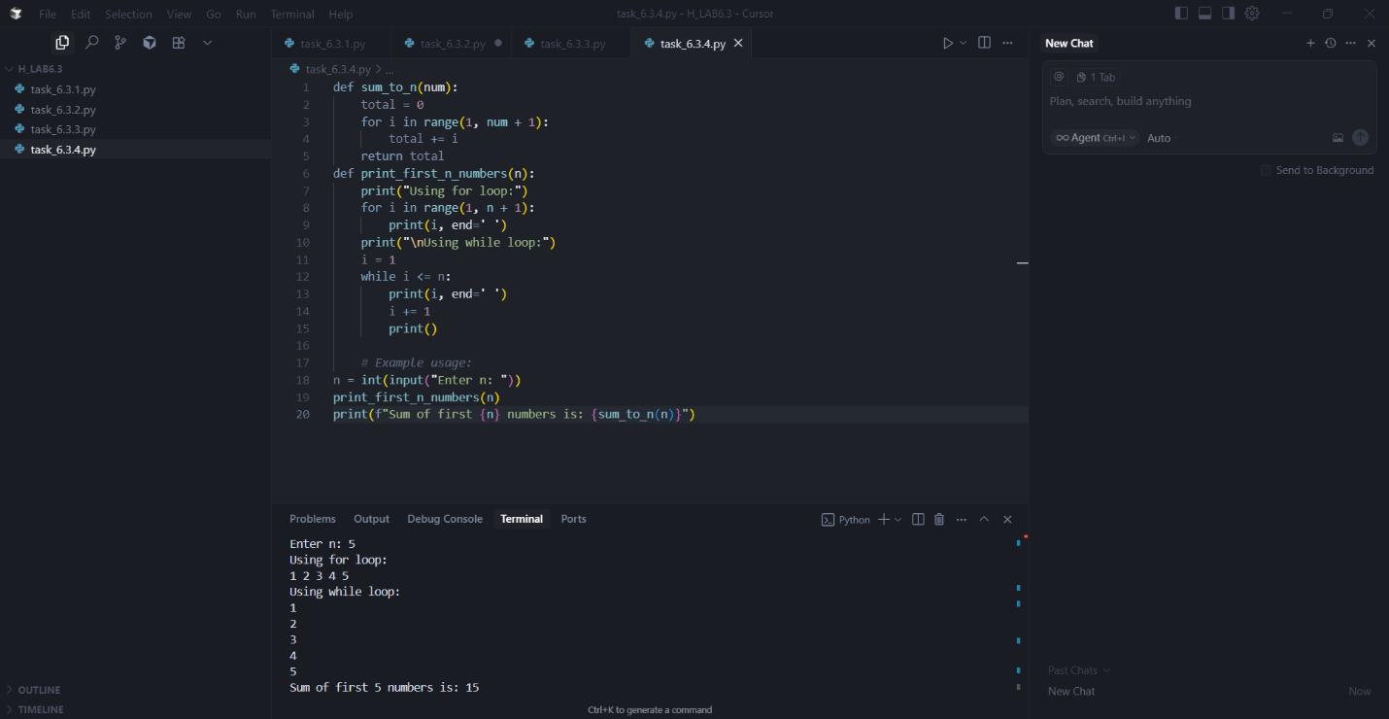

Task Description#5 (Class)
- Use AI to build a BankAccount class with deposit, withdraw, and balance methods.
- Analyze the generated code
- Add comments and explain code

Instructions
- Initialize BankAccount class with attributes like name, balance
- Method to deposit amount
- Method to withdraw amount
- Method to check balance

Expected Output#5
Python code with explanation

